Windows 10 gets a little protective if it doesn’t recognise the publisher of an EXE file. This is an anti-malware protection but it is a false positive for NeOGen which has been scanned for malware with multiple anti-virus algorithms. To bypass this message please follow the following instructions:

Windows 10 users may get this message when clicking Setup-NeOGen exe:

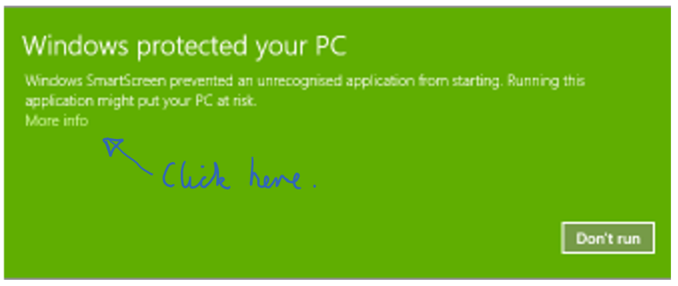

Click on “More Info”

The “Run anyway” button will appear:

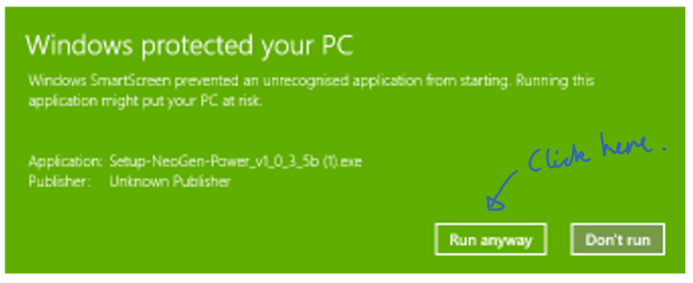

Click “Run anyway” to proceed with setup.