Oracle实战

oracle 安装

oracle 安装会自动产的生成sys用户和 system 用户

(1)sys是 超级用户，具有最高权限， 具有sysdba角色 有create database 的权限。
(2)system是 管理操作员，权限也很大，具有sysoper角色，没有create database权限。
(3)一般来讲，对数据库维护，使用system用户登录就可以了。

oracle 启动
在服务里面启动oracle实例和TNSListener

oracle 卸载
oracle卸载要动注册表

oracle常用工具
1)sql plus
查看当前用户是谁 show user
SQL> show user
User is "scott"

2)在运行中输入sqlplusw
3)oracle企业管理器
4)pl/sql developer

常用命令
连接命令:conn 用户名/密码@网络服务 [as sysdba/sysoper]
SQL> conn sys/m123@MYORACL1 as SYSDBA;

断开连接：disc
SQL> disc

修改密码：passw 如果修改别人密码要用sys或system登录。
Scott 更改自己的口令：
SQL> passw
更改SCOTT的口令
旧口令: *****
新口令: *****
重新键入新口令:*****
口令已更改

管理员更改scott口令
SQL> conn manager/m123@MYORACL1 as SYSDBA;
已连接。
SQL> passw scott
更改scott的口令
新口令: *****
重新键入新口令:*****
口令已更改

文件操作命令：
运行sql脚本：start 路径脚本名。
编辑指定的脚本：edit 脚本名。
将sqlplus屏幕上的内容输出到指定的文件上。
spool 文件名
spool off

交互命令：&
要看本用户有哪些表可以使用，可以用pl/sql developer看
显示行的宽度：set linesize 宽度
设置每页显示的行数 pagesize 行数

用户管理
创建用户：
create user username identified by password; 要dba权限才能创建
SQL> create user xiaoming identified by m123;

删除用户：drop user 用户名
SQL> drop user xiaoming;

在删除用户时，注意如果要删除的用户已经创建了表，就需要带 cascade

用户管理综合案例：
创建新的用户是没有任何权限的，甚至连登录数据库的权限都没有，需要为其指定相应的权限。给一个用户指定权限使用grant，收回权限用revoke
SQL> create user xiaoming identified by m123;

给用户登录数据库的权限
SQL> grant connect to xiaoming;
SQL> conn xiaoming/m123;

重要的角色：connect，dba，resource(可以在任何表空间建表)
要xiaoming可以建表
SQL> grant resource to xiaoming;

对象权限：select, insert, update, delete, all....
要xiaoming访问scott的emp表
SQL> grant select on emp to xiaoming;

scott希望收回xiaoming对emp表的查询权限
SQL> revoke select on emp from xiaoming;
对权限的维护
希望xiaoming可以查询scott的emp表/还希望能xiaoming把这种权限继续给别人
SQL> grant select on emp to xiaoming with grant option;

管理员创建xiaohong，xiaoming给xiaohong赋予查询scott.emp的权限
SQL> conn sys/m123 as sysdba;
SQL> create user xiaohong identified by m123;
SQL> grant connect to xiaohong;
SQL> conn xiaoming/m123;
SQL> grant select on scott.emp to xiaohong;

如果是系统权限
system给xiaoming赋权时：
SQL> grant connect to xiaohong with admin option;
xiaoming可以继续往下赋权

使用profile管理用户口令

(1)账户锁定
指定一个用户登录是最多可以输入密码次数，也可指定用户锁定的时间（天）一般用dba身份去执行

创建profile文件
SQL> create profile pro_name limit failed_login_attempts 3 password_lock_time 2;
SQL> alter user scott profile pro_name;

当scott尝试登录三次没有成功，以后再登录出现如下提示：
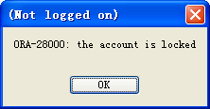
(2)给账户解锁
SQL> conn sys/m123 as sysdba;
SQL> alter user scott account unlock;
SQL> conn scott/tiger;

(3)口令历史
如果希望用户在修改密码的时候，不能使用以前使用过的密码
可以使用口令历史
create profile myprofile limit password_life_time
10 password_grace_time 2 password_resue_time 10;

删除profile
SQL> drop profile pro_name cascade;

表的操作
建表
SQL> create table student(
2 xh number(4),
3 xm varchar2(20),
4 sex char(2),
5 birthday date,
6 sal number(7,2)
7 );

删表
SQL> drop table student;

SQL> create table class(
2 classid number(2),
3 classname varchar2(40)
4 );

添加一个字段
SQL> alter table student add(classid number(2));
SQL> desc student;
Name Type Nullable Default Comments
-------- ------------ -------- ------- --------
XH NUMBER(4) Y
XM VARCHAR2(20) Y
SEX CHAR(2) Y
BIRTHDAY DATE Y
SAL NUMBER(7,2) Y
CLASSID NUMBER(2) Y
修改表的名字
rename student to stu;

所有字段都插入数据
SQL> insert into student values(1001,'张三','男','25-11月-1985',1000,2);

修改默认的日期格式
SQL> alter session set nls_date_format='yyyy-mm-dd';

修改后，可以按如下方式加入信息
SQL> insert into student values(1002,'李四','男','1985-3-30',100,2);

插入空值
SQL> insert into student(xh,xm,sex,birthday) values(1003,'王五','女',null);

查询birthday空值的行
SQL> select * from student where birthday is null;
XH XM SEX BIRTHDAY SAL CLASSID
----- -------------------- --- ----------- --------- ----------------------------------- -- ---------------------
1003 王五 女

修改一个字段
SQL> update student set sex='女' where xh='1002';
SQL> select * from student;
XH XM SEX BIRTHDAY SAL CLASSID
----- ---------------------------- ----------------- ------------ --- - ---------- --------- ------- ------ -----
1001 张三 男 1985-11-25 1000.00 2
1002 李四 女 1985-3-30 100.00 2
1003 王五 女

修改多个字段
SQL> update student set sal=sal/2 where birthday is not null;
SQL> select *from student;
XH XM SEX BIRTHDAY SAL CLASSID
----- ---------------------------- ----------------- ------------ --- - ---------- --------- ------- ------ -----
1001 张三 男 1985-11-25 500.00 2
1002 李四 女 1985-3-30 50.00 2
1003 王五 女

删除数据
设置保存点，删除数据后还可以回滚到保存点
SQL> savepoint aa;
SQL> delete from student;
SQL> select * from student;
XH XM SEX BIRTHDAY SAL CLASSID
----- ---------------------------- ----------------- ------------ --- - ---------- --------- ------- ------ -----
SQL> rollback to aa;
SQL> select * from student;
XH XM SEX BIRTHDAY SAL CLASSID
----- ---------------------------- ----------------- ------------ --- - ---------- --------- ------- ------ -----
1001 张三 男 1985-11-25 500.00 2
1002 李四 女 1985-3-30 50.00 2
1003 王五 女

删除一条数据
SQL> delete from student where xh='1001';
快速删除表中的所有内容，保留表结构
SQL> truncate table student;

查询
desc 表名;查看表结构
SQL> select * from dept; --查看所有，少用这种方式
DEPTNO DNAME LOC
------ -------------- -------------------------------------------------------------
10 ACCOUNTING NEW YORK
20 RESEARCH DALLAS
30 SALES CHICAGO
40 OPERATIONS BOSTON

查询指定列
select 列名 from 表名

set time on打开时间
疯狂复制
insert into users(userid,username,userpss)
select * from users;

查看共有多少行记录
SQL> select count(*) from emp;

COUNT(*)
----------------
16

如何取消重复行, 消除了相同部门同时是相同职业的人
SQL> select distinct deptno,job from emp;
DEPTNO JOB
------ --- ------
10 CLERK
10 MANAGER
10 PRESIDENT
10 clerk
20 ANALYST
20 CLERK
20 MANAGER
30 CLERK
30 MANAGER
30 SALESMAN

显示员工SMITH的信息
SQL> select * from emp where ename='SMITH';
EMPNO ENAME JOB MGR HIREDATE SAL COMM DEPTNO
----- ----------- - ----------------------------------- ---------- --------- ----- ----------- --------- --------- ------
7369 SMITH CLERK 7902 1980-12-17 800.00 20

使用算数表达式显示雇员的年工资
处理null值的函数，nvl()
SQL> select ename,sal*13+nvl(comm,0)*13 "年薪" from emp;
ENAME 年薪
---------- ------------------- --------
SMITH 10400
ALLEN 24700
WARD 22750
JONES 38675
MARTIN 35750
BLAKE 43550
CLARK 31850
SCOTT 4030
KING 78000
TURNER 19500
ADAMS 14300
JAMES 13650
FORD 39000
MILLER 16900
李涛 90000
ok 903.98

显示工资高于3000的员工
SQL> select ename, sal from emp where sal > 3000;
ENAME SAL
---------- -----------------------
BLAKE 3350.00
KING 6000.00
李涛 30000.00

查询1982年1月1号以后入职的员工
SQL> select * from emp where hiredate>'1-1月-1982';
EMPNO ENAME JOB MGR HIREDATE SAL COMM DEPTNO
----- ---------- --------- ----- ----------- --------- --------- ------------------------------------------------
7788 SCOTT ANALYST 7566 1987-4-19 110.00 200.00 20
7876 ADAMS CLERK 7788 1987-5-23 100.00 20
7934 MILLER CLERK 7782 1982-1-23 1300.00 10
9999 李涛 clerk 7788 2008-10-10 30000.00 10
8888 ok MANAGER 7782 1999-12-12 123.23 23.23 10

如何显示工资在2000-2500的员工
SQL> select ename, sal from emp where sal>=2000 and sal<=5000;
或者
SQL> select ename, sal from emp where sal between 2000 and 5000;

ENAME SAL
---------- ----------------------
JONES 2975.00
BLAKE 3350.00
CLARK 2450.00
FORD 3000.00

如何显示首字母为‘S’的员工
SQL> select * from emp where ename like 'S%';
EMPNO ENAME JOB MGR HIREDATE SAL COMM DEPTNO
----- ------------------------------------------------------ --------- ----- ----------- --------- --------- ------
7369 SMITH CLERK 7902 1980-12-17 800.00 20
7788 SCOTT ANALYST 7566 1987-4-19 110.00 200.00 20

显示第三个字符为大写O的所有员工的姓名和工资
SQL> select ename,sal from emp where ename like'__O%';

ENAME SAL
---------- ----------------------
SCOTT 110.00

显示雇员的编号为123，345， 800......
select * from emp where empno in(123，345，800);这种查询速度快

显示没有上级的员工查询出来
SQL> select * from emp where mgr is null;
EMPNO ENAME JOB MGR HIREDATE SAL COMM DEPTNO
----- ------------------------------------------------------ --------- ----- ----------- --------- --------- ------
7839 KING PRESIDENT 1981-11-17 6000.00 10

查询工资高于500或岗位为MANAGER的雇员，同时满足他们的姓名首写字母为大写的J
SQL> select * from emp where (sal>500 or job='MANAGER') and ename like 'J%';
EMPNO ENAME JOB MGR HIREDATE SAL COMM DEPTNO
----- ------------------------------------------------------ --------- ----- ----------- --------- --------- ------
7566 JONES MANAGER 7839 1981-4-2 2975.00 20
7900 JAMES CLERK 7698 1981-12-3 1050.00 30

如何按工资从低到高的顺序显示雇员的信息
SQL> select * from emp order by sal;
EMPNO ENAME JOB MGR HIREDATE SAL COMM DEPTNO
----- ------------------------------------------------------ --------- ----- ----------- --------- --------- ------
7788 SCOTT ANALYST 7566 1987-4-19 110.00 200.00 20
8888 ok MANAGER 7782 1999-12-12 123.23 23.23 10
7369 SMITH CLERK 7902 1980-12-17 800.00 20
7900 JAMES CLERK 7698 1981-12-3 1050.00 30
7876 ADAMS CLERK 7788 1987-5-23 1100.00 20
7521 WARD SALESMAN 7698 1981-2-22 1250.00 500.00 30
7654 MARTIN SALESMAN 7698 1981-9-28 1250.00 1500.00 30
7934 MILLER CLERK 7782 1982-1-23 1300.00 10
7844 TURNER SALESMAN 7698 1981-9-8 1500.00 0.00 30
7499 ALLEN SALESMAN 7698 1981-2-20 1600.00 300.00 30
7782 CLARK MANAGER 7839 1981-6-9 2450.00 10
7566 JONES MANAGER 7839 1981-4-2 2975.00 20
7902 FORD ANALYST 7566 1981-12-3 3000.00 20
7698 BLAKE MANAGER 7839 1981-5-1 3350.00 30
7839 KING PRESIDENT 1981-11-17 6000.00 10
9999 李涛 clerk 7788 2008-10-10 30000.00 10

如何按工资从高到低的顺序显示雇员的信息
SQL> select * from emp order by sal desc;
EMPNO ENAME JOB MGR HIREDATE SAL COMM DEPTNO
----- ------------------------------------------------------ --------- ----- ----------- --------- --------- ------
7788 SCOTT ANALYST 7566 1987-4-19 110.00 200.00 20
8888 ok MANAGER 7782 1999-12-12 123.23 23.23 10
7369 SMITH CLERK 7902 1980-12-17 800.00 20
7900 JAMES CLERK 7698 1981-12-3 1050.00 30
7876 ADAMS CLERK 7788 1987-5-23 1100.00 20
7521 WARD SALESMAN 7698 1981-2-22 1250.00 500.00 30
7654 MARTIN SALESMAN 7698 1981-9-28 1250.00 1500.00 30
7934 MILLER CLERK 7782 1982-1-23 1300.00 10
7844 TURNER SALESMAN 7698 1981-9-8 1500.00 0.00 30
7499 ALLEN SALESMAN 7698 1981-2-20 1600.00 300.00 30
7782 CLARK MANAGER 7839 1981-6-9 2450.00 10
7566 JONES MANAGER 7839 1981-4-2 2975.00 20
7902 FORD ANALYST 7566 1981-12-3 3000.00 20
7698 BLAKE MANAGER 7839 1981-5-1 3350.00 30
7839 KING PRESIDENT 1981-11-17 6000.00 10
9999 李涛 clerk 7788 2008-10-10 30000.00 10

按照部门号升序而雇员的工资降序排列
SQL> select * from emp order by deptno, sal desc;
EMPNO ENAME JOB MGR HIREDATE SAL COMM DEPTNO
----- ------------------------------------------------------ --------- ----- ----------- --------- --------- ------
9999 李涛 clerk 7788 2008-10-10 30000.00 10
7839 KING PRESIDENT 1981-11-17 6000.00 10
7782 CLARK MANAGER 7839 1981-6-9 2450.00 10
7934 MILLER CLERK 7782 1982-1-23 1300.00 10
8888 ok MANAGER 7782 1999-12-12 123.23 23.23 10
7902 FORD ANALYST 7566 1981-12-3 3000.00 20
7566 JONES MANAGER 7839 1981-4-2 2975.00 20
7876 ADAMS CLERK 7788 1987-5-23 1100.00 20
7369 SMITH CLERK 7902 1980-12-17 800.00 20
7788 SCOTT ANALYST 7566 1987-4-19 110.00 200.00 20
7698 BLAKE MANAGER 7839 1981-5-1 3350.00 30
7499 ALLEN SALESMAN 7698 1981-2-20 1600.00 300.00 30
7844 TURNER SALESMAN 7698 1981-9-8 1500.00 0.00 30
7521 WARD SALESMAN 7698 1981-2-22 1250.00 500.00 30
7654 MARTIN SALESMAN 7698 1981-9-28 1250.00 500.00 30
7900 JAMES CLERK 7698 1981-12-3 1050.00 30

使用列的别名排序
按年薪排序
SQL> select ename,(sal+nvl(comm,0))*13 "年薪" from emp order by "年薪";
ENAME 年薪
---------- ------------------------------
ok 1903.98
SCOTT 4030
SMITH 10400
JAMES 13650
ADAMS 14300
MILLER 16900
TURNER 19500
WARD 22750
ALLEN 24700
CLARK 31850
MARTIN 35750
JONES 38675
FORD 39000
BLAKE 43550
KING 78000
李涛 390000

oracle复杂查询
数据分组—max(), min(), avg(), sum(), count()

如何显示所有员工中最高工资和最低工资
SQL> select max(sal), min(sal) from emp;
MAX(SAL) MIN(SAL)
---------- ------- ---
30000 110

显示最高工资的雇员姓名和工资
SQL> select ename,sal from emp where sal=(select max(sal) from emp);

ENAME SAL
---------- ------------------------
李涛 30000.00

显示工资高于平均工资的员工的信息
SQL> select * from emp where sal>(select avg(sal) from emp);
EMPNO ENAME JOB MGR HIREDATE SAL COMM DEPTNO
----- ------------------------------------------------------ --------- ----- ----------- --------- --------- ------
7839 KING PRESIDENT 1981-11-17 6000.00 10
9999 李涛 clerk 7788 2008-10-10 30000.00 10

group by用于对查询结果分组统计，having子句用于限制分组显示结果。

如何显示每个部门的平均工资和最高工资
SQL> select avg(sal),max(sal),deptno from emp group by deptno;
AVG(SAL) MAX(SAL) DEPTNO
---------- ---------- ------
7974.646 30000 10
1597 3000 20
1666.66666 3350 30

显示每个部门的每种岗位的平均工资和最低工资
SQL> select avg(sal),min(sal),deptno,job from emp group by deptno,job;
AVG(SAL) MIN(SAL) DEPTNO JOB
---------- ---------- ------ ----------------------- -----
1300 1300 10 CLERK
30000 30000 10 clerk
1286.615 123.23 10 MANAGER
6000 6000 10 PRESIDENT
950 800 20 CLERK
1555 110 20 ANALYST
2975 2975 20 MANAGER
1050 1050 30 CLERK
3350 3350 30 MANAGER
1400 1250 30 SALESMAN

显示平均工资高于1000的部门号和它的平均工资，按升序排列
SQL> select deptno, avg(sal) from emp group by deptno having avg(sal)>1000 order by avg(sal);
DEPTNO AVG(SAL)
------ ---------- ------------
20 1597
30 1666.66666
10 7974.646

多表查询
显示雇员名，雇员工资以及所在部门的名字
SQL> select ename, sal, dname from emp, dept where emp.deptno = dept.deptno;

ENAME SAL DNAME
---------- --------- --------------
SMITH 800.00 RESEARCH
ALLEN 1600.00 SALES
WARD 1250.00 SALES
JONES 2975.00 RESEARCH
MARTIN 1250.00 SALES
BLAKE 2850.00 SALES
CLARK 2450.00 ACCOUNTING
SCOTT 5755.00 RESEARCH
KING 6000.00 ACCOUNTING
TURNER 1500.00 SALES
ADAMS 1100.00 RESEARCH
JAMES 950.00 SALES
FORD 3000.00 RESEARCH
MILLER 1430.00 ACCOUNTING

如何显示部门号为10的部门名、员工名和工资
SQL>select a2.dname,a1.ename,a1.sal from emp a1,dept a2 where a2.deptno=10 and a1.deptno=a2.deptno;
DNAME ENAME SAL
-------------- ---------- ---------
ACCOUNTING CLARK 2450.00
ACCOUNTING KING 6000.00
ACCOUNTING MILLER 1300.00
ACCOUNTING 李涛 30000.00
ACCOUNTING ok 123.23

显示各个员工的姓名，工资，及其工资的级别

SQL> select a1.ename,a1.sal,a2.grade from emp a1, salgrade a2
2 where a1.sal between a2.losal and a2.hisal
ENAME SAL GRADE
---------- --------- ----------
SMITH 800.00 1
ADAMS 1100.00 1
JAMES 1050.00 1
WARD 1250.00 2
MARTIN 1250.00 2
MILLER 1300.00 2
ALLEN 1600.00 3
TURNER 1500.00 3
JONES 2975.00 4
CLARK 2450.00 4
FORD 3000.00 4
BLAKE 3350.00 5
KING 6000.00 5

显示雇员名，雇员工资及所在部门的名字，并按部门排序
SQL> select a1.ename, a1.sal, a2.dname from emp a1, dept a2 where a1.deptno = a2.deptno order by a2.deptno;
ENAME SAL DNAME
---------- --------- --------------
CLARK 2450.00 ACCOUNTING
KING 6000.00 ACCOUNTING
李涛 30000.00 ACCOUNTING
MILLER 1300.00 ACCOUNTING
ok 123.23 ACCOUNTING
SMITH 800.00 RESEARCH
ADAMS 1100.00 RESEARCH
FORD 3000.00 RESEARCH
SCOTT 110.00 RESEARCH
JONES 2975.00 RESEARCH
ALLEN 1600.00 SALES
BLAKE 3350.00 SALES
MARTIN 1250.00 SALES
JAMES 1050.00 SALES
TURNER 1500.00 SALES
WARD 1250.00 SALES

自连接:自连接是指在同一张表的连接查询。
显示FORD的上级领导的姓名
SQL> select a1.ename, a2.ename "上级领导" from emp a1, emp a2
2 where a1.mgr = a2.empno and a1.ename = 'FORD';
ENAME 上级领导
---------- ------------
FORD JONES

子查询:嵌入在其他sql语句中的sql语句
单行子查询
如何显示与SMITH同一部门的所有员工
SQL> select * from emp where deptno = (select deptno from emp where ename='SMITH');
EMPNO ENAME JOB MGR HIREDATE SAL COMM DEPTNO
----- ---------- --------- ----- ----------- --------- --------- ------
7369 SMITH CLERK 7902 1980-12-17 800.00 20
7566 JONES MANAGER 7839 1981-4-2 2975.00 20
7788 SCOTT ANALYST 7566 1987-4-19 110.00 200.00 20
7876 ADAMS CLERK 788 1987-5-23 1100.00 20
7902 FORD ANALYST 7566 1981-12-3 3000.00 20

--数据库在执行sql语句时，是从右到左扫描
--所以尽可能把一次可以去除很多记录的的条件写到右边

多行子查询
如何查询和部门10的工作相同的雇员的名字，岗位，工资，部门号
SQL> select ename,job,sal,deptno from emp where job in (select job from emp where deptno=10);
ENAME JOB SAL DEPTNO
---------- --------- --------- ------
SMITH CLERK 800.00 20
ADAMS CLERK 1100.00 20
MILLER CLERK 1300.00 10
JAMES CLERK 1050.00 30
JONES MANAGER 2975.00 20
CLARK MANAGER 2450.00 10
ok MANAGER 123.23 10
BLAKE MANAGER 3350.00 30
KING PRESIDENT 6000.00 10
李涛 clerk 30000.00 10

如何显示工资比部门30的任意一个员工的工资高的员工的姓名，工资和部门号
SQL> select ename,sal,deptno from emp where sal>any (select sal from emp where deptno=30);
ENAME SAL DEPTNO
---------- --------- ------
ALLEN 1600.00 30
WARD 1250.00 30
JONES 2975.00 20
MARTIN 1250.00 30
BLAKE 3350.00 30
CLARK 2450.00 10
KING 6000.00 10
TURNER 1500.00 30
ADAMS 1100.00 20
FORD 3000.00 20
MILLER 1300.00 10
李涛 30000.00 10

多列子查询
如何查询与smith的部门和岗位完全相同的所有的员工
SQL> select * from emp where (deptno,job)=(select deptno,job from emp where ename='SMITH');
EMPNO ENAME JOB MGR HIREDATE SAL COMM DEPTNO
----- ---------- --------- ----- ----------- --------- --------- ------
7369 SMITH CLERK 7902 1980-12-17 800.00 20
7876 ADAMS CLERK 7788 1987-5-23 1100.00 20

如何显示高于自己部门的平均工资的员工的信息
SQL> select * from emp, (select avg(sal) asal,deptno from emp group by deptno) ga
4 where emp.sal>ga.asal and emp.deptno=ga.deptno;
EMPNO ENAME JOB MGR HIREDATE SAL DEPTNO ASAL
----- ---------- --------- ----- ----------- --------- --------- ------ ---------- -----
9999 李涛 clerk 7788 2008-10-10 30000.00 10 7974.646
7902 FORD ANALYST 7566 1981-12-3 3000.00 20 1597
7566 JONES MANAGER 7839 1981-4-2 2975.00 20 1597
7698 BLAKE MANAGER 7839 1981-5-1 3350.00 30 1666.66666

建立新表，希望能把原来表中的数据导入到新表中
SQL> create table litao(myId number(4),myname varchar2(50),
2 myDept number(5));

将emp表的10号部门的员工导入
SQL> insert into litao(myid,myname,mydept)
2 select empno,ename,deptno from emp where deptno=10;
SQL> select * from litao;
MYID MYNAME MYDEPT
----- -----------------------------------------------------------------------------------------------------
7782 CLARK 10
7839 KING 10
7934 MILLER 10
9999 李涛 10
1 haiter 10

希望员工scott的岗位，工资，补助与smith员工的一样
SQL> update emp set (job,sal,comm)=(select job,sal,comm from emp where ename='SMITH') where ename='SCOTT';
SQL> SELECT * from emp where (job,sal)=(select job,sal from emp where ename='SCOTT');
EMPNO ENAME JOB MGR HIREDATE SAL COMM DEPTNO
----- ---------- --------- ----- ----------- --------- --------- ------
7369 SMITH CLERK 7902 1980-12-17 800.00 20
7788 SCOTT CLERK 7566 1987-4-19 800.00 20

事务
事务用于保证数据的一致性。
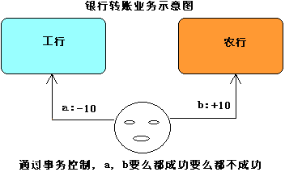

事务和锁的概念：
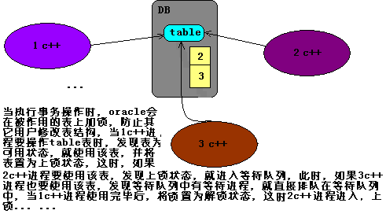

提交事务
当执行commit语句后可以提交事务。当执行commit语句后会确认事务的变化，结束事务，删除保存点，释放锁。当使用commit语句结束事务后，其它会话将可以查看到事务变化后的新数据

回退事务
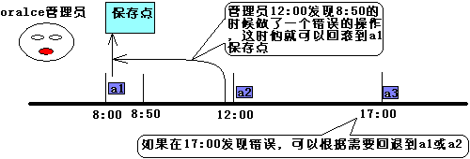

对上图举例说明：
SQL> savepoint a1;
SQL> delete from emp where empno=7788;
SQL> select * from emp;
EMPNO ENAME JOB MGR HIREDATE SAL COMM DEPTNO
----- ---------- --------- ----- ----------- --------- --------- ----------------------------------------------------
7369 SMITH CLERK 7902 1980-12-17 800.00 20
7499 ALLEN SALESMAN 7698 1981-2-20 1600.00 300.00 30
7521 WARD SALESMAN 7698 1981-2-22 1250.00 500.00 30
7566 JONES MANAGER 7839 1981-4-2 2975.00 20
7654 MARTIN SALESMAN 7698 1981-9-28 1250.00 1500.00 30
7698 BLAKE MANAGER 7839 1981-5-1 3350.00 30
7782 CLARK MANAGER 7839 1981-6-9 2450.00 10
7839 KING PRESIDENT 1981-11-17 6000.00 10
7844 TURNER SALESMAN 7698 1981-9-8 1500.00 0.00 30
7876 ADAMS CLERK 7788 1987-5-23 1100.00 20
7900 JAMES CLERK 7698 1981-12-3 1050.00 30
7902 FORD ANALYST 7566 1981-12-3 3000.00 20
7934 MILLER CLERK 7782 1982-1-23 1300.00 10
9999 李涛 clerk 7788 2008-10-10 30000.00 10
8888 ok MANAGER 7782 1999-12-12 123.23 23.23 10
8889 sti CLERK 7499 1982-11-11 80.00 20
SQL> savepoint a2;
SQL> delete from emp where empno=9999;
SQL> select * from emp;
EMPNO ENAME JOB MGR HIREDATE SAL COMM DEPTNO
----- ---------- --------- ----- ----------- --------- --------- ----------------------------------------------------
7369 SMITH CLERK 7902 1980-12-17 800.00 20
7499 ALLEN SALESMAN 7698 1981-2-20 1600.00 300.00 30
7521 WARD SALESMAN 7698 1981-2-22 1250.00 500.00 30
7566 JONES MANAGER 7839 1981-4-2 2975.00 20
7654 MARTIN SALESMAN 7698 1981-9-28 1250.00 1500.00 30
7698 BLAKE MANAGER 7839 1981-5-1 3350.00 30
7782 CLARK MANAGER 7839 1981-6-9 2450.00 10
7839 KING PRESIDENT 1981-11-17 6000.00 10
7844 TURNER SALESMAN 7698 1981-9-8 1500.00 0.00 30
7876 ADAMS CLERK 7788 1987-5-23 1100.00 20
7900 JAMES CLERK 7698 1981-12-3 1050.00 30
7902 FORD ANALYST 7566 1981-12-3 3000.00 20
7934 MILLER CLERK 7782 1982-1-23 1300.00 10
8888 ok MANAGER 7782 1999-12-12 123.23 23.23 10
8889 sti CLERK 7499 1982-11-11 80.00 20
SQL> rollback to a2;
EMPNO ENAME JOB MGR HIREDATE SAL COMM DEPTNO
----- ---------- --------- ----- ----------- --------- --------- ----------------------------------------------------
7369 SMITH CLERK 7902 1980-12-17 800.00 20
7499 ALLEN SALESMAN 7698 1981-2-20 1600.00 300.00 30
7521 WARD SALESMAN 7698 1981-2-22 1250.00 500.00 30
7566 JONES MANAGER 7839 1981-4-2 2975.00 20
7654 MARTIN SALESMAN 7698 1981-9-28 1250.00 1500.00 30
7698 BLAKE MANAGER 7839 1981-5-1 3350.00 30
7782 CLARK MANAGER 7839 1981-6-9 2450.00 10
7839 KING PRESIDENT 1981-11-17 6000.00 10
7844 TURNER SALESMAN 7698 1981-9-8 1500.00 0.00 30
7876 ADAMS CLERK 7788 1987-5-23 1100.00 20
7900 JAMES CLERK 7698 1981-12-3 1050.00 30
7902 FORD ANALYST 7566 1981-12-3 3000.00 20
7934 MILLER CLERK 7782 1982-1-23 1300.00 10
9999 李涛 clerk 7788 2008-10-10 30000.00 10
8888 ok MANAGER 7782 1999-12-12 123.23 23.23 10
8889 sti CLERK 7499 1982-11-11 80.00 20
SQL> rollback to a1;
SQL> select * from emp;
EMPNO ENAME JOB MGR HIREDATE SAL COMM DEPTNO
----- ---------- --------- ----- ----------- --------- --------- ----------------------------------------------------
7369 SMITH CLERK 7902 1980-12-17 800.00 20
7499 ALLEN SALESMAN 7698 1981-2-20 1600.00 300.00 30
7521 WARD SALESMAN 7698 1981-2-22 1250.00 500.00 30
7566 JONES MANAGER 7839 1981-4-2 2975.00 20
7654 MARTIN SALESMAN 7698 1981-9-28 1250.00 1500.00 30
7698 BLAKE MANAGER 7839 1981-5-1 3350.00 30
7782 CLARK MANAGER 7839 1981-6-9 2450.00 10
7788 SCOTT ANALYST 7566 1987-4-19 110.00 200.00 20
7839 KING PRESIDENT 1981-11-17 6000.00 10
7844 TURNER SALESMAN 7698 1981-9-8 1500.00 0.00 30
7876 ADAMS CLERK 7788 1987-5-23 1100.00 20
7900 JAMES CLERK 7698 1981-12-3 1050.00 30
7902 FORD ANALYST 7566 1981-12-3 3000.00 20
7934 MILLER CLERK 7782 1982-1-23 1300.00 10
8888 ok MANAGER 7782 1999-12-12 123.23 23.23 10
8889 sti CLERK 7499 1982-11-11 80.00 20

注意：保存点只对还没有提交事务的情况起作用，实验结果如下：
SQL> savepoint a1;
Savepoint created
SQL> delete from emp where ename='ok';
1 row deleted
SQL> commit;
Commit complete
SQL> rollback to a1;
rollback to a1
ORA-01086: 从未创建保留点 'A1'

只读事务
只允许查询操作，不允许其他操作，使用只读事务可以确保用户只能读取某时间点以前的数据，假定机票代售点每天18点开始统计当天的销售情况，这时可以使用只读事务，在设置只读事务后，尽管其它会话可能会提交新的事务，但只读事务将不会取得最新数据的变化，从而可以保证取得特定时间点的数据信息
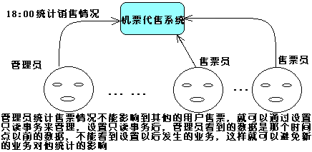
设置只读事务
Set transaction read only;
实例演示：
SQL> conn manager/m123 as sysdba
SQL> set transaction read only;
SQL>insert into emp values('0001','haiter','MANAGER',8889,to_date('1983-1-1','yyyy-mm-dd'),
3000,90,10);
1 row inserted
SQL> select count(*) from emp;

COUNT(*)
----------------
17

manager查询结果
SQL> select count(*) from scott.emp;

COUNT(*)
----------
16

SQL函数的使用
常用的字符函数
lower(char):将字符串转化为小写格式

upper(char):将字符串转化为大写格式
length(char):返回字符串的长度
substr(char,m,n):取字符串的字串
replace(char1,search_string,replace_string)
instr(char1,char2)取子串在字符串的位置

将员工scott的名字按小写的方式显示
SQL> select lower(ename) from emp where ename='SCOTT';

LOWER(ENAME)
------------
scott

将员工haiter的名字按大写的方式显示
SQL> select upper(ename) from emp where ename='haiter';

UPPER(ENAME)
------------

HAITER

显示正好为5个字符大员工的姓名
SQL> select ename from emp where length(ename)=5;

ENAME
----------

SMITH

ALLEN
JONES
BLAKE
CLARK
SCOTT
ADAMS
JAMES

显示员工scott姓名的前三个字符
SQL> select substr(ename,1,3) from emp where ename='SCOTT';

SUBSTR(ENAME,1,3)
-----------------

SCO

以首字母大写的方式显示员工scott的姓名
SQL> select substr(upper(ename),1,1) || substr(lower(ename),2,length(ename)-1) "name" from emp where ename='SCOTT';
name
------------

Scott

显示所有员工的姓名，用"我"替换所有的'A'
SQL> select replace(ename,'A','我') from emp;
REPLACE(ENAME,'A','我')
-----------------------

SMITH
我LLEN
W我RD
JONES
M我RTI N
BL我KE
CL我RK
SCOTT
KING
TURNER
我D我MS
J我MES
FORD
MILLER
李涛
liming
sti
haiter

数学函数(财务和银行系统中用的多)
round(n,m)该函数用于四舍五入，如省掉m，则四舍五入到整数，如果m是正数，则四舍五入到小数点m位后，如果是负数，则四舍五入到小数点的m位前。
trunc(n,m)该函数用于截取数字，如果省略掉m，就截取小数部分

，如果m是正数，则截取到小数点m位后，如果是负数
则截取到小数点的m位前
mod(m,n)
floor(n)返回小于或等于n的最大整数
ceil(n)返回大于或等于n的最小整数

显示在一个月为30天的情况所有员工的日薪金，忽略余数
SQL> select trunc(sal/30) "日薪", to_char(sal/30,'99,999.99') "日薪(小数)" from emp;
日薪 日薪(小数)
---------- ----------
26 26.67
53 53.33
41 41.67
99 99.17
41 41.67
111 111.67
81 81.67
26 26.67
200 200.00
50 50.00
36 36.67
35 35.00
100 100.00
43 43.33
1000 1,000.00
2 2.67
100 100.00

日期函数
默认情况下日期格式dd-mon-yy
(1)sysdate:返回系统时间
(2)add_months(d,n)
(3)las_day(d):返回指定日期所在月份的最后一天

返回系统当前时间
SQL> select sysdate from dual;

SYSDATE
-----------
2010-1-12 1

查找入职300个月多的员工
SQL> select * from emp where sysdate>add_months(hiredate,300);

EMPNO ENAME JOB MGR HIREDATE SAL COMM DEPTNO
----- ---------- --------- ----- ----------- --------- --------- ------
7369 SMITH CLERK 7902 1980-12-17 800.00 20
7499 ALLEN SALESMAN 7698 1981-2-20 1600.00 300.00 30
7521 WARD SALESMAN 7698 1981-2-22 1250.00 500.00 30
7566 JONES MANAGER 7839 1981-4-2 2975.00 20
7654 MARTIN SALESMAN 7698 1981-9-28 1250.00 1500.00 30
7698 BLAKE MANAGER 7839 1981-5-1 3350.00 30
7782 CLARK MANAGER 7839 1981-6-9 2450.00 10
7839 KING PRESIDENT 1981-11-17 6000.00 10
7844 TURNER SALESMAN 7698 1981-9-8 1500.00 0.00 30
7900 JAMES CLERK 7698 1981-12-3 1050.00 30
7902 FORD ANALYST 7566 1981-12-3 3000.00 20
7934 MILLER CLERK 7782 1982-1-23 1300.00 10
8889 sti CLERK 7499 1982-11-11 80.00 20
1 haiter MANAGER 8889 1983-1-1 3000.00 90.00 10

显示满10年服务年限的员工的姓名和受雇日期
SQL> select ename,hiredate from emp where sysdate>add_months(hiredate,120);
ENAME HIREDATE
---------- -----------
SMITH 1980-12-17
ALLEN 1981-2-20
WARD 1981-2-22
JONES 1981-4-2
MARTIN 1981-9-28
BLAKE 1981-5-1
CLARK 1981-6-9
SCOTT 1987-4-19
KING 1981-11-17
TURNER 1981-9-8
ADAMS 1987-5-23
JAMES 1981-12-3
FORD 1981-12-3
MILLER 1982-1-23
sti 1982-11-11
haiter 1983-1-1

显示每个员工入职天数
SQL> select ename, trunc(sysdate-hiredate) "入职天数" from emp;
ENAME 入职天数
---------- ----------
SMITH 10618
ALLEN 10553
WARD 10551
JONES 10512
MARTIN 10333
BLAKE 10483
CLARK 10444
SCOTT 8304
KING 10283
TURNER 10353
ADAMS 8270
JAMES 10267
FORD 10267
MILLER 10216
李涛 459
liming 1
sti 9924
haiter 9873

找出各个月倒数第三天受雇的员工
SQL> select ename,hiredate from emp where last_day(hiredate)=hiredate+2;
ENAME HIREDATE
---------- -----------
MARTIN 1981-9-28

转换函数
用以将一种数据类型转成另外一种。
to_char()
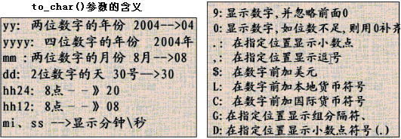

日期是否可以显示 时/分/秒
SQL> select ename,to_char(hiredate,'yyyy-mm-dd hh24/mi/ss') hiredate from emp where ename='liming';
ENAME HIREDATE
---------- -------------------
liming 2010-01-11 18/22/26

显示1980年入职的所有员工
SQL> select * from emp where to_char(hiredate,'yyyy')=1980;
EMPNO ENAME JOB MGR HIREDATE SAL COMM DEPTNO
----- ---------- -------- ----- -------- --- --------- --------- ------
7369 SMITH CLERK 7902 1980-12-17 800.00 20

显示所有12月份入职的员工
SQL> select * from emp where to_char(hiredate, 'mm')=12;
EMPNO ENAME JOB MGR HIREDATE SAL COMM DEPTNO
----- ---------- --------- ----- ----------- --------- --------- ------
7369 SMITH CLERK 7902 1980-12-17 800.00 20
7900 JAMES CLERK 7698 1981-12-3 1050.00 30
7902 FORD ANALYST 7566 1981-12-3 3000.00 20

系统函数
sys_context(‘USERENV’,’以下的参数’)
terminal:当前会话客户所对应的终端的标识符
lanuage:语言
db_name:当前数据库名称
nls_date_format:当前会话客户所对应的日期格式
session_user:当前会话客户所对应的数据库用户名
current_schema:当前会话客户所对应的默认方案名称
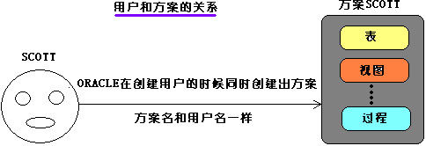
host:返回数据库所在的主机名称
查看当前会话客户所对应的默认方案
SQL> select sys_context('userenv','current_schema') "方案" from dual;
方案
---------

SCOTT

数据库管理
数据库管理的主要用户sys和system，他们最主要的区别是：
sys：所有oracle的数据字典的基表和视图都存放在sys用户中，这些基表和视图对于oracle的运行至关重要，有数据库自己维护，任何用户都不能手动更改。sys用户拥有dba，sysdba，sysoper角色或权限，是oracle权限最高的用户。
system：用于存放次一级的内部数据，如oracle的一些特性或工具的管理信息。system用户拥有dba，sysdba角色或系统权限。
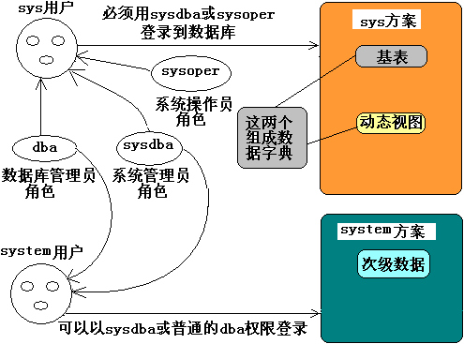
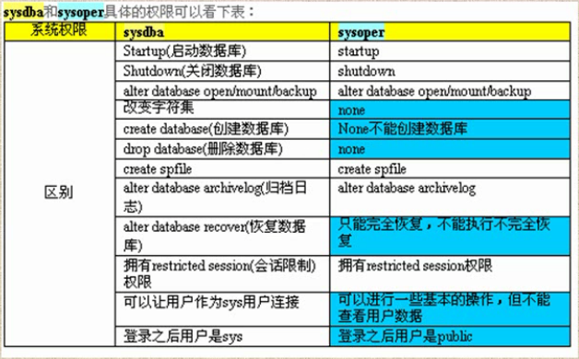

初始化参数
oracle9i提供了200多个参数，可以通过show parameter查看

数据库(表)备份和恢复
逻辑备份用export将数据对象的结构和数据导出到文件的过程，逻辑恢复是指当数据库对象被误操作而损坏后使用工具import利用备份的文件把数据对象导入到数据的过程。逻辑备份要求数据库在open状态

导出分为：导出表，导出方案，导出数据库三种方式.
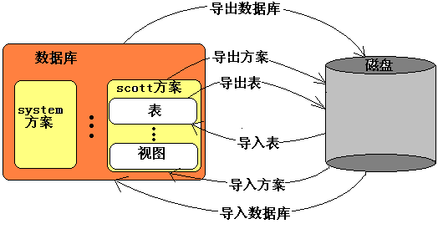
exp命令的选项有：
userid:用于指定执行导出操作的用户名，口令，连接字符串
tables:用于指定执行导出操作的表
owner:用于指定执行导出操作的方案
full=y:用于指定执行导出操作的数据库
inctype:用于指定执行导出操作的增量类型
rows:用于指定执行导出操作是否要导出表中的数据
file:用于指定导出文件名

导出表

特别说明：
在导入和导出的时候要到oracle主目录下的bin目录下去导

(1)导出自己的表
exp userid=scott/tiger@MYORACL1 tables=(emp) file=d:\e1.dmp
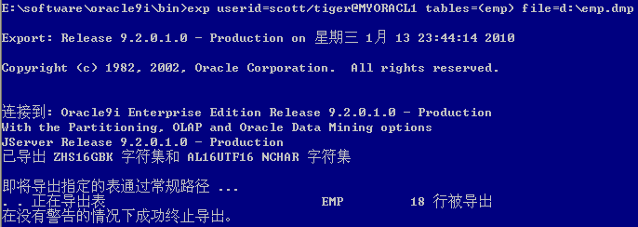
(2)导出其他方案的表
如果要导出其他方案的表，需要dba权限或者exp_full_database权限
exp userid=sys/m123@MYORACL1 tables=(scott.emp) file=d:\e1.dmp

(3)导出表结构
exp userid=scott/tiger@MYORACL1 tables=(emp) file=d:\e1.dmp rows=n;

(4)使用直接导出方式:这种方式当数据量大的时候速度快
exp userid=scott/tiger@MYORACL1 tables=(emp) file=d:\e1.dmp direct=y;

导出方案
(1)导出自己的方案
exp userid=scott/tiger@MYORACL1 owner=scott file=d:\scott.dmp

(2)导出其他的方案
要有exp_full_database权限

导出数据库
exp userid=system/m123@MYORACL1 full=y inctype=complete file=d:\e1.dmp direct=y;

逻辑导入

导入自己表
imp userid=scott/tiger@MYORACL1 tables=(emp) file=d:\a.dmp;

方案和数据库的导入都于表的导入类似

数据字典和动态性能视图
数据字典是oracle数据库中最重要的组成部分，他提供了数据库的一些系统信息，用户只能查询，但不能修改数据字典。
数据字典视图主要包括
user_xxx, 如：user_tables;显示当前用户所拥有的表
all_xxx,如：all_tables;显示当前用户可以访问的所有的表
dba_xxx，如：dba_tables;显示所有方案拥有的数据库表,要有dba角色或select_any_table系统权限才可以查看

动态性能视图记载了例程启动后的相关信息

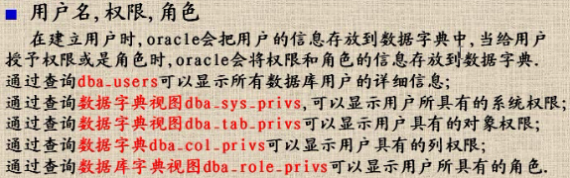

角色和权限的关系：
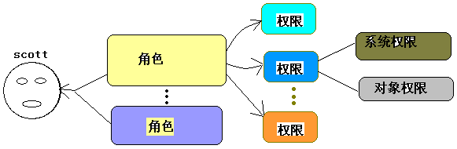
oracle中究竟有多少种角色？
SQL> select * from dba_roles;

一个角色包含多少系统权限
SQL> select * from dba_sys_privs where grantee='DBA'

一个角色包含多少对象权限
SQL> select * from dba_tab_privs where grantee='CONNECT';
如何查看一个用户有哪些角色
select * from dba_role_privs where grantee='用户名'

表空间和数据文件
表空间是数据库的逻辑组成部分，从物理上，数据库数据存放在数据文件中；从逻辑上，数据库数据则存放在表空间中，表空间由一个或多个数据库文件组成。
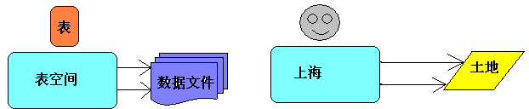
oracle逻辑结构包括段，区，块
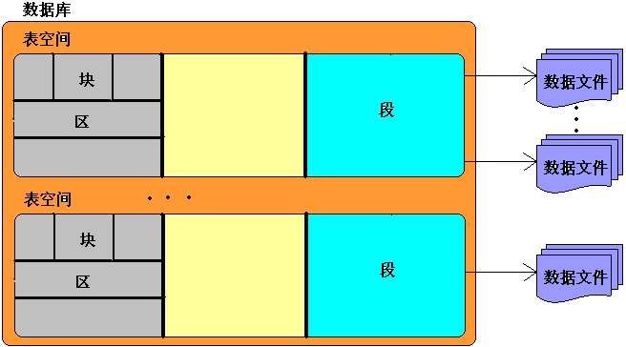
通过表空间可以达到：
(1)控制数据库占用的磁盘空间。
(2)dba可以将不同的数据类型部署到不同的位置，这样有利于提高i/o性能，同时利于备份和恢复等操作。

建立表空间
建立表空间要有create_tablespace系统权限。
create tablespace litao(表空间名字) datafile '数据文件'size 数据文件大小<500M uniform size 128k(区大小);
SQL> create tablespace litao datafile 'D:\litao.ts' size 20m uniform size 128k;

使用表空间
SQL> create table login(
2 username varchar2(10),
3 passwd varchar2(10))
4 tablespace litao;
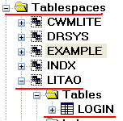
改变表空间的状态
当建立表空间的时候，表空间是联机状态，此时该表空间可以访问，并且可以读写。但在进行系统维护或是数据维护时，可能需要改变表空间状态。

(1)使表空间脱机
alter tablespace 表空间名 offline;

(2)使表空间联机
alter tablespace 表空间名 online;
SQL> alter tablespace litao offline;
SQL> select * from login;
ORA-00376: 此时无法读取文件 11
ORA-01110: 数据文件 11: 'D:\LITAO.TS'
SQL> alter tablespace litao online;
SQL> select *from login;
USERNAME PASSWD
---------- ----------
litao 001125
liming 001021

(3)只读表空间
如果不希望在表空间上执行update,delete,insert操作，可以将表空间修改为只读。
SQL> alter tablespace litao read only;
SQL> select * from login;
USERNAME PASSWD
---------- ----------
litao 001125
liming 001021
SQL> insert into login values('scuff','m123');
ORA-00372: 此时无法修改文件 11
ORA-01110: 数据文件 11: 'D:\LITAO.TS'
如果想继续能够读写：
SQL> alter tablespace litao read write;

看表空间有哪些表
SQL> select table_name from all_tables where tablespace_name=upper('litao');

TABLE_NAME
-----------------------

LOGIN

知道表名，查看在哪个表空间
SQL> select tablespace_name,table_name from user_tables where table_name=upper('login');

TABLESPACE_NAME TABLE_NAME
------------------------------ --------------------
LITAO LOGIN

删除表空间
drop tablespace litao including contents and datafiles;

扩展表空间
当表空间不足以后，需要扩展表空间
SQL> insert into login select * from login;
ORA-01653: 表SYS.LOGIN无法通过16（在表空间LITAO中）扩展

扩展表空间的方法：

(1)增加数据文件
SQL> alter tablespace litao add datafile 'd:\LIAO.TS'size 20m
(2)增加数据文件的大小
alter tablespace datafile 'd:\LITAO.TS' resize 20m;
(3)设置文件的自动增长
alter tablespace datafile 'd:\litao.ts' autoextend on next 10m maxsize 500m;

移动数据文件
如果数据文件所在的盘损坏，该数据文件将不能使用，为了能重新使用，需要将这些文件的副本移动到其他的磁盘，然后恢复
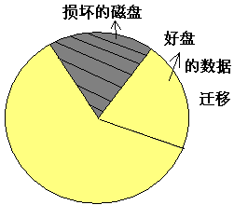
(1)确定数据所在的表空间
select tablespace_name from dba_data_files where file_name='d:\litao.ts';
(2)是表空间脱机
alter tablespace litao offline;
(3)使用命令移动数据文件到指定的目标位置
host move d:\litao.ts e:\litao.ts;
(4)执行alter tablespace命令
alter tablespace litao rename datafile 'd:\litao.ts' to 'e:\litao.ts';
(5)使表空间联机
alter tablespace litao online;

数据完整性
数据完整性用于确保数据库遵从一定的商业逻辑。
oracle中，数据完整性可以使用约束，触发器，应用程序(过程，函数)三种方式来实现，其中约束最易维护，并且具有最好的性能，所以作为维护数据完整性的首选。

约束用于确保数据库中数据满足特定商业规则。
oracle中约束包括：
not null,插入数据时，必须提供该列数据
unique,不能重复，但可为空
primary key,不能重复，不能为空
foreign key，
cheek，用于强制行数据必须满足的条件

商店收货系统表设计
现有一个商店的数据库，记录客户及其狗屋情况，由下面三个表组成：
商品goods(商品号goodsId,商品名goodsName,单价unitprice,类别category,供应商provider);
客户customer(客户号customerId,姓名name，住址address,email,性别sex，身份证cardId);
购买purchase(客户号customerId，商品号goodsId，购买数量nums);
请用SQL语言完成下列功能：
1 建表，在定义中要求声明：
(1)每个表的主外键
(2)客户的姓名不能为空值
(3)单价必须大于0，购买数量必须在1到30之间
(4)电子邮件不能重复
(5)客户的性别必须是男 或 女，默认是男

SQL> create table goods(
2 goodId char(8) primary key,
3 goodsName varchar(20),
4 unitprice number(10,2) check(unitprice>0),
5 category varchar2(10),
6 provider varchar2(30));

SQL> create table customer(
2 customerId char(8) primary key,
3 name varchar2(30) not null,
4 address varchar2(30),
5 email varchar(20) unique,
6 sex char(2) default '男' check(sex in('男','女'))
7 );

SQL> create table purchase(
2 customerId char(8) references customer(customerid),
3 goodsId char(8) references goods(goodid),
4 nums number(2) check(nums between 1 and 30)
5 );
商店售货系统表设计案例（2）
如果在建表的时候忘记必要的约束，可以在建表以后用
alter table命令为表增加约束，但要注意：增加
not null约束的时候要用modify选项，其他的用add选项
(1)商品名不能为空
SQL> alter table goods modify goodsName not null;

(2)身份证不能为空
SQL> alter table customer add constraint cardUnique unique(cardId);

(3)要求客户住址只在上海，浙江，江苏
SQL> alter table customer add constraint AddRange check(address in('上海','浙江','江苏'));

删除约束
alter table 表名 drop constraint 约束名称
在删除主键约束的时候要带上cascade

管理索引
索引用于加速数据存取的数据对象。合理使用索引可以大大降低i/o次数，从而提高数据访问性能。
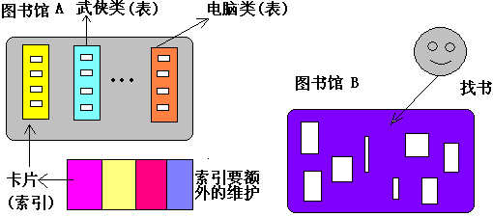
创建索引
单列索引
create index name_index on emp(ename);做了这句话，相当于上图建立了卡片。

复合索引
复合索引是基于两列或多列的索引。应该把很容易缩小数据范围的东西放在后面。
create index name_sal_index on emp(ename,sal);

使用原则
1.在大表上建立索引才有意义
2.在where子句或是连接条件上经常使用的列上建立索引
3.索引的层次不要超过4层

索引的缺点
1.建立索引，系统要占用大约为表的1.2倍的硬盘和内存空间来保存索引
2.更新数据的时候，系统必须用额外的时间来对索引进行更新。

pl/sql
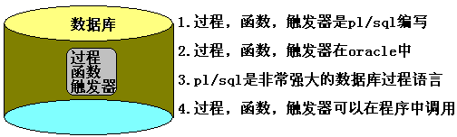

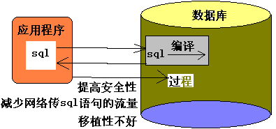

向表添加数据的存储过程
1.建表
create table login(name varchar2(30),passwd varchar2(30));
2.创建过程
create or replace procedure litao_insert is
begin
insert into login('李涛','m123');
end;
这个过程有编译错误，通过
show errors;
查看错误信息

如何调用该过程
exec 过程名();
call 过程名();

删除表中信息的过程
create or replace procedure litao_delete is
begin
delete from login;
end;

简单分类

|--------------过程
|
|--------------函数
块(编程) ------------|
|--------------触发器
|
|--------------包
编写规范

1.注释
单行注释 --
select * from emp where empno=7788 --取得员工信息
多行注释
/*......*/来划分

2.标识符的命名规范
1)定义变量，建议用v_作前缀 v_sal
2)定义常量，建议用c_作前缀 c_rate
3)定义游标，建议用_cursor作为后缀 emp_cursor
4)定义例外，建议用e_作前缀 e_error

块是pl/sql的基本单元，编写pl/sql实际上就是编写块
块由三个基本部分：定义部分，执行部分，例外处理部分
declare

/*定一部分---------定义常量，变量，游标，例外，复杂数据类型*/
begin
/*执行部分----------执行pl/sql语句或sql语句*/
exception
/*例外处理部分-------处理运行的各种错误*/
end;

打开输出选项
set serveroutput on

输出Hello world
begin
dbms_output.put_line('Hello World!');
end;

输入雇员号，返回雇员名和薪水
declare
v_ename varchar2(5);
v_sal number(7,2);
begin
select ename,sal into v_ename, v_sal from emp where empno = &no;
dbms_output.put_line('雇员名: '||v_ename||' 工资: '|| v_sal);
end;
&表示要接收从控制台输入的数据

oracle事先预定义了一些例外，no_data_found就是找不到数据的例外

declare
v_ename varchar(5);
begin
select ename into v_ename from emp where empno = &no;
dbms_output.put_line('雇员名: '||v_ename);
exception
when no_data_found then
dbms_output.put_line('编号有错！');
end;

过程
过程用于执行特定的操作。当建立过程时，既可以指定输入参数，也可以指定输出参数，通过在过程中使用输入参数，可以将数据传递到执行部分；通过使用输出参数，可以将执行部分的数据传递到应用环境。

写一个过程，可以输入雇员名，新工资 可以修改雇员的工资
create or replace procedure litao_modifysal(v_ename varchar2,v_sal number) is
begin
update emp set sal=v_sal where ename=v_ename;
end;

函数
函数用于返回特定的数据，当建立函数时，在函数头部必须包含return语句

输入雇员的姓名，返回该雇员的年薪
create function litao_fun(v_ename varchar2)
return number is yearSal number(7,2);
begin
select sal*12 + nvl(comm,0)*12 into yearSal from emp
where ename = v_eanem;
return yearSal;
end;

定义变量
var income number;
call litao_fun('SCOTT') into: income;

包
包用于在逻辑上组合过程和函数，它有包规范和包体两部分组成。
1.创建包
创建包litao_package,
声明了一个过程litao_update,
声明了一个函数litao_fun
create package litao_package is
procedure litao_update(v_name varchar2, v_sal number);
function litao_fun(v_name varchar2) return number;
end;
2.创建包体:把包里声明的函数和过程实现
create package body litao_package is

create function litao_fun(v_ename varchar2)
return number is yearSal number(7,2);
begin
select sal*12 + nvl(comm,0)*12 into yearSal from emp
where ename = v_eanem;
return yearSal;
end;
end;
3.调用包的过程和函数
call litao_package.litao_update('SCOTT',1233);

变量
1.标量:标量像C语言里的基本基本类型
定义标量
定义一个变长字符串
v_ename varchar2(10)
定义一个小数
v_sal number(6,2)
定义一个小数并给一个初始值为5.4
v_sal number(6,2):=5.4
定义一个日期类型的数据
v_hiredate date
定义一个布尔变量，不能为空，初始值为false
v_valid boolean not null default false
使用标量
输入员工号，显示雇员姓名，工资，个人所得税(税率0.03)
declare
c_tax_rate number(3,2):=0.03;
v_ename varchar2(5);
v_sal number(7,2);
v_tax_sal number(7,2);
begin
select ename,sal into v_ename,v_sal from emp where empno=&no;
v_tax_sal:=v_sal*c_tax_rat;
dbms_output.putline('name:'||v_ename||' sal:'||v_sal||' tax:'||v_tax_sl);
end;

标量应该和%type一起使用
declare
c_tax_rate number(3,2):=0.03;
v_ename emp.ename%type;
v_sal emp.sal%type;
v_tax_sal number(7,2);
begin
select ename,sal into v_ename,v_sal from emp where empno=&no;
v_tax_sal:=v_sal*c_tax_rat;
dbms_output.putline('name:'||v_ename||' sal:'||v_sal||' tax:'||v_tax_sl);
end;

2.复合变量
复合变量包括：pl/sql记录，pl/sql表...
pl/sql记录，类似高级语言的结构体
declare
定义pl/sql记录类型，名字 emp_record_type ，类型包含三个数据
type emp_record_type is record(
name emp.ename%type,
salary emp.sal%type,
title emp.job%type
);
定义了一个变量，变量名 litao_record
litao_record emp_record_type;
begin
select ename, sal, job into litao_record
from emp where empno = 7788;
dbms_output.put_line(' name:'||litao_record.name
||' sal:'||litao_record.salary);
end;

pl/sql表，相当于高级语言的数组
declare
定义pl/sql表类型，litao_tbale_type ,该类型用于存放emp.ename%type
index by binary_integer表示下标是整数
type litao_table_type is table of emp.ename%type index by binary_integer;
litao_table litao_table_type;
begin
select ename into litao_table(0) from emp wehere empno=7788;
dbms_output.put_line('name:'||litao_table(0));
end;
如果把where条件去掉，如何呢?使用参照变量

3.参照变量
游标变量 当定义游标时，不需要指定相应的select语句
但是使用游标时需要指定select语句，这样游标就可以和select结合了

输入一个部分，显示该部门所有员的工姓名和工资
declare
type emp_cursor is ref cursor;
test_cursor emp_cursor;
v_ename emp.ename%type;
v_sal emp.sal%type;
begin
open test_cursor for select ename,sal from emp where deptno=&no;
loop
fetch test_cursor into v_ename, v_sal;
exit when test_cursor%notfound;
dbms_outpu.put_line('name:'||v_ename||' sal:'|| v_sal);
end loop;
end;

控制结构

分支结构
编写一个过程，可以输入一个雇员名，如果该雇员的工资低于2000，就给该雇员工资增加10%
create or replace procedure pro_add_sal(v_ename varchar2) is
v_sal emp.sal%type;
begin
select sal into v_sal from emp where ename = v_ename;
dbms_output.put_line(' before update, sal: '|| v_sal);
if v_sal<2000 then
update emp set sal = sal*1.1 where ename = v_ename;
end if;
select sal into v_sal from emp where ename = v_ename;
dbms_output.put_line(' after update, sal: '|| v_sal);
end;

编写一个过程，可以输入一个雇员名，如果该雇员的补助不是0，就在原来的基础上增加100
如果原来的补助为0就在补助设置为200
create or replace procedure pro_update_comm(v_ename varchar2)
is
v_comm emp.comm%type;
begin
select nvl(comm,0) into v_comm from emp where ename = v_ename;
dbms_output.put_line('befor update comm: '|| v_comm);
if v_comm <> 0 then
update emp set comm = comm + 100 where ename = v_ename;
select comm into v_comm from emp where ename = v_ename;
dbms_output.put_line('after update comm: '|| v_comm);
else
update emp set comm = nvl(comm,0) + 200 where ename = v_ename;
select comm into v_comm from emp where ename = v_ename;
dbms_output.put_line('after update comm: '|| v_comm);
end if;
end;

编写一个过程，可以输入一个雇员编号，如果该雇员的置为是PRESIDENT就工资增加1000，
如果是MANAGER就增加500，其他职员增加200
create or replace procedure pro_add_sal_no(v_no emp.empno%type)
is
v_job emp.job%type;
v_ename emp.ename%type;
v_sal emp.sal%type;
begin
select job,ename,sal into v_job,v_ename,v_sal from emp where empno = v_no;
dbms_output.put_line('before name:'||v_ename||' sal:'||v_sal||' job:'||v_job);
if v_job = 'PRESIDENT' then
update emp set sal = sal+1000 where empno=v_no;
select job,ename,sal into v_job,v_ename,v_sal from emp where empno = v_no;
dbms_output.put_line('after name:'||v_ename||' sal:'||v_sal||' job:'||v_job);
elsif v_job = 'MANAGER' then
update emp set sal = sal+500 where empno=v_no;
select job,ename,sal into v_job,v_ename,v_sal from emp where empno = v_no;
dbms_output.put_line('after name:'||v_ename||' sal:'||v_sal||' job:'||v_job);
else
update emp set sal = sal+200 where empno=v_no;
select job,ename,sal into v_job,v_ename,v_sal from emp where empno = v_no;
dbms_output.put_line('after name:'||v_ename||' sal:'||v_sal||' job:'||v_job);
end if;
end;

循环结构
编写一个过程，可以输入用户名，并循环添加10个用户到users表中，用户编号从1开始增加
create table users(num number,username varchar2(20));
create or replace procedure pro_loop_insert_user(v_name varchar2)
is
v_num number:=1;
begin
loop
insert into users values(v_num,v_name);
exit when v_num = 10;
v_num := v_num + 1;
end loop;
end;

编写一个过程，输入用户名，并循环添加10和用户到users表，编号从11开始
create or replace procedure pro_while_insert(v_name varchar2)
is
v_num number:=11;
begin
while v_num<=20 loop
insert into users values(v_num,v_name);
v_num := v_num + 1;
end loop;
end;

goto 案例
declare
i int := 1;
begin
loop
dbms_output.put_line('i='|| i);
if i = 10 then
goto end_loop;
end if;
i := i+1;
end loop;
--<<end_loop>>
dbms_output.put_line('finish1');
<<end_loop>>
dbms_output.put_line('finish2');
end;

分页存储过程
create table book (bookId number,
bookName varchar2(50),
publishHouse varchar2(50)
);

create or replace procedure pro_pagination(v_bookId in number,
v_bookName in varchar2, v_publishHouse in varchar2)
is
begin
insert into book values(v_bookId,v_bookName,v_publishHouse);
end;

编写一个过程，输入书的编号，要求返回书的名字，出版社
create or replace procedure pro_in_out_book(v_bookId in number,v_bookName out varchar2, v_publishHouse out varchar2) is
begin
select bookname,publishhouse into v_bookName,v_publishHouse from book where bookId = v_bookId;
end;

返回结果集的过程
编写一个过程，输入部门号，返回该部门的额所有员工的信息
1.建包，在该包中定义一个游标
create or replace package testpackage as
type test_cursor is ref cursor;
end testpackage;

2.建过程
create or replace procedure pro_result(v_No in number,
p_cursor out testpackage.test_cursor) is
begin
open p_cursor for select * from emp where deptno=v_No;
end;

开发包
create or replace package testpackage as
type test_cursor is ref cursor;
end testpackage;
编写分页过程
create or replace procedure pro_fenye
(tableName in varchar2,v_size in number,
v_pageNow in number,myRows out number,
myPageCount out number,
p_cursor out testpackage.test_cursor) is
v_sql varchar2(1000);
v_begin number:=(v_pageNow-1)*v_size+1;
v_end number:=v_pageNow*v_size
begin
v_sql:='select * from
(select t1.*,rownum rn from (select * from '||tableName
||' order by sal) t1 where rownum<='|| v_end ||')
where rn >='|| v_begin;
open p_cursor for v_aql;
v_sql:='select coutn(*) from '||tableName;
execute immediate v_sql into myRows;
if mod(myRows,v_size)=0 then
myPageCount := myRows/v_size;
else
myPageCount := myRows/_size+1;
end if;
close p_cursor;
end;

例外处理

编写一个过程，可以接收雇员编号，并显示雇员的姓名，如果雇员编号不存在，怎么处理？
create or replace procedure pro_except(v_eno emp.empno%type) is
v_ename emp.ename%type;
begin
select ename into v_ename from emp where empno = v_eno;
dbms_output.put_line('name : '|| v_ename);
exception
when no_data_found then
dbms_output.put_line('输入的编号不正确!');
end;

预定义例外，预定义例外是由pl/sql所提供的系统例外。
case_not_found 开发pl/sql块中编写的case语句时，如果在when子句中没有包含必须的条件分支，就会被触发。
create or replace procedure pro_case_not_fd(v_no number) is
v_sal emp.sal%type;
begin
select sal into v_sal from emp where empno = v_no;
case
when v_sal<1000 then
update emp set sal = sal+100 where empno = v_no;
when v_sal<2000 then
update emp set sal = sal+200 where empno = v_no;
end case;
exception
when case_not_found then
dbms_output.put_line('case语句没有于'||v_sal ||'相匹配的条件.');
end;

cursor_already_open 当重新打开游标时，会触发这个例外。
declare
cursor emp_cursor is select ename, sal from emp;
begin
open emp_cursor for emp_record1 in emp_cursor loop
dbms_output.put_line(emp_record1.ename);
end loop;
exception
when cursor_already_open then
dbms_output.put_line('cursor is already opened!');
end;

dup_val_on_index 在唯一索引所对应的列上插入重复的值时，被触发
begin
insert into users values(12,'litao');
exception
when dup_val_on_index then
dbms_output.put_line('num 列上不能出现重复值!');
end;

invalid_cursor 当试图在不合法的游标上执行操作时，会触发。
declare
cursor emp_cursor is select ename, sal from emp;
emp_record emp_cursor%rowtype;
begin
--open emp_cursor
fetch emp_cursor into emp_record;
dbms_output.put_line(emp_record.ename);
close emp_cursor;
exception
when invalid_cursor then
dbms_output.put_line('请检查游标是否打开');
end;

invalid_number 当输入有误，会触发
begin
update emp set sal = sal + '1oo';
exception
when invalid_number then
dbms_output.put_line('invalid number!');
end;

too_many_rows 当执行select into 时，返回多了一行，会被触发
declare
v_ename emp.ename%type;
begin
select ename into v_ename from emp;
exception
when too_many_rows then
dbms_output.put_line('return too many lines!');
end;

zeor_divide 当 2/0 语句时，被触发。

value_error 当执行赋值操作时，如果变量长度不足以容纳实际数据，被触发。
declare
v_ename varchar2(4);
begin
select ename into v_ename from emp where empno = &no;
dbms_output.put_line(v_ename);
exception
when value_error then
dbms_output.put_line('buffer of variable is too small.');
end;

自定义例外
编写pl/sql,接收一个雇员编号，并给雇员工资增加1000元，如果雇员不存在，请提示。
create or replace procedure pro_exception(v_no number) is
--定义一个例外
myex exception;
begin
update emp set sal = sal+100 where empno = v_no;
--sql%notfound表示没有update
--raise myex;触发myex
if sql%notfound then
raise myex;
end if;
exception
when myex then
dbms_output.put_line('没有更新任何用户');
end;

视图
视图是一个虚拟的表，其内容由查询定义，视图并不实际存在，行和列有定义视图的查询所引用的表。
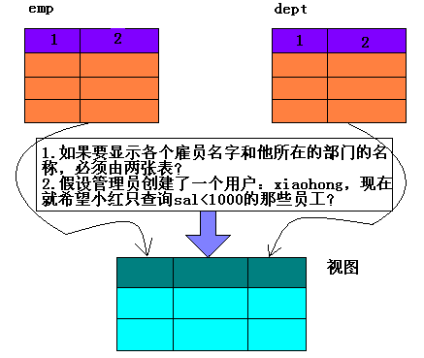
视图和表的区别
1.表要占用磁盘空间，视图不需要
2.视图不能添加索引
3.使用视图可以简化查询
4.视图可以提高安全性

创建视图
把emp表薪水小于1000的雇员映射为该视图
create view lt_1000 as select * from emp where sal<1000;
select * from lt_1000;
EMPNO ENAME JOB MGR HIREDATE SAL COMM DEPTNO
----- ---------- --------- ----- ----------- --------- --------- ------
7369 SMITH CLERK 7902 1980-12-17 800.00 20
7900 JAMES CLERK 7698 1981-12-3 950.00 30
create view info_view
as select emp.empno,emp.ename,dept.dname
from emp, dept where emp.deptno=dept.deptno;

