

WEB BASED STALL MANAGEMENT SYSTEM FOR CENTER POINT

A Capstone Project Presented to the Faculty of
College Department of
West Prime Horizon Institute, Inc.
Pagadian City

In Partial Fulfillment
of the Requirements for the Capstone Project II
For the Degree Bachelor of Science in Information Technology
Academic Year 2025-2026

By
Angcap, Crisandra Mae B.
Malongo, Alvin A.
Pasiol, Jasper R.
Sagga, Mark G.
Else, Jhack L.
Fiel, Jay-ar T.

July 2026
CHAPTER I
INTRODUCTION
Background of the Study
In recent years, modernization has significantly influenced various sectors, including business management and administrative operations. While technology has improved efficiency in industries such as banking, education, and healthcare, some local commercial establishments still rely on traditional methods. One example is Center Point, a commercial establishment in Pagadian City that provides multiple stalls for rent to different vendors and small entrepreneurs across its floor levels.
Center Point plays an important role as a local business hub where small entrepreneurs operate daily. It supports the local economy by providing accessible spaces for vendors to sell goods and services. However, despite its significance, the management of stalls had been handled through manual processes such as handwritten records, paper-based receipts, and physical logbooks. Prospective tenants also had no formal channel for applying for a stall online, requiring them to physically visit the office for inquiries and applications.
These traditional methods had become increasingly inefficient as the number of tenants grew. Tracking stall occupancy, monitoring rental payments, managing tenant records, and handling lease contract expirations manually was time-consuming and prone to human error. Records could be misplaced, data could become inconsistent, and retrieving information was difficult. Moreover, tenants had limited visibility into their own accounts, relying entirely on the office to verify payment history and outstanding balances.
Another major challenge was the absence of a convenient and secure payment system, a structured communication channel for tenant concerns, a centralized document repository for tenant records, and a reliable mechanism for notifying tenants and administrators of approaching lease expiration dates. Administrative accounts also lacked a layered security mechanism to protect sensitive financial and tenant data.
To address these challenges, this study presents the design and development of the Web Based Stall Management System for Center Point. The system digitizes and streamlines all stall management processes through a web-based platform developed using Laravel 12 and Livewire 3. It provides a tenant portal for self-service account access, an online payment gateway via PayMongo, automated monthly invoicing with multi-stage SMS and email reminders, a live support ticket chat system, a tenant document repository with statements of account, advanced financial reporting and analytics, a public stall application portal with application status lookup and a waitlist, announcements, lease expiry notifications, Google and Facebook social login, Two-Factor Authentication (2FA) for administrator accounts, encrypted database backups, and layered web security protections.
By implementing these features, the system aims to enhance efficiency, accuracy, transparency, security, and overall service quality in managing stall operations at Center Point.
Project Context
The concept for this project was developed through direct observation of the daily operations at Center Point, where stall management processes were primarily handled manually. Administrators relied heavily on physical records when managing tenant information, stall assignments, lease contracts, and payment tracking. When tenants requested to verify their payment status or account balance, the office had to manually search through logbooks, resulting in delays and inconvenience.
Tenants had no direct access to their own records. This lack of transparency led to repeated inquiries and dependency on the office for simple information such as payment history, outstanding balances, or copies of their lease contracts. The absence of a centralized digital system also made it difficult to monitor stall availability in real time across floor levels.
The reliance on manual payment collection, the lack of advance notifications for expiring leases, the absence of a public reservation channel for prospective tenants, and the lack of layered authentication security for administrative accounts were additional operational gaps that needed to be addressed.
To address all of these problems, the proposed system introduces a comprehensive digital solution built on Laravel 12 and Livewire 3. Beyond the core tenant portal and PayMongo payment integration, the system incorporates advanced financial reporting with exportable summaries, automated lease expiry notifications sent through Mailjet email and Semaphore SMS 60 and 30 days before contract end dates, Google and Facebook social login, a public stall application portal, a tenant document repository with downloadable statements of account, announcements, an administrative calendar and global search, encrypted database backups, and optional Two-Factor Authentication via SMS OTP for administrator accounts.
By implementing these enhancements, the system transforms the manual operations at Center Point into a more efficient, transparent, secure, and user-centered management process.
Software and Technologies Used
To ensure the system is robust, secure, and user-friendly, the researchers utilized a specific set of modern software development tools and frameworks. Each tool was selected based on its ability to handle the complex requirements of the stall rental management system.
- Laravel 12 (PHP Framework): The primary backend framework enforcing the Model-View-Controller (MVC) pattern. Provides Eloquent ORM, middleware, Artisan CLI for scheduled commands, and a comprehensive application ecosystem.
- Livewire 3: Powers all reactive, server-rendered UI components including the floor plan grid editor, support ticket chat, notification bell, advanced reports interface, document repository, and reservation portal, without requiring a separate JavaScript framework.
- MySQL / MariaDB: The relational database management system storing all system data including tenant profiles, stall records, lease contracts, payment transactions, support tickets, audit logs, stall applications, and two-factor codes. Uses InnoDB with foreign key constraints and indexed columns.
- Laravel Breeze with Socialite: Authentication is handled by Laravel Breeze. Google OAuth 2.0 and Facebook OAuth 2.0 social logins are both implemented via the laravel/socialite package.
- PayMongo API: Enables online rental payments via GCash, Maya, credit cards, and debit cards through checkout sessions and asynchronous webhook listeners.
- Mailjet: Transactional email service, used through Laravel's built-in mailer over the Mailjet SMTP relay, for payment reminders, overdue notices, lease expiry alerts, application updates, announcements, and account emails.
- Semaphore SMS API: Sends SMS notifications for billing reminders, lease expiry alerts, Two-Factor Authentication OTP codes, and other account events.
- Dompdf: Generates official PDF receipts with embedded QR codes, and produces exportable financial summary PDF reports.
- Chart.js: A JavaScript charting library integrated into the advanced financial reporting module to render interactive monthly and annual revenue trend charts and occupancy rate visualizations.
- Tailwind CSS 3 and DaisyUI 4: A CSS framework of small reusable classes and a component library, used for the responsive interface and compiled with Vite 5.
- Alpine.js: A lightweight JavaScript framework, bundled with Livewire, used for small interactions such as modals, dropdowns, and drag-and-drop on the floor plan.
- Cloudflare Turnstile (optional): A privacy-friendly CAPTCHA that protects public forms when its keys are configured.
- Laragon: The local development environment providing a fast and lightweight stack with Apache, PHP 8.3, and MySQL.
- Visual Studio Code: The primary code editor for writing, managing, and debugging the system source code.
Development and Testing Environment
The development and testing environment refers to the software, hardware, local server stacks, testing tools, and third-party API sandboxes utilized during the design, implementation, and quality assurance of the Web Based Stall Management System for Center Point.
Development Environment:
- Hardware Specification: Host workstation equipped with an Intel Core processor, 16GB RAM, and 512GB SSD running Windows 11 64-bit operating system.
- Local Server Stack: Laragon local development environment providing an integrated, high-performance stack with Apache 2.4 web server, PHP 8.2+ runtime environment, and MySQL 8.0 relational database server.
- Code Editor and IDE: Visual Studio Code equipped with PHP Intelephense, Laravel Extra Intellisense, Blade Snippets, Tailwind CSS IntelliSense, and Git integration for code editing, syntax verification, and version control.
- Dependency Management: Composer 2.x for PHP backend dependency resolution (Laravel framework, Livewire 3, Socialite, Dompdf, PhpSpreadsheet) and NPM for frontend asset building.
- Version Control System: Git repository tracking system for source code change management, branch isolation, and feature tracking.
Testing Environment:
- Automated Testing Framework: PHPUnit 11 with Laravel's built-in testing utilities for executing unit tests, feature tests, HTTP endpoint assertions, database state assertions, and mock API service responses.
- API Testing & Webhook Sandbox: Postman and PayMongo Sandbox Environment for constructing and testing API requests, verifying JSON payloads, and simulating PayMongo webhook signature events (e.g., payment confirmation, checkout session completion).
- Third-Party API Test Gateways:
  - Mailpit, a local mail catcher, for capturing and checking emails during development instead of sending them.
  - Laravel SMS Catcher for capturing SMS messages and 2FA codes locally during development instead of sending them.
- Cross-Browser & Device Simulation: Google Chrome DevTools and Microsoft Edge for responsive UI testing across desktop, tablet, and mobile viewport dimensions, ensuring cross-browser compatibility and consistent rendering of Chart.js graphs and Livewire interactive components.
Purpose and Description
The primary purpose of this study is to develop the Web Based Stall Management System for Center Point — a comprehensive, full-stack digital platform that replaces all manual stall management processes with an integrated, automated, and user-centered system for administrators, tenants, and prospective tenants.
The system serves as a centralized platform where administrators can manage floor plan layouts, assign leases, monitor tenant records, track rental payments, review financial analytics, manage stall applications from prospective tenants, and configure system-wide settings. Tenants are provided with a self-service portal for account monitoring, online payments, support communication, and document access.
Key features of the system include:
- Interactive Floor Plan Grid Editor: A visual Livewire-powered editor for configuring stall layouts per floor level.
- Stall Management Module: Tracks stall identifiers, pricing, descriptions, images, grid positions, and occupancy status (Available, Reserved, Occupied, Maintenance).
- Lease Mapping and Contract Management: Assigns tenants to stalls with defined contract periods, PDF contract uploads, and a renewal request workflow.
- Lease Expiry Automated Notifications: At 60 and 30 days before a lease ends, notifies the tenant by in-app notification, email, and SMS, and the administrators by in-app notification (skipped when a renewal request is already pending).
- Automated Monthly Invoicing: Generates invoices for active leases via a scheduled Artisan command with multi-stage email and SMS payment reminders.
- Online Payment Integration (PayMongo): Secure multi-method digital payments via GCash, Maya, credit cards, and debit cards.
- QR Code PDF Receipts: Official receipts with embedded QR codes for online authenticity verification.
- Tenant Document Repository: A secure, centralized download center in the tenant portal for lease contracts, payment receipts, and billing statements.
- Advanced Financial Reporting and Analytics: Interactive revenue trend charts (Chart.js), occupancy rate analytics, overdue payment aging reports, and exportable CSV and PDF financial summaries.
- Public Stall Reservation Portal: A guest-accessible page where prospective tenants can view available stalls and submit a formal application online.
- Support Ticket System with Live Chat: Threaded messaging with file attachments, typing indicators, and read receipts.
- In-App Notification Center: Notification bell with unread badge counters, refreshed every 10 seconds.
- Google OAuth and Facebook OAuth Social Login: Social sign-in via both Google and Facebook accounts.
- Two-Factor Authentication (2FA): Optional SMS OTP-based 2FA for administrator accounts, enforced once enabled per account.
- Audit Log System: Append-only record (no edit or delete in the interface) of all significant administrative actions.
- Announcements: Administrators post notices to all tenants or to one floor; tenants receive them through the notification bell, optional email, and their dashboard.
- Application Status Lookup: Applicants check the status of a stall application with their reference number (for example, APP-2026-000123) and email address, without signing in.
- Stall Waitlist: Visitors can ask to be emailed when an occupied stall becomes available again.
- Tenant Account Management: Administrators list tenants with their active leases and unpaid balances, deactivate or reactivate accounts, and resend set-password links.
- Statement of Account: Every charge and payment for a tenant with a running balance, viewable on screen and downloadable as a PDF.
- Administrative Calendar: A monthly calendar of lease end dates, invoice due dates (overdue in red), and renewal requests.
- Global Search: A search box on every administrator page that finds tenants, stalls, invoices, and support tickets.
- Encrypted Database Backups: One-click and scheduled daily backups, encrypted with the application key; the latest 14 are kept.
- Security Hardening: A Content-Security-Policy, security response headers, rate limiting on sign-in, registration and password reset, a strong password rule, security event logging, and optional Cloudflare Turnstile CAPTCHA.
Overall, the system transforms manual stall management into a comprehensive, efficient, secure, and organized digital process.
General and Specific Objectives
General Objective
To design and develop the Web Based Stall Management System for Center Point using Laravel 12 and Livewire 3 that enhances operational efficiency, transparency, security, and user accessibility through automated billing, digital payments, real-time communication, advanced analytics, and comprehensive tenant self-service features.
Specific Objectives
To realize this project, the following specific objectives were achieved:
- To design a structured relational database for managing tenant, stall, lease, payment, support ticket, announcement, waitlist, stall application, and two-factor authentication data.
- To develop an interactive floor plan grid editor that allows administrators to configure stall layouts per floor level.
- To implement a stall management module that provides real-time updates on stall availability and occupancy status.
- To integrate an online payment gateway using PayMongo for secure rental payment transactions via GCash, Maya, and cards.
- To create a tenant portal where users can view stall details, active lease contracts, payment history, and account status.
- To implement a tenant document repository providing secure, on-demand access to lease contracts, payment receipts, and billing statements.
- To develop an automated monthly invoicing system using a Laravel Artisan scheduler with multi-stage SMS and email payment reminders.
- To implement automated lease expiry notification dispatching via Mailjet email and Semaphore SMS at 60 and 30 days before contract end dates.
- To generate official PDF receipts with embedded QR codes for online authenticity verification using Dompdf.
- To develop a support ticket module with live threaded chat (refreshed every 3 seconds), file attachments, and read receipts for structured tenant-management communication.
- To implement announcements, an application status lookup, a stall waitlist, and tenant account management that keep tenants, applicants, and administrators informed.
- To develop an advanced financial reporting and analytics module with interactive charts, aging reports, and exportable CSV and PDF summaries.
- To create a public-facing stall reservation portal for prospective tenants to view available stalls and submit online applications.
- To implement Google OAuth 2.0 and Facebook OAuth 2.0 social login via laravel/socialite.
- To implement optional Two-Factor Authentication (2FA) via SMS OTP for administrator accounts.
- To implement an audit logging system that records administrative actions with timestamps and IP addresses for operational accountability.
- To provide statements of account, an administrative calendar, and a global search for faster access to records.
- To protect system data through encrypted scheduled database backups, a Content-Security-Policy, rate limiting, a strong password policy, and security event logging.
- To evaluate the system's functionality, security, and performance through automated testing, end-to-end testing, and an independent code review.
Significance of the Study
The development and implementation of the Web Based Stall Management System for Center Point yields substantial benefits for various stakeholders involved in commercial stall operations in Pagadian City, Zamboanga del Sur. Specifically, this study is significant to the following groups:
- Center Point Management and Administrators — Provides a centralized, automated control panel to manage floor plan layouts, stall inventory, tenant profiles, and lease contracts. Automates monthly invoicing and dispatches multi-stage payment reminders and 60/30-day lease expiry alerts, drastically reducing administrative workload, billing computation errors, and unmanaged lease expirations. Advanced financial reporting tools with exportable CSV and PDF summaries empower management with real-time financial visibility and data-driven decision-making capabilities.
- Stall Tenants — Enhances transparency and convenience by providing a 24/7 self-service tenant portal. Tenants can monitor active lease terms, view billing statements, pay rent online via GCash, Maya, or cards, download official receipts and contractual documents from a secure document repository, and receive automated email and SMS reminders for upcoming payments and lease contract end dates.
- Prospective Tenants and Applicants — Eliminates the requirement to physically visit the administrative office for stall rental inquiries. The public-facing stall reservation portal allows prospective vendors to view real-time stall availability across floor levels and submit formal online applications with supporting documents conveniently from any location.
- Future Researchers and IT Practitioners — Serves as a comprehensive reference and foundation for academic research regarding modern web-based property and stall rental management systems. Demonstrates the practical integration of Laravel 12, Livewire 3, online payment gateways (PayMongo), multi-channel messaging (Mailjet email and Semaphore SMS), OAuth 2.0 social authentication, and Two-Factor Authentication (2FA) in local commercial establishments.
Scope and Limitations
This study covers the design, development, testing, and deployment of the Web Based Stall Management System for Center Point in Pagadian City, covering tenant registration, stall assignment, lease contract management and termination, automated billing, online payment processing, statements of account, support ticket communication, announcements, advanced financial reporting, the public stall application portal with status lookup and waitlist, tenant document repository, lease expiry notifications, social authentication, Two-Factor Authentication, database backups, and audit logging.
The system has two types of user accounts with distinct access levels, plus public visitors:
- Administrator — Full system control including stall and floor management, lease allocation and termination, tenant account management, payment management, statements of account, support tickets, announcements, advanced financial reports, the calendar, global search, stall application management, audit and error logs, database backups, and system settings including the SMS switch; each administrator turns on 2FA from their own profile.
- Tenant — Can access their own portal, view stall and lease details, pay rent online, access the document repository, submit support tickets, and receive in-app, SMS, and email notifications.
- Visitor (not signed in) — Can browse available stalls, submit a rental application, check its status with a reference number, and join a stall waitlist.
The system supports online payments through PayMongo (GCash, Maya, credit and debit cards), automated invoicing, multi-stage payment reminders, lease expiry alerts, social logins via Google and Facebook, optional SMS OTP-based 2FA for privileged accounts, and exportable financial reports in CSV and PDF formats.
However, the system has certain limitations. It requires a stable internet connection for online payment processing, webhook handling, email and SMS dispatching, and real-time notification updates. Service disruptions from PayMongo, Mailjet, or Semaphore may temporarily affect the corresponding features. The system does not compute electricity or water charges, late-payment penalties, or partial payments, and does not handle advanced accounting functions such as tax computation or multi-currency support. It is limited to stall rental management and does not include inventory tracking for individual tenant businesses. The floor plan grid editor is designed for structured grid-based layouts and may not accommodate highly irregular physical floor configurations. Two-Factor Authentication is available for administrator accounts only and relies on SMS delivery by the Semaphore gateway. Database backups are stored on the same server and must be copied elsewhere by the administrator for off-site safekeeping.
Definition of Terms
The following terminology is used as a tool to conceptualize the study:
These are:
Term | Operational Definition
Laravel 12 | A modern PHP web application framework following the Model-View-Controller (MVC) pattern, serving as the primary backend framework of the system.
Livewire 3 | A full-stack reactive component framework for Laravel enabling real-time server-side UI interactions without a separate JavaScript framework.
Center Point | The commercial establishment in Pagadian City, Zamboanga del Sur, that serves as the client of this study, offering stalls for rent across its floor levels.
Stall | A designated physical space within Center Point that is rented by a vendor for business operations.
Tenant | An individual or business entity that rents a stall and is registered in the system with access to the tenant portal.
Tenant Portal | The system interface allowing tenants to access their stall details, lease information, payment history, document repository, and support tickets.
Stall Mapping (Lease Contract) | A system record linking a tenant to a stall for a defined contract period with start and end dates and a PDF contract document.
Lease Expiry Notification | An automated alert 60 and 30 days before a lease ends: the tenant receives an in-app notification, a Mailjet email, and a Semaphore SMS; administrators receive an in-app notification.
Online Stall Application | A public-facing feature allowing prospective tenants to submit a formal rental application online, including business information and a preferred stall selection.
Stall Application | A record in the system representing a formal online rental application submitted by a prospective tenant through the public reservation portal.
Tenant Document Repository | A secure section of the tenant portal where tenants can access and download their lease contracts, payment receipts, billing statements, and other related documents.
Advanced Financial Reporting | A system module providing interactive revenue trend charts, occupancy rate analytics, overdue payment aging reports, and exportable financial summaries in CSV and PDF formats.
PayMongo | A Philippine payment gateway integrated into the system for secure online payment transactions via GCash, Maya, credit cards, and debit cards.
Automated Invoicing | The system's capability to automatically generate monthly rental invoices for all active leases using a scheduled Laravel Artisan command.
PDF Receipt | An official payment receipt generated using Dompdf, featuring an embedded QR code for online authenticity verification.
QR Code Verification | A feature allowing anyone to scan a QR code on a receipt to confirm its authenticity through an online verification endpoint.
Support Ticket | A digital concern or request submitted by a tenant, handled through a threaded live chat interface with file attachment support.
Audit Log | An append-only record of all significant administrative actions, including user identity, action, affected entity, timestamp, and IP address.
Role-Based Access Control (RBAC) | A security mechanism restricting system access based on the user's assigned role (Administrator or Tenant).
Google OAuth 2.0 | A social login protocol allowing users to sign in using their Google account, implemented via the laravel/socialite package.
Facebook OAuth | A social login protocol allowing users to sign in using their Facebook account, also implemented via the laravel/socialite package.
Two-Factor Authentication (2FA) | An optional additional security layer for administrator accounts requiring a one-time SMS OTP code sent via Semaphore after the initial password login.
OTP (One-Time Password) | A temporary, single-use numeric code sent to a user's registered mobile number via Semaphore SMS as part of the Two-Factor Authentication process.
Artisan Scheduler | A Laravel feature automating the execution of console commands on a defined schedule, used for monthly invoice generation, payment reminders, and lease expiry notifications.
Mailjet | A transactional email service, used through Laravel's mailer over its SMTP relay, for payment reminders, overdue notices, lease expiry alerts, application updates, and announcements.
Semaphore SMS | An SMS gateway used to send billing reminders, lease expiry alerts, and Two-Factor Authentication OTP codes.
Dompdf | A PHP HTML-to-PDF library used to generate official payment receipts and exportable financial report documents.
Chart.js | A JavaScript charting library used in the advanced financial reporting module to render interactive revenue trend and occupancy rate charts.
Dashboard | The main administrative control panel displaying key performance indicators such as total revenue, occupied stalls, active leases, pending applications, and pending support tickets.
Announcement | A notice posted by an administrator to all tenants or to the tenants of one floor, delivered through the notification bell, optional email, and the tenant dashboard.
Application Reference Number | A code such as APP-2026-000123 given to each stall application, used with the applicant’s email to check its status.
Stall Waitlist | A list of visitors who asked to be emailed when an occupied stall becomes available.
Statement of Account | A record of every charge and payment of a tenant with a running balance, downloadable as a PDF.
Account Deactivation | An administrator action that prevents a tenant account from signing in while keeping its records.
Global Search | A search box on administrator pages that finds tenants, stalls, invoices, and support tickets.
Encrypted Backup | A copy of the database encrypted with the application key, created on demand or daily by the scheduler.
Content-Security-Policy (CSP) | A browser security rule sent by the system that only allows scripts carrying a secret per-session token to run, blocking injected scripts.
Rate Limiting | A limit on how many times an action (sign-in, registration, password reset, lookups) can be attempted in a period of time, to stop guessing and abuse.
Cloudflare Turnstile | An optional CAPTCHA service that verifies a human is submitting a public form.

CHAPTER II
REVIEW OF RELATED LITERATURE AND RELATED STUDIES
This chapter presents the related literature and studies that support the development of the Web Based Stall Management System for Center Point. The review focuses on rental and property management systems, automated billing, online payment processing, tenant self-service portals, real-time communication systems, digital document repositories, and security authentication mechanisms. These studies establish the theoretical and empirical foundations that justify the transition from manual processes to digital platforms in improving operational efficiency, transparency, security, and service quality.
The reviewed studies are categorized into international and local studies, followed by a synthesis that identifies research gaps addressed by the system.
International Related Studies
Magno, Pelayo, and Soberano (2024) developed an apartment rental management system aimed at improving transaction tracking and overall task organization within rental operations. The study emphasized that traditional rental practices often rely on manual record-keeping, which can result in inaccurate data, missed payments, and inefficient workflows. Their findings demonstrated that the implementation of a digital system significantly enhanced data accuracy, minimized operational errors, and improved overall efficiency. In addition, the system enabled real-time monitoring of billing and payment transactions, which helped reduce disputes between tenants and property managers.
However, the study primarily focuses on transaction automation and data management without extensive discussion on user-centered workflow design or adaptability to different types of rental environments. This indicates the need for a system that not only automates billing and record-keeping but also ensures usability and flexibility for specific business contexts. This supports the development of the proposed system, which integrates automated monthly invoicing, multi-stage payment reminders, advanced financial analytics, and centralized data management within a structured and user-friendly platform built on Laravel 12.
Buradkar et al. (2022) designed a property rental management system that transforms traditional rental operations into a digital environment. The system incorporates both a tenant-facing application and a backend database to manage rental transactions and records efficiently. The study highlighted the importance of integrating frontend and backend components to ensure seamless data access and processing. It also emphasized the role of tenant portals in improving accessibility, transparency, and user engagement.
Despite these contributions, the study places greater emphasis on system architecture and integration rather than on workflow efficiency and role-based interaction within the organization. This suggests the need for a more comprehensive system that not only connects system components but also supports structured operational processes with clearly defined user roles. This supports the proposed system's tenant portal feature and document repository architecture, which together enable users to access information and manage operations while maintaining a structured role-based workflow.
A study published in the International Journal of Creative Research Thoughts (2024) examined rental house management systems and identified the limitations of traditional manual processes. The study noted that manual systems are often inefficient, prone to errors, and lack effective communication mechanisms between stakeholders. It emphasized that modern rental management platforms should incorporate automated billing and payment processing, maintenance request tracking, and integrated communication systems.
While the study clearly identifies essential system features, it focuses more on general system capabilities rather than on implementation strategies tailored to specific business environments. These findings support the proposed system, particularly its automated billing functionality, Artisan-scheduled invoice generation, lease expiry notification automation, and support ticket module, which together enhance communication efficiency and service management.
According to a global market report (2024), digital payment systems in rental management allow tenants to complete transactions electronically, access payment history, and receive notifications, while administrators can efficiently monitor transactions and generate reports. The study further emphasized that automation in payment processing reduces administrative workload and minimizes human errors, making it an essential component of modern rental systems.
However, the report focuses primarily on payment technologies and does not fully address how these systems integrate with broader management workflows. This indicates the need for a more unified platform that combines payment processing with other operational functions. This supports the integration of the PayMongo payment gateway and the advanced financial reporting and analytics module in the proposed system, which together enhance convenience, financial visibility, and operational decision-making.
Research on automated property management systems highlights that digital platforms enable real-time updates, recurring billing, and tenant access to financial records through dedicated portals. These systems improve transparency and encourage timely payments by allowing tenants to monitor their accounts and settle balances conveniently.
Despite these advantages, the discussion is largely centered on financial transparency and automation, with limited attention to internal coordination, communication processes, and document accessibility. This aligns with the proposed system's tenant portal, automated invoicing, document repository, and lease expiry notification features, which work together to improve transparency, reduce reliance on manual verification, and ensure tenants are proactively informed of important account events.
Local Related Studies
Magno et al. (2024), conducted in Cebu, Philippines, examined the implementation of a digital apartment rental management system and its impact on operational efficiency. The study revealed that manual systems often lead to delays, inconsistencies, and inaccuracies in billing and tenant management. In contrast, the adoption of an automated system significantly improved data accuracy, streamlined processes, and enhanced overall performance. The study also found that tenants responded positively to the increased transparency and accessibility that a digital platform provides.
However, the study focuses mainly on system effectiveness and outcomes rather than on detailed system design, user interaction patterns, and security mechanisms for privileged user accounts. These findings support the development of the proposed system, particularly in addressing similar operational challenges in local commercial establishments such as Center Point in Pagadian City, Zamboanga del Sur.
Recent studies on rental management systems in the Philippine context indicate a growing trend toward automation, cloud-based solutions, and integrated communication tools to improve efficiency and scalability. While these studies highlight technological advancements, they provide limited discussion on how such systems can be adapted to small-scale or localized business environments such as commercial stall arcades. This supports the proposed system's use of the Laravel framework with Eloquent ORM and a MySQL relational database, which provide a scalable yet maintainable architecture for local deployment.
Studies on automated rent collection systems emphasize that digital payment solutions eliminate manual processes, reduce delays, and improve tenant satisfaction. The availability of local digital payment options such as GCash and Maya further reinforces the viability of integrating online payment gateways in systems targeting Filipino users. However, these studies often focus on payment systems as standalone solutions rather than as part of an integrated management platform. This reinforces the importance of integrating PayMongo within the proposed system as part of a holistic management platform that also includes advanced financial reporting, tenant document access, and automated lease management.
Research in the area of authentication security and multi-factor authentication systems indicates that implementing additional verification layers such as OTP-based Two-Factor Authentication significantly reduces the risk of unauthorized access to sensitive administrative systems. This is particularly relevant for web-based platforms handling financial data, tenant records, and contractual documents. This supports the implementation of optional SMS OTP-based Two-Factor Authentication for administrator accounts within the proposed system.
Synthesis
The reviewed international and local studies consistently demonstrate that digital rental and property management systems significantly improve operational efficiency, data accuracy, billing transparency, and communication between tenants and administrators. Studies by Magno et al. (2024), Buradkar et al. (2022), and other related research highlight the importance of automation, centralized data management, and system integration in modern rental operations. Similarly, research on digital payment systems, automated billing, multi-factor authentication, and tenant portal design emphasizes the role of technology in reducing manual errors, accelerating payment processing, improving account security, and enhancing user experience.
However, the literature also reveals several important gaps. Many existing systems focus primarily on automation, payment processing, and general system integration, with limited emphasis on structured tenant document repositories, automated lease expiry notification pipelines, comprehensive financial analytics with exportable reports, public-facing reservation portals for prospective tenants, and layered security mechanisms such as Two-Factor Authentication for privileged user accounts. There is also insufficient integration of social authentication options beyond Google OAuth, despite the widespread use of Facebook among the target user base in the Philippine context.
These gaps justify the development of the Web Based Stall Management System for Center Point. The system addresses all identified gaps by providing a comprehensive, user-centered digital platform that integrates: stall and floor plan management; tenant self-service access through a dedicated portal with a document repository; automated monthly invoice generation via Laravel Artisan scheduler with multi-stage Mailjet email and Semaphore SMS reminders; automated lease expiry notifications at 60 and 30 days in advance; secure online payment processing through the PayMongo gateway with GCash, Maya, and card support; official PDF receipts with QR code authenticity verification using Dompdf; a public stall reservation portal for prospective tenants; advanced financial reporting with interactive Chart.js visualizations and exportable CSV and PDF summaries; a structured support ticket system with live threaded chat (refreshed every 3 seconds) and file attachments; a full audit log system for administrative accountability; Google OAuth and Facebook OAuth social logins; and optional SMS OTP-based Two-Factor Authentication for administrator accounts. By combining these features within a scalable Laravel 12 and Livewire 3 architecture with PHPUnit-tested components, the proposed system extends existing studies and delivers a comprehensive, maintainable solution tailored to the operational needs of Center Point, together with announcements, statements of account, encrypted backups, and layered web security protections.

CHAPTER III
DESIGN AND METHODOLOGY
Requirement Analysis
To fully understand the operational needs of the client, the proponents conducted site visits, interviews, and direct observation at Center Point in Pagadian City, Zamboanga del Sur. These activities allowed the proponents to examine how stall management processes were currently performed across its floor levels, and to identify the inefficiencies associated with the existing manual system.
The gathered data revealed that stall assignments, tenant records, lease contracts, and payment tracking were primarily managed using logbooks and paper-based documentation. This approach often resulted in delays in processing transactions, difficulty in retrieving records, a higher risk of human error, and a lack of advance communication to tenants regarding approaching lease expiration dates. The absence of a centralized system limited transparency for tenants and made coordination between management and tenants less efficient.
The proponents also identified the absence of a formal online channel for prospective tenants to apply for stall rentals, a lack of a secure self-service document repository for existing tenants, insufficient security mechanisms for administrative accounts, and no centralized financial reporting tools for management decision-making.
The proponents applied structured observation, interviews, and document analysis to collect relevant data. Key operational issues identified include inefficient billing processes, the lack of an integrated digital payment system, limited tenant access to account information and documents, the absence of lease expiry notifications, and unstructured communication between tenants and management.
The analysis of the collected data became the foundation for designing the Web Based Stall Management System for Center Point using Laravel 12 and Livewire 3 to directly address all identified operational challenges.
Requirement Documentation
All gathered requirements were compiled into a System Requirements Document (SRD). The SRD serves as a formal and comprehensive record that outlines both the functional and non-functional requirements of the system. It establishes a clear agreement between the proponents and the client by defining expected system functionalities, user roles, system behavior, and operational limitations.
The SRD acted as the primary reference throughout the system development life cycle, guiding the design, development, testing, and deployment phases. The documented requirements include stall management, tenant management, lease contract tracking, lease expiry notification, automated billing and invoice generation, online and manual payment processing, support ticket communication, document repository, public stall reservation, advanced financial reporting, social authentication (Google and Facebook), Two-Factor Authentication, dashboard reporting, audit logging, in-app notifications, and email and SMS dispatching.
Functional Requirements
The functional requirements of the Web Based Stall Management System for Center Point are as follows:
- Provide a secure login system that authenticates users based on assigned roles (administrator and tenant), with support for Google OAuth 2.0 and Facebook OAuth social logins via laravel/socialite.
- Provide optional Two-Factor Authentication (2FA) for administrator accounts, requiring an SMS OTP code sent via Semaphore upon login when 2FA is enabled on the account.
- Manage tenant registration, profiles, and account information including profile picture and phone number.
- Manage stall location records organized by floor level or zone.
- Manage stall records, including floor plan grid positioning per floor, status (available, reserved — assigned and awaiting the first payment — occupied, maintenance), monthly pricing, and description images.
- Provide an interactive floor plan grid editor for administrators to configure and update stall positions per floor level.
- Assign stalls to tenants through lease contracts with defined start and end dates and PDF contract document uploads.
- Support lease renewal requests by tenants with administrator approval or rejection workflows.
- Automatically notify the tenant by in-app notification, Mailjet email, and Semaphore SMS, and the administrators by in-app notification, 60 and 30 days before a lease ends, unless a renewal request is already pending.
- Generate monthly rental invoices automatically for all active leases using a scheduled Artisan console command.
- Dispatch multi-stage payment reminders via Mailjet email and Semaphore SMS at seven days, three days, and on the due date of each invoice.
- Integrate online payment processing through the PayMongo API (GCash, Maya, credit cards, debit cards) with asynchronous webhook status verification.
- Support manual office payment recording by administrators with custom reference IDs.
- Generate official PDF payment receipts using Dompdf, featuring tenant details, billing information, and an embedded QR code for online authenticity verification.
- Provide tenants with a self-service portal to view stall details, active lease information, payment history, and invoices.
- Provide tenants with a secure document repository to access and download their lease contracts, payment receipts, and billing statements through IDOR-protected endpoints.
- Allow tenants to create, monitor, and participate in threaded support ticket conversations with file attachment support.
- Enable administrators to respond to, manage, and resolve support tickets with message threading and read receipts.
- Provide an in-app notification center with automatically refreshed unread badge counters and mark-as-read functionality.
- Provide a public-facing stall reservation portal for guest users, displaying available stalls and an online application form for prospective tenants.
- Manage stall applications submitted through the reservation portal, allowing administrators to review, approve, or reject applications.
- Generate advanced financial reports including interactive revenue trend charts, stall occupancy rate analytics, overdue payment aging reports, and exportable CSV and PDF financial summaries.
- Generate dashboard summaries and analytics for management.
- Record all significant administrative actions in an audit log with user identity, action description, entity type and ID, timestamp, and IP address.
- Allow administrators to terminate a lease with a recorded reason, showing the unpaid balance for that stall and notifying the tenant; an unpaid reservation’s first invoice is cancelled instead of left as debt.
- Allow administrators to post announcements to all tenants or to the tenants of one floor, with optional email delivery.
- Allow applicants to check the status of an application using its reference number and email address.
- Allow visitors to join a waitlist for an occupied stall and email them once when it becomes available.
- Allow administrators to deactivate or reactivate tenant accounts and resend set-password links; deactivated accounts cannot sign in by any method.
- Provide tenants and administrators with a statement of account showing every charge and payment with a running balance, downloadable as a PDF.
- Provide administrators with a monthly calendar of lease end dates, invoice due dates, and renewal requests, and a global search across tenants, stalls, invoices, and tickets.
- Create encrypted database backups on demand and daily at 2:00 AM, keeping the latest 14, with download and delete from System Settings.
- Allow administrators to switch SMS notifications off, while Two-Factor Authentication codes are always sent.
Non-Functional Requirements
The non-functional requirements ensure that the system performs efficiently, securely, and reliably. These include:
- Operate as a web-based system accessible through modern web browsers without requiring client-side software installation, including the public-facing stall reservation portal accessible to unauthenticated users.
- Respond to user interactions such as login, 2FA verification, payment processing, invoice generation, and report generation within an acceptable response time under normal server load conditions.
- Provide a clean, organized, and user-friendly interface suitable for administrators, tenants, and prospective tenant applicants of varying technical backgrounds.
- Implement role-based access control and route-level middleware to restrict system features and data access based on the assigned user role.
- Enforce Two-Factor Authentication for administrator accounts where 2FA has been enabled, with OTP expiry enforced at the database level.
- Maintain data accuracy and consistency through server-side validation, Eloquent ORM constraints, and centralized MySQL database storage with referential integrity.
- Ensure reliable system performance with minimal downtime during regular operations.
- Be compatible with desktop and mobile devices through a responsive interface.
- Support scalability for additional tenants, stalls, and system features through the Laravel MVC architecture and Eloquent ORM.
- Allow easy maintenance and updates through the use of Laravel migrations, Composer dependency management, and modular Livewire components.
- Ensure data security through Laravel authentication middleware, CSRF protection, IDOR-guarded file endpoints, webhook signature verification for PayMongo events, and OTP-based Two-Factor Authentication for privileged accounts.
- Send security response headers (X-Frame-Options, X-Content-Type-Options, Referrer-Policy, Permissions-Policy, and HSTS over HTTPS) and a nonce-based Content-Security-Policy that blocks injected scripts.
- Limit repeated attempts: sign-in (5 per minute per email and connection), password reset requests (3 per 10 minutes), new accounts (5 per hour per connection), application status lookups (10 per minute), and waitlist sign-ups (5 per hour).
- Require new passwords to have at least 8 characters with both letters and numbers, and never reveal through the password reset form whether an email address is registered.
- Record security events — sign-ins, failed sign-ins, lockouts, password resets, and 2FA failures — in the audit log.
- Store uploaded files under server-chosen names whose extension is detected from the file content, and refuse to execute scripts from public storage.
- Re-check the user’s role, 2FA status, and account status on every interactive (Livewire) action, not only on page loads.
Technical Background and System Architecture
The Web Based Stall Management System for Center Point is developed as a full-stack, database-driven web application built on the Laravel 12 PHP framework, which enforces the Model-View-Controller (MVC) architectural pattern. This ensures proper separation of concerns, improves code organization, and supports long-term maintainability.
The following architectural diagram illustrates the layers of the system: the users, the security layer that every request passes through, the Livewire presentation layer, the Laravel service layer, and the data and external services:
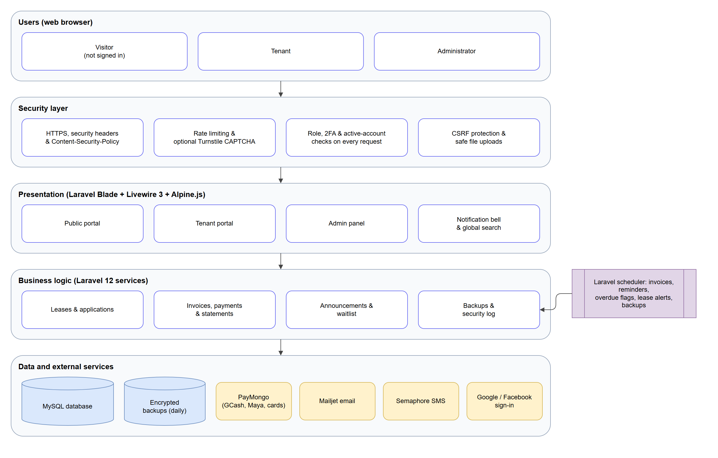
Figure 1. System architecture of the Web Based Stall Management System for Center Point
Core Database Design (MySQL)
The relational database schema is structured around the following core entities and their relationships, managed through Laravel migrations and Eloquent ORM:
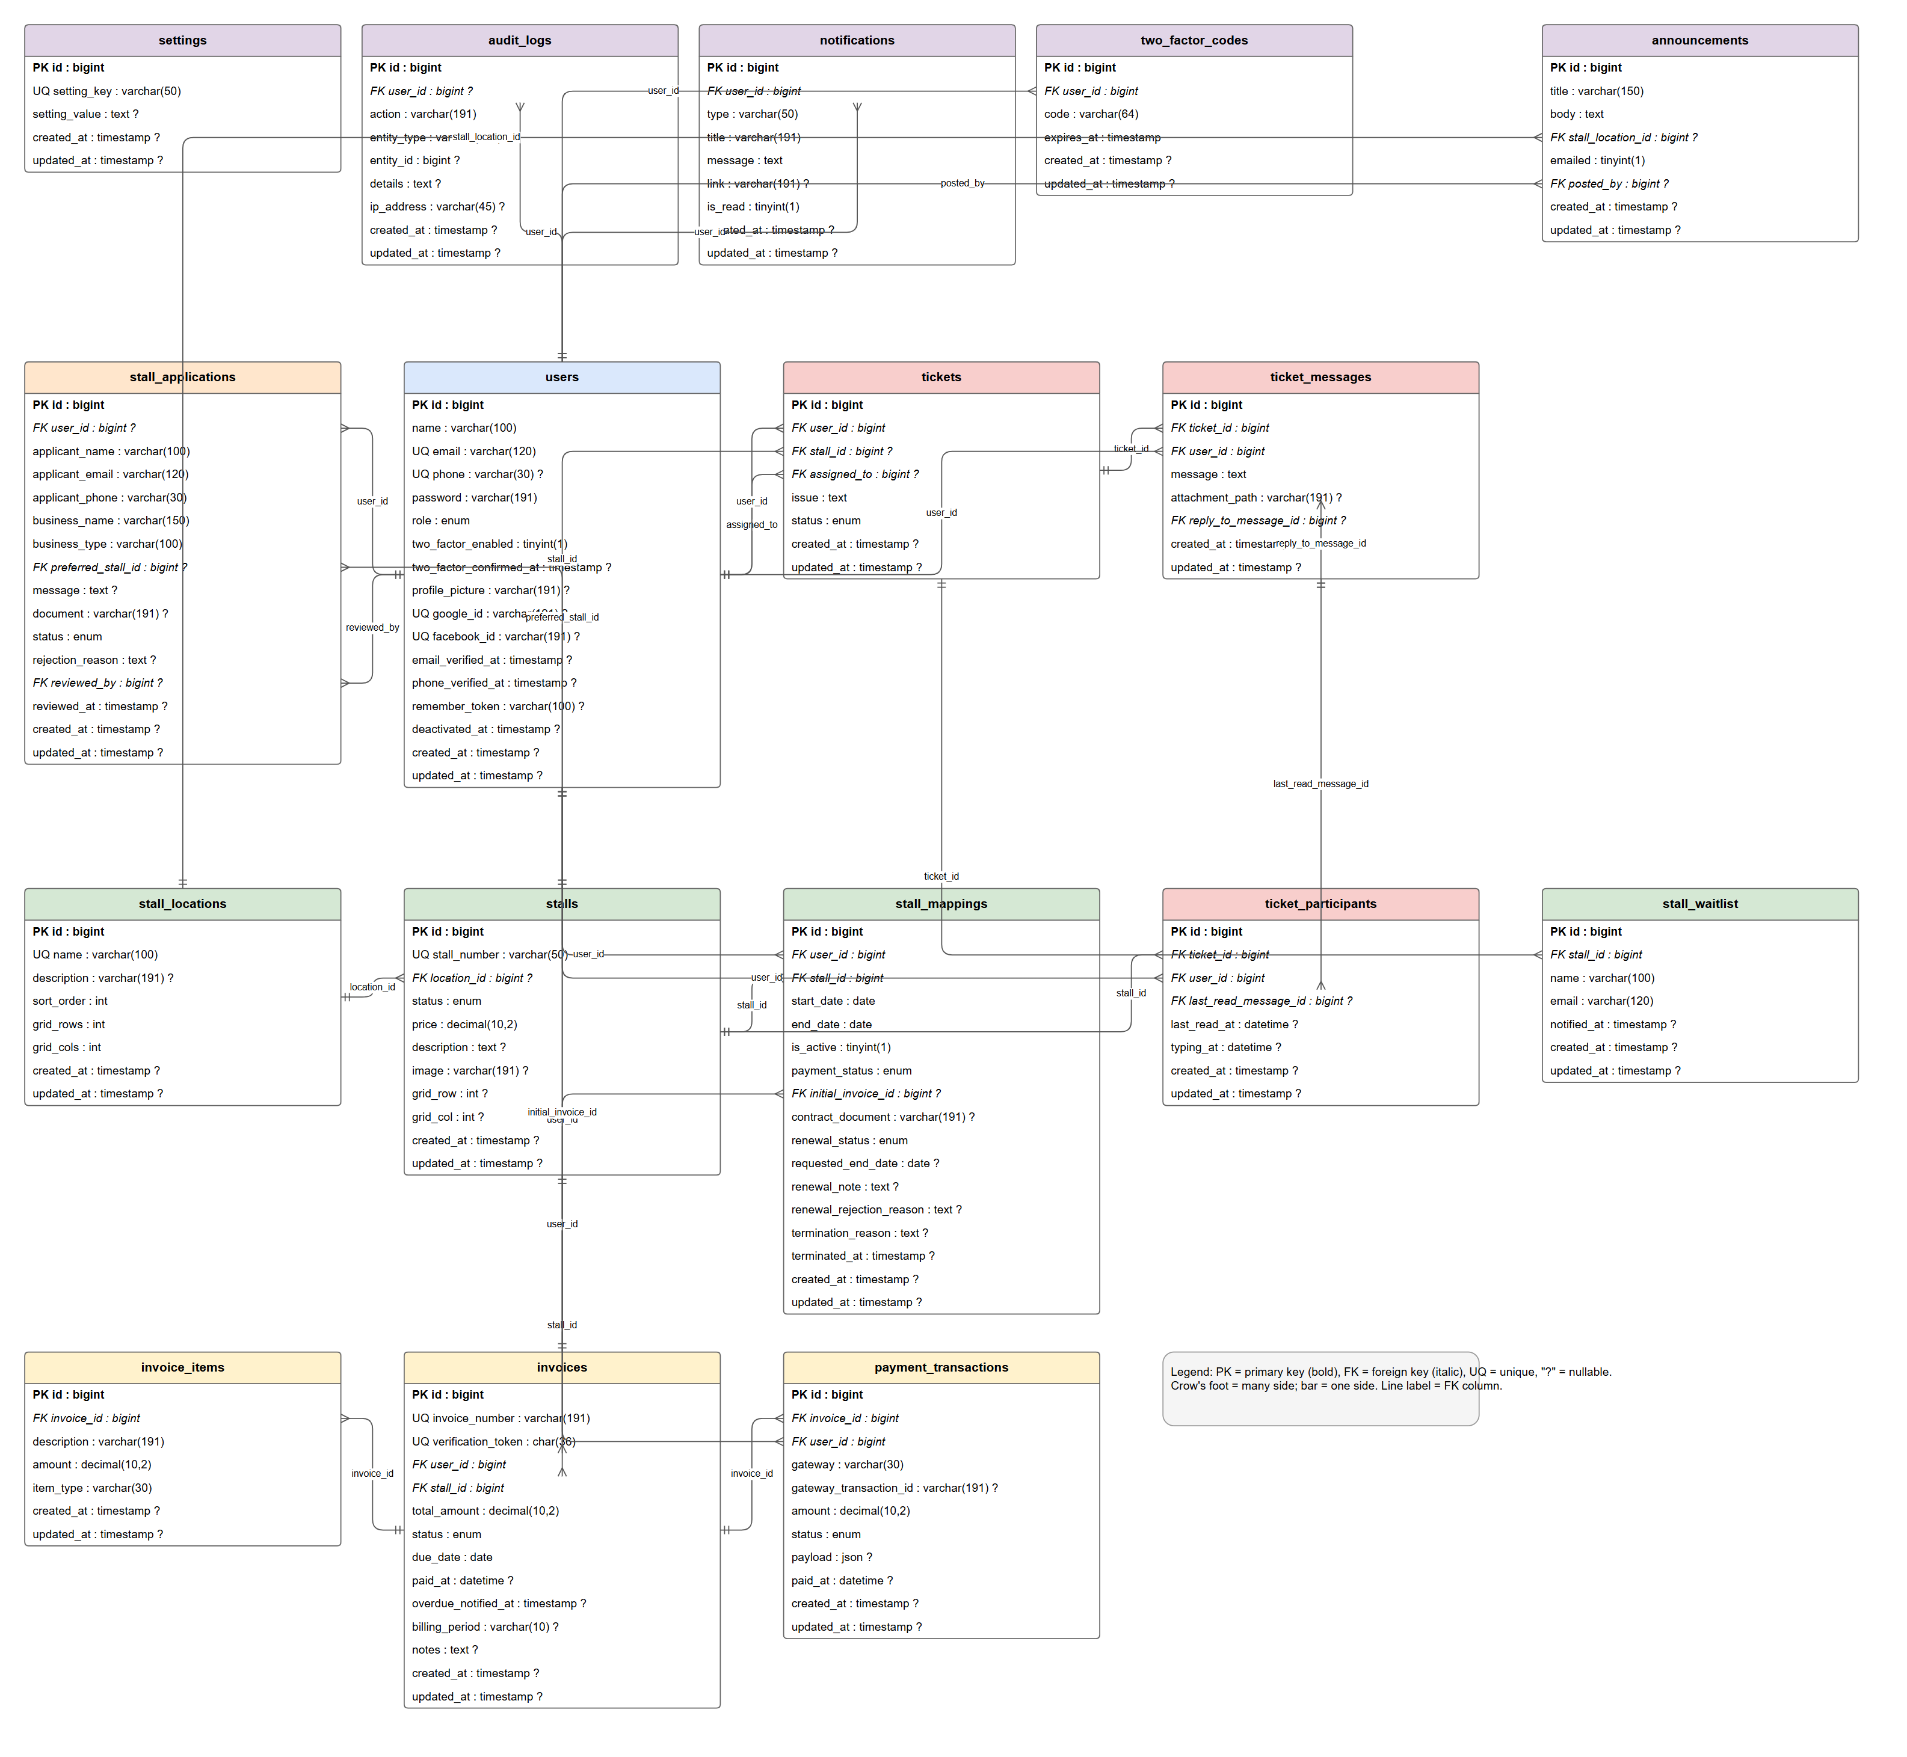
Figure 2. Entity Relationship Diagram of the Web Based Stall Management System for Center Point

Technical Background
The Web Based Stall Management System for Center Point is developed as a full-stack, database-driven web application built on the Laravel 12 PHP framework, which enforces the Model-View-Controller (MVC) architectural pattern. This ensures proper separation of concerns, improves code organization, and supports long-term maintainability.
Reactive user interface components are powered by Livewire 3, enabling server-rendered real-time interactions without a dedicated frontend JavaScript framework. This approach simplifies development while maintaining a dynamic user experience for features such as the floor plan grid editor, real-time notification bell, support ticket chat, document repository, advanced reports interface, and reservation portal form handling.
The backend handles business logic including authentication with Google and Facebook OAuth, optional Two-Factor Authentication via Semaphore SMS OTP, stall management, lease management, automated invoice generation, lease expiry notification dispatching, payment processing computation, support ticket coordination, document repository access, public reservation management, advanced financial reporting, and audit logging. MySQL is used as the relational database management system with InnoDB storage engine, foreign key constraints, indexed columns, and Laravel Eloquent ORM.
The system integrates the PayMongo payment gateway for online rental payments, Mailjet for transactional email (sent through Laravel's mailer over the Mailjet SMTP relay), and the Semaphore SMS Gateway for SMS notifications and 2FA OTP codes. Official PDF receipts and financial report documents are generated using the Dompdf library. Interactive revenue trend and occupancy rate charts in the advanced reporting module are rendered using Chart.js. Authentication is implemented using Laravel Breeze with Google OAuth 2.0 and Facebook OAuth social login via the laravel/socialite package. Role-based access is enforced through a CheckRole middleware applied to all route groups. Two-Factor Authentication is enforced through a dedicated RequiresTwoFactor middleware applied to administrator routes when 2FA is enabled on the account. IDOR-protected file endpoints secure all private document downloads.

Programming Environment
The development of the system utilized the following programming environment:
- Backend Framework: Laravel 12 (PHP 8.2+) providing routing, Eloquent ORM, middleware, Artisan CLI, and a comprehensive web application ecosystem.
- Reactive UI Layer: Livewire 3 for server-rendered reactive components with minimal custom JavaScript.
- Database: MySQL / MariaDB managed through Laravel migrations and Eloquent ORM.
- Frontend: Blade templating engine with Tailwind CSS 3 and DaisyUI 4, compiled with Vite 5, for a responsive and modern user interface; Alpine.js (bundled with Livewire) for small interactions; Chart.js 4 for interactive financial charts.
- Local Development Server: Laragon (Apache, PHP 8.3, MySQL).
- Code Editor: Visual Studio Code with PHP and Laravel extensions.
- Version Control: Git for source code tracking.
- Testing Framework: PHPUnit 11 with Laravel's testing utilities for automated feature and unit testing.
- Web Browsers: Google Chrome and Microsoft Edge for testing and user acceptance verification.
Hardware Specification
The system operates on standard computing devices without requiring specialized hardware. The following table presents the recommended hardware specification:
Hardware Component | Purpose | Specifications
Server / Computer | System hosting and administration access | Intel Core i5 or higher, minimum 8GB RAM, minimum 50GB storage
Client Computer | Administrator access | Intel Core i3 or higher, minimum 4GB RAM
Mobile Device | Tenant portal and reservation portal access | Android or iOS smartphone with a modern browser
Internet Connection | Online payments, webhooks, email, SMS, and 2FA OTP | Stable broadband connection (minimum 5 Mbps)
Table 1. Web Based Stall Management System for Center Point — Hardware Specification.
Software Specification
The following table presents the software specification used in the project:
Software | Purpose | Specifications
PHP | Backend programming language | PHP 8.2+ (developed and tested on PHP 8.3)
Laravel | Backend web application framework (MVC) | Laravel 12
Livewire | Reactive server-side UI component layer | Livewire 3
MySQL / MariaDB | Relational database management | MySQL 8.x / MariaDB 10.x
Tailwind CSS and DaisyUI | Responsive interface styling and components | Tailwind CSS 3.4, DaisyUI 4
Chart.js | Interactive financial charts (revenue trends, occupancy) | Chart.js 4.5
Dompdf | PDF generation for receipts and financial reports | Dompdf 3.1
PayMongo API | Online payment gateway (GCash, Maya, cards) | PayMongo REST API v1
Mailjet | Transactional email through Laravel Mail | Mailjet SMTP relay
Semaphore SMS API | SMS notifications, payment reminders, and 2FA OTP | Semaphore REST API
laravel/socialite | Google and Facebook OAuth 2.0 social authentication | Socialite 5.x
PHPUnit | Automated unit and feature testing | PHPUnit 11
Laragon | Local development server environment | Laragon (Apache, PHP 8.3, MySQL)
Visual Studio Code | Primary code editor | Latest stable version
Vite | Front-end asset build tool | Vite 5
PhpSpreadsheet | Excel (.xlsx) exports of payments, analytics, and logs | PhpSpreadsheet 5
Cloudflare Turnstile | Optional CAPTCHA for public forms | Turnstile (enabled by configuration)
Table 2. Web Based Stall Management System for Center Point — Software Specification.
Modules Described
The system is organized into the following functional modules:
- 1. Authentication Module — Manages user registration, login, password reset, and Google OAuth 2.0 and Facebook OAuth social sign-in via laravel/socialite. Enforces role-based access control via CheckRole middleware for admin and tenant roles.
- Two-Factor Authentication (2FA) Module — Provides optional SMS OTP-based Two-Factor Authentication for administrator accounts. When enabled on an account, the system generates a 6-digit OTP, stores it with an expiry timestamp in the two_factor_codes table, and dispatches it via Semaphore SMS. Access to administrator areas is blocked until the OTP is successfully verified within the session.
- Stall Location Management Module — Allows administrators to organize stalls by floor level or zone (e.g., Ground Floor, Second Floor) for structured navigation and floor plan organization.
- Stall Management Module — Handles stall records including stall number, description, monthly price, image, grid layout position, and occupancy status (available, reserved — assigned and awaiting the first payment — occupied, maintenance). Includes a Livewire-powered interactive floor plan grid editor for visual stall configuration per floor.
- Lease Mapping Module — Manages stall allocation to tenants. Records contract start and end dates, PDF contract document uploads, lease renewal request workflows, and active or inactive lease status.
- Lease Expiry Notification Module — A scheduled Artisan command (stallm:notify-expiring-leases) that runs daily at 07:00, finds active leases ending in exactly 60 and 30 days without a pending renewal request, and notifies the tenant by in-app notification, Mailjet email, and Semaphore SMS, and the administrators by in-app notification.
- Automated Billing Module — Generates monthly rental invoices for all active tenant leases through a scheduled Laravel Artisan command. Prevents duplicate invoice generation per billing period.
- Payment Management Module — Records and tracks all rental payment transactions, including PayMongo online payments and manually recorded cash or office payments. Invoice statuses are pending, paid, and cancelled; payment transactions are pending, successful, or failed.
- PayMongo Online Payment Module — Integrates the PayMongo API for secure digital rental payment processing via GCash, Maya, credit cards, and debit cards. Handles checkout session creation, tenant redirection, and asynchronous webhook event verification.
- PDF Receipt and Document Generation Module — Generates official A4 payment receipts using Dompdf on request once the invoice is paid. Receipts include tenant details, billing period, payment method, amount, transaction reference, and an embedded SVG QR code for online authenticity verification. Also generates exportable PDF financial summary reports.
- Tenant Document Repository Module — Provides tenants with a secure, centralized section in their portal to access and download all their documents including lease contracts, payment receipts, and billing statements. All files are served through IDOR-protected endpoints to prevent unauthorized access.
- Support Ticket and Chat Module — A structured helpdesk system powered by Livewire 3 where tenants submit support tickets and engage in live threaded chat (refreshed every 3 seconds) with administrators. Features include file attachments, read receipts, and typing indicators.
- Public Stall Reservation Module — A guest-accessible module allowing prospective tenants to view available stalls on a read-only floor plan, and submit a formal online rental application including business information, preferred stall selection, and an optional supporting document upload. Submissions are stored in the stall_applications table and trigger a confirmation email via Mailjet.
- Stall Application Management Module — Allows administrators to review, approve, or reject submitted stall applications. Approved applications can be linked to an existing or newly created tenant account for lease assignment.
- Advanced Financial Reporting and Analytics Module — Provides administrators with interactive revenue trend charts and stall occupancy rate visualizations rendered via Chart.js, an overdue payment aging report table, and exportable financial summaries in CSV and PDF formats using Dompdf.
- In-App Notification Center Module — Delivers in-app notifications through a Livewire-powered notification bell refreshed every 10 seconds. Notifies users of payment reminders, overdue notices, ticket replies, lease events, lease expiry warnings, announcements, and application status updates.
- Audit Log Module — Records all significant administrative actions, including the responsible user, action performed, affected entity, timestamp, and IP address, for security monitoring and operational accountability.
- Analytics Dashboard Module — Displays key performance indicators for administrators including total revenue, stall occupancy rates, active lease counts, overdue invoices, pending applications, and pending support tickets.
- Lease Termination Module — Ends a lease with a required reason, shows the unpaid balance for that stall, keeps unpaid invoices on record (or cancels an unpaid reservation’s first invoice), frees the stall, and notifies the tenant.
- Announcements Module — Lets administrators post notices to all tenants or one floor, delivered through the notification bell, optional email, and the tenant dashboard.
- Application Status and Waitlist Module — Gives every application a reference number that applicants use to check its status, and lets visitors join a waitlist that emails them once when an occupied stall becomes available.
- Tenant Account Management Module — Lists tenants with active leases and unpaid balances, and lets administrators deactivate or reactivate accounts and resend set-password links.
- Statement of Account Module — Builds each tenant’s ledger of charges and payments with a running balance, shown on screen and exported as a PDF.
- Calendar and Global Search Module — A monthly calendar of lease ends, invoice due dates, and renewal requests, and a search box that finds tenants, stalls, invoices, and tickets.
- Database Backup Module — Creates encrypted backups on demand and every day at 2:00 AM, keeps the latest 14, and lets administrators download or delete them.
- Security Module — Content-Security-Policy and security headers, rate limiting, a strong password rule, security event logging, safe upload handling, optional Cloudflare Turnstile CAPTCHA, and an SMS on/off switch.
Benefits of the System
The proposed system provides several significant advantages for Center Point operations.
First, it improves operational efficiency by automating manual processes such as monthly invoice generation, lease expiry notification dispatching, multi-stage payment reminder dispatching, and payment record updating through webhook events. This reduces processing time, minimizes administrative workload, and increases overall productivity.
Second, it minimizes human errors in record-keeping, billing computation, and document management through automation, server-side validation, and centralized MySQL database storage with referential integrity constraints.
Third, it enhances transparency by providing tenants with self-service access to their lease details, payment history, invoice status, statement of account, and all their documents through the tenant portal and document repository, reducing dependency on the office for routine inquiries.
Fourth, it improves communication between tenants and management through the support ticket system with threaded live chat, file attachments, and read receipts, ensuring all concerns are properly documented and resolved.
Fifth, the integration of the PayMongo payment gateway and the advanced financial reporting module with exportable CSV and PDF summaries provides management with comprehensive financial visibility and supports strategic decision-making.
Sixth, the public stall reservation portal eliminates the need for prospective tenants to visit the office for inquiries, making the rental application process more accessible and reducing administrative overhead.
Seventh, automated lease expiry notifications reduce the risk of unplanned lease terminations by ensuring that both administrators and tenants are proactively informed of upcoming contract end dates.
Eighth, the optional Two-Factor Authentication mechanism for administrator accounts significantly strengthens the security posture of the system by adding a layered verification step, protecting sensitive financial data and tenant records.
Ninth, the audit log system enhances operational accountability by maintaining a append-only record of all significant administrative actions, supporting both internal review and security monitoring.
Tenth, encrypted daily database backups and layered web security measures — a Content-Security-Policy, rate limiting, a strong password policy, and security event logging — protect tenant and financial data against loss and common attacks.
Design of System Software, Product, and/or Process
The design and development of the system followed a structured and systematic process to ensure that all client requirements were properly addressed.
The process began with data gathering through site visits, interviews, and observations at Center Point. These activities identified key operational challenges across manual stall management, billing, payment collection, lease management, tenant communication, and security.
Following data collection, requirement analysis was conducted and formalized in the System Requirements Document. During the system design phase, the relational database schema was planned using Laravel migrations, the system architecture was organized into modular Livewire components, and the user interface was designed using the Blade templating engine with Tailwind CSS.
The development phase involved implementing the system using Laravel 12, Livewire 3, MySQL, and all integrated third-party services including PayMongo, Mailjet, Semaphore, Dompdf, Chart.js, and laravel/socialite. All functional modules were developed and integrated during this phase.
Testing and refinement followed using PHPUnit 11 with Laravel's testing utilities. Automated tests were written to verify authentication flows, social login, 2FA, access control, billing generation, lease expiry notification, payment processing, reservation submission, document repository access, and ticket management.
Finally, the system was prepared for deployment with documentation of the installation procedure, environment configuration, cron scheduler setup, and maintenance guidelines.
Throughout the process, the proponents prioritized usability, scalability, security, and maintainability to ensure the system meets the full operational needs of both administrators and tenants at Center Point.

CHAPTER IV
DEVELOPMENT, TESTING, AND MAINTENANCE
This chapter details the development lifecycle, testing strategies, and deployment guidelines for the Web Based Stall Management System for Center Point. Developed to replace manual workflows at Center Point in Pagadian City, Zamboanga del Sur, the system automates tenant onboarding, stall lease contracts, monthly invoice generation, lease expiry notifications, online payments, tenant document access, public stall reservation, advanced financial reporting, and administrative audit logging, all secured with social authentication and optional Two-Factor Authentication.
To build a reliable platform, the research team adopted the Software Development Life Cycle (SDLC) using the sequential Waterfall Model. The structured phases — Planning, Analysis and Design, Coding and Development, Testing, Implementation, and Maintenance — ensured that each technical and operational milestone was verified before proceeding to the next.
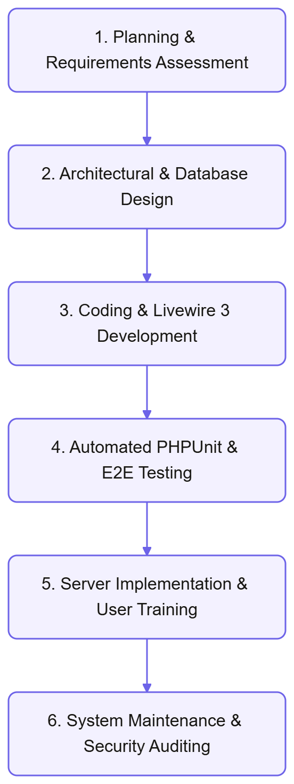
Figure 3. Waterfall model used in the development of the system
Planning
The planning phase began with an assessment of the administrative workflows at Center Point. Through interviews with the property manager and observation of daily operations, the researchers analyzed the challenges and inefficiencies of the existing manual administration system.
Historically, the administration tracked tenancies and payments using paper ledgers and physical folders stored in the office. The researchers identified several key operational bottlenecks:
- Stall Allocation Overlaps: Tracking occupied, vacant, or maintenance-status stalls across multiple floor levels using paper logs was prone to booking conflicts and data inconsistencies, resulting in significant administrative overhead.
- Invoicing and Computation Errors: Manually calculating monthly rent amounts and generating handwritten receipts resulted in arithmetic errors, delayed invoice delivery, and inconsistent billing records.
- Delayed Payment Reconciliation: Tenants paid via physical cash, requiring manual verification of paper receipts. This delayed payment logging and created opportunities for financial discrepancies.
- Unstructured Support Requests: Maintenance requests were submitted verbally or through informal messaging, leading to delays in resolution, a lack of documentation, and reduced accountability.
- Lack of Tenant Transparency: Tenants had no self-service access to view their payment history, outstanding balances, lease details, or personal documents, creating frequent inquiries to the office.
- No Formal Reservation Channel: Prospective tenants had no formal online method for applying for a stall, requiring in-person visits for inquiries.
- Absence of Lease Expiry Alerts: Administrators manually monitored lease end dates with no automated notification system, leading to risks of unmanaged contract expirations.
- Insufficient Account Security: Administrative accounts had no layered authentication mechanism to protect sensitive financial and tenant data.
- Lack of Financial Visibility: Management had no centralized financial reporting tool for analyzing revenue trends, occupancy rates, or overdue payment aging.
These findings confirmed the need for a centralized, automated digital platform to address all identified operational gaps.
Analysis and Design
Following the planning phase, the researchers defined the system modules, technical architecture, and relational database schema. The system was designed using Laravel 12 with Livewire 3 for reactive, server-rendered user interface components.
The system architecture was organized into the following functional modules:
- Authentication and Access Control: Secure user registration and login with Laravel Breeze scaffolding, Google OAuth 2.0 and Facebook OAuth social logins via laravel/socialite, CSRF protection, and a CheckRole middleware enforcing role-based access for administrator and tenant roles. A public guest route serves the stall reservation portal without requiring authentication.
- Two-Factor Authentication (2FA): An optional per-account security layer for administrator users. When enabled, the system generates a 6-digit OTP, stores it with an expiry timestamp in the two_factor_codes table, and dispatches it to the user's registered phone number via Semaphore SMS. A dedicated RequiresTwoFactor middleware blocks access to privileged routes until the OTP is verified within the current session.
- Stall Location Management: Organizing stall inventory by floor level or zone for structured navigation and floor plan organization.
- Stall Administration: Managing stall records including stall identifier, monthly rental price, description, display image, grid position, and occupancy status (available, reserved — assigned and awaiting the first payment — occupied, maintenance). An interactive Livewire-powered floor plan grid editor allows administrators to visually configure stall layouts per floor.
- Stall Mapping and Lease Contracts: Linking tenants to stalls with specific contract start and end dates, active lease status tracking, PDF contract document uploads, and a lease renewal request workflow with administrator approval or rejection.
- Lease Expiry Notification: A dedicated Artisan console command (stallm:notify-expiring-leases) scheduled daily at 07:00. It finds active leases ending in exactly 60 and 30 days without a pending renewal request and notifies the tenant by in-app notification, Mailjet email, and Semaphore SMS, and the administrators by in-app notification.
- Automated Monthly Invoicing: Generating monthly rental invoices for all active tenant leases using a scheduled Laravel Artisan console command (billing:generate-invoices). The command uses optimized Eloquent queries to avoid N+1 query problems and prevents duplicate invoice generation per billing period.
- Payment Processing: Recording manually collected cash or office payments with custom reference IDs, and processing online payments via the PayMongo API using checkout sessions. An asynchronous webhook listener verifies the PayMongo signature and updates the invoice status as soon as PayMongo confirms the payment.
- Public Stall Reservation: A guest-accessible Livewire component displaying available stalls on a read-only floor plan grid. Prospective tenants can submit a formal rental application form including their name, contact details, business information, preferred stall, and an optional supporting document upload. Submissions are stored in the stall_applications table and trigger a confirmation email via Mailjet.
- Stall Application Management: An administrative interface for reviewing, approving, or rejecting submitted stall applications. Approved applications can be linked to an existing or newly created tenant account for direct lease assignment.
- Tenant Document Repository: A secure Livewire-powered section within the tenant portal where tenants can view and download all their documents, including lease contract PDFs, payment receipt PDFs, and billing statements. All file downloads are served through IDOR-protected file endpoints to prevent unauthorized access.
- Advanced Financial Reporting and Analytics: An administrative reporting module providing interactive revenue trend charts (monthly and annual) and stall occupancy rate visualizations rendered using Chart.js. The module also provides an overdue payment aging report table and supports one-click export of financial summaries in CSV format and printable PDF reports via Dompdf.
- Support Tickets and Live Chat: An interactive helpdesk powered by Livewire 3 where tenants submit maintenance requests or inquiries. Features include live threaded messaging (Livewire polling every 3 seconds), typing indicators, file attachments, and read receipt tracking.
- In-App Notification Center: A Livewire-powered notification bell delivering in-app notifications, refreshed every 10 seconds, for payment reminders, overdue notices, ticket replies, lease events, lease expiry warnings, announcements, and application status updates.
- Audit Logging and Security Monitoring: Recording all significant administrative actions with the responsible user's identity, action description, affected entity, timestamp, and IP address.
- Lease Termination: Ending a lease with a required reason and the unpaid balance shown, keeping unpaid invoices on record, and notifying the tenant.
- Announcements: Notices to all tenants or one floor through the notification bell, optional email, and the tenant dashboard.
- Application Status and Waitlist: Reference-number status lookup for applicants and email alerts for visitors waiting on an occupied stall.
- Tenant Accounts and Statements: Account deactivation and set-password resend for administrators, and statements of account for tenants and administrators.
- Calendar, Global Search and Backups: An administrative calendar, a system-wide search box, and encrypted scheduled database backups.
- Security Hardening: Content-Security-Policy, security headers, rate limiting, password policy, security event logging, safe uploads, and optional CAPTCHA.
The relational database schema is structured around the following core tables, managed through Laravel migrations:
- users: Stores credentials, roles (admin, user), Google ID and Facebook ID for social logins, profile picture, email and phone verification timestamps, two_factor_enabled flag, and two_factor_confirmed_at timestamp.
- stall_locations: Categorizes stall zones or floor levels.
- stalls: Stores stall profiles, monthly rental rates, descriptions, display images, occupancy status, and grid layout positions per floor.
- stall_mappings: Tracks lease agreements linking a user to a stall. Stores contract start and end dates, active status, PDF contract document path, and renewal request status.
- invoices, invoice_items, payment_transactions: Track monthly and initial invoices with their line items, due dates and statuses (pending, paid, cancelled), and each online or office payment transaction with its gateway, reference, amount, and status.
- stall_applications: Stores online rental applications from the public reservation portal. Includes applicant name, email, phone, business name, business type, preferred stall ID, message, optional document path, application status (pending, approved, rejected), reviewed_by user ID, and reviewed_at timestamp.
- two_factor_codes: Stores active OTP codes for 2FA. Includes user ID, code, and expires_at timestamp. Codes are invalidated after use or expiry.
- tickets, ticket_messages, ticket_participants: Handles the support ticket system including message histories, file attachments, typing status, and read receipt tracking.
- notifications: Stores in-app notifications per user with read/unread status.
- audit_logs: Logs administrative actions with user identity, action description, entity type and ID, timestamp, and IP address.
- settings: Stores global system configuration as key-value pairs.
- announcements: Stores notices posted by administrators, the target floor (or all tenants), whether they were emailed, and who posted them.
- stall_waitlist: Stores visitors waiting for an occupied stall and when they were notified.
- In addition, users records when an account was deactivated; stall_mappings stores the lease payment status (pending_initial, good_standing, past_due, settled), the initial invoice, and the termination reason and date; stall_applications links an approved applicant to their user account and stores the rejection reason; and two_factor_codes stores only a SHA-256 hash of each code, never the code itself.
Coding and Debugging
During the development phase, the researchers implemented the application using PHP 8.2+ and the Laravel 12 framework. The development stack included:
- IDE: Visual Studio Code with PHP Intelephense and Laravel extensions.
- Local Server Environment: Laragon, providing a lightweight local stack with Apache, PHP 8.3, and MySQL for fast development and testing.
- Dependency Management: Composer for managing the following key third-party libraries:
- laravel/livewire: Provides the reactive Livewire 3 component layer.
- laravel/socialite: Implements Google OAuth 2.0 and Facebook OAuth social authentication.
- dompdf/dompdf: Generates official PDF payment receipts and exportable financial report documents with embedded QR codes.
- Mailjet SMTP relay: Laravel's built-in mailer sends all transactional email through Mailjet's SMTP service; no separate Mailjet package is required.
- phpoffice/phpspreadsheet: Produces the Excel (.xlsx) exports for payments, the analytics dashboard, audit logs, and error logs.
- Frontend Design: Blade templating engine with Tailwind CSS for a modern, responsive, and clean user interface. Chart.js 4.x for interactive financial charts in the advanced reporting module.
- Testing Framework: PHPUnit 11 with Laravel's built-in testing utilities for automated feature and unit testing.

Automated Monthly Invoice Generation
The system generates monthly rental invoices automatically through a dedicated Laravel Artisan console command (billing:generate-invoices) that the scheduler runs on the first day of every month at 00:00. For each active lease, it creates a pending invoice for that billing period, due on the 6th day of the month, and skips any stall that already has an invoice for the same billing period.
The Laravel Artisan scheduler is configured to run this command monthly and to dispatch multi-stage payment reminder notifications — via Mailjet email and Semaphore SMS — at seven days before the due date, three days before the due date, and on the due date itself.
Lease Expiry Automated Notification System
The system dispatches automated lease expiry notifications through a separate scheduled Artisan command (stallm:notify-expiring-leases), which runs daily at 07:00. It queries the stall_mappings table for active leases whose end_date falls exactly 60 or 30 days from the current date and that have no pending renewal request. For each matching lease, the tenant receives an in-app notification, a Mailjet email, and a Semaphore SMS prompting a renewal request if needed, and every administrator receives an in-app notification. This eliminates the risk of unmanaged lease expirations and reduces administrative oversight requirements.

PayMongo Online Payment Gateway Integration
To support online rental payments via GCash, Maya, and credit or debit cards, the system integrates with the PayMongo REST API. The following sequence diagram details the interaction flow between the tenant, the StallM system backend, the PayMongo API, and the database upon payment completion:
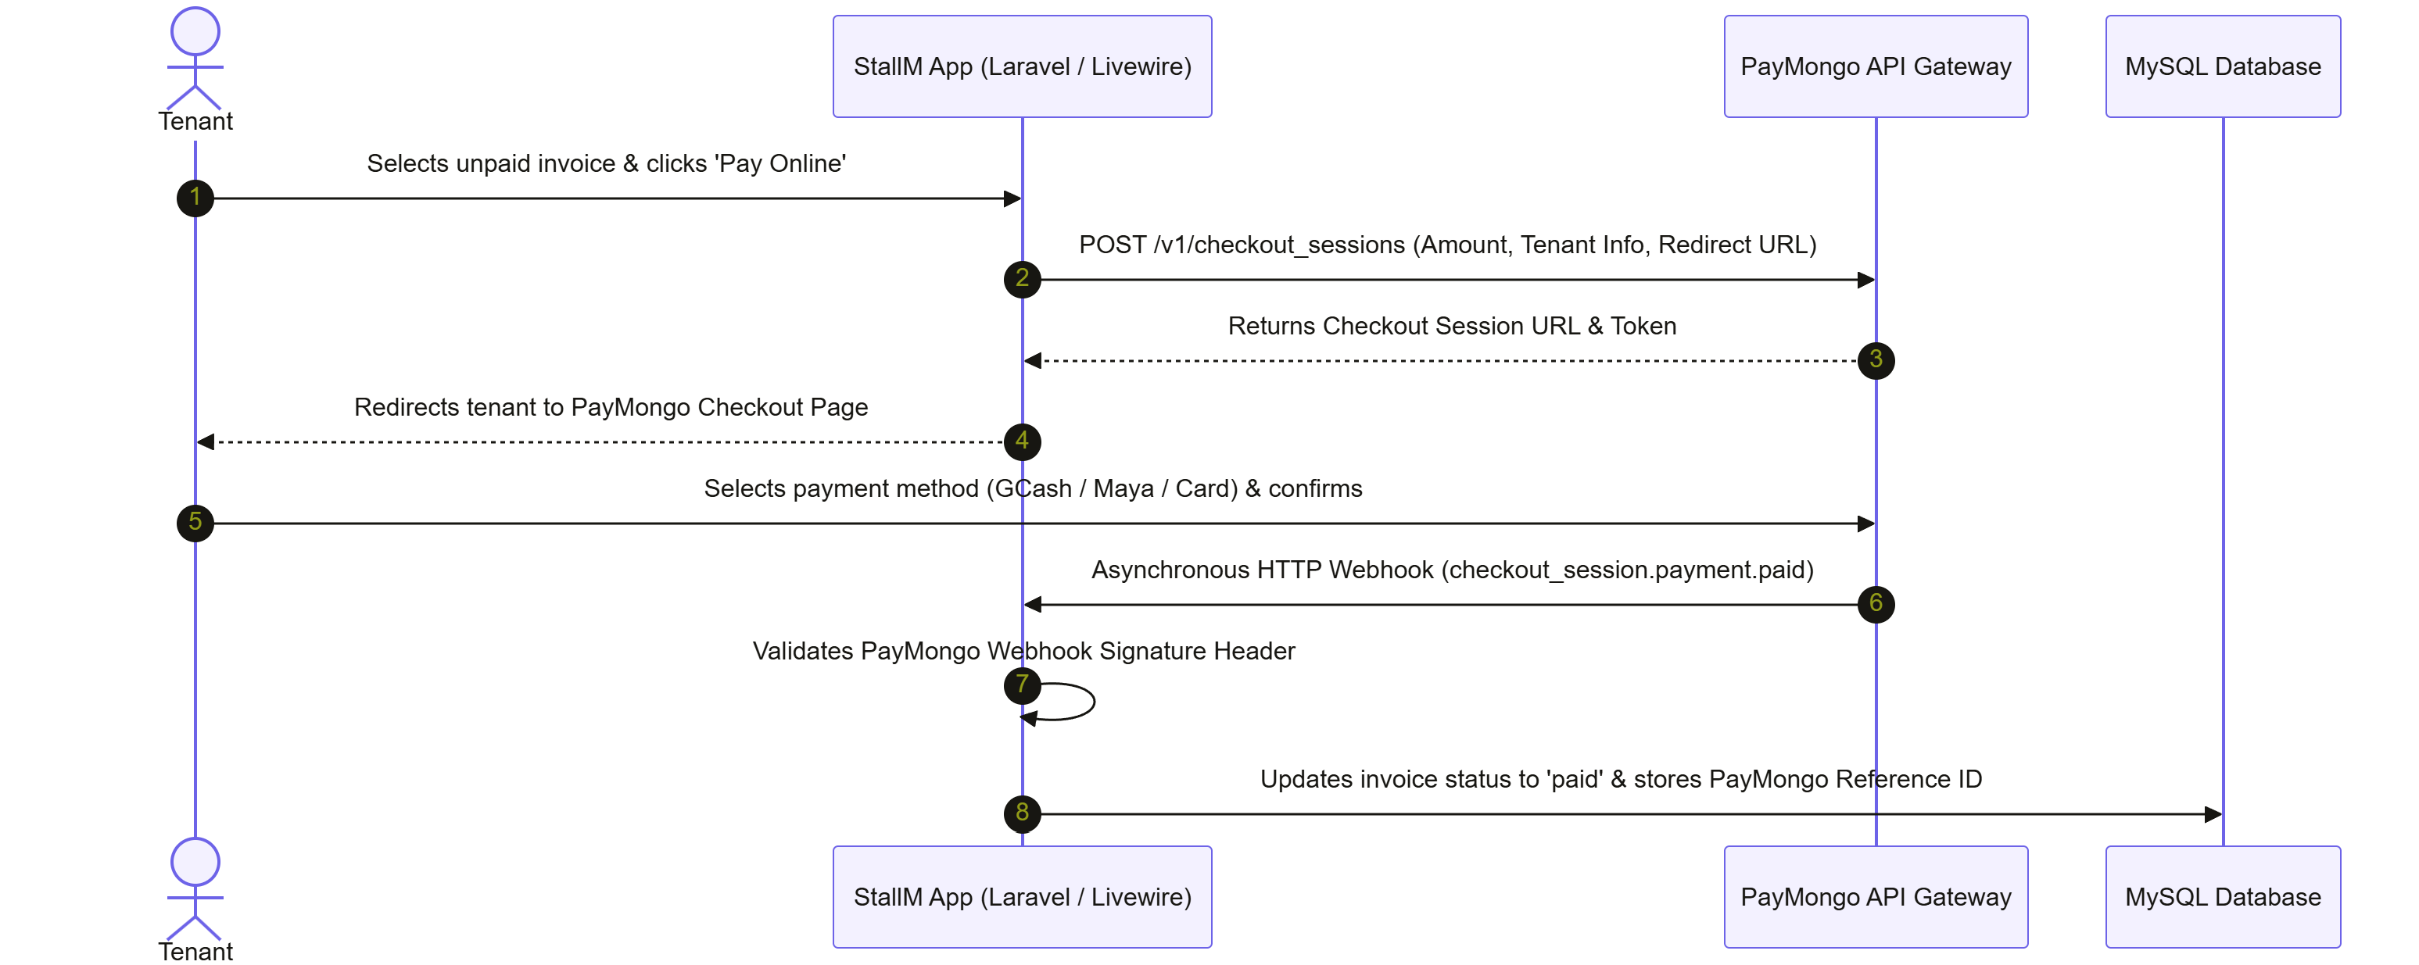
Figure 4. PayMongo online payment sequence
- Session Creation: When a tenant selects unpaid invoices and clicks "Pay Online," the payment controller sends a request to the PayMongo API to create a Checkout Session populated with billing details, tenant information, and redirect URLs.
- Tenant Redirection: PayMongo returns a unique checkout URL. The system redirects the tenant to this hosted payment page to complete the transaction.
- Asynchronous Webhook Verification: Upon successful payment, PayMongo dispatches an HTTP POST webhook event. The system validates the PayMongo signature header, parses the event payload, locates the corresponding invoice records, and updates their status to "paid" with the payment method, PayMongo transaction ID, and paid timestamp.
- PDF Receipt Generation: Once the invoice is paid, the tenant (or an administrator) can download an official A4 PDF receipt, generated on request using Dompdf, with an embedded QR code linking to the online receipt verification page.
Advanced Financial Reporting and Analytics
The advanced reporting module provides administrators with a comprehensive financial overview of Center Point operations. The module renders interactive revenue trend charts using Chart.js, displaying monthly and annual rental income. Stall occupancy rate charts provide a visual breakdown of available, occupied, and maintenance-status stalls. An overdue payment aging report table lists all tenants with overdue invoices grouped by the number of days past due. Administrators can export revenue and payment data to CSV using Laravel's streaming response, and generate a printable PDF financial summary report via Dompdf.
Two-Factor Authentication (2FA)
The system implements optional Two-Factor Authentication for administrator accounts. When an administrator enables 2FA through their account settings, all subsequent logins trigger a secondary verification step. The security verification sequence is illustrated in the flowchart below:
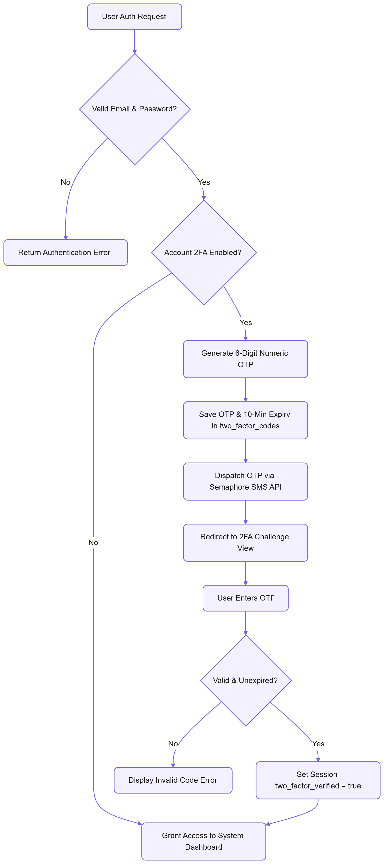
Figure 5. Two-Factor Authentication sign-in flow
After successful password authentication, the system generates a cryptographically random 6-digit OTP, stores it in the two_factor_codes table with an expiry timestamp of 10 minutes, and dispatches it to the user's registered phone number via Semaphore SMS. The user is then redirected to a challenge page where they must enter the OTP to complete the login. A dedicated RequiresTwoFactor middleware, applied to all administrator route groups, verifies the presence of a valid two_factor_verified flag in the session and redirects unverified users to the challenge page. OTP codes are invalidated immediately upon successful verification or upon expiry.
Public Stall Reservation Portal
The public-facing stall reservation module is accessible to unauthenticated users. The module displays the available stalls on a read-only floor plan grid. Prospective tenants can select a preferred stall and complete an online application form providing their name, contact details, business name, business type, and an optional supporting document. Upon submission, a record is created in the stall_applications table, a confirmation email is dispatched to the applicant via Mailjet, and an in-app notification is sent to the administrator. Administrators can then review, approve, or reject applications through the Stall Application Management interface.
Tenant Document Repository
The tenant document repository provides tenants with a centralized, secure section within their portal to access all their personal documents. The repository lists lease contract PDFs (sourced from stall_mappings.contract_document), payment receipt PDFs (generated on demand via Dompdf), and billing statements. All documents are served through IDOR-protected file endpoints in the FileController, which verify that the requesting user is the authorized owner of the requested document before serving the file. This prevents unauthorized access to other tenants' sensitive documents.
Support Ticket and Live Chat System
The support ticket module enables structured communication between tenants and the administration. Tenants submit support tickets through the dedicated Livewire component, describing the issue and the related stall. A participant record is created when each user opens or types in the conversation, recording when they last read it. The Livewire-powered chat interface supports threaded messaging with the last-read timestamp tracked per participant, file attachment uploads served through IDOR-protected endpoints, and typing indicators.
Audit Trail Logging
The system records all significant administrative actions in the audit_logs table including updates to stall pricing or status, lease contract creation or termination, manual payment recording, payment status adjustments, stall application reviews, 2FA configuration changes, and support ticket resolutions. Each log entry captures the responsible user's identity, the action performed, the affected entity type and record ID, the timestamp, and the user's IP address.
Lease Termination with Reason and Balance Check
Terminating a lease opens a form that requires a reason of 10 to 500 characters and shows the tenant’s unpaid balance for that stall. When a balance exists, the administrator must confirm that it remains owed; unpaid invoices stay on record and the lease is marked past due, otherwise it is settled. For a reservation that was never paid, the first invoice is cancelled instead. The stall becomes available, the reason and date are saved, and the tenant is notified in-app and by email. A lease that has already ended cannot be terminated again.
Announcements
Administrators post a title and message to all tenants or to the tenants of one floor. Every tenant with an active lease on the target floor receives a notification once, deactivated accounts are skipped, and an optional email is sent after the page responds so posting stays fast. Tenants see the latest three announcements that apply to them on their dashboard.
Application Status Lookup and Stall Waitlist
Each stall application receives a reference number such as APP-2026-000123, shown after submitting and in the confirmation email. The public Application Status page shows the status, stall, dates, and rejection reason when the reference and email match, and the same message for any mismatch so it never reveals who has applied. On an occupied stall, visitors can join a waitlist; when the stall becomes available (by termination or an administrator edit) everyone waiting is emailed once, and only delivered emails are marked as sent.
Tenant Account Management and Statement of Account
The Tenant Accounts page lists every tenant with their active leases and unpaid balance. Administrators can deactivate an account (the tenant is signed out on the next request and cannot sign in by password, Google, or Facebook), reactivate it, or resend a set-password link. The statement of account lists every non-cancelled invoice as a charge and every successful payment as a credit, in date order with a running balance, and downloads as a PDF for the tenant or an administrator.
Administrative Calendar and Global Search
The calendar shows a month grid of active lease end dates, pending invoice due dates (red when overdue), and renewal requests; each item links to the matching record. The global search box on every administrator page (press / to focus) returns up to five matches each for tenants, stalls, invoices, and tickets; typed % and _ characters are treated literally.
Encrypted Database Backups
A backup service writes the whole database to a file using PHP alone, reading every table at one consistent moment, then encrypts it with the application key and deletes the unencrypted copy. Backups are created from System Settings or daily at 2:00 AM by the scheduler, the latest 14 are kept, and downloads are decrypted on the fly into a normal restorable .sql file. File names are strictly validated, so a crafted name can never read files outside the backup folder.
Security Hardening
Every response carries security headers and a Content-Security-Policy that only runs scripts carrying a secret per-session token; all inline event handlers were moved to Alpine.js for this. Sign-in, registration, password reset, status lookups, and waitlist sign-ups are rate limited, and the password reset form never reveals whether an email is registered. New passwords need 8 or more characters with letters and numbers. Uploads are stored under random names with an extension taken from the file content, and public storage refuses to run scripts. The administrator role, 2FA, and account status are re-checked on every Livewire action, and security events appear in the audit log. Cloudflare Turnstile CAPTCHA can be switched on for public forms by adding its keys, and SMS notifications can be switched off in System Settings while 2FA codes are always sent.
Testing
Testing was conducted in two structured stages: Automated Component Testing using PHPUnit 11 and End-to-End System Testing simulating complete user workflows.
Component Testing
Each system module was verified against its functional requirements using PHPUnit 11 automated test cases. The following areas were covered:
- Authentication: Verified standard login, Google OAuth login, and Facebook OAuth login flows, and confirmed that role-based redirects function correctly for admin and tenant accounts.
- Two-Factor Authentication: Verified OTP generation, Semaphore SMS dispatching, OTP verification, OTP expiry enforcement, and that the RequiresTwoFactor middleware correctly blocks access when 2FA is enabled and not yet verified in the session.
- Lease Mapping: Verified that stall mappings are correctly created, that stall status is updated accordingly, and that lease renewal workflows function correctly.
- Lease Expiry Notifications: Verified that the stallm:notify-expiring-leases command finds the correct leases at 60 and 30 days, notifies the tenant by email, SMS, and in-app notification and the administrators in-app, and skips leases with a pending renewal request.
- Invoice Generation: Confirmed that the invoice generation command produces exactly one invoice per stall per billing period without duplication.
- PayMongo Webhook: Verified that the webhook endpoint correctly validates PayMongo signatures and accurately updates invoice payment status.
- Stall Reservation: Confirmed that the public reservation form creates a stall_applications record, dispatches a confirmation email, and sends an admin in-app notification.
- Document Repository: Verified that tenants can access only their own documents through the IDOR-protected endpoints, and that unauthorized access attempts are correctly rejected.
- Advanced Reports: Verified that revenue aggregation queries return correct totals and that CSV and PDF exports are generated without errors.
- Support Ticket System: Confirmed that ticket creation, message threading, and participant mapping function correctly for both tenant and administrator users.
- Lease Termination: Verified that a reason is required, that only the unpaid balance for the same tenant and stall counts, that unpaid reservations cancel their first invoice, and that the tenant is notified.
- Announcements, Waitlist and Status Lookup: Verified that announcements reach only the targeted tenants, that waitlist emails are sent once and only on a change to available, and that status lookups reveal nothing on a mismatch.
- Accounts, Statements and Backups: Verified deactivation at every sign-in path and mid-session, running balances in statements, PDF access rules, encrypted backups that download as the original SQL, and rejection of crafted backup names.
- Security: Verified security headers, the Content-Security-Policy nonce on every script, rate limits, the password rule, identical responses for known and unknown emails, upload naming, the reply-to check in ticket chats, and that a tenant cannot replay an administrator action.
In total, the automated suite contains 340 tests (1271 assertions) in 65 test files, and all of them pass. Table 3 groups them by area.
Area | Tests | Test files
Sign-in, accounts and Two-Factor Authentication | 58 | 11
Stalls, floors and the floor map | 26 | 4
Stall applications and status lookup | 28 | 4
Leases, renewals and termination | 31 | 5
Billing, payments and statements | 34 | 10
Support tickets, notifications and announcements | 29 | 6
Administration tools (dashboard, calendar, search, settings, backups) | 46 | 8
Security hardening (headers, CSP, uploads, CAPTCHA, review fixes) | 50 | 8
Interface, navigation and demo data | 38 | 9
Total | 340 | 65
Table 3. Automated test results by area (PHPUnit 11, all passing).
System Testing
Once component testing was complete, the researchers conducted end-to-end integration testing following a complete tenant lifecycle:
Reservation Portal Submission → Admin Application Review & Approval → Tenant Account Creation → Google or Facebook OAuth Login → Admin 2FA Setup and Verification → Stall Assignment → Stall Lease Mapping with PDF Contract → Monthly Invoice Generation → Lease Expiry Notification (at 60 and 30 days) → PayMongo Online Checkout → Webhook Status Verification → PDF Receipt Download → Document Repository Access → Support Ticket Submission → Admin Chat Response → Lease Renewal Request → Advanced Reports Generation and Export → Lease Termination
- Database Transaction Verification: The database was monitored to ensure that stall status updates, payment record creation, lease status changes, notification dispatching, and stall application status updates were all triggered correctly without data anomalies.
- Security Assessment: Access control was rigorously verified by attempting to access administrative URLs using tenant-role accounts, by attempting to download another tenant's documents through direct URL manipulation, and by attempting to bypass 2FA challenge routes using session manipulation. All unauthorized access attempts were correctly blocked.
- Browser Compatibility: The user interface, reservation portal, and advanced reporting charts were tested on Google Chrome and Microsoft Edge, confirming responsive layout and correct Chart.js rendering across screen sizes.
- Payment Gateway Testing: PayMongo checkout flows were tested using the PayMongo sandbox environment, verifying correct session creation, payment redirection, webhook delivery, signature verification, and invoice status updating.
- Content-Security-Policy Check: Every guest, tenant, and administrator page was loaded in a browser, including page changes without a full reload, with zero policy violations in the browser console.
Implementation
The system was deployed using the following installation procedure.
Installation Checklist
- Server Environment Setup: Install PHP 8.2+, Apache or Nginx, and MySQL on the server machine.
- Application Deployment: Clone the application source code repository to the target server directory.
- Environment Configuration: Copy the .env.example file to .env and configure the following environment variables:
  - Database connection credentials (DB_HOST, DB_DATABASE, DB_USERNAME, DB_PASSWORD)
  - Application key (generated via artisan key:generate)
  - PayMongo keys (PAYMONGO_SECRET_KEY, PAYMONGO_WEBHOOK_TOKEN)
  - Mailjet SMTP credentials (MAILJET_API_KEY, MAILJET_SECRET_KEY)
  - Semaphore SMS settings (SEMAPHORE_API_KEY, SEMAPHORE_SENDER_NAME)
  - Google OAuth credentials (GOOGLE_CLIENT_ID, GOOGLE_CLIENT_SECRET, GOOGLE_REDIRECT_URI)
  - Facebook OAuth credentials (FACEBOOK_CLIENT_ID, FACEBOOK_CLIENT_SECRET, FACEBOOK_REDIRECT_URI)
  - Application URL (APP_URL)
  - Production security settings (APP_ENV=production, APP_DEBUG=false, SESSION_SECURE_COOKIE=true, SESSION_ENCRYPT=true, CSP_MODE=enforce)
  - Optional CAPTCHA keys (TURNSTILE_SITE_KEY, TURNSTILE_SECRET_KEY)
- PHP Dependencies: Run Composer to install all required PHP packages:
composer install --optimize-autoloader --no-dev
- Application Key Generation:
php artisan key:generate
- Database Migration: Execute all Laravel migrations to create the required database schema including stall_applications and two_factor_codes tables:
php artisan migrate
- Database Seeding: Run the database seeder to create the default administrator account and system settings (the separate DemoSeeder adds demonstration tenants for presentations only):
php artisan db:seed
- Storage Link: Create the symbolic link from the public storage directory:
php artisan storage:link
- Cron Scheduler Configuration: Configure a server cron job to execute the Laravel Scheduler every minute, enabling automated invoice generation, payment reminder dispatching, and daily lease expiry notification dispatching.
- Front-end Assets: Build the interface styles and scripts:
- npm ci && npm run build
- Backups and Keys: Keep a secure copy of the APP_KEY value; it is required to restore the encrypted database backups. Copy downloaded backups to separate storage regularly.
User Handover and Training
The researchers conducted a user training and handover session for the administrators of Center Point covering:
- Stall management: Assigning floor locations and configuring the floor plan grid editor.
- Tenant onboarding: Creating tenant accounts, assigning stalls, and uploading PDF lease contracts.
- Stall application management: Reviewing, approving, and rejecting online rental applications submitted through the public reservation portal.
- Payment management: Recording manual payments and reviewing PayMongo online payment records.
- Viewing and downloading PDF receipts and verifying payments through the QR code endpoint.
- Accessing the tenant document repository as an administrator to verify document availability.
- Advanced financial reporting: Generating revenue trend charts, occupancy reports, aging reports, and exporting financial summaries in CSV and PDF formats.
- Managing support tickets: Responding to tenant concerns through the threaded chat interface.
- Two-Factor Authentication setup: Enabling 2FA on administrator accounts and configuring registered phone numbers.
- Reviewing audit logs: Monitoring the administrative audit trail for accountability.
- Tenant accounts: Deactivating and reactivating accounts, resending set-password links, and viewing statements of account.
- Announcements, calendar and search: Posting notices, reading the monthly calendar, and finding records with the global search.
- Backups: Creating, downloading, and safely storing encrypted backups.
- Security best practices: Password policies, API key rotation, and regular database backups.
Maintenance
To ensure the long-term reliability, security, and performance of the system, the researchers recommend the following maintenance guidelines:
- Database Backups: The system creates an encrypted backup every day at 2:00 AM and keeps the latest 14. Administrators should download a copy at least weekly, store it off the server together with a secure copy of APP_KEY, and test a restore occasionally.
- Software and Dependency Updates: The PHP environment, Laravel framework, and Composer-managed packages (including Dompdf, laravel/socialite, Chart.js,) should be periodically reviewed and updated to address security vulnerabilities.
- API Key Rotation: PayMongo, Mailjet, Semaphore, Google OAuth, and Facebook OAuth credentials should be rotated annually or immediately if suspected to be compromised.
- Log Management: Administrators should review system error logs (storage/logs/laravel.log) and audit log records monthly to identify anomalies or unauthorized access attempts.
- Scheduler Monitoring: The Laravel Artisan scheduler — responsible for monthly invoice generation, payment reminders, and daily lease expiry notifications — should be periodically verified to confirm correct cron execution on the server.
- Storage Management: The private file storage directory (used for lease contract PDFs, ticket attachments, and reservation application documents) should be monitored for disk space usage and cleaned up as needed.
- Two-Factor Authentication Review: Administrators should periodically review which accounts have 2FA enabled and ensure that all active administrator accounts have registered and verified phone numbers to support the SMS OTP delivery.
- Interface Assets: After any change to the interface templates, rebuild the front-end assets (npm run build) so new styles are included.

CHAPTER V
RESULTS AND DISCUSSIONS
This chapter presents the results of developing, testing, and implementing the Web Based Stall Management System for Center Point, discusses how the system answers the problems identified in Chapter I, and shows the system flowcharts, use case diagram, content diagram, and entity relationship diagram.
Functionality and Testing Results
All functional requirements listed in Chapter III were implemented and verified. The automated test suite contains 340 tests with 1271 assertions in 65 test files, and every test passes (Table 3). The tests run against a fresh database each time and cover sign-in and Two-Factor Authentication, stalls and the floor map, stall applications and status lookup, leases including renewal and termination, invoices, payments and statements, support tickets, notifications and announcements, administration tools, and the security measures.
Beyond the automated tests, every page was opened in a web browser with the Content-Security-Policy enforced, including page changes without a full reload, and no policy violations were reported. An independent code review of the final version found no critical problems; every important finding was fixed and covered by a new test before release.
Results of System Implementation
The system replaced the logbooks and paper receipts at Center Point with a single web platform. Administrators see what needs attention on the dashboard (pending applications, renewal requests, overdue invoices, and unassigned tickets), manage stalls on a visual floor map, and track every lease, invoice, and payment. Invoices are generated automatically each month, reminders and overdue notices are sent by email and SMS, and tenants pay online through PayMongo and download official receipts with a QR code for verification.
Tenants now have their own portal for leases, invoices, statements of account, documents, announcements, and support conversations, which removes most of the routine inquiries to the office. Prospective tenants apply online, check their application status with a reference number, and can ask to be notified when an occupied stall becomes available.
Implementation Flow
A visitor browses the available stalls on the public portal and submits an application. The administrator reviews it; approval creates the tenant account and emails a link for setting the password. The administrator then assigns the stall through a lease, which issues the first invoice; once it is paid online or at the office, the lease becomes active and the stall occupied.
From then on, the scheduler issues monthly invoices, sends payment reminders and lease expiry alerts, flags overdue invoices, and backs up the database every night. Tenants pay, request renewals, and raise concerns through support tickets; administrators approve renewals, post announcements, and terminate leases with a recorded reason when needed. Every important action is written to the audit log.
Problems Encountered During Implementation
Scope changes: billing for electricity and water readings and a separate office-employee role were removed during development to keep the system focused on what Center Point needs; every page, permission, and record that referred to them was updated.
Security review findings: a review of the system found that some administrator actions could be replayed by other users and that the password reset form revealed which emails were registered. Both were fixed, and the role and account checks now run on every interactive action.
Content-Security-Policy: Livewire and Alpine.js run code written inside page attributes, so 31 inline event handlers had to be rewritten and the per-request security token was changed to a per-session token so pages that load without a full refresh keep working.
Stale interface styles: new pages initially appeared partly unstyled because the compiled style sheet was out of date; rebuilding the front-end assets fixed it, and the deployment checklist now includes this step.
Backups without database tools: the server may not have the mysqldump program installed, so backups are produced by the system itself and encrypted with the application key.
System Flowchart for Admin
The administrator signs in (with Two-Factor Authentication when enabled), reaches the dashboard, and works in one module at a time until signing out.
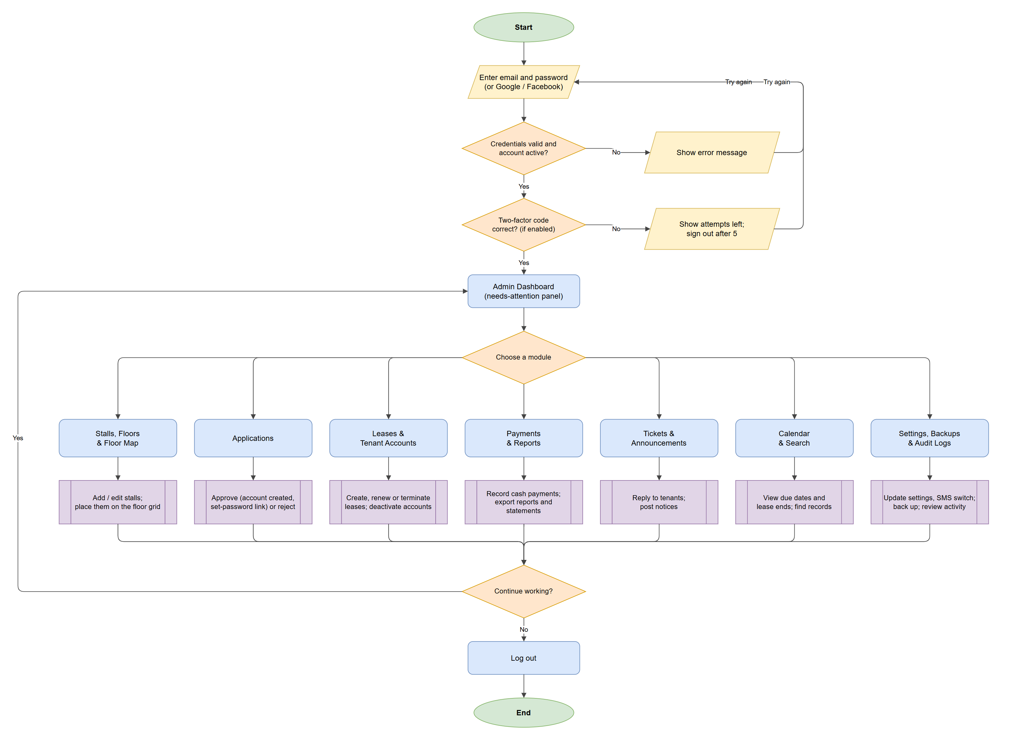
Figure 6. System flowchart for the administrator
System Flowchart for Tenant
A visitor without an account applies for a stall first; a tenant signs in and uses the portal modules until signing out.
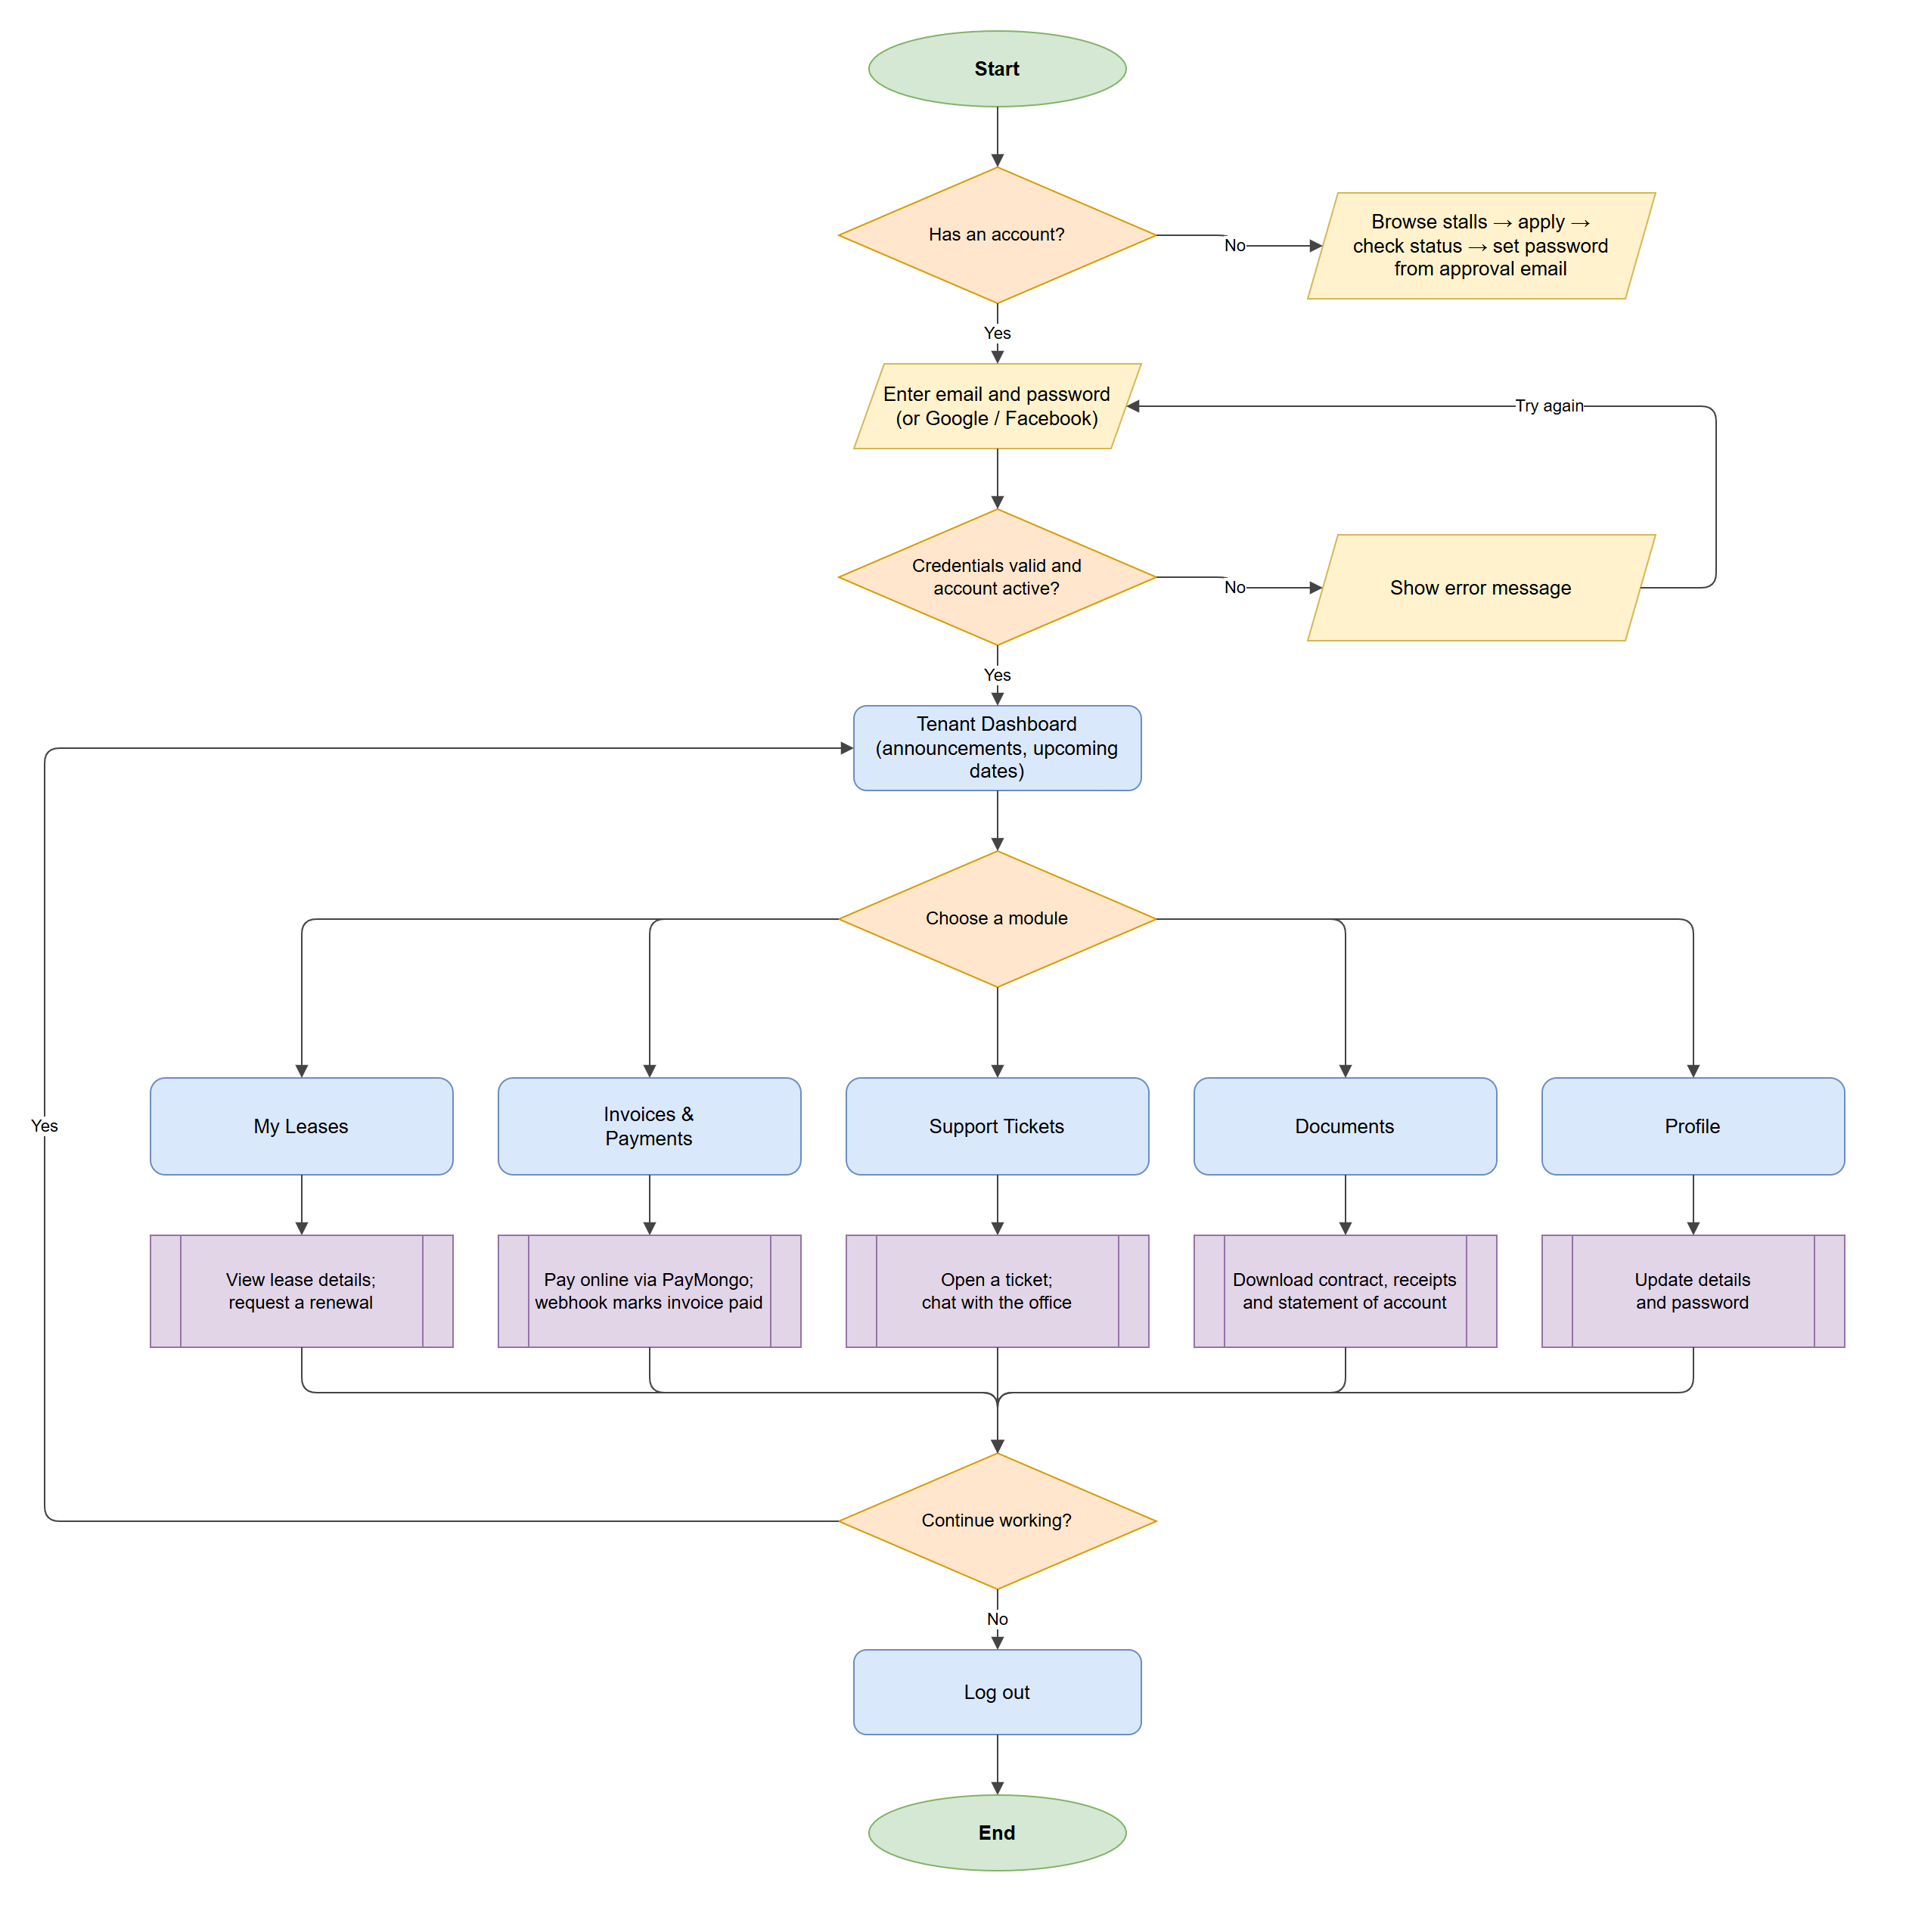
Figure 7. System flowchart for the tenant
Use Case Diagram
The use case diagram shows what each actor can do in the system, including the external PayMongo gateway and the scheduler.
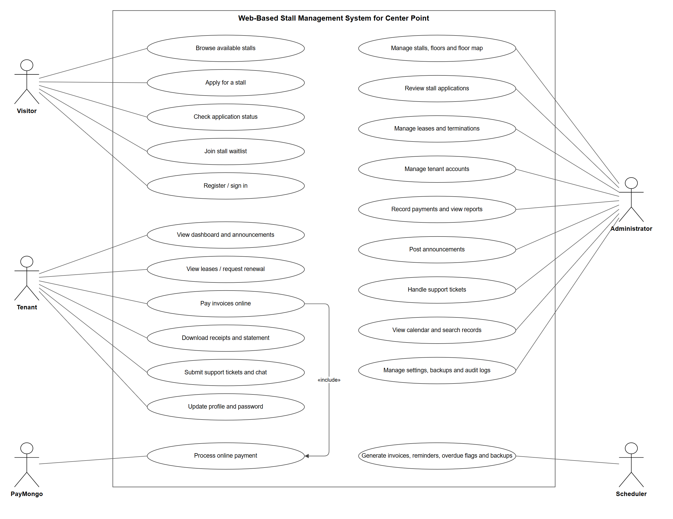
Figure 8. Use case diagram
Content Diagram
The content diagram shows every page of the public site, the tenant portal, and the administrator panel.
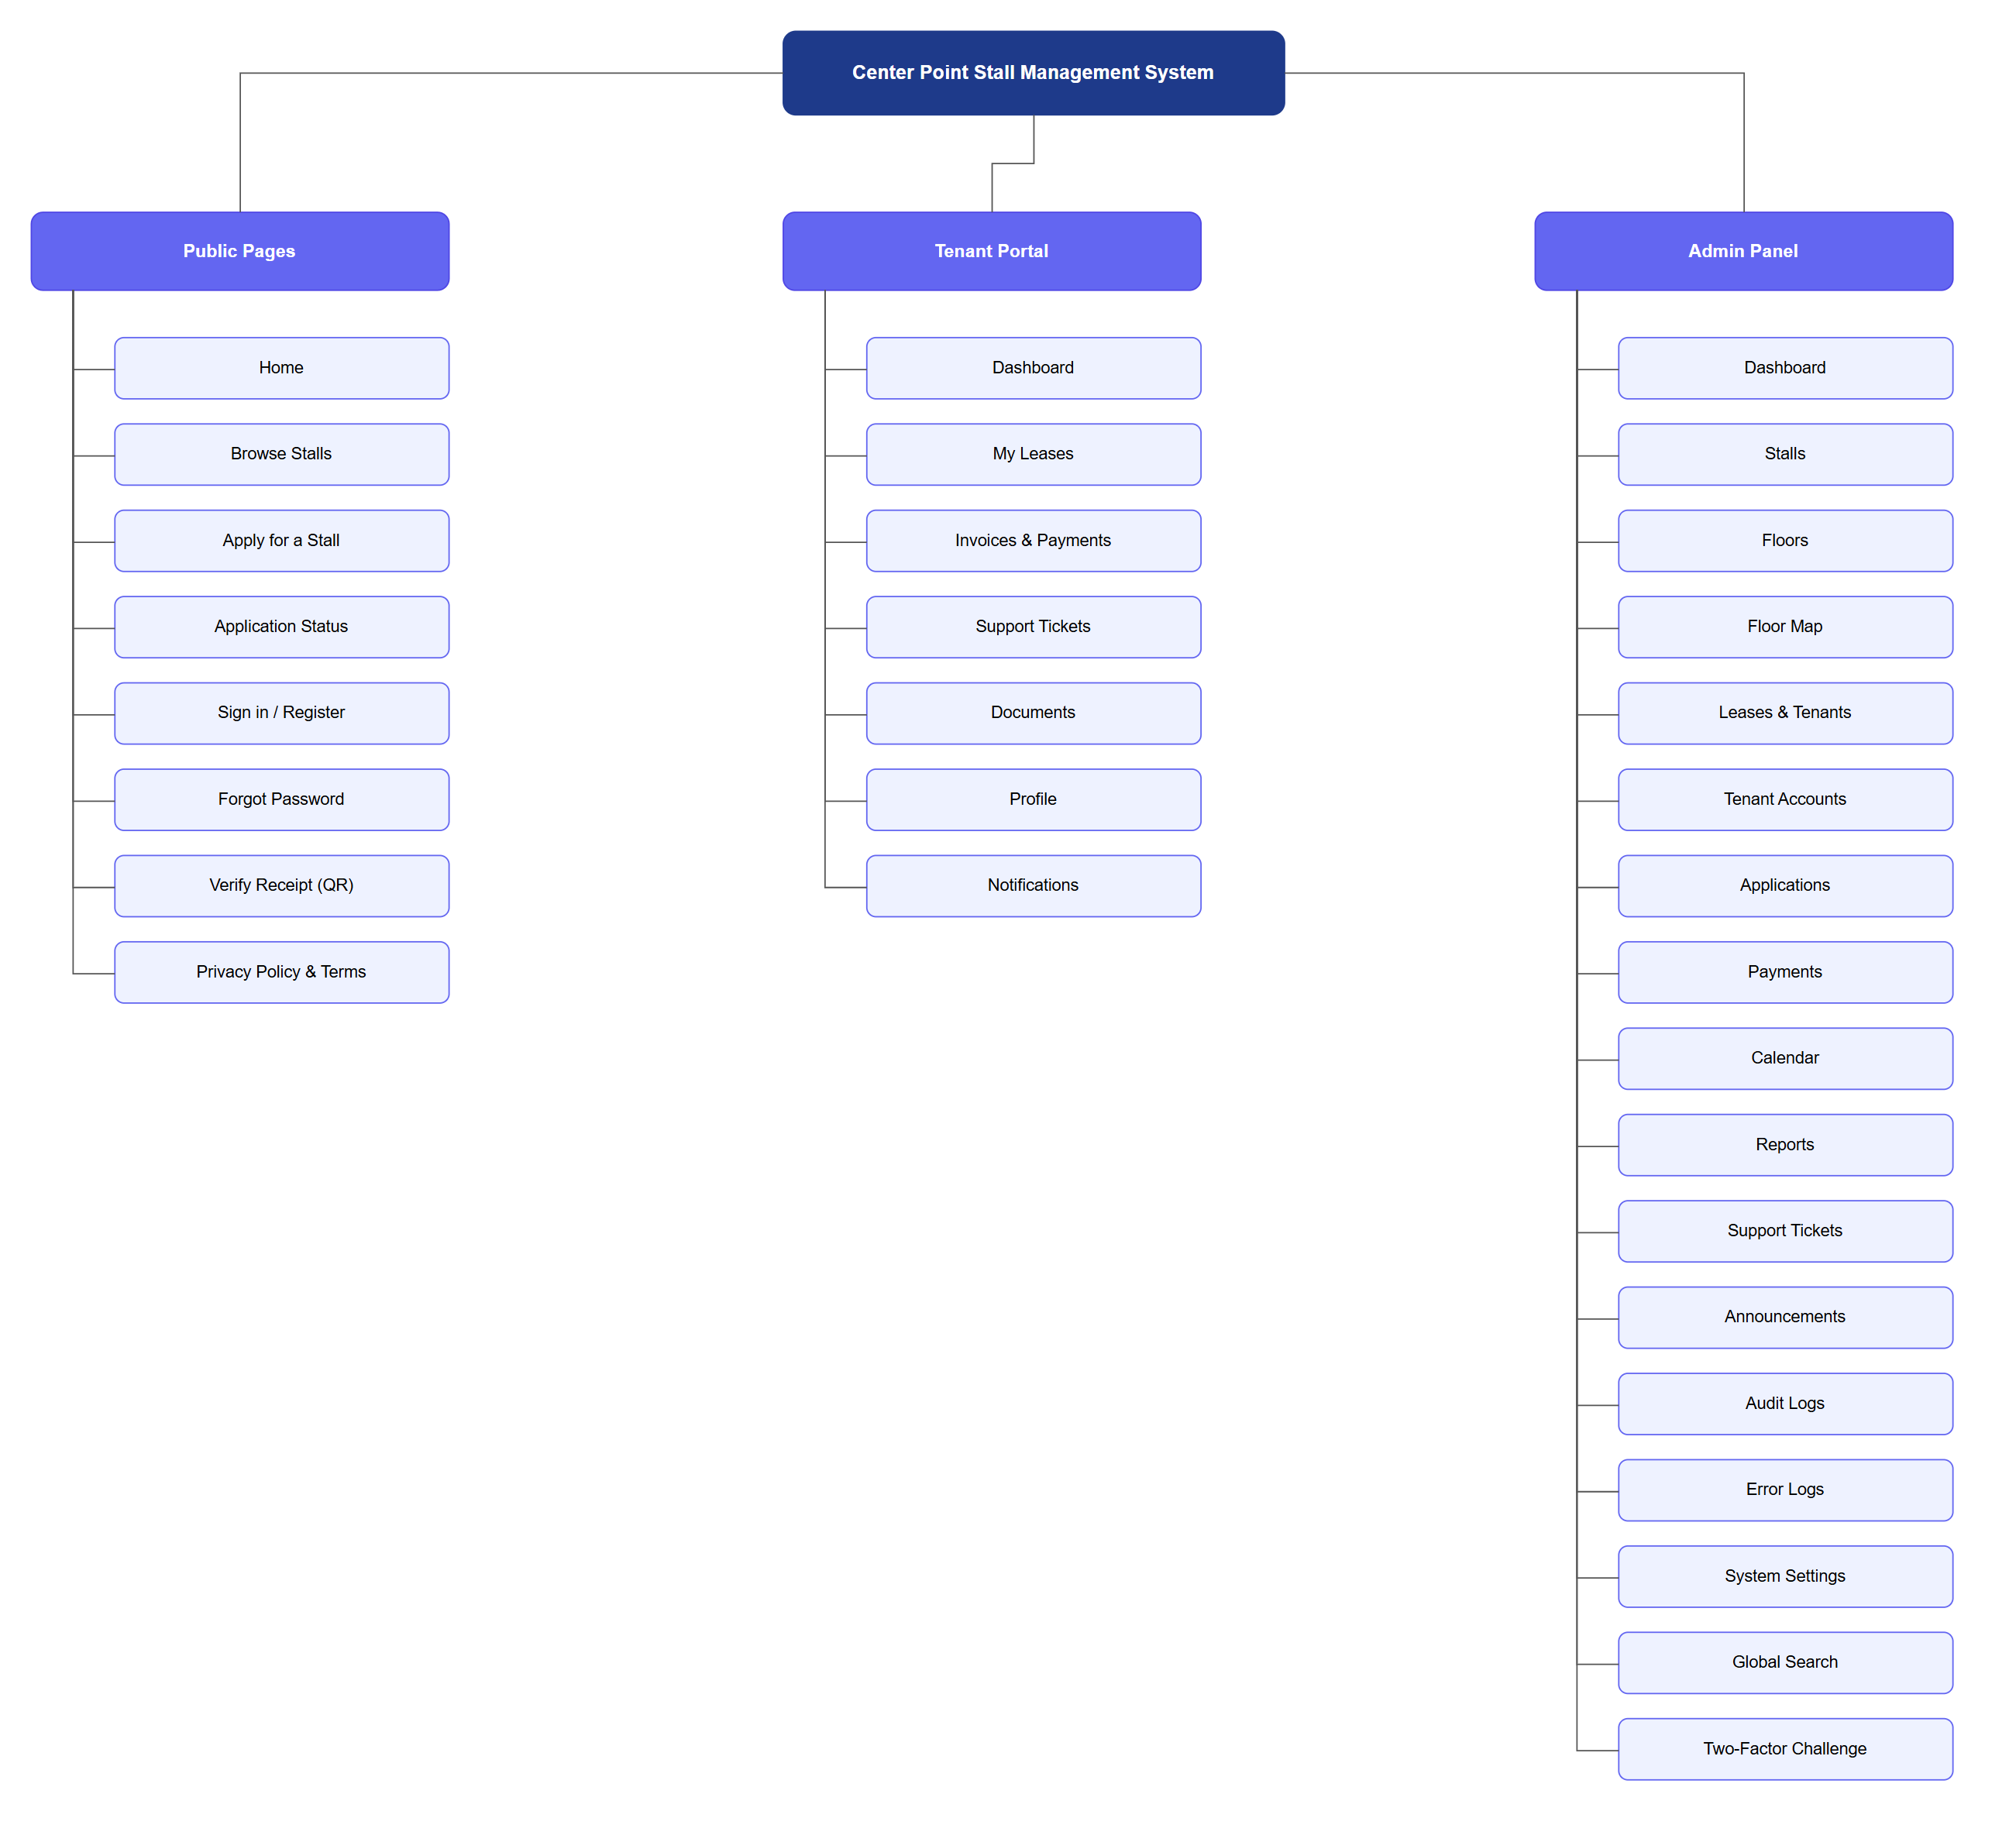
Figure 9. Content diagram (site map)
Entity Relationship Diagram
The entity relationship diagram shows the database tables, their columns, and how they relate to each other.
Figure 10. Entity relationship diagram
Conclusions
Based on the results of the development, testing, and implementation of the Web Based Stall Management System for Center Point, the following conclusions are drawn:
- The system successfully replaced the manual stall management processes at Center Point with a centralized, automated digital platform. The integration of a relational MySQL database with Laravel Eloquent ORM and enforced referential integrity eliminated the data inconsistencies and record duplication associated with the previous manual logbook approach.
- The interactive Livewire-powered floor plan grid editor provided administrators with an intuitive and efficient tool for configuring and updating stall layouts per floor level, significantly reducing the time required to manage physical stall assignments and visualize floor occupancy.
- The automated monthly invoicing system, driven by a scheduled Laravel Artisan command, reliably generated rental invoices for all active leases without duplication and dispatched multi-stage payment reminders through Mailjet email and Semaphore SMS. This automation reduced the administrative workload associated with manual invoice preparation and follow-up, and improved payment compliance among tenants.
- The lease expiry automated notification system, powered by a dedicated daily Artisan command, proactively informed tenants by email, SMS, and in-app notification, and administrators in-app, of approaching lease contract expiration dates at 60 and 30 days in advance. This eliminated the risk of unmanaged contract expirations and gave tenants sufficient notice to submit renewal requests.
- The integration of the PayMongo payment gateway with support for GCash, Maya, credit cards, and debit cards provided tenants with a convenient, secure, and flexible online payment experience. The asynchronous webhook verification mechanism ensured accurate and prompt invoice status updates without requiring manual payment confirmation by administrators.
- The PDF receipt generation module using Dompdf produced professional-quality official receipts featuring embedded QR codes for online authenticity verification, replacing the need for handwritten receipts and providing tenants with a verifiable and portable record of their payments.
- The tenant document repository provided tenants with secure, on-demand, self-service access to all their personal documents including lease contracts, payment receipts, and billing statements through IDOR-protected download endpoints. This significantly reduced document-related inquiries to the administration and improved tenant autonomy.
- The public stall reservation portal provided prospective tenants with a formal, accessible, and convenient online channel for submitting rental applications without requiring an in-person office visit. The stall application management interface enabled administrators to systematically review and process applications, replacing informal and unstructured inquiry handling.
- The advanced financial reporting and analytics module, featuring interactive Chart.js revenue and occupancy charts, an overdue payment aging table, and exportable CSV and PDF summaries, provided management with a comprehensive financial oversight tool that was entirely absent from the previous manual system. This supports evidence-based operational and strategic decision-making.
- The optional Two-Factor Authentication mechanism for administrator accounts, implemented via SMS OTP dispatched through the Semaphore gateway, significantly strengthened the security posture of the system by adding a verifiable second authentication layer to protect sensitive financial data, tenant records, and administrative functions.
- The tenant self-service portal, combined with the document repository and in-app notification center, provided transparent, real-time, on-demand access to all relevant tenant information, significantly reducing repetitive inquiries to the administration and improving overall tenant satisfaction.
- The support ticket and live chat module replaced informal communication channels with a documented, threaded helpdesk system. All tenant concerns, maintenance requests, and inquiries were formally recorded, tracked, and resolved within the platform.
- The audit log system maintained a complete, append-only record of all significant administrative actions, supporting internal accountability, security monitoring, and operational review.
- The automated PHPUnit test suite confirmed that all critical system functions — including authentication, social login, Two-Factor Authentication, lease expiry notifications, invoice generation, PayMongo webhook processing, document repository access control, stall reservation submission, and ticket management — operated correctly and securely under both normal and adversarial conditions.
- The role-based access control (Administrator, Tenant, and visitors who are not signed in) enforced through middleware effectively restricted access to system features based on user responsibilities, preventing unauthorized actions and maintaining system security.
- The announcements, application status lookup, stall waitlist, and tenant account management closed the remaining communication gaps between the office, tenants, and applicants.
- Statements of account, the administrative calendar, and the global search gave both tenants and administrators faster, clearer access to balances, dates, and records.
- Encrypted daily backups and the security measures — Content-Security-Policy, rate limiting, a strong password policy, security event logging, and safe upload handling — protect the system’s data against loss and common web attacks.
Overall, the Web Based Stall Management System for Center Point successfully achieved all of its stated general and specific objectives. The system demonstrated that a well-designed, comprehensive, and integrated web application built on a modern PHP framework can effectively address a broad range of operational, financial, security, and communication challenges in a local commercial stall management environment, improving efficiency, accuracy, transparency, security, and service quality across all stakeholder groups.

Recommendations
Based on the findings, conclusions, and limitations of the study, the researchers offer the following recommendations for future development and enhancement of the Web Based Stall Management System for Center Point:
- Mobile Application Development — It is recommended that a dedicated mobile application for Android and iOS platforms be developed as a future enhancement. A native mobile app would provide tenants with push notification support for billing reminders, payment confirmations, lease expiry alerts, and ticket replies, further improving accessibility and user engagement beyond the current web-based interface.
- Multi-Branch or Multi-Location Scalability — The system architecture should be evaluated and enhanced to support multi-branch configurations, enabling the same platform to manage stall operations across multiple separate commercial locations or buildings under the same administration, with centralized reporting and management.
- Integration with Local Government Regulatory Systems — Future versions of the system could explore integration with local government units or business permit processing systems to automate the generation and tracking of business permit-related documents for tenant businesses operating within Center Point. This would further reduce the administrative burden on both management and tenants during annual business permit renewal periods.
- Comprehensive User Acceptance Testing with a Larger Sample — It is recommended that a formal user acceptance testing (UAT) study be conducted with a broader and more representative sample of actual administrators, tenants, and prospective tenants at Center Point. Quantitative evaluation using a validated usability instrument such as the System Usability Scale (SUS) would provide statistically significant evidence of the system's usability, effectiveness, and user satisfaction, contributing to the existing body of literature on digital stall management systems in the Philippine context.
- Off-site Backup Storage — Automatically copy the encrypted daily backups to cloud storage or another server so a copy survives a server failure.
- Livewire 4 Upgrade — Upgrading to Livewire 4 would allow the Content-Security-Policy to drop its remaining allowance for runtime-evaluated code.
- Tenant Two-Factor Authentication — Offer optional Two-Factor Authentication to tenants as well as administrators.
- Partial Payments and Electricity/Water Billing — If Center Point later requires them, support partial invoice payments and charges for electricity and water readings as separate modules.
TRANSMITTAL LETTER
[Date]
[Name of Recipient]
[Position], Center Point Commercial Complex
Pagadian City, Zamboanga del Sur
Dear [Sir / Ma’am]:
We are pleased to formally turn over the Web Based Stall Management System for Center Point, developed as our capstone project in partial fulfillment of the requirements for the degree Bachelor of Science in Information Technology at West Prime Horizon Institute, Inc.
The system includes the public stall portal, the tenant portal, and the administrator panel, together with this manuscript, the User GUI Guide, and the System User Guide Manual. We thank you for your cooperation throughout the study.
Respectfully yours,
[Signatures and names of the researchers]
Received by: ____________________ Date: ____________
PHOTO DOCUMENTATION
[Insert photos of the interviews, data gathering, system testing, and turnover at Center Point, each with a one-line caption.]
USER GUI GUIDE
The following screens show the main interfaces of the system using demonstration data.
1. Home Page Interface
The public landing page with live stall counts, the floor directory, and links to browse stalls, sign in, register, and check an application.
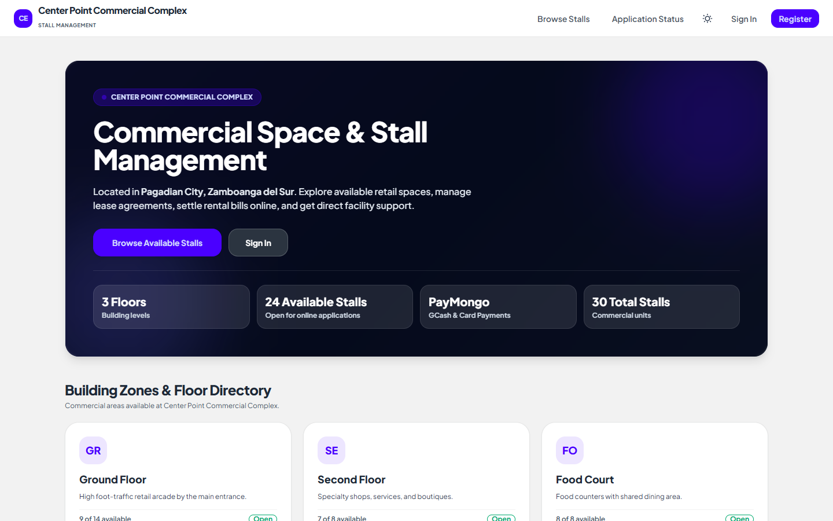
Figure 11. Home Page interface
2. Browse Stalls Interface
Visitors pick a floor and see every stall on the floor map, coloured by status.
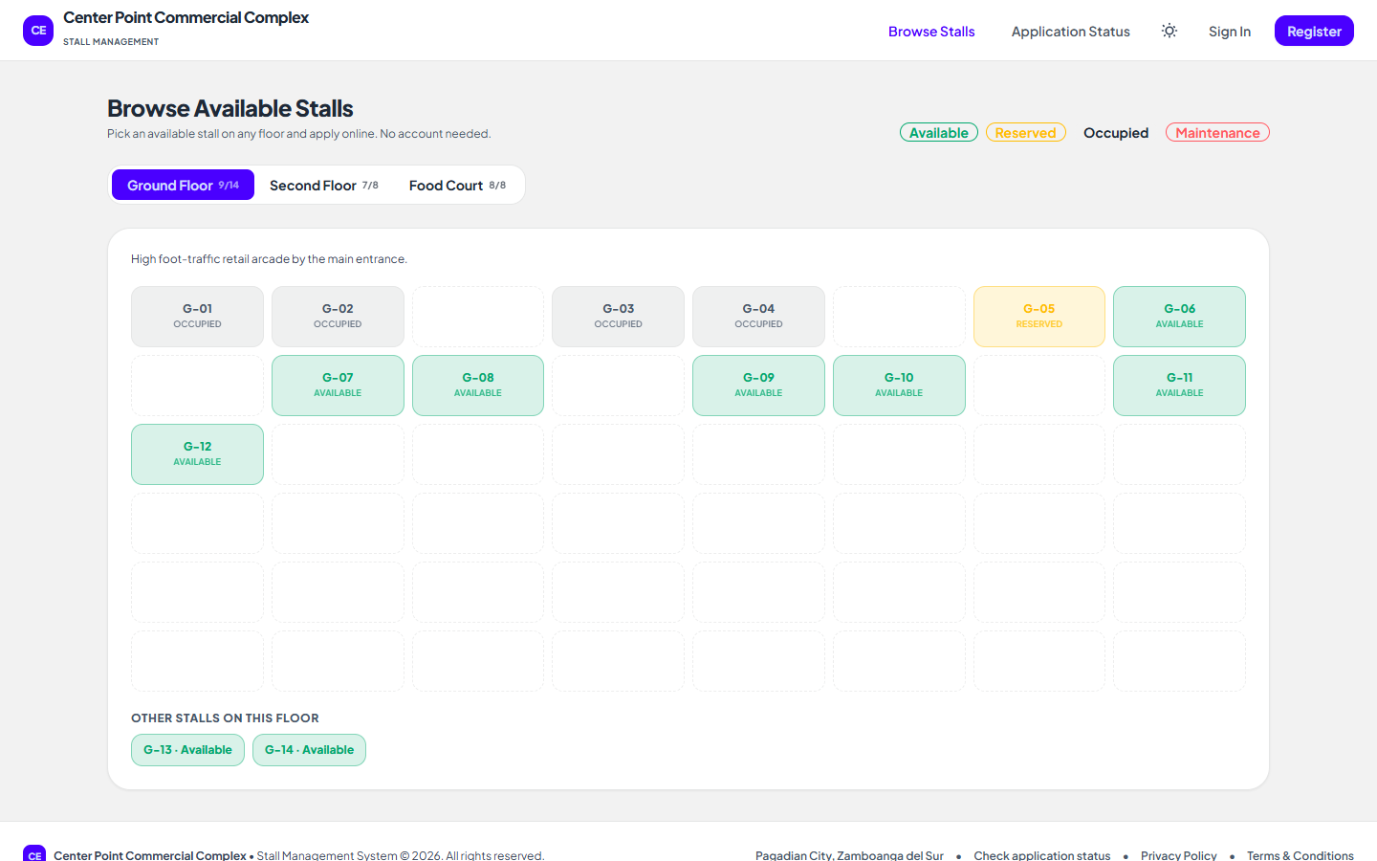
Figure 12. Browse Stalls interface
3. Stall Application Form Interface
Selecting an available stall shows its details and the online application form.
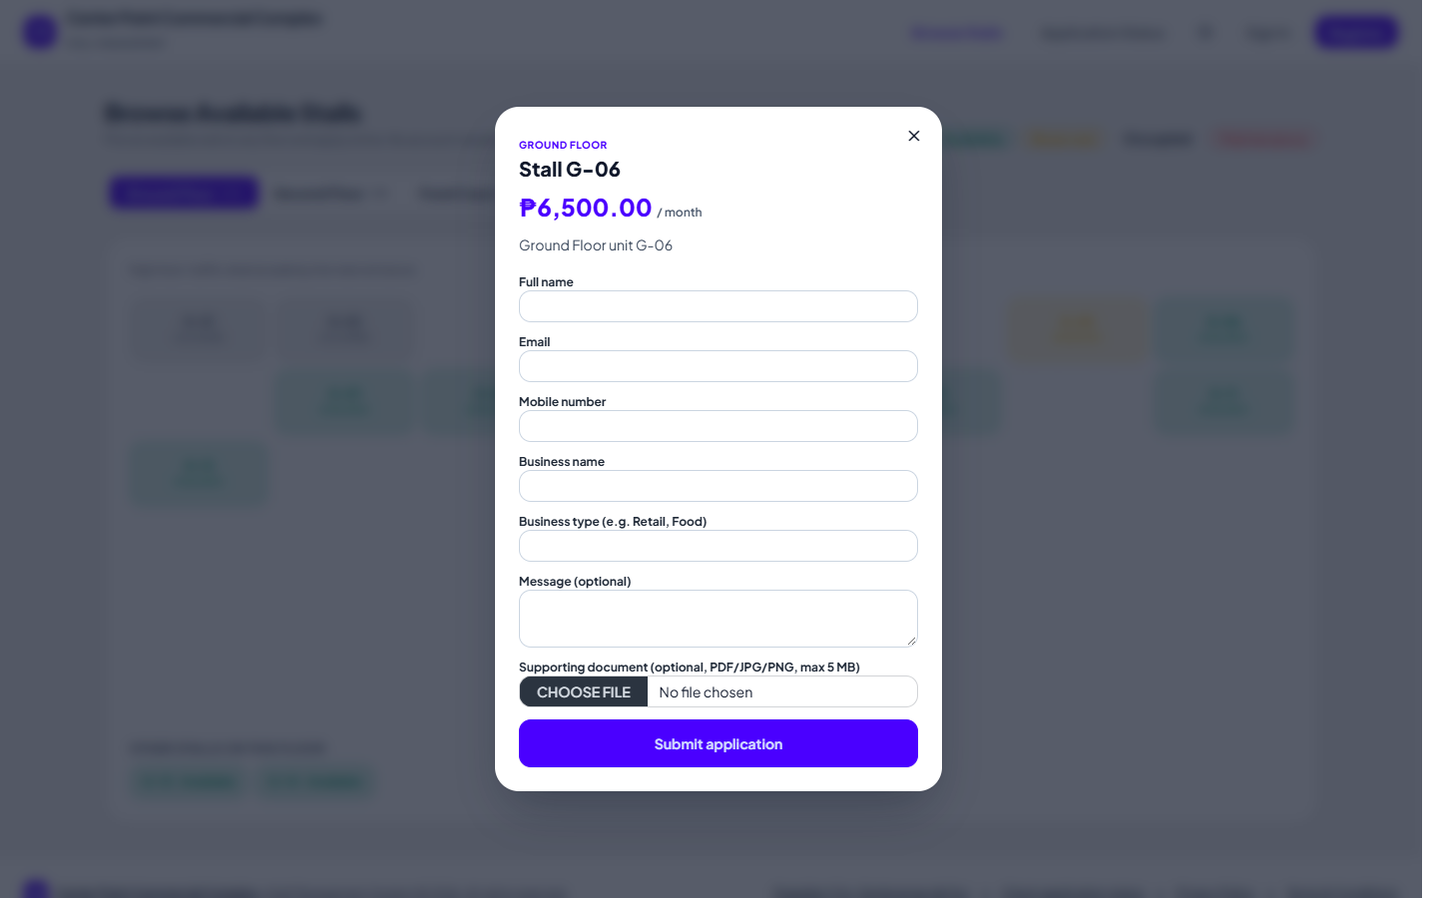
Figure 13. Stall Application Form interface
4. Application Status Interface
Applicants enter their reference number and email to see the status of their application.
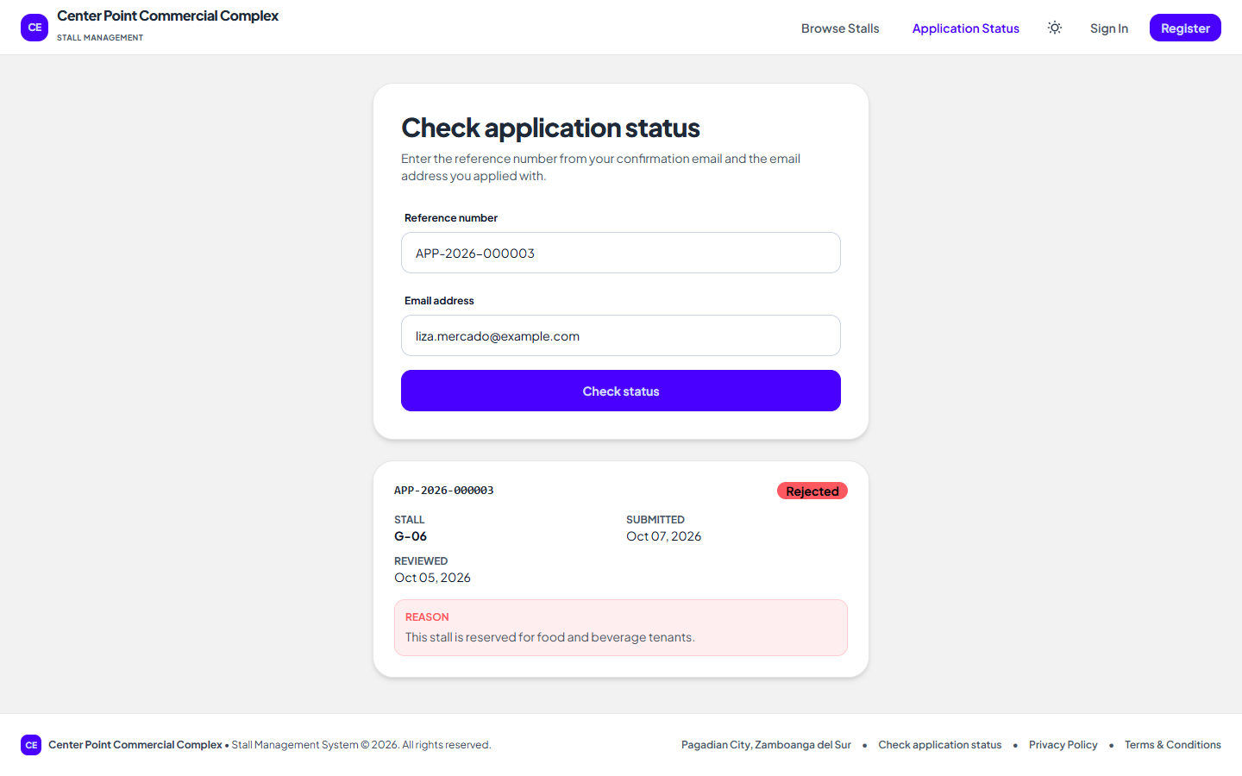
Figure 14. Application Status interface
5. Sign In Interface
Sign in with email and password, or with Google or Facebook.
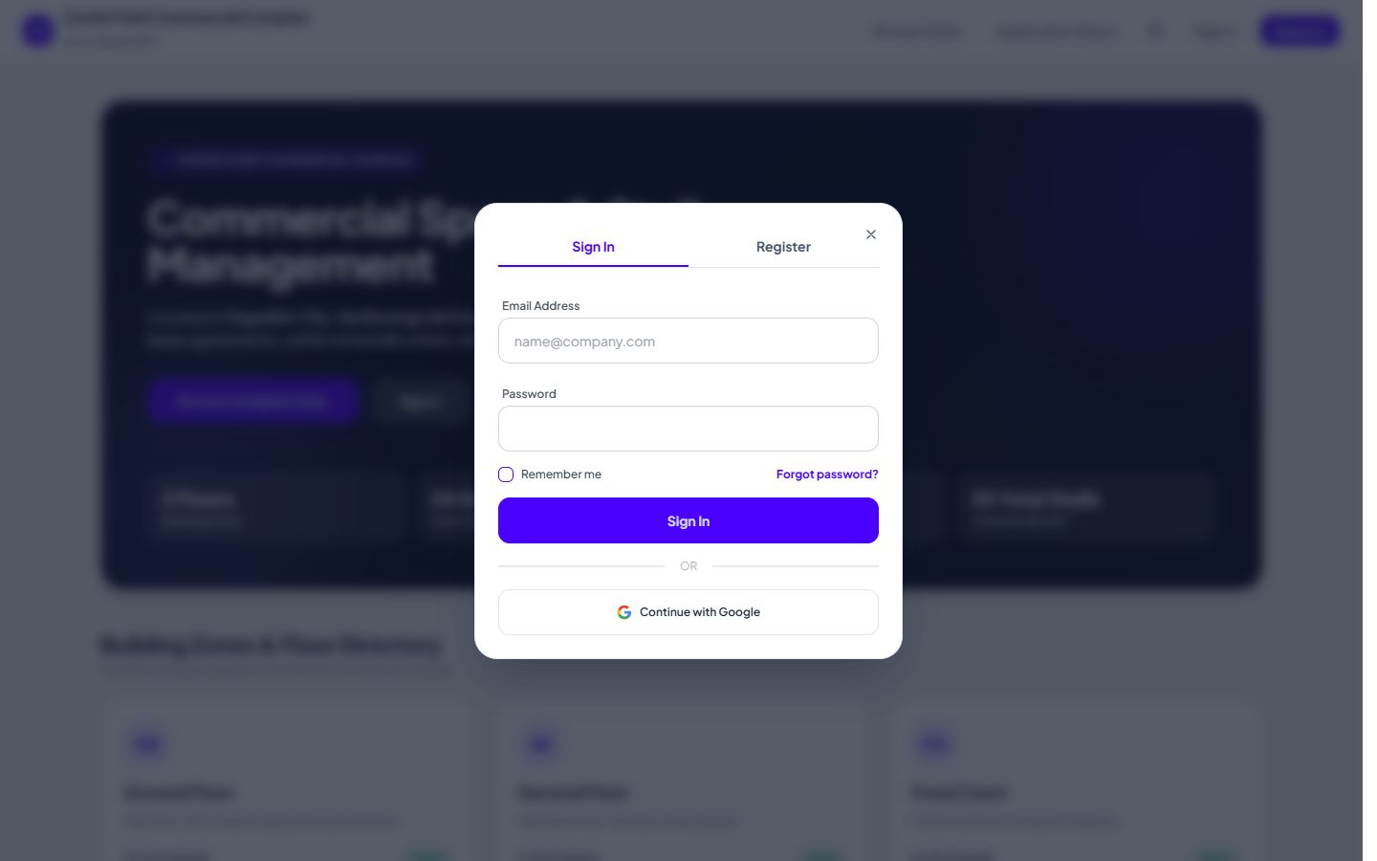
Figure 15. Sign In interface
6. Register Interface
New users create a tenant account; passwords need 8 or more characters with letters and numbers.
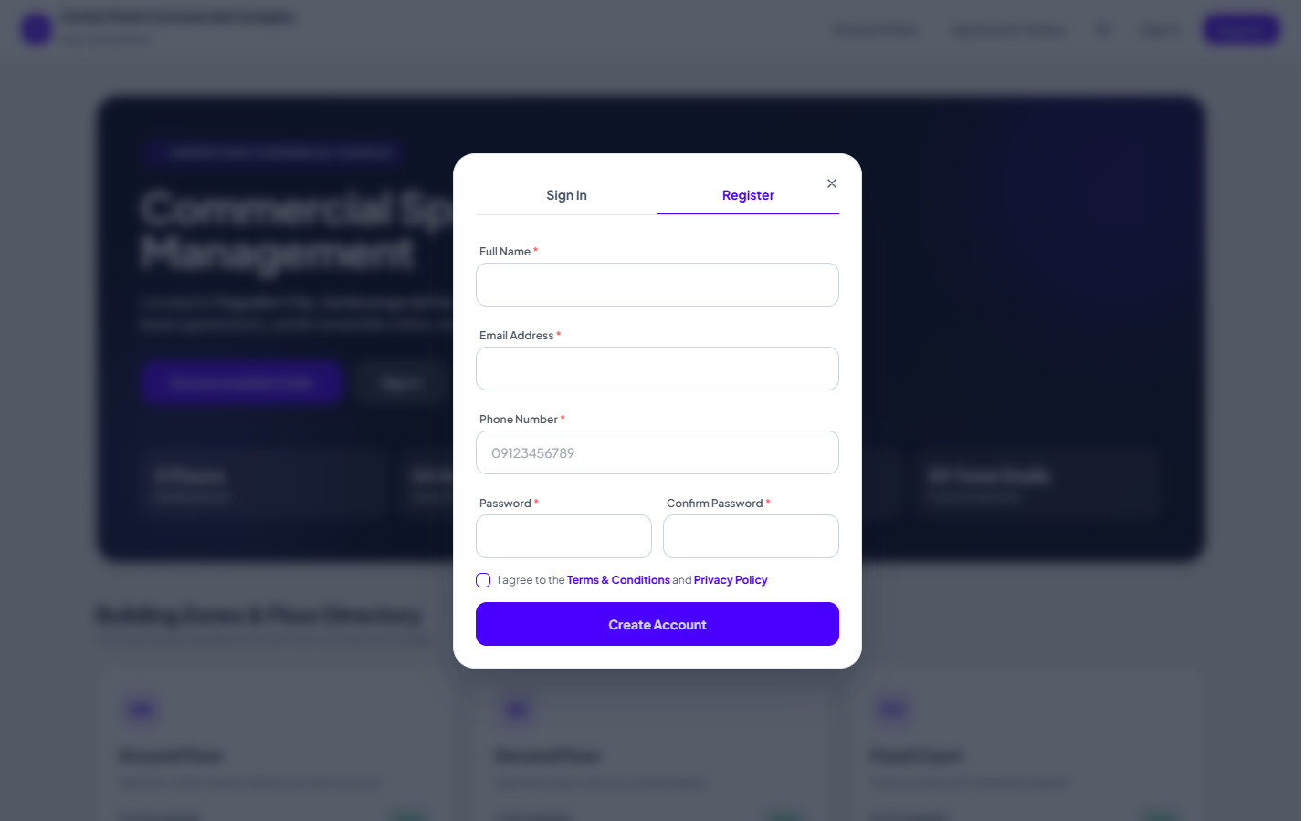
Figure 16. Register interface
7. Forgot Password Interface
Request a 6-digit reset code by email and SMS.
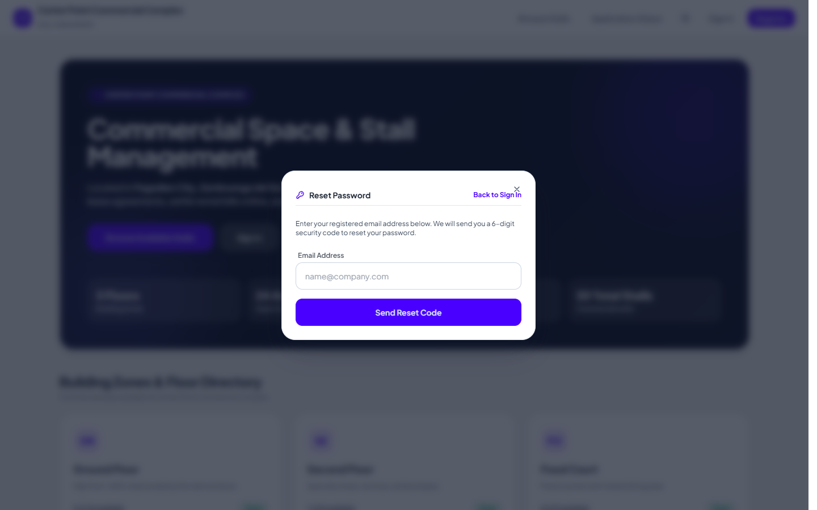
Figure 17. Forgot Password interface
8. Administrator Dashboard Interface
Items that need attention, key figures, the revenue trend, payment channels, and floor occupancy.
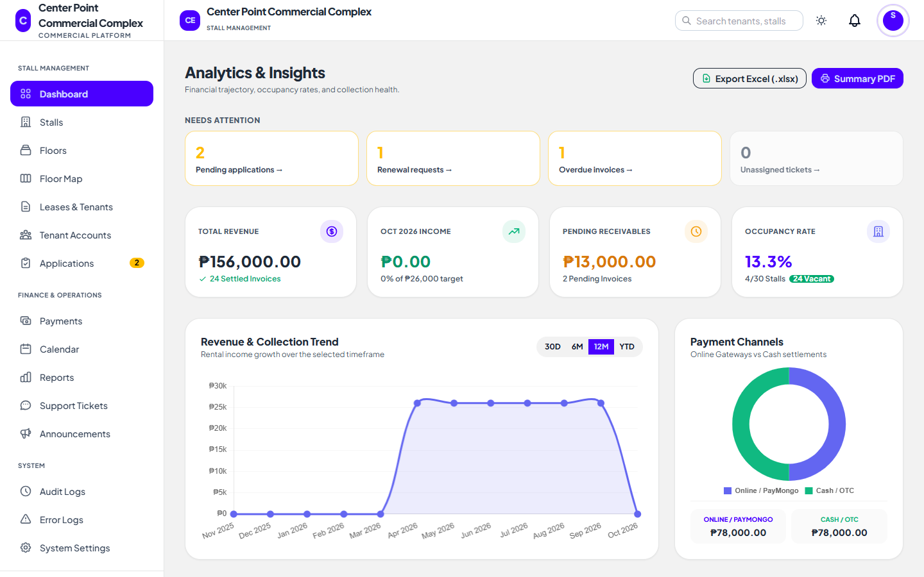
Figure 18. Administrator Dashboard interface
9. Stall Applications Interface
Review applications from the public portal and approve or reject them.
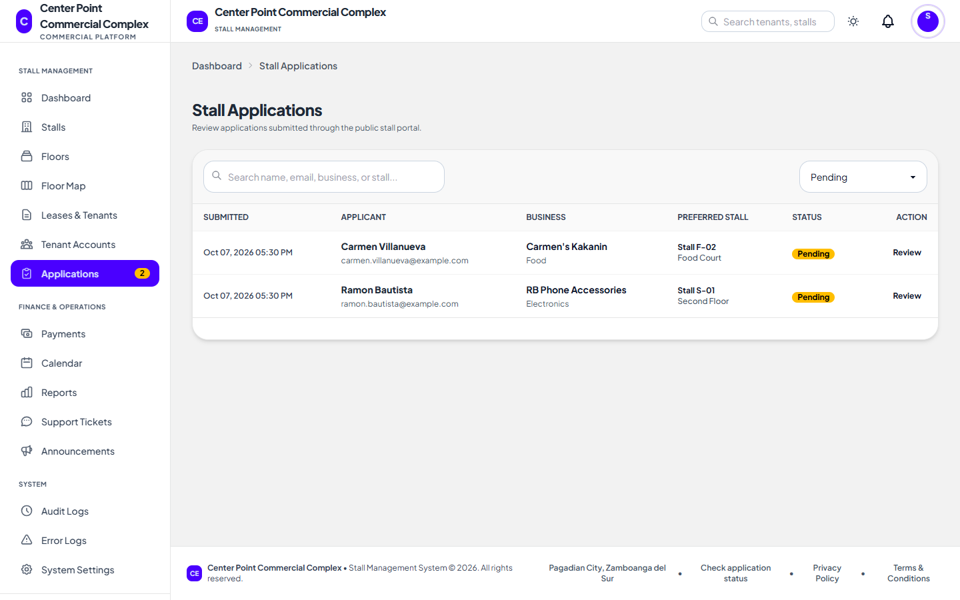
Figure 19. Stall Applications interface
10. Stalls Interface
Add, edit, and delete stalls; a waitlist badge shows visitors waiting for a stall.
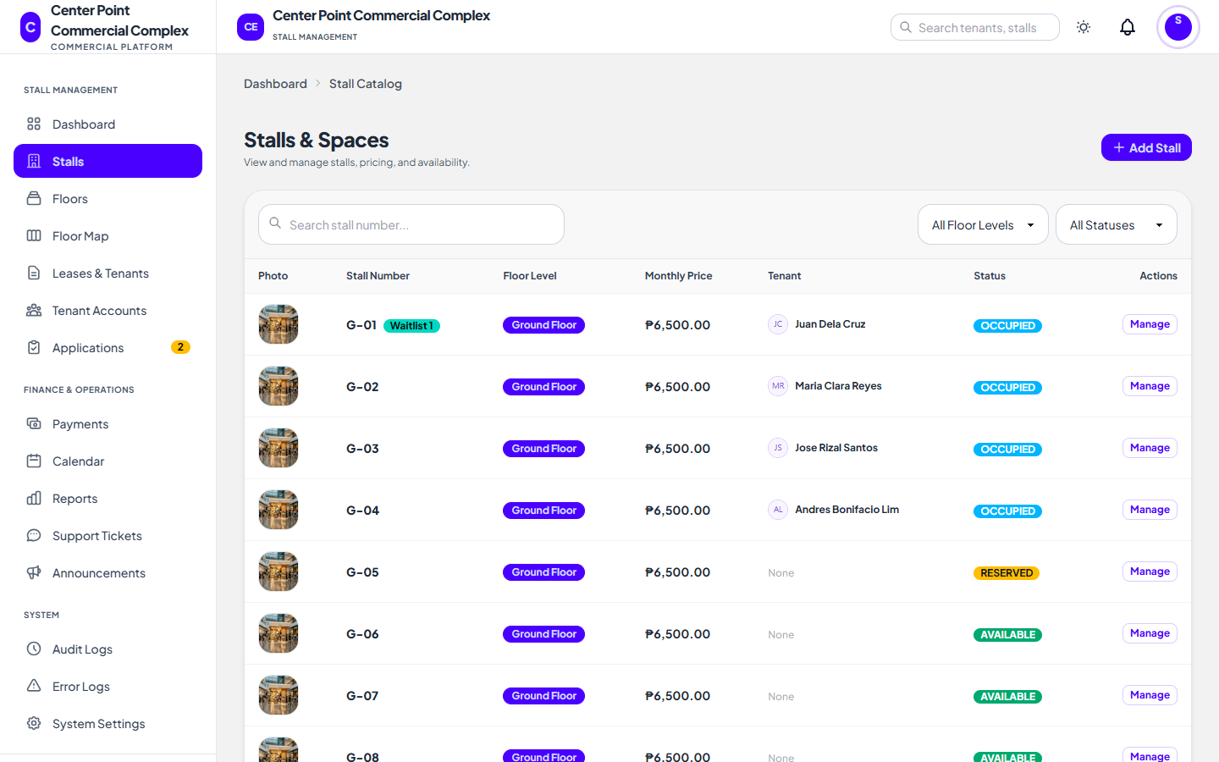
Figure 20. Stalls interface
11. Floors Interface
Manage floor levels and their grid sizes.
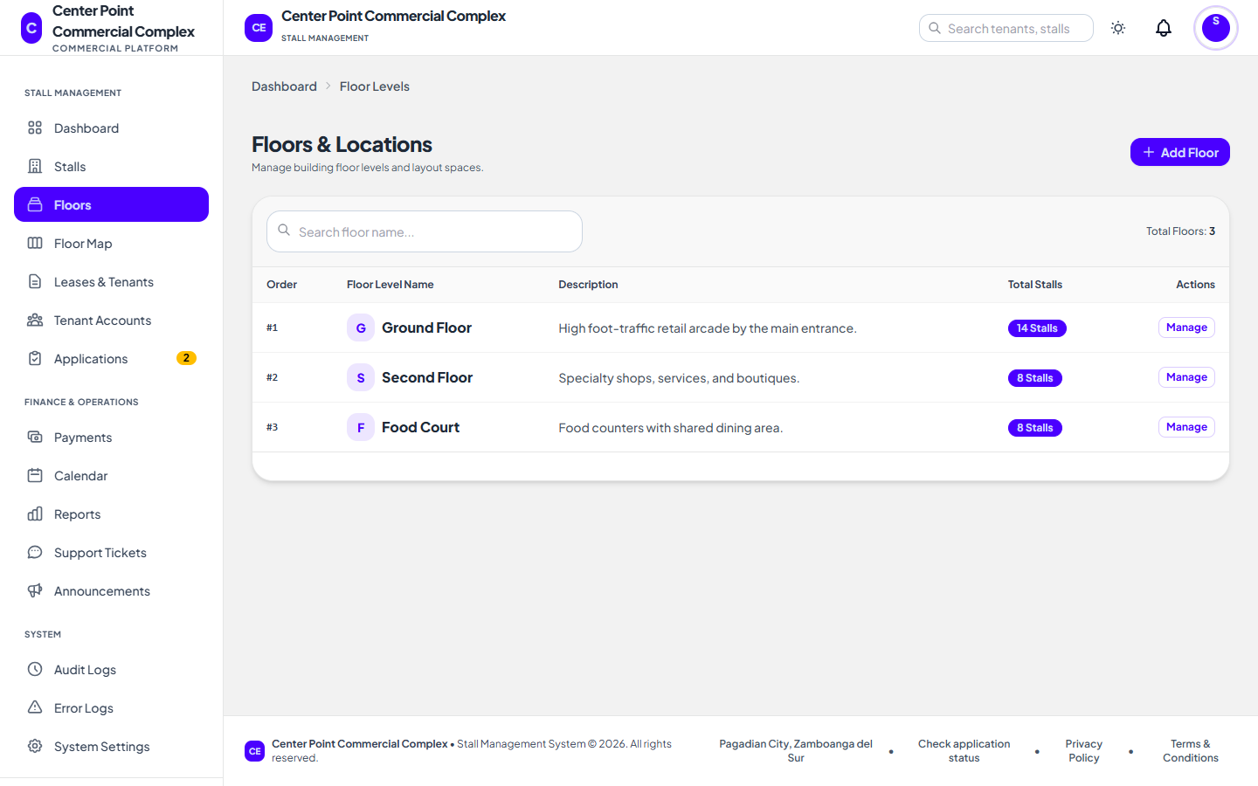
Figure 21. Floors interface
12. Floor Map Interface
Drag stalls onto the floor grid to match the building layout.
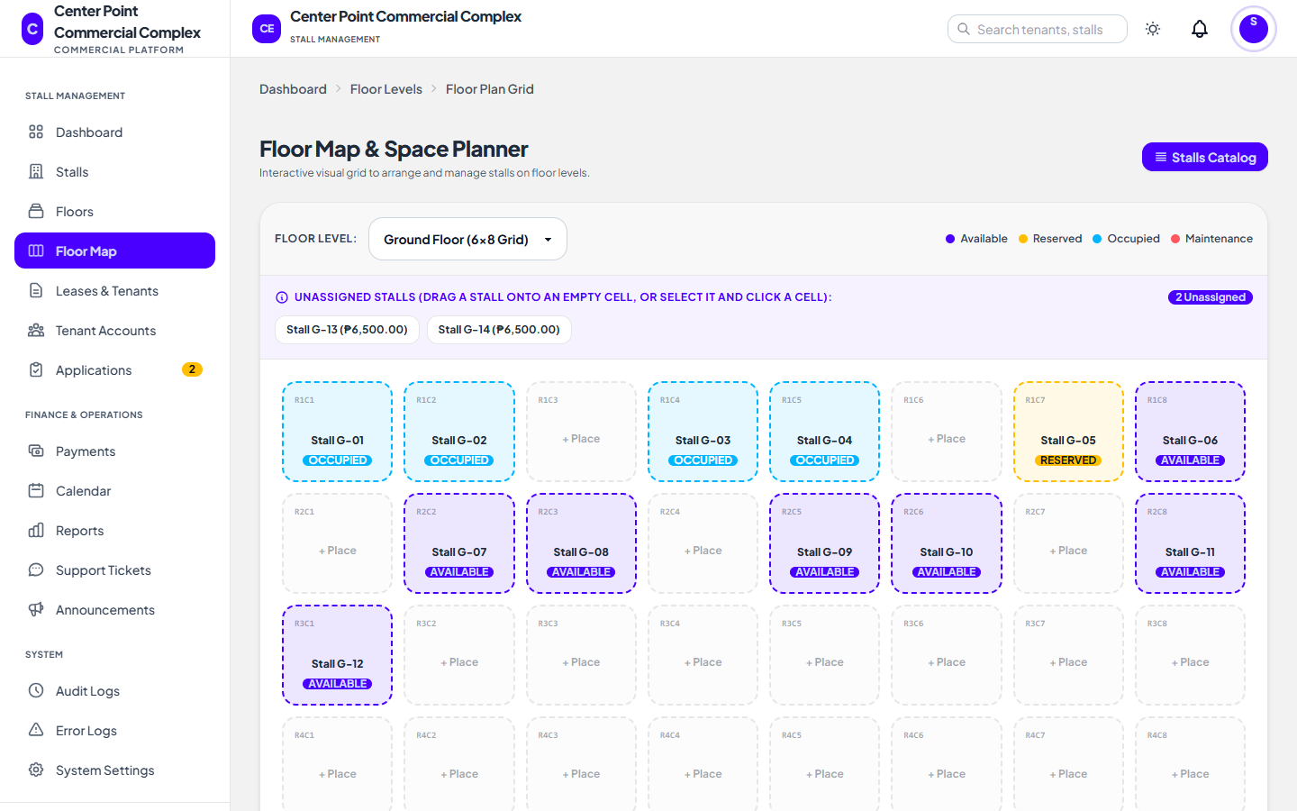
Figure 22. Floor Map interface
13. Leases and Tenants Interface
Every lease with its period and status; create leases and review renewal requests.
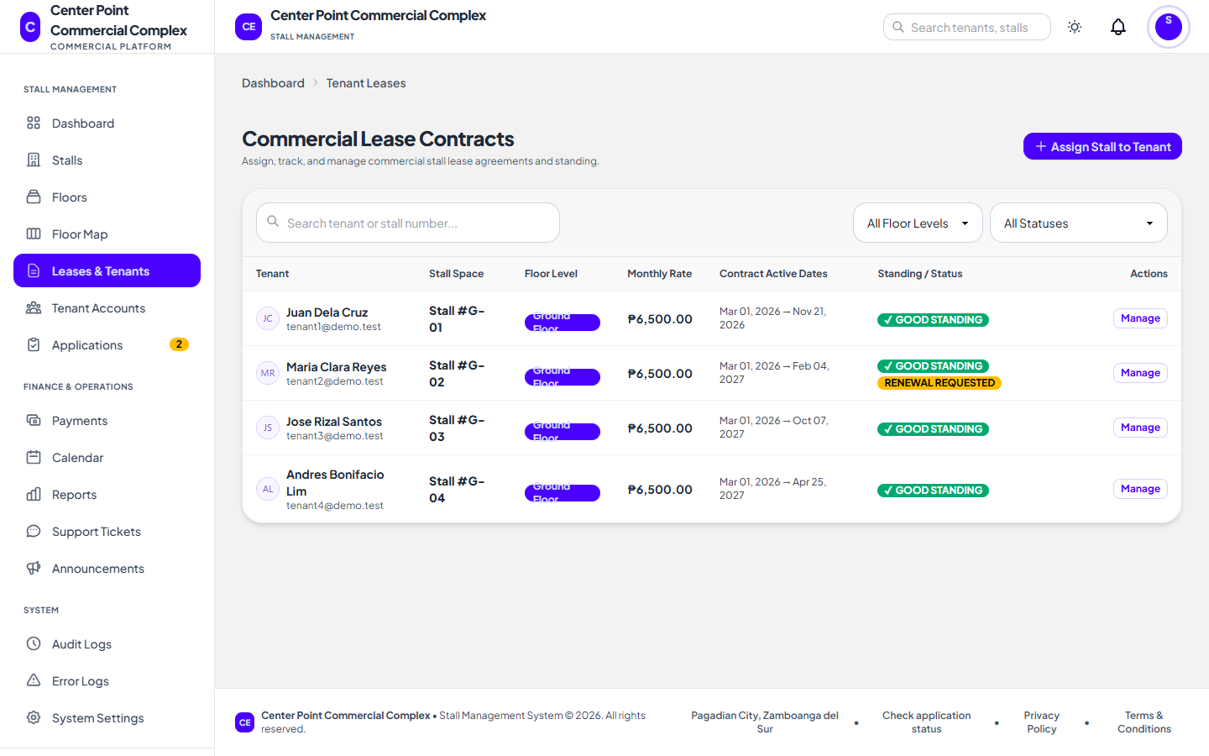
Figure 23. Leases and Tenants interface
14. Terminate Lease Interface
Terminating a lease requires a reason and shows any unpaid balance.
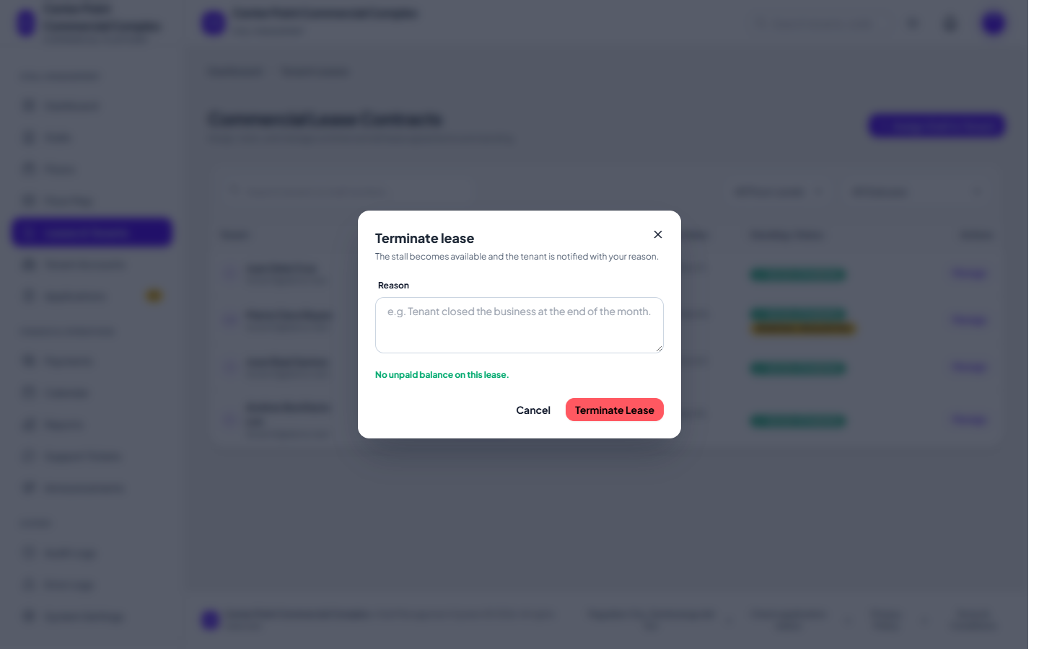
Figure 24. Terminate Lease interface
15. Tenant Accounts Interface
Tenants with their active leases, unpaid balances, and account status.
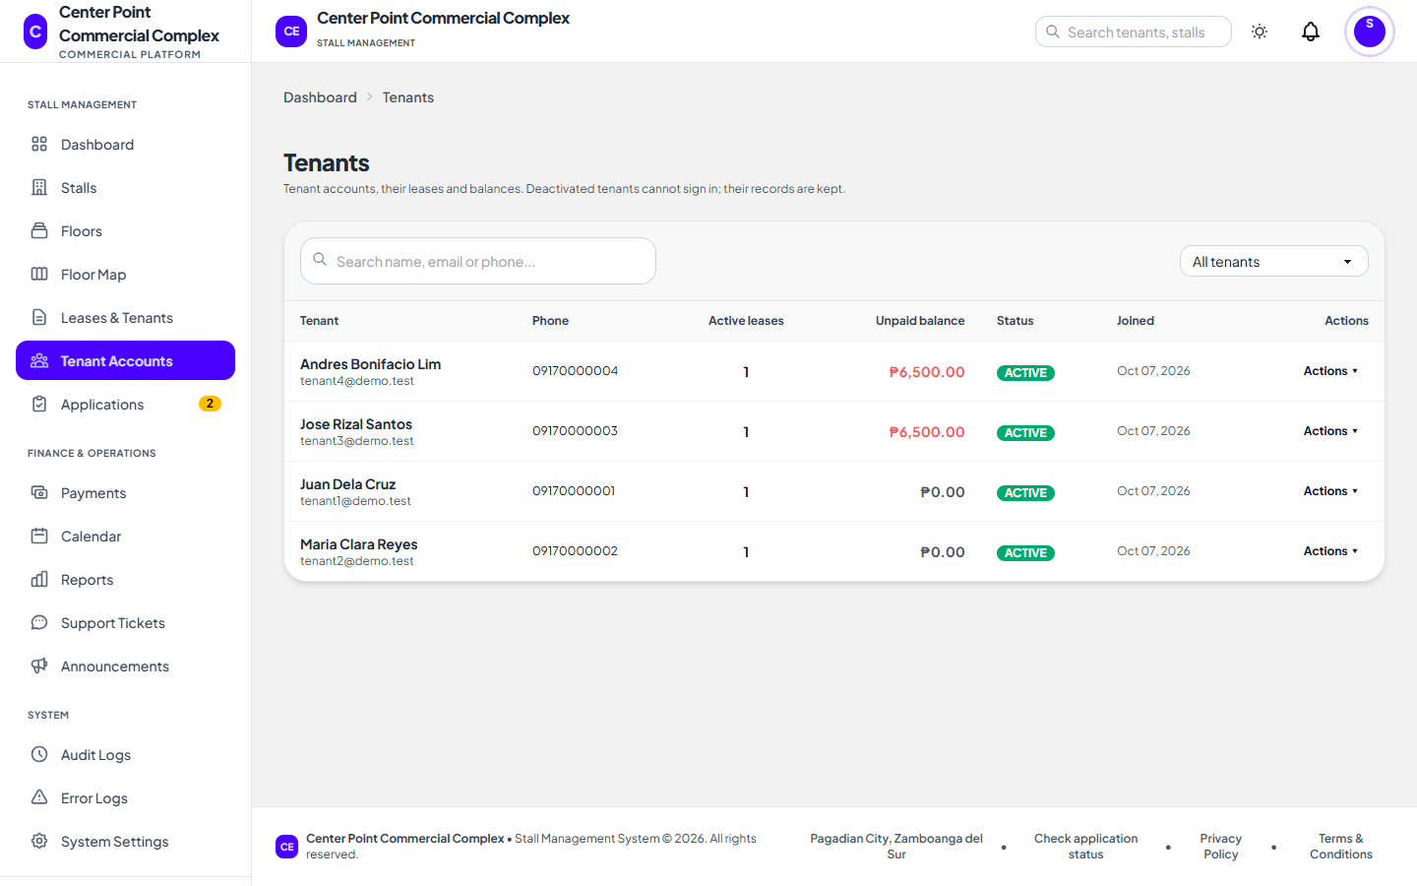
Figure 25. Tenant Accounts interface
16. Statement of Account Interface
Every charge and payment of a tenant with a running balance, downloadable as a PDF.
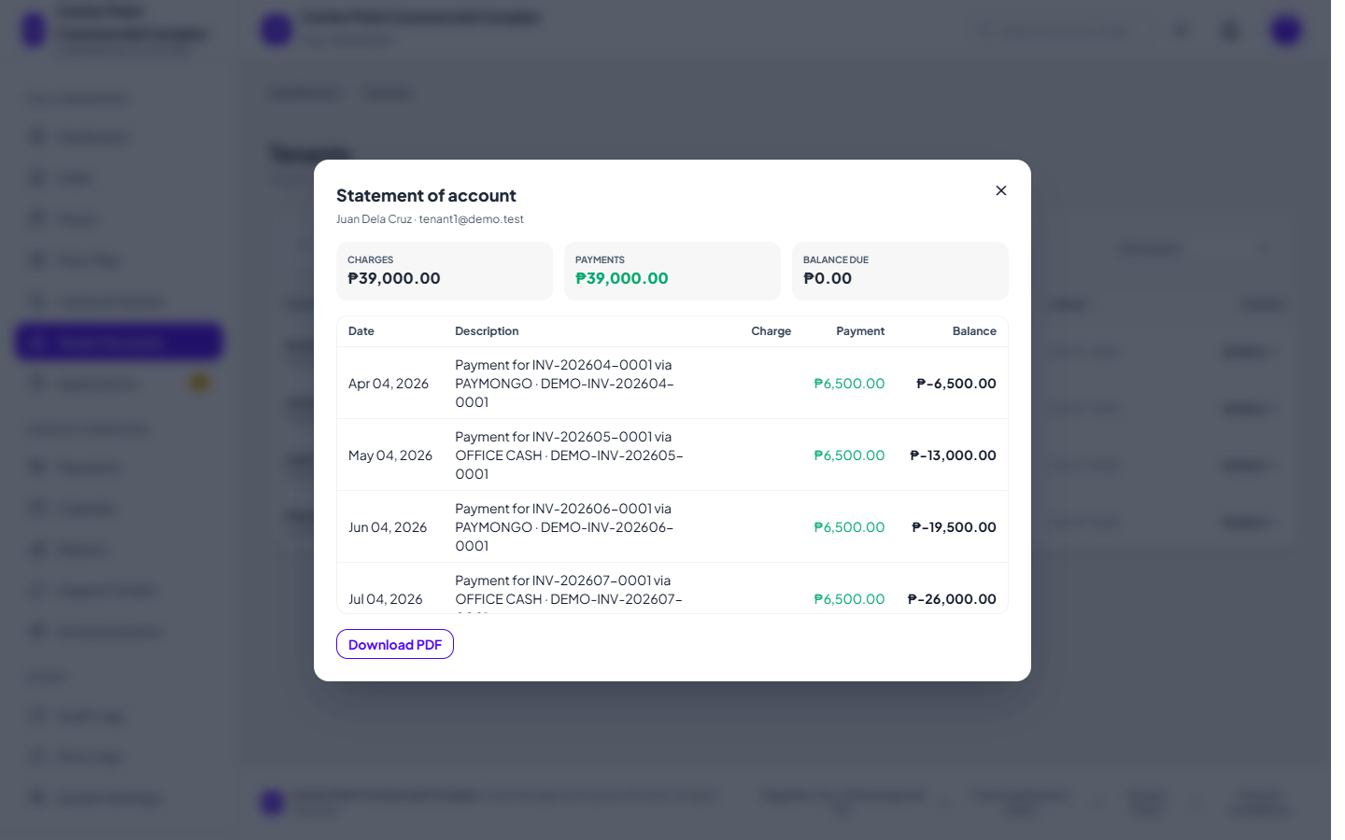
Figure 26. Statement of Account interface
17. Payments Interface
All invoices with their status; record office payments and export to Excel.
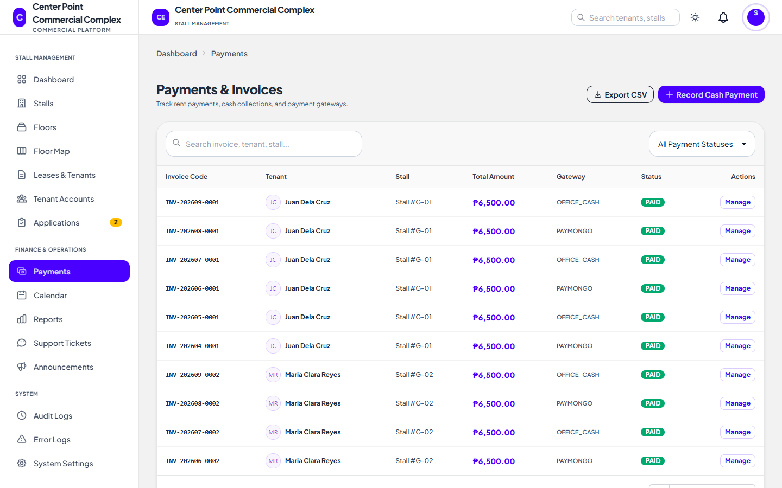
Figure 27. Payments interface
18. Calendar Interface
Lease end dates, invoice due dates, and renewal requests by month.
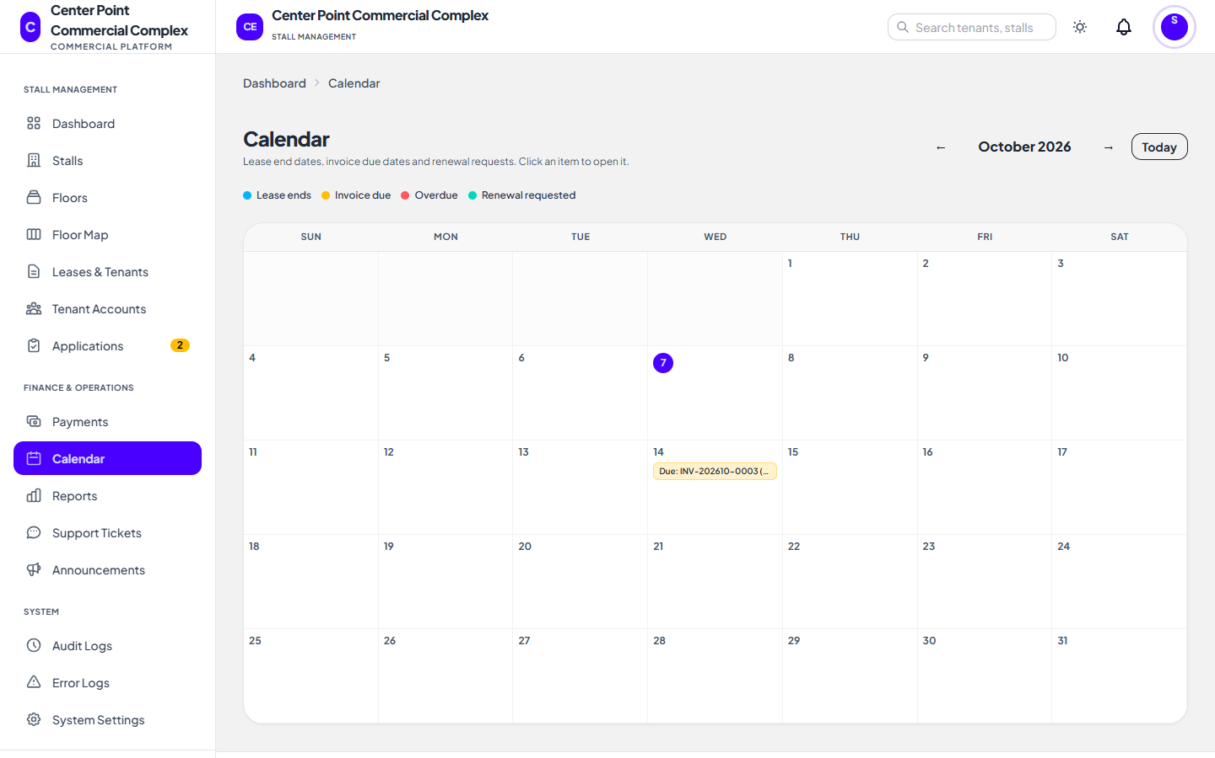
Figure 28. Calendar interface
19. Announcements Interface
Post notices to all tenants or one floor, optionally by email.
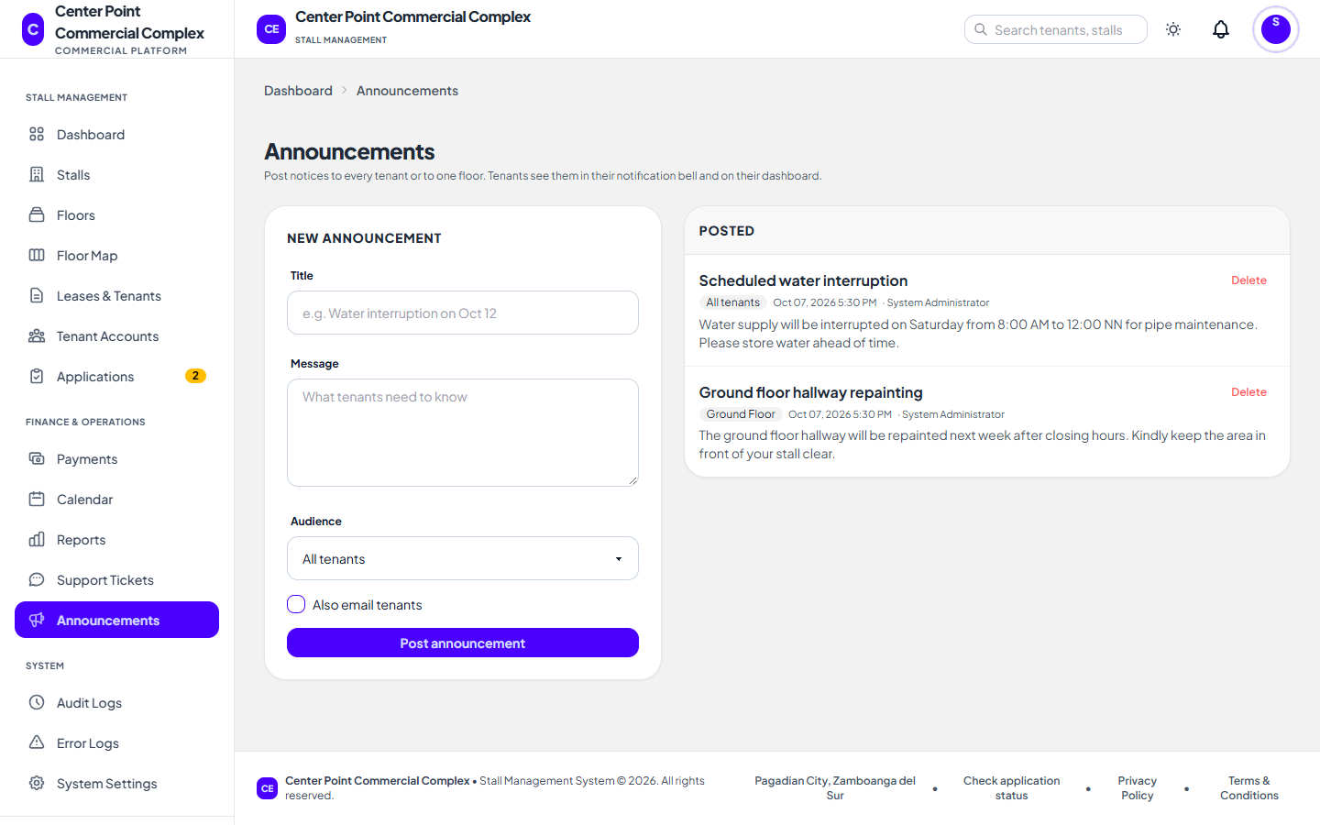
Figure 29. Announcements interface
20. Support Tickets (Administrator) Interface
Reply to tenant concerns in a chat window, claim and close tickets.
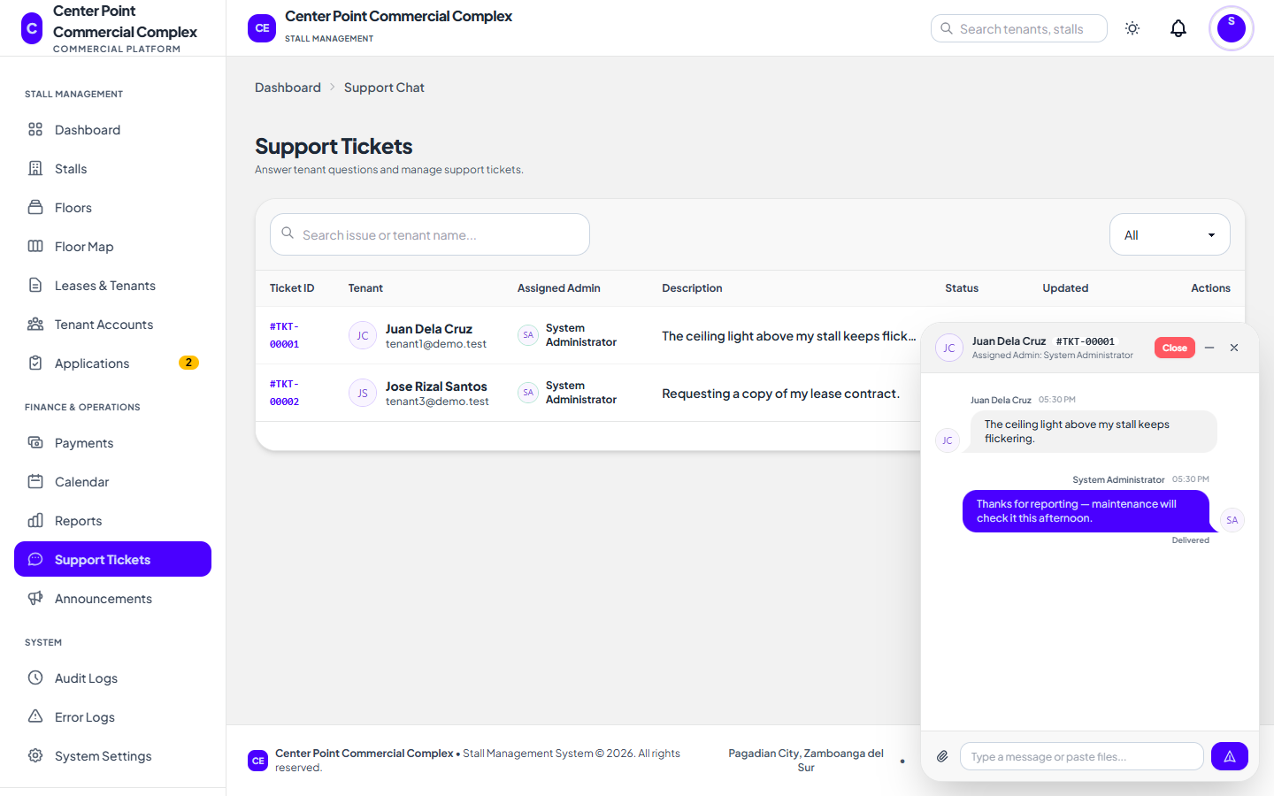
Figure 30. Support Tickets (Administrator) interface
21. Financial Reports Interface
Revenue trend, occupancy, and overdue aging, exportable to CSV and PDF.
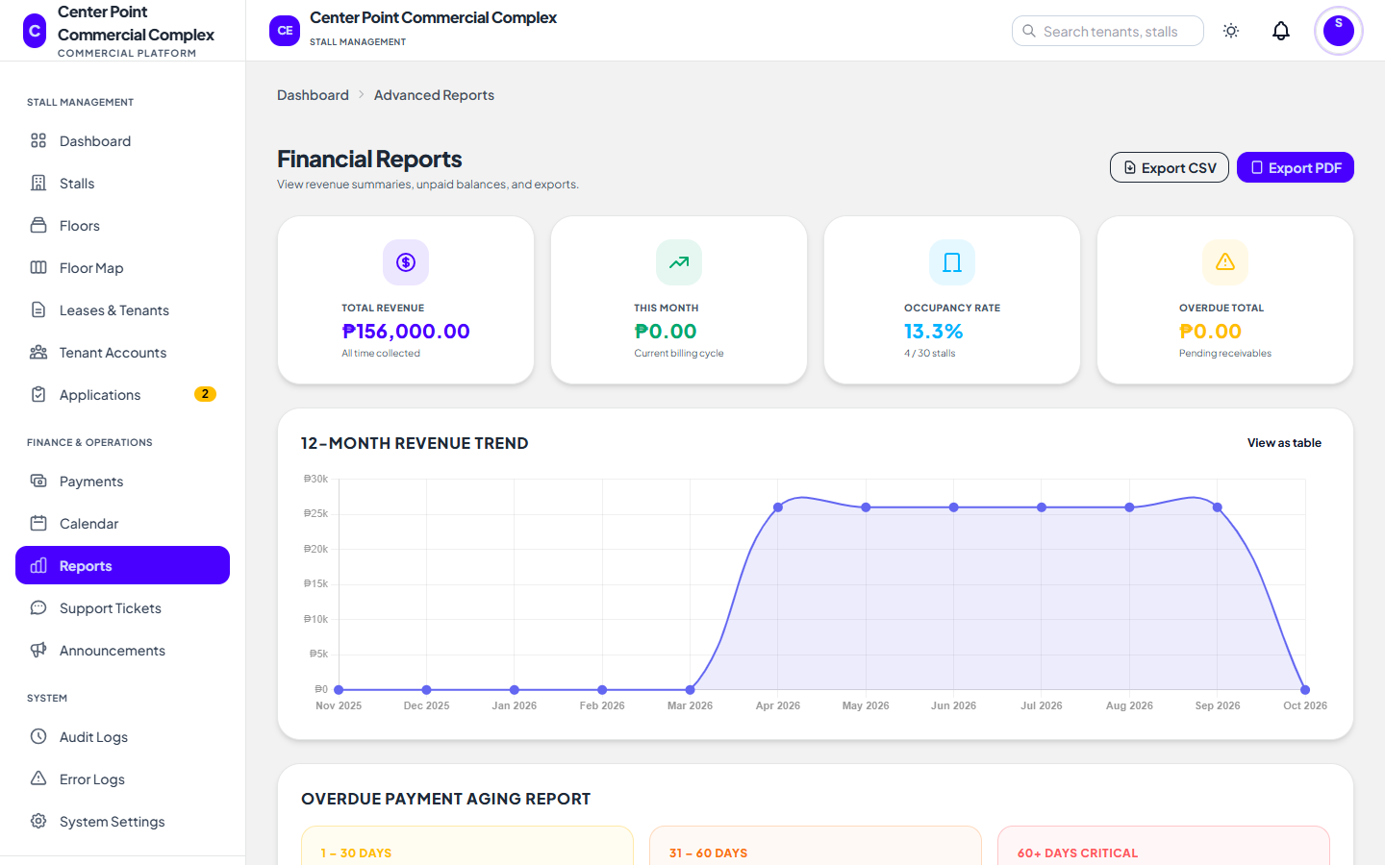
Figure 31. Financial Reports interface
22. Audit Logs Interface
Every recorded action, including sign-ins and security events.
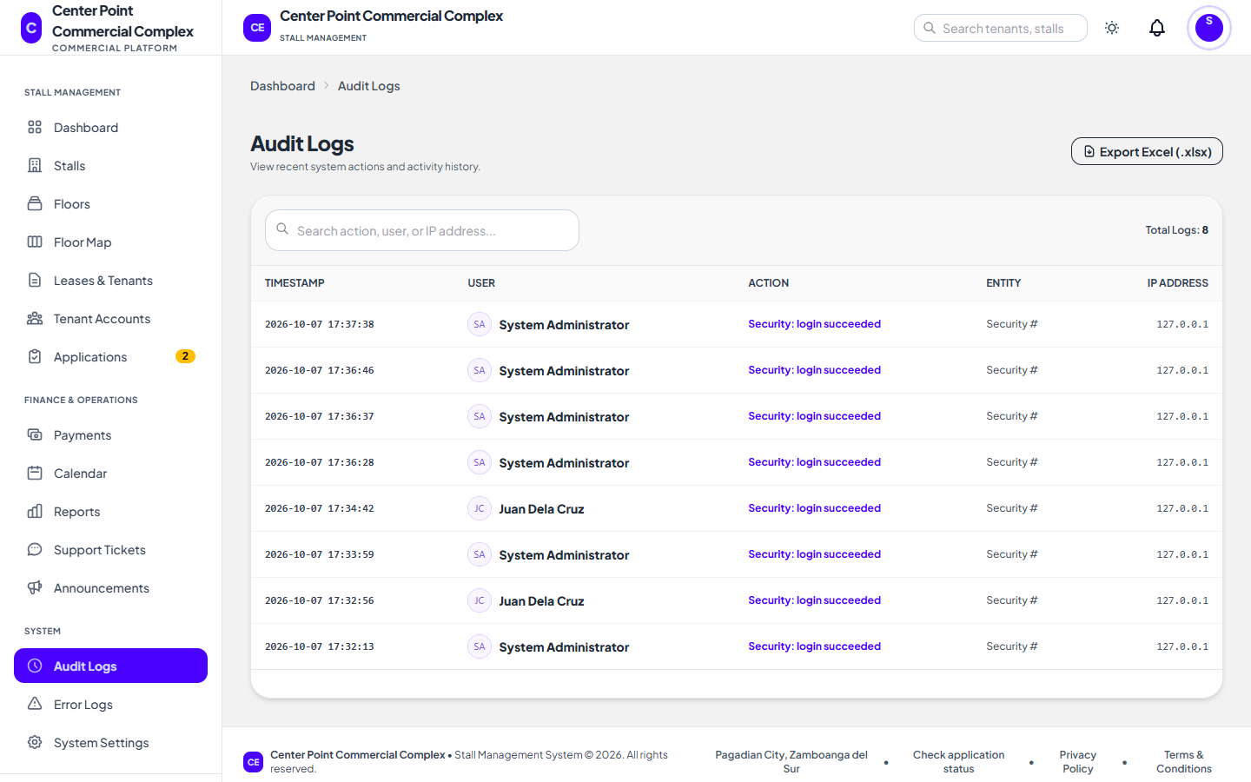
Figure 32. Audit Logs interface
23. System Settings and Backups Interface
Platform details, the SMS switch, and encrypted database backups.
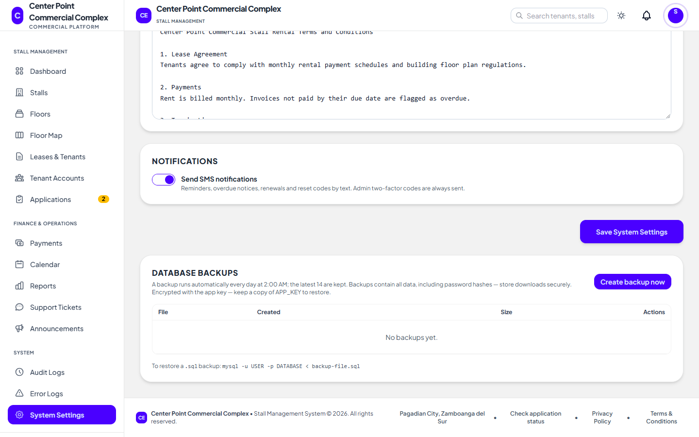
Figure 33. System Settings and Backups interface
24. Global Search Interface
Find tenants, stalls, invoices, and tickets from any administrator page.
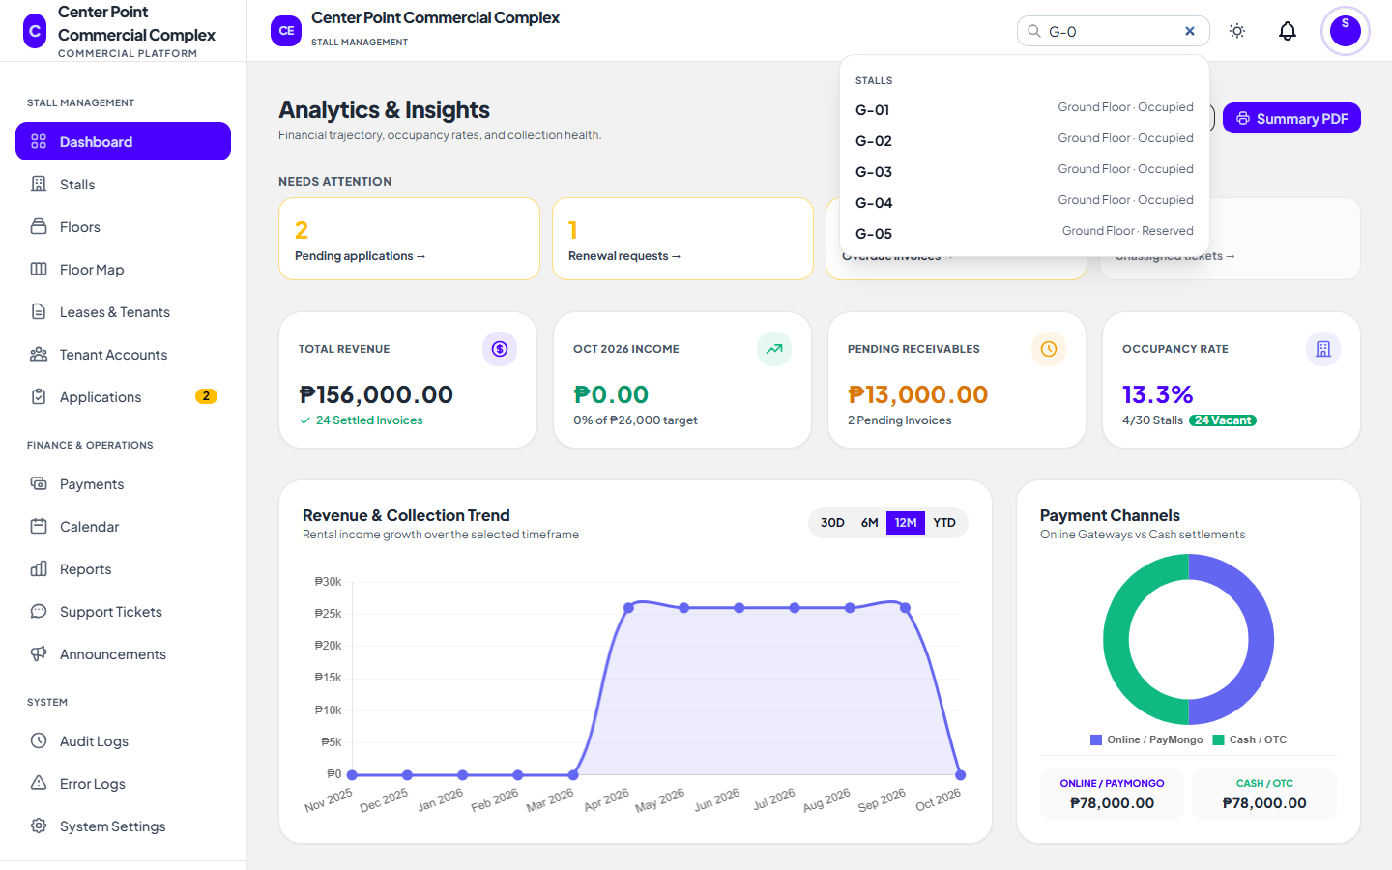
Figure 34. Global Search interface
25. Tenant Dashboard Interface
Announcements, upcoming dates, leases, the next bill, and open tickets.
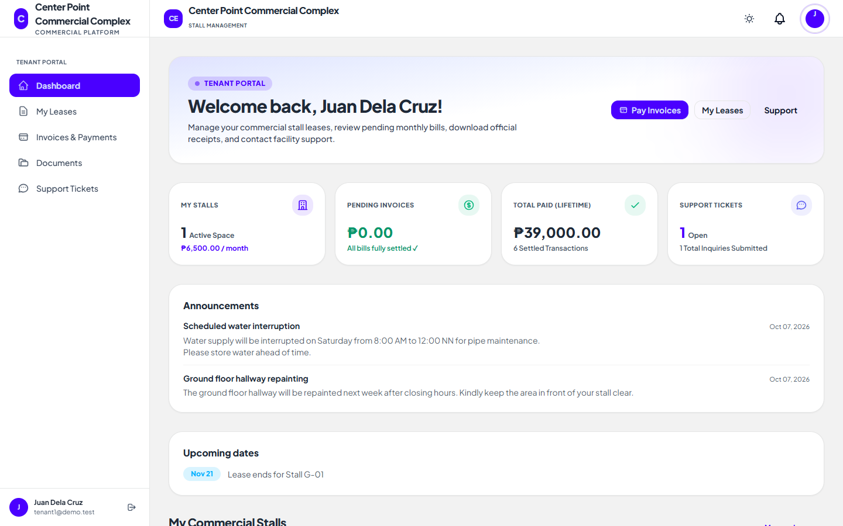
Figure 35. Tenant Dashboard interface
26. My Leases Interface
Lease details and renewal requests.
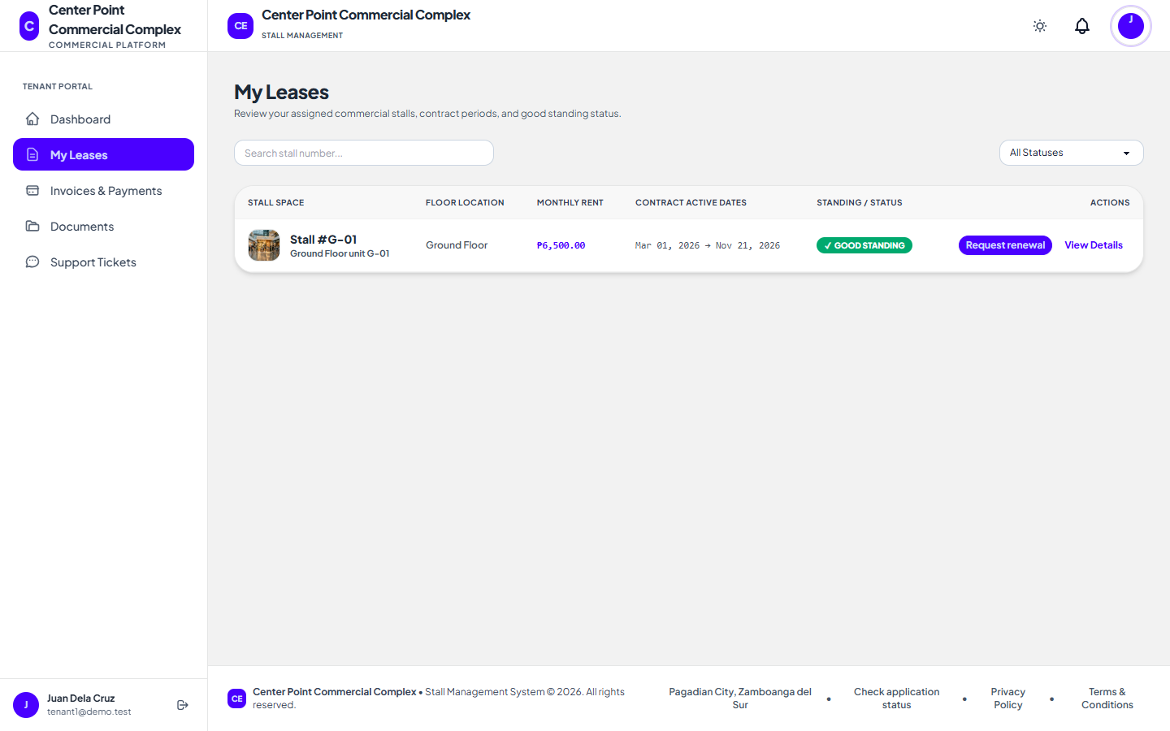
Figure 36. My Leases interface
27. Invoices and Payments Interface
Select invoices and pay online through PayMongo.
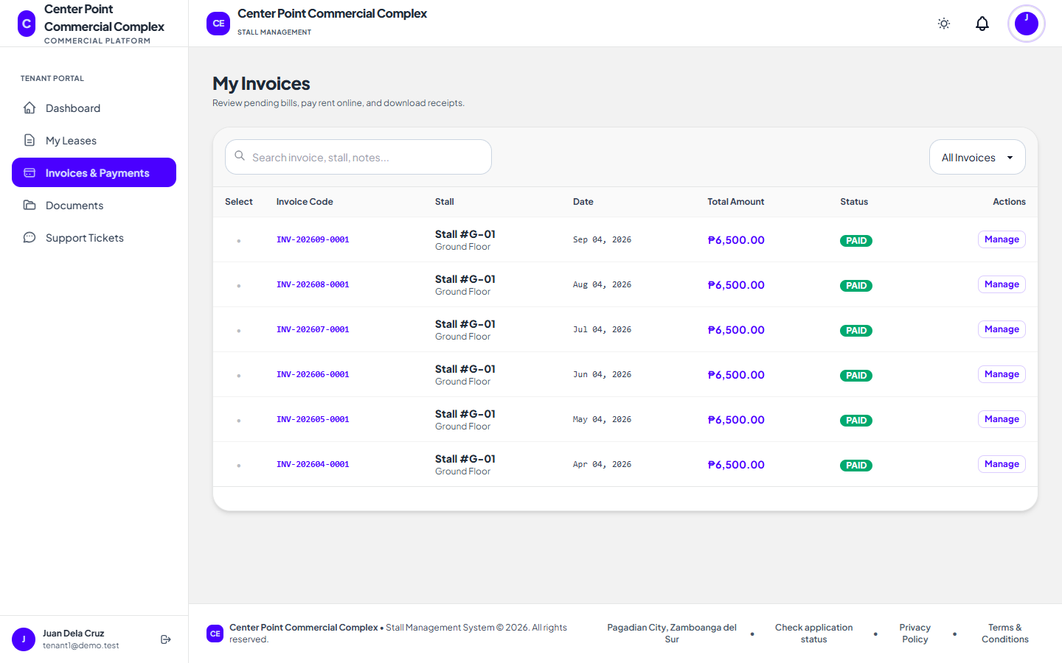
Figure 37. Invoices and Payments interface
28. Support Tickets (Tenant) Interface
Open a ticket and chat with the office.
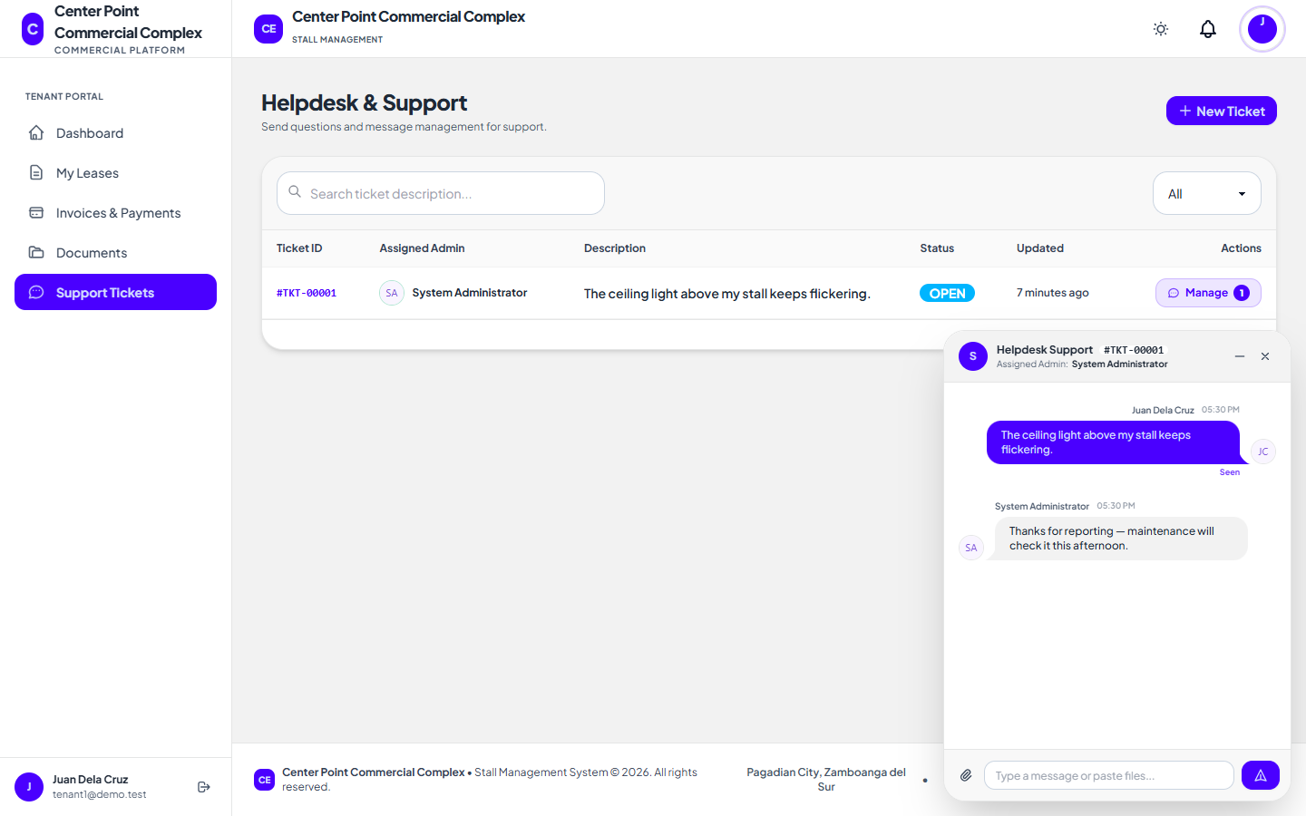
Figure 38. Support Tickets (Tenant) interface
29. Documents Interface
The account statement, lease contracts, and billing statements with receipts.
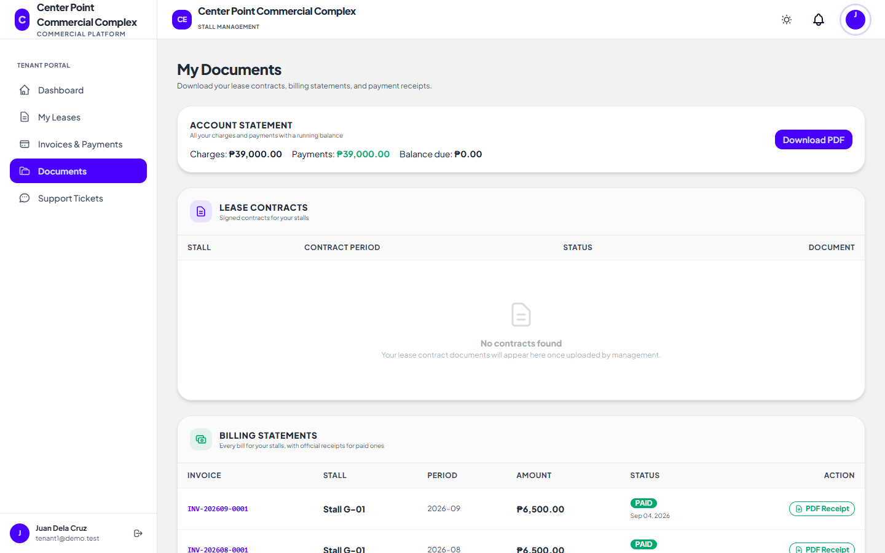
Figure 39. Documents interface
SYSTEM USER GUIDE MANUAL
Web Based Stall Management System for Center Point
1. Introduction
This manual explains how to use the Web Based Stall Management System for Center Point. It is written for the administrators who run the system and for tenants who use the tenant portal. Visitors who are not signed in can browse stalls, apply, check an application, and join a stall waitlist.
2. System Requirements
Any up-to-date web browser (Google Chrome, Microsoft Edge, Mozilla Firefox, or Safari) on a computer, tablet, or smartphone, and a stable internet connection. No software needs to be installed.
Requirement | Recommended
Device | Computer, tablet, or smartphone
Browser | Latest Chrome, Edge, Firefox, or Safari
Internet | Stable broadband or mobile data
Account | Administrator or tenant account (not needed to browse or apply)
Table 4. Requirements for using the system.
3. Signing In
1. Open the system and click Sign In.
2. Enter your email and password, or click Continue with Google or Continue with Facebook.
3. Administrators with Two-Factor Authentication enabled enter the 6-digit code sent to their phone.
4. Forgot your password? Click Forgot password, enter your email, and use the 6-digit code you receive to set a new password.
After five wrong passwords, sign-in pauses for a minute. A deactivated account cannot sign in; contact the office.
4. Administrator Procedures
4.1 Stalls, Floors and the Floor Map
1. Open Floors to add each floor level and its grid size.
2. Open Stalls and click Add Stall; enter the stall number, floor, monthly price, status, and an optional photo.
3. Open Floor Map, choose a floor, and drag each stall onto its place on the grid.
4.2 Stall Applications
1. Open Applications and click an application to see the details and attached document.
2. Click Approve to create the tenant account (an email with a set-password link is sent) or Reject and enter a reason.
3. After approving, click Assign stall to create the lease.
4.3 Leases, Renewals and Termination
1. In Leases & Tenants, click Assign Stall to Tenant, choose the tenant, an available stall, and the contract dates, and attach the signed contract.
2. The first invoice is created; when the tenant pays it (online or at the office), the lease becomes active.
3. To approve a renewal request, open the lease, check the new end date, and click Approve renewal.
4. To end a lease, open it, click Terminate Lease, enter the reason, and confirm any unpaid balance.
4.4 Tenant Accounts and Statements
1. Open Tenant Accounts to see every tenant with their leases and unpaid balance.
2. Use Actions to view the statement of account, resend a set-password link, or deactivate and reactivate the account.
4.5 Payments and Reports
1. Open Payments to see invoices; use the filter for paid, pending, or overdue.
2. Click Record Cash Payment for payments received at the office, or Mark as Paid on an invoice.
3. Open Reports for the revenue trend, occupancy, and overdue aging, and export them to CSV or PDF.
4.6 Announcements, Calendar and Search
1. Open Announcements, enter a title and message, choose all tenants or one floor, tick Also email tenants if needed, and click Post announcement.
2. Open Calendar to see lease end dates, due dates, and renewal requests for the month.
3. Use the search box at the top of any administrator page (or press /) to find a tenant, stall, invoice, or ticket.
4.7 Support Tickets
1. Open Support Tickets and click a ticket to open the chat.
2. Click Claim to take the ticket, reply to the tenant, and change the status to resolved or closed when done.
4.8 Settings, Backups and Audit Logs
1. Open System Settings to update the platform details, policies, landing image, and the Send SMS notifications switch.
2. In Database Backups, click Create backup now, or download and delete existing backups. Keep downloaded backups and a copy of the APP_KEY in a safe place.
3. Open Audit Logs to review recorded actions and security events, and Error Logs to review system errors.
4. Turn on Two-Factor Authentication from your profile (avatar menu → Profile → Password & Security).
5. Tenant Procedures
5.1 Pay Invoices Online
1. Open Invoices & Payments, tick the invoices to pay (or Select all pending), and click Pay with PayMongo.
2. Complete the payment with GCash, Maya, or a card on the PayMongo page; you return to the system automatically.
3. The invoice is marked paid within moments, and the receipt can be downloaded from Documents.
5.2 Leases and Renewals
1. Open My Leases to see each lease and its end date.
2. When a lease is within 60 days of ending, click Request renewal, choose the new end date, and send the request.
5.3 Documents and Statement of Account
Open Documents to download your account statement, lease contracts, and receipts for paid bills.
5.4 Support Tickets
1. Open Support Tickets and click New Ticket; describe the concern and choose the stall.
2. Chat with the office in the ticket window; you can attach photos or files.
5.5 Profile and Password
Open the avatar menu → Profile to update your name, phone, photo, and password.
6. Visitor Procedures
1. Open Browse Stalls, choose a floor, and click an available (green) stall.
2. Click Apply for this stall, fill in the form, and submit. Keep the reference number shown and emailed to you.
3. Open Check application status, enter the reference number and your email to see the result.
4. For an occupied stall, click Notify me when available to be emailed when it opens up.
7. Troubleshooting Guide
Problem | Likely cause | Solution
Cannot sign in | Wrong email or password, too many attempts, or the account is deactivated | Check the details, wait one minute after five failed tries, or contact the office if the account is deactivated.
Did not receive the 2FA or reset code | SMS delay or an old phone number on the account | Wait one minute and click Resend; confirm the phone number in your profile.
Invoice still unpaid after paying online | The payment confirmation from PayMongo is still on its way | Refresh after a few minutes; if it remains unpaid, open a support ticket with the PayMongo reference.
"Please complete the security check" | The CAPTCHA was not completed or expired | Complete the check again and resubmit the form.
Page looks unstyled | Front-end assets were not rebuilt after an update | The administrator runs npm run build on the server.
No backups listed | The scheduler is not running | Make sure the server cron job runs php artisan schedule:run every minute.
Table 5. Troubleshooting guide.
8. Frequently Asked Questions
Q: Can I pay at the office instead of online?
A: Yes. The administrator records the payment and it appears in your invoices and statement.
Q: How do I know my application was approved?
A: You receive an email; you can also check it with your reference number on the Application Status page.
Q: Why is my password rejected?
A: New passwords need at least 8 characters with both letters and numbers.
Q: Can someone else see my invoices or documents?
A: No. Each tenant can only open their own records; administrators can see all records.
9. Contact and Support Information
System Administrator: [Name]
Email: [Email address]
Contact Number: [Phone number]
Support Hours: [Days and hours]
END OF USER GUIDE MANUAL
REFERENCES
Articles
International Journal of Creative Research Thoughts. (2024). Rental house management system study. Retrieved from https://www.ijcrt.org/papers/IJCRT24A5568.pdf
Market Research Reports. (2024). Global online rent payment system market report. Retrieved from https://www.marketresearchreports.com/mrrpb5/global-online-rent-payment-system-market-research-report-2024
PMarket Research. (2025). Rental payment software market trends. Retrieved from https://pmarketresearch.com/worldwide-rental-software-market-research-2024-by-type-application-participants-and-countries-forecast-to-2030/
Archive Market Research. (2026). Rental management system industry analysis. Retrieved from https://www.archivemarketresearch.com/reports/rental-management-system-28796
Better HouseKeeper. (2025). Automated rent collection systems. Retrieved from https://betterhousekeeper.com/2025/07/01/why-automated-rent-collection-is-the-future-of-rental-property-management
Research on Property Management Systems. (2023). Tenant portal and automation study. Retrieved from https://www.researchgate.net/publication/366163745_Property_Management_-_An_Industry_of_Fragmented_Technology_Solutions
Journals
Magno, J. M., Pelayo, R. S., & Soberano, K. T. (2024). Apartment rental management system for real-time transaction and task organization. International Journal of Multidisciplinary Research and Analysis. Retrieved from https://www.researchgate.net/publication/382384541_Apartment_Rental_Management_System_for_Real-Time_Transaction_and_Task_Organization
Buradkar, K., Kori, S., Ruikar, S., & Galfat, V. (2022). Property rental management system. International Journal of Computer Science and Mobile Computing. Retrieved from https://www.researchgate.net/publication/365875447_Property_Rental_Management_System

PERSONAL INFORMATION
[2x2 photo]
Name: Angcap, Crisandra Mae B.
Address: [Address]
Date of Birth: [Date]
Email: [Email]
Contact Number: [Number]
Educational Attainment | School Name | Year Graduated
Tertiary | West Prime Horizon Institute, Inc. | [Year]
Secondary | [School] | [Year]
Primary | [School] | [Year]
Table 6. Educational background of Angcap, Crisandra Mae B.
PERSONAL INFORMATION
[2x2 photo]
Name: Malongo, Alvin A.
Address: [Address]
Date of Birth: [Date]
Email: [Email]
Contact Number: [Number]
Educational Attainment | School Name | Year Graduated
Tertiary | West Prime Horizon Institute, Inc. | [Year]
Secondary | [School] | [Year]
Primary | [School] | [Year]
Table 7. Educational background of Malongo, Alvin A.
PERSONAL INFORMATION
[2x2 photo]
Name: Pasiol, Jasper R.
Address: [Address]
Date of Birth: [Date]
Email: [Email]
Contact Number: [Number]
Educational Attainment | School Name | Year Graduated
Tertiary | West Prime Horizon Institute, Inc. | [Year]
Secondary | [School] | [Year]
Primary | [School] | [Year]
Table 8. Educational background of Pasiol, Jasper R.
PERSONAL INFORMATION
[2x2 photo]
Name: Sagga, Mark G.
Address: [Address]
Date of Birth: [Date]
Email: [Email]
Contact Number: [Number]
Educational Attainment | School Name | Year Graduated
Tertiary | West Prime Horizon Institute, Inc. | [Year]
Secondary | [School] | [Year]
Primary | [School] | [Year]
Table 9. Educational background of Sagga, Mark G.
PERSONAL INFORMATION
[2x2 photo]
Name: Else, Jhack L.
Address: [Address]
Date of Birth: [Date]
Email: [Email]
Contact Number: [Number]
Educational Attainment | School Name | Year Graduated
Tertiary | West Prime Horizon Institute, Inc. | [Year]
Secondary | [School] | [Year]
Primary | [School] | [Year]
Table 10. Educational background of Else, Jhack L.
PERSONAL INFORMATION
[2x2 photo]
Name: Fiel, Jay-ar T.
Address: [Address]
Date of Birth: [Date]
Email: [Email]
Contact Number: [Number]
Educational Attainment | School Name | Year Graduated
Tertiary | West Prime Horizon Institute, Inc. | [Year]
Secondary | [School] | [Year]
Primary | [School] | [Year]
Table 11. Educational background of Fiel, Jay-ar T.

