

WEST PRIME HORIZON INSTITUTE, INC.
West Prime Institute Building
V. Sagun cor. M. Roxas St.
San Francisco Dist. Pagadian City

Web-Based Boarding House Management System with Integrated Online Payment

A Capstone Project Presented to the Faculty of
Bachelor of Science in Information Technology

In Partial Fulfillment of the Requirements for the Degree of
Bachelors of Science in Information Technology

Paula Katrina L. Amar
Jean Claude C. Ciena
John Mark R. Medina
Junel Jay I. Caberte
Marjun P. Bordios
Marelou G. Apao

The Proponents

October, 2026

CHAPTER I
BACKGROUND OF THE STUDY
Introduction
As technology continues to advance, it has become an integral part of daily life and business operations. Many processes that were once handled manually are now automated to improve efficiency, accuracy, and record management. In small to medium-sized businesses such as boarding houses, however, manual methods are still commonly used in managing tenants, room assignments, and rental payments. These traditional practices often result in inaccurate records, misplaced documents, and difficulty in tracking payment histories.
One of the most common problems encountered by boarding house owner is the incorrect recording of payments. Mistakes such as forgetting which tenants have already paid, miscalculating rent and utility charges, or losing previous records can lead to confusion and disputes. These issues become more problematic when tenants check out and later return, as retrieving their previous payment history and records becomes difficult without a proper system.
Another challenge faced by boarding house administrators is the manual computation of monthly rent, water, and electricity bills. Calculating these charges by hand increases the risk of human error and consumes time that could be spent on other important tasks. In addition, tenants often require a printed breakdown of their monthly charges to clearly understand how much they are expected to pay. Without a structured system, providing clear and consistent billing statements is difficult.
To address these concerns, the proponents propose the Web-Based Boarding House Management System with Integrated Online Payment, a browser-based information system designed to automate tenant management, room administration, billing computation, payment processing, and record management, room records, billing computation, payment tracking, and bill printing. The system provides an organized and reliable way to record transactions, compute monthly charges accurately, and generate printable billing statements, ensuring transparency and accountability in boarding house operations.
Project Context
The Boarding House Management System was designed to assist Mrs. Myrna V. Larubis, the owner of Larubis Boarding House, located in San Pedro, Fisherville, Pagadian City. The system aims to streamline daily operations at the boarding house, which offers accommodation services through 21 individual rooms. The system will serve as a centralized platform for managing tenant information, room details, monthly billing, and payment history, providing Mrs. Larubis with an efficient, organized solution to run her business smoothly and effectively.
In the case of Larubis Boarding House, the owner independently manages the daily operations of the establishment, including the supervision of 21 individual rooms, tenant monitoring, billing computation, and payment recording. Handling these responsibilities alone makes manual record-keeping time-consuming and prone to errors, particularly when tracking monthly rent, water, and electricity payments for multiple tenants. The absence of an automated system increases the difficulty of maintaining accurate records and retrieving historical data, especially when tenants check out and later return. Implementing the Boarding House Management System in Larubis Boarding House provides the owner with an efficient and organized solution for managing all 21 rooms, generating accurate bills, printing billing statements for tenants, and maintaining complete payment histories, thereby reducing workload and improving operational efficiency.
In many boarding houses, administrators manage multiple tenants and rooms while also dividing shared utility expenses such as water and electricity. Without a digital system, these records are often stored in notebooks or loose papers, making them difficult to retrieve and prone to errors. When tenants request clarification regarding their charges or previous payments, the administrator may struggle to provide accurate information promptly.
The system allows administrators to easily generate monthly bills, record payments and print billing statements for distribution to tenants. It also maintains historical records that can be accessed even after tenants have checked out. This ensures that when a tenant returns, their previous records can be reviewed quickly, supporting better decision-making and efficient management.
The Web-Based Boarding House Management System is designed to assist boarding house owners or administrators in managing daily operations efficiently through a secure browser-based platform. The system enables authorized users to access and manage tenant records, room information, billing, and payment transactions using a local or internet-connected network, depending on the deployment environment. The system serves as a centralized platform for handling tenant information, room details, monthly billing, and payment history.
Used Software
In this project, several software tools and technologies were used to develop, manage, and test the Web-Based Boarding House Management System with Integrated Online Payment. These software components support the system’s major functions such as user authentication, tenant and room management, billing generation, payment recording, online payment processing, and record monitoring. The following are the primary software technologies used in the development of the system.
Programming Language
The system is developed using PHP with the Laravel Framework. PHP is used as the main server-side programming language to handle the system’s core processes, including user authentication, data processing, billing logic, tenant record management, and payment transaction handling. Laravel provides a structured framework for organizing the application through models, views, controllers, routing, middleware, and database migration tools. Its built-in features also help improve code maintainability, security, and development efficiency.
The project uses MySQL as its relational database management system. MySQL is responsible for storing and organizing the system’s data, including user accounts, tenant information, room records, billing details, payment transactions, and tenant history. It allows the system to retrieve, update, and maintain data efficiently while supporting accurate record-keeping and long-term storage of important transaction histories.
The user interface of the system was developed using HTML, CSS, JavaScript, and Blade Templates. HTML is used to structure the web pages, CSS is applied for layout and visual styling, and JavaScript is used to improve interactivity and user experience. Laravel Blade serves as the templating engine that connects the front-end interface with dynamic data from the back-end. These technologies help create a responsive, organized, and user-friendly interface for both administrator and tenant users.
The system is developed and maintained using Visual Studio Code as the primary code editor. Visual Studio Code provides a flexible environment for writing, editing, and managing the project files efficiently. In addition, Composer is used to install and manage Laravel dependencies and required PHP packages. For local development and testing, tools such as Laragon or XAMPP are used to provide the necessary web server, PHP runtime, and MySQL database environment needed to run the system during development.
For the online payment functionality of the system, a payment gateway such as PayMongo is integrated to support digital payment transactions. This allows tenants to pay their bills through supported online payment channels, while administrators can monitor transaction references and payment status within the system. The integration of online payment functionality improves convenience for tenants and adds efficiency to billing and payment management.
The system is accessed and tested using modern web browsers such as Google Chrome and Microsoft Edge. These browsers are used to verify the functionality, responsiveness, and usability of the system interface for both administrator and tenant users. Browser-based testing helps ensure that the system performs properly in a real web environment.
Each of these software tools contributed significantly to the successful development of the project. Together, they enabled the creation of a secure, organized, and efficient web-based Boarding House Management System capable of handling tenant management, room monitoring, billing generation, payment recording, tenant history, and integrated online payment processing.

Purpose and Description
The purpose of this project was to develop a Web-Based Boarding House Management System with Integrated Online Payment that automates tenant management, room monitoring, billing generation, payment recording, and administrative reporting. The system aims to minimize human error, improve record accuracy, and provide clear and transparent billing information to tenants.
The system allows the administrator to register tenants, manage room details, assign rooms, and generate monthly bills that include rent, water charges, and electricity charges. These charges are automatically calculated based on the values entered by the administrator, ensuring consistency and accuracy in billing.
A key feature of the system is its bill printing functionality, which enables the administrator to generate and print detailed billing statements. These printed bills are provided to tenants so they can clearly see the breakdown of their monthly charges and the total amount due. This feature promotes transparency and helps avoid misunderstandings regarding payments.
All payment transactions are recorded and stored in a centralized MySQL database, creating a complete payment history for each tenant. This allows administrators to review past transactions, correct recording errors when necessary, and retrieve historical records when tenants return. The system provides reliable access to stored records through a web browser within the deployed network environment, while internet connectivity is utilized for online payment processing.

Objectives
General Objectives
The general objective of this study was to develop a Boarding House Management System that improves the accuracy, efficiency, and reliability of managing tenant records, room details, billing, and payment history.
Specific Objectives
Specifically, this project aimed to:
- Develop a system that allows administrators to record and manage tenant information efficiently.
- Enable administrators to add, update, and monitor room details and occupancy status.
- Implement a billing process for rent, water, and electricity charges.
- Maintain a complete and accurate payment history for each tenant.
- Generate and print billing statements and payment records.
- Reduce human error in billing computation and payment recording.
- Integrate an SMS Gateway feature to provide automated notifications and reminders to tenants regarding billing updates, and payment due dates.
Significance of the Study
The Boarding House Management System is expected to provide significant benefits to various involved participants in boarding house operations. By automating record management, billing computation, and payment tracking, the system contributes to improved efficiency, accuracy, and transparency.

Boarding House Owners / Administrators
The system assists boarding house owners and administrators by providing an organized and reliable platform for managing tenant records, room assignments, and billing information. Automated computation of rent, water, and electricity charges reduces human error and saves time. The availability of printable billing statements allows administrators to clearly present monthly charges to tenants, minimizing misunderstandings and disputes. In addition, the system’s payment history feature enables administrators to review past transactions easily, especially when tenants check out and later return.
Tenants
Tenants benefit from receiving clear and detailed printed billing statements that show a breakdown of their monthly rent and utility charges. This transparency helps tenants understand how their total payment is calculated and promotes trust between tenants and the boarding house management. The system also ensures that payment records are accurately maintained, protecting tenants from incorrect or duplicated charges.
Future Developers and Researchers
The study serves as a reference for future researchers and system developers interested in online management systems, billing automation, and record-tracking applications. The design and implementation of the Boarding House Management System may be used as a foundation for further enhancements, such as online payment integration or multi-branch support.

Academic Institutions
For academic institutions, this study demonstrates the practical application of system development concepts, including database management, billing automation, and report generation. It contributes to academic knowledge by presenting a real-world solution to common administrative problems faced by small-scale businesses.
Scope and Limitations of the Study
Scope of the Study
This study focused on the development and implementation of a Boarding House Management System designed to assist the boarding house owner or administrator in managing tenants, rooms, billing, and payment records efficiently. The system aimed to replace manual record-keeping with a digital platform that improves the organization, accuracy, and accessibility of boarding house information. The system included modules for tenant management, room management, billing generation, utility billing management, payment recording, payment history tracking, and report generation. The administrator can register and manage tenant information, assign rooms, calculate monthly bills including utility charges, and record payments made by tenants. The system also integrated online payment functionality, allowing tenants to pay their bills electronically through supported payment channels. Once a payment transaction is confirmed, the system automatically records it in the payment history.
Additionally, the system provided a tenant portal where tenants can view their billing details, utility charges, payment records, request room change, and account information. The administrator can also generate and print reports such as billing statements and payment summaries for monitoring and record-keeping purposes. The system was developed as a web-based application that can be accessed through standard web browsers within the boarding house management environment.
Limitations of the Study
Despite the capabilities of the system, several limitations were acknowledged. The system was designed to manage only a single boarding house establishment and does not support multiple properties or branch management. Although the system was accessible through a web browser, it was primarily optimized for desktop use and may not be fully responsive on mobile devices or smaller screens. Online payment features depend on stable internet connectivity and the availability of the integrated payment gateway. If the internet connection is unavailable, tenants may not be able to complete online payment transactions, although the administrator can still record manual payments within the system.
The system focused on the core functions of tenant management, room assignment, billing, utility tracking, and payment processing. Other features such as maintenance request management, visitor monitoring, automated utility meter integration, or advanced property management tools were not included in the current version of the system. Furthermore, the processing and verification of online payment transactions rely on the third-party payment service provider, which was beyond the direct control of the system developers.

Definition of Terms
The following terms are defined based on how they are operationally used within the system:
Administrator Refers to the boarding house owner or authorized personnel responsible for managing tenants, rooms, billing, payments, and printed statements within the system.
Tenant An individual who rents a room in the boarding house and whose personal details, billing records, and payment history are stored in the system.
Room A rentable unit within the boarding house that is assigned to a tenant and includes details such as room number, rate, and occupancy status.
Billing The process of calculating a tenant’s total monthly charges, including rent, water, and electricity expenses.
Billing Statement A system-generated document that shows a detailed breakdown of rent, water, and electricity charges, including the total amount due, which can be printed and given to tenants.
Online Payment Integration A built-in system feature that connects digital payments services, allowing tenants to pay bills electronically and administrators to verify transactions.
Password Reset The administrator action that creates a new temporary password so a tenant can regain account access securely when needed again.
Database A structured storage used by the system to save tenant records, room details, billing data, and payment histories securely.

CHAPTER II
REVIEW OF RELATED LITERATURE AND RELATED STUDIES
This chapter presents the related literature and studies that support the development of the Boarding House Management System. The review focuses on studies related to boarding house systems, rental management systems, billing automation, and payment monitoring. These studies help establish the importance of automating manual processes such as tenant record management, room monitoring, monthly billing computation, and receipt generation.
The reviewed studies are divided into international and local studies. Each study provides positive findings regarding system automation and its impact on operational efficiency, transparency, and accuracy. These findings support the development of the of Web-Based Boarding House Management System With Integrated Online Payment.
Kurnia and Wijaya (2024) developed a web-based information system designed to improve boarding house management and information accessibility. According to them, digital systems significantly improve data organization and reduce the difficulty of managing boarding house information manually. Their study showed that system automation enhanced efficiency and minimized data inconsistencies.
Although their system focused more on information accessibility and listing, it supports the idea that a computerized boarding house system improves record accuracy and operational management. This supports the project, which extends automation into billing computation and receipt generation.
On the other hand, Hamzah and Findawati (2021) stated that implementing a digital system improves user experience and simplifies accommodation management. While their system emphasized location-based searching, it confirms that replacing manual systems with digital solutions increases efficiency and reliability. This strengthens the need for a structured Boarding House Management System that includes billing and receipt printing functions.
Since automated billing reduces human error and improves transparency between tenants and property managers (Yadhav et al. 2025).
The study highlighted how system-generated records improve payment tracking and reporting accuracy. However, the study focused on online transactions. In contrast, the proposed system is designed to function completely offline while still maintaining accurate billing computation and printable receipts.
Rahman and Islam (2019) developed a web-based hostel management system designed to automate room allocation, tenant registration, billing, and payment monitoring. According to the study, the implementation of an automated hostel management system significantly improved administrative efficiency and reduced errors caused by manual record-keeping. The study also emphasized that digital systems provide better monitoring of tenant records and financial transactions.
Their findings support the Boarding House Management System because both systems aim to replace manual processes with a structured computerized solution. However, while their study focuses on a web-based platform, the present study emphasizes a fully online web-based system with automated monthly billing computation and printable billing statements for tenants.
Speaking of software tools, Manalu and Dongka (2025) developed a web-based boarding house management system using PHP and MySQL. According to their study, structured digital record management significantly improves administrative performance and reduces confusion in managing tenant data.
In summary, the reviewed studies highlight the numerous benefits of implementing automated systems in managing boarding houses and rental properties. The studies by Kurnia and Wijaya (2024), Hamzah and Findawati (2021), Yadhav et al. (2025), Rahman and Islam (2019), and Manalu and Dongka (2025) demonstrate how system automation can significantly improve operational efficiency, data accuracy, and transparency in managing tenant information, billing, and payment tracking. Although some studies focused on web-based platforms and online transactions, their findings strongly support the integration of digital solutions to replace manual methods. These studies emphasize the positive impact of automation in enhancing user experience, reducing human errors, and improving record management, all of which align with the goals of this project. By building on the strengths of these previous works, the system aimed to provide a reliable, and cost-effective solution for small-scale boarding house management, with automated billing, receipt generation, and tenant record management functionalities.
On the other hand, Encarnacion et al. (2025) emphasized that automation improved billing transparency and reduced disputes between landlords and tenants. Their system allowed administrators to generate billing records and monitor payment history efficiently. This directly supports the proposed system’s objective of automating billing computation and maintaining complete payment records.
Similarly, Bisquera et al. (2026) developed a smart accommodation solution for boarding houses in Nueva Vizcaya. The study reported improved efficiency and high usability ratings among users.
Although their system focused mainly on accommodation location, it demonstrates that digital boarding house solutions can improve operational organization and management.
Furthermore, Pernate et al. (2025) developed a smart mobile solution for boarding house rentals in Ormoc City, which received high satisfaction ratings in terms of functionality, performance, and usability.
Their study confirms that digitized boarding house systems improve service efficiency and record management. However, the present study differs by focusing on a web-based system with automated billing computation and printable receipts.
Based on the reviewed studies, computerized boarding house and rental management systems improve operational efficiency, billing accuracy, and record reliability. However, most existing systems focus on general management functions or require online connectivity. Limited studies focus on an integrated system for small-scale boarding houses that combines tenant management, automated billing computation, payment tracking, and receipt generation.
Therefore, the Boarding House Management System aimed to address these gaps by providing a system that automates tenant management, billing computation for rent and utilities, payment monitoring, and receipt printing.

CHAPTER III
DESIGN AND METHODOLOGY
Requirement Analysis
To fully understand the operational needs of the client, interviews, direct observation, and review of existing boarding house practices were conducted. The proponents examined how tenant records, room occupancy, billing, and payment monitoring were currently handled and identified recurring difficulties such as delayed payment tracking, scattered records, and the absence of a centralized tenant management process.
The analysis of the gathered data served as the basis for determining the major problems to be addressed by the system. The proponents focused on identification of how the boarding house owner manages tenant accounts, room assignments, billing records, payment transactions, and tenant history. The collected information was organized, analyzed, and interpreted to ensure that the resulting system design would respond directly to the client's actual workflow and operational concerns.
Requirement Documentation
All identified requirements for the Web-Based Boarding House Management System with Integrated Online Payment were compiled into a System Requirements Document (SRD). The SRD served as the formal reference for the development team and the client, clearly listing the functions, constraints, expected behavior, and quality requirements of the system. It guided the design, development, testing, and deployment of the project and ensured that the completed system remained aligned with the needs of the boarding house owner and the tenant users.

Functional Requirements
The functional requirements of the Web-Based Boarding House Management System with Integrated Online Payment are as follows:
- Provides secure login for administrator and tenant users.
- Allows the administrator to create, update, deactivate, and reactivate tenant accounts.
- Require tenants to change their temporary password upon first login or after an administrator reset.
- Manage room records, including room number, floor, capacity, monthly rent, and occupancy status.
- Assign available rooms to tenants and automatically reflect room occupancy.
- Process tenant checkout and preserve tenant history and previous transaction records.
- Generate billing records for tenants based on the assigned room and billing period.
- Allow administrators to record cash payments and online payment transactions.
- Allow tenants to view their bills, payment history, and account-related information.
- Track payment status such as due, paid, or partially paid when applicable.
- Store payment references and transaction details for audit and monitoring purposes.
- Display dashboard summaries for rooms, tenants, billings, and payments.
- Provide searchable and paginated records for efficient management of data.
- Show tenant history with access to profile details, past transactions, and account reactivation options.
- Maintain a complete record of previous payments even after a tenant checks out.
- Send automated SMS notifications to tenants regarding billing reminders, and due date notification.
- Allow administrators to manage and trigger SMS notifications through the system
Non-Functional Requirements
The non-functional requirements of the system are outlined below:
- Provide a responsive and easy-to-use web interface for both administrator and tenant users.
- Secure passwords through hashing and protect access through role-based authorization.
- Maintain reliable data storage for tenant records, rooms, billings, and payments.
- Support accurate and consistent transaction recording with minimal manual error.
- Ensure that common pages and record listings load efficiently under normal boarding house usage.
- Allow the system to operate on standard computers and modern web browsers.
- Present a clean and professional user interface suitable for a ready business system.
- Maintain historical records even when tenant accounts are deactivated after checkout.
- Be maintainable and expandable for future features such as sms notifications.
- Provide dependable local development and testing through commonly available tools and frameworks.
Technical Background
The system is a web-based information system designed to centralize the day-to-day operations of a boarding house. It combines record management, room monitoring, billing, and payment tracking into a single platform accessible through a browser. Unlike manual record keeping, the system reduces repetitive administrative work and improves the consistency of tenant and payment information.
The application is developed using PHP through the Laravel framework, which provides structured routing, database management, authentication, and controller-based processing. MySQL serves as the primary database for storing user accounts, room data, billing records, payment transactions, and tenant history. The front-end is built using HTML, CSS, JavaScript, and Blade templates to provide an organized interface for both the administrator and tenant users.
For payment-related functionality, the system is designed to support integrated online payment workflows alongside manually encoded cash transactions. This approach allows the boarding house owner to handle both traditional and digital payment methods while preserving complete transaction history. The overall technical approach emphasizes accessibility, security, maintainability, and suitability for a real-world boarding house environment.
Programming Environment
The development of the Web-Based Boarding House Management System with Integrated Online Payment is carried out using a modern web development environment. Visual Studio Code is used as the code editor for writing and organizing the project files. Laravel provides the primary application structure for routing, middleware, models, controllers, and views, while Composer manages PHP dependencies and project packages.
The system uses HTML, CSS, JavaScript, and Blade templating for the front-end presentation layer. MySQL is used to manage relational data, while local development and testing are performed using tools such as XAMPP or Laragon. These tools provide the required web server, PHP runtime, and database services needed to run the application during development.
Overall, the programming environment supports rapid development, organized code structure, and maintainability. It is appropriate for developing a capstone-ready information system that can be demonstrated locally and later improved for production-style deployment.
Hardware Specification
The hardware resources used in the development and operation of the system are intended to support coding, testing, data storage, and browser-based access. Since the project is a web-based information system, the hardware requirements focus on standard computing devices rather than embedded components.
Hardware Component | Purpose | Specification | Estimated Cost (PhP)
Laptop or Desktop Computer | Main development and system administration device | Intel/AMD processor, 8GB RAM or higher, SSD/HDD storage | ₱20,200 - ₱25,000
Internet Connection | Required for package installation and online payment integration testing | Broadband or mobile hotspot connection | ₱899 – ₱1,299  100 mbps
Printer (Optional) | Printing billing slips, receipts, or reports when needed | Inkjet or Thermal printer | ₱2,500 – ₱5,000
Table 1. Hardware Specification of the Proposed System
Software Specification
The selected software tools are essential for the successful development, testing, and maintenance of the proposed system. These tools provide the framework, database environment, interface design support, and local server services required to build the application efficiently.
Software | Purpose | Specification | Estimated Cost (PhP)
Visual Studio Code | Source code editing and project management | Lightweight code editor with extensions for PHP, Laravel, and web development | 0
Laravel Framework | Main application framework | PHP web framework for routing, authentication, MVC structure, and database handling | 0
PHP | Server-side scripting language | Used to process system logic and dynamic content | 0
MySQL | Relational database management | Stores users, rooms, billings, payments, and tenant history | 0
XAMPP / Laragon | Local development server environment | Provides Apache/Nginx, PHP, and MySQL/MariaDB for local testing | 0
Composer | Dependency and package manager | Installs and manages Laravel and PHP packages | 0
Web Browser | System access and interface testing | Google Chrome, Microsoft Edge, or equivalent | 0
Table 2. Software Specification of the Proposed System
Modules Described
- Authentication and Access Control Module: This module manages login, logout, password hashing, role-based access, and forced password change upon first login or after administrator reset.
- Tenant Management Module: This module allows the administrator to create tenant accounts, update tenant information, reset passwords, deactivate checked-out tenants, and reactivate former tenants when needed.
- Room Management Module: This module handles room records such as room number, floor, capacity, rent amount, and current availability or occupancy status.
- Billing Management Module: This module generates billing records for tenants and keeps track of bill amounts, due dates, billing periods, and payment status.
- Payment Management Module: This module records cash and online payments, stores references and transaction details, and keeps historical payment records for monitoring and auditing.
- Tenant History Module: This module preserves data of tenants who have checked out, including profile details, past transactions, and account status for future reactivation.
- Dashboard and Monitoring Module: This module displays summarized information such as total tenants, total rooms, available rooms, occupied rooms, pending bills, and payment activity.
- Search, and Record Viewing Module: This module helps users browse records efficiently through filtering, and search list views.
Benefits of the System
The system centralizes tenant, room, billing, and payment records into a single platform, reducing dependence on paper-based monitoring and improving overall record management. It enhances the accuracy of monitoring room occupancy and tenant account status, allowing the boarding house owner to efficiently manage available and occupied rooms. The system also speeds up billing and payment tracking by providing organized records and clear payment statuses for each tenant.
Furthermore, it preserves historical data even after checkout, ensuring that previous records remain accessible for future reference, auditing, and possible account reactivation. For tenants, the system improves convenience by allowing them to access their billing and payment information through their own accounts. It also strengthens security through controlled user access, password protection, and role-based permissions.
Overall, the system provides a more professional and modern service process that promotes trust, efficiency, and better operational management for the boarding house.
Design of System Software, Product, and/or Process
The design of the system followed a structured process to ensure that the final output would directly address the operational needs of the client. The process began with data gathering through interview and observation, where the proponents identified the difficulties of manual room monitoring, tenant management, and payment recording.
After gathering the necessary information, the proponents conducted requirement analysis and documented the results in the System Requirements Document. From this stage, the main functions of the system were defined, including authentication, room management, tenant account handling, billing generation, payment recording, tenant history preservation, and dashboard monitoring.
The next stage involved system design. Database tables such as users, rooms, billings, and payments were planned to support the core business process of the boarding house. User roles were defined to separate administrator functions from tenant-accessible features. Interface layouts were also designed to provide simple navigation and easy access to major functions such as room records, billing lists, payment management, and tenant history.
During development, the system was implemented using Laravel, PHP, MySQL, HTML, CSS, and JavaScript in a modular manner. Each module was built and tested based on its intended purpose to ensure that the system remained organized and maintainable. Special attention was given to preserving transaction history, allowing tenant reactivation, and keeping room occupancy synchronized with tenant account activity.
Finally, the completed design was refined through repeated testing and interface adjustments. The overall goal was to produce a capstone-ready boarding house management system that is functional, organized, secure, and practical for real administrative use.

CHAPTER IV
DEVELOPMENT, TESTING, AND MAINTENANCE
This chapter presents the development, testing, and implementation of the Web-Based Boarding House Management System with Integrated Online Payment. The development process was carried out based on the requirements gathered from the client and the methodology presented in Chapter III. A structured software development approach was followed to ensure that the proposed system satisfied the operational requirements of the boarding house owner while providing an organized, efficient, and secure platform for tenant management, room administration, billing generation, payment monitoring, and online payment integration.
The development process involved several phases, including planning, analysis and design, coding and development, testing, implementation, and maintenance. Each phase contributed to the successful completion of the project by ensuring that every functional requirement was properly implemented and verified before deployment. Throughout the development process, emphasis was placed on usability, data accuracy, security, maintainability, and operational efficiency to produce a system capable of replacing the existing manual record-keeping procedures.
The proponents adopted the Software Development Life Cycle (SDLC) using the Waterfall Model as the primary development methodology. The Waterfall Model provided a systematic and sequential process that guided the project through requirement analysis, system design, implementation, testing, deployment, and maintenance. The structured nature of the methodology ensured that every development phase was completed before proceeding to the next stage, minimizing development errors and maintaining consistency with the client’s requirements.
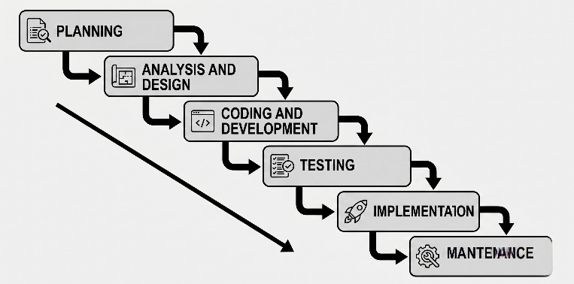

Figure 1. Waterfall Model
Planning
The planning phase was initiated through a comprehensive assessment of the operational procedures currently practiced at Larubis Boarding House located in San Pedro, Fisherville, Pagadian City. Interviews and direct observations were conducted with the boarding house owner to identify the challenges associated with manual tenant management, room monitoring, billing computation, and payment recording. The information gathered during this phase served as the primary basis for defining the overall objectives and functional requirements of the proposed system.
The existing management process was carefully examined to determine the limitations of the manual record-keeping approach. It was observed that tenant information, room occupancy, billing records, and payment histories were maintained manually, resulting in delays in retrieving records, difficulties in monitoring payment status, and increased risk of computation errors. These findings established the need for an automated management system capable of centralizing all boarding house operations into a single platform.
Analysis and Design
Following the completion of the planning phase, the gathered requirements were analyzed to determine the functional and non-functional requirements of the Web-Based Boarding House Management System with Integrated Online Payment. Information obtained through interviews and observations was reviewed to ensure that the identified operational problems were addressed through appropriate system functions.
The analysis identified the major system modules, including the Authentication and Access Control Module, Tenant Management Module, Room Management Module, Billing Management Module, Payment Management Module, Tenant History Module, Dashboard and Monitoring Module, and Search and Record Viewing Module. These modules were designed to automate the boarding house's daily administrative operations.
The system was designed using the Laravel Framework with the Model-View-Controller (MVC) architecture, while MySQL was utilized for database management. The user interface was developed using HTML, CSS, JavaScript, and Blade Templates to provide an organized, responsive, and user-friendly environment for both administrators and tenants.
Security features, including password hashing, role-based authentication, and access control, were incorporated to protect user information and system resources. Overall, the analysis and design phase established a structured, secure, and maintainable system architecture that served as the foundation for the succeeding development process.
Coding and Development
The coding and development phase involved the implementation of the system based on the approved system design and documented requirements. During this stage, the proponents translated the system design into a fully functional web application using PHP with the Laravel Framework. Laravel was selected because of its structured Model-View-Controller (MVC) architecture, which simplified code organization, improved maintainability, and enhanced application security.
Visual Studio Code was utilized as the primary integrated development environment for writing and organizing the source code. Composer was employed to install and manage Laravel dependencies, while Laragon served as the local development server that provided the Apache web server, PHP runtime environment, and MySQL database services necessary during system development.
The development process was performed incrementally, allowing each functional module to be completed, tested, and refined before proceeding to the succeeding module. This approach ensured that errors were identified early and corrected immediately without affecting other system components.
Additional system functionalities, including search, filtering, record viewing, report generation, and printable billing statements, were also implemented to improve user productivity and facilitate faster retrieval of information.
Throughout the coding process, debugging and code optimization were continuously performed. Syntax errors, database inconsistencies, validation issues, routing conflicts, and interface problems were identified and corrected through repeated testing until all modules operated according to the documented system requirements.
Testing
Following the completion of system development, comprehensive testing procedures were conducted to verify that every module performed according to its intended functionality. The testing phase was divided into two major stages: Component Testing and System Testing.
Component Testing
Each module of the Web-Based Boarding House Management System with Integrated Online Payment was individually evaluated to verify its functionality and ensure compliance with the documented system requirements.
Search functionality, filtering options, and report generation features were likewise tested to ensure accurate retrieval and presentation of stored information. Any errors encountered during component testing were corrected through additional debugging sessions before the complete system evaluation was conducted.
System Testing
After all individual modules successfully passed component testing, the complete system underwent system testing to evaluate its overall performance under actual operating conditions.
Various user scenarios were performed to simulate daily boarding house operations. These scenarios included tenant registration, room assignment, billing generation, payment recording, online payment processing, tenant checkout, tenant reactivation, report generation, and billing statement printing.
The integration among system modules functioned successfully throughout the testing process. Tenant information was synchronized with room occupancy records, billing computations were automatically generated based on room assignments, payment records updated billing status accurately, and historical information remained accessible after tenant checkout.
Database transactions were carefully monitored to ensure consistency during simultaneous operations. Data validation procedures successfully prevented incomplete or invalid records from being stored within the database.
System security was also evaluated by verifying user authentication, access restrictions, session management, and password protection mechanisms. Unauthorized access attempts were successfully restricted through Laravel's authentication and authorization features.
Browser compatibility testing was conducted using Google Chrome and Microsoft Edge. The system interface displayed correctly across supported browsers, while navigation, form validation, report generation, and online payment functionalities operated without significant issues.
The results of system testing confirmed that the Web-Based Boarding House Management System with Integrated Online Payment satisfied its intended functional and operational requirements. The completed system demonstrated accurate billing computation, reliable record management, efficient payment monitoring, secure user authentication, and organized tenant administration suitable for practical boarding house operations.
Implementation
Upon successful completion of the testing phase, the system was prepared for implementation at Larubis Boarding House. The deployment process included installation of the application, configuration of the local development environment, database initialization, and administrator account creation.
The completed system was installed on the designated computer to serve as the primary administrative workstation for managing boarding house operations. Required software components, including the local web server environment, PHP runtime, Laravel framework, and MySQL database, were configured to ensure proper system functionality.
The initial database was populated with sample room information, tenant accounts, billing records, and administrative credentials to facilitate system demonstration and user orientation. Trial transactions were subsequently performed to verify that all implemented modules continued functioning correctly after deployment.
The boarding house owner was provided with an orientation regarding the operation of the system. Demonstrations included tenant registration, room assignment, billing generation, payment recording, online payment verification, report generation, and billing statement printing. Guidance was likewise provided regarding password management, account maintenance, and basic troubleshooting procedures.
Following the orientation, the system was evaluated through actual operational scenarios. The implementation confirmed that the developed application effectively automated tenant management, room monitoring, billing computation, payment recording, and transaction history management while significantly reducing manual administrative workload.
Maintenance
To ensure continuous reliability and efficiency of the Web-Based Boarding House Management System with Integrated Online Payment, appropriate maintenance procedures were recommended following system deployment.
Regular database backups were recommended to prevent permanent loss of tenant information, billing records, payment histories, and administrative data. Backup files should be securely stored to facilitate system recovery whenever necessary.
Periodic software updates should be should be perform to maintain compatibility with newer versions of PHP, Laravel, Composer, and supporting libraries. Updating these components enhancing application security, improves performance, and resolves previously identified software vulnerabilities.
Routine monitoring of the online payment gateway should likewise be conducted to verify continuous communication between application and payment processing services. Transaction references and payment confirmation should be periodically reviewed to ensure successful synchronization of payment records.
User accounts should be monitored regularly to maintain system security. Password updates, administrator account reviews, and access verification should be conducted whenever personnel changes occur or whenever security concerns arise.
Database optimization and routine maintenance should also be performed to improve query performance, maintain storage efficiency, and preserve data integrity as transaction records continue to accumulate over time.
Browser compatibility testing should be conducted whenever significant software updates are installed to ensure that the system interface continues functioning properly across supported web browsers.
In addition, periodic evaluation of system performance should be undertaken to identify opportunities for future enhancements. Potential improvements may include SMS notifications, multi-branch boarding house support, advanced financial reporting, automated utility meter integration, and additional administrative monitoring features.
Proper maintenance of both hardware and software resources will ensure that the Web-Based Boarding House Management System continues to provide accurate, reliable, and efficient support for boarding house management while remaining adaptable to future operational requirements.

CHAPTER V
RESULTS AND DISCUSSIONS
This chapter presents the results obtained from the testing and implementation of the Web-Based Boarding House Management System with Integrated Online Payment. It discusses the effectiveness of the developed system in addressing the problems identified during the preliminary investigation, the implementation process carried out at the client's establishment, the overall system performance, and the observations gathered during deployment. This chapter also presents the system diagrams that illustrate the overall architecture, functionality, and database structure of the developed application.
The findings presented in this chapter demonstrated how the developed system improved the boarding house management process by automating tenant management, room administration, billing generation, payment recording, and transaction monitoring. The implementation of the system was evaluated based on its functionality, usability, reliability, and its ability to satisfy the operational requirements of the client.
Functionality and Testing Results
After the completion of the development phase, comprehensive testing procedures were conducted to verify that every functional module of the system operated according to its intended purpose. Individual modules, including user authentication, tenant management, room management, billing generation, payment recording, online payment integration, report generation, and dashboard monitoring, were evaluated before conducting the overall system testing.
The testing results indicated that the implemented modules successfully performed their designated functions with minimal errors. User inputs were properly validated, data were accurately stored within the database, and records were correctly retrieved whenever necessary. The integrated online payment features successfully processed payment transactions and updated billing records accordingly.
The system also demonstrated consistent performance during repeated testing scenarios. Navigation between modules remained responsive, generated reports reflected accurate information, and administrative functions operated according to the specified system requirements. The successful completion of these tests confirmed that the developed system was ready for deployment and actual implementation.
Results of System Implementation
Following the successful completion of testing, the developed system was implemented for use by the client. The implementation process included the installation of the application, database configuration, administrator account creation, and initial system setup. Existing boarding house information, including room details and tenant records, was encoded into the system to facilitate actual operation.
After implementation, the client was oriented regarding the different features and functionalities of the system. Demonstrations were conducted to familiarize the administrator with tenant registration, room assignment, billing generation, payment recording, online payment verification, report generation, and tenant history management. The client was then allowed to perform actual transactions using the system to evaluate its usability and functionality.
The implementation demonstrated that the developed system significantly improved the management of boarding house operations. Administrative tasks that were previously performed manually became more organized, efficient, and less time-consuming. The centralized database allowed faster retrieval of records, improved billing accuracy, and simplified payment monitoring. Furthermore, the integrated online payment functionality provided tenants with a more convenient payment option while allowing administrators to monitor transactions efficiently.
Implementation Flow
The implementation of the system followed a structured process to ensure successful deployment and user adoption. The process began with the installation of the system on the designated computer or server. After installation, the database was configured, and the administrator account was created. Initial boarding house information, including room records and tenant information, was encoded into the database to prepare the system for actual operation.
Following the initial setup, the client received an orientation regarding the operation of the system. The administrator was introduced to the major functions of the application, including managing tenant information, monitoring room occupancy, generating monthly billing statements, recording payments, verifying online payment transactions, and generating reports.
After the orientation, actual transactions were performed using the system to validate its functionality under normal operating conditions. Successful completion of these activities confirmed that the system was capable of supporting the daily administrative operations of the boarding house.
Problem Encountered During Implementation
During the implementation phase, several minor issues were encountered while configuring and operating the system. These included initial database configuration errors, incorrect data entry during testing, browser compatibility adjustments, and minor interface modifications requested by the client. These issues were immediately identified and resolved through system debugging, database optimization, and interface refinements.
The integrated online payment functionality also required proper configuration to ensure successful communication between the application and the selected payment gateway. Necessary adjustments were performed during testing to verify accurate transaction processing and payment verification.
Despite these minor challenges, no major system failures were encountered during implementation. The identified issues were successfully corrected before the system was officially deployed, resulting in a stable and reliable application suitable for actual use.
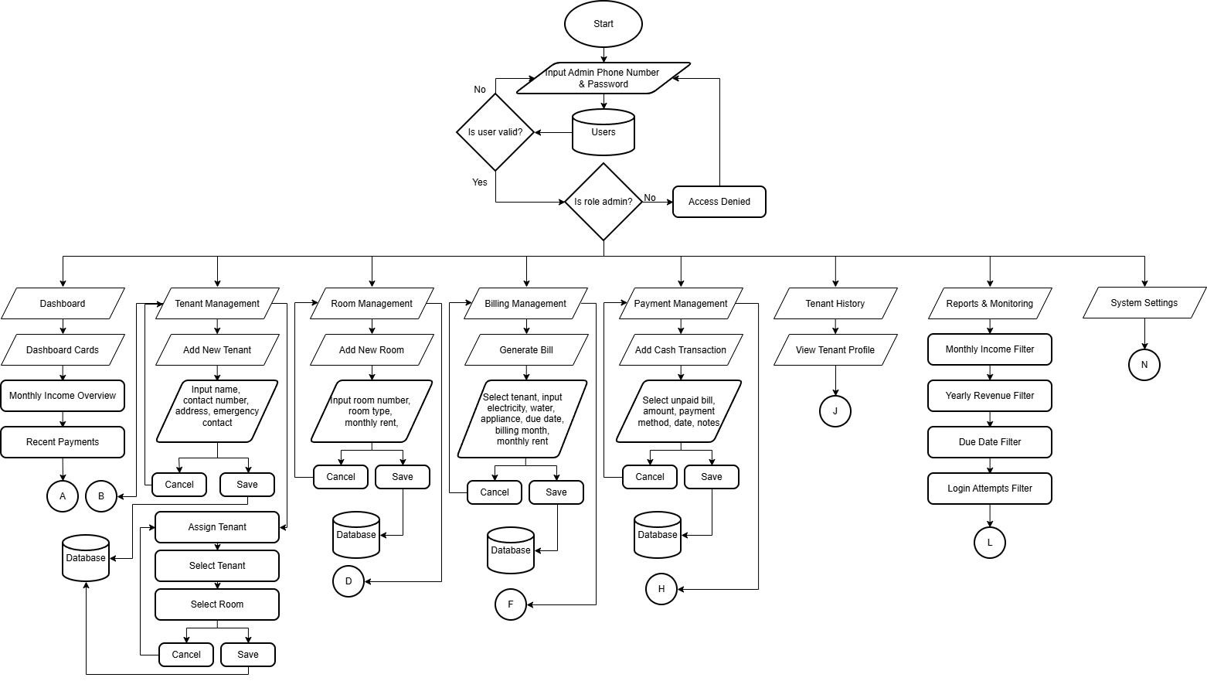
System Flowchart for Admin

Figure 2.1 Admin Flowchart of Web-Based Boarding House Management System with Integrated Online Payment

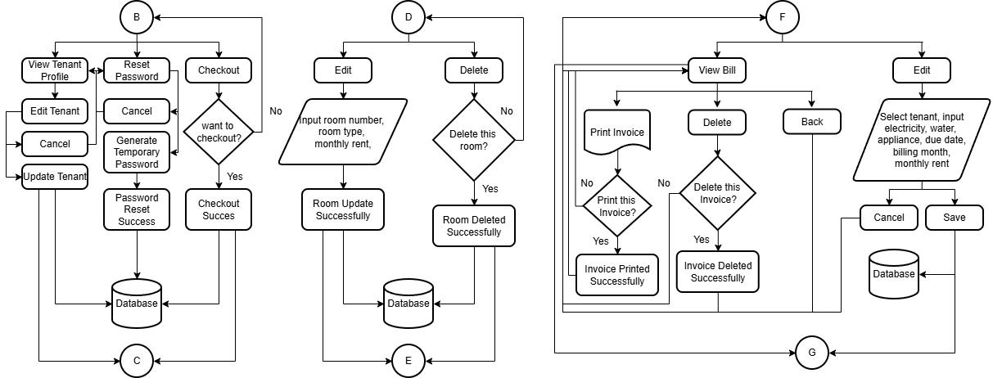
System Flowchart for Admin

Figure 2.2 Admin Flowchart of Web-Based Boarding House Management System with Integrated Online Payment

System Flowchart for Admin
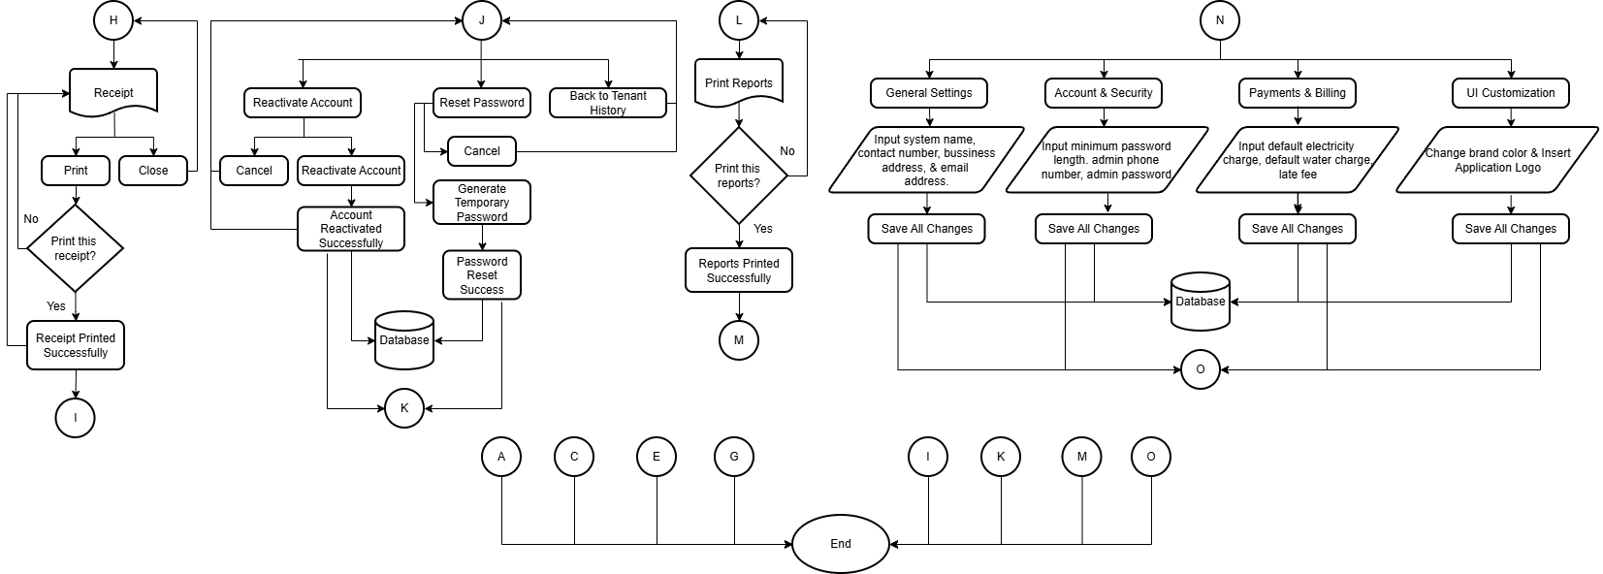

Figure 2.3 Admin Flowchart of Web-Based Boarding House Management System with Integrated Online Payment

System Flowchart for Tenant
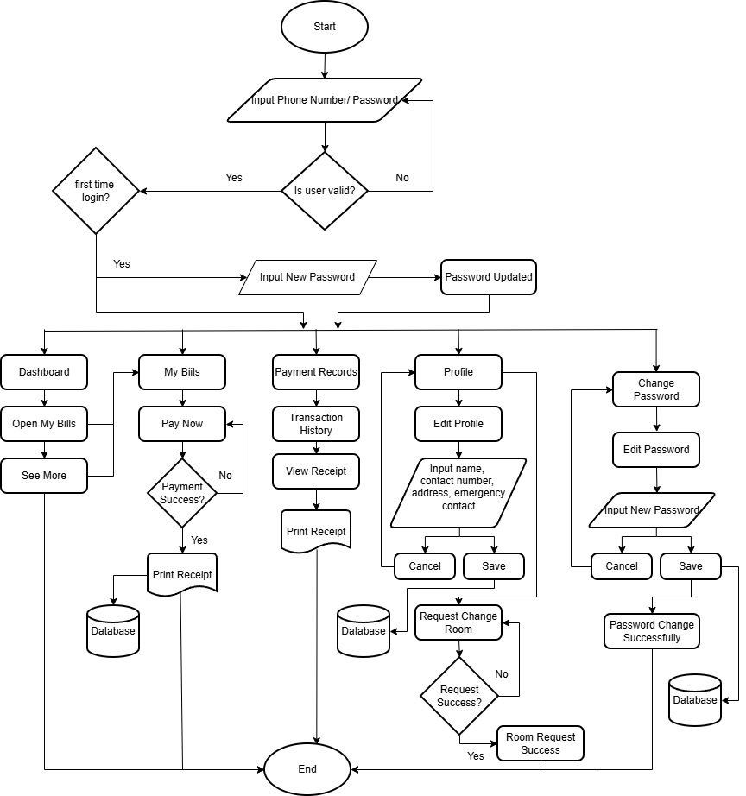
Figure 3. Tenant User Flowchart of Web-Based Boarding House Management System with Online Integrated Payment System

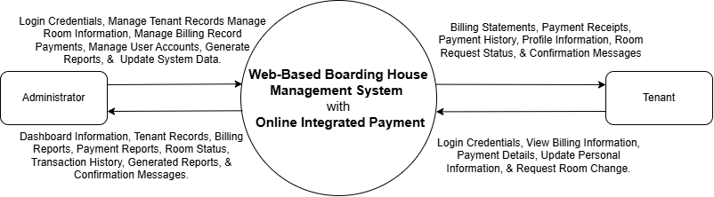
Content Diagram

Figure 4. Context Diagram of Web-Based Boarding House Management System with Online Integrated Payment
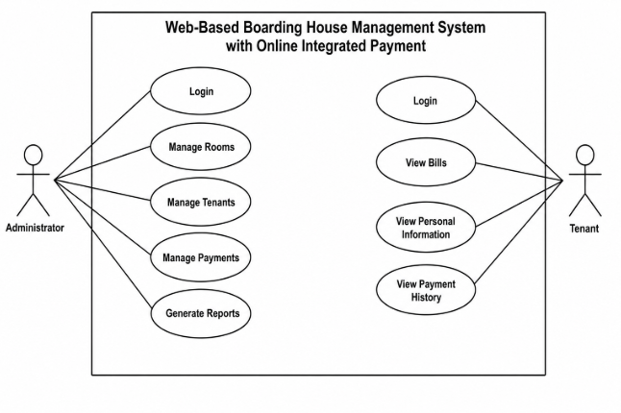
Use Case Diagram
Figure 5. Use Case Diagram of Web-Based Boarding House Management System with Online Integrated Payment

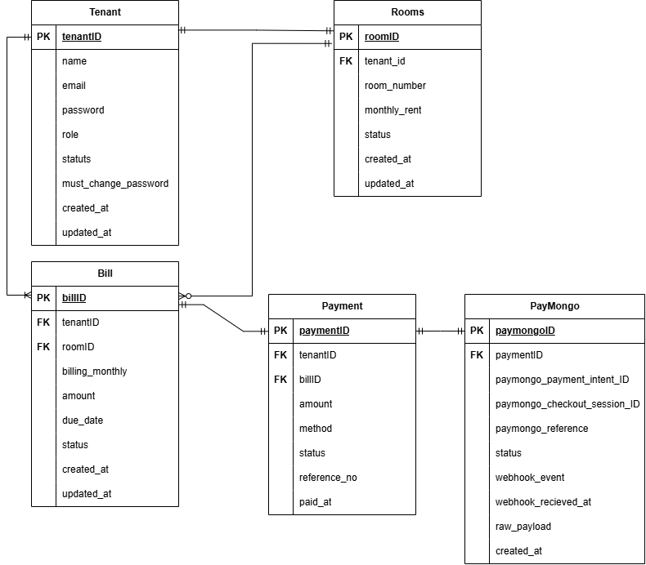
Entity Relationship Diagram

Figure 6. Entity-Relationship Diagram
Conclusion
Based on the results obtained during testing and implementation, the proponents therefore concluded that the Web-Based Boarding House Management System with Integrated Online Payment successfully achieved its intended objectives. The developed system effectively automated the boarding house's daily administrative operations, including tenant management, room administration, billing computation, payment recording, and report generation.
The implementation of the system significantly improved the efficiency of record management by reducing manual processing, minimizing computation errors, and accelerating information retrieval. The integrated online payment functionality further enhanced the convenience of payment transactions while improving transparency between tenants and administrators.
Although the system successfully addressed the major operational concerns identified by the client, several opportunities for improvement remain. Future enhancements may include the addition of SMS and email notifications, mobile application support, advanced financial reporting, cloud deployment, and automated utility meter integration. These improvements would further enhance the functionality, accessibility, and scalability of the developed application.
Recommendations
Based on the findings and conclusions of the study, the following recommendations are proposed to further enhance the developed Web-Based Boarding House Management System with Integrated Online Payment:
- Integrate Smart Electric Meter Monitoring to automatically collect electricity consumption data from each room. This feature would eliminate manual meter reading, generate more accurate electricity charges, minimize human error, and improve the efficiency of utility billing.
- Support Multi-Branch Boarding House Management to allow owners with multiple boarding house properties to manage all branches within a single centralized system.
- Strengthen System Security by implementing additional security measures such as two-factor authentication (2FA), stronger password policies, audit logs, and enhanced data encryption to further protect user accounts and sensitive information.

WEST PRIME HORIZON INSTITUTE, INC.
West Prime Horizon Institute Building
V. Sagun cor. M. Roxas St.
San Francisco Dist. Pagadian City
TRANSMITTAL LETTER
January 26, 2026
Mrs. Myrna Eskasena Larubis
Boarding House Owner
San Pedro, Pagadian City, Zamboanga del Sur

Ma’am:

Greetings of peace!

In partial fulfillment of the requirements for our subject Capstone 1, we, the 3rd-year students of West Prime Horizon Institute, Inc., namely Jean Claude C. Ciena, Paula Katrina L. Amar, John Mark R. Medina, Junel Jay I. Caberte, Marjun P. Bordios, and Marelou G. Apao, would like to respectfully request your permission to conduct an interview and gather necessary information related to our research project entitled Web-BASED Boarding House Management System with Integrated Online Payment at your establishment.

We assure you that all information and data collected during the interview will be treated with strict confidentiality and will be used solely for academic purposes. The gathered data will contribute significantly to the completion of our capstone project and the development of our proposed system/study.

We sincerely hope for your favorable response and support in allowing us to conduct this academic activity. Your approval and cooperation will be highly appreciated and will greatly help us accomplish the requirements of our subject.
Thank you very much for your time and consideration.

Respectfully yours,

The Proponents Noted by:
Ciena, Jean Claude
Apao, Marelou WAIEN G. WATAMAMA, Ed.D
Amar, Paula Katrina Capstone Adviser
Medina, John Mark
Caberte, Junel Jay
Bordios, Marjun Received by:

Mrs. Myrna Eskasena Larubis
Boarding House Owner

WEST PRIME HORIZON INSTITUTE, INC.
West Prime Horizon Institute Building
V. Sagun cor. M. Roxas St.
San Francisco Dist. Pagadian City

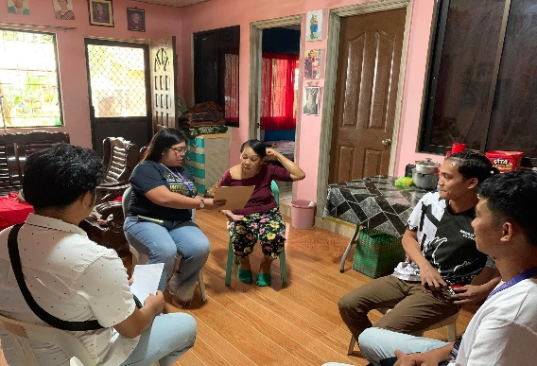
PHOTO DOCUMENTATION
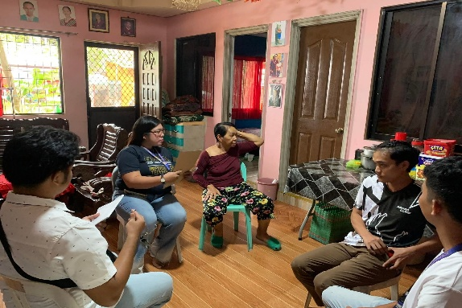

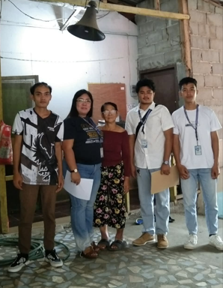
The project team conducted an interview with the boarding-house owner and staff to identify the system features needed for daily operations. The discussion focused on tenant management, room assignment, monthly billing, payment monitoring, notifications, and report generation. Their responses helped the team determine which functions should be included in the Web-Based Boarding House System.
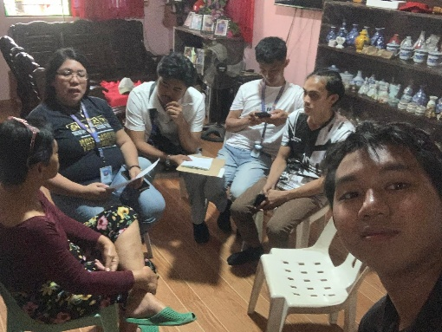

The proponents gathered information about the current boarding-house process by asking how tenant records, room availability, bills, and payments are handled. They reviewed the flow of activities from tenant registration and room assignment to billing, payment recording, and tenant checkout. This data was used to plan a system workflow that matches the actual business operations of the boarding house.
USER GUI GUIDE

Prepared by:

Jean Claude C. Ciena
West Prime Horizon Institute Inc.
September 10, 2026

Table of Contents

1. Login Page Interface
2. Change Password Interface
3. Forgot Password Interface
4. Administrator Dashboard Interface
5. Tenant Dashboard Interface
6. Tenant Management Interface
7. Add Tenant Interface
8. Room Management Interface
9. Billing Management Interface
10. Payment Management Interface
11. Tenant History Interface
12. Reports and Monitoring Interface
13. System Settings Interface
14. Tenant Bills Interface
15. Tenant Payment Interface
16. Tenant Payment History and Receipt Interface
17. Tenant Profile Interface
18. Room Change Request Interface

1. Login Page Interface
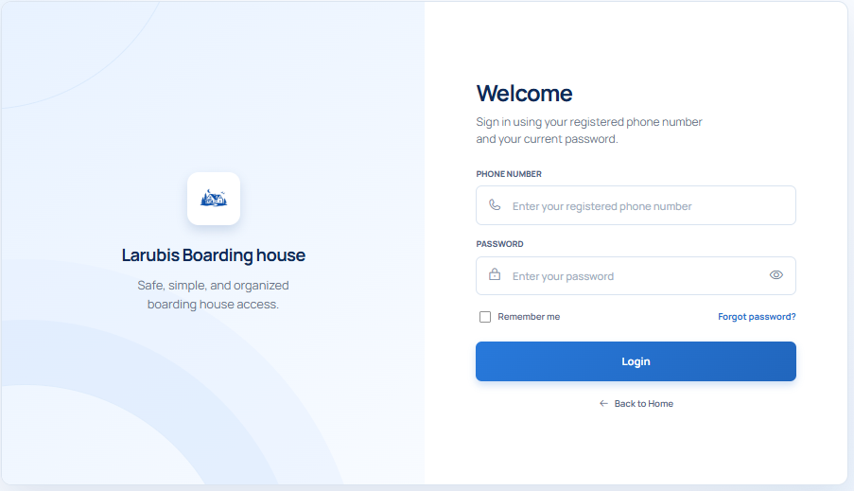

Figure 7. Login Page Interface
The Login Page is the first screen displayed when users access the Larubis Boarding House System. It allows registered administrators and tenants to enter their account credentials and proceed to the correct portal based on their role. The interface includes fields for the registered phone number and password, an option to remember the login session on a trusted device, a password recovery link, and a login button for account validation.

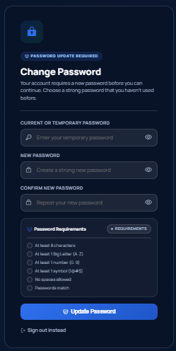
2. Change Password Interface

Figure 8. Change Password Interface
The Change Password Interface is used when a user needs to replace a temporary password or update an existing password. This page helps protect the account by requiring the user to enter the current or temporary password before setting a new one. It also includes a confirmation field to make sure the new password is typed correctly before it is saved.

3. Forgot Password Interface

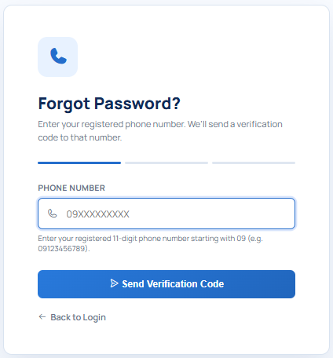

Figure 9. Forgot Password Interface

The Forgot Password Interface allows users to recover access to their account when they cannot remember their password. The user enters the mobile number registered to the account and follows the SMS verification process. After verification, the user can create a new password and return to the Login Page to sign in again.

4. Administrator Dashboard Interface
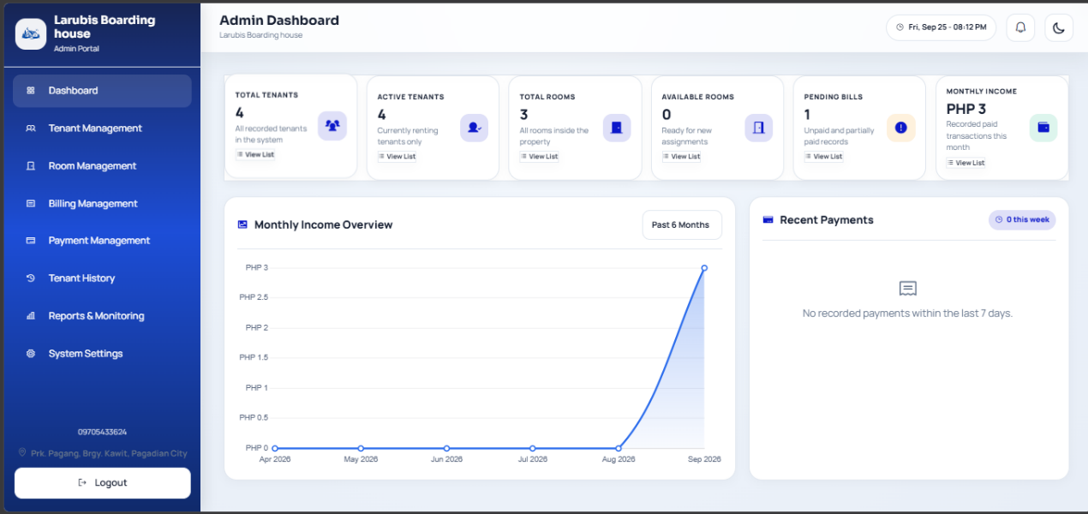

Figure 10. Administrator Dashboard Interface
The Administrator Dashboard serves as the main control panel for the boarding-house administrator. It gives an overview of important system information such as rooms, tenants, pending bills, payment records, and income summaries. From this page, the administrator can quickly navigate to tenant management, room management, billing, payments, reports, history, notifications, and system settings.

- Tenant Dashboard Interface

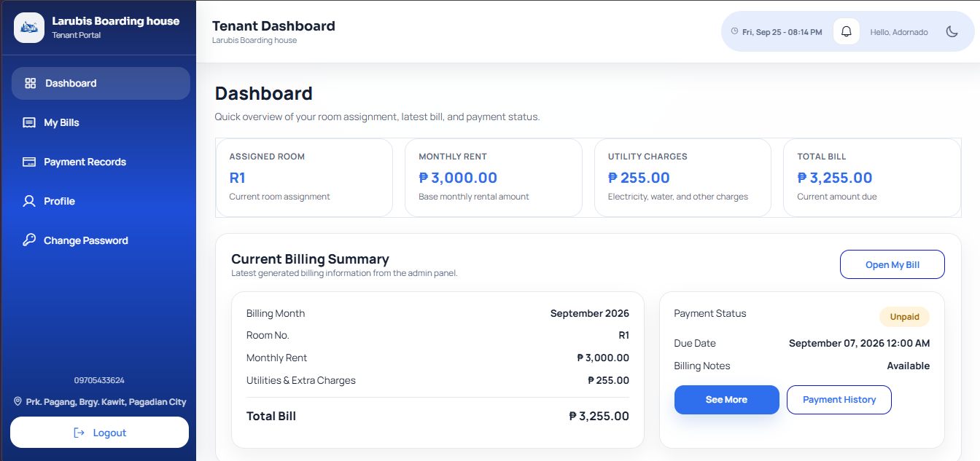
Figure 11. Tenant Dashboard Interface
The Tenant Dashboard is the main page displayed after a tenant logs in. It summarizes the tenant's assigned room, current rent, utility charges, and latest bill information. The interface helps tenants quickly check their current billing status, access their bills, review payments, view notifications, update profile details, and submit room-related requests.

- Tenant Management Interface
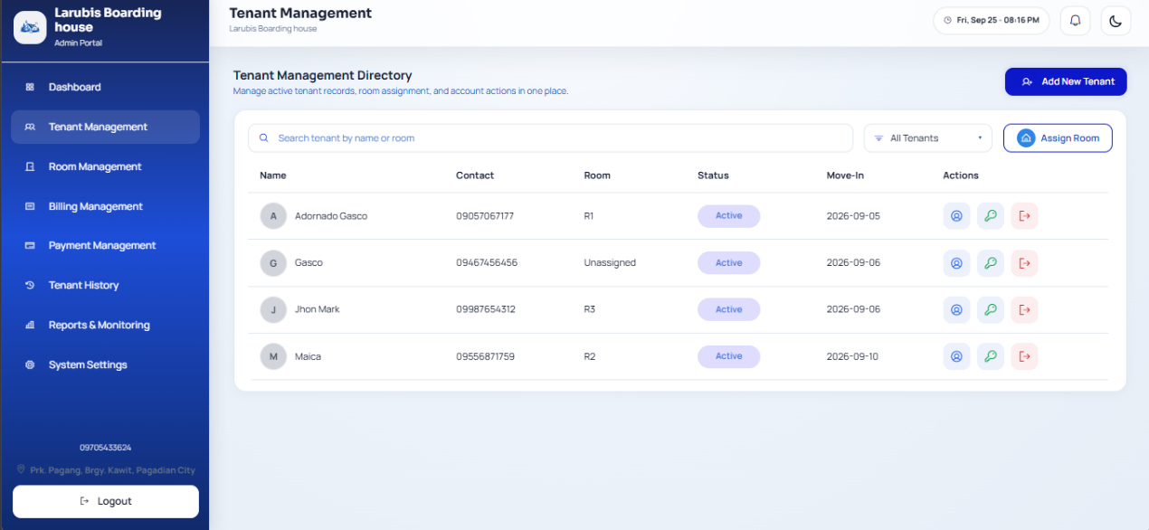

Figure 12. Tenant Management Interface
The Tenant Management Interface is used by the administrator to view and manage tenant accounts. It displays active tenants and provides controls for adding new tenants, updating tenant details, assigning rooms, resetting passwords, and processing tenant checkout. This page helps the administrator keep tenant records organized and accessible.

7. Add Tenant Interface
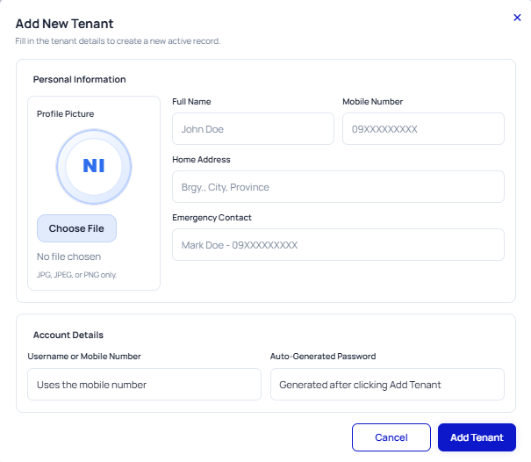

Figure 13. Add Tenant Interface
The Add Tenant Interface allows the administrator to create a new tenant record in the system. The form collects the tenant's personal details, contact information, emergency contact, address, and login-related information. Once the tenant is added, the account can be used for room assignment, billing, and tenant portal access.
- Room Management Interface
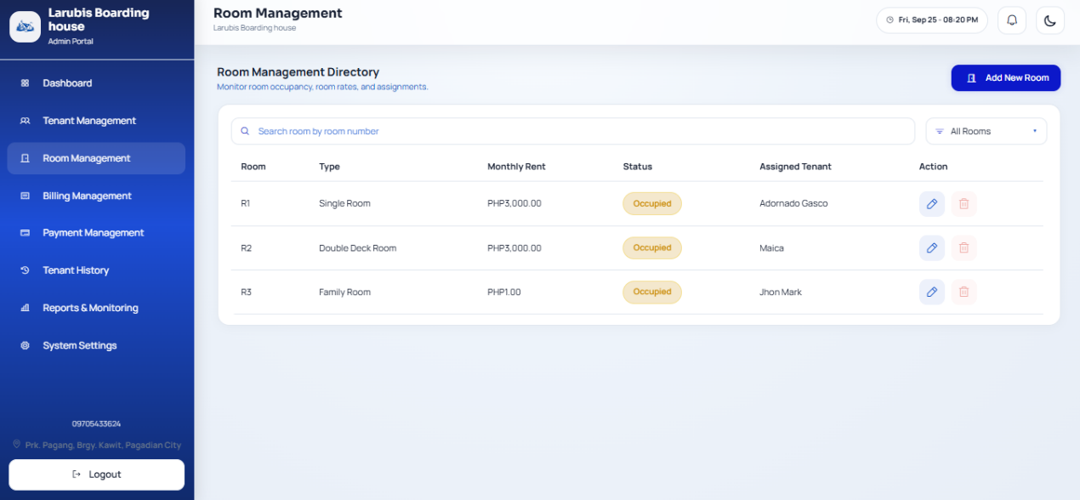

Figure 14. Room Management Interface
The Room Management Interface allows the administrator to organize and monitor boarding-house rooms. It shows room information such as room number, type, rent amount, capacity, occupancy, and availability. The administrator can use this page to add rooms, update room details, check room status, and identify available or occupied spaces.
- Billing Management Interface
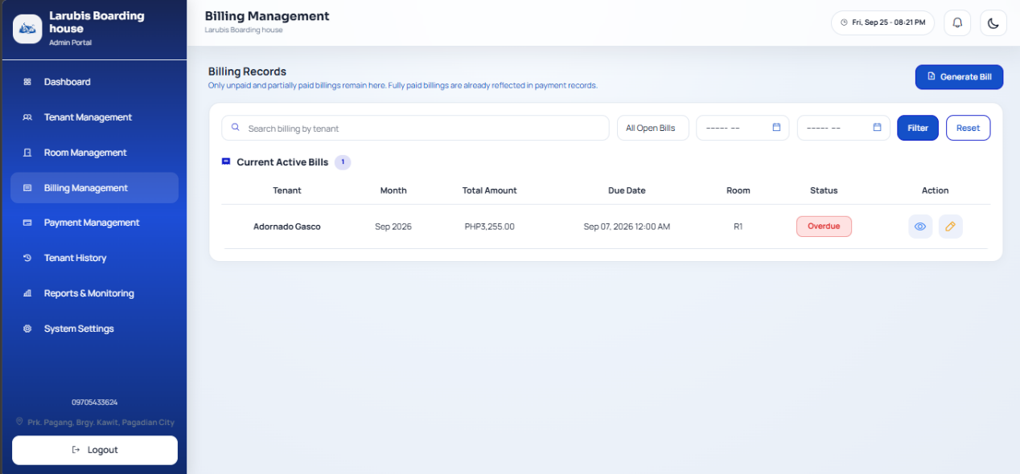

Figure 15. Billing Management Interface
The Billing Management Interface is used to create, review, and manage tenant bills. It displays billing records with charge details, due dates, and payment status. This interface helps the administrator monitor unpaid bills, generate new charges, update billing information, and maintain accurate financial records for each tenant.
- Payment Management Interface
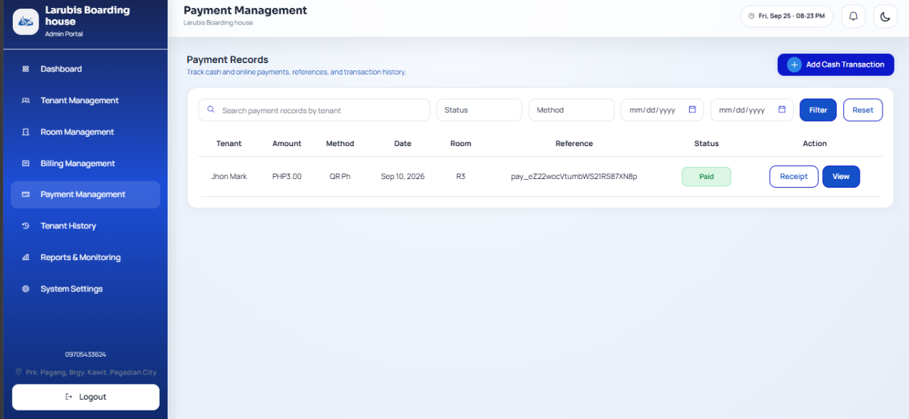

Figure 16. Payment Management Interface
The Payment Management Interface allows the administrator to track and manage payment transactions. It lists payments made by tenants and shows important details such as the related bill, payment amount, payment method, transaction status, and date of payment. This page supports monitoring of settled, pending, or failed payments and helps keep financial records updated.
- Tenant History Interface
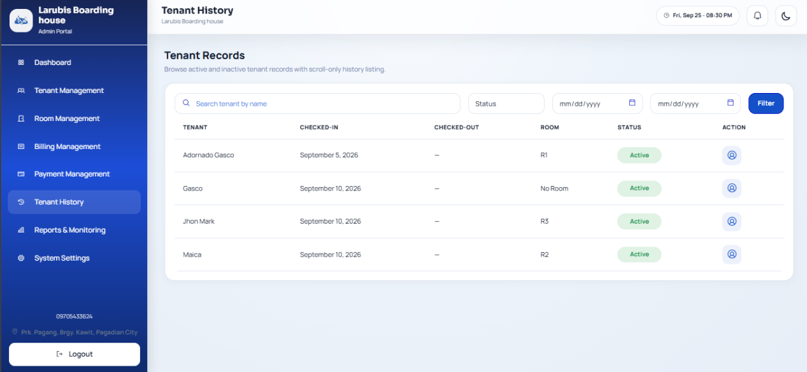

Figure 17. Tenant History Interface
The Tenant History Interface stores records of previous tenant activities and completed tenancy details. It allows the administrator to review tenant information even after checkout. This page is useful for record keeping, tracking previous room assignments, reviewing past payments, and maintaining a history of boarding-house occupancy.
- Reports and Monitoring Interface
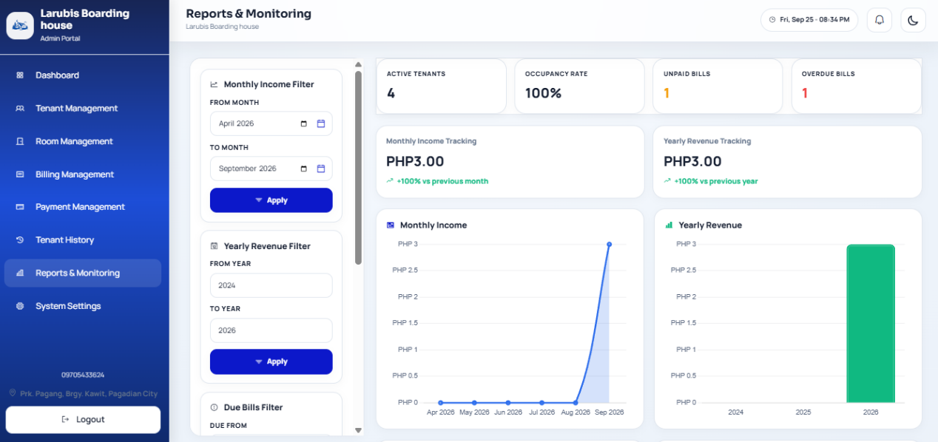

Figure 18. Reports & Monitoring Interface
The Reports and Monitoring Interface provides summarized information about the system's operations. It helps the administrator review occupancy, revenue, billing status, due payments, recent transactions, and other important activity. This page supports decision-making by presenting system data in organized summaries, charts, and filtered report views.
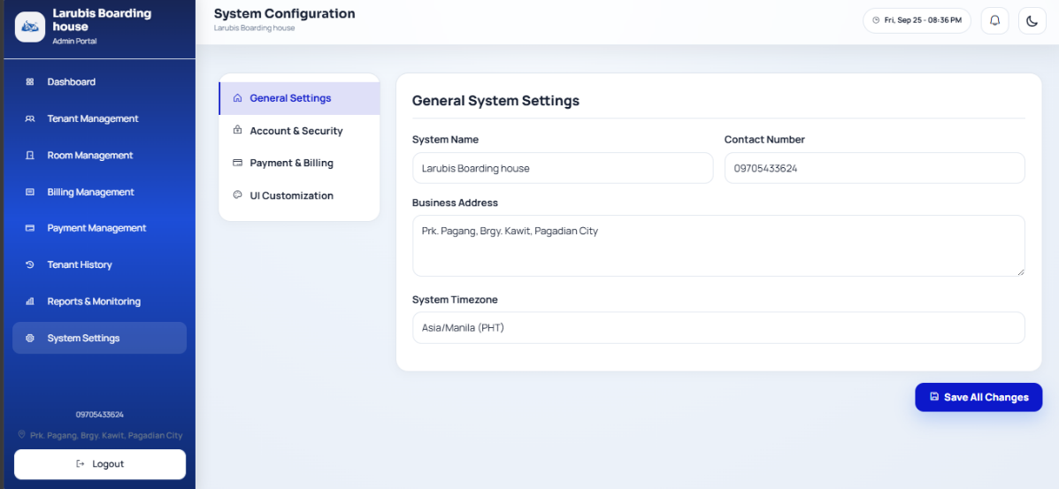
- System Settings Interface

Figure 19. System Settings Interface
The System Settings Interface allows the administrator to configure system-wide options. This may include organization information, security preferences, billing rules, SMS reminder settings, and visual appearance settings. Changes made on this page affect how the system behaves and how information is displayed to users.

- Tenant Bills Interface
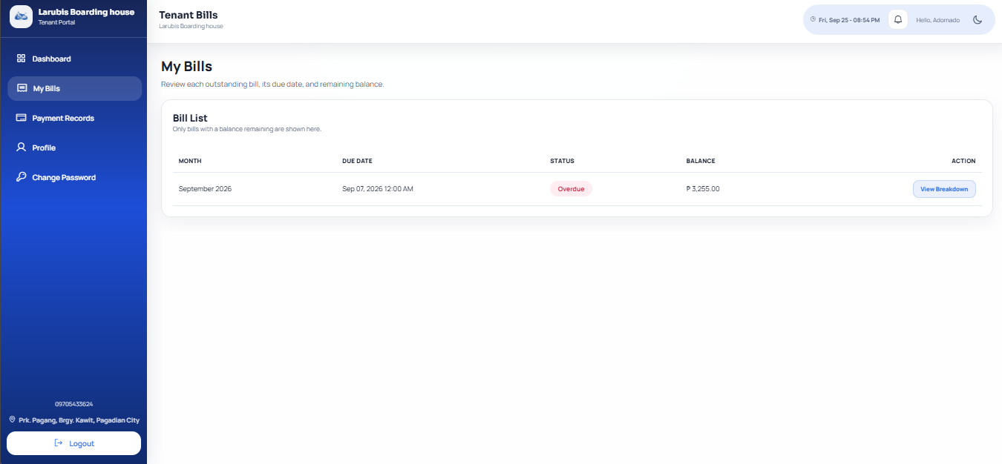

Figure 20. Tenant Bill Interface
The Tenant Bills Interface allows tenants to view their billing records. It displays generated bills, amounts due, due dates, billing status, and payment options. Tenants use this page to check outstanding balances, review previous charges, and proceed to payment when a bill is still unpaid.
15. Tenant Payment Interface
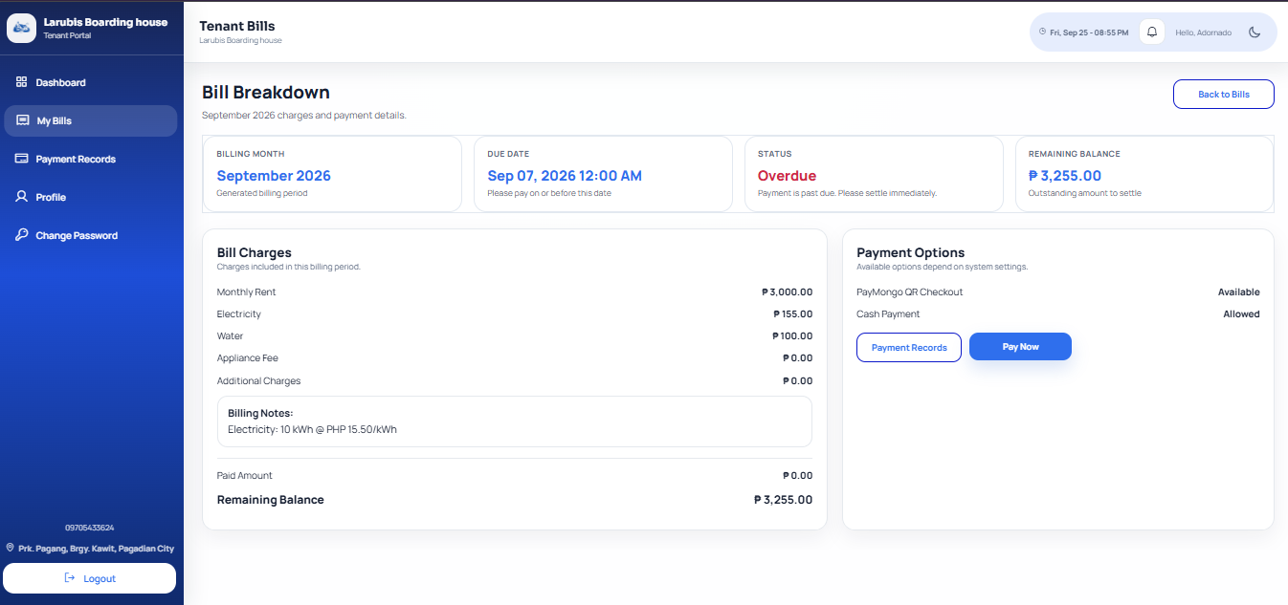

Figure 21. Tenant Payment Interface

The Tenant Payment Interface is used by tenants to pay an outstanding bill. It presents the selected bill details and the payment instructions required to complete the transaction. If QR payment is available, the page may show a QR code or related payment area. The tenant can follow the instructions and submit the payment information for recording or confirmation.

16. Tenant Payment History and Receipt Interface
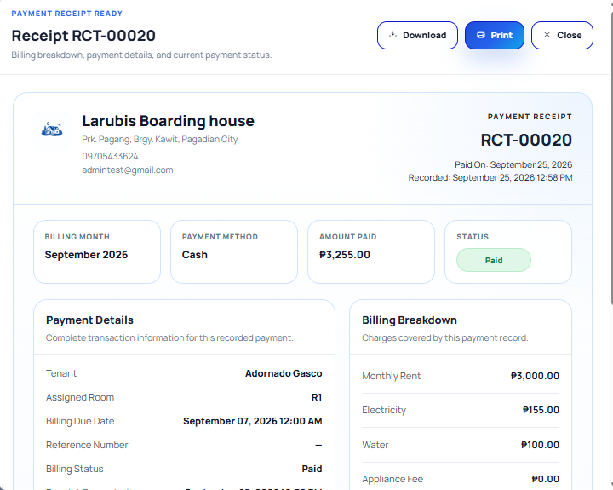

Figure 22. Receipt Interface
The Tenant Payment History and Receipt Interface allows tenants to review previous payment transactions. It shows payment details such as amount paid, payment date, payment method, and related bill information. When receipts are available, the tenant can use this page to view or download proof of payment for personal records.

17. Tenant Profile Interface

Figure 23. Tenant Profile Interface
The Tenant Profile Interface displays the tenant's personal account information. Depending on system permissions, tenants may update selected details such as contact information, address, emergency contact, or profile photo. This page helps keep tenant records accurate and current.
18. Room Change Request Interface
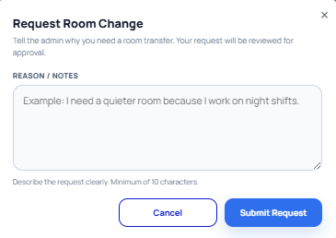

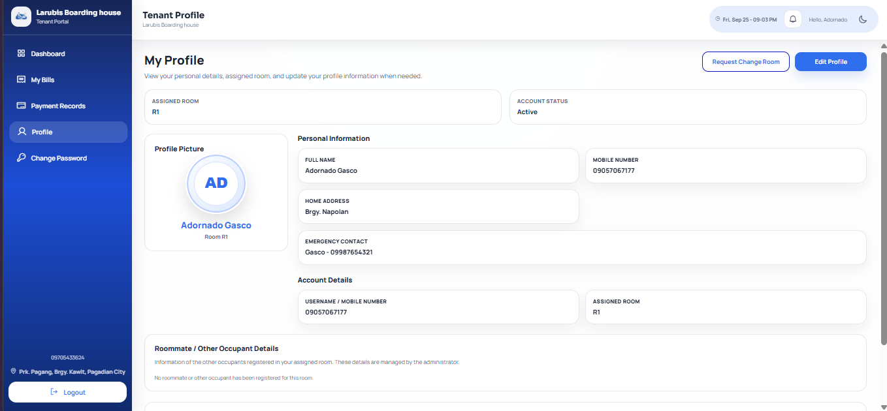

Figure 24. Room Change Request Interface
The Room Change Request Interface allows tenants to submit a request to move to another room. The form may show the tenant's current room, requested room details, reason for the request, and request status. After submission, the administrator can review the request and decide whether to approve or reject it based on room availability and boarding-house rules.

End of User GUI Guide

SYSTEM USER GUIDE MANUAL

Larubis Boarding House System

Prepared By:

Jean Claude C. Ciena
West Prime Horizon Institute Inc.
September 10, 2026

Table of Contents

1. Introduction
2. System Overview
3. System Requirements
4. User Access and Authentication
5. Interface Overview
6. Administrator Procedures
7. Tenant Procedures
8. Reports and Records Management
9. Troubleshooting Guide
10. Frequently Asked Questions
11. Contact and Support Information

- Introduction

  - About This Manual

This guide explains how to use the Larubis Boarding House System, a web-based system for boarding-house operations. It provides procedures for administrators and tenants, describes each major page, and identifies the screenshot required at each point.

1.2 Purpose of the System
The system is designed to:
- Maintain organized tenant, room, billing, and payment records.
- Monitor room availability and occupancy.
- Generate tenant bills and record cash or electronic payments.
- Let tenants view their bills, pay through the available QR payment flow, view receipts, update permitted profile details, and request a room change.
- Provide operational monitoring, tenant history, notifications, and configurable billing reminders.

1.3 Intended Users
User type | Main responsibilities
Administrator Manages rooms, tenant accounts, billing, payments, reports, history, notifications, and system settings. |
Tenant Views assigned-room and billing information, pays outstanding bills, reviews payment records, maintains profile details, and submits room-change requests.
2. System Overview
2.1 System Description
Larubis Boarding House System centralizes day-to-day boarding-house administration. Access is role-based: an administrator is taken to the Admin Portal, while a tenant is taken to the Tenant Portal. Each user sees only the functions relevant to their role.

2.2 Key Features
- Room directory with availability, occupancy, maintenance status, type, and monthly rent.
- Tenant creation, profile management, room assignment, password reset, checkout, and history.
- Bill generation with rent, utility, appliance, and additional charges.
- Cash and supported electronic payment recording; tenant QR payment and receipts.
- Payment and room-change notifications.
- Reports for occupancy, revenue, billing status, upcoming dues, recent payments, and login activity.
- Configurable organization, security, billing, SMS reminder, and visual settings.
2.3 System Workflow
Login
↓
Role-based dashboard
↓
Administrator: rooms → tenants → bills → payments → reports/history
Tenant: dashboard → My Bills → Pay Now → confirmation → receipt

3. System Requirements
3.1 Hardware Requirements
Requirement | Recommended Specification
Computer or Mobile Devices | Modern desktop/laptop, tablet, or smartphone
Processor | Dual-core 2.0 GHz or better
RAM | 4GB minimum; 8GB recommended
Storage | At least 200mb free space for browser files and downloads.
Internet | Stable connection required for access, SMS-dependent recovery, and online QR Payments.

3.2 Software Requirements
Software | Requirement
Operating System | Windows 10/11, macOS, Linux, Android, or iOS
Browser | Latest Google Chrome, Microsoft Edge, Mozilla Firefox, or Safari

4. User Access and Authentication
4.1 Login Page
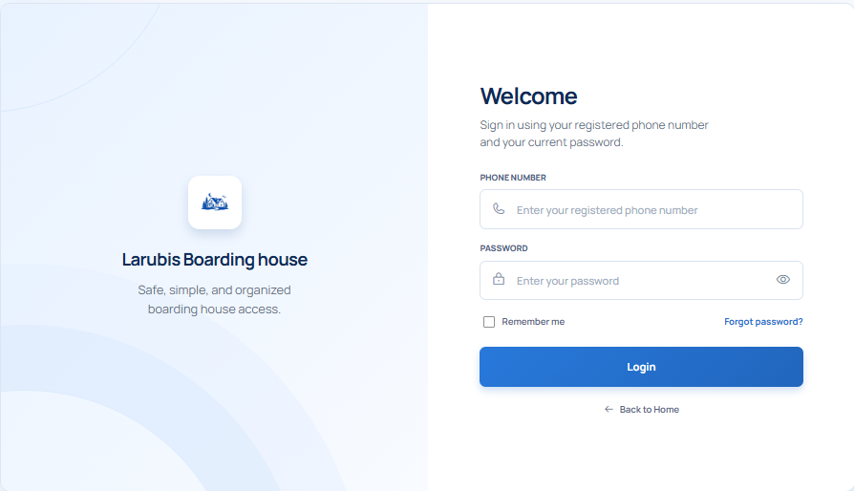

Figure 25. Login Interface
Component | Description
Phone Number | Enter the registered 11-digit mobile number.
Password | Enter the current account password. Use the eye icon to show or hide it.
Remember me | Keeps the browser session available on a trusted personal device. Do not use on a shared computer.
Forgot password? | Starts password recovery using the registered mobile number and SMS verification.
Login | Validates credentials and directs the user to the proper portal.

How to log in?
1. Open the system URL in a supported browser.
2. Enter the registered phone number.
3. Enter the password.
4. Optionally select Remember me only on a private, trusted device.
5. Click Login.
6. If the account is set to use a temporary password, follow the password-change prompt before continuing.
7. The system opens the Admin Portal or Tenant Portal according to the account role.

4.2 First Login or Password Change
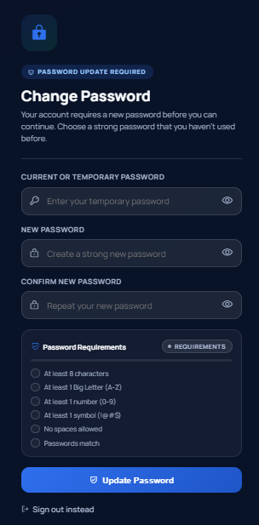

Figure 26. First Time Login Change Password Page
1. Enter the temporary or current password.
2. Enter a new password that meets the displayed requirements.
3. Re-enter the new password for confirmation.
4. Select the button to save or update the password.
5. Log in again if prompted.

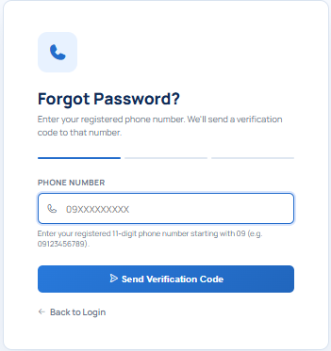
4.3 Forgot Password (SMS Recovery)

Figure 27. SMS Recovery Password
1. On the Login page, click Forgot Password?.
2. Enter the mobile number registered to the account and submit it.
3. Enter the verification code sent through SMS.
4. Set and confirm a new password.
5. Return to the Login page and sign in using the new password.

5. System Interface Overview
5.1 Administrator Interface
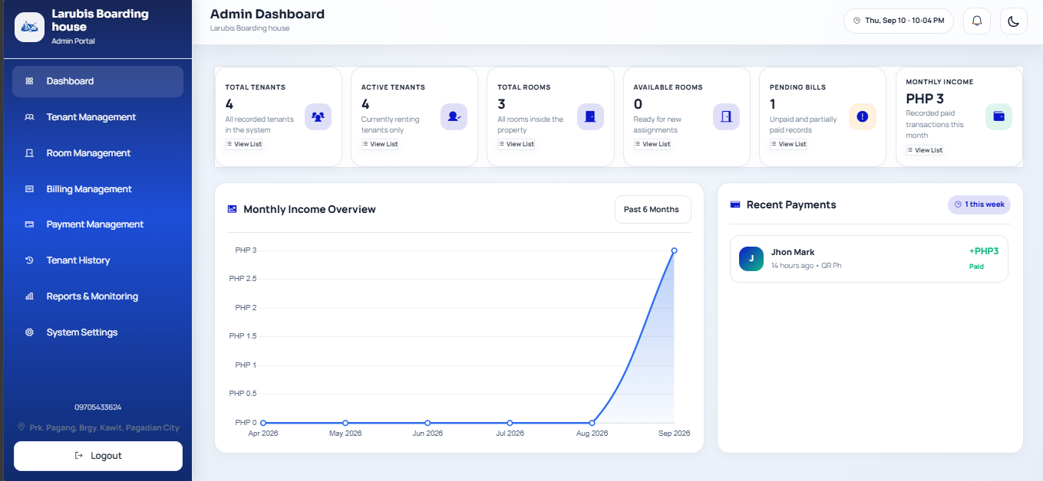

Figure 28. Administrator Dashboard
Area | Description
Sidebar | Opens Dashboard, Tenant Management, Room Management, Billing Management, Payment Management, Tenant History, Reports & Monitoring, System Settings, and Logout.
Summary Cards | Present totals such as rooms, available/occupied rooms, tenants, pending bills, and current-month income. Cards may open supporting details.
Income chart | Displays settled payment totals for the selected period.
Recent payments | Lists recently settled payments for quick monitoring.
Notification bell | Shows payment alerts and tenant room-change requests.
Theme Toggle | Switches the interface between light and dark appearance.

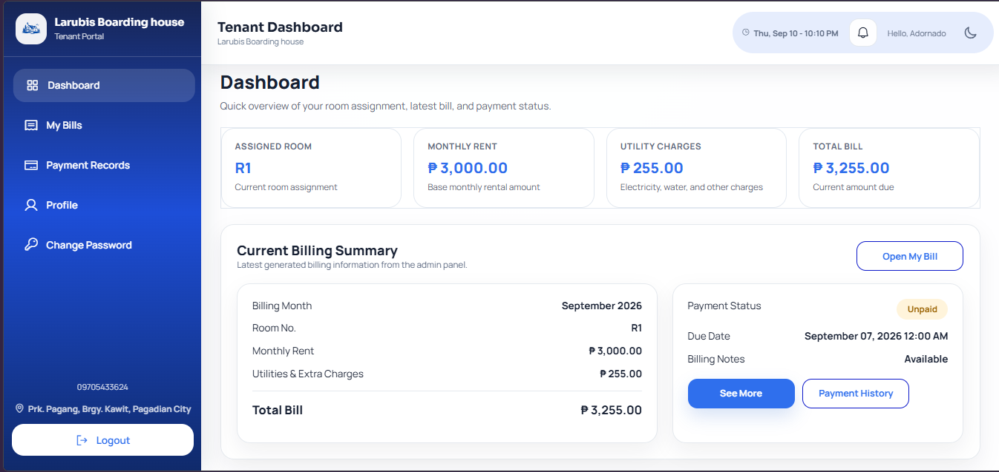
5.2 Tenant Interface

Figure 29. Tenant Dashboard
Area | Description
Dashboard Cards | Show the current room, rent, utility charges, and latest total bill.
Current Billing Summary | Shows the latest generated bill, due date, status, and available actions.
My Bills | Opens full billing details and the payment action for outstanding bills.
Payment History | Opens the tenant’s recorded transactions and receipts.
Notification bell | Shows billing and room-request updates, when available.

6. Administrator Procedures
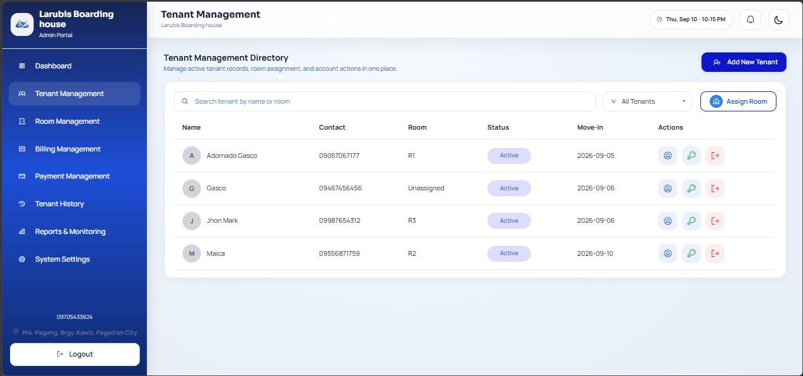
6.1 Tenant Management

Figure 30. Tenant Management Directory
Add a Tenant
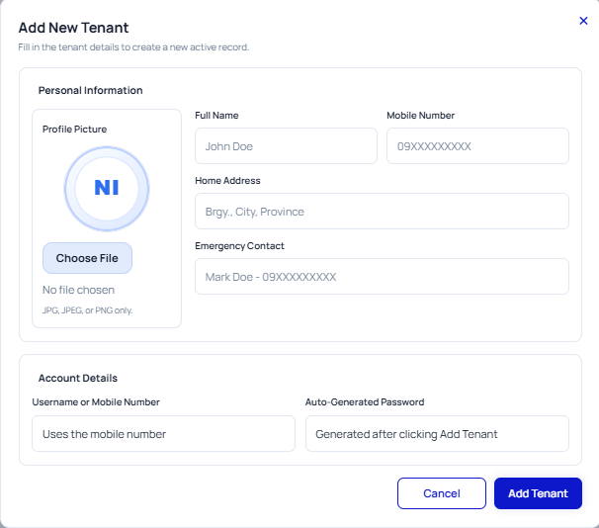

Figure 31. Add New Tenant Form
1. Open Tenant Management from the sidebar.
2. Click Add New Tenant.
3. Complete the tenant’s name, 11-digit phone number, address, and emergency contact. Add a profile photo if needed.
4. Verify that the phone number belongs to the tenant; it is used for login and SMS recovery.
5. Click Add Tenant.
6. Record the displayed temporary password securely and give it only to the tenant. The tenant must change it upon first login.

Assign a room and roommates
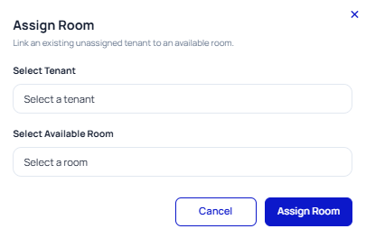

Figure 32 Assign Room Form
1. Click Assign Room.
2. Select an active, unassigned tenant.
3. Select an available room compatible with the required occupancy.
4. Enter roommate/other occupant details when applicable.
5. Click Assign Room and verify the room and tenant status in their directories.

Edit, reset password, or check out a tenant
1. Use the search box or assignment filter to locate the tenant.
2. Select the profile/edit icon to update personal information, photo, or roommate details, then click Save Changes.
3. To reset a tenant password, select the key/reset icon and confirm. Give the generated temporary password securely to the tenant.
4. To check out a tenant, select the checkout icon and confirm. The account becomes inactive, the room becomes available, and the record is retained in Tenant History.
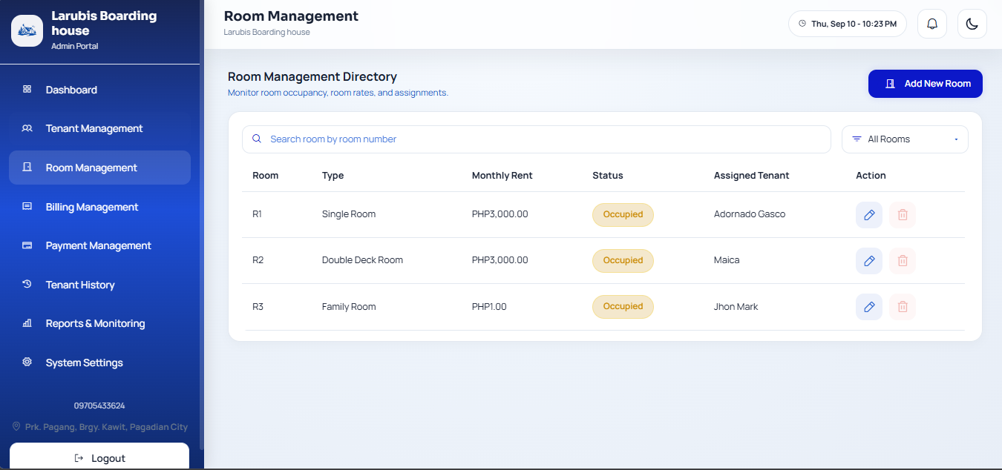
6.2 Room Management

Figure 33. Room Management Directory and Add Room Form
Add or update a room
1. Open Room Management.
2. Click Add New Room.
3. Enter the room number, room type, monthly rent, and current status.
4. Click Add Room.
5. To modify a room, click its edit icon, revise the required fields, and save.

Search, filter, or delete a room
1. Enter a room number in the search box to find a record.
2. Use the status filter for Available, Occupied, or Maintenance rooms.
3. Use the delete icon only for an unoccupied room and confirm the action.
4. Do not change an occupied room to an unavailable status unless the tenant is intentionally being unassigned; the system removes its assignment in that situation.

6.3 Billing Management
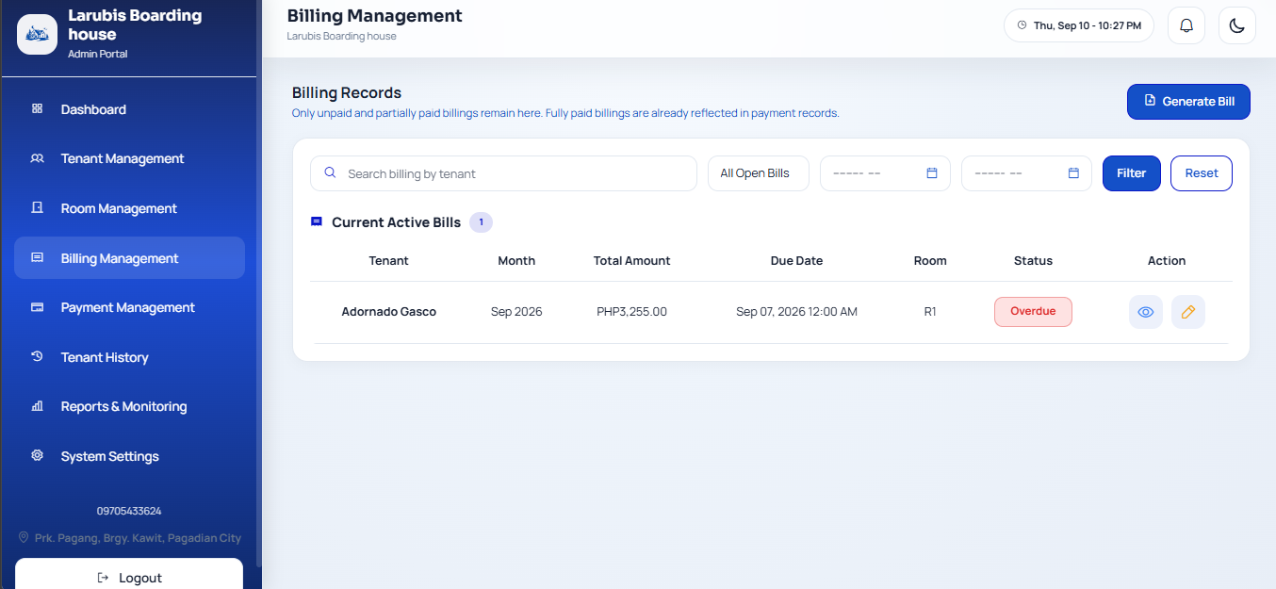

Figure 34. Billing Records and Generate Bills Form
Generate bills
1. Open Billing Management and click Generate Bill.
2. Select the billing month and set the due date/time.
3. For each intended tenant, review monthly rent and enter applicable electricity usage/charge, water, appliance fee, additional charges, and notes.
4. Review the calculated total for each selected tenant.
5. Submit the form to generate the bills.
6. Confirm the new entries appear in the active billing list. The system prevents duplicate bills for the same tenant and billing month.
Review or update an open bill
1. Use the tenant search, status filter, or month filters to find the bill.
2. Click the eye icon to view bill details.
3. Click the edit icon to change an open bill, then save the revised details.
4. Paid bills are reflected in Payment Management rather than the active-bills list.
6.4 Payment Management
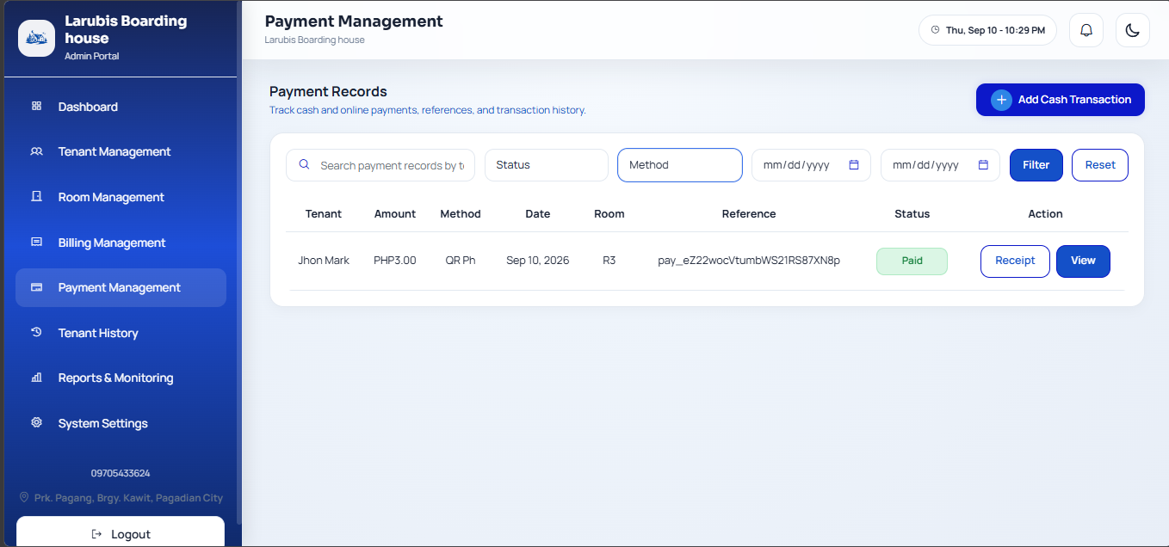

Figure 35. Payment Management and Record Payment Form
Record an administrator-received payment
. Open Payment Management.
2. Select Record Payment (or the equivalent add-payment control).
3. Select the tenant’s open billing record.
4. Enter the amount received, payment method, payment date, optional reference number, and notes.
5. Save the payment.
6. Review the generated receipt. The system updates the bill to Partially Paid or Paid based on the remaining balance.

Find a payment or receipt
1. Use search and the status, method, and date filters to narrow the transactions.
2. Open the receipt/view action for the required payment.
3. Verify tenant, room, bill, amount, method, date, and reference information before printing or sharing the receipt.

6.5 Notifications and Room Change Requests
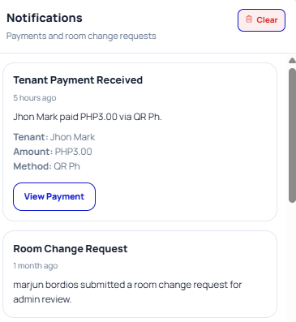

Figure 36. Administrator Notifications
1. Click the notification bell in the top bar.
2. Review payment notifications, or read the tenant’s current room and stated reason for a room-change request.
3. For a pending room request, select a suitable available room.
4. Add an optional administrator note.
5. Click Approve to reassign the tenant, or Reject to decline the request.
6. Use Clear only after reviewing notifications; clearing removes them from the notification list.

6.6 Tenant History
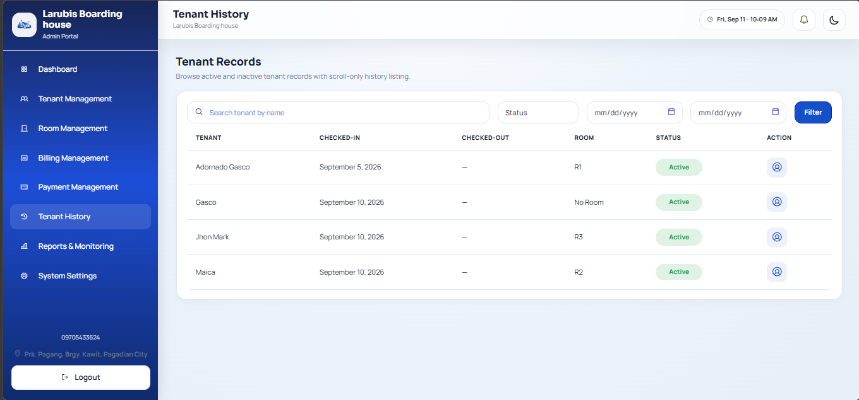

Figure 37. Tenant History Directory
1. Open Tenant History.
2. Search by tenant name or filter by account status and check-in/check-out date range.
3. Select the profile-view action to open a tenant’s record.
4. Use the available report-generation or reactivation action only when authorized. Reactivated tenants may still need room assignment and must change their temporary password on next login.

8. Reports and Records Management
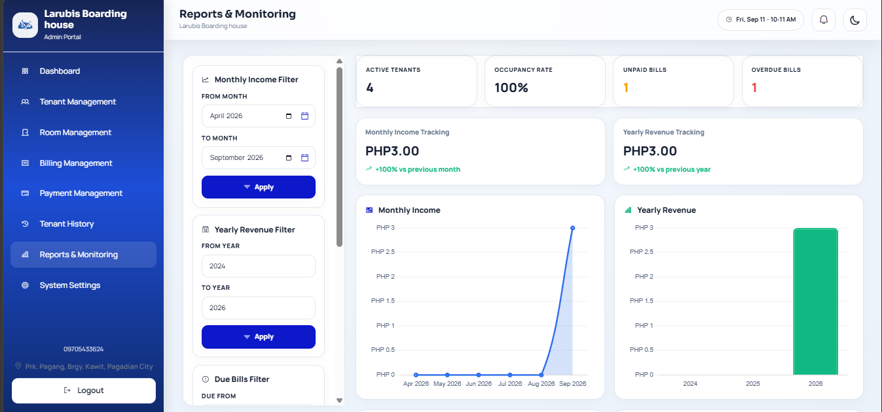
8.1 Reports and Monitoring

Figure 38. Reports & Monitoring
Report Area | Use
Occupancy | View total/occupied rooms and occupancy rate.
Monthly income | Review settled payment totals across a chosen monthly range.
Yearly revenue | Compare settled revenue across selected years.
Billing status | Monitor unpaid, partially paid, paid, and overdue billing records.
Due bills | Review bills due within the selected date range.
Recent payments | Check recently settled tenant payments.
Login activity | Review successful and failed login entries; filter by type.

Use report filters
1. Open Reports & Monitoring.
2. Choose the relevant month, year, due-date, or login-log filters.
3. Apply the filter controls on the page.
4. Review the resulting charts and lists.
5. Clear login logs only when authorized by the organization’s audit policy.

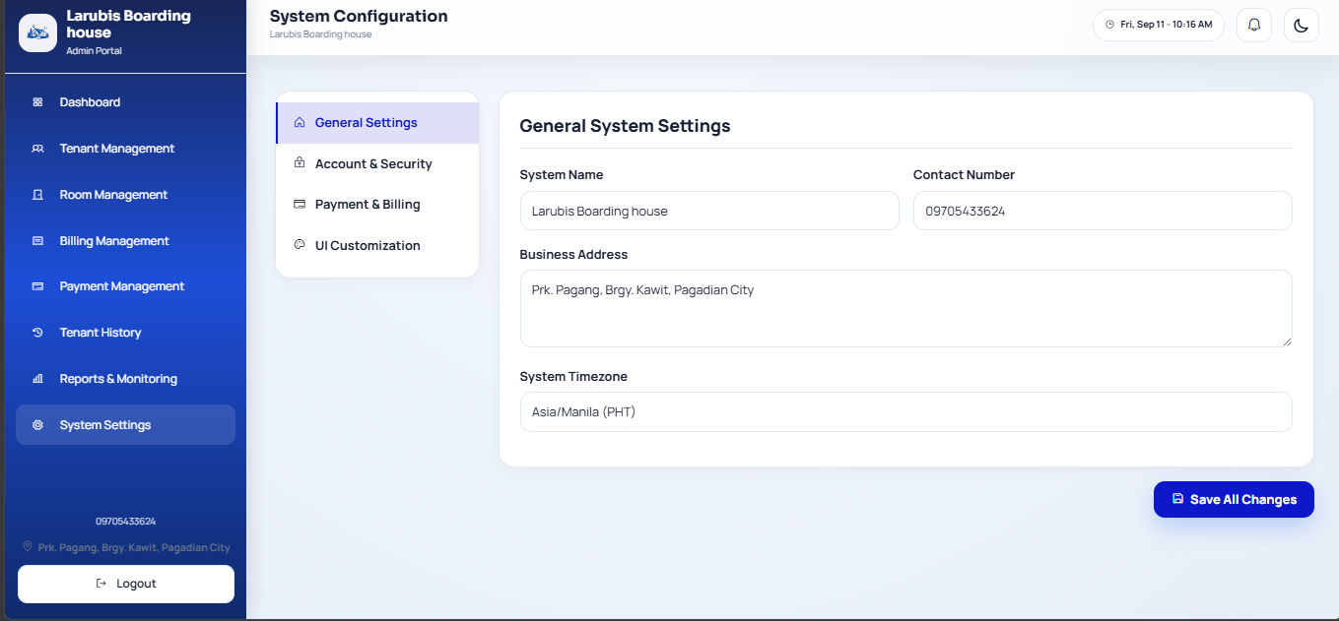
9. System Settings

Figure 39. System Settings
1. Open System Settings.
2. Update general details such as boarding-house name, contact details, address, or time zone as authorized.
3. Review account and security settings before changing the administrator phone number or password.
4. Configure billing rate, schedule, due date/time, and reminder options carefully; these values affect generated bills and messages.
5. Configure SMS reminder templates only with the supported placeholders shown by the page.
6. Use UI customization to change the primary color or upload a valid logo if required.
7. Click Save Changes and verify the confirmation message.
8. Use cache clearing only when a setting or interface update is not appearing as expected. Use database backup only according to the organization’s backup procedure.

10. Tenant Procedures
10.1 View Bills and Pay Online
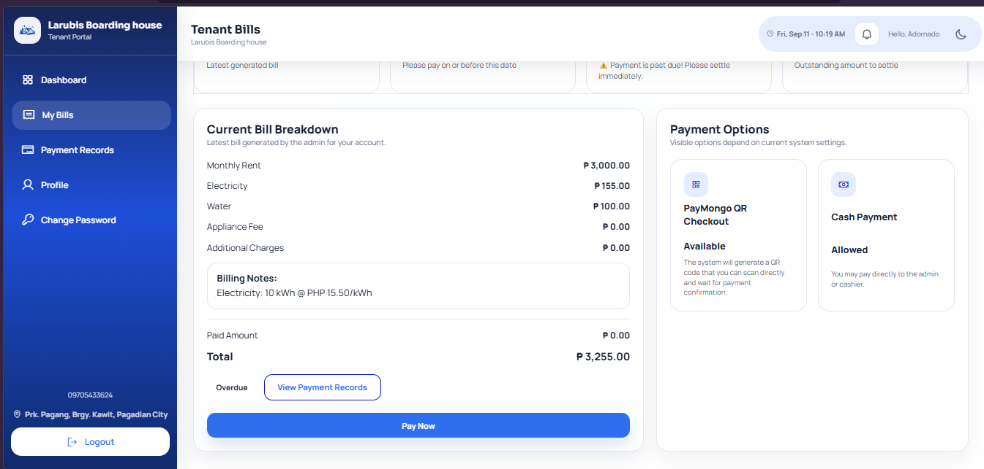

Figure 40. My Bills Page
1. Open My Bills from the tenant navigation or click My Bills on the dashboard.
2. Review the billing month, room, rent, utilities, other charges, total, due date, and status.
3. If the bill is correct and outstanding, click Pay Now.

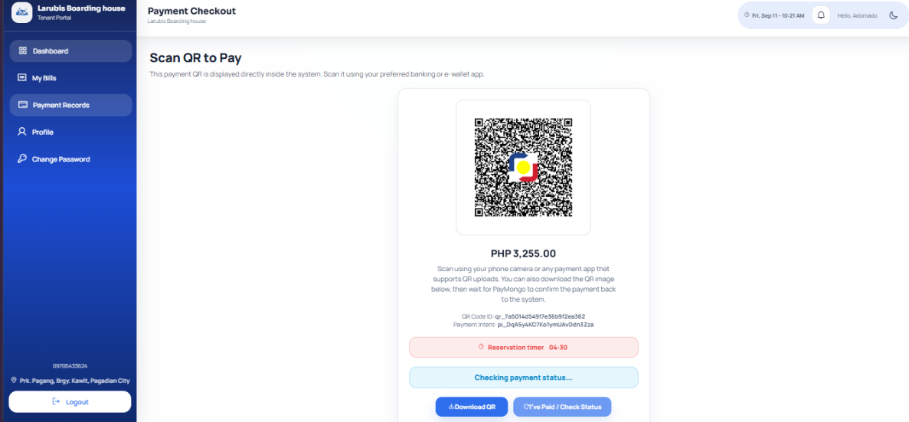

Figure 41. QR Payment Checkout
4. Scan the QR code with a supported payment application, or use Download QR if needed.
5. Complete payment in the payment application.
6. Return to the checkout page and click Check Payment Status. Do not pay twice while confirmation is still pending.
7. When payment is confirmed, the system redirects to Payment Records and makes the receipt available.
10.2 View Payment Records and Receipt
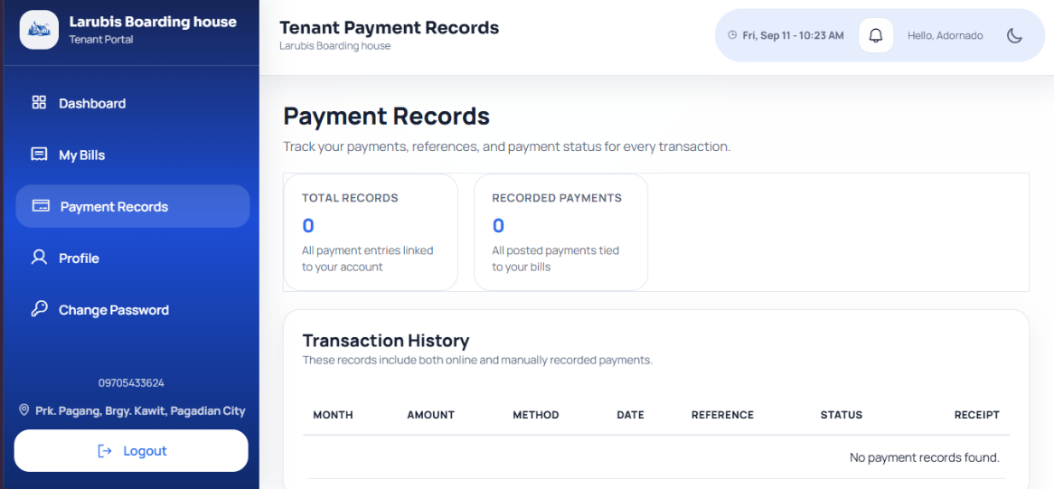

Figure 42. Tenant Payment Records
1. Open Payment History.
2. Review the transaction date, billing reference, amount, payment method, and status.
3. Click View Receipt for a transaction.
4. Review the receipt details and save or print it where permitted.

10.3 Update Profile and Roommate Details
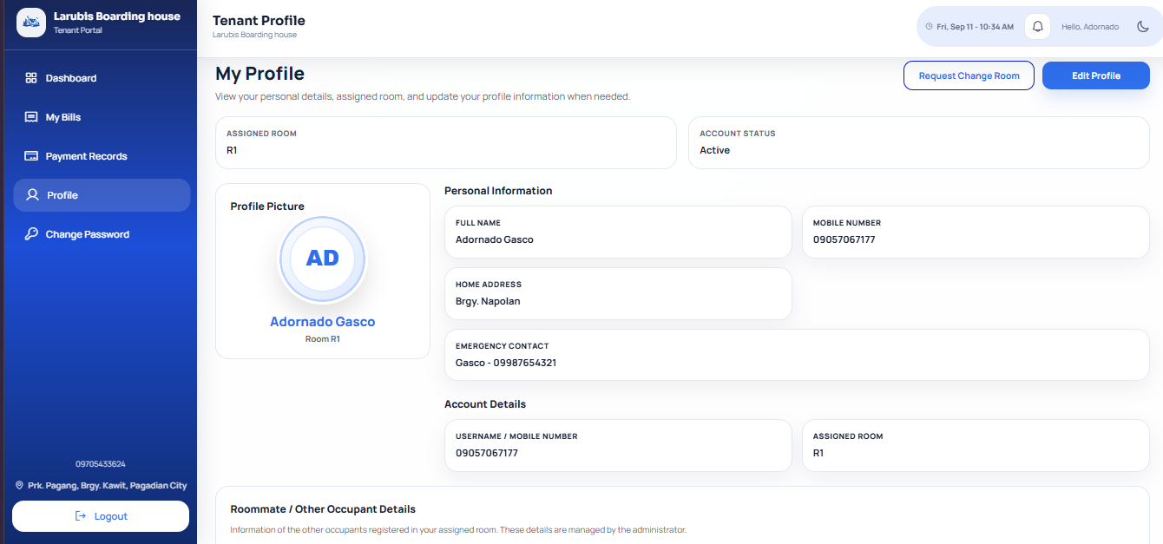

Figure 43. My Profile and Edit Profile
1. Open My Profile.
2. Click Edit Profile.
3. Update allowed information such as address, emergency contact, or profile photo.
4. Click Save Changes.
5. Review the Roommate / Other Occupant Details section when an occupant is registered. These details are read-only for tenants; contact an administrator if a correction is needed.

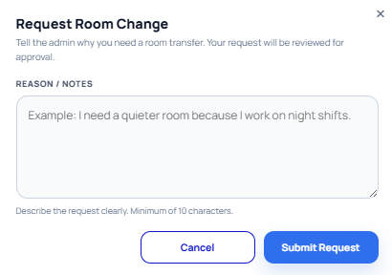
10.4 Request a Room Change

Figure 44. Room Change Request Form
1. Open My Profile.
2. Click Request Room Change.
3. Clearly state the reason for the request.
4. Submit the request.
5. Wait for the administrator’s review. Check notifications for the approval/rejection result and any administrator note.

10.5 Log Out
1. Open the account/menu area in the portal.
2. Select Logout.
3. Confirm when prompted.
4. Close the browser on shared devices.
11. Troubleshooting Guide
Problem | Likely Cause | Solution
Cannot log in | Incorrect phone number/password, inactive account, or temporary-password requirement. | Confirm the registered phone number, re-enter the password, use SMS recovery, or contact the administrator.
SMS code is not received | Incorrect/unregistered phone number, carrier delay, or SMS service issue | Wait briefly, confirm the number, then contact the administrator if it still does not arrive. Never share verification codes.
Tenant cannot be assigned to a room | No compatible available room or tenant already has an assignment. | Check Room Management status, room type/capacity, and tenant assignment first.
Cannot generate a bill | Bill already exists for that tenant/month or required fields are missing. | Select an unbilled month and complete the required billing details.
Payment cannot be recorded | Amount exceeds remaining balance or bill is fully paid. | Verify the open bill and remaining balance; record only the received amount.
QR payment remains pending | Payment provider has not confirmed the transaction. | Use Check Payment Status, wait for provider confirmation, and avoid paying again. Contact the administrator with the payment reference if needed.
Page does not display the latest settings | Browser/server cache | Refresh the page; an authorized administrator may use the cache-clear setting.
Cannot delete a room | Room is occupied or has tenants | Check out or reassign tenants first; occupied rooms cannot be deleted.
Changes are not saved | Missing/invalid required input | Read the validation message, correct the field, then save again.

12. Frequently Asked Questions
Q1. Who creates tenant accounts?
Answer: Administrators create tenant accounts. Tenants receive a temporary password and must change it when first signing in.
Q2. Can a tenant register directly from the login page?
Answer: No. Tenant accounts are created through Administrator Tenant Management.
Q3. What happens after a tenant pays only part of a bill?
Answer: The bill is marked Partially Paid and remains open until the remaining balance is recorded or confirmed.
Q4. Why is a paid bill no longer in Billing Management?
Answer: Billing Management displays open bills. Fully paid transactions are retained in Payment Management and the tenant’s Payment Records.
Q5. Can a tenant choose a new room through a room-change request?
Answer: The tenant submits a reason for the request. The administrator reviews it and selects an appropriate available room when approving it.
Q6. What should be done if a tenant forgets a password?
Answer: Use Forgot password? and complete SMS verification, or ask the administrator to reset the tenant password
Q7. Is it safe to share a QR payment screenshot or receipt?
Answer: Share only when required and hide sensitive QR data, personal phone numbers, and payment references in public documents.

13. Contact and Support Information

For technical assistance, contact:

System Administrator:
[Name]
Email:
[Email]
Contact Number:
[Phone Number]
Support Hours:
[Days and hours]

END OF USER GUIDE MANUAL

REFERENCES
Articles
Encarnacion, R. E., Laulita, F. A. G., Cruiz, H. J. B., & Quinte, J. L. E. (2025). Design and evaluation of an online payment monitoring system for student boarding houses near a university campus in the Philippines. Proceedings of the International Exchange and Innovation Conference on Engineering & Sciences, 11, 1225–1231. https://doi.org/10.5109/7395667
Hamzah, A., & Findawati, Y. (2021). Boarding house information system based on geographic location in Sidoarjo. Procedia of Engineering and Life Science, 1(1). https://doi.org/10.21070/pels.v1i1.866
Pernate, W. J. A., Rosales, D. R. E., Aya-ay, L. A. S., & Artigas, A. L. (2025). BH Niyo App: A smart mobile solution for boarding house room rentals in Ormoc City. Business, Education, Social Sciences, and Technology, 1(2). https://doi.org/10.69478/BEST2025v1n2a013
Rahman, M., & Islam, S. (2025). A digital approach to efficient hostel management: Development of a web-based hostel management system. Bangladesh Journal of Computer Applications, 12(1), 45–55. Retrieved from https://www.researchgate.net/publication/394284043_A_Digital_Approach_to_Efficient_Hostel_Management
Journals
Bisquera, C. A. D., Perdido, V. G., & Mendoza, N. A. M. (2026). Smart accommodation solution: Innovative boarding house locator in Bayombong municipality. International Journal of Informatics and Communication Technology, 15(1), 1–12. https://doi.org/10.11591/ijict.v15i1.pp1-12
Kurnia, Z. Y., & Wijaya, M. C. (2024). Web-based information system for boarding house information. International Journal of Scientific Research and Management, 12(3), 1098–1104. https://doi.org/10.18535/ijsrm/v12i03.ec11
Manalu, E. L., & Dongka, R. H. (2025). Development of a web-based boarding house information system in Sorong Regency using PHP and MySQL. International Journal of Embedded Computer Engineering, 1(1), 12–30.

Yadhav, U., Savant, S., Yaragatti, M., Kumbar, P., & Ganiger, N. (2025). House rental management system. International Journal of Research Publication and Reviews, 6(12), 3618–3621.


PERSONAL INFORMATION

Name: Jean Claude C. Ciena
Age: 21
Gender: Male
Date of Birth: December 30, 2004
Status: Single
Citizenship: Filipino
Religion: Born Again
Address: Dao, Pagadian City, Zamboanga Del Sur
Father's Name: Dionisio G. Ciena
Occupation: Truckman
Mother's Name: Gina C. Ciena
Occupation: Self-Employed
Educational Attainment | School Name | Year Graduated
Elementary | Dao Elementary School | 2016
Junior High School | Pagadian City National Comprehensive High School | 2021
Senior High School | Liceo De Cagayan University | 2023
College | West Prime Horizon Institute Inc.  Course: Bachelor of Science in Information Technology | Present


PERSONAL INFORMATION

Name: Marelou G. Apao
Age: 35
Gender: Female
Date of Birth: March 13, 1991
Status: Single
Citizenship: Filipino
Religion: Roman Catholic
Address: San Pedro, Masanagon 1 Pagadian City
Father's Name: Ronie H. Apao
Occupation: Disease
Mother's Name: Erlinda M. Gonzaga
Occupation: Vendor
Educational Attainment | School Name | Year Graduated
Elementary | San Pedro Central Elementary School | 2003
Junior High School | Zamboanga Del Sur National High School, San Pedro Annex | 2007
Senior High School | Zamboanga Del Sur National High School, San Pedro Annex | 2007
College | West Prime Horizon Institute Inc.  Course: Bachelor of Science in Information Technology | Present


PERSONAL INFORMATION

Name: Junel Jay I. Caberte
Age: 21
Gender: Male
Date of Birth: April 18, 2005
Status: Single
Citizenship: Filipino
Religion: Church of God
Address: Mecolong, Dumalinao, Zamboanga Del sur
Father's Name: Eduardo B. Caberte Jr
Occupation: Driver
Mother's Name: Gina I. Iniego
Occupation: Housewife
Educational Attainment | School Name | Year Graduated
Elementary | Mecolong Elementary School | 2016
Junior High School | Mecolong National High School | 2021
Senior High School | Mecolong National High School | 2023
College | West Prime Horizon Institute Inc.  Course: Bachelor of Science in Information Technology | Present


PERSONAL INFORMATION

Name: John Mark R. Medina
Age: 21
Gender: Male
Date of Birth: June 20, 2005
Status: Single
Citizenship: Filipino
Religion: Catholic
Address: Lumbia Disct., Pagadian City, Zamboanga Del sur
Father's Name: Mardie D. Medina
Occupation: Driver
Mother's Name: Jovie R. Medina
Occupation: Housewife

Educational Attainment | School Name | Year Graduated
Elementary | Camp Abelon Elementary School | 2016
Junior High School | Zamboanga Del Sur National High School | 2021
Senior High School | Zamboanga Del Sur National High School | 2023
College | West Prime Horizon Institute Inc.  Course: Bachelor of Science in Information Technology | Present


PERSONAL INFORMATION

Name: Paula Katrina L. Amar
Age: 20
Gender: Female
Date of Birth: September 13, 2005
Status: Single
Citizenship: Filipino
Religion: Born Again
Address: Anonang, Dumalinao, Zamboanga Del Sur
Father's Name: Ramil P. Amar
Occupation: Laborer
Mother's Name: Marina L. Amar
Occupation: OFW
Educational Attainment | School Name | Year Graduated
Elementary | Anonang Elementary School | 2016
Junior High School | Norberta Guillar Memorial National High School | 2020
Senior High School | Norberta Guillar Memorial National High School | 2023
College | West Prime Horizon Institute Inc.  Course: Bachelor of Science in Information Technology | Present


PERSONAL INFORMATION

Name: Marjun P. Bordios
Age: 25
Gender: Male
Date of Birth: March 4, 2001
Status: Single
Citizenship: Filipino
Religion: Catholic
Address: Napolan, Pagadian City Zamboanga Del sur
Father's Name: Enerio L. Bordios
Occupation: Construction Worker
Mother's Name: Suzette S. Pedrosa
Occupation: Housewife
Educational Attainment | School Name | Year Graduated
Elementary | Napolan Elementary School | 2016
Junior High School | Napolan National High School | 2020
Senior High School | Napolan National High School | 2022
College | West Prime Horizon Institute Inc.  Course: Bachelor of Science in Information Technology | Present

