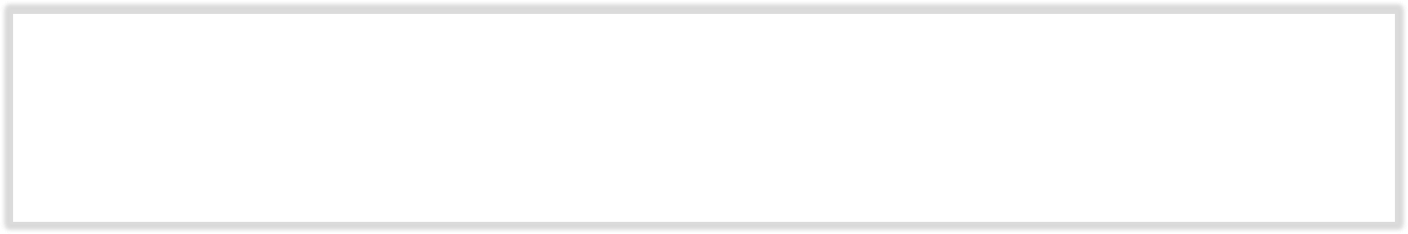

**Name**

**: Rajkumar B L**

**Reg.No : 2047120**

**Course : MCS 272 Mobile Application (App-Cycle) Cycle)**

Output:

# Welcome_App Created 2. Welcome_App Started

Note : Activity 2 welcome screen displays avatar of some students from 2 mcs. Clicking on a specific avatar switches to activity 3 displaying respective avatars details.

# 3.Welcome_App Paused 4. Welcome_App Started

# 5.Welcome_App Stopped 6. Welcome_App Destroyed

# A picture containing text Description automatically generated7.Cookie_App Created 8. Cookie_App Started

# 9.Cookie_App Paused 10. Cookie_App Resumed

**Log-Cat**

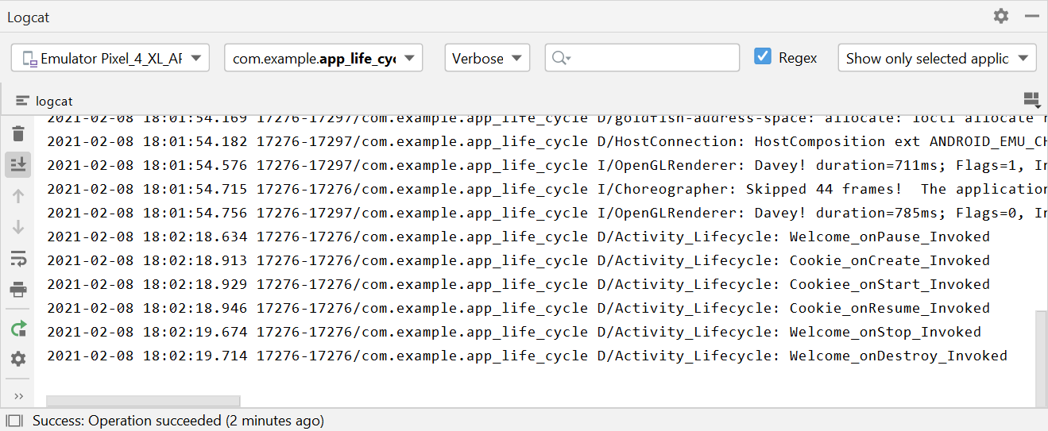

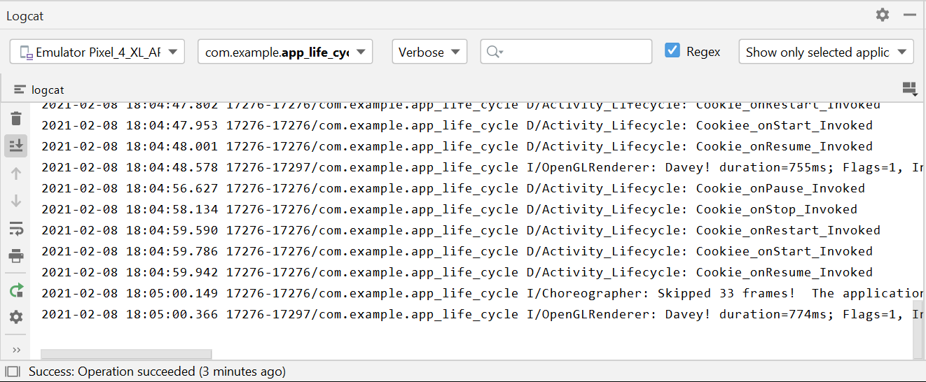

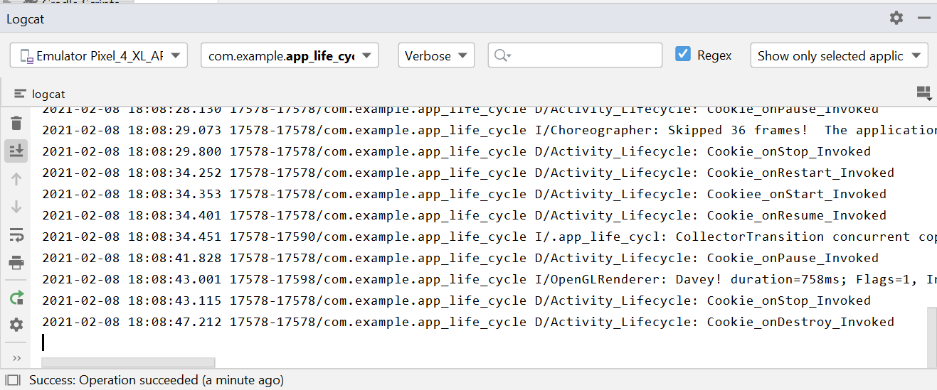

**The code used in the Main Activity, XML layout is attached below for reference.**