

**Name**

**: Rajkumar B L**

**Reg.No : 2047120**

**Course : MCS 272 Mobile Application (Program 03)**

Output:

# 1. Welcome Screen 2.Invalid Login Credintials.

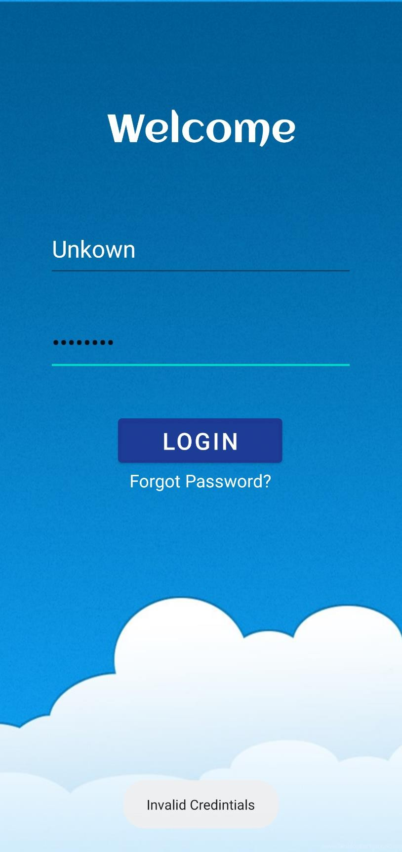

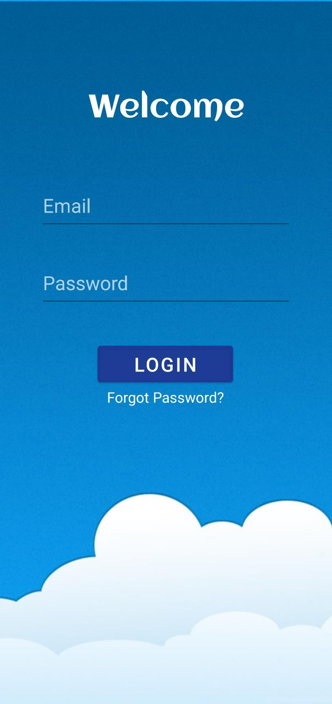

Note : Activity 2 welcome screen displays avatar of some students from 2 mcs. Clicking on a specific avatar switches to activity 3 displaying respective avatars details.

# 3. Correct Login Credintials. 4. Activity 2 welcome screen.

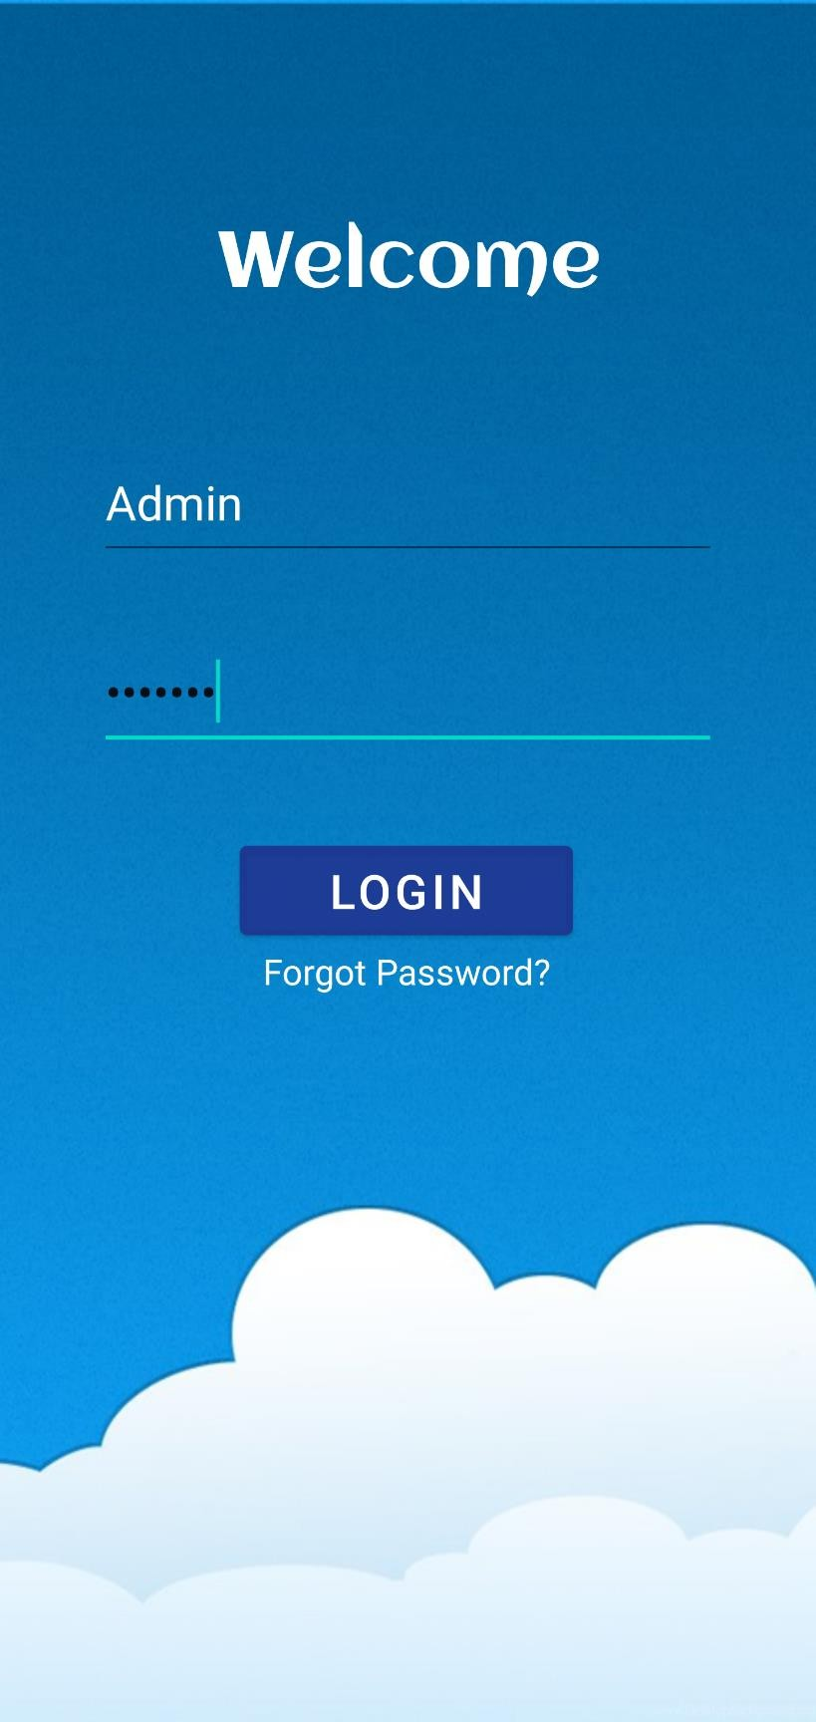

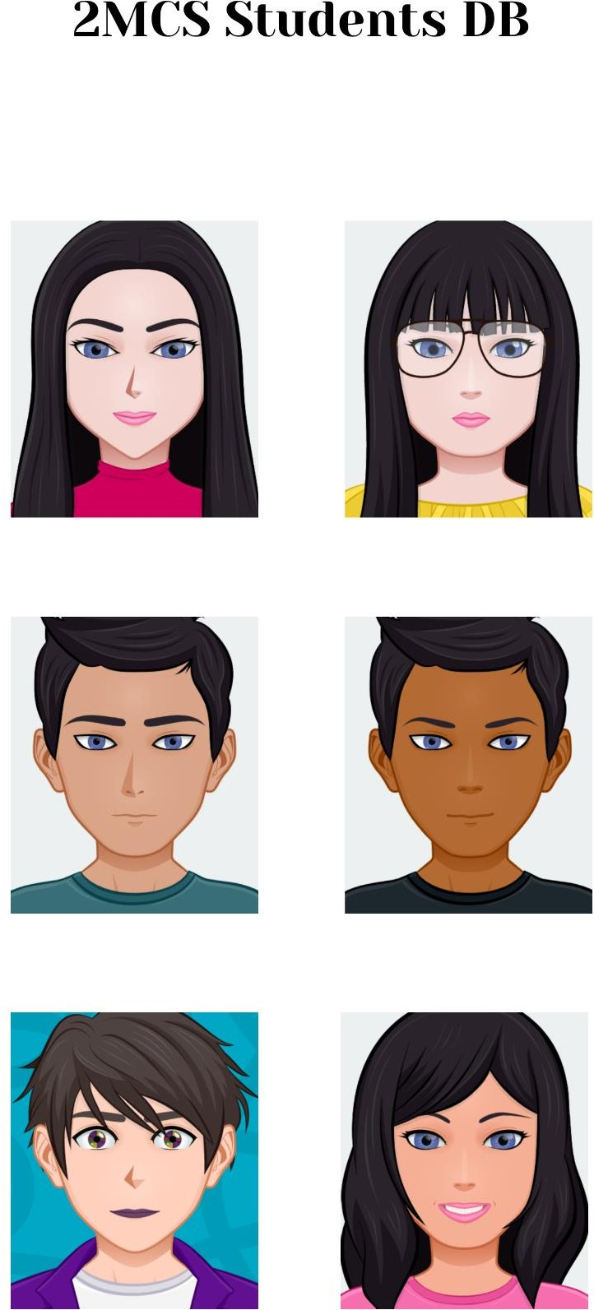

5. Raj avatar takes to respective details in activity 3. 6. Clicking on Raj phone icon – takes to dial pad.

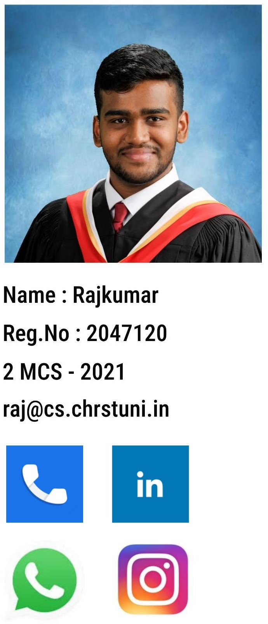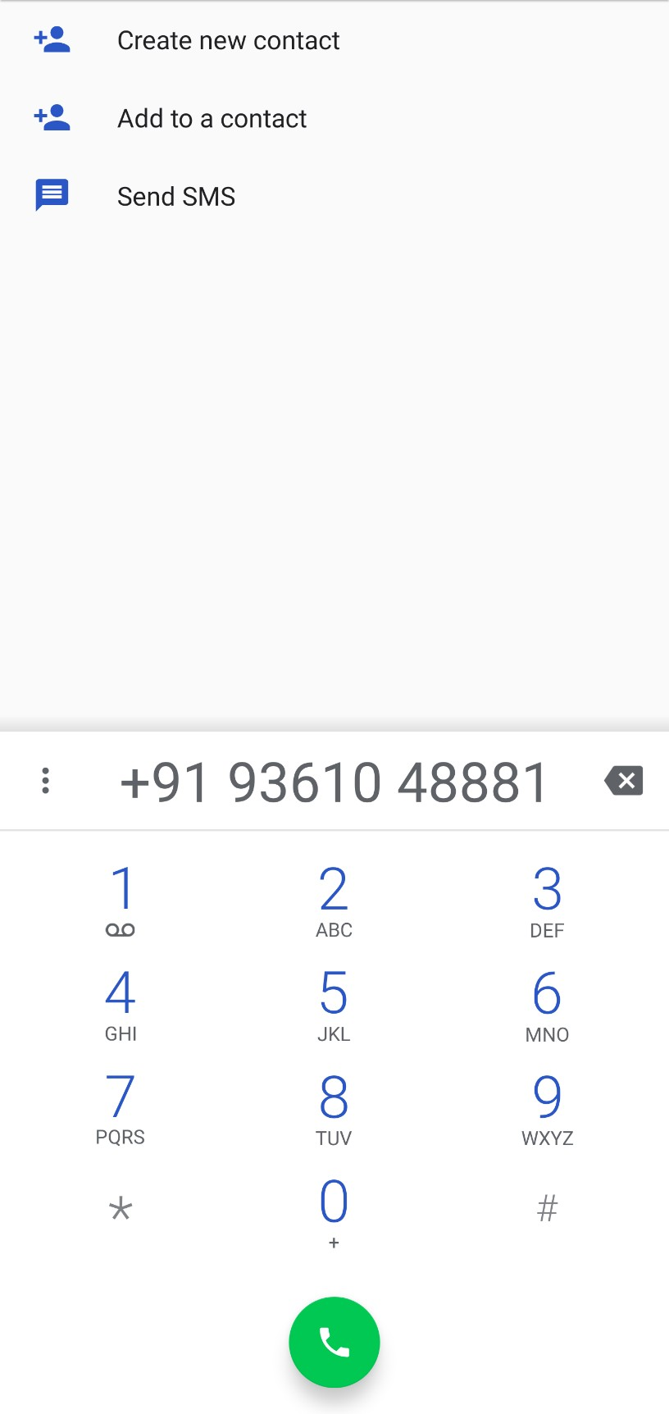

# 7. Chui details. 8. Chui phone number.

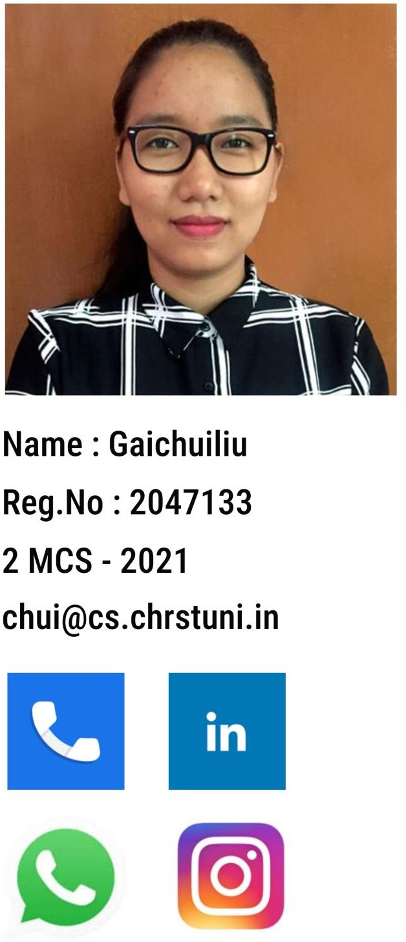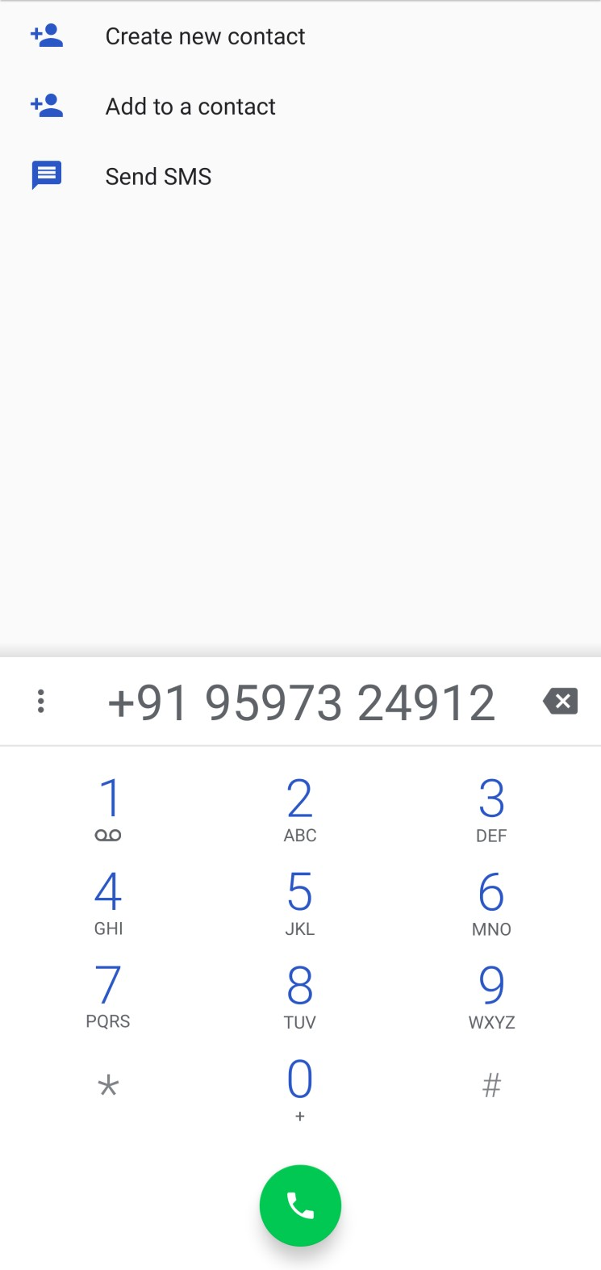

# 7. Chanchal details. 8. Chanchal linkedin.



**The code used in the Main Activity, XML layout, Splash scree, button ripple effect is attached below for reference.**