**Output:**

# **Name : Rajkumar B L**

# **Reg.No : 2047120**

# **Course : MCS 272 Mobile Application**

# **(Lab 07 – Christ University)**

1.App Icon 2. Splash Screen



3. Welcome(Home Screen) 4. Navigational Drawer Menu

5. Menu 6. Attendance

7. From Date - Picker 8. Date Validation

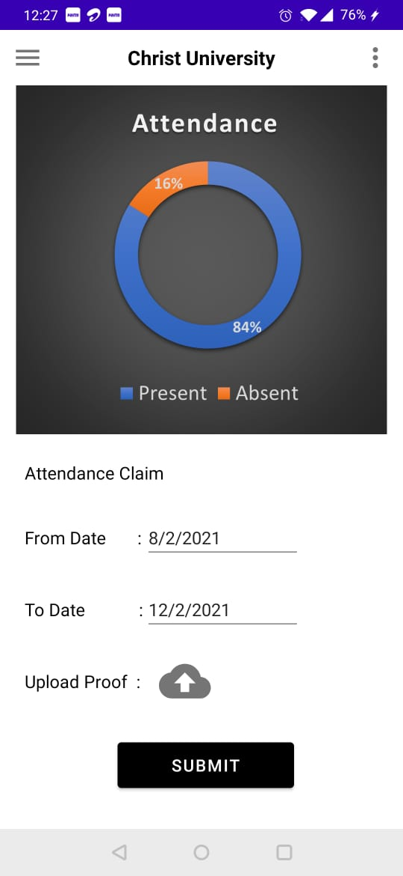9. Valid 🡪 From & To Date 10. Submit – Under Maintenance

11. Menu 12. Database

13. Menu 14. Hostel

15. Menu 16. Canteen

17. Menu 18. Logout

**The code used in all the Activities, XML layouts, Splash screen are attached below for reference.**