**Output:**

# **Name : Rajkumar B L**

# **Reg.No : 2047120**

# **Course : MCS 272 Mobile Application**

# **(Lab 11 – Vroom Car Share)**

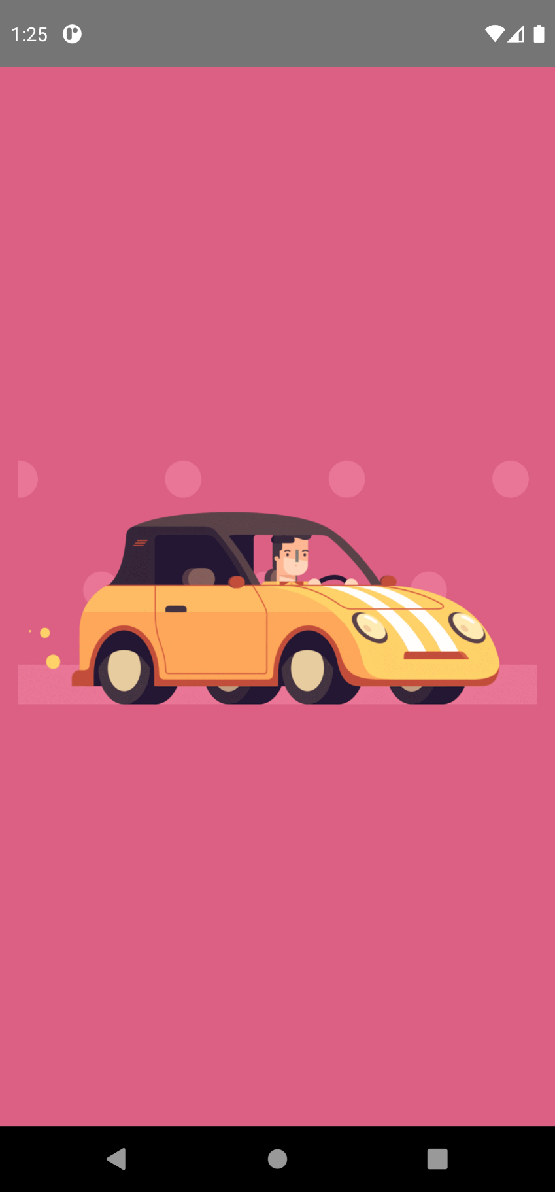1. App Icon 2. Splash Screen



3. Welcome Screen 4. Invalid Login

5. Wi-Fi is disabled 6. Register – No Internet

7. Raju Control Panel - Settings 8. Wi-Fi is enabled (01)

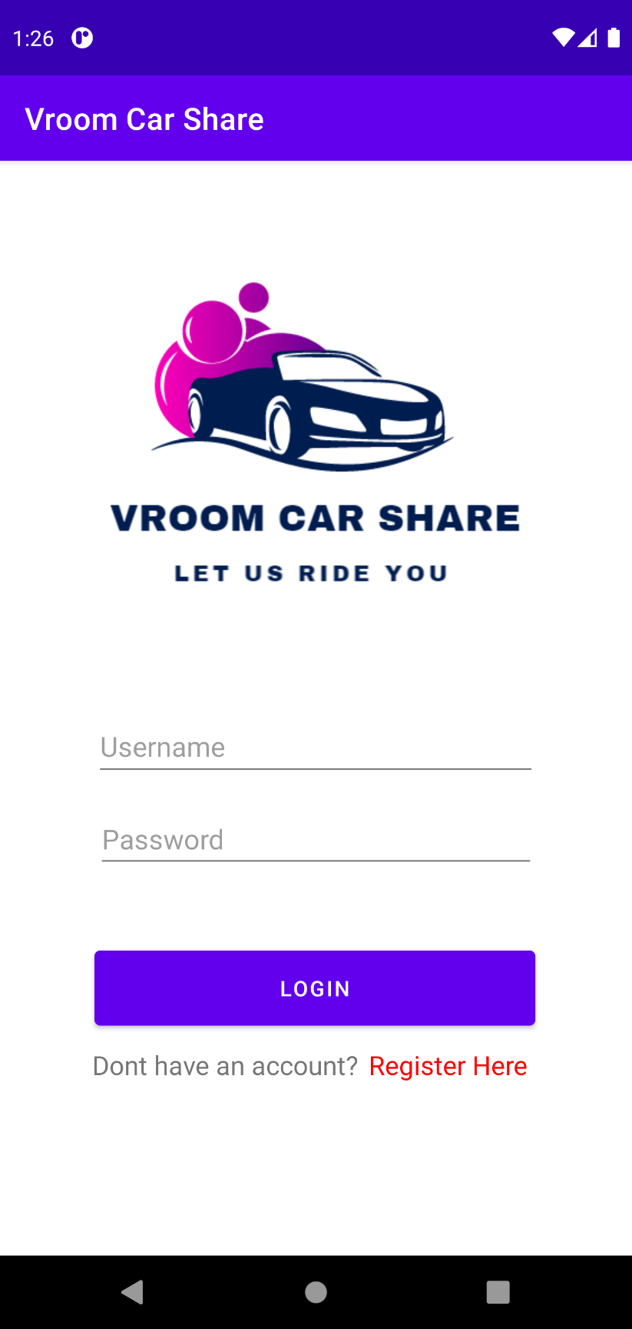9. WI-FI is enabled (02) 10. Click on register again

11. Register Form 12. Register Form (01)

13. Register Form (02) 14. Register Form (Loading)

15. Register Success 16.Login Page

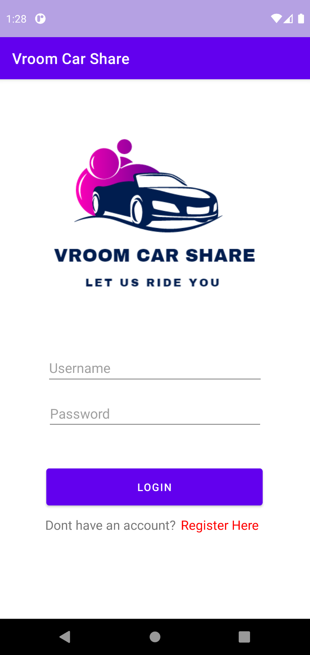

17. PHPmyadmin – MySQL - Database Before Registration

18. PHPmyadmin – MySQL - Database After Registration

