**Output:**

# **Name : Rajkumar B L**

# **Reg.No : 2047120**

# **Course : MCS 272 Mobile Application**

# **(Lab 15 – Vroom Car Share)**

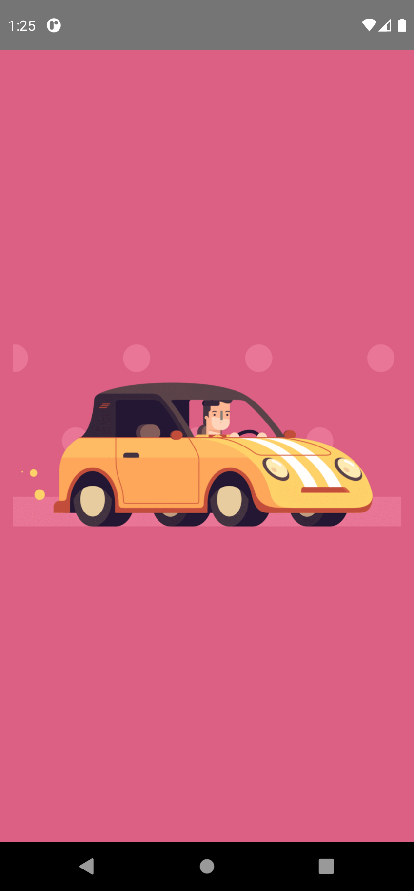1. App Icon 2. Splash Screen



3. Welcome Screen 4. Invalid Login

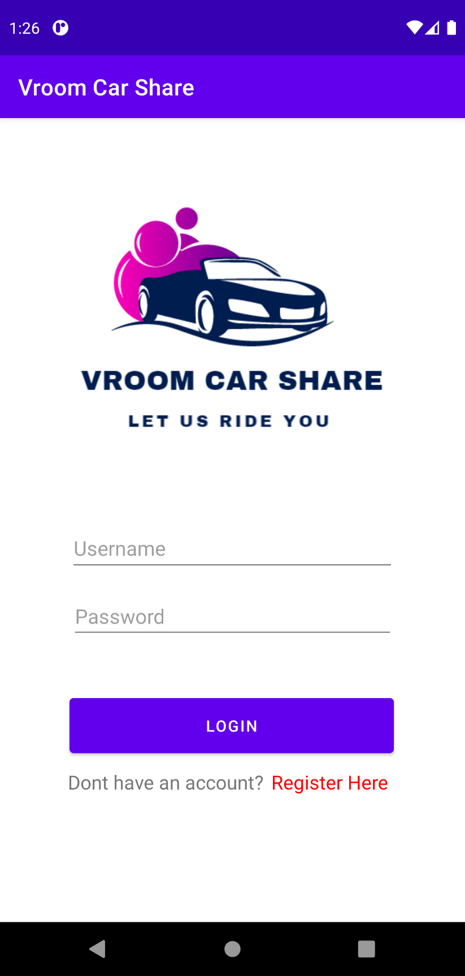9. Click on register 10. Register Form (01)

11. Register Form (02) 12. Register Form (Filling 01)

13. Register Form (Filling 02) 14. Data saved (Shared – Private)

15. Form Cleared 16. App closed

17. App Reopened 18. Data Retrieved - SharedPreference

