**CRUD Operations:**

# **Name : Rajkumar B L**

# **Reg.No : 2047120**

# **Course : MCS 273 NoSQL (Lab 01)**

1. **Creation of database of my domain – Car Rental System.**

DB name – binodcarshare

Table/Collection – members

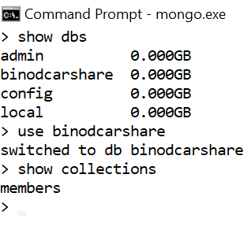

1. **Unique Index for every row insertion.**

The members registered with the company has unique member id that distinguishes each document.

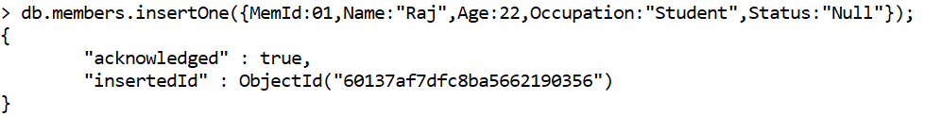

1. **Inserting 10 documents to the database collection.**

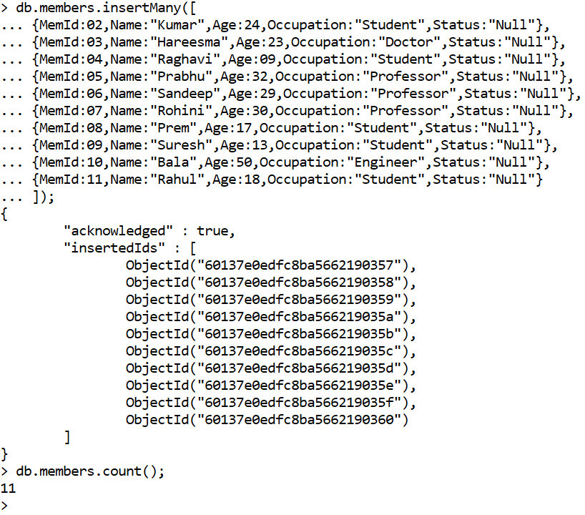

1. **Performing 3 update operations.**
2. An individual whose member id is 2 is updated with an age set to 25.

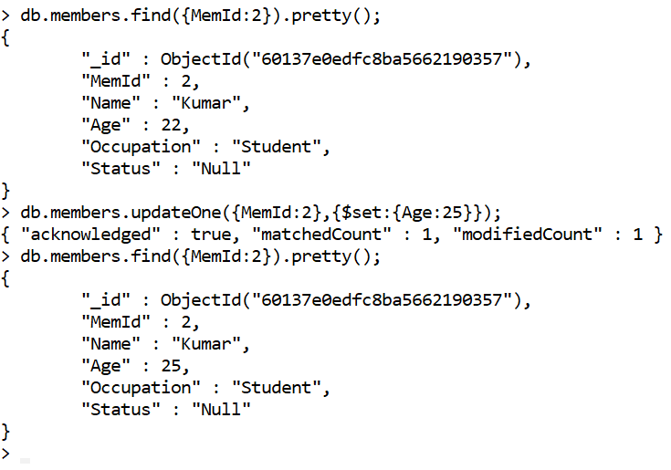

1. The status of all members age below 18 is set to “Rejected”.

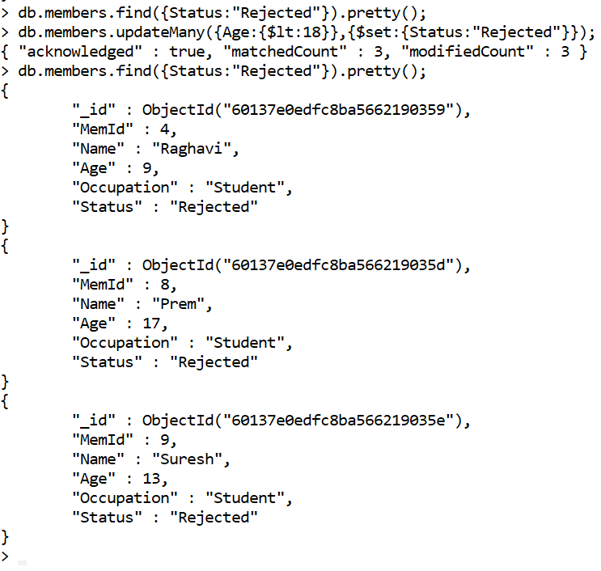

1. Adding new field to the record/Document using update.

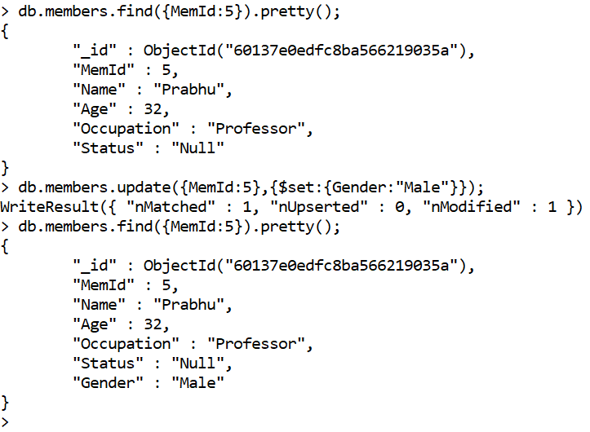

1. **Performing 3 delete operations.**
2. Deleting the record with member id 01.

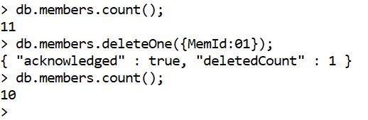

1. Deleting the first record with Occupation as “Doctor”.

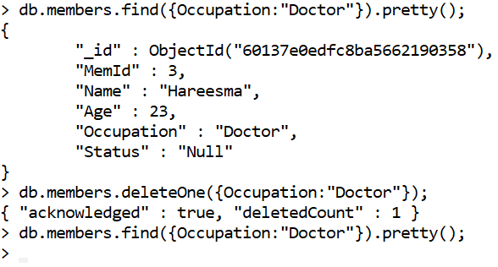

1. Deleting multiple records with status as “Rejected”.

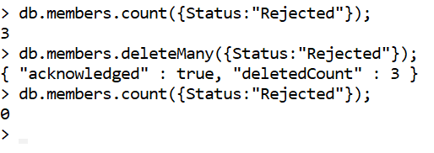

1. **Performing 3 show operations.**
2. Showing all the records whose status is “Accepted”.

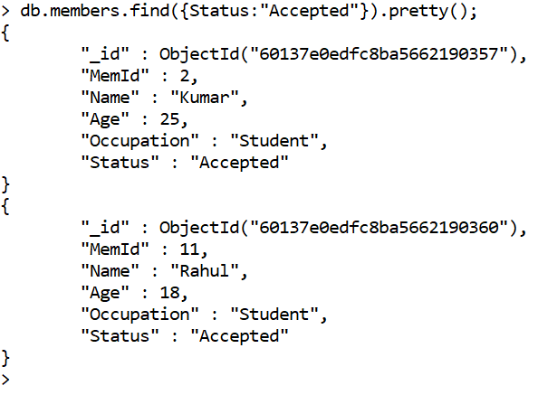

1. Showing the record of member whose age is less than equal to 22, Occupation is Student and Status is Accepted.

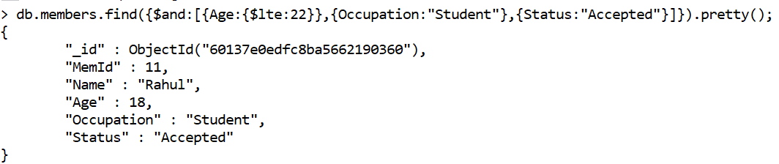

1. Showing all the records of members whose age is greater than equal to 30.

