**Aggregation:**

# **Name : Rajkumar B L**

# **Reg.No : 2047120**

# **Course : MCS 273 NoSQL (Lab 02)**

1. **Creation of database of my domain – Car Rental System**

DB name – binodcarshare

Table/Collection – members

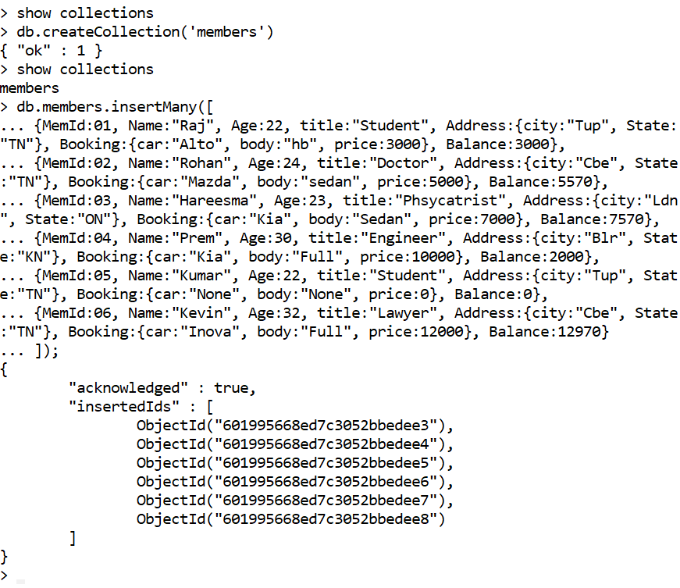

1. **Five Aggregate Operations.**
2. Finding the count of numbers who are yet to pay the balance.

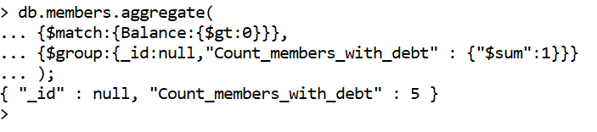

1. ****Finding the minimum balance payable.
2. Finding the maximum balance payable.
3. ****Sum the company’s total recivable amount from the members.
4. Getting the names of all payees from respective states



1. Finiding the name, title and balance from respective states

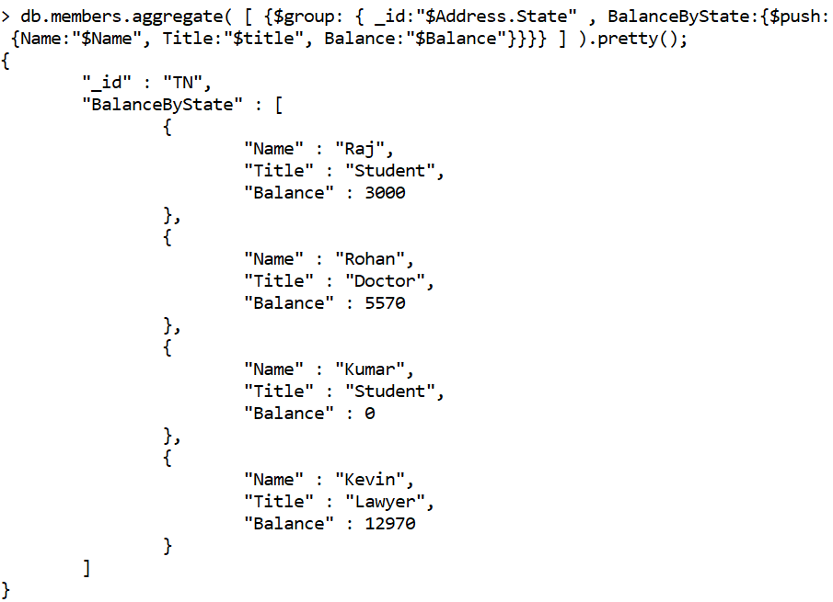

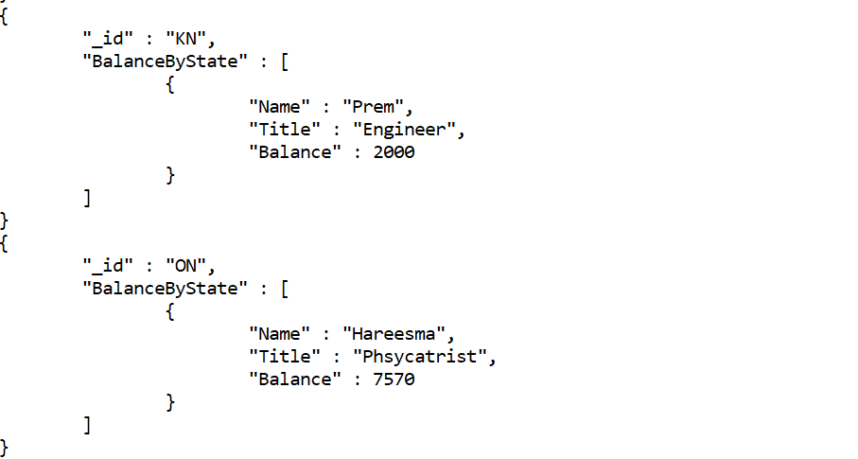

1. **Use Group By.**

Grouping member details by their city

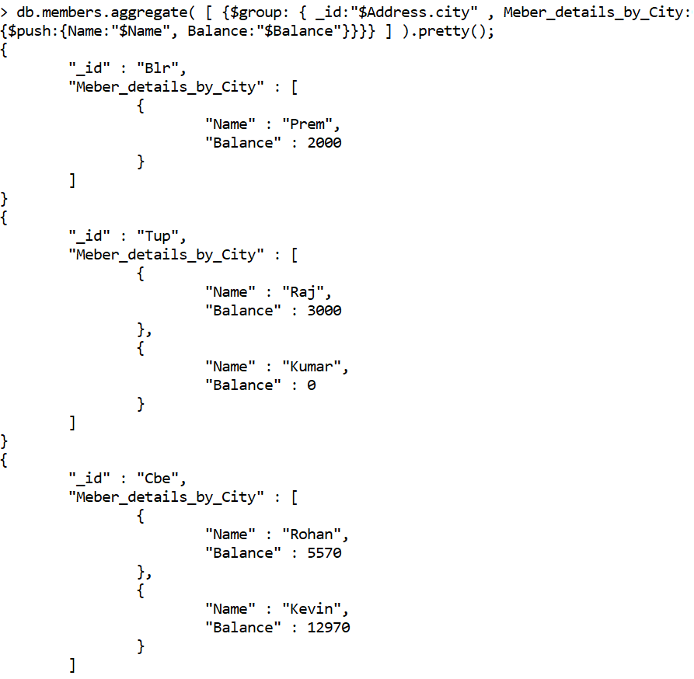

1. **Sorting data in ascending and descending order**

Find -> Sort using name in ascending order

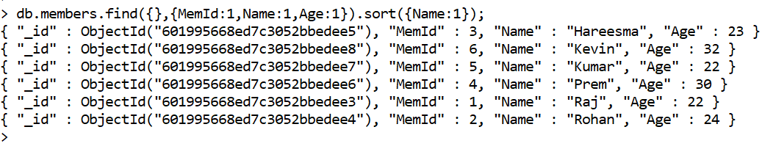

Find -> Sort using name in descending order

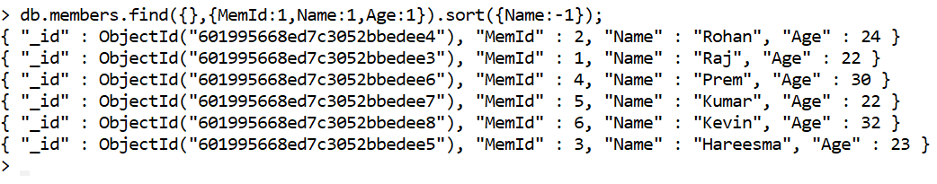

Aggregate -> Sort using id - State in ascending order

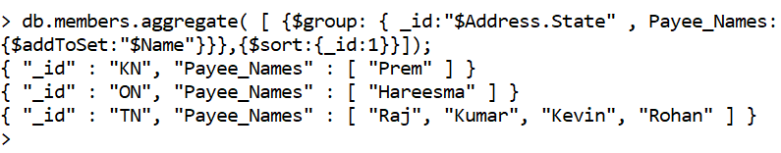

Aggregate -> Sort using id - State in descending order

