# **Name : Rajkumar B L**

# **Reg.No : 2047120**

# **Course : MCS 273 NoSQL (Lab 03 – Part A)**

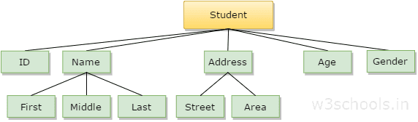

1. **Create the tree structure in mongodb**

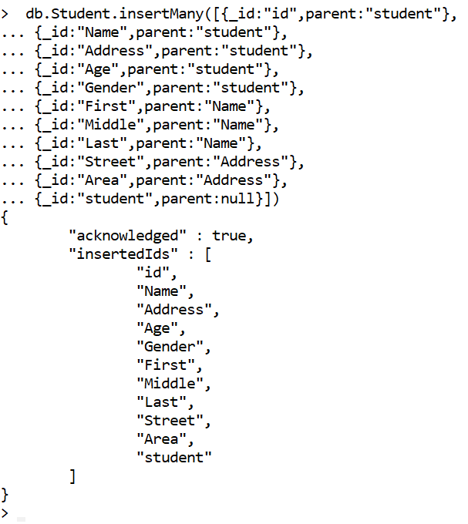

1. **Create an index on the field parent and child.**

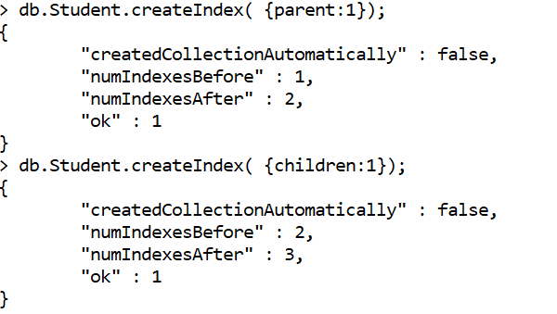

1. **Insert parent and child preference nodes.**

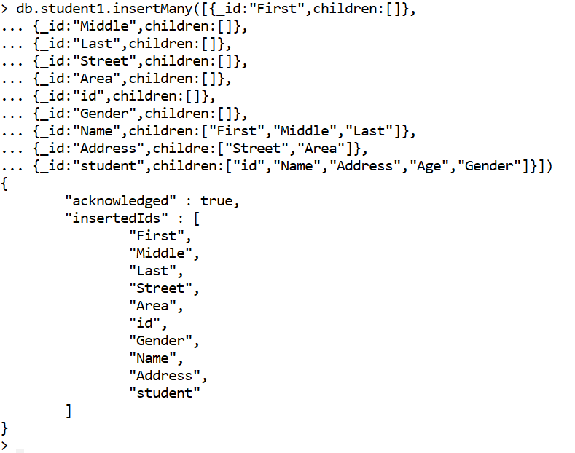

1. **Retrieve parent nodes(First, Street, Id).**

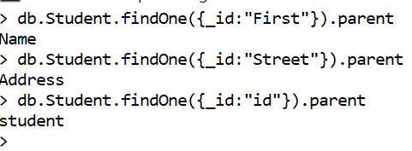

1. **Retrieve child nodes(Address, Name, Student).**

