**Indexe Types:**

# **Name : Rajkumar B L**

# **Reg.No : 2047120**

# **Course : MCS 273 NoSQL (Lab 03)**

1. **Single Index**

DB name – binodcarshare

Table/Collection – members

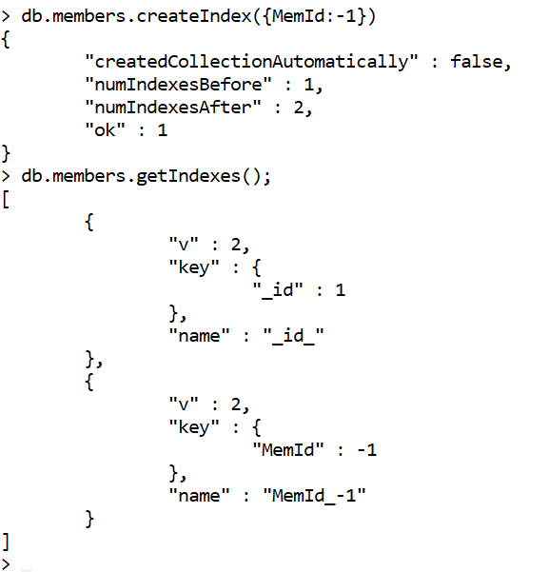

1. **Compound Index**

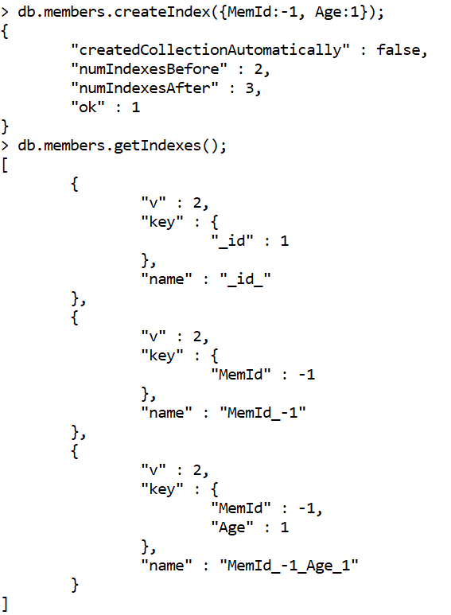

1. **Muti-Key Index.**

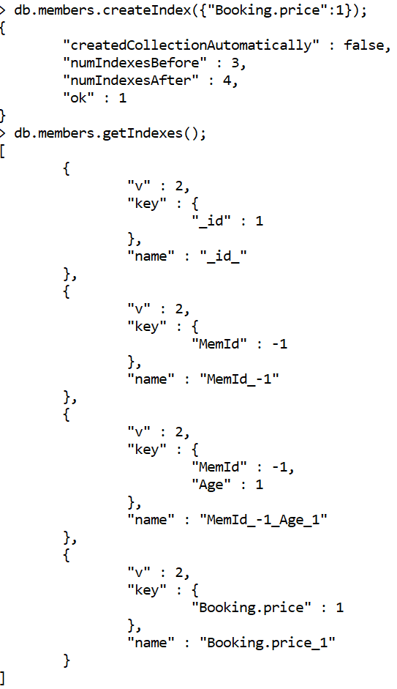

1. **Text Index.**

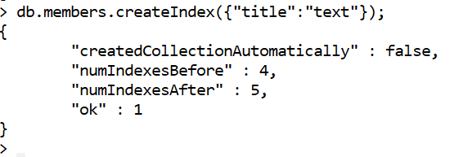

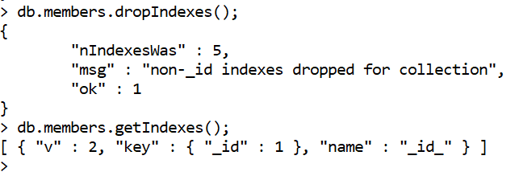

**Index properties:**

1. **Unique**

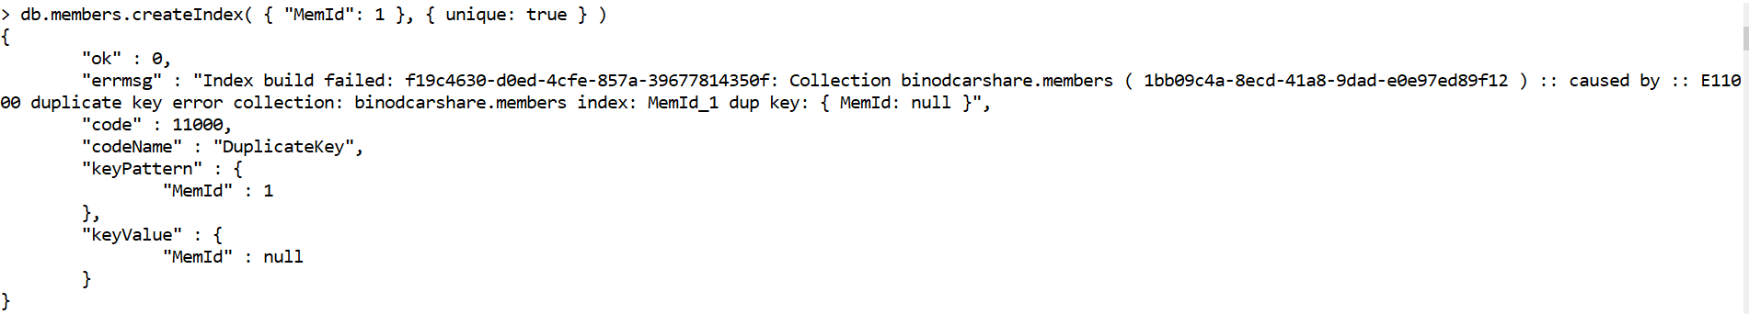

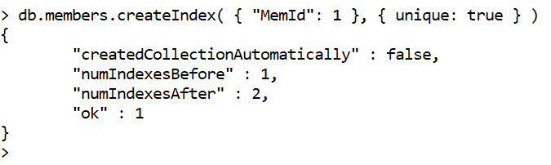

1. **Partial**

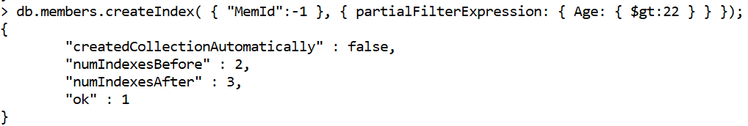

1. **Sparse**

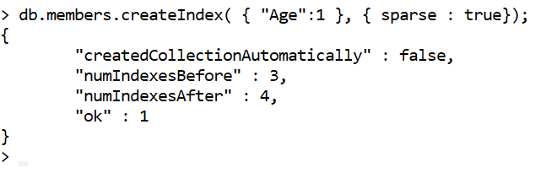

**Collation:**

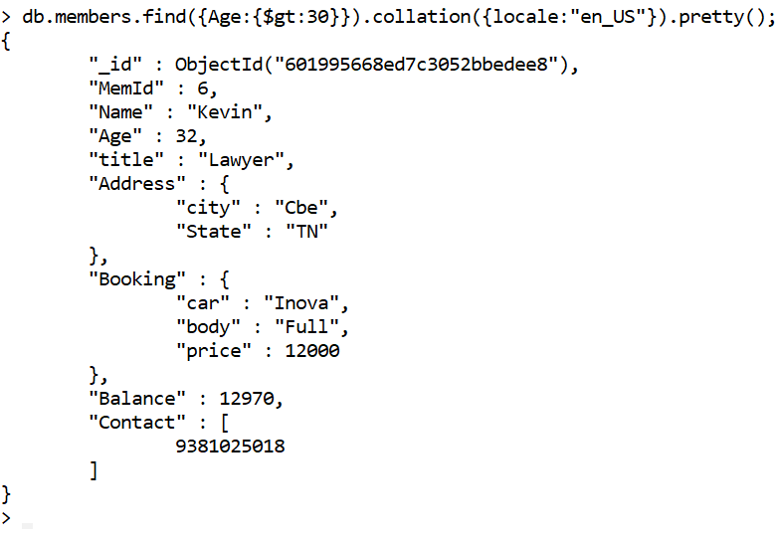

**Covered Queries:**

