**Cassandra CRUD Operations:**

# **Name : Rajkumar B L**

# **Reg.No : 2047120**

# **Course : MCS NoSQL (LAB 05)**

**Keyspace**

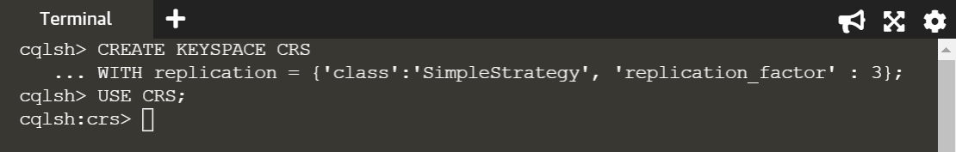

**Create:**

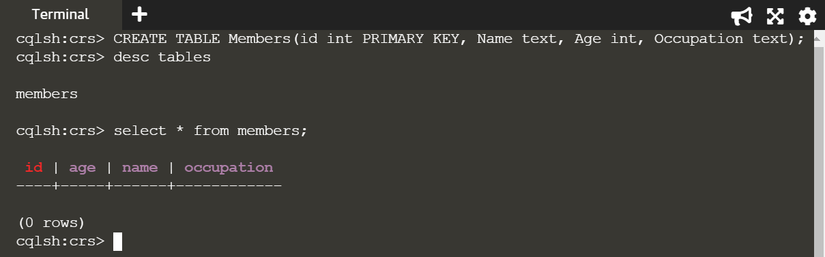

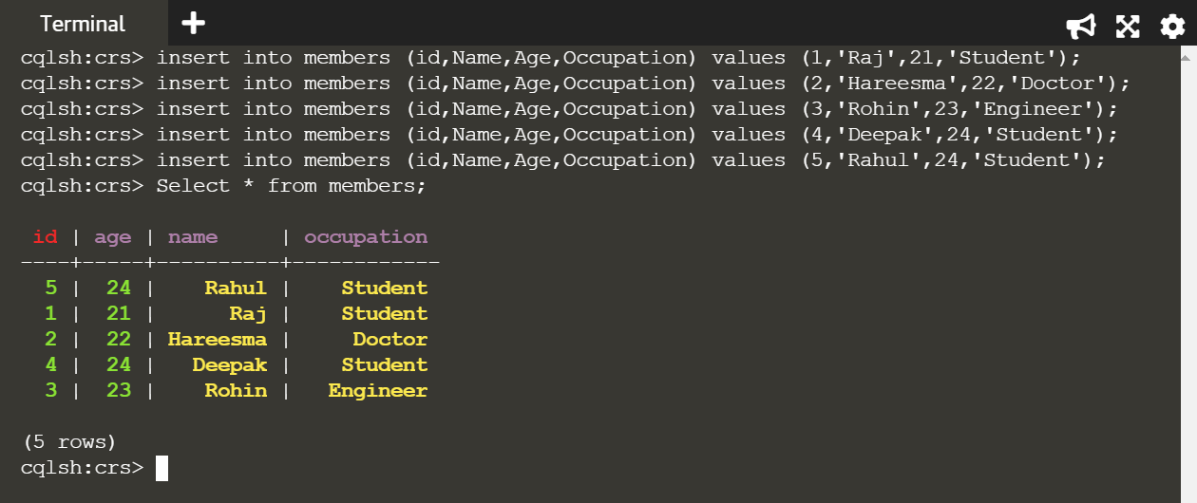

**Read:**

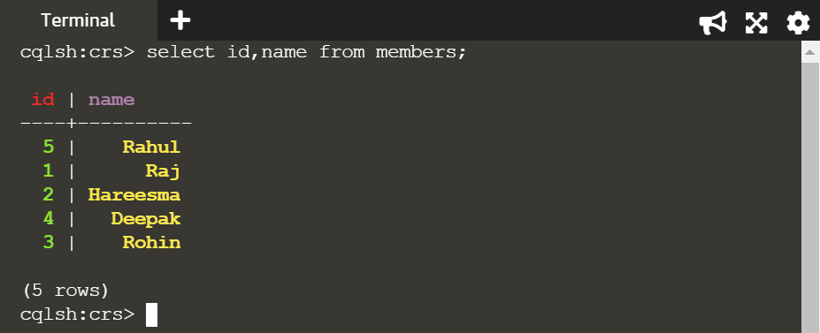

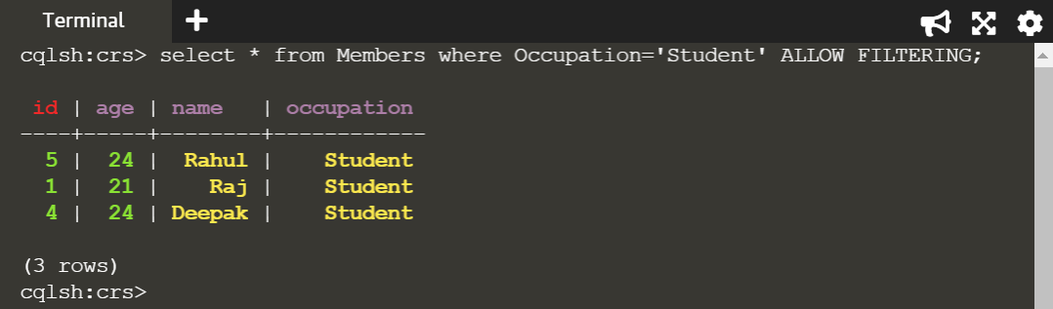

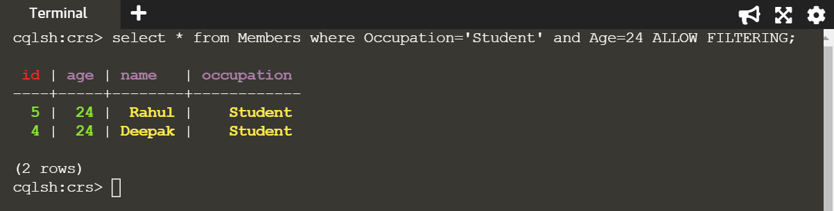

**Update:**

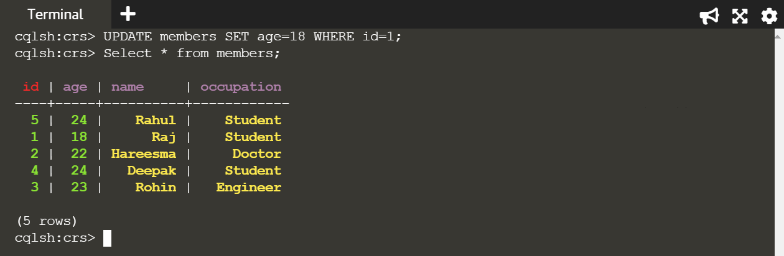

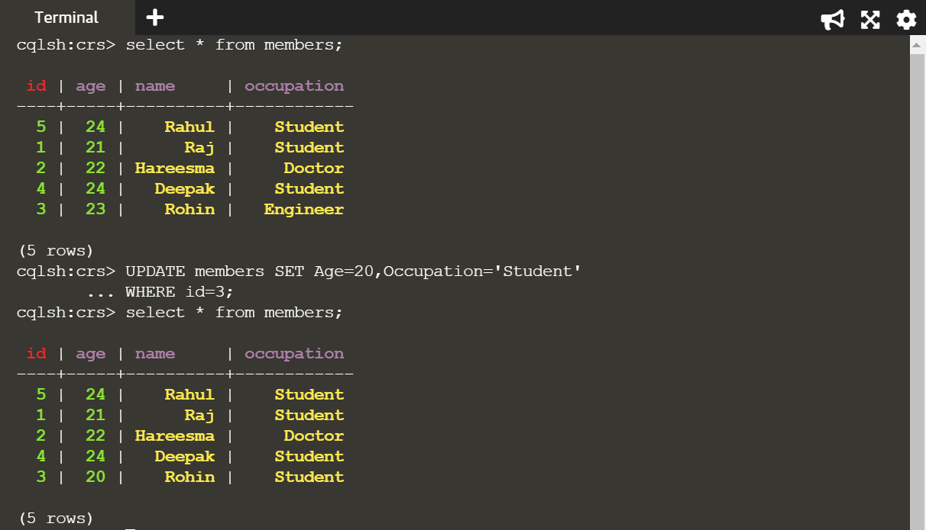

**Delete:**

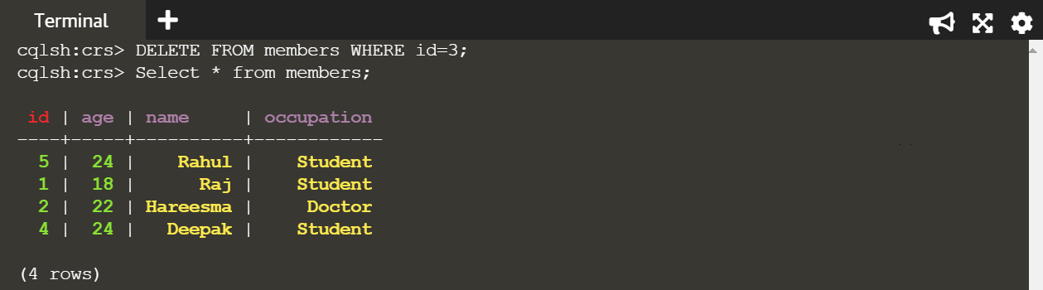

**Code:**

CREATE KEYSPACE CRS WITH replication = {'class':'SimpleStrategy', 'replication_factor' : 3};

USE CRS

create table members(id int PRIMARY KEY, Name text, Age int, Occupation text);

insert into members (id,Name,Age,Occupation) values (1,'Raj',21,'Student');

insert into members (id,Name,Age,Occupation) values (2,'Hareesma',22,'Doctor');

insert into members (id,Name,Age,Occupation) values (3,'Rohin',23,'Engineer');

insert into members (id,Name,Age,Occupation) values (4,'Deepak',24,'Student');

insert into members (id,Name,Age,Occupation) values (5,'Rahul',24,'Student');

Select * from members;

UPDATE members SET age=18 WHERE id=1;

DELETE FROM members WHERE id=3;