**Cassandra INDEX Operations:**

# **Name : Rajkumar B L**

# **Reg.No : 2047120**

# **Course : MCS NoSQL (LAB 06)**

**Create Index:**

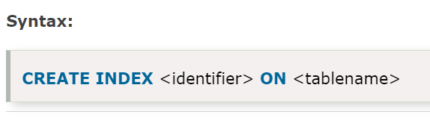

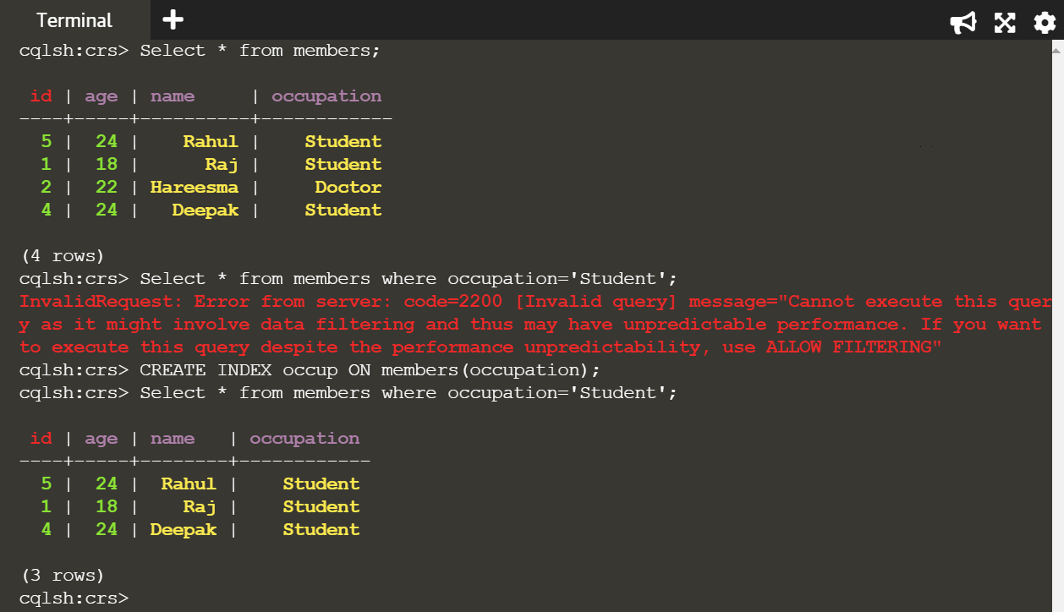

**Drop Index:**

