**Neo4J:**

# **Name : Rajkumar B L**

# **Reg.No : 2047120**

# **Course : MCS NoSQL (LAB 08)**

**Creating Nodes:**

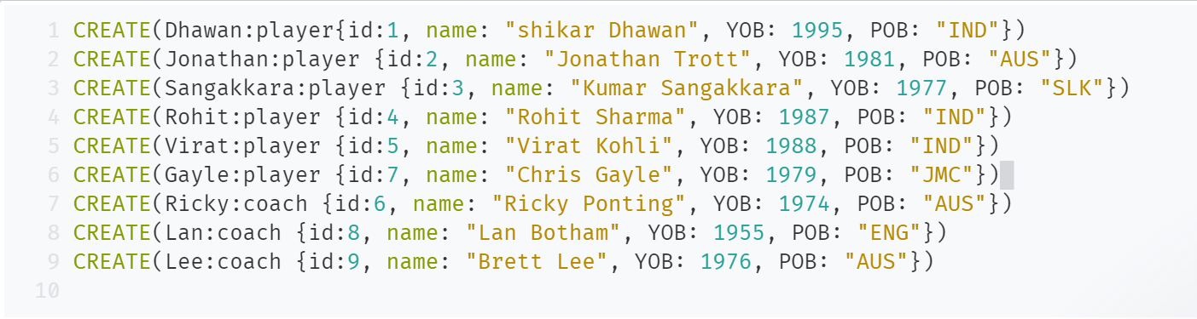

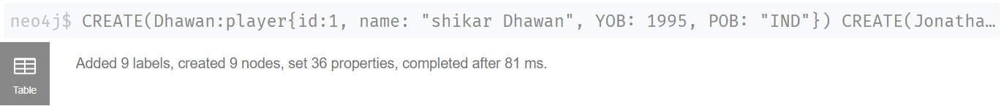

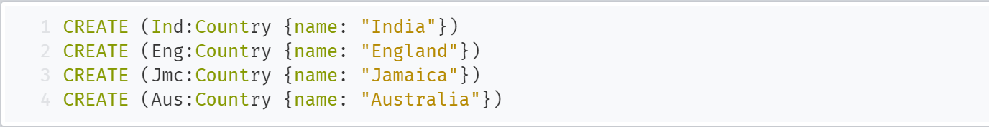

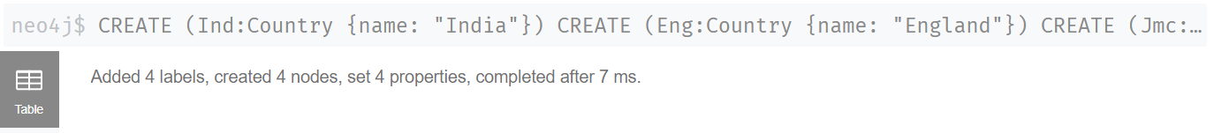

**Creating Relationships:**

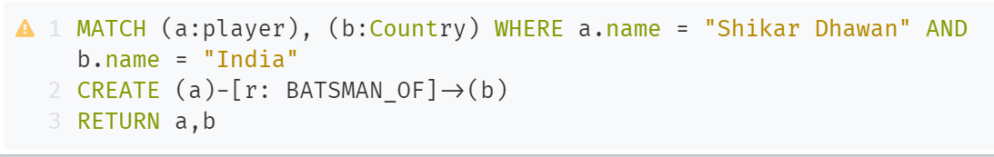

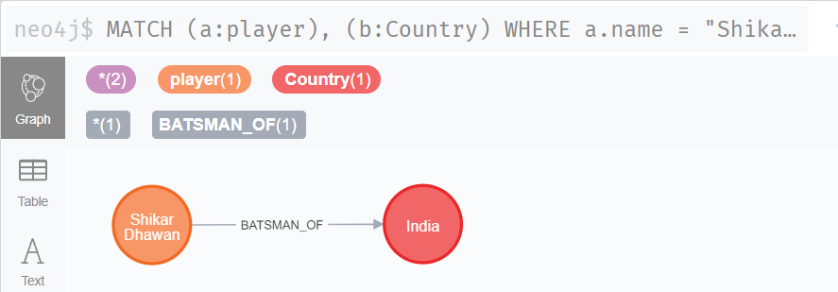

**Case Expressions:**

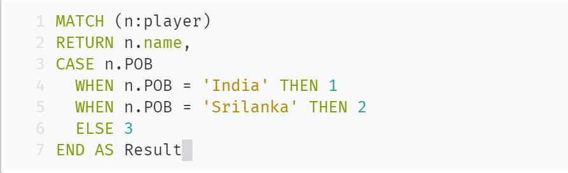

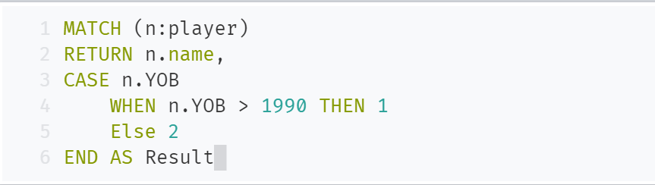

**Boolean Operators**



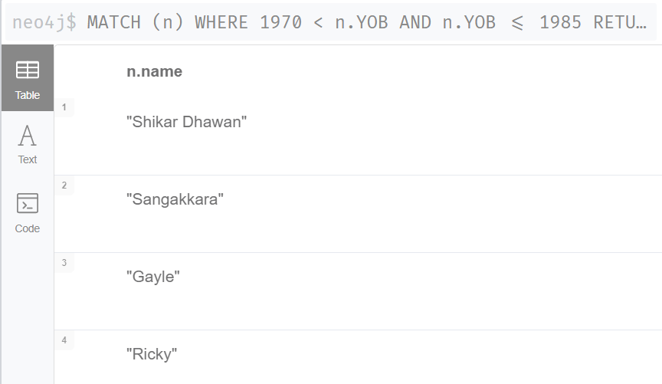

**Temporal Operators**

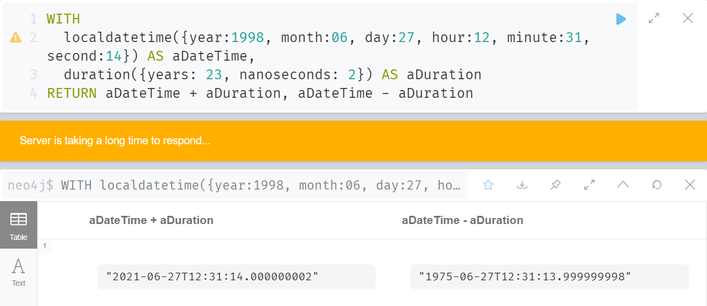

**Distinct Operators**

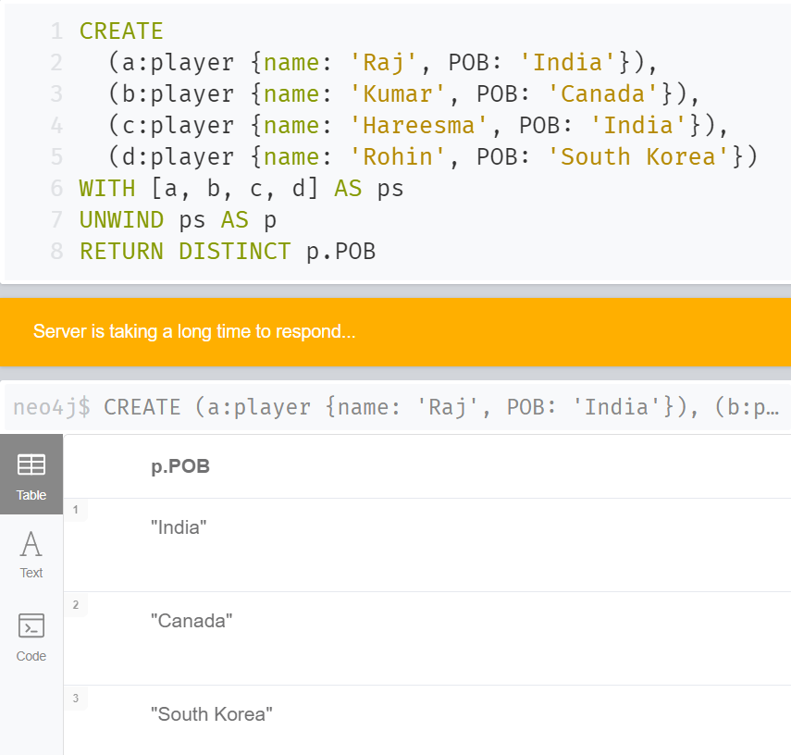



**String Operators**

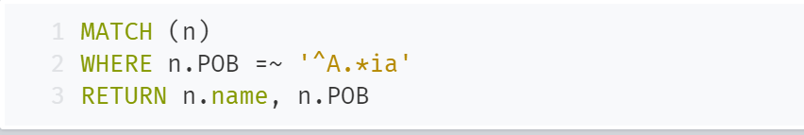

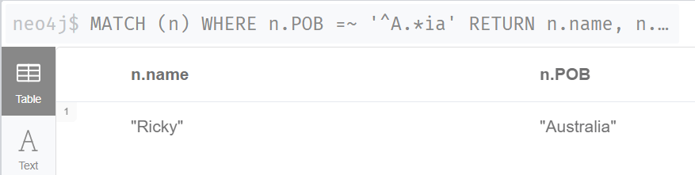

**Property Operators**

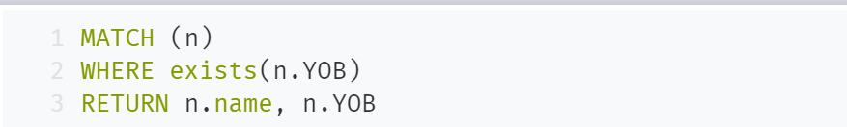

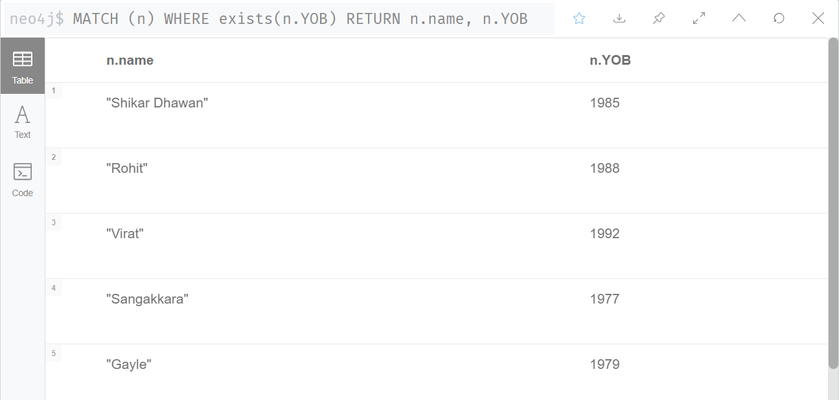

**Map Operators : Static**

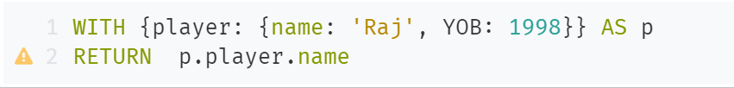

**Map Operators : Dynamic**

{mykey:”name”}

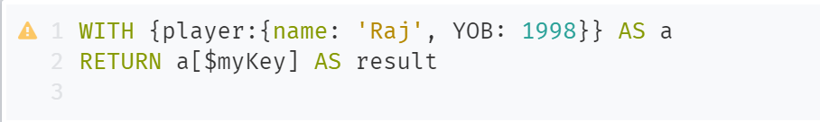

**List Operators**

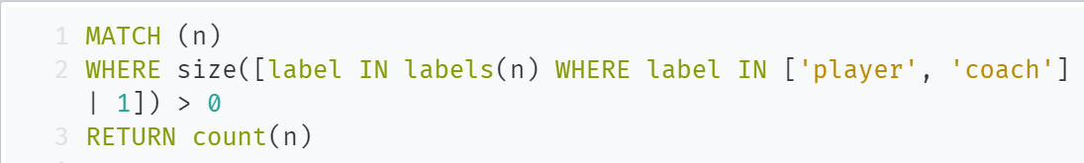

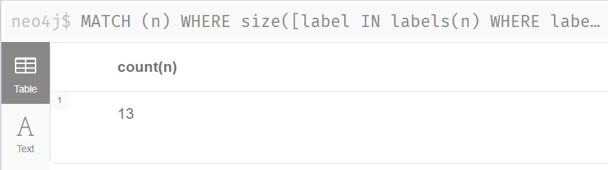

**Patterns:**

(virat)-->(india)

(virat)-->( india)<--(rohit)

(n:player)-->(india)

(virat)-[:BATSMAN_OF]->(India)

**Temporal Values:**

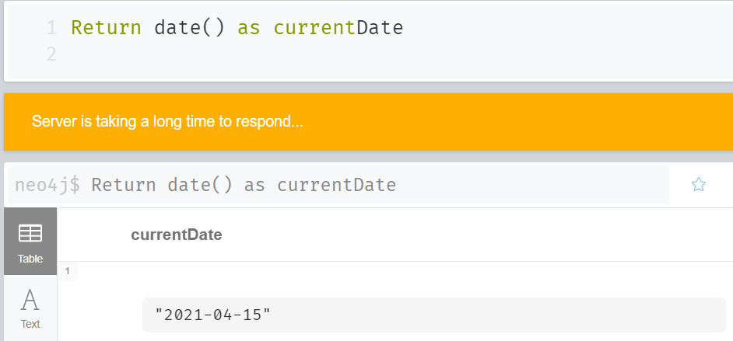

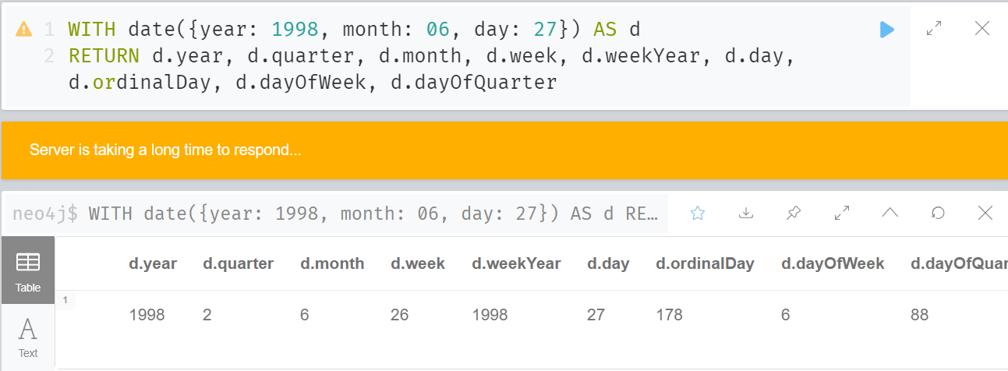

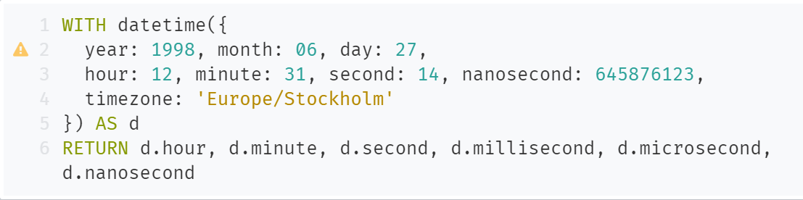

**Spatial Values:**

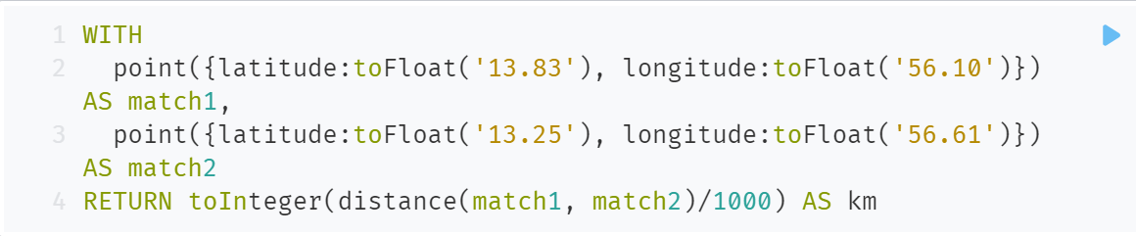

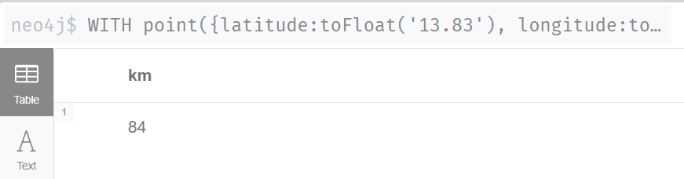

**List:**

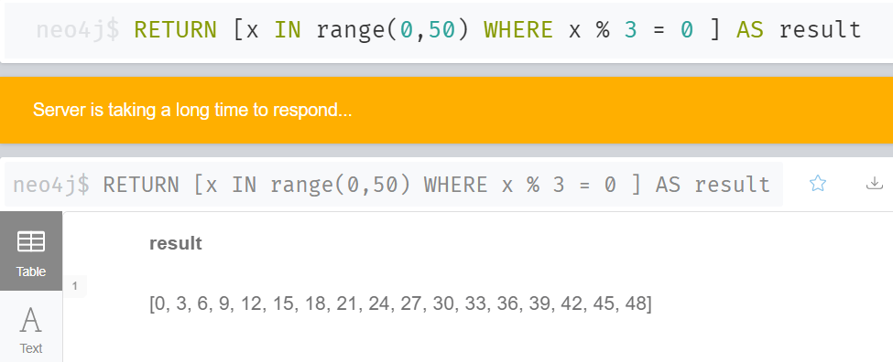

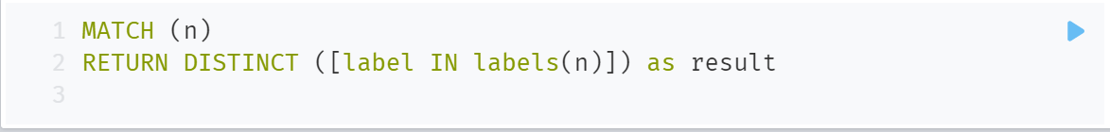

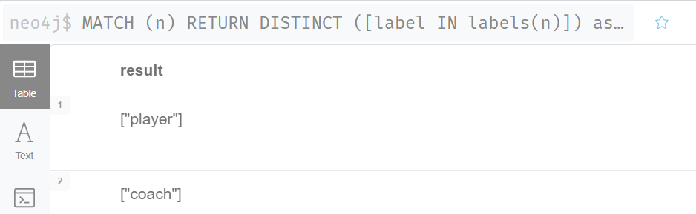

**Map:**

