**Cassandra Collections:**

# **Name : Rajkumar B L**

# **Reg.No : 2047120**

# **Course : MCS NoSQL (LAB 07)**

**Set:**

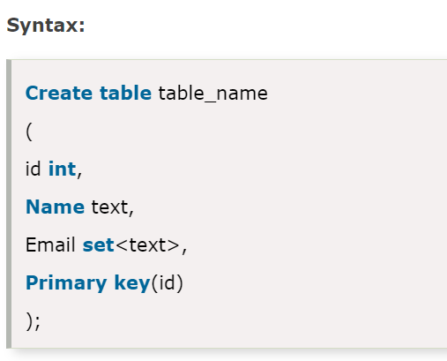

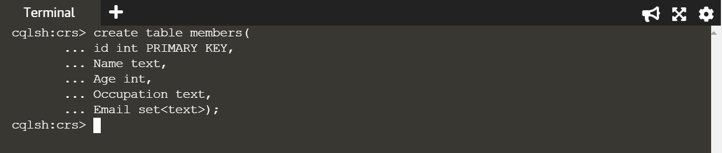

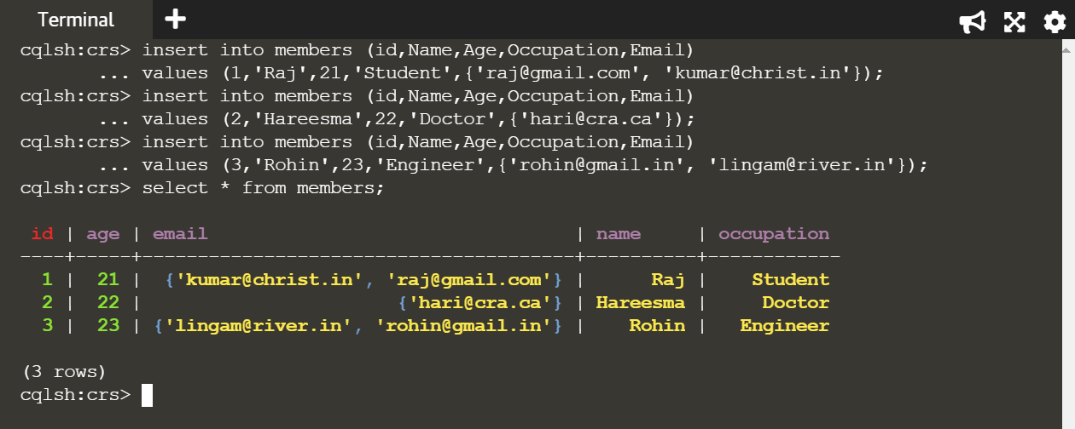

**List:**

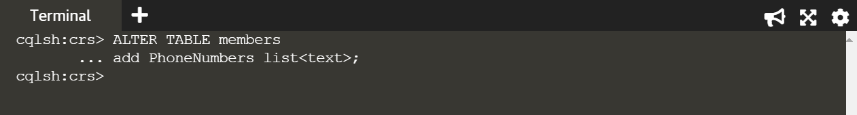

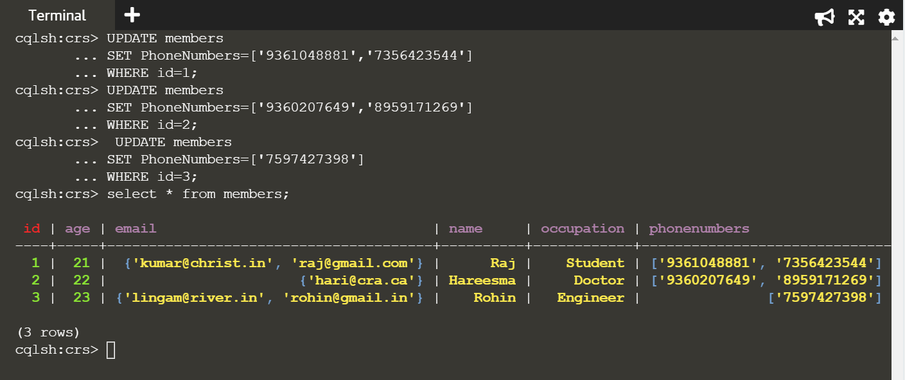

**Map:**



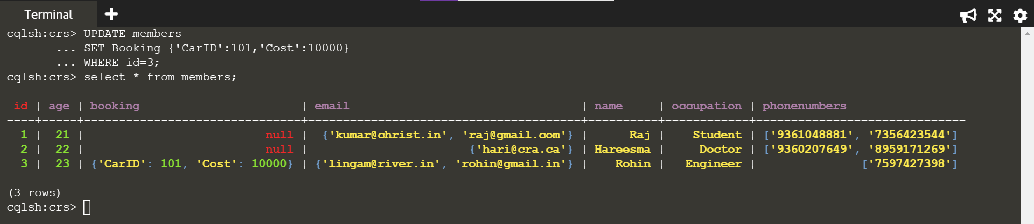

**Export Data to CSV File:**

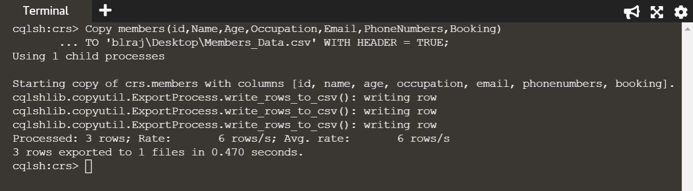

**Import Data From CSV File:**

