**Question 02 – Redis Data Structures ( Car Rental System )**

# **Name : Rajkumar B L**

# **Reg.No : 2047120**

# **Course : MCS NoSQL (CAT 03)**

**Question 02 - String:**

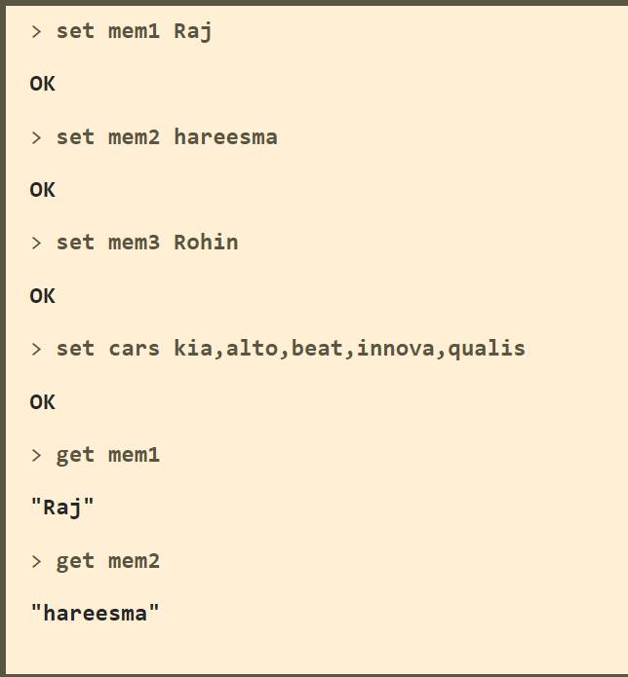

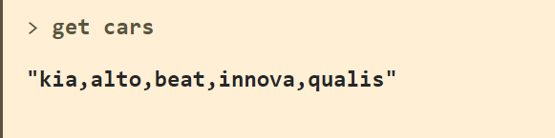

**Question 02 - List:**

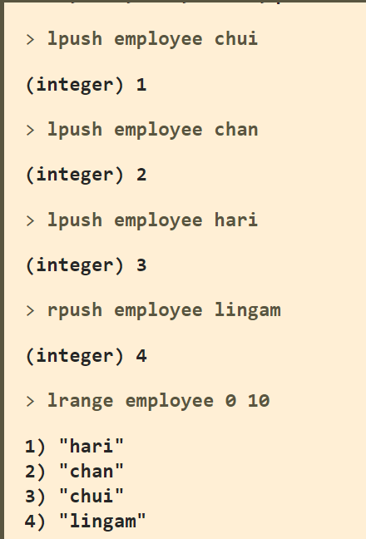

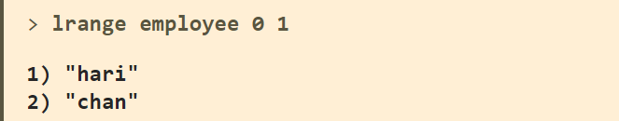

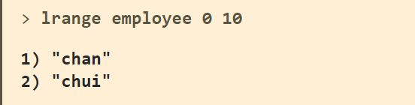

**Question 02 - Set:**

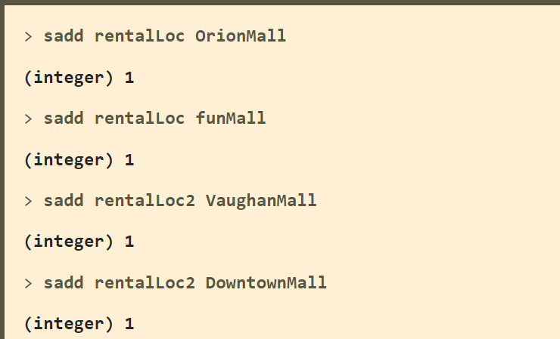

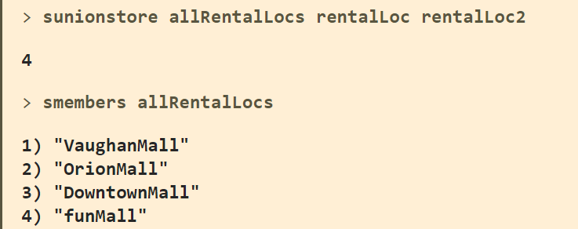

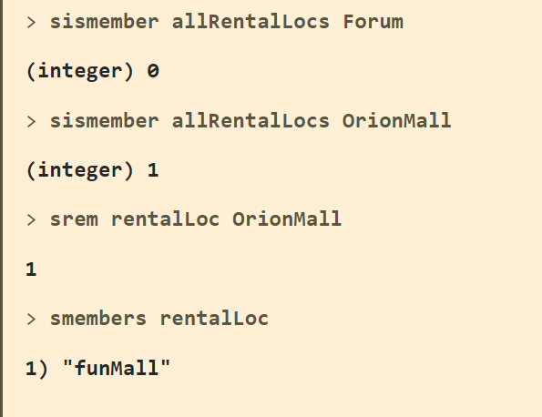

**Question 02 - Hash:**

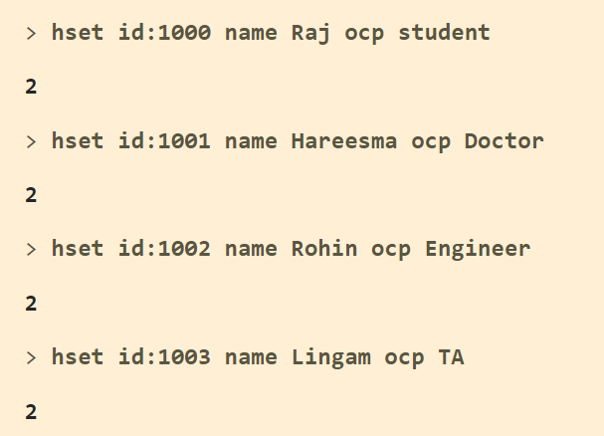

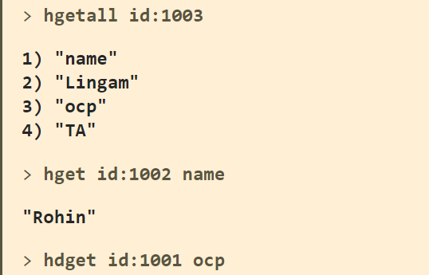

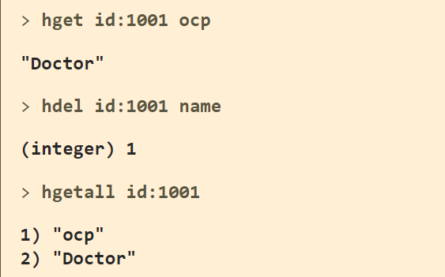

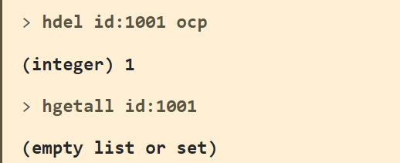

**Question 02 - Sorted Set:**

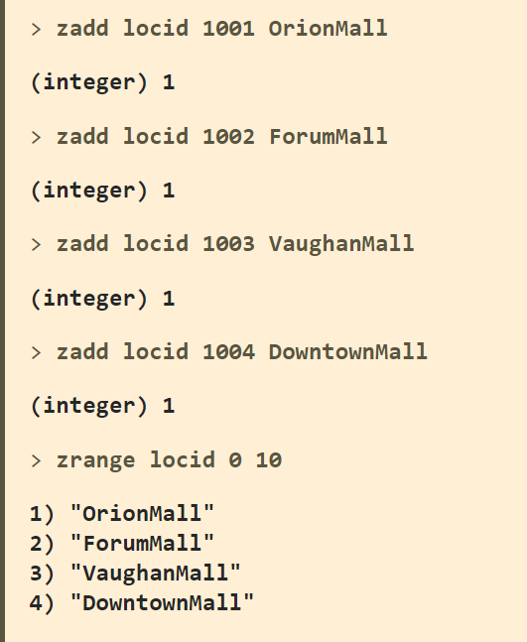

**Question 02 - HyperLogLog:**

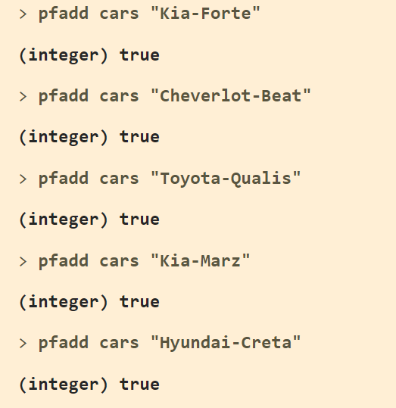

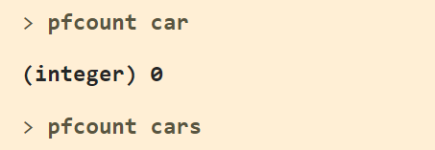

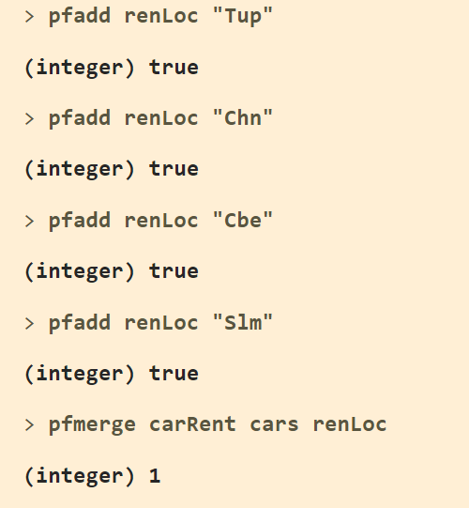

**Question 04 – SET**

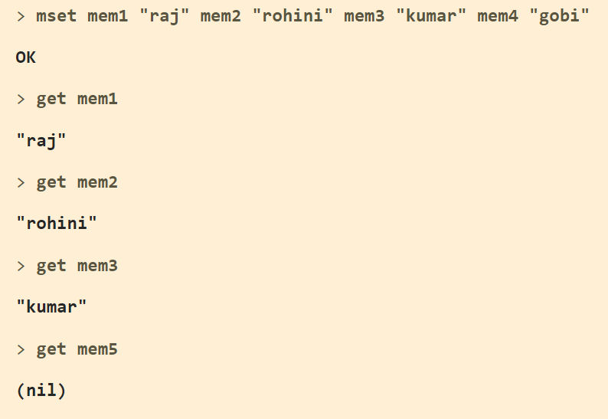

**Question 04 – GET**

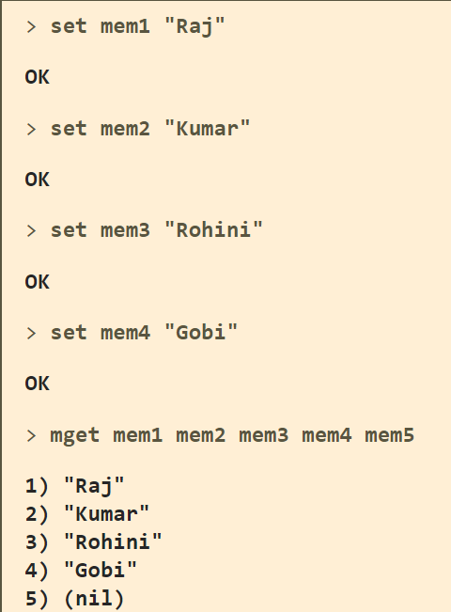

**Question 05:**

$(echo -en "PING\r\n SET  member rajkumar\r\n GET member\r\n INCR visitor\r\n INCR visitor\r\n INCR visitor\r\n"; sleep 10) |   nc localhost 6379

