Beehive Health Monitoring with .NET Gadgeteer

**MSc Computer Science**

**September 2013**

Author**:**

**Ben Lee-Rodgers**

Supervisor**:**

Dean Mohamedally

This report is submitted as part requirement for the MSc Computer Science degree at UCL. It is substantially the result of my own work except where explicitly indicated in the text.

The report may be freely copied and distributed provided the source is explicitly acknowledged.

**Abstract**

Beekeeping is a crucial activity that concerns the management of colonies of honeybees, which are the primary pollinators of the UK’s crops. However, monitoring the health of these colonies is difficult to do manually. By bringing the world of internet-connected embedded electronics to beehive management, it is hoped that this process will become both easier and more effective. This ultimately may help arrest the alarming decline in colony numbers that has seen a 30% decrease in their number over the past few years.

In this project, I set out to develop an extensible system to enable beekeepers to monitor the health of their honeybee colonies with greater ease and frequency, and more robustly. The system comprises software for an embedded device to automate and transmit sensor readings, a web API for collection and distribution of the data, and a front-end for live monitoring. This functionality was achieved with a range of technologies: Gadgeteer, an open-source toolkit for developing small electronic devices; a Node.js-powered API; Windows Azure Storage for the database; and a thick-client JavaScript web application for the front-end.

With over a quarter of million beehives in the UK, the market for such systems could be very significant. Despite considerable research activity in monitoring honeybee colonies, the majority of beekeepers are amateurs and they are currently poorly served, with only inextensible commercial solutions and limited hobbyist attempts that only cover small parts of the system.

By building an extensible system of independent components, this project achieved its primary goals of demonstrating how automated beehive monitoring could be useful, and of providing a platform for future development in this area. Significantly, through provision of the data in cloud-based services, it is feasible that when scaled to multiple beehives across the country, the wealth of data that would become available for analysis about bee colonies could be of significant research value.

**Contents**

1 Introduction 4

1.1 Overview 4

1.2 Aims and Goals 4

1.3 Scope 5

1.4 Structure and strategy 5

1.5 Report outline 6

2 Context, Background and Research 6

2.1 Beekeeping 6

2.1.1 Colonies 6

2.1.2 Hive monitoring 7

2.1.3 Beehive health properties 8

2.2 Technologies 10

2.2.1 Gadgeteer platform 10

2.2.2 Web API 10

2.2.3 Web front-end 11

2.2.4 Version control 12

2.2.5 Deployment 12

2.3 Existing work 12

3 Requirements Analysis 13

3.1 Problem statement 13

3.2 Terminology 14

3.3 Requirements 14

3.3.1 Monitoring device 14

3.3.2 Front-end application 16

3.3.3 Data API and Services 17

3.4 Domain model 18

3.5 Use cases 18

3.6 Work packages 19

4 Design and Implementation 20

4.1 System architecture 20

4.2 System components 22

4.2.1 Monitoring Device 22

4.2.2 Web API 29

4.2.3 Web application 34

5 Testing 38

5.1 Adding new sensors 38

5.2 Device-API communication 40

5.2.1 Maximum frequency 40

5.2.2 Buffering 41

5.3 User-acceptance 42

6 Conclusions 42

6.1 Summary 42

6.1.1 Financial aspects 43

6.2 Critical evaluation 44

6.2.1 Fulfilling requirements 44

6.2.2 Technologies 44

6.2.3 Design 44

6.3 Further work 45

6.3.1 Device operations and practicalities 45

6.3.2 API and front-end 45

6.3.3 Multiple hives 45

Bibliography 47

Other Sources 50

Appendices 52

A1 Project Resources 52

A2 Use Case Specification 53

A3 Building a Gadgeteer Mass Sensor 57

A4 System Manual 59

A5 User Manual 61

A6 Source Code 72

# Introduction

## Overview

Honeybee colonies are an incredibly important part of agriculture in the UK and elsewhere, as they pollinate most of the crops we eat and produce valuable honey. Unfortunately they are in decline, and beekeepers are facing difficulty keeping their colonies alive from one season to the next. Through automated, more frequent and less intrusive monitoring, this project aims to aid beekeepers in improving the survival chances of their bee colonies.

The physical monitoring will be done using ‘Gadgeteer’ hardware provided by Microsoft, the external client for this project. This hardware consists of a microcontroller with a range of connected modules such as a Wi-Fi transmitter, SD card reader/writer, and a range of sensors, for example thermometers and light detectors, which will be used to measure certain health variables of the colony. The microcontroller, which hosts the .NET Micro Framework, will be programmed with the Gadgeteer SDK, with the primary function of automating the monitoring process and transmitting the sensor data to an internet service.

The second aspect of the project is the software to collect, display and visualise data coming from the monitoring device located in a beehive. Requirements from UK beekeepers will determine the nature and extent of this cloud-based, web-fronted application, though always ensuring extensibility is not compromised.

## Aims and Goals

Beekeeping is a widely practiced hobby and is also done as part of a large amount of research due to its great agricultural importance. The primary aim is therefore to develop a system that will be useful for other beekeepers wishing to implement and (if so experienced) further develop a beehive health monitoring system. The ideal outcome is to better the survival chance of bee colonies, and perhaps learn more about the state of UK-based beehives such that the community can come closer to understanding the cause of declining colony numbers.

Thus, the goals for the system being developed are:

* Demonstrate what useful beehive properties can be monitored with off-the-shelf programmable hardware.
* Demonstrate how beekeepers could be better informed about the health of their colonies than is possible at present with traditional tools. This will be though the use of web services to connect the hive’s data to a modern web-based user interface.
* Produce easily extensible open-source software so that the beekeeping community can easily progress with automated hive health monitoring.

## Scope

In general, allowances need to be made for the fact that access to operational beehives will be difficult, so testing is mainly or entirely from laboratory simulations. Assumptions about the type and location of the beehive can therefore be freely made (e.g. near mains power and a Wi-Fi hotspot); this is also to limit timewasting from working with potentially unreliable hardware such as GSM and batteries.

Specifically:

* Primary hardware should be commercially available and Gadgeteer-compatible
* A web-facing application will be the single system front-end
* Reliability of data is a secondary hardware concern; in general, hardware sophistication will be limited by time and cost
* The full system prototype will be designed to work with a single beehive.

## Structure and strategy

The project is externally supervised by Steven Johnston from Microsoft. He has kindly provided all the Gadgeteer hardware and offered advice on areas to explore, as well as providing contacts within the beekeeping community to discuss requirements and test the prototypes and final systems. The bulk of the work, however, is unsupervised and self-directed through individual research of what is needed.

The stimulus for the project was a Gadgeteer ‘hack weekend’ Mr Johnston was involved with, designed for experienced developers to experiment with Gadgeteer [1]. The experimenting was in the same context as this project, beehive monitoring. Full details are available in the reference.

Due to the rather experimental nature of the project, and the lack of external constraint on the direction to be taken, it was important to decide on a good software development strategy. The technique decided upon was the evolutionary prototype model. By frequently refining prototypes and testing them on users and in the laboratory, valuable early feedback can be introduced to inform the project direction and requirements for the final system [2]. This iterative method is ideal given the rather broad areas to be researched and developed, and given that the end-users may not initially know what they require.

## Report outline

The next chapter will detail the necessary background theory and review existing research as well as any commercial or amateur software for beehive monitoring. Chapter three presents the requirements analysis, wherein the details of requirements capture and analysis are described. Following that is a discussion of the system design and implementation in chapter four, then testing and an evaluation of the project in chapters five and six respectively.

# Context, Background and Research

## Beekeeping

### Colonies

The European honeybee is in trouble. Over the past decade, colonies have been dying out a rate of about 20-30% a year in the UK [3] (and even higher in the US [4]), with no known definitive cause [5]. The deaths are sometimes part of a recently discovered phenomenon of rapid and unexpected death known as Colony Collapse Disorder (CCD) [4], which has sparked a great deal of research into what may be responsible. Theories include environmental changes, human pesticide use, and parasitic disease [5].

In addition to the threat from CCD, colonies also face the persistent threat of death from other sources, such as unseasonable weather and disturbance from wildlife [6]. The cold, wet summer of 2012 is thought to be the greatest cause of the unusually large losses reported in the UK in 2012/13 [3].

Regardless of the precise cause of colony deaths, what may help improve survival rates is better monitoring of these colonies so beekeepers can be better informed about what is happening in their hives.

For millennia, the honeybee has been of great importance to human agriculture, and today colonies are responsible for the pollination of more than half of UK pollinated crops, worth an estimated £200 million [7]. This huge impact makes CCD and the decline in the bee population a serious concern, and recently there have been attempts to start monitoring beehives more closely through use of automated systems to replace intrusive, laborious manual checks.

Colonies of domesticated honeybees are housed in man-made beehives (relatively few wild colonies exist), with around a quarter of a million hives existing in the UK alone [7]. Moreover, most apiaries (beehive ‘farms’) are run by amateurs – 67% of all hives in the EU [8]. These two facts mean that for effective, widespread monitoring, an inexpensive and easy-to-implement system is needed. Focused and sophisticated monitoring is already underway at research laboratories, but the amateur market lacks a complete and extensible open-source solution.

### Hive monitoring

A typical beehive houses a colony of around 50,000 honeybees at its summer peak, headed by a single queen [6]. Typically, the colony will lie mostly dormant for the winter as the bees struggle to survive on supplies built up during the summer. In spring, activity resumes and the hive will begin raising new bees (the brood) and gathering honey. In early summer, as the population swells, a swarming event may occur. This is how new colonies are formed, as the queen leaves the hive with a subset of her colony and tries to find a new nest.

Beekeeping mainly concerns looking after the hive to ensure it is healthy so the benefits of crop pollination and the production of honey and wax can be realised. A secondary goal is to manage the swarming events by either moving the bees to a fresh hive when ready (rather than let them escape to probable death), or by preventing it altogether. Beekeepers undertake a number of monitoring tasks currently, involving manual, intrusive checks – for disease, queen presence, food stores, and brood size amongst others [6]. It would be beneficial to the colony to reduce these checks as far as possible, as these disturbances are considered harmful to its normal operation. This would also be more convenient for the beekeepers themselves, who rarely live alongside their hives.

Crucially, beekeepers typically only check their hives on a weekly basis, and not at all in the winter season [9]. Thus, when potentially damaging incidents occur between checks, such as swarming or foreign species attack, the beekeeper is often unable to respond to the threat in time, and the colony would likely die. Automation and warning systems are therefore fundamental to any proposed monitoring system.

### Beehive health properties

A number of factors affect the health of the populations of beehives and by monitoring these effectively, preventative action can be taken. The most important impacting properties are discussed here.

#### Temperature and humidity

Temperature and humidity are significant variables affecting colony survival, both for mature bees and for the raising of larvae in the spring. In the UK the problem is that conditions can be too cold or wet; the colony thrives in a warm, dry environment, and can die when the temperature or humidity stray from a certain range [6]. In particular, it is the temperature differential between the hive core and the natural external environment that is the most important indicator of hive health [10]. The activity of the colony drives this differential, which is high when the bees are healthy and energetic, and approaches zero when the colony dies [11].Thus, by observing this differential, an intervention to discover and rectify the cause could be staged if it were to drop significantly. Present manual techniques cannot detect approaching death in this way, as it is considered dangerous to open a hive in the winter when the risks are greatest, so they tend to be left alone for many months in the cold season.

#### Mass

The hive’s mass is primarily an indicator of honey storage and bee population. Although it is difficult to decouple these two contributions to the overall mass, especially with small but variable contributions from debris, food and the brood [6], it is expected that the overall mass could give useful insights. Sharp changes in mass are expected from bulk departure of bees (swarming, a common problem for beekeepers), whilst long-term trends could indicate honey storage [12]. At present, honey quantities are estimated by the practice of ‘hefting’, whereby a part of the hive is physically lifted from the base and heaved up and down to gather an estimate. Given the shortcomings of this cumbersome technique, and the potential to discover other useful insights from trends in the hive mass, automated electronic mass measurement would evidently be helpful.

#### Disturbance and vandalism

Hives can be knocked over by common wild animals such as moles and badgers, and human vandals have been known to disrupt innocent beehives [6]. By detecting these events early enough for the beekeeper to respond, the colony might be saved. Automated tools such as accelerometers are expected to be able to provide this mechanism.

#### General activity

The entrance to a beehive is typically a thin strip that permits only a few bees at a time. Consequently, the area around the entrance can be a good indicator of the activity of the foragers in the colony, as bees will tend to cluster there in large numbers when activity is high [9]. Additionally, the entrance is where foreign invaders such as wasps will stage an attack [6]. It is therefore valuable to be able to visually monitor the events in this area.

#### Other

Many other informative properties could be measured. After extensive research, the above are only the ones deemed feasible given the timeframe and project scope. Detection of foreign species (invaders and parasitic mites) through image analysis is one example. Sound detection with a microphone, which has a multitude of potential uses including queen, swarming and disease-detection [13], was thoroughly researched but became too complex to proceed because there are no off-the-shelf microphones available on the Gadgeteer platform.

However, these interesting properties could form part of future systems; the present system is designed such that integrating further sensors as they become available should be easy to achieve.

## Technologies

### Gadgeteer platform

Microsoft’s Gadgeteer platform is “an open-source toolkit for prototyping small electronic devices” [14]. A Gadgeteer device consists of modules that plug into a microcontroller (mainboard) running on the .NET Micro Framework (NETMF) [15]. NETMF is essentially a subset of Microsoft’s powerful .NET framework that can run on devices with limited memory and processing power, with some additional features specifically targeted to embedded applications. Numerous companies have used Gadgeteer’s SDK and hardware specification to produce commercially available mainboards with a growing number of modules, each of which has its own SDK to allow end-users to program the microcontroller. All programs on NETMF are written in C# and developed in the Visual Studio IDE.

Gadgeteer’s plug-based, solderless design provides an abstraction of the underlying electronics, which makes it quick and simple to set-up and deploy working prototypes, giving it an advantage over similar platforms such as Arduino and Raspberry Pi. The downside is higher cost and the limited availability of off-the-shelf modules, though it is possible to expose the inner mainboard connections and thus make a custom module.

For beehive monitoring, the useful Gadgeteer modules are mainly passive sensors like thermometers, with other utility modules needed for operations such as internet connection.

### Web API

In early prototypes of the system, an Internet of Things web service called Xively [16] was used. This provides the tools to connect an embedded device to the internet through a private API, and subsequently retrieve any data pushed from the device. This service worked well for distributing current data from a fixed number of sensors. It has a number of major drawbacks, however, which ultimately meant that a replacement had to be found. The principal problems are the limitation and difficulty in retrieval of historical data, and the low level of flexibility for changing what sensors are used. Additionally, a number of other web services were required, so it made sense to combine them all into a single custom-built platform.

To this effect, it was decided that a custom API would be built with Node.js [17], a server-side software platform ideal for building networking applications such as RESTful APIs [18]. Writing a Node application is done in JavaScript, meaning seamless integration with any client-side web applications, particularly in terms of passing data (as JSON) to and from the API. The concurrency model uses an asynchronous, single threaded approach, in contrast with the conventional (e.g. Apache) multi-threaded technique. When IO is required, Node continues running the thread and sets up an event to trigger a callback to execute when the IO is finished. The multithreaded technique of halting the thread doing IO and switching to other threads is the norm for web servers. The latter is better for algorithmically-intense applications such as multimedia processing, but Node performs better for lightweight RESTful services [18]. It is for all these reasons that Node.js was selected to perform all the server-side tasks.

The other component needed for the API is storage for the sensor data. Microsoft’s Windows Azure Storage (WAS) was chosen to fulfil this role because of its flexibility and scalability [19], important given that vast amounts of data can be generated by a continuously running monitoring device. Specifically, the ‘Tables’ aspect of WAS offers structured storage of key-value pairs in a NoSQL database; this is where the data points will be stored.

### Web front-end

The system’s front-end, a Graphical User Interface (GUI), was built using the standard web technology stack of HTML5, CSS3, and JavaScript. Additionally, to speed the development of UI components, the jQuery JavaScript library [20] and Twitter Bootstrap CSS framework [21] were used. Use of these tools is a valuable way to save time in building a modern, responsive GUI. For similar reasons, a graphing library called flot was used to power any charts; this is a popular, free, and well-maintained JavaScript library [22].

### Version control

GitHub was chosen to host the source code and documentation. This is a modern version control platform using Git that has achieved widespread acceptance and integration with other services (see ‘Deployment’ below), making it ideal for use over the alternatives. Codeplex (running the Apache Subversion system) was trialled in an early prototype, but its poor integration with other services meant it was eventually disfavoured.

### Deployment

All the server-side software mentioned above are tested and developed on a local machine. However, in order to improve the visibility of the project (particularly the front-end) so that beekeepers can provide feedback during the project lifecycle, it would be beneficial to also deploy the entire project on the World Wide Web during the development cycle. Windows Azure’s Web Site service is ideal given its support for Node.js, and the useful feature of automatic deployment from GitHub each time the linked repository is updated. Local access to real time Azure server logs can be achieved using the Azure SDK.

## Existing work

A number of research efforts have been conducted in the field of beehive colony health monitoring, typically involving custom-engineered (i.e. not off-the-shelf) hardware with a view to investigating a specific monitoring property. Notable examples include: using accelerometers to detect swarming [13], swarm-detection with thermometers and microphones [23], and detecting signs of colony development by monitoring temperature differentials [10]. All these efforts lack the crucial internet connection and front-end aspect of this project’s intention, elements that are of use to amateur beekeepers and will enable future progression in widespread monitoring, but have provided the author with useful ideas for what hive properties to monitor (see §2.1.3).

The HOBOS teaching project is a sophisticated and complete all-round monitoring system, with a web front-end for a live video stream of the hive entrance and live graphs of all the sensors [24]. However, it is intended as a one-off educational tool, costs many thousands of pounds, and is closed-source. These facts make HOBOS unsuitable for a widely implemented hive monitoring system.

A few commercial integrated monitoring systems exist too, e.g. Arnia [25], BeeWise [26] and Swienty [27]. Due to the proprietary nature of the software and hardware involved, these systems are not considered competitors, as a main goal of this project is to provide a platform for further development. Nevertheless, many of these seem to have accomplished an internet-connected system with sophisticated sensors and informative front-ends.

Various hobbyist attempts at a few of the sensors, some with internet connection and basic front-end, can also be found in the literature. Examples include HiveTool [28], Honey Bee Counter [29], Beehive Scale [30], and Bee Hive Monitor [31]. However, no integrated, extensible, internet-connected, multi-sensor solution can be found, and the few web interfaces that do exist leave much to be desired in functionality and modernity.

It is therefore evident that the work to be undertaken is sufficiently novel to justify its implementation, and it is hoped that it will become a standard for future beehive health monitoring projects. However, the apparent strength of the commercial solutions available indicates that it will be important to focus on extensibility when designing the present monitoring system.

# Requirements Analysis

## Problem statement

The honeybee is the most researched non-human organism [6], in part due to its economic significance. Despite this, the millions of bee colonies around the world face the serious threat of death every season. It is evident that the reasons are complex and not entirely known, but what is certain is that inadequate automated monitoring is currently done of these beehives, yet this can save colonies from death and may provide useful data to help discover the cause. The research efforts involved in monitoring are inaccessible to the ordinary beekeeper, even though amateurs manage most of the colonies. The small number of commercial solutions lack expansibility, and the few hobbyist solutions are inadequate in their coverage.

Beekeepers lack a flexible system for automated monitoring; one that can be further developed, is well documented, easily implemented, and has a useful front-end that can aid them in increasing the survival chance of their bee colonies. The community as a whole may benefit from much wider adoption of monitoring technologies so that much-needed data can be collected, which may help identify the reasons for Colony Collapse Disorder.

## Terminology

The physical hardware to be placed inside the beehive shall be referred to by the component names (microcontroller, sensor etc.), or ‘MCU’ to refer to the whole. The program running on the microcontroller shall be referred to as the ‘Device’, an abbreviation of ‘hive health monitoring device’.

The ‘User’ is the target market for deployment and day-to-day use of the system – UK beekeepers.

‘(Data) API’ refers to the server-side software for data collection, distribution and manipulation; ‘Services’ includes any additional server-side tasks. ‘Application’ alludes to the front-end user-facing application and logic.

The hive health properties being measured by ‘Sensors’ may be referred to as ‘Channels’ in the case of numeric data, or generically as ‘Sensor data’.

## Requirements

Requirements for the different parts of the system follow. Priorities follow a 1-3 scale, with 1 being top-priority.

### Monitoring device

Requirements for the monitoring device to be placed in beehives were gathered from a number of sources:

* Discussions with beekeepers, both hobbyists from the software development community and professionals from the British Beekeepers Association
* Research of existing works from the available literature (see §2.3)
* Results from prototyping and testing in laboratory conditions.

Hardware (table 3.1) and software requirements (table 3.2) are presented below.

|  |  |  |
| --- | --- | --- |
| ID | Description | Priority |
| RH01 | The MCU shall be capable of measuring the following basic properties of the beehive: internal temperature, external temperature, internal humidity, light level, and movement. | 1 |
| RH02 | The MCU shall be capable of measuring the overall mass of the beehive. | 2 |
| RH03 | The MCU shall be capable of capturing still images of the hive entrance. | 2 |
| RH04 | The MCU shall have the ability to connect to wireless internet. | 1 |
| RH05 | The MCU shall be able to read and write data from local storage. | 1 |

Table 3.1. Hardware requirements for the monitoring device (MCU). Priorities are generally influenced by availabilty, cost, complexity and time limitations, whilst some are essential for the rest of the project to run succesfully.

|  |  |  |
| --- | --- | --- |
| ID | Description | Priority |
| RS01 | The Device shall transmit live Sensor data, including any binary data (such as images), to the Data API through HTTP. | 1 |
| RS02 | The Device shall additionally commit all numeric (non-binary) Sensor data to local storage, in CSV format for easy reading. | 2 |
| RS03 | The Device shall buffer numeric data when no internet connection is available, writing the full buffer on resumption. | 2 |
| RS04 | The Device shall load all necessary configuration settings from local storage in XML format, so the Device does not have to be reprogrammed. | 1 |
| RS05 | The Device shall read Sensor data at regular intervals, specifiable in the configuration file. | 1 |
| RS06 | The Device shall be able to operate with any Wi-Fi network connection through specification in the configuration file. | 1 |
| RS07 | The Device shall commit to the API endpoint specified in the configuration file. | 3 |

Table 3.2. Software requirements for the monitoring device. The emphasis is on configurability and flexibility, reducing the need to reprogram the device if the hive is relocated or front-end requirements change.

### Front-end application

These were gathered primarily from the beekeepers contacted about the monitoring device, but also by consideration of flexibility to future hardware availability. Refinement of the requirements (table 3.3) was done iteratively as front-end prototypes were developed and tested on the same beekeepers initially contacted.

|  |  |  |
| --- | --- | --- |
| ID | Description | Priority |
| RU01 | The User shall be able to view all live Channels, and any binary data (e.g. pictures), in a prominent ‘dashboard’ display. | 1 |
| RU02 | The User shall be able to view recent (~3hr) trends of the Channels in colourful graphical format. | 1 |
| RU03 | The User shall be able to view an alarm for each Channel indicating whether it has breached a configurable threshold. | 1 |
| RU04 | The User shall be able to observe and manipulate graphs of longer-term Channel trends, configurable on the period, period length, and Channels to display. | 1 |
| RU05 | The User shall be able to view tabular historical data based on a specified date range; this shall be exportable to CSV. | 1 |
| RU06 | The User shall be able to view reports on simple statistical analysis of the collected data such as monthly min/max/mean. | 3 |
| RU07 | The User shall be able to view a local weather report from a configurable UK location. | 3 |
| RU08 | The Application shall load dynamically based on settings obtained through the API – in particular, which Channels and alarms to show and their customisations. | 1 |
| RU09 | The User shall be able to modify these settings in the GUI itself, i.e. be able to add/delete/modify alarms and Channels. | 2 |
| RU10 | The Application shall update any live data automatically as soon as new data is expected. | 1 |
| RU11 | The Application shall connect to data solely through asynchronous requests to the Data API. | 1 |
| RU12 | The Application shall use responsive design to be suitable for use on desktop and mobile devices, and run in a standard modern browser. | 2 |

Table 3.3. Front-end User Application requirements. Priorities are mostly based on aggregated responses from amateur beekeepers (the key user).

### Data API and Services

These requirements (table 3.4) are from direct analysis of how the needs for the other straddling system components (Device and front-end Application) can be met.

|  |  |  |
| --- | --- | --- |
| ID | Description | Priority |
| RA01 | The API shall be capable of receiving and storing data points from the Device. | 1 |
| RA02 | The API shall store data in a way that is independent of what and how many data Channels are used. | 1 |
| RA03 | The API shall expose methods for querying the stored data based on date range, most recent periods, and latest data point. | 1 |
| RA04 | The API shall be capable of receiving and storing binary image data. | 1 |
| RA05 | The API shall expose a method to retrieve the current stored image. | 1 |
| RA06 | The API shall expose methods for reading and writing Application settings. | 1 |
| RA07 | The API shall be able to return Channel data in JSON, XML, and CSV format. | 2 |
| RA08 | The API shall require a password for all requests for data input. | 2 |
| RA09 | The Services shall automatically send alerts of alarm threshold breaches to a configurable email at a configurable rate. | 1 |

Table 3.4. API requirements based on the needs of other system components, and good software design practices. In addition, requirements to fulfil some non-UI-based server-side logic tasks.

## Domain model

From analysis of the requirements, it is straightforward to identify the key actors and their interaction with the various system components (fig. 3.1).

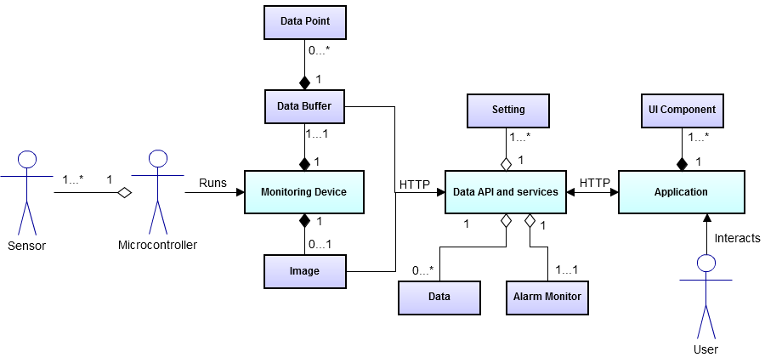

Figure 3.1. Domain Model showing core entities from the requirements. Some sub-entities have been combined for clarity.

## Use cases

There is little human interaction from the User during run time (though potentially a reasonable amount of setup), but the MCU itself is also an important actor as the external hardware running the monitoring device software. The use case specification is provided in Appendix 2, and summarised in the diagram below (fig. 3.2).

Core use cases for the MCU ‘interacting’ with the Device are shown. These include a few initiated by the MCU on booting, but mainly the operations are time-based triggers. An outline of some of the key use cases for the beekeeper interacting with the front-end is also presented. Largely the user interaction merely involves viewing various data in very intuitive and obvious ways, so the focus is on interesting interactions.

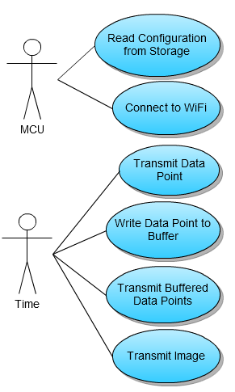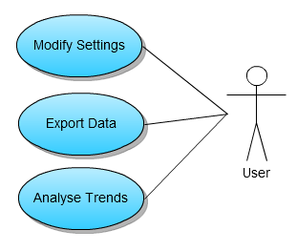

Figure 3.2. Use case diagram showing key use cases for the main system actors.

## Work packages

The key stages in the development were as follows, based on early mini-prototypes and testing of the various platforms and technologies, as well as experimenting with the Gadgeteer sensors and analysing the above requirements.

1. Core system prototype – initial Gadgeteer sensors, with their data pumped to the Xively API, and displayed on the native Xively interface.
2. Full stack prototype – custom JavaScript front-end, API and database back-end using Azure and Node.js, plus a refined monitoring device that implements its full requirement set.
3. Gadgeteer simulator - for testing the ability to use new sensors; this negates the need to build new sensors, which proved difficult.
4. Flexible system that is customisable on the sensors (in both the API and User Application), and on any other elements such as the alarms.

# Design and Implementation

## System architecture

The overall system (fig. 4.1) designed consists of three core independent modules, ideally independent from one another. These are:

1. Monitoring device – software running on the physical Gadgeteer hardware (MCU) with two core functions
   1. Gather data from the sensors
   2. Transmit all available data to the Data API.
2. Cloud services – Node.js software running on the Windows Azure platform with a number of core functions
   1. API for retrieval and storage of any incoming data
   2. API for querying and outputting available data (internal and external)
   3. Web server to deliver content
   4. Services for the web application.
3. Front-end – web application for users with the central operation being
   1. GUI to display live data and trends through customisable access to the Data API.

Module 2 is really two sub-modules operating in the same environment; they too are in fact operationally independent. The Data API carries out tasks 2a and 2b, leaving the Web Services to perform tasks 2c and 2d.

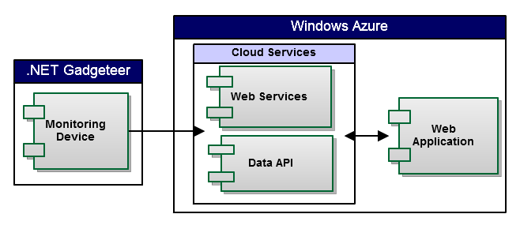Figure 4.1. Architecture overview. Outer swim lanes show the components’ deployment environment. Arrows indicate transfer of data.

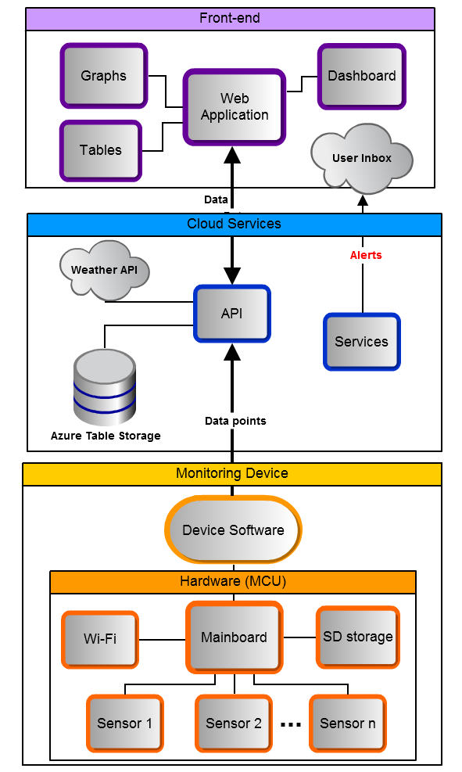

Figure 4.2. Detailed architecture showing the make-up of the three core components and their connections. The grey ‘clouds’ represent external sub-components.

The key point is that any individual module (fig. 4.2) can be replaced by a similarly-operating one to leave the full system running in the same way as before. For example, someone may wish to implement the system on a different platform, perhaps a traditional ASP.NET plus SQL Server implementation, which would require a rewrite of the Cloud Services module but no other components need be affected. Similarly, the Gadgeteer module could quite easily be replaced by a similar piece of embedded hardware like the Arduino running a program to send data from a series of sensors. Finally, the front-end is very replaceable due to the designed flexibility of the Data API.

## System components

Each of the three core components will now be examined in much greater detail.

### Monitoring Device

#### Hardware configuration

The Gadgeteer hardware was assembled with the following off-the-shelf modules (fig 4.3, provided by Microsoft Research Cambridge but commercially available):

1. Microcontroller core – 14-socket FEZ Spider mainboard
2. Power supply - dual support for USB and 9V DC
3. SD card module
4. Wi-Fi module
5. Sensors
   1. Light
   2. Temperature / Humidity (combined)
   3. Temperature / Pressure (combined)
   4. Accelerometer
   5. Camera - 320 x 240 resolution

In addition, an ordinary SD card (8GB SanDisk SDHC) is used in the SD module for permanent storage, and the mainboard is powered by a commercial 5V USB power pack. It is likely that combinations of similar modules would work just as well; these are merely the most useful ones available for this project.

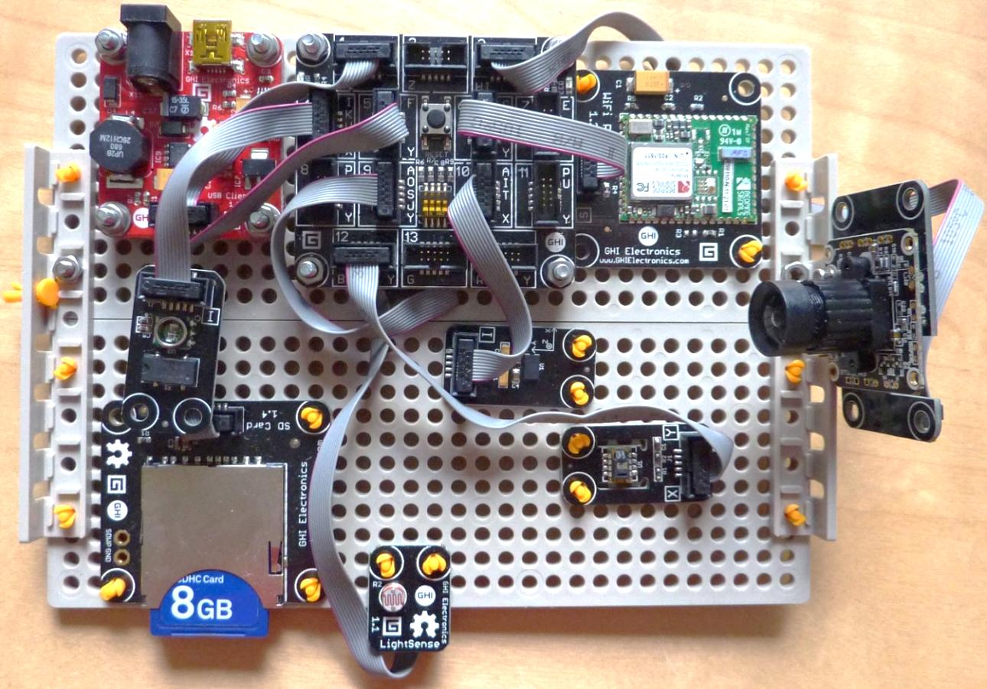

Figure 4.3. Fully assembled hardware. Assembly takes under one hour thanks to Gadgeteer’s simple modular socket-based architecture. The modules are mounted on a Tamiya prototyping plate (16 x 12 cm).

Based on the requirements, as informed by the research of what is useful for monitoring the health of a beehive (see §2.1.3), it was decided that the following properties were to be derived from these sensors, in the first instance:

* **Temperature**, inside
* **Temperature**, outside
* **Temperature differential** (in minus out)
* **Humidity**, inside
* **Light** level
* **Motion**, as a Boolean (moving or not), indicating external disturbance
* **Image**, at the beehive entrance.

The six core numeric properties (Channels) are the variables that form a single data point every time a measurement is made. The still image is captured simultaneously, but is not bundled with the numeric data.

The variable missing from this list but of significant importance from the requirements is beehive mass. No Gadgeteer sensor exists for this purpose, so during the second round of prototyping an attempt was made to build such a mass sensor for Gadgeteer. This was ultimately unsuccessful (see Appendix A3), but inspired the idea of making a Gadgeteer simulator to produce semi-random data for any arbitrary numeric sensor. This allows testing of the system to ensure it is able to support new Channels when more sensors become available (see §5.1).

#### Programming the MCU

Having built the physical hardware, it is then programmed in Visual Studio with the Gadgeteer SDK (fig. 4.4). Debugging and deployment is through a USB connection.

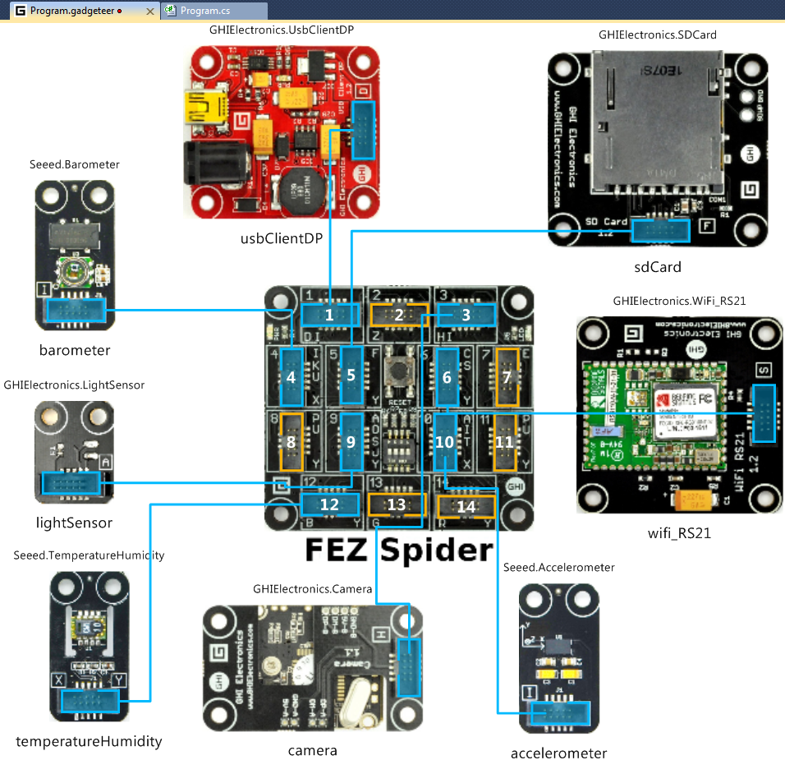

Figure 4.4. Visual Studio’s Gadgeteer Design View. The modules to be used are selected and virtually connected to the mainboard socket to which each is physically connected. Doing so exposes each module’s SDK so it can be used when writing the Device program.

#### Program design

The Gadgeteer platform differs from traditional embedded device programming, which mainly focuses on compact, relatively low-level C code. It instead uses a very high-level, object-oriented language, C#. This offers advantages in speeding up development time and allows use of good design practices. The key design this allows is the event-driven model, which is used by many of the Gadgeteer modules [32]. Rather than running a while (true) loop and polling sensors, buttons and other IO modules, an event handler is setup, with its callback method fired when the hardware responds (fig 4.5).

//Attach event handler

camera.PictureCaptured += new Camera.PictureHandler(pictureCaptured);

//Define callback

void pictureCaptured( Camera sender, GT.Picture picture ) {

//handle captured picture (send to API)

}

Figure 4.5. Setting up an event handler for the camera module, and defining the callback fired when the event dispatcher dequeues the event.

Multiple handlers are queued on the Gadgeteer event dispatcher, which sends events back to the main program thread for execution when ready. Because of this design, the ideal way to perform regular operations is using the native Gadgeteer.Timer class, which allows a method to be fired repeatedly at a regular interval.

The main use of this in the present system is to retrieve data from the sensors periodically, which is then transmitted to the web API over HTTP. In fact, almost all activity after the initial device boot is governed by this one Timer. The initial boot itself sets up all the module handlers and initialises their state (connecting to Wi-Fi, loading settings from the SD card, creating directory structures on the file system, synchronising the system clock etc.), and finally starts the Timer to schedule periodic sensor readings (fig 4.6).

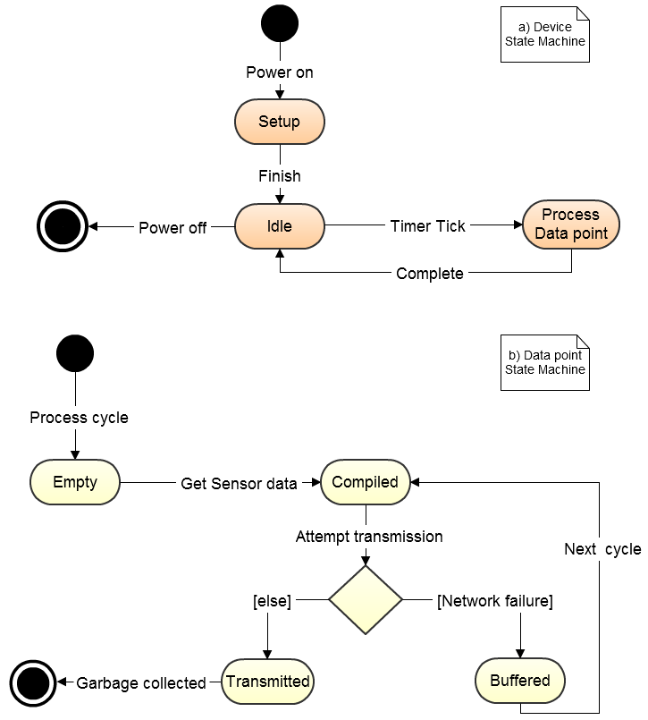

Figure 4.6. UML State machines for Device (a) and Data point (b). The Device runs continuously until power failure, producing data points from the sensors that are compiled and transmitted to the API, or buffered in case of network failure.

Despite the advantages of the Gadgeteer software platform, it cannot overcome the limitations of embedded devices. Their small memory means the NETMF libraries are much reduced from .NET’s offering. For example, there are no key-value pair based data structures (e.g. hash table) on NETMF, and string operations are much more limited. This fact necessitated implementing a few methods and classes normally taken for granted, such as string.join(), and line-by-line file reading.

The overall class structure (fig. 4.7) reflects the delegation of activity from the main program to individual functional modules, both for internal purposes (SdHandler, WifiHandler), and external communication (APIconnector). A number of utility classes provide resources missing from the core libraries, whilst the static Config class keeps configurable settings in one location.

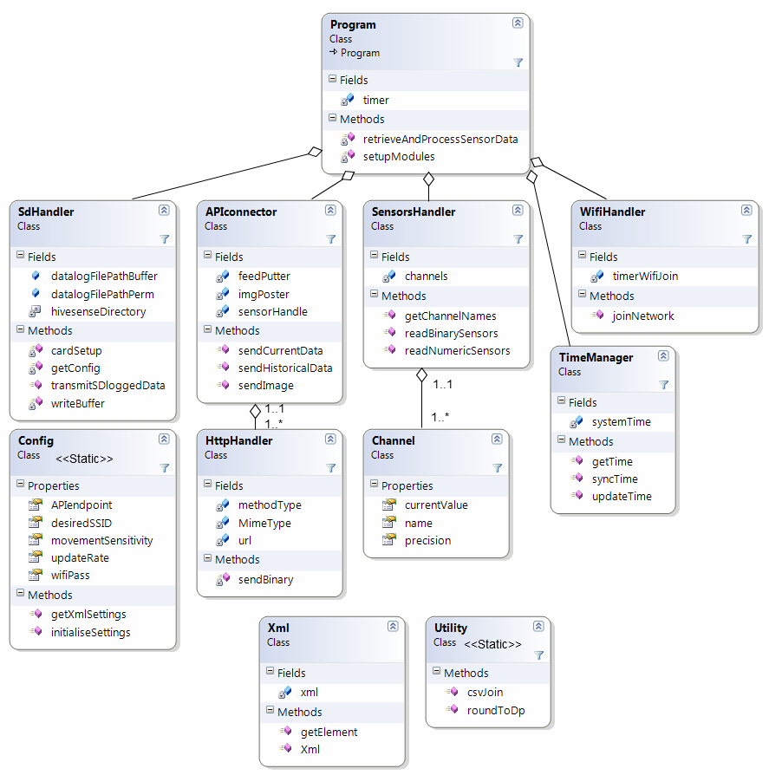

Figure 4.7. Class diagram for the monitoring Device program. Some class members are hidden for clarity, and not all associations are shown.

Device flexibility is obtained through two means: good class design, and use of the SD card to load numerous settings from an XML configuration file. Due to Gadgeteer’s varying implementation of different sensor modules, and the fact that multiple Channels can be derived from a single sensor (The ‘temperatureHumidity’ sensor reads both temperature and humidity properties), the class design approach taken was to focus on the Channels themselves. The Channel class abstracts the details of a property away from its parent sensor, so the Device can be modelled as a serious of sensors giving rise to a set of distinct Channels (fig 4.8 below).

class Channel {

public string name { get; protected set; }

public int precision { get; protected set; }

public double currentValue { get; set; }

...

}

Figure 4.8. Channel class, simplified to show the properties stored by a Device Channel.

The SensorsHandler class sets up the sensor modules and their event handlers, and lays out which Channels to measure (fig. 4.9. below).

class SensorsHandler {

...

/** Channels **/

Channel t1 = new Channel( "temp1", 1 );

Channel t2 = new Channel( "temp2", 1 );

Channel tdiff = new Channel( "tempdiff", 1 );

Channel hum = new Channel( "humi", 0 );

Channel light = new Channel( "light", 0 );

Channel motion = new Channel( "motion", 0 );

Channel[] channels;

...

}

Figure 4.9. SensorsHandler class, much simplified to show just the declaration of which Channels to store in a data point.

It is thus straightforward to start measuring a new Channel, especially so from an existing sensor, but also by implementing a new sensor module. No other classes need modifying, and all Channels will flow to the API.

Whilst it is essential to change the program code when new sensors are added, the same is not true for many other settings variables. The XML configuration file (fig. 4.10) offers an easy way to change the Device settings without having to reprogram the MCU. This is particularly important for non-technically-minded users, who may be given a pre-built and pre-programmed MCU but have a need to change the settings.

<?xml version="1.0" encoding="utf-8"?>

<config>

  <!-- Network Settings for wifi -->

  <SSID>CSSTUDENT</SSID>

  <password>GowerStreet6BT</password>

  <!-- Frequency of readings in seconds (must exceed 5) -->

  <updateRate>30</updateRate>

  <!-- Movement detection threshold: -7.9 (most sensitive) to +7.9 -->

  <sensitivity>-7</sensitivity>

  <!—Base URL of the server running the API to receive the data. -->

  <server>http://hivesensenodejs.azurewebsites.net</server>

</config>

Figure 4.10. XML configuration file for the Device. It is stored on the SD card and read at boot-time, and provides some flexibility to the program.

Most usefully, the network settings can be changed so the Device can work on different wireless networks by simply changing of the configuration file. Similarly, the update frequency can be reduced to minimise power use.

### Web API

#### RESTful design

By conforming to RESTful architectural constraints, the data API delivers the important properties of portability, scalability, flexibility and robustness [33], which are desirable in any system for data distribution. The core constraints followed, as identified by the author of REST [34], were achieved as follows:

Client-Server. Data returned from the API does not conform to the needs of any particular user interface, so it can be freely used by any number of them. Although a specific user interface was developed for this system, the goals are clear that the API should not be tied to its implementation (fig. 4.11).

{

  updated: "Wed, 21 Aug 2013 09:07:33 GMT",

  channels: [

    {

     id: "temp1",

     current_value: 29

    },

    {

     id: "humi",

     current_value: 54

    },

    {

     id: "light",

     current_value: 19

    }

  ]

}

Figure 4.11. Sample server GET response for the current data point. The JSON format is part of good client-server independence, as it is suitable for any web application.

Stateless. Individual requests are self-contained; the server does not keep clients’ state between requests.

Cache. All requests have an appropriate caching policy to minimise resources by preventing excess requests; this improves general scalability and client performance, whilst reducing the chance of server failures due to overload. Specifically, static content requests are labelled with a long-lifespan cache, whilst sensor data is given a short cache roughly equal to the update frequency, and PUT requests are never cached. These are all set using the HTTP 1.1 Cache-Control and Last-Modified headers.

Code-On-Demand. Although optional in REST, this was implemented to enhance client functionality. The JSON settings object can be manipulated through the API, or set on the server. These settings are specific to a user interface, but any number of arbitrary settings can be defined, modified, and deleted.

Uniform Interface. This is the most important feature of REST [34], and the key part is identifying which resources are available on the server, and specifying how these can be manipulated by clients. This is implemented through proper use of HTTP methods, caching, URIs, and internet media types. The resources identified that make up the API were:

* Channel feed (numeric sensors)
* Image feed (camera sensor)
* Settings
* External (accessing other APIs, e.g. weather).

Each resource has its own URL and supported methods and internet media types. For example, PUT and GET methods determine respectively whether data are being saved (from Device to API), or retrieved (web application) for the image and data point feeds, whilst the External resource only allows GET. Appendix A5 details the complete list of supported operations.

#### Overall Design

The key goal of the design for the overall web API and services was achieving logical separation of the API resources, the database implementation, the web services, and any web server logic. These are the distinct operations of the Node.js-implemented software, so the components need to be decoupled should any of their implementation requirements change. For example, the API relies heavily on a database, but the particular one chosen should be replaceable without affecting the API itself.

This decoupling has been achieved through effective modularisation. In Node, modules form the core of the system design and effectively act as classes. Apart from a few core functional modules that have global scope, each module (from both the Node library and those that are imported or created) is isolated from every other until explicitly imported. Only members (fields and methods) defined as exportable (‘public’) are available, allowing encapsulation to be achieved since other members remain hidden to the importing module (fig. 4.12).

//Public method as it is attached to the ‘exports’ object

exports.giveNoResourceError = function (res) {

    clientError(res, 'No resource exists here.', 404);

};

//Private method

function clientError(res, message, type) {

    res.writeHead(type, { 'Content-Type': defaultType });

    res.end(JSON.stringify({ error: message }));

}

Figure 4.12. Encapsulation on Node.js, using the global-scope ‘exports’ object.

On top of this, a layered approach has been adopted to further constrain the system design into proper separation of operations. This should improve the ability to maintain and extend the system’s operations, for example by adding more API resources. The layers are implemented as simple directories, but used such that modules (‘classes’) in one layer (‘package’) may only import modules from a higher layer (fig. 4.13).

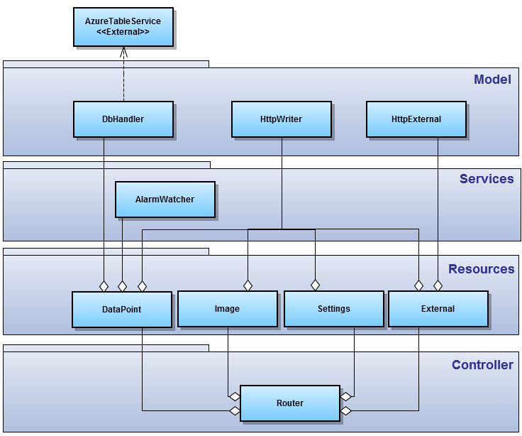Figure 4.13. Package and module structure for the API and web services. The independent layered approach is evident. The external AzureTableService module is part of the Azure SDK; usage notes are available on the website [35].

#### Data model

The Azure Table Service (ATS) is a highly scalable distributed NoSQL database platform. To maximise the advantages it offers whilst maintaining flexibility in querying, it is necessary to design the storage model effectively. Only one table is needed, which stores all data points from the Device, as received through the API data point feed resource. Each row corresponds to a single data point, comprising the dateTime of the recording and values for each measurement channel taken (see fig 4.14).

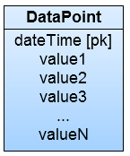

Figure 4.14. Data model for storing data points in the Azure Table Service. Each value corresponds to a measurement channel on the Device (light, humidity etc.).

After experimenting with a relational-style model of one row per channel per data point, with a channelID foreign key to a separate channel table, the one table approach was favoured for a number of important reasons:

* No need to maintain a separate list of channels in another table, which impacts detrimentally on flexibility when new sensors are produced offering new measurement channels
* More compact storage
* Faster retrieval of data points
* More data points returnable (ATS has a 1000 per query limit).

ATS uses a concept of a ’partitionKey’, a required field for each row that effectively indexes the table. For time series data, this feature of ATS can be exploited by putting the dateTime field here, achieving two useful results:

Firstly, rows can be returned in a specific order, something not normally possible with ATS, which does not have an ‘order by’ concept for fields of a table, instead always returning rows ordered by partitionKey. This is used to return the most recent data points, a very useful feature for the API. Secondly, ATS will automatically group rows by similar partitionKey, as its distributed storage model uses the partitionKey to group similar data in the same system node for faster retrieval [36]. Consequently, data points for similar dates are likely to be partitioned together, making queries for specific date ranges (another feature of the API) faster.

Other data (settings, images) are stored internally on the server file system, since the small quantity and simplicity of such data do not justify use of more sophisticated storage techniques. In fact, the settings are stored as JSON, which offers the advantage of easy integration with Node.js; JSON is a natural and effective storage format when working with JavaScript since it can be manipulated with native syntax and methods. Moreover, hierarchical data structures can be created and manipulated very easily compared to flat representations such as database tables.

### Web application

Following best practices [37], all behavioural code (JavaScript) is separate from the visual content (HTML), which in turn is separate from its styling (CSS). Consequently, event handlers (onLoad, onClick etc.) are added after the DOM has loaded, which is also when all dynamic content, as obtained asynchronously from the API, is added.

#### Dynamic loading

Using the Settings resource of the API (see sec 4.2.2.1) for storage, many of the UI components are loaded dynamically at start-up, and can be modified at runtime by the user. Principally, the dynamic components are the alarms (threshold breaches for individual Channels) and the Channel blocks (current value, trend, graph of a Channel), the latter being particularly important for achieving flexibility to a change in the Channels used by the Device. Essentially, this design means changing a few lines in the settings file (through a form on the web application) will achieve corresponding changes in the GUI (see testing §5.1). The settings themselves are encoded in JSON for optimal ease of manipulation with client- and server-side JavaScript; even complex structures such as the Channel blocks are easy to manipulate (see fig. 4.15).

channels: [

  {

id: "temp1",

  label: "Temp-in",

  unit: "C",

graphOptions:

   {

  labelShort: "T-in",

  colour: "#f32",

    }

  },

  {

  id: "humi",

  label: "Humidity",

  unit: "%",

...

]

Figure 4.15. Simplified sample of the JSON Settings file used to load UI elements dynamically. Here, the Channel blocks are being defined.

#### Single-page application

The application is designed as a single-page application (SPA) to maximise user experience by providing a fluid approach to the loading of resources.

The SPA has been achieved through the ‘thick-client’ architecture – heavy use of event handlers and AJAX communication, both made easy with the jQuery library. The initial page request loads all static content (CSS, JavaScript source), with all subsequent HTTP requests made asynchronously through AJAX requests to the Node.js server, which responds with JSON data from the API (fig. 4.16 below). This in turn is manipulated by the client browser running the JavaScript, using the JSON to inform the modification of the existing DOM, by adding or changing existing HTML.

this.getDataCurrent = function (callback) {

    $.get(API_ENDPOINT_DATA + "?current",

function (data) {

    callback(data);

}, "json"

);

};

Figure 4.16. jQuery AJAX request from client to server to retrieve new data. The callback may specify various DOM manipulations and data model updates.

#### Class design

A Model-View-Controller (MVC) architectural design was adopted, as is natural and very common for web applications [38]. Since most of the View is defined by the HTML page, the JavaScript classes are contained on just two layers, a View-Controller (VC) for interacting with the DOM and triggering updates, and a Model for communicating with the API and providing content for the VC (fig. 4.17). As required by MVC, the Model cannot use or call methods of the VC, but simply exposes methods for it to use to update the DOM as required by user interaction or automated data updates.

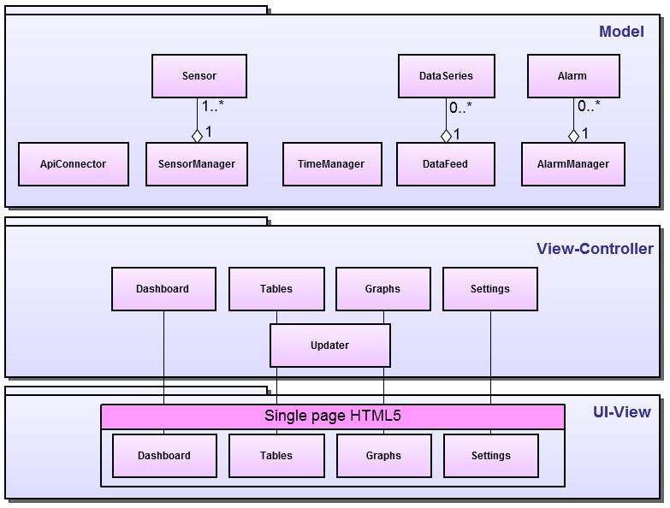

Figure 4.17. Simplified class diagram for the web application, showing the layered MVC packages and core classes used.

Classical class-based object-oriented programming (OOP) does not come naturally to JavaScript development, as evidenced by the native language’s absence of explicit class declarations, access modifiers, and namespace support, for example [37]. However, all of these features can be implemented in JavaScript’s prototype-style OOP to provide a more maintainable and comprehensible code design than its natural ‘scripting’ style (see fig 4.18 below).

Namespaces. Classes for the View-Controller and Model are logically separated so have been put in separate namespaces. A namespace is achieved by creating an empty global-scope object with the variable name of the namespace, then subsequently attaching classes to that object.

var Model = new function() {

/* Model Namespace */

};

Model.SensorManager = function() {

    /* SensorManager Class */

    //public field

    this.API = "URL";

    //private field

    var sensors = {};

    //public method

    this.getSensor = function(id) {

return sensors[id];

};

    //private method

    function getTrend(name) {

        //logic

};

}

Figure 4.18. Achieving support for classical OOP-style namespaces, encapsulation and classes in JavaScript.

Classes. Everything in JavaScript is really an object, but class-like behaviour can be achieved in numerous ways, all variations on declaring a function ‘object’ and attaching class members to it, with any arguments of the function comprising the constructor parameters. Static classes, whereby all members can be accessed without first creating an object and calling the constructor, are achieved by adding the new keyword to the class declaration, which effectively calls the constructor immediately. This latter ‘Singleton’-like approach was rather heavily adopted in the present system.

Visibility. Restricting access to class members is an important OOP concept for its encapsulation effect, and is achieved in JavaScript through careful scoping of variables. There are multiple ways to achieve this, but the approach adopted here was to use the this keyword to attach public members to the class ‘object’ , and the var or function keyword to maintain private access for fields and methods respectively.

Using these tricks, an application made with some classical OOP principles in mind was developed, though perhaps using a JS framework would have helped achieve better design (see evaluation §6.2.).

# Testing

Broadly, it was desirable to test the key points in the design and ensure that the software is robust and extensible in the way specified in the requirements. The nature of the development phase, involving prototyping and oft-changing requirements, meant than unit testing was not suitable. A higher-level approach based on black-box system and integration testing was therefore followed.

## Adding new sensors

Because a key feature of the software is its flexibility to the addition of new sensors to the Device, this is a key area of testing across all components. Due to the aforementioned failure to produce a physical mass sensor to add to the Device itself, such a sensor was simulated. This was done with a .NET command-line program to simulate the API-connection of the Gadgeteer Device (fig. 5.1).

private static readonly string[] channelNames = { "temp1", "humi", "motion", "light", "temp2", "tempdiff", "mass" };

channels[6] = randomSensorValue( 80, 100, 1 );

Figure 5.1. Adding a new Channel to the Device simulator. The randomSensorValue method will produce a random value between 80 and 100 with a 1 decimal place precision.

Using the simulator, data for new sensor channels can be sent to the API, allowing its extensibility to be tested, as well as its compatibility with altogether different devices. With new channels available in the API (fig. 5.2.), the front-end’s adaptability is then tested by updating the JSON settings to include a new measurement channel (fig. 5.3), and observing the successful accommodation of this in the GUI (fig. 5.4).

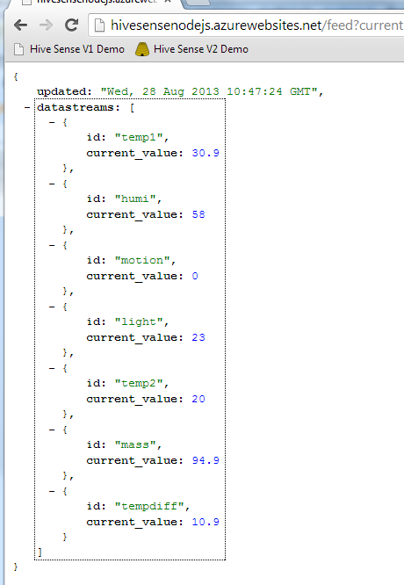

Figure 5.2. The new “mass” Channel appears in the API current data point feed.

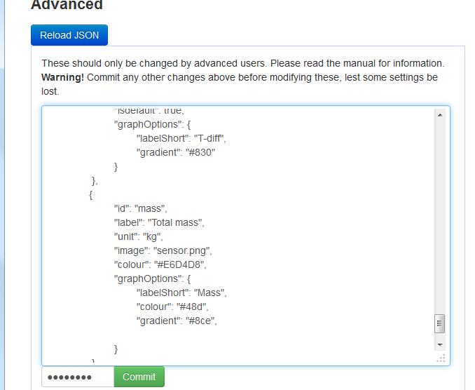

Figure 5.3. Adding the new Channel to the settings so it will show on the GUI.

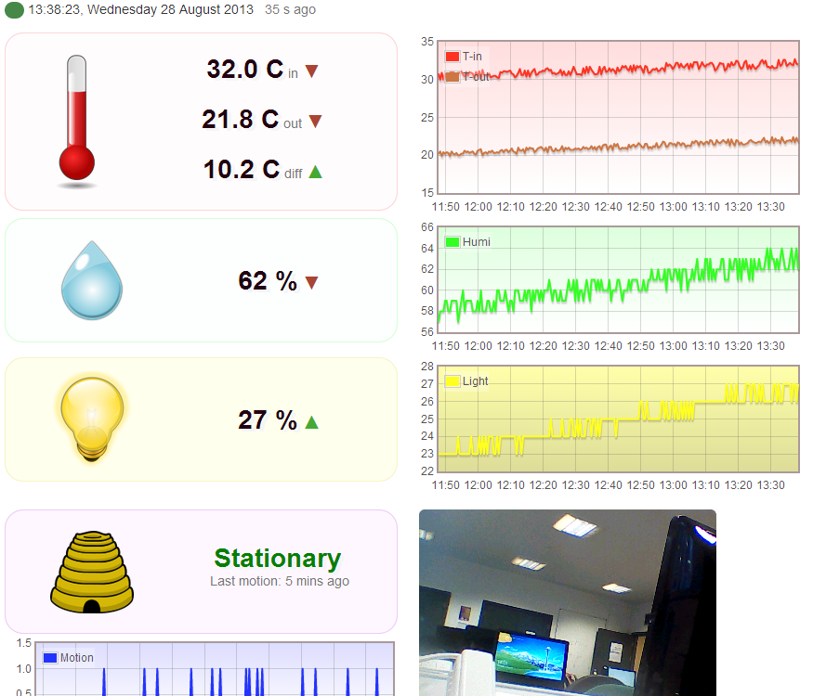 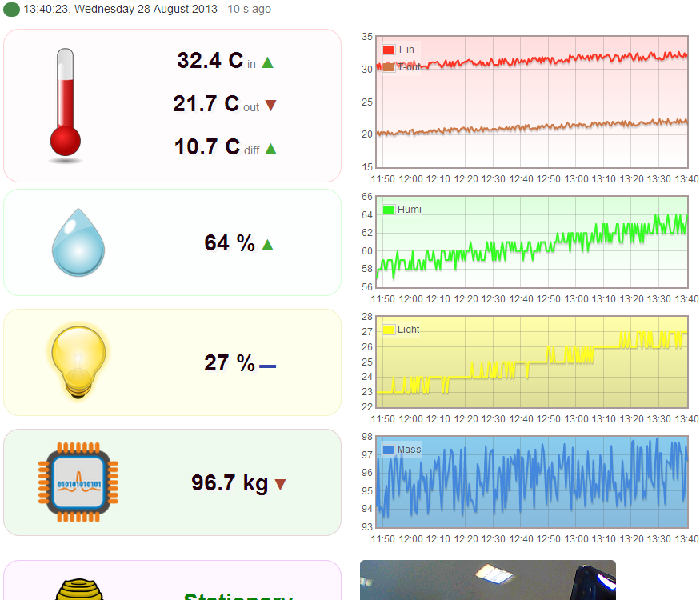

Figure 5.4. Adding a Channel block to the GUI. Left: Before addition of mass sensor, Right: afterwards. The front-end accommodates the new sensor channel successfully.

## Device-API communication

Without data, the API and front-end serve little purpose, so ensuring that data reaches the API from the Device is critical. A series of performance tests were therefore executed to reveal the limitations of this connection, and uncover problems in edge cases.

### Maximum frequency

It is expected that performance at the Device end will limit how frequently data points can be sent to the API. In this stress test, the Device sensor-process frequency was varied to find the maximum frequency possible (see table 5.1). The testing revealed a number of bugs in the software that only appear at high frequency, due to overlapping execution of event callbacks as they are fired from the dispatch queue. A number of these bugs were fixed (for instance, over synchronising of the clock leading to incorrect system times). However, at frequencies below five seconds, the overlapping is excessive and the dispatch queue eventually fills up and results in the device crashing with an out-of-memory exception. At five seconds, the Device is running almost continually (very little idle time), but the success rate of data points reaching the API is close to 100%. Five seconds is therefore deemed the maximum possible frequency in the current setup, though this is likely to differ under different network conditions and with more/fewer sensors.

To ensure the API was not at fault, the aforementioned Device simulator was used on a desktop machine to transmit at one second intervals. The simulator gave a 100% success rate at this frequency, so the API is clearly capable of handling high frequencies in the event of a better performing Device being used.

|  |  |  |
| --- | --- | --- |
| Frequency / s | Success rate / % | Comments |
| 1 | 28 | Device crashed before end |
| 3 | 64 | Device crashed before end |
| 5 | 98 | Very little idle time |
| 10 | 100 | No problems |
| 30 | 100 | No problems |

Table 5.1. Success rate for Device-API data point transmission at different frequencies. The test period was 50 data points. Success rate is calculated as number of points saved by API / number of points expected (50). For the three and one second frequencies, even before the Device crashed the rate of transmission was less than expected.

### Buffering

Many beehives are in remote areas where network availability may be poor. To account for this, buffering of data (when network connectivity drops) has been implemented as per the requirements. To test this, a button was added to the Device, which disables the network temporarily to allow the buffer to fill. These small test cases were successful, with all buffered data transmitted to the API without fault.

In practice, network loss may be for a period of up to a week (the typical frequency of beekeeper visits to his hive). By producing semi-random data to simulate a week of data capture (just over 10,000 data points using a 60s interval), the long-term buffering capability was also tested. The simulated data was compiled to API-friendly format and sent to the API on a desktop machine to test the API’s ability to receive such a large quantity of data points.

The result revealed a potential problem with the database. Using detailed logging it was discovered that it could only process approximately 12 data points per second, and would ‘hang’ every minute or so; the full process took almost 20 minutes and gave a success rate of only around 80% compared to the usual 100%. Moreover, during processing of the 10,000-strong batch the database could not process any other requests.

To mitigate this problem, a safe limit of 100 data points was decided upon and successfully tested; this quantity only takes a few seconds to process so does not interfere with other requests. Therefore, on the Device itself, the buffer will only transmit 100 data points per process cycle (usually every minute), leaving the database time to process and preventing any memory issues with the Device having to send megabytes worth of data points in one instance. This change in strategy required modification of the Device software, which was performed and tested successfully on a buffer of 10,000 data points.

## User-acceptance

The limited time and remote availability of willing beekeepers for testing the physical device in a real beehive was such that field testing was not feasible. Moreover, the project scope is clear that this is not necessary as the conceptual demonstration of beehive health monitoring possibilities is more important. However, a core part of the project is the front-end, and this was informally user-tested in an iterative manner throughout its development, in order that its features best match the needs of beekeepers. This testing was achieved by communicating with three beekeeper contacts provided by the external client, Mr Johnston. Using the publically available URL for the front-end, hosted on an Azure Web Site, the beekeepers could provide useful feedback which was successfully used to inform and refine later prototypes, and validate existing features.

# Conclusions

## Summary

The project has offered a good insight into what is likely to be a rich and much-developed field, and the software developed provides a useful platform for that further development. Automated beehive health monitoring is part of the trend in the internet-of-things world, whereby ordinary objects are transformed into networked components producing data to inform and advise [39]. To-date, little work has been done to connect beehives to the ‘cloud’ and produce visual front-ends for real-time viewing of hive data. The present work sought to address this by targeting the many thousands of beekeepers in the UK with a system that demonstrates how automated hive monitoring using commercially available hardware could aid them in looking after their bee colonies.

Using simple but useful sensors such as thermometers and accelerometers, pushing this data to a cloud-hosted API for storage, and finally viewing this data on a modern web-based user interface, the project goals have been achieved. Through specific design choices, the extensibility of the system – particularly to emerging sensors on the Gadgeteer platform – has been demonstrated. This should allow the present work to achieve greater practical use, either through implementation of a custom monitoring device or extension of the present one.

The system is ready to be trialled, and offers the first known non-commercial, ready-to-implement solution to automated, cloud-connected beehive health monitoring. Furthermore, it offers many opportunities for further expansion. With enormous potential benefits, it is possible to envisage its use in many thousands of beehives.

### Financial aspects

The current cost of the fully assembled device is approximately £200 in the UK (as per distributor list pricings of each component). However, this high price is largely a result of the prototype-oriented nature of the Gadgeteer platform. The raw hardware (sensors, microprocessor) is mass-produced and inexpensive, so a production device could likely be manufactured for much less than the current prototype.

As mentioned in section 2.1.1, the net value of the UK’s quarter of a million beehives exceeds £200m, largely due to the bees’ role in pollination of agricultural crops. This equates to £800 per hive, whilst the cost of replacing a dead colony is £50-£200 – and as much as £300 if infectious disease was involved, as the physical beehive needs replacing too [40]. Even at the prototype’s cost of £200, the monitoring device offers a good return on investment for individuals. For the agricultural economy, the benefits of preventing significant colony deaths are also apparent.

## Critical evaluation

### Fulfilling requirements

The vast majority of the requirements – for the monitoring device, web API, and font-end – were fulfilled successfully. The notable exception was the implementation of a mass sensor for the monitoring device, something desired by all beekeepers who were asked. Although much researched, the attempt failed (see Appendix A3). However, the ability to simulate the behaviour of a mass sensor on the API and front-end was demonstrated during testing. Consequently, this shortfall was not deemed particularly problematic, and it is expected that with the input of some more advanced electronics expertise, an effective mass sensor could be developed and integrated with this system.

### Technologies

In general, the chosen technologies (selected after early prototyping) were effective. In the stress testing, however, it emerged that the database implementation – Azure’s NoSQL Table Service (ATS) – gave unsatisfactory performance in certain cases. In addition, the range of operations is very limited, so doing any significant statistical analysis of the data is unlikely to be straightforward. For these reasons, an alternative implementation may be preferred. Due to good design of the API, which strongly separates the ATS logic, this should not be unduly difficult.

### Design

Throughout the software design stage, a principle of low-dependency was adopted, in order to make it easy to add and modify features – of the front-end, API and monitoring device. This was achieved through decoupling of logic into appropriate classes, and subsequent layering of these classes. Moreover, the high-level architecture of decoupled API, front-end and Device makes it easier to change any single component without affecting the others. Although these aspects were successful, robust object-oriented principles were not always followed. This is particularly noticeable in the JavaScript code (API and front-end), where, for example, there was excessive use of static classes. It is therefore probable that low-level design of the API and front-end could be much improved, probably with the use of a JavaScript framework which makes it easier to follow best OOP practices.

## Further work

A number of suggestions are made to further the development of the present system.

### Device operations and practicalities

On a practical level, field testing would certainly be useful. This would require long-term deployment of the Device in an operational beehive – one year at least, to capture the complete bee colony lifecycle. The issues raised by such testing are expected to be more hardware-related, for example battery failure, Device crashes, and weathering of components.

In addition, the range of sensors would need to be improved for the Device to meet the full requirements of most beekeepers. As discussed in the background research (§2.1.3), measurement of other properties, such as hive mass and colony noise, would be worthwhile. The ease of adding numeric sensors such as a mass sensor has been demonstrated, but properties such as sound require specialist interpretation and front-end delivery. Consequently, it may be desirable to improve the ease of adding these specialist sensors to the system.

### API and front-end

The front-end, whilst modern and attractive with an informative dashboard for live data, is somewhat light on features for historical data and analysis. This is a potential area for significant development, as the current graphs and tables only offer a snapshot. Incorporation of more in-depth data and trend analysis is expected to be of particular use to beekeepers. This could add value to warning systems, as finding deviation from normal trends may signal certain unusual hive activity. Moreover, different hives could be compared, and this wealth of data may be of use to honeybee researchers looking to arrest the rise in colony deaths.

### Multiple hives

The present system was scoped to focus on a system for a single hive. To realise the full benefits of bringing this technology to the beekeeping community, it is essential to consider how to make it work for multiple beehives across the country.

In meteorological circles, numerous web-based platforms exist for weather observers to connect their weather stations to a central service. Examples include Weather Underground (WU – “the world’s largest, with over 25,000 active stations”) [41], the Met Office’s Weather Observations Website (WOW) [42], and the Citizen Weather Observer Program (CWOP) [43]. These serve numerous purposes: comparison of weather data across the world [41] [42], meteorological research and forecasting [43], and provision of weather services such as web APIs [41] [43].

It is not too ambitious to envisage similar prospects for the beekeeping community. At one time, weather observers were akin to beekeepers in their use of traditional equipment to monitor their environment. The explosion of cheap electronic weather stations, and the availability of software for sending this data to the aforementioned web platforms, changed the weather community. Quite reasonably, devices such as the one in this project could eventually have a similar impact on beekeeping, especially in terms of mass availability of data for the extensive research into honeybees and the decline in their number over recent years.

Achieving this would be a project in itself, and would involve redesign of the API to accommodate multiple incoming devices, acting like WU, WOW and CWOP, which are dedicated to accumulating sensor data from multiple sources. In addition, a dedicated front-end for viewing aggregated data – in map form for example – could be developed. This would enable the community to reap the full benefits of the thousands of devices that could be deployed in hives across the country, with all data openly available for analysis.

With these possibilities for data sharing in mind, the software stack presented in this report could be just the beginning of a process through which we could considerably improve the knowledge of honeybee colonies, to the invaluable benefit of beekeepers and the agriculture industry alike.

# Bibliography

|  |  |
| --- | --- |
| [1] | J. McLoughlin, “.NET Gadgeteer hack weekend,” Developer South Coast, 27 April 2013. [Online]. Available: http://www.meetup.com/DeveloperSouthCoast/events/110389952/. |
| [2] | A. Davis, “Operational prototyping: a new development approach,” *Software, IEEE,* vol. 9, no. 5, pp. 70-78, Sept. 1992. |
| [3] | British Beekeepers Association, “BBKA release winter survival survey,” 13 June 2013. [Online]. Available: http://www.bbka.org.uk/files/pressreleases/bbka_release_winter_survival_survey_13_june_2013_1371062171.pdf. |
| [4] | J. Bromenshenk, “Colony collapse disorder (CCD) is alive and well,” *Bee Culture,* p. 52, 1 May 2010. |
| [5] | US Dept. Agriculture, “Colony Collapse Disorder Progress Report,” USDA, Washington DC, 2010. |
| [6] | I. Davis and R. Cullum-Kenyon, BBKA Guide to Beekeeping, London: Bloomsbury, 2012. |
| [7] | N. Carreck and I. Williams, “The economic value of bees in the UK,” *Bee World,* vol. 79, no. 3, pp. 115-123, 1998. |
| [8] | European Comission - Directorate-General for Health & Consumers, “Honeybee Health,” European Comission, Brussels, 2010. |
| [9] | M. Allan, Interviewee, *Bee Monitoring.* [Interview]. 15 April 2013. |
| [10] | E. Stalidzans and B. A, “Temperature changes above the upper hive body reveal the annual development periods of honey bee colonies,” *Computers and Electronics in Agriculture,* vol. 90, pp. 1-6, 2013. |
| [11] | A. Zacepins and E. Stalidzans, “Architecture of automatized control system for honey bee indoor wintering process monitoring and control,” in *International Carpathian Control Conference*, High Tatras, 2012. |
| [12] | J. Nickeson, “About Scale Hives,” Goddard Space Flight Center, NASA, 8 March 2010. [Online]. Available: http://honeybeenet.gsfc.nasa.gov/About/ScaleHives.htm. |
| [13] | M. Bencsik and e. al, “Identification of the honeybee swarming process by analysing the time course of hive vibrations,” *Computers and Electronics in Agriculture,* vol. 76, no. 1, pp. 44-50, 2011. |
| [14] | Microsoft, “Microsoft .NET Gadgeteer,” 19 April 2013. [Online]. Available: http://gadgeteer.codeplex.com/. |
| [15] | Microsoft, “Home - Gadgeteer,” 2011. [Online]. Available: http://www.netmf.com/gadgeteer/. |
| [16] | LogMeIn Inc., “Xively - Public Cloud for the Internet of Things,” 2013. [Online]. Available: https://xively.com/. |
| [17] | Joyent Inc., “node.js,” 2013. [Online]. Available: http://nodejs.org/. |
| [18] | S. Tilkov and S. Vinoski, “Node.js: Using JavaScript to Build High-Performance Network Programs,” *Internet Computing, IEEE,* vol. 14, no. 6, pp. 80-83, 2010. |
| [19] | B. Calder and e. al., “Windows Azure Storage: A Highly Available Cloud Storage Service with Strong Consistency,” in *23rd ACM Symposium on Operating Systems Principles*, Cascais, 2011. |
| [20] | The jQuery Foundation, “jQuery,” 2013. [Online]. Available: http://jquery.com/. |
| [21] | Bootstrap, “Bootstrap,” 2013. [Online]. Available: http://twbs.github.io/bootstrap/. |
| [22] | O. Laursen, “Flot: Attractive JavaScript plotting for jQuery,” IOLA, 2013. [Online]. Available: http://www.flotcharts.org/. |
| [23] | S. Ferrari et al., “Monitoring of swarming sounds in bee hives for early detection of the swarming period,” *Computers and Electronics in Agriculture,* vol. 64, no. 1, pp. 72-77, 2008. |
| [24] | Universitat Wurzburg, “HOBOS - Honeybee Online Studies,” [Online]. Available: http://www.hobos.de/en.html. |
| [25] | Arnia, “Bee Keepers,” [Online]. Available: http://bee-keepers.co.uk/. |
| [26] | Beewiz, “Bee hive monitoring, bee keeping equipment,” [Online]. Available: http://www.beewise.eu/. |
| [27] | Swienty, “BeeWatch Proffesional - hive scale,” [Online]. Available: http://www.swienty.com/shop/vare.asp?side=0&vareid=102360. |
| [28] | “HiveTool,” [Online]. Available: http://hivetool.org/. |
| [29] | Hydronics, “Honey Bee Counter,” 12 Oct. 2012. [Online]. Available: http://www.instructables.com/id/Honey-Bee-Counter/. |
| [30] | F. w. Technology, “Beehive scale build details,” 15 Sep. 2011. [Online]. Available: http://makingthingswork.wordpress.com/2011/09/15/70/. |
| [31] | G. Hudson, “Bee Hive Monitor,” 2011. [Online]. Available: http://openenergymonitor.org/emon/node/102. |
| [32] | K. Hammil, “Why not while(true)?,” Microsoft, 11 Dec 2011. [Online]. Available: http://blogs.msdn.com/b/net_gadgeteer/archive/2011/12/19/why-not-while-true.aspx. |
| [33] | S. Richardson and S. Ruby, RESTful Web Services, O'Reilly Media, 2008. |
| [34] | R. Fielding, *Architectural Styles and the Design of Network-based Software Architectures,* University of California, Irvine, 2000. |
| [35] | Microsoft Windows Azure, “How to use Azure Storage (Node.js),” [Online]. Available: http://www.windowsazure.com/en-us/develop/nodejs/how-to-guides/table-services/. |
| [36] | J. Go, “Designing a Scalable Partitioning Strategy for Windows Azure Table Storage,” 5 Oct. 2011. [Online]. Available: http://msdn.microsoft.com/en-us/library/windowsazure/hh508997.aspx. |
| [37] | S. Stefanov, Object-Oriented JavaScript, Packt Publishing, 2008. |
| [38] | A. Leff and J. Rayfield, “Web-application development using the Model/View/Controller design pattern,” in *Enterprise Distributed Object Computing*, Seattle, 2001. |
| [39] | N. Gershenfel et al., “The Internet of things,” *Scientific American,* vol. 291, no. 4, pp. 76-81, 2004. |
| [40] | G. Hood (Chair of British Beekeepers Asscoiation for Barnet, London), Interviewee, *Beekeeping costs.* [Interview]. 1 Sep 2013. |
| [41] | Weather Underground Inc., “Personal Weather Stations - Wunderground,” 2013. [Online]. Available: http://www.wunderground.com/weatherstation/about.asp. |
| [42] | Met Office, “Met Office WOW,” 2013 [Online]. Available: http://wow.metoffice.gov.uk/home. |
| [43] | NOAA, “Citizen Weather Observer Program,” 2011. [Online]. Available: http://wxqa.com/. |

## Other Sources

Node.js webserver design:

M. Kiessling, The Node Beginner Book, Learnpub, 2012

Diagrams were produced with <http://Gliffy.com>.

Some front-end images are from <http://OpenClipArt.org>.

GHI documentation: <https://www.ghielectronics.com/docs/> was used for small code samples to aid writing the program for the monitoring device in C#.

The Xively IoT [16] API was used as inspiration for the web API, with some conventions and naming borrowed.

General software engineering resources:

A. Cockburn, Writing Effective Use Cases, Addison-Wesley, 2000

J. Arlow, UML 2 and the Unified Process 2nd Ed., Addison-Wesley, 2005

I. Sommerville, Software Engineering 9th Ed., Pearson, 2011.

# Appendices

###### Project Resources

A few useful resources developed for the project are presented below. Note well, however, that any hyperlinks are not guaranteed to persist beyond September 2013.

Blog

A blog was kept for this project, inherited from the Gadgeteer ‘hack weekend’ that inspired this project. Only posts with ‘BenLR’ listed as the author were written by the present project author: <http://hivesense.wordpress.com/>.

Github repository

All versioned source code and documentation is available at the public GitHub repository ‘HiveSense’: <https://github.com/blrnw3/hivesense>.

Web application

A live demo of the front-end is available on Azure: <http://hivesensenodejs.azurewebsites.net/>.

###### Use Case Specification

MCU/Time

|  |
| --- |
| **Read Configuration from Storage** |
| **ID:** UC-M1 |
| **Summary:** The MCU access the configuration file on the SD card to load the pre-defined settings. |
| **Actors:** MCU |
| **Main flow:**   1. Triggered by the MCU booting-up 2. The MCU uses the SD card module to read the XML configuration file into memory 3. The Device parses the XML and updates its default configuration with the new values 4. The MCU closes the file. |
| **Alternative flows:**  2.1 The configuration file is not found so the use case ends.  3.1 The file cannot be parsed so no updates are made. |

|  |
| --- |
| **Connect to Wi-Fi** |
| **ID:** UC-M2 |
| **Summary:** The MCU connects to a wireless network |
| **Actors:** MCU, Time |
| **Main flow:**   1. Triggered by the MCU booting-up 2. The MCU accesses the Wi-Fi module 3. The Device searches for the specified network, joins the network and synchronises its clock 4. The MCU leaves the Wi-Fi module operational for future use. |
| **Alternative flows:**  1.1 Triggered by Time when network connectivity has been down for ten minutes.  3.1 The network is not found so the use case terminates. |

|  |
| --- |
| **Transmit Data Point** |
| **ID:** UC-M3 |
| **Summary:** The MCU reads a data point, which is sent to the Data API over HTTP |
| **Actors:** Time**,** MCU |
| **Main flow:**   1. Triggered by Time when a process cycle is required as per the specified interval 2. The MCU retrieves current data from all its sensors 3. The Device saves all channels into a single data point 4. The MCU opens an internet connection 5. The Device creates an HTTP request with the data point as the body 6. The MCU pushes the request to the specified API endpoint. |
| **Alternative flows:**   * 1. The MCU finds no internet available   2. The Device buffers the data point to SD storage   3. Use case ends, go to UC-M4 (saving data point). |

|  |
| --- |
| **Save Data Point** |
| **ID:** UC-M4 |
| **Summary:** The Device saves a data point to the external SD card buffer when Wi-Fi connection has failed. |
| **Actors:** Time, MCU |
| **Main flow:**   1. Triggered by failure of UC-M3 (transmit data point) 2. The MCU loads the SD storage module 3. The Device saves the data point to the buffer file 4. The MCU closes the SD connection. |
| **Alternative flows:**   * 1. The buffer is not found   2. The Device requests the MCU to create the file   3. The file is created and the use case continues. |

|  |
| --- |
| **Transmit Buffered Data Points** |
| **ID:** UC-M5 |
| **Summary:** The MCU reads from the data point buffer and transmits all the data to the API |
| **Actors:** Time**,** MCU |
| **Main flow:**   1. Triggered by Time when a process cycle is required as per the specified interval 2. The Device checks for the existence of data points in the buffer file 3. The MCU loads the data points into memory 4. The Device reads 100 points at a time, bundles them into API-compatible format and makes an HTTP request 5. The MCU fulfils the request and receives the server response 6. The Device reads the HTTP 200 – “OK” response and so deletes the buffer**.** |
| **Alternative flows:**  3.1 No data points are found so the use case ends  5.1 The request fails so the use case terminates. |

User

|  |
| --- |
| **Modify Settings** |
| **ID:** UC-U1 |
| **Summary:** The User modifies some of the Application settings in response to a change in their personal requirements or Device hardware availability. |
| **Actors:** User |
| **Main flow:**   1. Triggered when the User navigates to the settings area of the Application 2. The User completes and submits the form for the setting they wish to be changed 3. The Application processes the changes and updates the UI 4. The User reviews the changes and likes them 5. The User submits their password to commit the changes 6. The Application processes the commit 7. The User receives feedback that it was successful. |
| **Alternative flows:**  4.1 The User rejects the changes and ends the use case  7.1 The commit fails due to an incorrect password  7.2 The User retries; go to step 6. |

|  |
| --- |
| **Export Data** |
| **ID:** UC-U2 |
| **Summary:** The User exports some historical data using the Application. |
| **Actors:** User |
| **Main flow:**   1. Triggered when the User navigates to the history area of the Application 2. The User selects which date range and data format to export 3. The Application validates and fulfils the request 4. The User receives the data in their chosen format. |
| **Alternative flows:**  3.1 The Application finds no valid data for the specified period  3.2 The User receives a corresponding error message  3.3 The User reties; go to step 2  3.3.1 The User terminates the use case |

|  |
| --- |
| **Analyse Trends** |
| **ID:** UC-U3 |
| **Summary:** The User browses the Application to analyse trends from his Beehive. |
| **Actors:** User |
| **Main flow:**   1. Triggered when the User navigates to the Application graphs 2. The User modifies the graph by selecting which period and variables to view 3. The Application fulfils the request dynamically 4. The User observes various interesting trends so resumes the use case at step 2. |
| **Alternative flows:**  4.1 The User finds no more trends of use so terminates the use case. |

###### Building a Gadgeteer Mass Sensor

Although the attempt failed, it is nevertheless useful to discuss the theory and present the solution attempted in order that a more experienced hand can be better primed to succeed.

Each Gadgeteer mainboard contains a number of 10-pin sockets for attaching modules. One of these socket-types has inbuilt analogue-to-digital (ADC) converters, and by exposing the pins it is possible to attach a custom analogue sensor to the mainboard. Specifically, the “type-A” socket has this functionality, with three analogue input pins [A1]. In the program code, each numbered socket can be addressed directly, and the type-A socket enables direct reading of its analogue pins as ADC-converted digital values.

On the mass sensor side, the technology used was a modified load sensor. These are commonly found in a range of applications such as weighing scales, and consist of a series of strain gauges in a Wheatstone bridge arrangement, whose resistance varies with applied load in a linear fashion [A2]. The load sensor used was a Phidget’s 50kg micro cell [A3]. As with similar products, it outputs a voltage in the millivolt range, so this must be amplified before being fed into the Gadgeteer 5V circuit. Amplification of this sort was achieved with an Analog Devices AD620 instrumentation amplifier [A4], which has an adjustable gain of up to 10,000. By consulting the relevant data sheets for Gadgeteer and the products above, an appropriate schematic was devised (see fig. A3.1).

Having assembled this circuit, it was tested by measuring voltages with a digital multimeter. Despite numerous attempts at varying the force on the load cell, the output voltage (pin 6 on the AD620) did not change. The resistor was varied to alter the gain, but still without success. At this point, the attempt was permanently suspended.

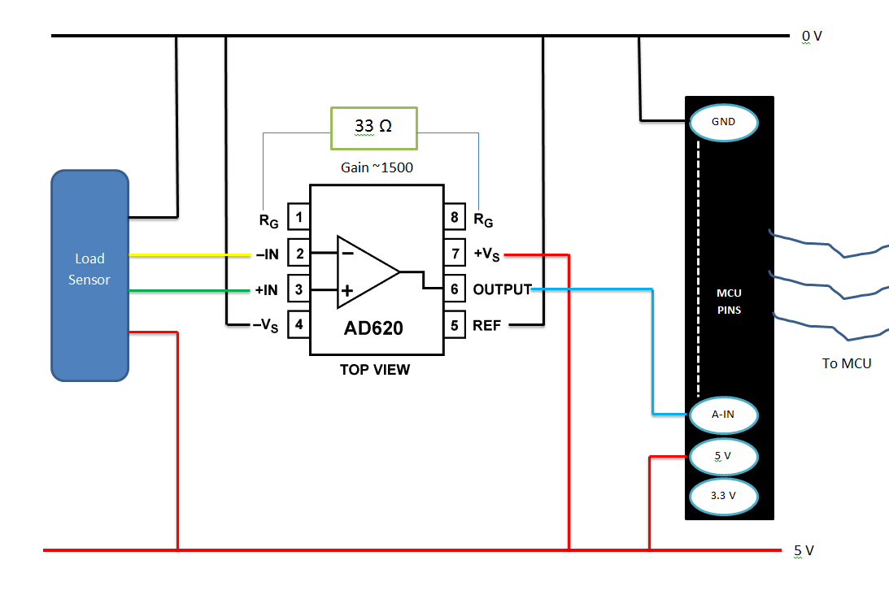

Figure A3.1. Schematic of wiring a load cell to a Gadgeteer socket. MCU refers to the Gadgeteer mainboard. Only the relevant pins of the type-A socket are shown. A description of the amplifier’s (AD620) pins is available at the reference [A4].

References

|  |  |
| --- | --- |
| [A1] | nvillar, “Microsoft Gadgeteer – Documentation - Socket Type A”, Nov. 2011. [Online]. Available: <http://gadgeteer.codeplex.com/wikipage?title=Socket%20Type%20A> |
| [A2] | Wikipedia, “Load Cell”, Aug. 2013. [Online]. Available: <http://en.wikipedia.org/wiki/Load_cell> |
| [A3] | Phidgets, “Phidgets Inc. Micro Load Cell (0-50kg)”, 2012. [Online]. Available: <http://www.phidgets.com/products.php?product_id=3135_0> |
| [A4] | Analog Devices, “AD620 datasheet and product info”, 2013. [Online]. Available: <http://www.analog.com/en/specialty-amplifiers/instrumentation-amplifiers/ad620/products/product.html> |

###### System Manual

Source code is available in the directory /Software/Device/ (attached to this report and mirrored on GitHub (see appendix A1).

Gadgeteer microcontroller

Prerequisites

* Gadgeteer + modules’ SDK (<https://www.ghielectronics.com/support/.net-micro-framework>)
* Visual Studio IDE (any edition 2010+)
* Hardware listed in §4.2.1.1 of the main report.

Instructions

1. Assemble the physical modules as shown in figure 4.3 of the main report.
2. Create a folder called ‘hivesense’ at the ROOT of your SD card, copy the XML file ./config.xml into this directory, and finally modify it to match your network environment.
3. Insert the SD card into the SD module and connect the assembled Gadgeteer microcontroller to your PC through USB.
4. Load the ./HiveSense.sln Visual Studio file and hit F5 to deploy and debug.

Node.js web API

Prerequisites

* Node.js 0.8+ environment
* Azure SDK.

The specifics depend on where you choose to deploy the system – on an Azure web site or on a custom machine.

Custom machine (also good for local development)

1. Install Node.js and the Azure SDK
2. Set the custom environment variable EMULATED=1 on the command line
3. Boot the Azure Storage Emulator (part of the SDK)
4. On the command line, launch the server with node ./server
5. Access to the API resources is through networking port 1337.

Azure Web Site

1. Set up an Azure Web Site (AWS) and an Azure Table Storage account
2. In your Azure web site management portal, go to configure->app settings and input the following keys:
   1. AZURE_STORAGE_ACCOUNT: [Table Storage account name]
   2. AZURE_STORAGE_ACCESS_KEY: [Primary access key for this account]
3. Deploy the code through GitHub, FTP, or the Azure SDK – see the AWS docs for details: <http://www.windowsazure.com/en-us/manage/services/web-sites/how-to-create-websites/#deployoptions>.

Web application

This is deployed along with the web API. No additional configuration is required.

###### User Manual

HiveSense – automated beehive health monitoring for beekeepers.

HiveSense is a software system to aid beekeepers in monitoring some simple properties of their bee colonies. It consists of some hardware for the physical beehive monitoring, a web API for storing the data and allowing it to be queried, and a web application to view the hive data in real time. Additionally, an alarms feature allows the beekeeper to be alerted when one of the measurement properties exceeds a customisable value.

The software stack is flexible to allow hardware developers to make new sensors for measuring more advanced hive properties, which can be easily incorporated into the web API and application. The web API is flexible so that software developers can make their own web application from the available data.

Device

Positioning

The plate hosting the internal sensors should be fixed to the inner wall of the beehive. The camera and secondary thermometer are loose and connected by long cables to the mainboard so these can be positioned wherever you desire.

Power

Any source of 5-30V is acceptable (including appropriate batteries). ~9V is recommended. Either micro-USB or 3mm plug-type connections can be used.

Maintenance / failure

The push button on the mainboard can be depressed to reset the device in case of failure; no other maintenance is required.

Settings

With the SD card inserted into your computer, open the /hiveSense/config.xml file in a text editor. Modify the text between the xml tags to change settings; the following can be freely configured:

* Details of the Wi-Fi network where the device will be deployed
* Sensitivity of the motion detector
* Update frequency (how often the hive properties are measured)
* URL of the API where data is to be sent.

Specific settings details are given in the file itself, as xml comments.

Retrieving raw data

Every single data point is recorded onto the SD card for your convenience. The log is available at /hiveSense/datalogAlways.csv, and can be freely deleted to save space at any time, as it is not used by the device except for writing (the datalog.csv is used for internal buffering purposes and should be ignored). Remember to turn off the power to the device when removing and inserting the SD card.

API

The API consists of a number of resources for input and retrieval of data. Data can be freely obtained from the HiveSense API by anyone, using HTTP GET requests.

Data input is only possible for validated users, and must be via the HTTP PUT method. Validation is through an X-HiveSenseSecureKey HTTP header, which authenticates users. Others will be rejected with a 401 Unauthorised before the payload is processed. If no data is PUT, the request will be interpreted as a GET.

Data points resource

Base URL: /feed

Retrieving

**Caching:** Results are cached for the period of the sensor update rate (approx. every minute, or as configured by the Device).

**Media Format:** Results can be obtained in one of the three possible formats by appending to the base URL one of: .json (default), .xml, .csv.

**Ordering:** Descending – when multiple data points are returned, the most recent will be at the top.

**Client Errors:** A 400 error will be returned if no data is available for the specified period or if a malformed query is sent. The response body will always be in JSON and contain a short descriptive message.

**Timestamps:** These must be UTC and in a JavaScript-friendly format: millisecond [Unix time](http://en.wikipedia.org/wiki/Unix_time) or an ISO date-string. Returned data uses Unix time for optimal brevity, or ISO strings when a readable format is desirable.

**Queries:**

|  |  |  |
| --- | --- | --- |
| Data query | Query string | Returns |
| Current | ?current | Most recent single data point |
| Recent | ?recent=[options]  where options is any number followed by the period-type: h, d or m (hours, days, months) | Most recent data available for the period specified, suitably sampled (somewhere between the sensor update rate and one day) to limit the response to less than 1000 data points. |
| Historical | ?date1=[ts]&date2=[ts]   where ts is a timestamp as described above (“Timestamps”). | Suitably sampled data from the specified range. |

Sending

**Format:** Only JSON is supported at this time, all other formats will be rejected.

**Caching**: Requests are never cached.

**Response body:** Format will be JSON. A 200 OK response will return a short success message. Client error 4XX (bad data sent) responses will include a descriptive error message.

**Examples:**

{

"datapoints": [

{

"channels": {

"temp": "34.6",

"humi": "54",

"light": "0",

"key": "value"

}

}

]

}

Example 1 – single data point.

{

"datapoints": [

{

"channels": {

"temp": "37.2",

"light": "0",

"key": "value"

},

"datetime": "2013-07-21 12:00:02"

},

{

"channels": {

"temp": "35.2",

"light": "5",

"key": "value"

},

"datetime": "JavaScript-compatible timestamp"

}

]

}

Example 2 - Multiple Data points

Images

Base URL: /image

Retrieving

**Caching:** Same policy as for data points.

**Format:** Always .bmp.

**Response:** The image.

**Queries:** None; access the resource directly to get the most recent available image.

Sending

**Caching:** Never.

**Format:** Must be .bmp.

**Response:** JSON format. Short success message, or client error plus reason if bad data is sent.

**Operations:** Only the current image should be sent, as only one can be stored.

Settings

Base URL: /settings

Retrieving

**Caching:** Cached if unchanged, else not.

**Format:** Always JSON.

**Response:** The complete settings resource.

**Queries:** None.

Sending

**Caching:** Never.

**Format:** Must be JSON.

**Response:** JSON format. Short success message, or client error plus reason if bad data is sent.

**Security:** Extra security is implemented. Must send a password field with correct password.

You only need to send the settings that have been changed since retrieval, or any new ones added. Pre-existing top-level settings will be overwritten if present in the request, new settings will be appended.

**Example:**

{

password: "xxxxx",

setting: value

beek: "Ben LR",

updateRate: 30,

alarms: [

{

label: "Disturbance",

value: 0,

type: "high"

},

{

label: "Too Hot",

value: 35,

type: "high"

},

]

}

So, if any sub-setting of the top-level setting 'alarms' is changed (i.e. an array item), you must send back the entire 'alarms' setting object, not just the changed component.

Web Application

Although the API offers all the resources needed to develop your own web application, a pre-built one has been developed for those seeking a simple and user-friendly way to monitor the health of their beehive.

In a modern (2013+) browser of your choice, navigate to the URL where the web server has been deployed.

The application is a single-page web application, which means all resources are loaded at start-up, or loaded in the background as needed when the application is running. All data updates occur automatically so no page refreshes should be performed. It has been designed to work in a range of browser sizes, so is suitable for both mobile and desktop devices. There are three main views for viewing the hive data, as tabs, in the application, plus a tab for settings, and one for documentation.

Dashboard

This is the view that loads on start-up, and provides an overview of the current status of the beehive. The dashboard updates when new data is available from the hive, or settings are changed (see “Settings” below). Most of the dashboard elements can be hovered over to provide a description.

The core elements are:

* Value for each measurement variable, with trend showing its movement since the last reading (up, down, or flat).
* Graph of the last ~3hrs for each variable.
* Photo from the hive entrance for viewing your bees.
* Data indicator light – red when no recent data, green otherwise (or amber when requesting data from the server).
* Alarms – red or green LED indicating whether the particular threshold has been breached.
* Local weather – temperature and weather condition from the nearest weather station to your beehive.

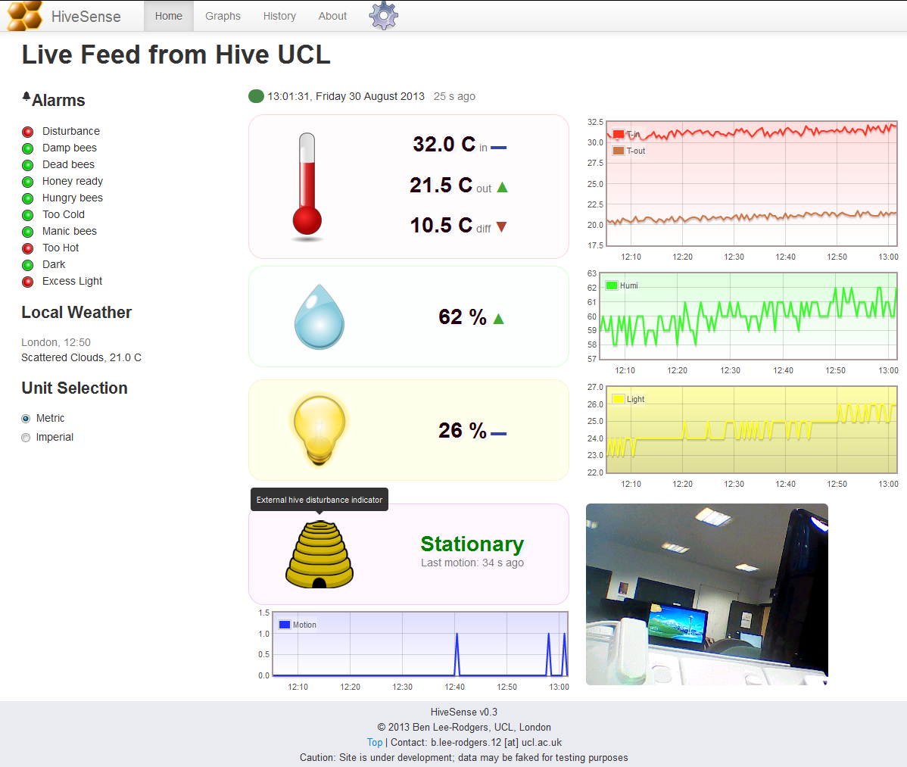

Alarms feature

An important side note should be made at this point. The alarms shown on the dashboard are continually monitored by the server as data is sent from the HiveSense Device. This means you can be alerted to the raising of a red alarm state without having to visit the dashboard; the alert will go straight to your email inbox. Details of configuring this are available in the ‘Settings’ section below.

Graphs View

This view contains a customisable graph of the hive data. Use the left panel to toggle the variables, and to change the viewing period. The graph dynamically resizes with the browser window, and re-plots as new data becomes available.

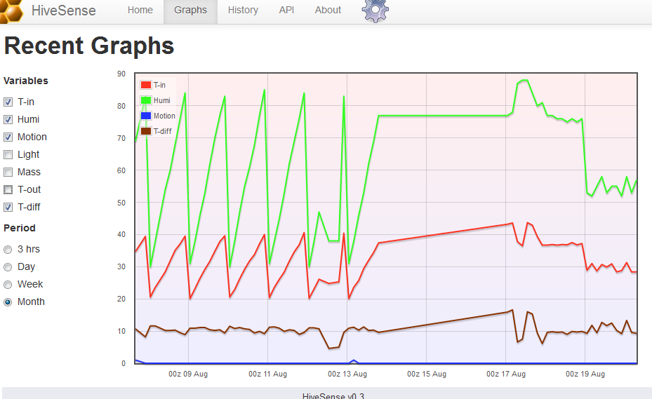

History View

Here you can view and export the hive data as tables. At application load, the table shows the past 24hrs data. To change the period, use the date pickers on the left to select start and end dates. The interval between consecutive data points will be automatically chosen based on the length of the period selected. To export data, simply choose the format (CSV, perfect for Microsoft Excel, is the default), and click the ‘export’ button.

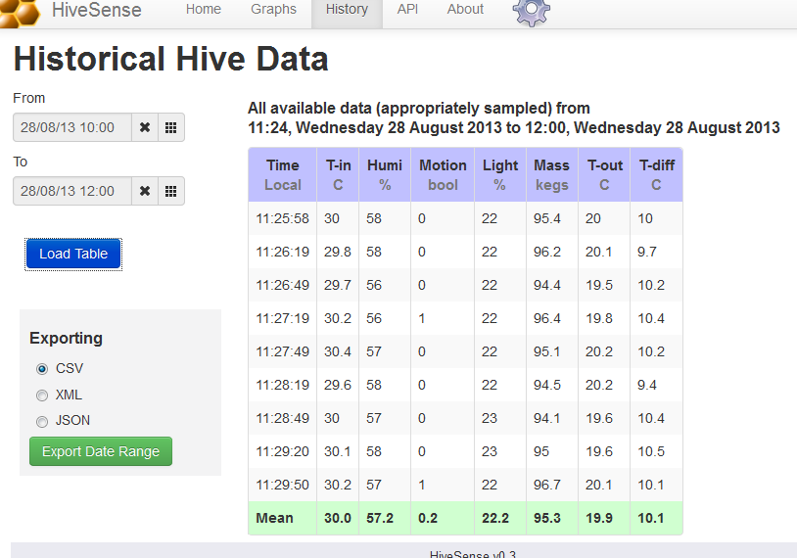

Settings

This is available through the tab with the ‘gear’ icon. Most application settings can be changed through the user interface. Any changes made can be previewed immediately before they are saved, so after making changes you should see their effect on the Dashboard. When you are happy with the changes, they can be saved permanently using the ‘commit’ button on the top-right panel of the settings tab – password required (default: ‘livehive’).

All settings, including some not available through the user interface, can be changed by modifying the raw file that stores the settings in JSON format on the server. This is done through the ‘Advanced’ section at the bottom of the settings page, and as the name suggests is only intended for advanced users with a working knowledge of JSON.

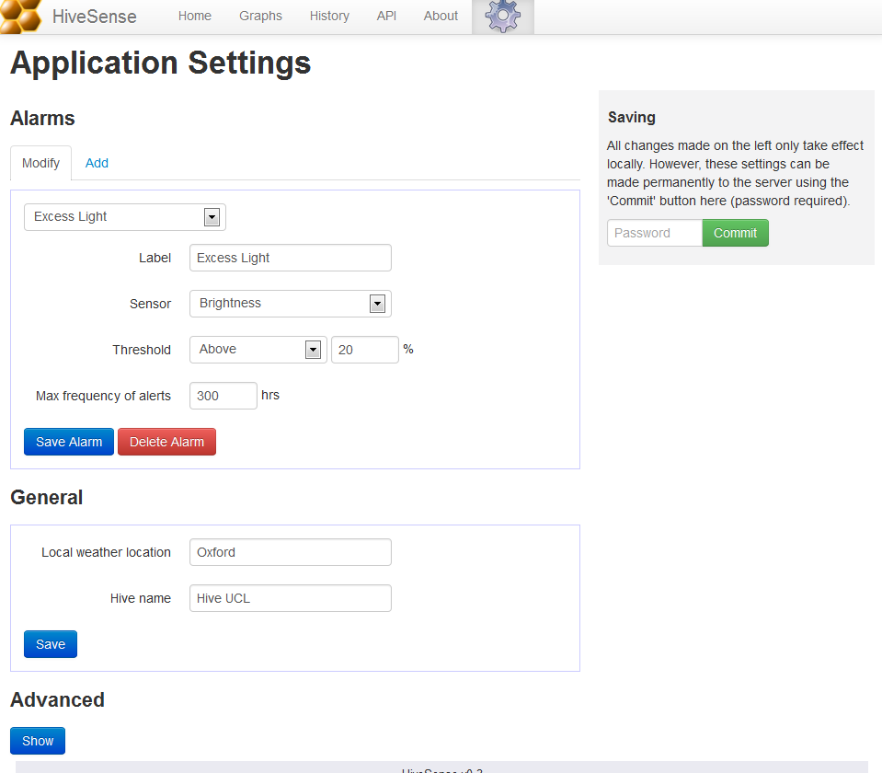

A full description of the settings available is as follows:

* “beek”: Your name, used in emails
* “email”: Your email address, where alerts are sent
* “hiveName”: Name of your beehive, used as the web application title
* “wxplace”: City in the UK to use for the local weather report
* “updateRate”: Update frequency of the Dashboard. Highly advisable to make this match the update frequency of the Device.
* “alarms”: Array of alarms for the Dashboard and email alerts
  + “label”: Name of the alarm
  + “sensor”: ID of the sensor (see “sensors” setting below) monitored by this alarm
  + “value”: Threshold value for the sensor, when breached the alarm is raised
  + “type”: Must be “high” or “low”, the direction of the breach to trigger the alert - when the sensor value goes above or below the threshold “value” respectively. See examples for better understanding.
  + “email”: Maximum frequency, in hours, at which to send alert emails for threshold breaches of this alarm. Set to 0 to disable emailing.
* “sensors”: Array of sensor variables to display on the Dashboard
  + “id”: ID of the sensor variable. Must match one of those produced by the Device (see API – current data feed – for which are available)
  + “label”: User-friendly name for the variable
  + “unit”: Physical unit of measurement
  + “isdefault”: Boolean. Do not delete sensors where this is true, as they are fixed to the user interface. When adding new sensors, set false
  + “graphOptions”: Styling for the graphs of the variable
    - “labelShort”: Short name for the legend
    - “colourGraph”: Line colour in hexadecimal
    - “colourGd1”: Start colour for the background gradient
    - “colourGd2”: End colour for the background gradient.

###### Source Code

Only samples are presented; the full listing is available on the attached digital media. Note well that the listing below is slightly altered (minor renaming and re- line-wrapping) for formatting purposes

Device (C#)

A sample of the Device classes is presented here: the Program, WiFiHandler and SensorsHandler classes, with the remaining eight not included. Additionally, using statements and namespace declarations are only shown for the first class, for purposes of brevity and formatting ease.

using Microsoft.SPOT;

using GT = Gadgeteer;

using Gadgeteer.Modules.GHIElectronics;

namespace HiveSenseV2 {

/// <summary>

/// Main

/// </summary>

/// <remarks>

/// In other classes, references are sometimes made to "GHI documentation";

/// this is found here: https://www.ghielectronics.com/docs/,

/// and consists of SDK documentation for the Gadgeteer modules,

/// with short code samples,

/// some of which have been incorporated into this source code.

/// </remarks>

public partial class Program {

private uint dataCount = 0;

private GT.Timer timer;

private SensorsHandler sensorsHandle;

private SdHandler sdHandle;

private WifiHandler wifiHandle;

private TimeManager timeManager;

private APIconnector api;

/// <summary>

/// Called on Device boot

/// </summary>

private void ProgramStarted() {

Debug.Print("Program Started");

Config.initialiseSettings();

setupModules();

}

private void setupModules() {

// ## System Time manager setup ##

timeManager = new TimeManager();

// ## Sensors setup ##

sensorsHandle = new SensorsHandler(lightSensor, accelerometer,

temperatureHumidity, barometer, camera);

//Make initial, unhandled readings so values have time to

// initialise and later won't be null

sensorsHandle.readNumericSensors();

sensorsHandle.readBinarySensors();

// ## Setup Sd card for config retrieval and data logging ##

sdHandle = new SdHandler(sdCard, sensorsHandle);

// ## Button setup ##

button.pressed += new Button.ButtonHandler(buttonPressed);

// ## Wifi setup ##

wifiHandle = new WifiHandler(wifi_RS21, timeManager);

// ## Timer setup ##

timer = new GT.Timer(Config.updateRate*1000);

timer.Tick += new GT.Timer.TickEventHandler(timer_Tick);

timer.Start();

}

private void timer_Tick(GT.Timer timer) {

timeManager.updateTime();

//Create the api handler when a valid url is available

if (Config.APIendpoint != "" && api == null) {

api = new APIconnector(Config.APIendpoint, sensorsHandle);

}

retrieveAndProcessSensorData();

}

/// <summary>

/// Gets the latest sensor readings and takes a picture for PUTing

/// before trying to save the text data to log as well as push it

/// to the web.<br/> Periodically, this method will reboot the device

/// for recovery management purposes.

/// </summary>

/// <remarks>Button's LED will turn on for method duration</remarks>

private void retrieveAndProcessSensorData() {

// Safety mechanism in case of device hang

if (dataCount == Config.rebootInterval) {

Debug.Print("REBOOTING NOW!");

Microsoft.SPOT.Hardware.PowerState.RebootDevice(true);

}

button.TurnLEDOn();

Debug.Print("Processing at: " + timeManager.getTime());

//Get data point and write to permanent log

var dataNum = sensorsHandle.readNumericSensors();

sdHandle.writeDataLineToSDcard(dataNum,

SdHandler.datalogFilePathPerm, timeManager.getTime());

//Attempt to transmit data point to web API

if (dataIsSendable() && api.sendCurrentData(dataNum)) {

//Transmit buffer (if present)

sdHandle.transmitSDloggedData();

timeManager.resyncIfOld();

}

else {

//Buffer to data point

Debug.Print("Data couldn’t be sent to API! Buffering.");

sdHandle.writeDataLineToSDcard(dataNum,

SdHandler.datalogBuffer, timeManager.getTime());

sdHandle.datalogBufferExists = true;

}

//Attempt to transmit binary data (the camera image)

var dataBin = sensorsHandle.readBinarySensors();

if (dataIsSendable()) {

api.sendImage(dataBin);

}

button.TurnLEDOff();

dataCount++;

}

private bool dataIsSendable() {

return wifi_RS21.IsNetworkConnected && api != null;

}

}

}

/// <summary>

/// Handler for the Wi-Fi module

/// </summary>

class WifiHandler {

private WiFi_RS21 wifiModule;

private TimeManager timemanager;

private GT.Timer timerWifiJoin;

/// <summary>

/// Activates wifi module and attempts to join a network.<br />

/// A timer is started that will trigger attempts to join

///  the network if later disconnected at any point

/// </summary>

/// <param name="wifiModule">The wifi RS21 module</param>

public WifiHandler(WiFi_RS21 wifiModule, TimeManager tm) {

this.wifiModule = wifiModule;

this.timemanager = tm;

joinNetwork();

// Timer to retry if failed on startup, or network goes down.

timerWifiJoin = new GT.Timer(600000); //10-mins

timerWifiJoin.Tick +=

new GT.Timer.TickEventHandler(timerWifiJoin_Tick);

timerWifiJoin.Start();

this.wifiModule.Interface.WirelessConnectivityChanged +=

new WiFiRS9110.WirelessConnectivityChangedEventHandler(

wirelessConnectivityChanged);

}

/// <summary>

/// Searches all networks in range, attmpting to join the first

/// that matches the config-specified SSID

/// </summary>

/// <remarks>Strongest signals are found first,

/// so the best connection is always used</remarks>

public void joinNetwork() {

// search for all available networks

WiFiNetworkInfo[] scanResults = wifiModule.Interface.Scan();

//search for the desired network

Debug.Print("Searching for SSID");

foreach (WiFiNetworkInfo result in scanResults) {

if (result.SSID == Config.desiredSSID) {

attemptJoin(result);

break;

}

}

}

/// <summary>

/// Try to join a wifi network

/// </summary>

/// <param name="network">desired network</param>

private void attemptJoin(WiFiNetworkInfo network) {

try {

wifiModule.Interface.Join(network, Config.wifiPass);

Debug.Print("Network joined");

}

catch (NetworkInterfaceExtensionException e) {

Debug.Print("Join error" + e.errorCode);

}

}

private void timerWifiJoin_Tick(GT.Timer timer) {

//poll in case of connection loss so device can (re)join

if (!wifiModule.IsNetworkConnected) {

joinNetwork();

}

}

private void wirelessConnectivityChanged(object sender,

WiFiRS9110.WirelessConnectivityEventArgs e) {

if (e.IsConnected) {

Debug.Print("NETWORK UP.");

//After connecting, get time from web for synching the clock

timemanager.syncTime();

}

else {

Debug.Print("NETWORK DOWN.");

}

}

}

/// <summary>

/// Handler for all monitoring sensor modules (temp, light etc.)

/// </summary>

class SensorsHandler {

/** Sensor modules (NB: may be more than one channel per sensor) **/

private LightSensor lightSensor;

private Accelerometer accelSensor;

private TemperatureHumidity tempHumiSensor;

private Barometer temp2Sensor;

private Camera camera;

/**

* Sensor Channels (individual numeric variables) -

* one for each measurement property/variable to use<br />

* Names are primarily used as identifiers for the API.

**/

private Channel t1 = new Channel("temp1", 1);

private Channel t2 = new Channel("temp2", 1);

private Channel tdiff = new Channel("tempdiff", 1);

private Channel hum = new Channel("humi", 0);

private Channel light = new Channel("light", 0);

private Channel motion = new Channel("motion", 0);

private Channel[] channels;

//Binary sensor data

private byte[] image;

/// <summary>

/// Attaches event handlers to all the modules,

/// for measurements gathering purposes

/// </summary>

/// <param name="li">Lightsensor module</param>

/// <param name="ac">Accelerometer module</param>

/// <param name="th">Temp-Humi module</param>

/// <param name="ba">Pressure-Temp module</param>

/// <param name="ca">Camera module</param>

public SensorsHandler(LightSensor li, Accelerometer ac,

TemperatureHumidity th, Barometer ba, Camera ca) {

lightSensor = li;

accelSensor = ac;

tempHumiSensor = th;

temp2Sensor = ba;

camera = ca;

channels = new Channel[] {t1, t2, tdiff, hum, light, motion};

//setup event handlers for reading sensor modules

tempHumiSensor.MeasurementComplete +=

new TemperatureHumidity.MeasurementCompleteEventHandler(

temperatureHumidity_MeasurementComplete);

temp2Sensor.MeasurementComplete +=

new Barometer.MeasurementCompleteEventHandler(

barometer_MeasurementComplete);

accelSensor.EnableThresholdDetection(Config.movementSensitivity,

true, true, true, false, false, true);

accelSensor.ThresholdExceeded +=

new Accelerometer.ThresholdExceededEventHandler(

accelerometer_ThresholdExceeded);

camera.PictureCaptured +=

new Camera.PictureCapturedEventHandler(pictureCaptured);

}

/// <summary>

/// Gets the name of each channel in the order that they are compiled

/// </summary>

/// <returns>all names</returns>

public string[] getChannelNames() {

string[] names = new string[channels.Length];

for (int i = 0; i < channels.Length; i++) {

names[i] = channels[i].name;

}

return names;

}

/// <summary>

/// Request or retrieve measurements from all sensors and store

/// cleaned values in class members

/// </summary>

/// <returns>members representing each channels's datum</returns>

public string[] readNumericSensors() {

tempHumiSensor.RequestMeasurement();

temp2Sensor.RequestMeasurement();

light.currentValue = lightSensor.ReadLightSensorPercentage();

tdiff.currentValue = t2.currentValue - t1.currentValue;

return getDataPt();

}

/// <summary>

/// Compile a data point from the Channels

/// </summary>

/// <returns>the data point</returns>

private string[] getDataPt() {

var cleanData = new String[channels.Length];

for (int i = 0; i < channels.Length; i++) {

Channel ch = channels[i];

cleanData[i] = Utility.roundToDp(ch.currentValue, ch.precision);

}

//motion is event driven, so reset to avoid over-reporting

motion.currentValue = 0;

return cleanData;

}

public byte[] readBinarySensors() {

camera.TakePicture();

return image;

}

//Remaining methods are callbacks for the sensor modules

private void accelerometer_ThresholdExceeded(Accelerometer sender) {

Debug.Print("Hive is moving!");

motion.currentValue = 1;

}

private void barometer_MeasurementComplete(Barometer sender,

Barometer.SensorData sensorData) {

double pres = sensorData.Pressure;

double temp2 = sensorData.Temperature;

t2.currentValue = temp2;

}

private void temperatureHumidity_MeasurementComplete(

TemperatureHumidity sender, double temperature,

double relativeHumidity) {

t1.currentValue = temperature;

hum.currentValue = (int) relativeHumidity;

}

private void pictureCaptured(Camera sender, GT.Picture picture) {

byte[] cameraSnapshot = picture.PictureData;

if (cameraSnapshot != null) {

image = cameraSnapshot;

}

}

}

Data API and Services (JavaScript)

Only one module from each layer is presented, plus the Server module that boots the application. The included modules are the most interesting – Router from the Controller, DataPoint from the API, part of DbHandler from the Model, and AlarmWatcher from the Service layer. Nine others have been excluded due to limited space.

/**

* Module: Server.js

* This script is called automatically on Node server boot.

* It must remain in the site root.

*

* @author Ben Lee-Rodgers

* @version 1.0, September 2013

*/

var webserver = require("./Model/webserver.js");

var router = require("./Controller/router.js");

//Start the web server

console.log("Running node version " + process.version);

webserver.boot(router.route);

/**

* Module: Router.js

* Handles routing of URLs to the correct API resource and method.

*/

var httpWrite = require('../Model/HttpWriter');

/** Define correct requests to the chosen API resource */

var Request = new function () {

    this.dataPtJson = function (res, query, data) {

        dataPt(res, query, data, 'json');

    };

    this.dataPtCsv = function (res, query, data) {

        dataPt(res, query, data, 'csv');

    };

    this.dataPtXml = function (res, query, data) {

        dataPt(res, query, data, 'xml');

    };

    function dataPt(res, query, data, type) {

        if (data !== undefined) {

            //PUT request

            API.dataPt.saveDataPoint(res, data);

        } else {

            //GET request

            API.dataPt.setFormat(type);

            if (query.current !== undefined) {

                API.dataPt.getCurrentDataPoint(res);

            } else if (query.recent !== undefined) {

                API.dataPt.getRecentDataPoints(res, query);

            } else if (query.date2 !== undefined || query.date1) {

                API.dataPt.getHistoricalDataPoints(res, query);

            } else if (query.time !== undefined) {

                API.dataPt.getTime(res);

            }

            else {

                httpWrite.giveRequestError(res);

            }

        }

    }

    this.image = function (res, query, data) {

        if (data === undefined) {

            API.image.getImage(res);

        } else {

            API.image.saveImage(res, data);

        }

    };

    this.wxgrab = function (res, query, data) {

        API.external.getWx(res, query);

    };

    this.settings = function (res, query, data) {

        if (data === undefined) {

            API.settings.getSettings(res);

        } else {

            API.settings.saveSettings(res, data);

        }

    };

};

/** API resources */

var API = {

    static: require('../API/Static'),

    settings: require('../API/Settings'),

    image: require('../API/Image'),

    dataPt: require('../API/DataPoint'),

    external: require('../API/External')

};

/** Valid URLs for dynamic API content */

var dynamicHandlers = {

    "/feed": Request.dataPtJson,

    "/feed.json": Request.dataPtJson,

    "/feed.csv": Request.dataPtCsv,

    "/feed.xml": Request.dataPtXml,

    "/image": Request.image,

    "/ext/wx": Request.wxgrab,

    "/settings": Request.settings

};

/**

* URL routing - get request to correct API resource

* @param {Object} path

* @param {Object} response

* @param {Object} sentData

*/

exports.route = function (path, response, sentData) {

    var url = path.pathname;

    //dynamic content handlers

    if (dynamicHandlers.hasOwnProperty(url)) {

        dynamicHandlers[url](response, path.query, sentData);

    }

    //static content handlers

    else if (url.startsWith('/css/')) {

        API.static.staticServe(response, url, 'text/css');

    } else if (url.startsWith('/js/')) {

        API.static.staticServe(response, url, 'application/javascript');

    } else if (url.startsWith('/img/')) {

        API.static.staticServe(response, url, 'image/png');

    } else if (url === '/') {

        API.static.staticServe(response, "/index.html", 'text/html');

    }

    //No handler found

    else {

        console.log("No request handler found for " + url);

        httpWrite.giveNoResourceError(response);

    }

};

/**

* Module: API/DataPoint.js

* API resource handler for manipuating data points - receive and deliver.

* Multiple operations for retrieval are supported:

* current, recent, and historical

*/

var fs = require('fs');

var util = require('../Model/utillib');

var httpWrite = require('../Model/HttpWriter');

var dbHandle = require('../Model/DbHandler');

var jtox = require('../Model/extlib/jsonToXml');

var alarmWatcher = require('../Services/AlarmWatcher');

/** JSON, XML, or CSV, the three supported return types */

var outputFormat;

/** Corresponding MIME type to return the correct HTTP header */

var outputMIME;

/** Template for returning multiple data points */

var multiResultShell = {

    datapoints: [],

    updated: ""

};

/*

* Save one to many data points

* @param {Object} res HTTP response

* @param {string} data JSON data point(s)

*/

exports.saveDataPoint = function (res, data) {

    try {

        data = JSON.parse(data.toString()).datapoints;

    } catch (e) {

        console.log("Input not parsable. Terminating");

        httpWrite.giveRequestError(res);

        return;

    }

    var isCurrent = (data.length === 1 && data[0].datetime === undefined);

    if (isCurrent) {

        //Check whether any channels of the data point raise any alarms

        alarmWatcher.checkForBreaches(data[0].channels);

    }

    for (var i = 0; i < data.length; i++) {

        var d = isCurrent ? new Date() : new Date(data[i].datetime);

        if (isNaN(d)) {

            //Invalid data point, move on

            console.log("bad datetime was " + data[i].datetime);

            console.log("faulty input. Dying now");

            continue;

        }

        var dt = Date.UTC(d.getUTCFullYear(), d.getUTCMonth(), d.getUTCDate(),

d.getUTCHours(), d.getUTCMinutes(), d.getUTCSeconds(), 0);

        //Datetime properties of the data point

        var options = {

            date: dt,

            dateObj: d

        };

        //Shell for the data point, including datetime

        var dataPt = {

            DateTime: dt

        };

        var cnt = 0;

        //Extract channels from the data point

        Object.keys(data[i].channels).forEach(function (key) {

            var val = parseFloat(data[i].channels[key]);

            if (isNaN(val)) {

                console.log("Error: tried to save non value ");

            } else {

                dataPt[key] = val;

                cnt++;

            }

        });

        if (cnt > 0) {

            //Save into database

            console.log("Processing " + cnt + " channels");

            httpWrite.giveSuccess(res);

            dbHandle.insertDataPoint(dataPt, options);

        } else {

            httpWrite.giveRequestError(res);

        }

    }

};

/**

* Return the most recently available data point

* @param {Object} res HTTP response

*/

exports.getCurrentDataPoint = function (res) {

    var resultShell = {

        updated: "",

        datastreams: []

    };

    dbHandle.retieveCurrentDataPt(resultShell, dbReturn, res);

};

/**

* Return a set of the most recently available data points

* @param {Object} res HTTP response

* @param {Object} period range of recency (see user API docs)

*/

exports.getRecentDataPoints = function (res, period) {

    var queryProperties = ageToDateQuery(parsePeriod(period.recent));

    queryProperties.skippable = false;

    dbHandle.retieveRecentDataPts(multiResultShell,

        queryProperties, dbReturn, res);

};

/**

* Return a set of data points from a specified range

* @param {Object} res HTTP response

* @param {type} period date range over which to look for data

*/

exports.getHistoricalDataPoints = function (res, period) {

    var queryProperties = dateRangeToQueryProperties(period.date1, period.date2);

    if (queryProperties === null) {

        httpWrite.giveRequestError(res);

        return;

    }

    queryProperties.skippable = true;

    dbHandle.retieveHistoricalDataPts(multiResultShell,

        queryProperties, dbReturn, res);

};

/**

* Return the current system time (good for synching clients)

* @param {Object} res HTTP response

*/

exports.getTime = function (res) {

    httpWrite.giveSuccess(res, formatOuput({ curr_time: new Date().getTime() }));

};

/**

* Callback for the dbHandler to execute on retriving data points.

* Outputs the data to the HTTP response

* @param {bool} wasSuccesful whether data could be returned from the db

* @param {Object} result the data points, or an error message if not successful

* @param {Object} res HTTP response

*/

function dbReturn(wasSuccesful, result, res) {

    if (wasSuccesful) {

        httpWrite.giveSuccess(res, formatOuput(result), outputMIME);

    } else {

        httpWrite.giveFailure(res);

        console.log(result);

    }

}

/**

* Parses a raw user API query for recent data

* @param {string} period friendly form for a number of hours, days, or months

* @returns {number} Number of minutes represented by the period

*/

function parsePeriod(period) {

    var re = /^([\d]+(?:\.[\d]+)?)([hmd]?)$/;

    var result = re.exec(period);

    //console.log(result);

    var length;

    var type;

    //Invalid period query

    if (!result) {

        length = 1;

        type = "h";

    } else {

        length = result[1];

        type = result[2];

    }

    //valid periods (hour, day, month); empty string gives default - hour

    periodTypes = { "h": 1, "d": 24, "m": 30 * 24, "": 1 };

    var age = length * periodTypes[type] * 60; //in minutes

    return age;

}

/**

* Finds the correct sampling interval of data points for a given date period.

* @param {number} age period length in minutes

* @returns {Object} Sampling interval and number of data points covered it

*/

function ageToDateQuery(age) {

    console.log("Request made for a period of " + age + " minutes");

    // distance in minutes between consecutive data points to use

    var periodGaps = [1, 5, 20, 60, 180, 1440];

    //reasonable limits on number of data points to return

    var maxDataPoints = 1000;

    var minDataPoints = 3;

    var pointsPerMin = 60 / require("../Storage/settings.json").updateRate;

    var resolutionIdeal = age / maxDataPoints * pointsPerMin;

    var resolution = periodGaps[periodGaps.length - 1];

    for (var i = 0; i < periodGaps.length; i++) {

        if (resolutionIdeal <= periodGaps[i]) {

            resolution = periodGaps[i];

            break;

        }

    }

    //get suitable number of data points in valid range

    var numDataPoints = Math.max(minDataPoints,

Math.min(Math.round(age / resolution) * pointsPerMin, maxDataPoits));

    return {

        "number": numDataPoints,

        "resolution": resolution,

        "resIndex": i

    };

}

/**

* Converts two datetimes, representing a date range,

*  in to properties useful for further parsing

* @param {string} date1 datetime one

* @param {string} date2 datetime two

* @returns {Object} Useful properties

*/

function dateRangeToQueryProperties(date1, date2) {

    var d1 = util.parseDate(date1);

    var d2 = util.parseDate(date2);

    var dmax = Math.max(d1, d2);

    var dmin = Math.min(d1, d2);

    var age = Math.round((dmax - dmin) / 60000);

    if (isNaN(age)) {

        return null;

    }

    var qp = ageToDateQuery(age);

    qp.upper = dmax.toString();

    qp.lower = dmin.toString();

    return qp;

}

this.setFormat = function (format) {

    outputFormat = format;

};

/**

* Formats a data point representation into CSV, JSON, or XML,

*  and set the correct MIME type for HTTP delivery

* @param {Object} obj data point(s) as JSON

* @returns Formatted data point(s)

*/

function formatOuput(obj) {

    if (outputFormat === 'csv') {

        outputMIME = 'text/csv';

        return util.jsonToCsv(obj, obj.datastreams !== undefined);

    } else if (outputFormat === 'xml') {

        outputMIME = 'application/xml';

        return jtox.jsonToXml(obj);

    } else {

        outputFormat = 'json';

        outputMIME = 'application/json';

        return JSON.stringify(obj);

    }

}

/**

* Module: Model/DbHandler.js

* Handler for querying the database

*/

var azure = require('azure');

/** Name of the data point table */

var TABLE_NAME_DATA = 'DataPoint';

/*

* Connect to the Azure Table Service.

* Only works if environment variables are set:

* http://www.windowsazure.com/en-us/develop/nodejs/how-to-guides/table-services/#setup-connection-string

*/

var tblService = azure.createTableService();

/** Azure system properties of every row in the database

* (need to be ignored when looping through actual sensor values) */

var systemProperties =

    ["Timestamp", "PartitionKey", "RowKey", "DateTime", "Period", "_"];

/** Datetime offset - used to order results by most recent */

var offset = 9999999999999;

tblService.createTableIfNotExists(TABLE_NAME_DATA, function (error) {

    if (error) {

        console.log(error);

    }

});

/**

* Get most recent data point from table

* @param {Object} result JSON shell to store the result

* @param {function} onFinish callback to execute on query return

* @param {Object} res HTTP response

*/

exports.retieveCurrentDataPt = function (result, onFinish, res) {

    var query = azure.TableQuery

.select()

.from(TABLE_NAME_DATA)

.top(1);

    tblService.queryEntities(query, function (error, entities) {

        if (!error) {

            if (entities.length === 0) {

                onFinish(true, { "datastreams": [] }, res);

                return;

            }

            var dataPt = entities[0];

            result.updated = new Date(dataPt.DateTime).toUTCString();

            //Eliminate redundant properties

            for (var i = 0; i < systemProperties.length; i++) {

                delete dataPt[systemProperties[i]];

            }

            var dataPtOut = [];

            var i = 0;

            Object.keys(dataPt).forEach(function (key) {

                dataPtOut[i] = {

                    id: key,

                    current_value: dataPt[key]

                };

                i++;

            });

            result.datastreams = dataPtOut;

            onFinish(true, result, res);

        } else {

            onFinish(false, error, res);

        }

    });

};

…HEAVILY TRUNCATED FOR BREVITY

/**

* Module: Services/AlarmWatcher.js

* Service for monitoring sensor channels for threshold breaches

*/

var fs = require('fs');

/**

* Checks a current data point against the alarm settings for any breaches.

* An alarm is raised if there is a breach.

* Old (buffered) data points are not checked

* @param {Oject} currentData current data point

* @returns {undefined}

*/

exports.checkForBreaches = function (currentData) {

var sensors = {};

var settings = require("../Storage/settings.json");

var alarms = settings.alarms;

var rawSensors = settings.sensors;

for (var i = 0; i < rawSensors.length; i++) {

sensors[rawSensors[i].id] = rawSensors[i];

}

for (var i = 0; i < alarms.length; i++) {

var alarm = alarms[i];

alarm.hivename = settings.hiveName;

var currentValue = currentData[alarm.sensor];

//Determine whether to raise an alarm

if (alarm.email > 0 && currentValue !== undefined) {

if (alarm.type === "low" && currentValue < alarm.value ||

alarm.type === "high" && currentValue > alarm.value) {

triggerAlarm(alarm, currentValue, sensors[alarm.sensor]);

}

}

}

};

/**

* Raises an alarm by sending an email

* @param {Object} alarm details of alarm from the settings

* @param {number} value current breaching value

* @param {Object} sensor Channel associated with the alarm

*/

function triggerAlarm(alarm, value, sensor) {

var alarmID = alarm.label;

var type = (alarm.type === "high") ? "above" : "below";

var subject = "Warning from " + alarm.hivename + " - " + alarmID;

var message = "A threshold for data channel '" + sensor.label +

 "' has been breached.\nCurrent value of " + value + " is " + type +

  " the threshold of " + alarm.value + " " + sensor.unit

  + "\nTake action now to save your bees.";

//Store record of breaches so the alarm is not raised too frequently

var breachesFile = "../Storage/alarmBreaches.json";

delete require.cache[require.resolve(breachesFile)];

var allBreaches = require(breachesFile);

var breach = allBreaches.breaches[alarmID];

var currTime = new Date().getTime();

var hasChanged = false;

if (breach === undefined) {

//First time this alarm has been triggered

breach = { latest: 0 };

hasChanged = true;

}

if (currTime - breach.latest > alarm.email * 3600000) {

//Alarm not triggered for a while

breach.latest = currTime;

sendAlert(subject, message);

hasChanged = true;

}

if (hasChanged) {

allBreaches.breaches[alarmID] = breach;

fs.writeFileSync("Storage/alarmBreaches.json",

 JSON.stringify(allBreaches, null, '\t'));

}

}

/** Physically send the email */

function sendAlert(subject, message) {

console.log("email being sent due to threshold breach");

require('./emailer.js').sendEmail(subject, message);

}

Front-end (JavaScript)

A few interesting classes are included – Updater, View, Dashboard (part), and AlarmManager. Nine other classes and the initiator script are excluded. All HTML and CSS are also not included here.

/**

* Handles automatic data feed updates for the application,

* and triggers all dynamic UI loading

*/

var Updater = new function () {

    var count = 0;

    var tables = new VC.Tables();

    var dash = new VC.Dashboard();

    var UI = new VC.View();

    /** Boots the application */

    this.boot = function () {

        VC.Settings.initialise();

        UI.loadUI();

        Updater.runUpdater();

    };

    /** Perform an update cycle */

    //Needs to be public for the setTimeout to be able to call it

    this.runUpdater = function () {

        if (Model.SettingsManager.isReady()) {

            if (count % Model.SettingsManager.getUpdateRate() === 0) {

                getNewData();

            }

            if (count % Model.SettingsManager.UPDATE_RATE_WEATHER === 0) {

                Model.SettingsManager.getWeather(dash.updateWeather);

            }

            if (count % Model.SettingsManager.UPDATE_RATE_HISTORY === 0) {

                dash.getRecentHistory();

                tables.populate();

                VC.Graphs.getRecentHistory();

            }

            dash.updateAgo();

            count++;

        }

        if (count % 1000 === 0) {

            Model.TimeManager.syncTime(true);

        } else {

            Model.TimeManager.syncTime(false);

        }

        setTimeout('Updater.runUpdater()', 1000);

    };

    /** Retrieve the latest data feed from the API */

    function getNewData() {

        dash.flashTime();

        Model.SensorManager.getCurrentDataValues(function (syncTime, isNew) {

            if (isNew) {

                dash.refresh();

                VC.Graphs.replot();

                count += syncTime;

            }

            //Make UI changes when the data dies or resurrects

            dash.setStatus();

            dash.flashTime();

        });

    };

};

/**

* View-Controller Namespace declaration

*/

var VC = new function () {

    /*

    * Application-level constants and UI control logic

    * (for permanent, non-View-specific components of the UI)

    */

    this.View = function () {

        /** Distinct Views (pages/tabs) of the Application */

        var pages = ["settings", "home", "graphs", "history", "about"];

        /**

        * Change active View

        * @param {String} target tab to switch to

        */

        function switchPage(target) {

            for (var i = 0; i < pages.length; i++) {

                if (pages[i] === target) {

                    $("#" + target).show(0);

                    $("#li-" + target).attr("class", "active");

                } else {

                    $("#" + pages[i]).hide(0);

                    $("#li-" + pages[i]).attr("class", "");

                }

            }

            VC.Graphs.replot();

        };

        /** Bind general UI event handlers */

        function bindEvents() {

            console.log("binding events");

            (new VC.Dashboard).bindEvents();

            VC.Settings.bindEvents();

            //View switching

            for (var i = 0; i < pages.length; i++) {

                //Use closure to bind loop var (i) to each listener,

                //i.e. keep i in scope for the clickListener function

                //Source: http://stackoverflow.com/questions/13227360/

javascript-attach-events-in-loop?lq=1

                (function (i) {

                    $("#li-" + pages[i]).click(function () {

                        switchPage(pages[i]);

                    });

                } (i));

            }

        };

        /** Load general UI */

        this.loadUI = function () {

            bindEvents();

        };

    };

};

/**

* Controller for the Dashboard View

* @namespace ViewController

*/

VC.Dashboard = function () {

    /** Unicode values for the three possible channel trend indicators */

    var trendArrowUnicodes = {

        level: '&#x25ac;',

        down: '&#x25bc;',

        up: '&#x25b2;'

    };

    /** Dash status - active (data feed alive), or inactive (frozen feed) */

    var isInactive = false;

    /** Class for the activity LED */

    var LedClass = 'success';

    /** Refresh the UI elements of the Dash */

    this.refresh = function () {

        updateSensorBlocks();

        updateLastMotion();

        updateCamera();

        updateTime();

        this.updateAlarms();

        this.updateAgo();

    };

    /** Update the Dash by retriveing last ~3hrs data points from the API */

    this.getRecentHistory = function () {

        Model.ApiConnector.getRecentDataValues("3h", function (feed) {

            Model.DataFeed.saveDataFeed(feed, "now");

            updateLastMotion();

            VC.Graphs.replot();

        });

    };

    /** Set the active/inactive status of the Dash */

    this.setStatus = function () {

        if (Model.TimeManager.isOld()) {

            if (!isInactive) {

                deactivate();

            }

        } else if (isInactive) {

            activate();

        }

    };

    /** Turn the LED status indicator to amber */

    this.flashTime = function () {

        $('#updated-led').toggleClass('badge-' + LedClass + ' badge-warning');

    };

    /** Get status for the Alarms area and refresh it */

    this.updateAlarms = function () {

        $.each(Model.AlarmManager.getAlarmStati(), function (key, value) {

            $("#alarms [data-label='" + key + "'] img").

                attr('src', getLED(value));

        });

    };

    /** Update the time of last data element */

    this.updateAgo = function () {

        $('#updated-ago').html(Model.TimeManager.updated_ago());

    };

    /** Update the local weather report area */

    this.updateWeather = function (wx) {

        $('#weather-place').html(wx.place);

        $('#weather-weather').html(wx.weather + ", " +

            Model.SensorManager.convert(wx.temp, "temp1"));

        $('#weather-time').html($.format.date((wx.time) * 1000, "HH:mm"));

    };

    /** Bind event listeners to any interactive Dash elements */

    this.bindEvents = function () {

        $('#unit_EU').click(function () {

            Model.SensorManager.setMetric();

            updateSensorBlocks();

        });

        $('#unit_US').click(function () {

            Model.SensorManager.setImperial();

            updateSensorBlocks();

        });

    };

    /** Dynamically generate an Alarm for the alarms area */

    this.generateAlarm = function (alarm) {

        var sensorInfo = Model.SensorManager.getSensor(alarm.sensor);

        if (sensorInfo === undefined) {

            console.log("Cannot generate alarm for unknown sensor");

            return;

        }

        var id = "data-label='" + alarm.label + "' ";

        var title = sensorInfo.label + " &" +

((alarm.type === "high") ? "g" : "l") +

"t; " + alarm.value + " " + sensorInfo.unit;

        $("#alarms").append("<tr " + id +

"data-toggle='tooltip' title='" + title + "'>" +

"<td><img src='img/LED_Blue.png' alt='' /></td>" +

"<td>" + alarm.label + "</td>" +

"</tr>"

);

        $('#settings-alarm-choose').append("<option value='" +

            alarm.label + "'>" + alarm.label + "</option>");

    };

… TRUNCATED FOR BREVITY

/**

* Manages the Alarms for the Dashboard

* @namespace Model

*/

Model.AlarmManager = new function () {

    /** Alarms objects as defined by the Settings */

    var alarms = {};

    /**

    * Get the status of all the alarms (active or not)

    * @returns {Object} Alarm stati

    */

    this.getAlarmStati = function () {

        var currentSensorValues = Model.SensorManager.getCurrentSensorValues();

        result = {};

        $.each(alarms, function (i, alarm) {

            if (alarm.type === "high") {

                result[alarm.label] = currentSensorValues[alarm.sensor] >

                    alarm.value;

            } else {

                result[alarm.label] = currentSensorValues[alarm.sensor] <

                    alarm.value;

            }

            result["Disturbance"] =

                (Model.SensorManager.getLastMoveTime() / 1000) < 3600 ||

    currentSensorValues["motion"] == 1;

        });

        return result;

    };

    /**

    * Gets an Alarm object

    * @param {string} label id of the alarm

    * @returns {Object} Alarm

    */

    this.getAlarm = function (label) {

        return alarms[label];

    };

    /**

    * Adds an alarm to the set

    * @param {Object} Alarm to add

    */

    this.addAlarm = function (alarm) {

        alarms[alarm.label] = alarm;

    };

    /**

    * Removes an alarm from the set

    * @param {String} label alarm id

    */

    this.removeAlarm = function (label) {

        delete alarms[label];

    };

    /**

    * Converts stored alarms into the correct API representation (keyless)

    * @returns {Object} Alarms array

    */

    this.getAlarmsForSetings = function () {

        return $.map(alarms, function (value) {

            return value;

        });

    };

};

Device Simulator (C#)

The script is presented mostly in full, though some methods that are similar to ones used on the Device are excluded for brevity. Again, using statements have been excluded.

namespace GadgeteerSimulator {

/// <summary>

/// Simulator for testing the API by sending data points (live sim or from a log)

/// Source of HTTP Send and CreateRequest methods: MSDN C# documentation

/// Source of Command-line arg parsing: http://commandline.codeplex.com/

/// </summary>

class Program {

private static readonly string[] channelNames = {

"temp1", "humi", "motion", "light", "temp2", "mass", "tempdiff" };

const string APIkey = "blr2013ucl";

static string RESTurlPublic = "http://hivesensenodejs.azurewebsites.net";

static string RESTurlLocal = "http://localhost:1337";

static string RESTurl;

static bool bigRandom;

static Random r = new Random();

static void Main(string[] args) {

var options = new Options();

if (CommandLine.Parser.Default.ParseArguments(args, options)) {

RESTurl = options.isLocal ? RESTurlLocal : RESTurlPublic;

if (options.isImage) {

RESTurl += "/image";

Send(getImageBytesForPOST(), RESTurl);

} else if (options.save) {

bigRandom = true;

saveDataPoints(options);

} else {

RESTurl += "/feed";

bigRandom = false;

if (options.isHistory) {

compileMultipleDatapoints();

} else {

int wait = options.interval;

int limit = options.number;

int cnt = 1;

Console.Out.WriteLine("Beginning hivesense Gadgeteer" +

" simulation.\nSystem will auto-send a total of " +

limit + " random data points every " + wait + "s");

while (cnt <= limit) {

Console.Out.WriteLine("Transmitting random" + " point "  + cnt + " of " + limit);

compileSingleDataPoint();

if (cnt < limit) {

Console.Out.Write("waiting "+wait+ "s");

Systm.Threading.Thread.Sleep(wait*1000);

}

cnt++;

}

Console.Out.WriteLine("All posts sent");

}

}

} else {

Console.Out.WriteLine("WTF?");

}

}

static string randomSensorValue(int minInt, int maxInt, int precision) {

double timestamp = System.DateTime.UtcNow.Hour * 60 +

System.DateTime.UtcNow.Minute;

double baseValue = minInt + (maxInt - minInt) / 1440.0 * timestamp;

//Increase by small randomly decided fraction and clean up.

int smallness = bigRandom ? 8 : 25;

return Math.Round(baseValue *

(r.NextDouble() / smallness + 1), precision).ToString();

}

static string[] getRandomDatapoint() {

var fargs = new string[channelNames.Length];

fargs[0] = randomSensorValue(20, 42, 1);

fargs[1] = randomSensorValue(30, 90, 0);

//random boolean, biased towards false

fargs[2] = Math.Round(r.NextDouble() - 0.45).ToString();

fargs[3] = randomSensorValue(0, 50, 0);

fargs[4] = randomSensorValue(9, 33, 1);

fargs[5] = randomSensorValue(89, 99, 1);

fargs[6] = (Double.Parse(fargs[0]) - Double.Parse(fargs[4]));

return fargs;

}

static void compileSingleDataPoint() {

sendTextyPost(dataLineToAPIFormat(getRandomDatapoint(), ""));

}

static void compileMultipleDatapoints() {

sendTextyPost(getHistoricalData(@"..\..\datalog.csv"));

}

private static void saveDataPoints(Options o) {

string[] date = o.date.Split('/');

var start = new DateTime(Int32.Parse(date[0]),

Int32.Parse(date[1]), Int32.Parse(date[2]));

int[] dates = new int[6];

string[] rdp;

int cnt = 0;

while (cnt < o.number) {

string line = "";

rdp = getRandomDatapoint();

dates[0] = start.Year;

dates[1] = start.Month;

dates[2] = start.Day;

dates[3] = start.Hour;

dates[4] = start.Minute;

dates[5] = start.Second;

for (int i = 0; i < dates.Length; i++) {

line += dates[i] + ",";

}

for (int i = 0; i < rdp.Length; i++) {

line += rdp[i];

if (i < rdp.Length - 1) {

line += ",";

}

}

start = start.AddSeconds(o.interval);

cnt++;

}

}

}

/// <summary>

/// Command line options for the simulator

/// Modified from docs of: http://commandline.codeplex.com/

/// </summary>

class Options {

[Option('l', "local", HelpText = "Use localhost rather than WWW")]

public bool isLocal { get; set; }

[Option('i', "interval", DefaultValue = 60, HelpText = "Send freq in s.")]

public int interval { get; set; }

[Option('n', "number", DefaultValue = 60, HelpText = "No. points to sim.")]

public int number { get; set; }

[Option('h', "history", HelpText = "Load points from log (no live sim).")]

public bool isHistory { get; set; }

[Option('b', "image", HelpText = "Send an image.")]

public bool isImage { get; set; }

[Option('s', "save", HelpText = "Save points to text file (no transmit).")]

public bool save { get; set; }

[Option('d', "date", HelpText = "Start date for saving data points")]

public string date { get; set; }

}

}