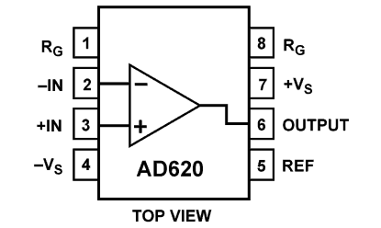

To MCU

Gain ~1500

5 V

0 V

33 Ω

**MCU PINS**

Load Sensor