1. Communities in the West are reliant on surface and ground water supplies to **irrigate their agricultural lands** (Figure 1) and **mitigate the impacts of water scarcity, drought, and increasing urban water demand**; thus, growers in this region are extremely vulnerable to changes in access to, and supply of, water resources.

Figure 1. Percent of a county’s agricultural lands irrigated in 2018. Data: USDA NASS Survey.

2. Despite the importance of irrigation to agriculture and farmer livelihoods in the West, analyses that link farm(er) characteristics to irrigation practices and trends are lacking. This is because our best source of data on US irrigated agriculture linked to farm(er) data is from the Farm & Ranch Irrigation Surveys (2003, 2008, 2013) and the Irrigation & Water Management Surveys (2018), but **these data are only released at state scales**, irrelevant to targeted outreach and research.

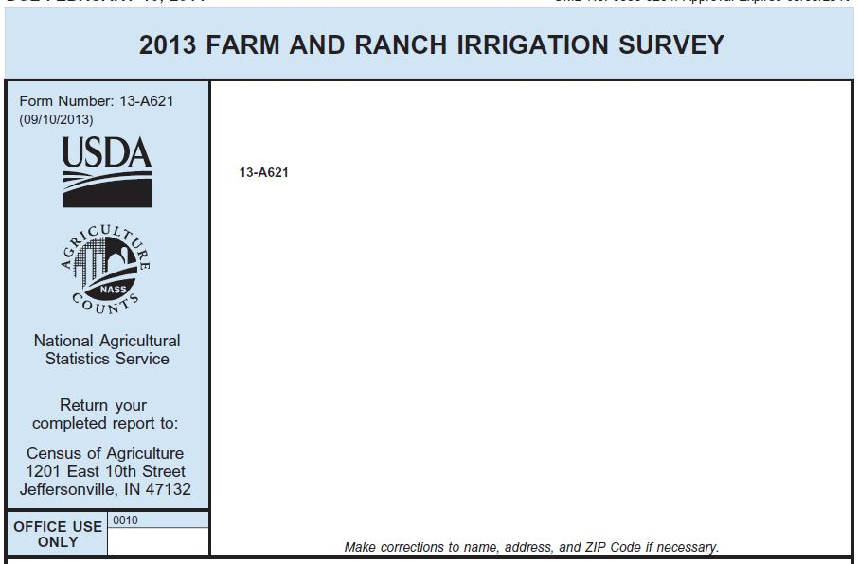Figure 2. The first page of the FRIS, a survey sent out to a sample of all growers that indicate they irrigate any agricultural acreage in the previous years’ Census of Agriculture.

3. Matt Yost received a grant to access these data at the grower-level; the county-level trends we report below are all **county-level aggregations of these grower-level data**. So, if you responded to any of the FRIS or IWMS surveys over the past two decades, your answers[1] are included in these data. Below we show trends in irrigation productivity, and the sources of information, scheduling methods, barriers and bridges to irrigation improvements identified by Utah and Idaho growers.

4. We measure irrigation productivity in pounds crop produced / acre foot water applied. This is essentially a measure of the efficiency with which crops are produced (not counting precipitation). Counties with darker shades of green, orange, purple, and blue, produce alfalfa, wheat, corn silage, and corn grain the most efficiently. **These counties are not, however, necessarily the highest producing**. For example, Gem has the highest average IP in alfalfa (6850 lbs/acre), but is only the 9th highest producing county in Idaho.

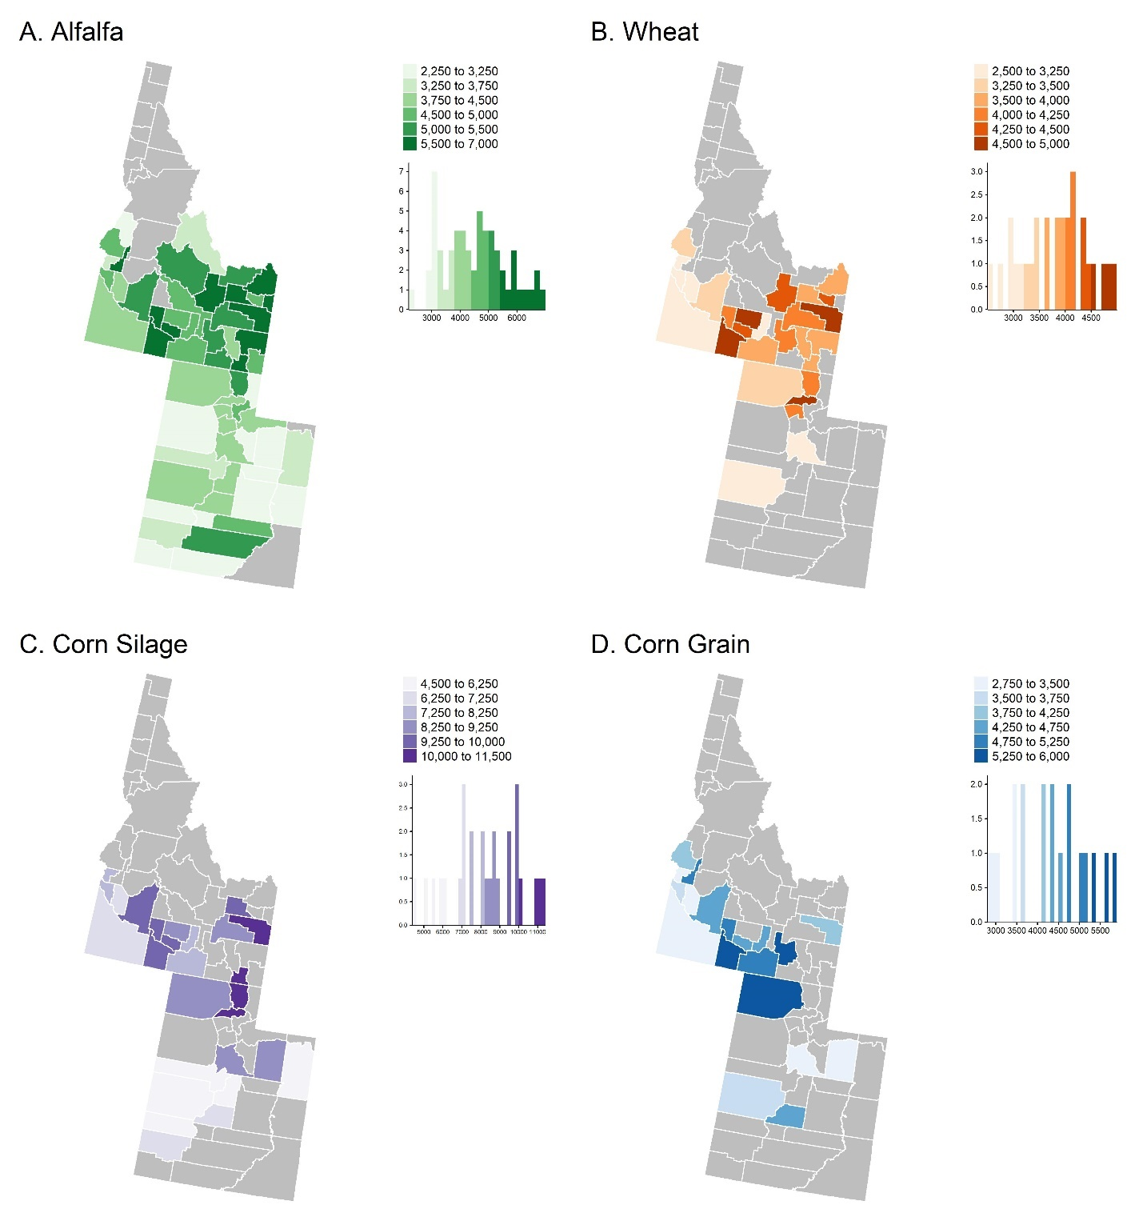

Figure 3. Trends in irrigation productivity across the four years of the FRIS/IWMS surveys.

5. The most important source of information for growers in UT & ID is **neighbors**. Interestingly, equipment dealers are important in ID, but less so in UT. The second most important source of information was extension agents or university specialists, highlighting the importance of both local knowledge and expert information networks in irrigation decision-making. See Figure 5 for the proportional distribution of information sources across ID and UT counties.

**A. 2018 B. Across Panel**

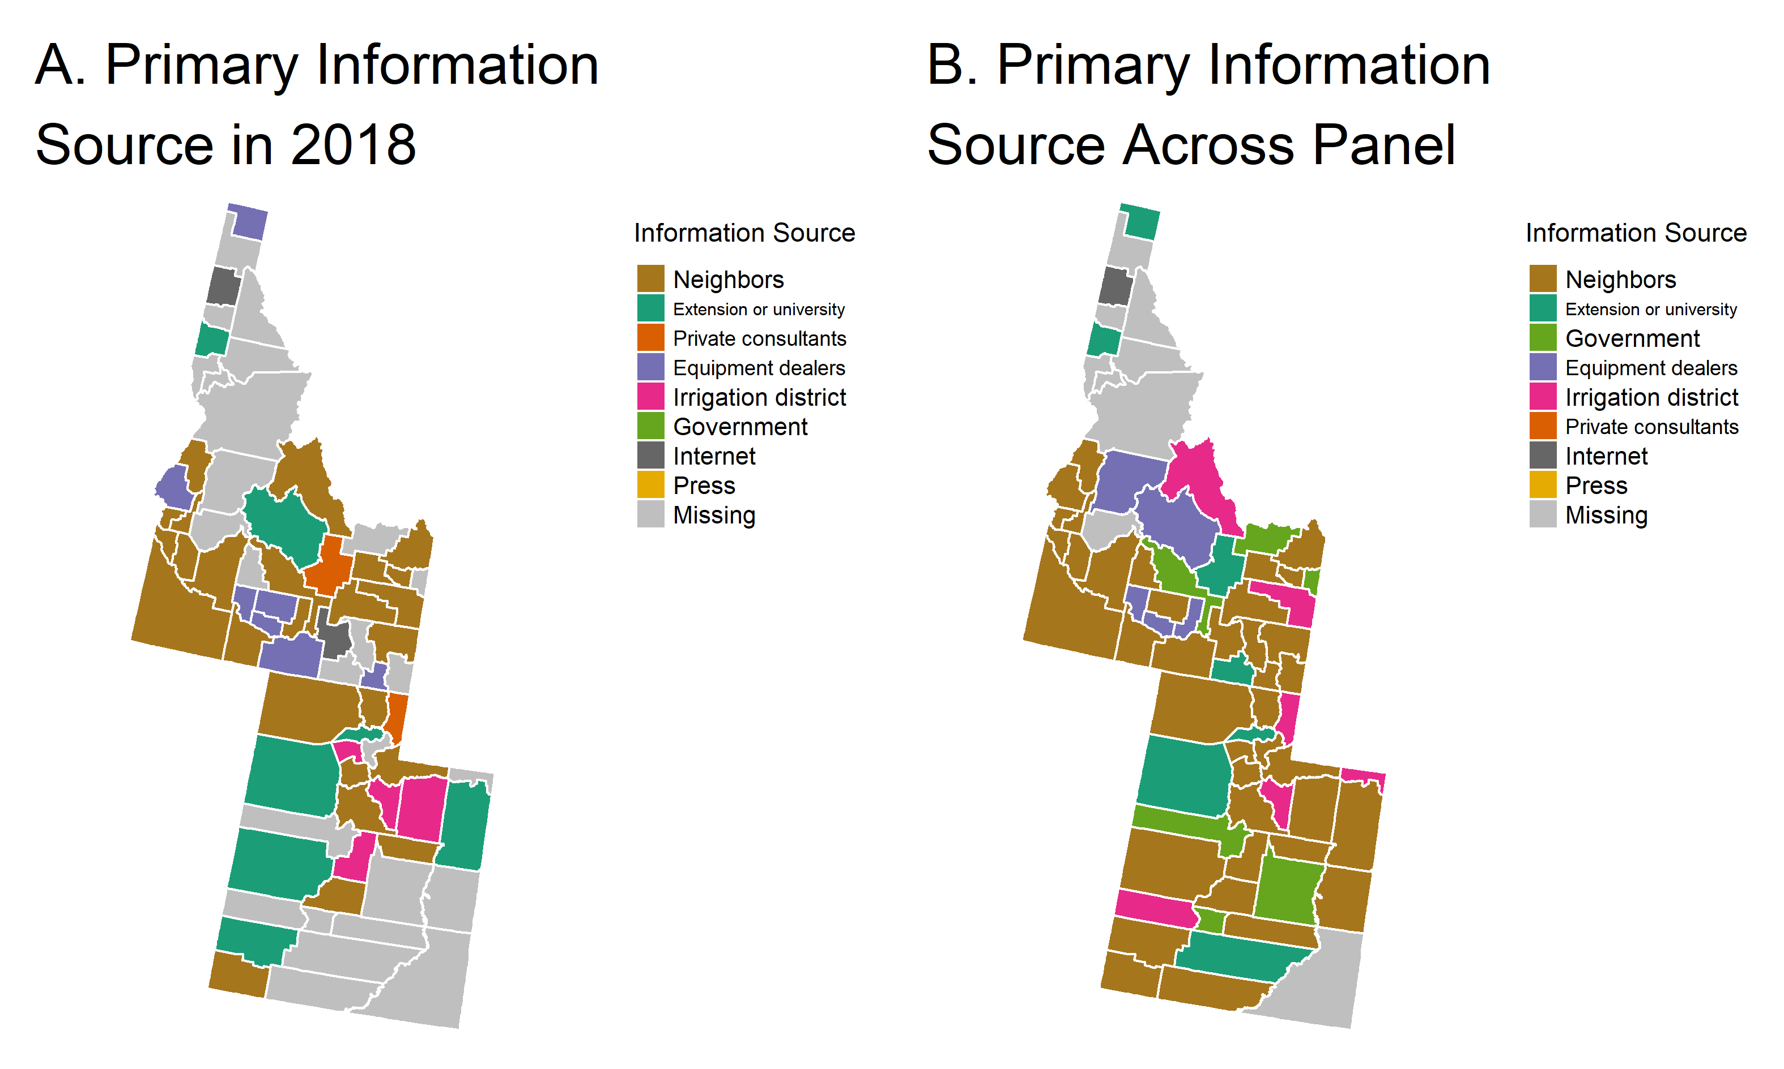

Figure 4. Primary Sources of Information used by growers in irrigation decision-making in A) 2018, and B) across the panel.

Figure 5. Pooled Proportion of Information Sources Used by Farmers Across Panel in Idaho and Utah.

6. The most important scheduling methods for growers in UT & ID is **condition of crop**. The second most important scheduling method was water delivered in turn, highlighting the importance of water rights. See Figure 7 for the proportional distribution of scheduling methods across ID and UT counties.

**A. 2018 B. Across Panel**

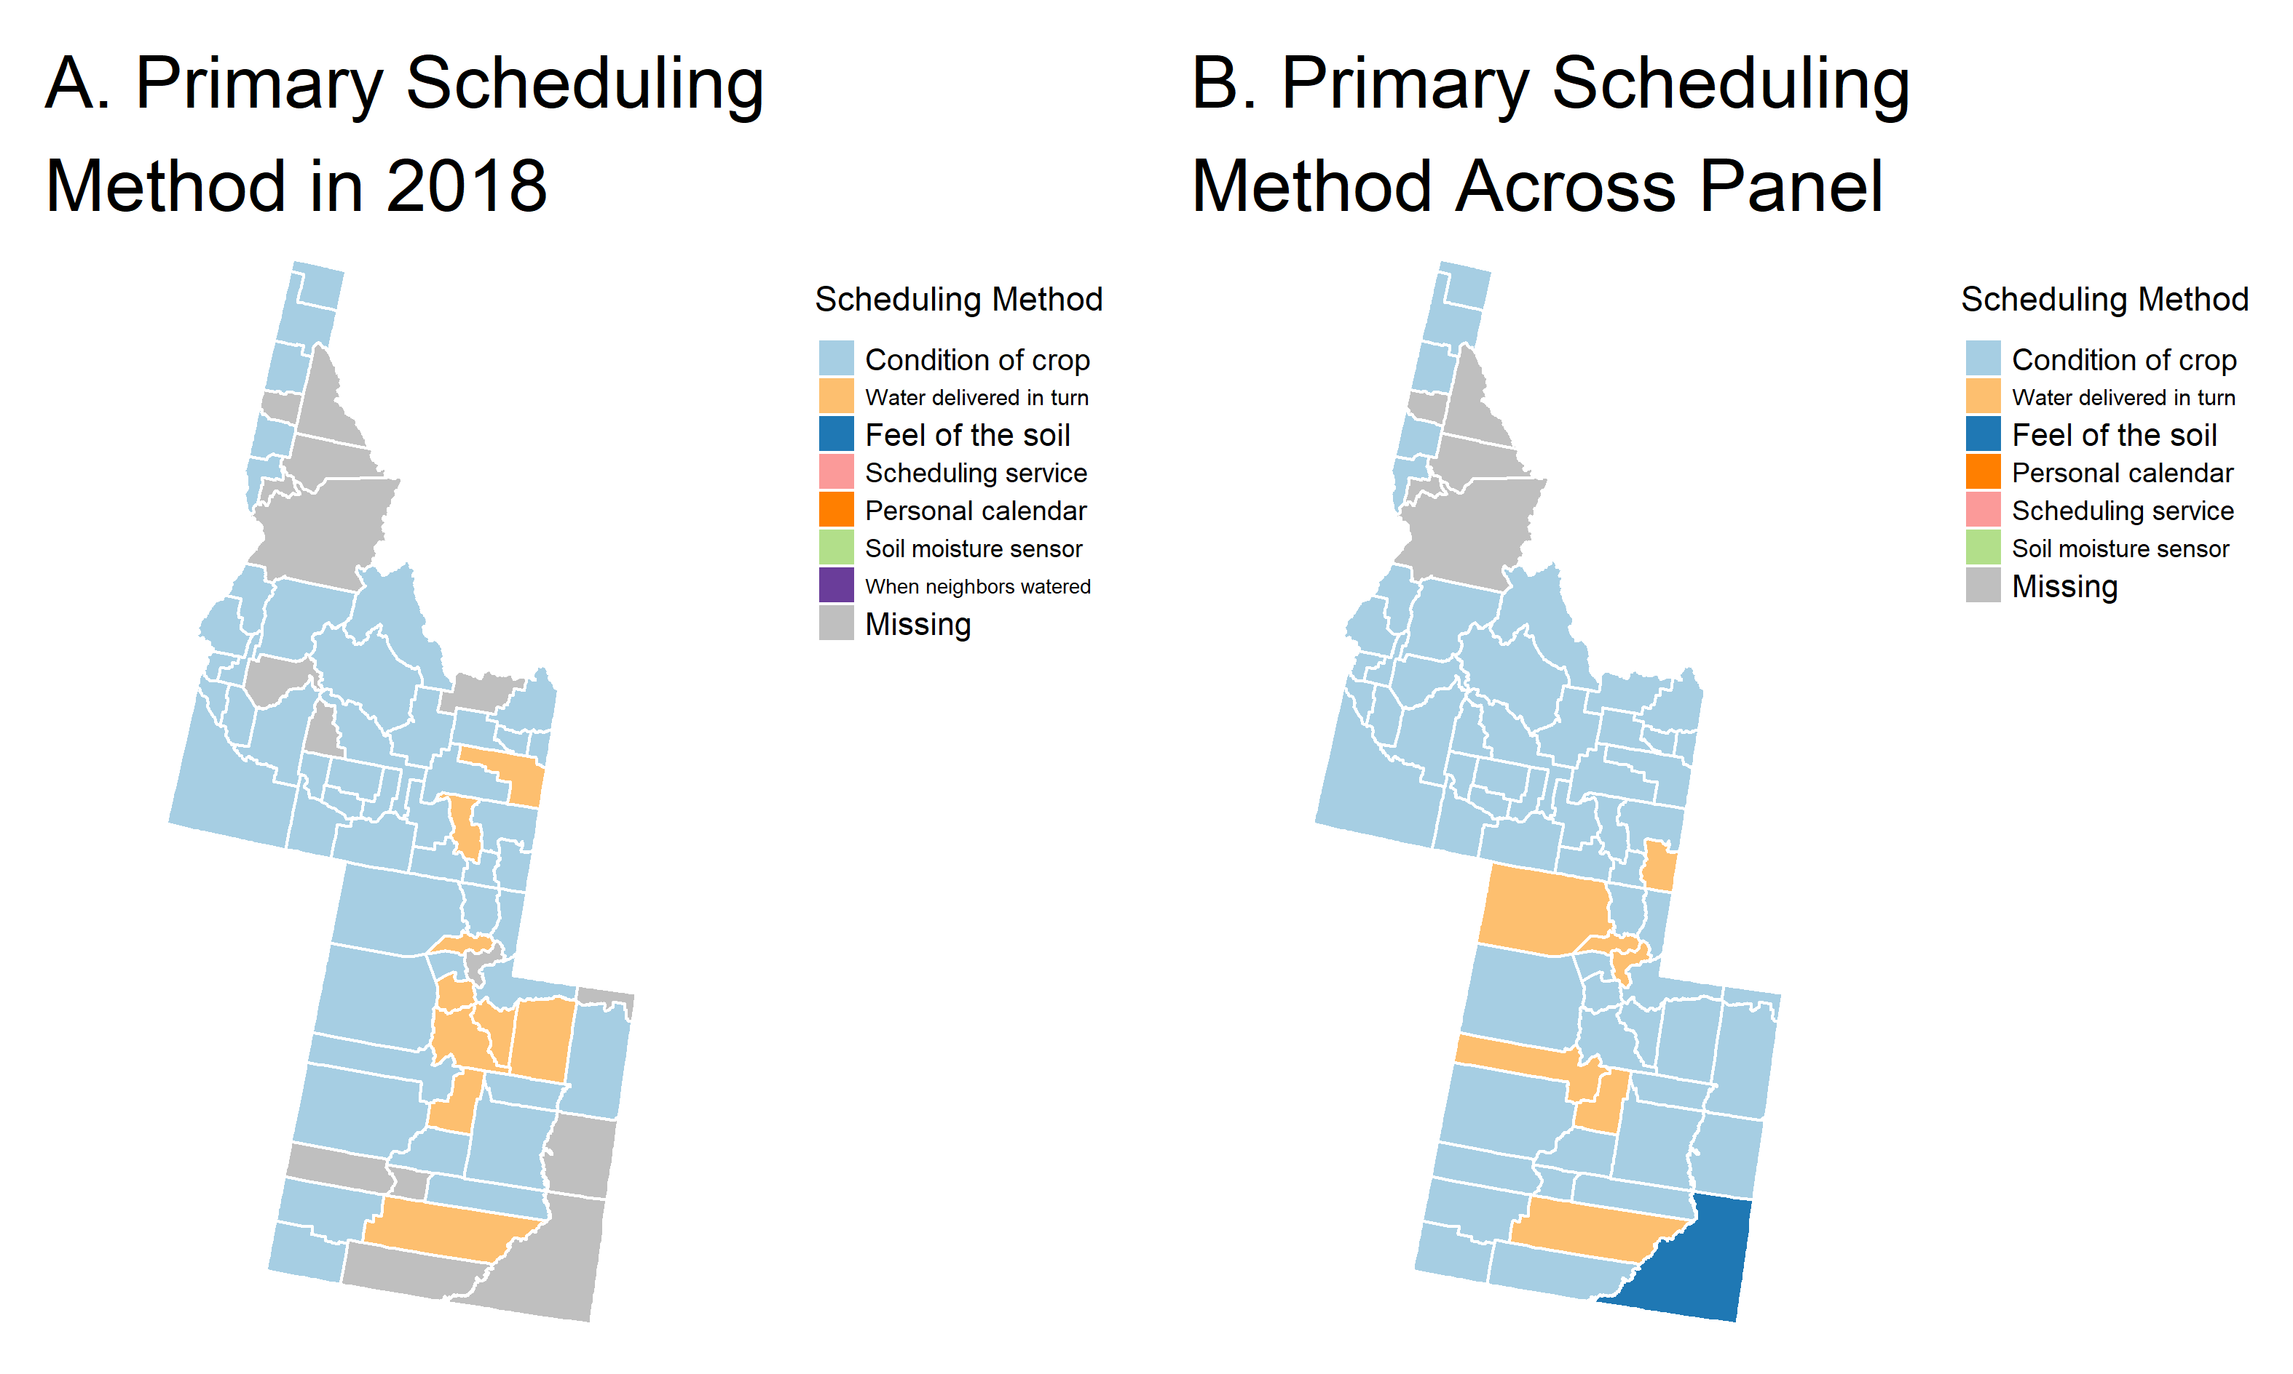

Figure 6. Primary Scheduling Methods used by growers in irrigation decision-making in A) 2018, and B) across the panel.

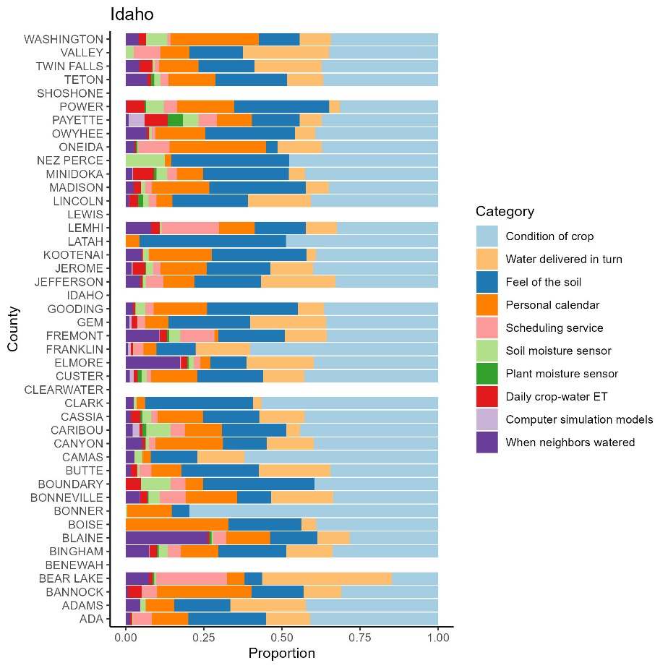 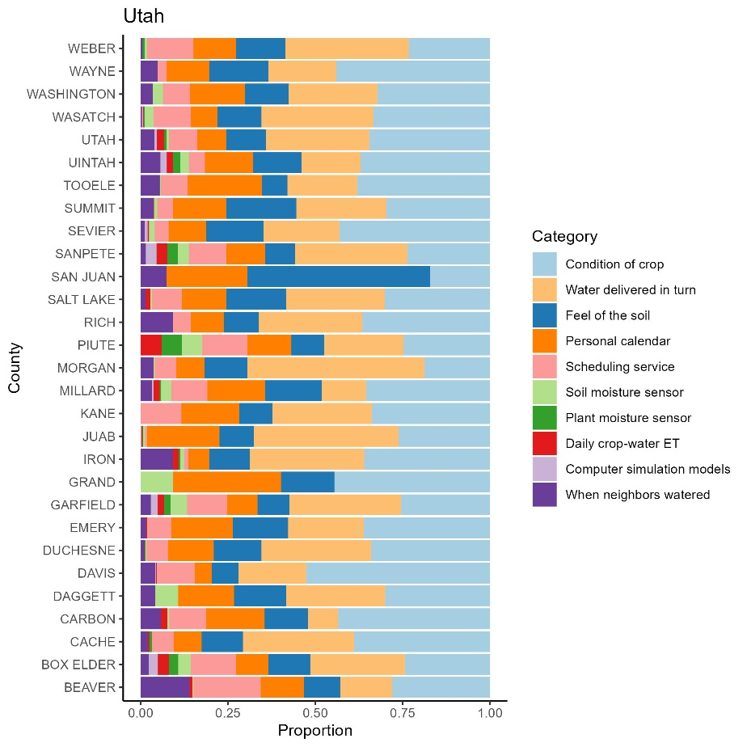

Figure 7. Pooled Proportion of Scheduling Methods Used by Farmers Across Panel in Idaho and Utah.

7. The most important barrier for growers in UT & ID is **financial**. Interestingly, the 3rd most important is water uncertainty. See Figure 9 for the proportional distribution of barriers across ID and UT counties.

**A. 2018 B. Across Panel**

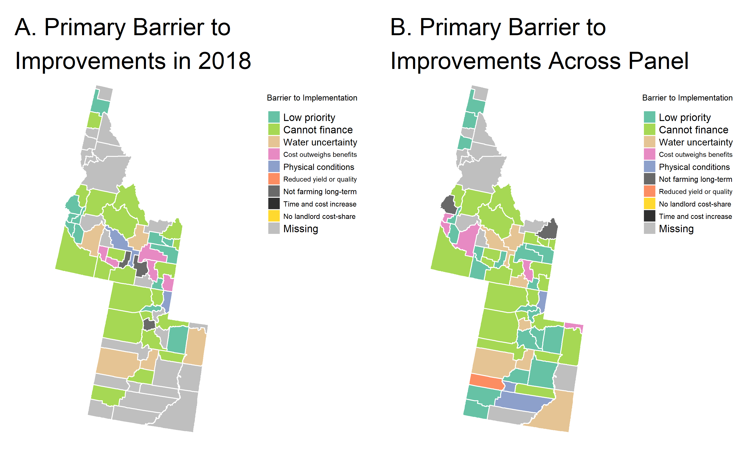

Figure 8. Primary Barriers to Implementing Irrigation Improvements in A) 2018, and B) across the panel.

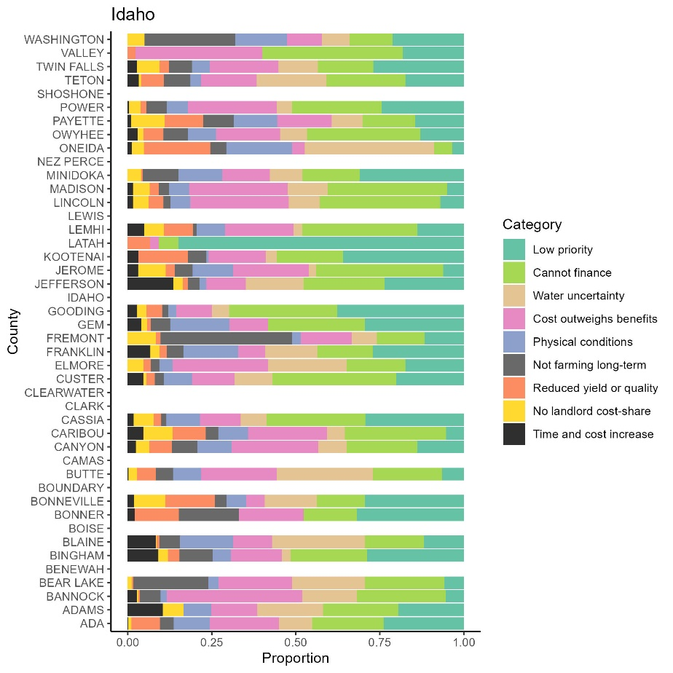

Figure 9. Pooled Proportion of Barriers Identified by Farmers Across Panel in Idaho and Utah.

8. The most important source of assistance are **USDA conservation funding**. The second most important is USDA conservation technical assistance (all technical assistance denoted with *). See Figure 11 for the proportional distribution of assistance sources across ID and UT counties.

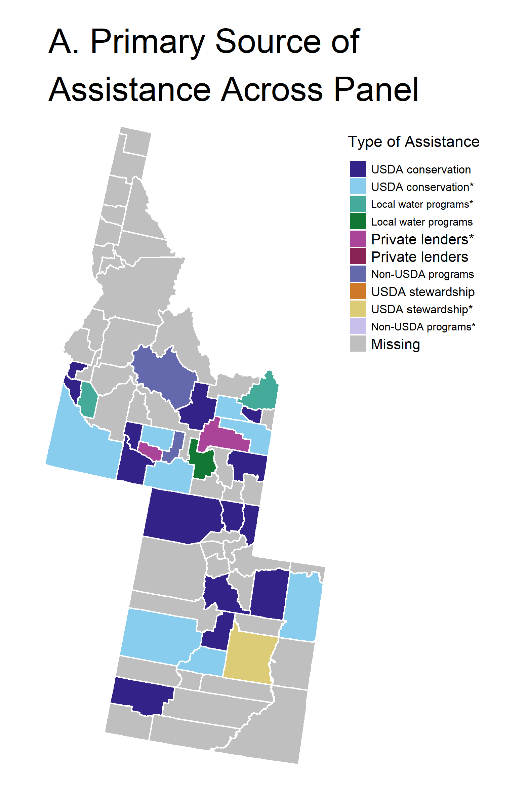

Figure 10. Primary Source of Assistance for Implementing Irrigation Improvements across the panel.

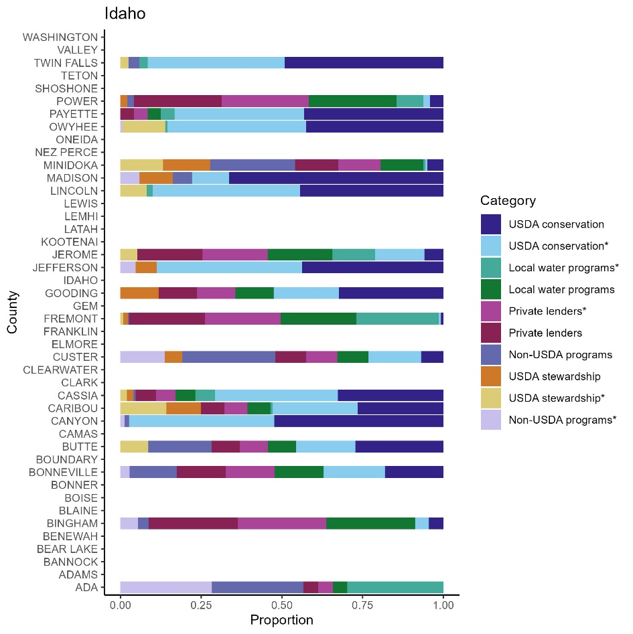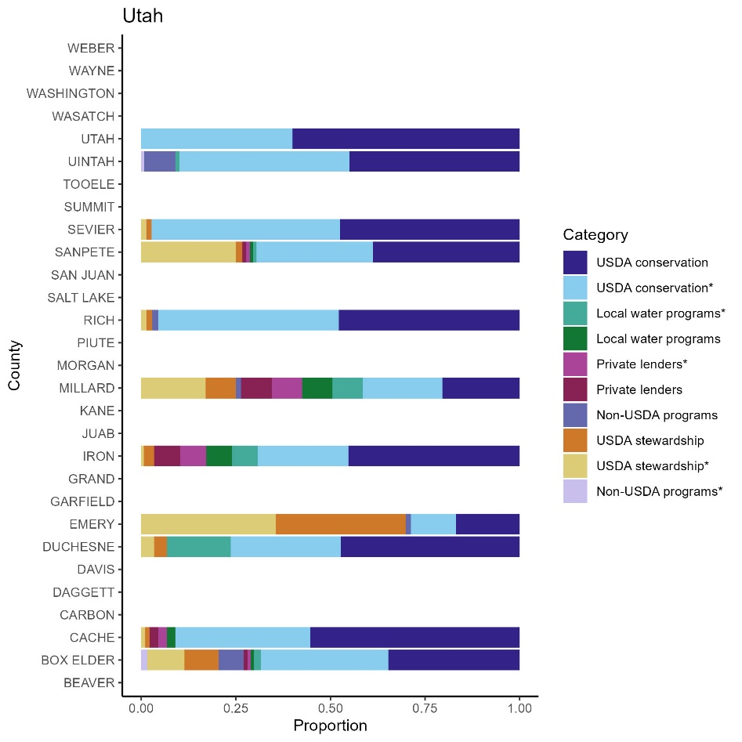

Figure 11. Pooled Proportion of Assistance Sources Identified by Farmers Across Panel in Idaho and Utah.

**TAKE-AWAYS:**

1. Agriculture in the West is incredibly diverse.;
2. THUS, state-level summaries are not sufficient for building extension or research initiatives that target growers’ specific needs.;
3. We need data aggregated at the county-level to give growers accurate information and to target their needs.

**ADDITIONALLY:**

1. The FRIS/IWMS surveys are our only source of irrigation data linked to farm(er) characteristics. They are incredibly important for understanding trends in irrigation practices and the needs of growers across space and time. Filling them out thoroughly and portraying irrigation practices accurately is highly important for the future of US agriculture resilience.

1. All data is anonymized, so no identifying information is attached to your answers.