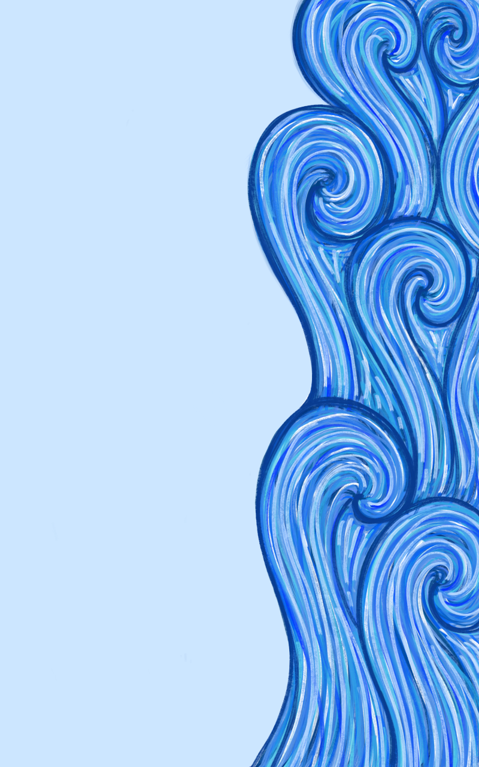
”והמים להם חומה
מימינם ומשמאלם“
“And the water was to them like a wall
from their right
and from their left”

