ZIMOX RFID Tool User Manual

1. Version Information
Software Version: v3.0.2.0
Release Date: 2026-06-30
Update Description: Bug fixes and operation optimization

2. Download and Installation
Download Link: https://github.com/blu-blue/RFIDToolsForThailand

Step1,download project as RFIDToolsForThailand-main.zip file
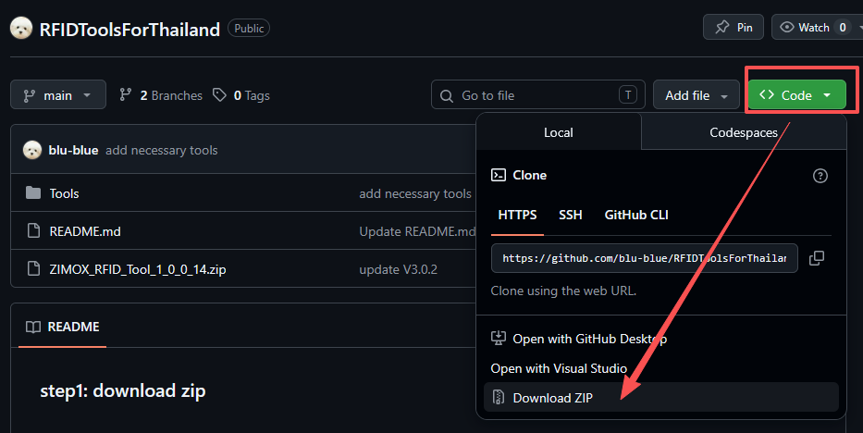

step2:Unzip the file RFIDToolsForThailand-main.zip to the folder RFIDToolsForThailand-main
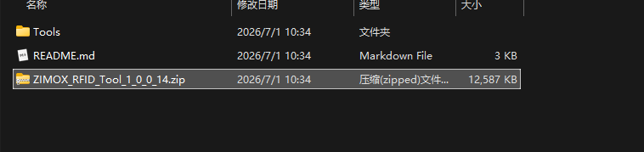

Step3:Unzip the file ZIMOX_RFID_Tool_1_0_0_14.zip to the folder ZIMOX_RFID_Tool_1_0_0_14
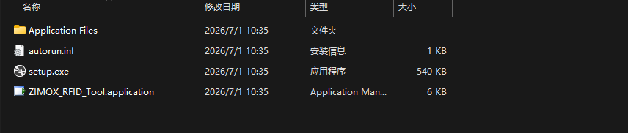

Step4:Run setup.exe to finish installation,if you can see the panel as below,it means the software is installed sucessfully and we can continue the next step.
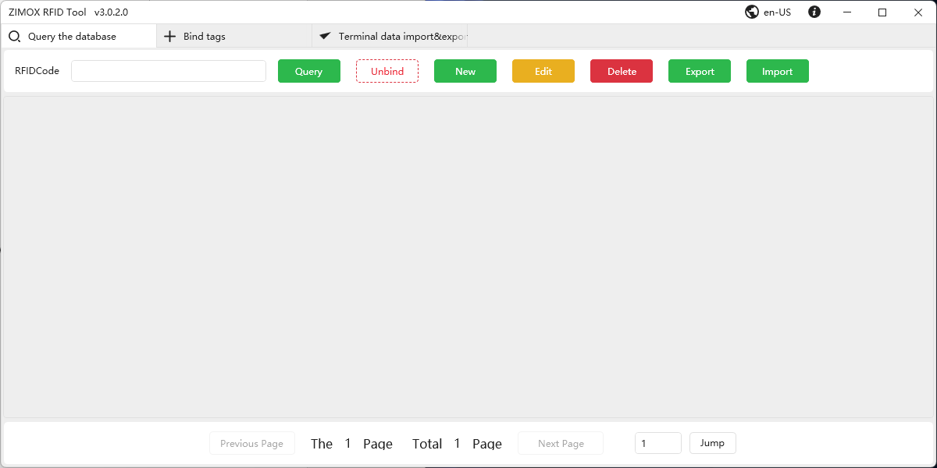

Step5: Copy the dependencies required for software operation. Click the "Open Directory" button to navigate to the root folder. Copy all the folders in tools to the application root folder
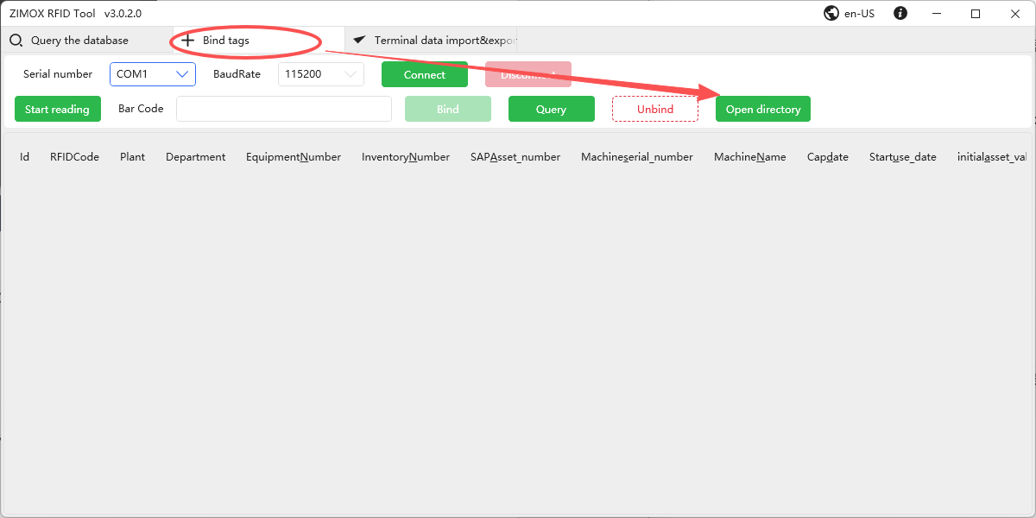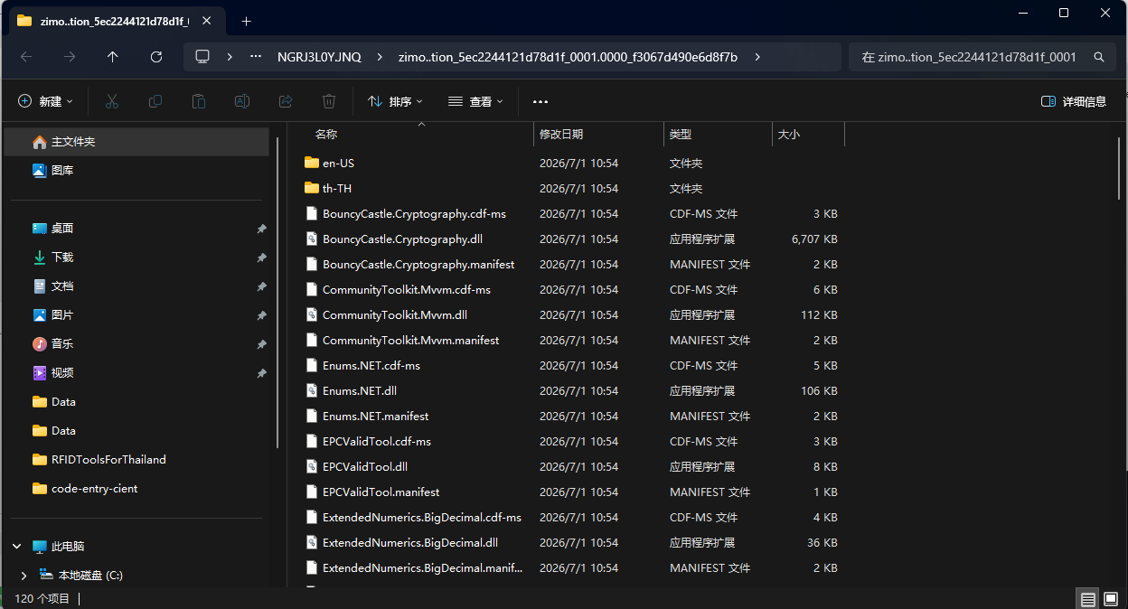
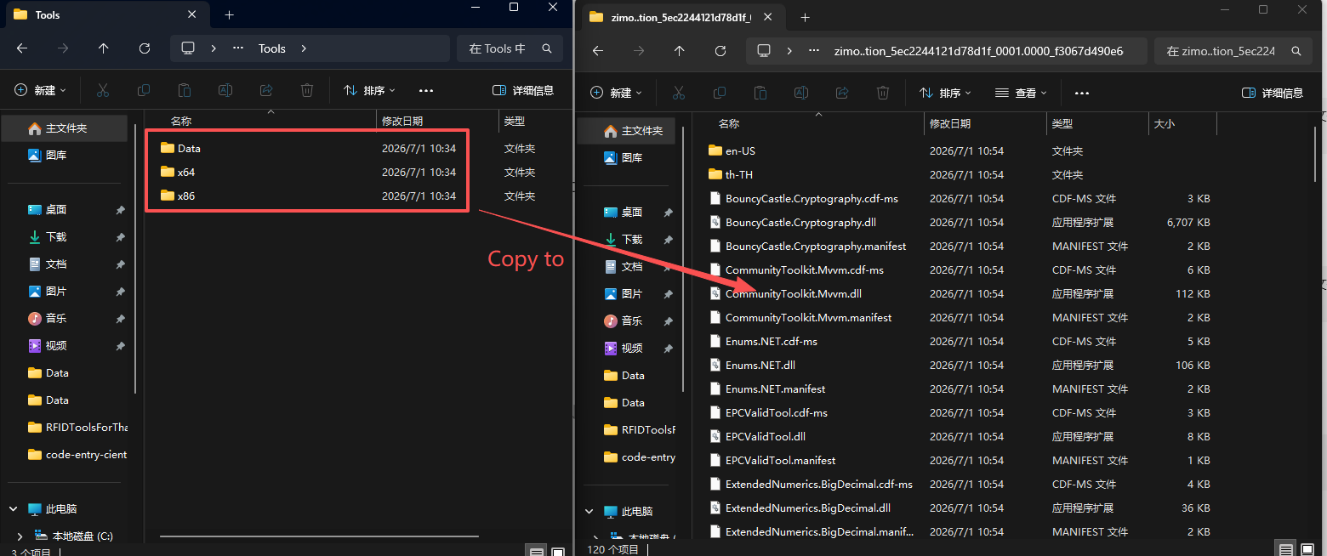

3. Make sure the desktop driver is ready, if it has ready, skip this step.
1. Connect desktop reader and computer via the usb cable.
2. Open computer management panel, make sure “Silicon Labs CP210x USB to UART Bridge” item in Ports group is normal. like this as below
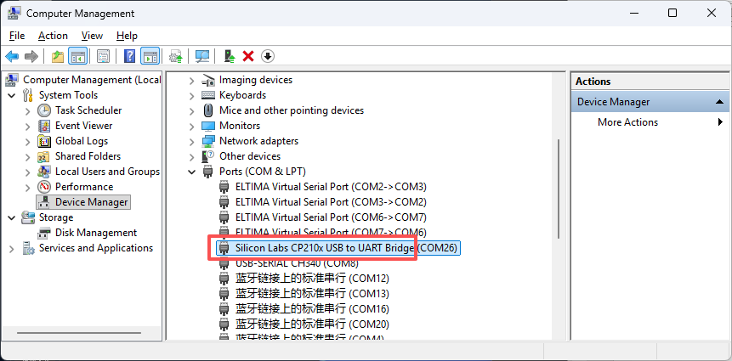
3. If the driver is not ready, like this below picture shows, the computer need to install the driver. The driver has be putted in “driver” folder
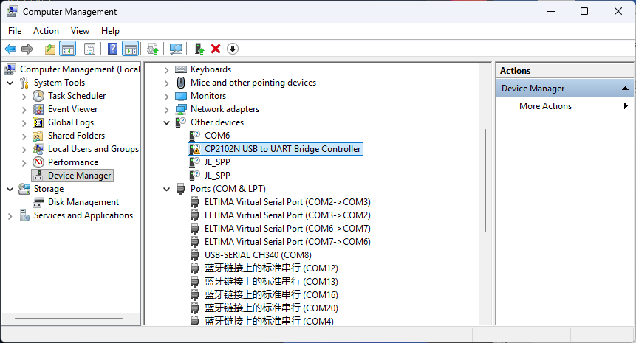
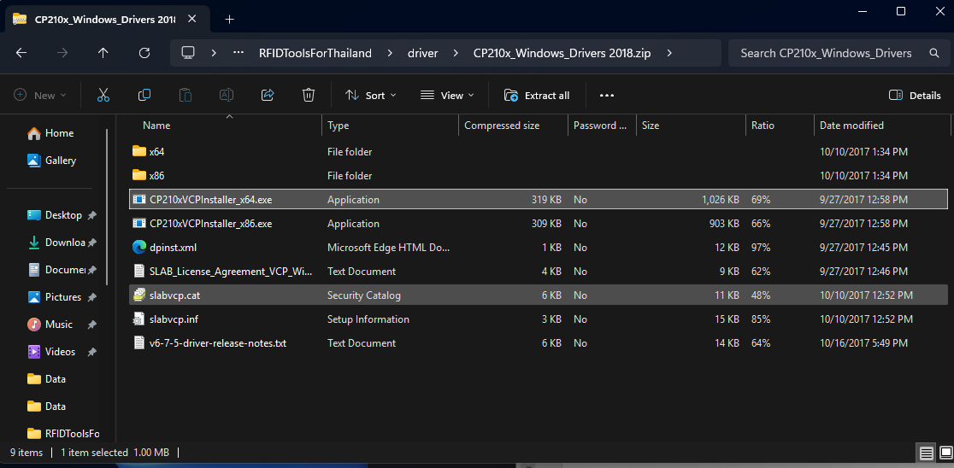

4. Read a tag
1. Connect desktop reader and computer via the usb cable.
2. Put one tag on the desktop reader. Like this
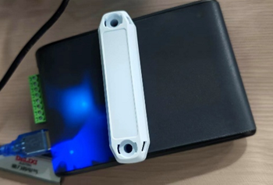
3. Chose the driver’s com number, select the baudrate to 115200 , then click the connect button.
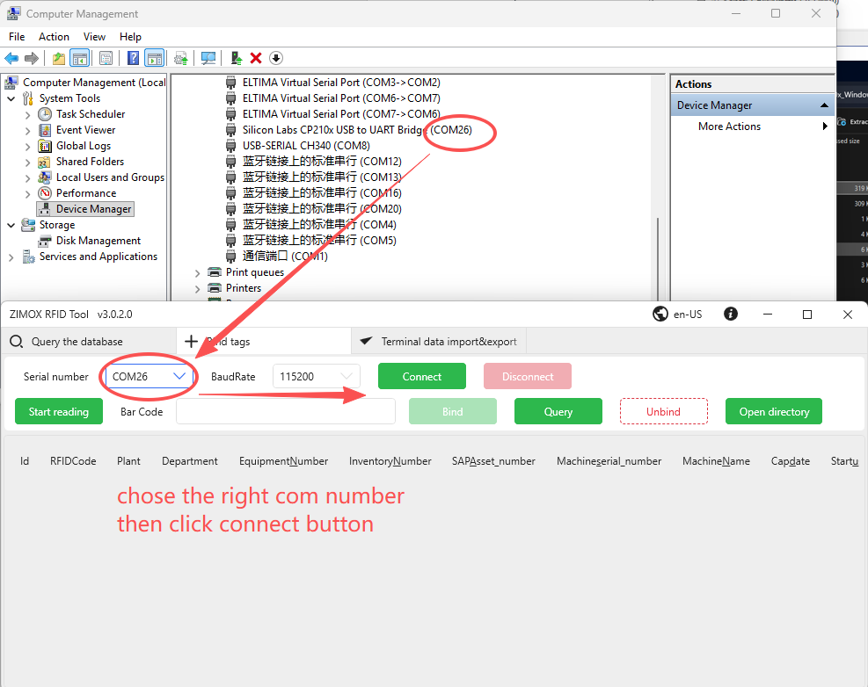
4. Click Start reading button, the tag number will be shown in the text box
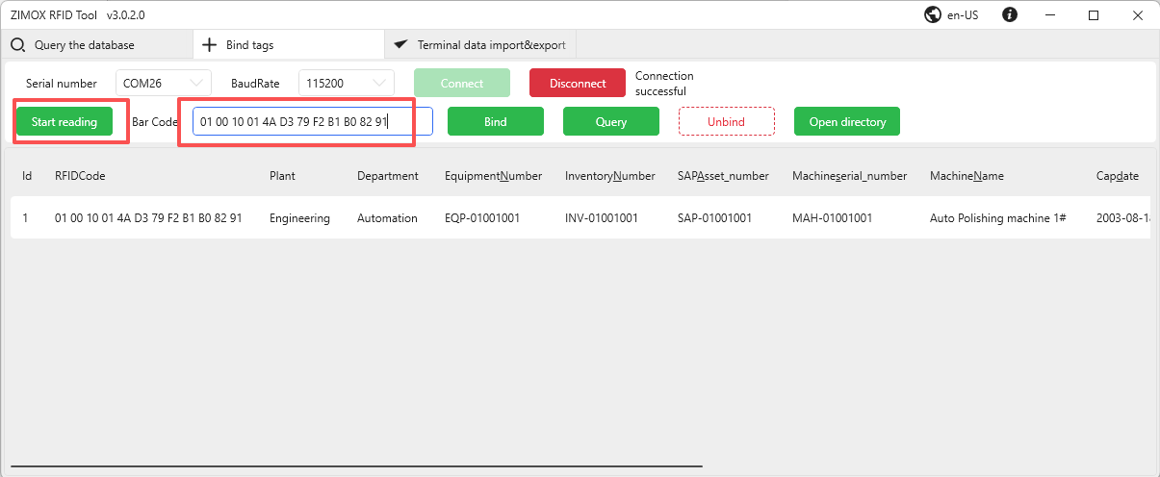

5. Import asset information
1. Click Open Directory Button to access the data folder , find “InputAssetsTable.xlsx” and Open “InputAssetsTable.xlsx” in Excel. Add some data to this spreadsheet, then close it. 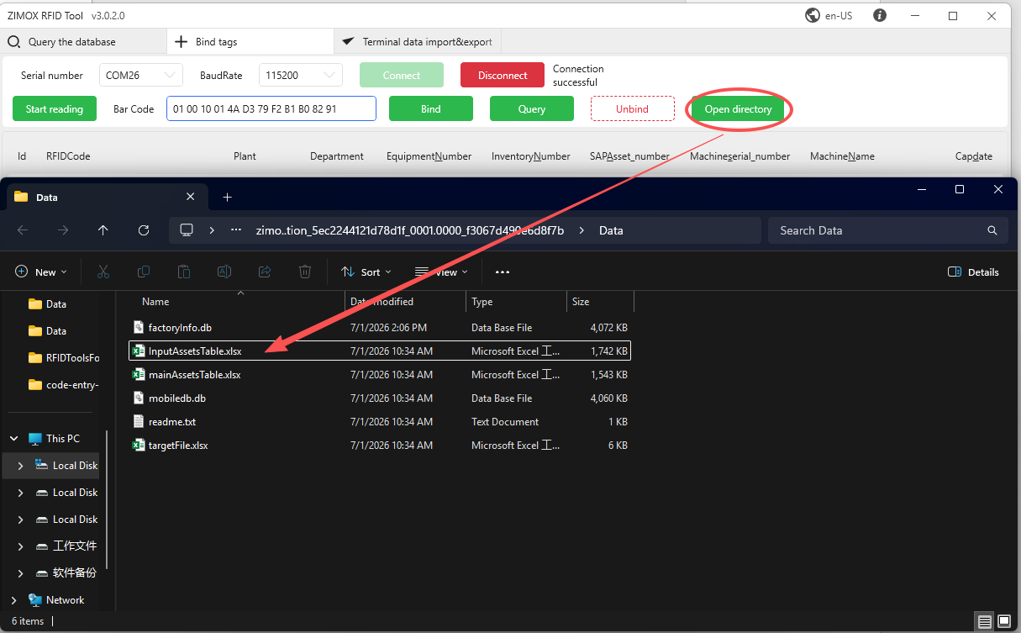
2. Navigate to “Query the database” panel, click import button. Wait the importing progress finish then click Complete button.
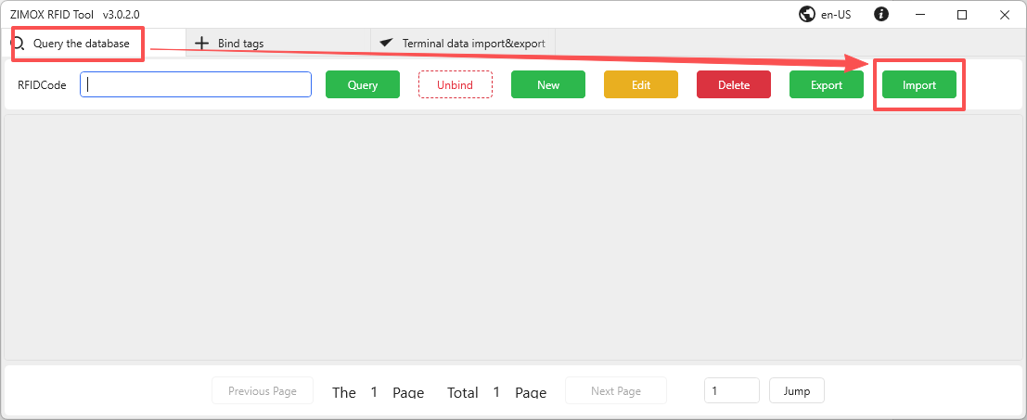
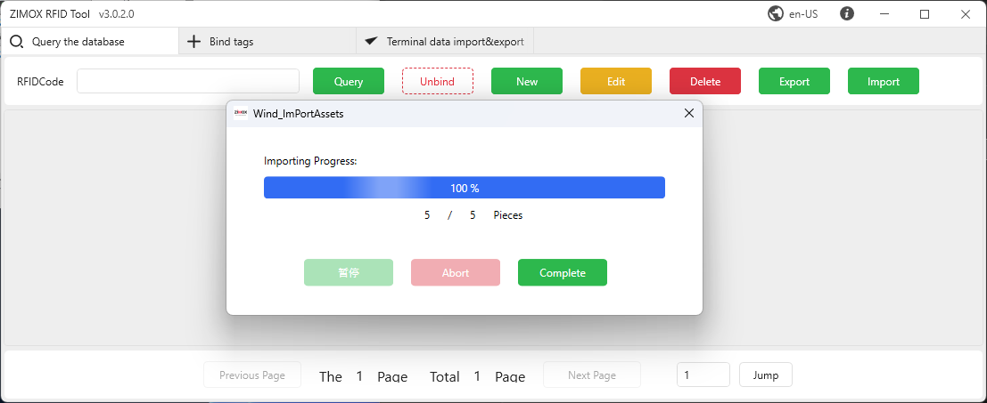
3, Navigate to “Bind tags” panel, click query button, the asset data will be shown in the table
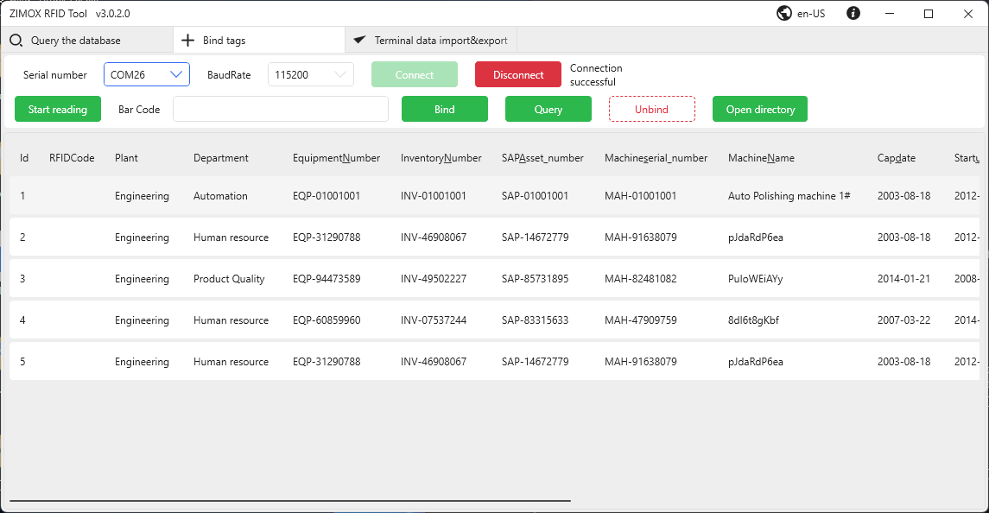

6. Bind a tag with one asset data
1. Navigate to “Bind tags” panel, click “start reading”, make sure the tag number is shown in the text box, chose one asset , click bind button. The application will finish the binding action. If it success , the panel will show as this
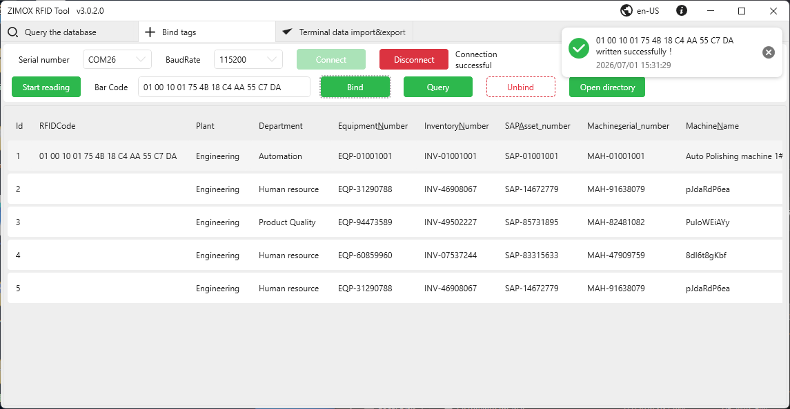
2. The binding action will do these things
- Get the asset sap number
- Create a new tag number which include sap information
- Write new tag number to tag
- Bind tag number to asset data and write the relationship into “factoryInfo.db” which is in data folder.

6. Unbind a tag
1. select an asset which we want to unbind, then click unbind button
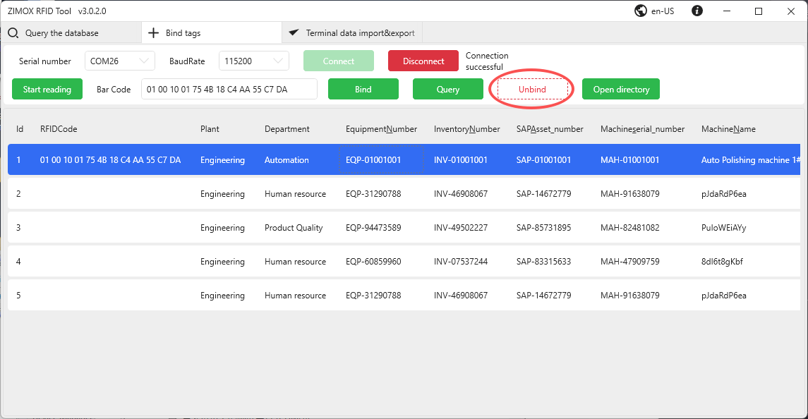
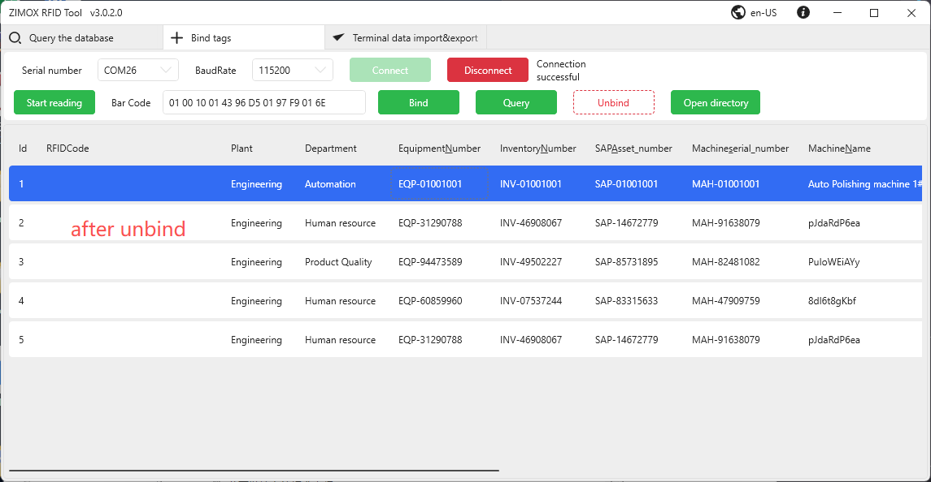

7. Other Notes
At the ESTAR factory, when writing the EPC code to a specific tag, other nearby tags close to the reader may accidentally receive the EPC data.
To avoid this problem during operation:
Keep all unused tags at least one meter away from the reader.
place idle tags inside a metal box for shielding if possible.

