ZIMOX RFID Tool User Guid

1. Version Information
Software Version: v3.0.5.0
Terminal App Version: v1.1.2.0

2. Download and Installation
Download Link: https://github.com/blu-blue/RFIDToolsForThailand
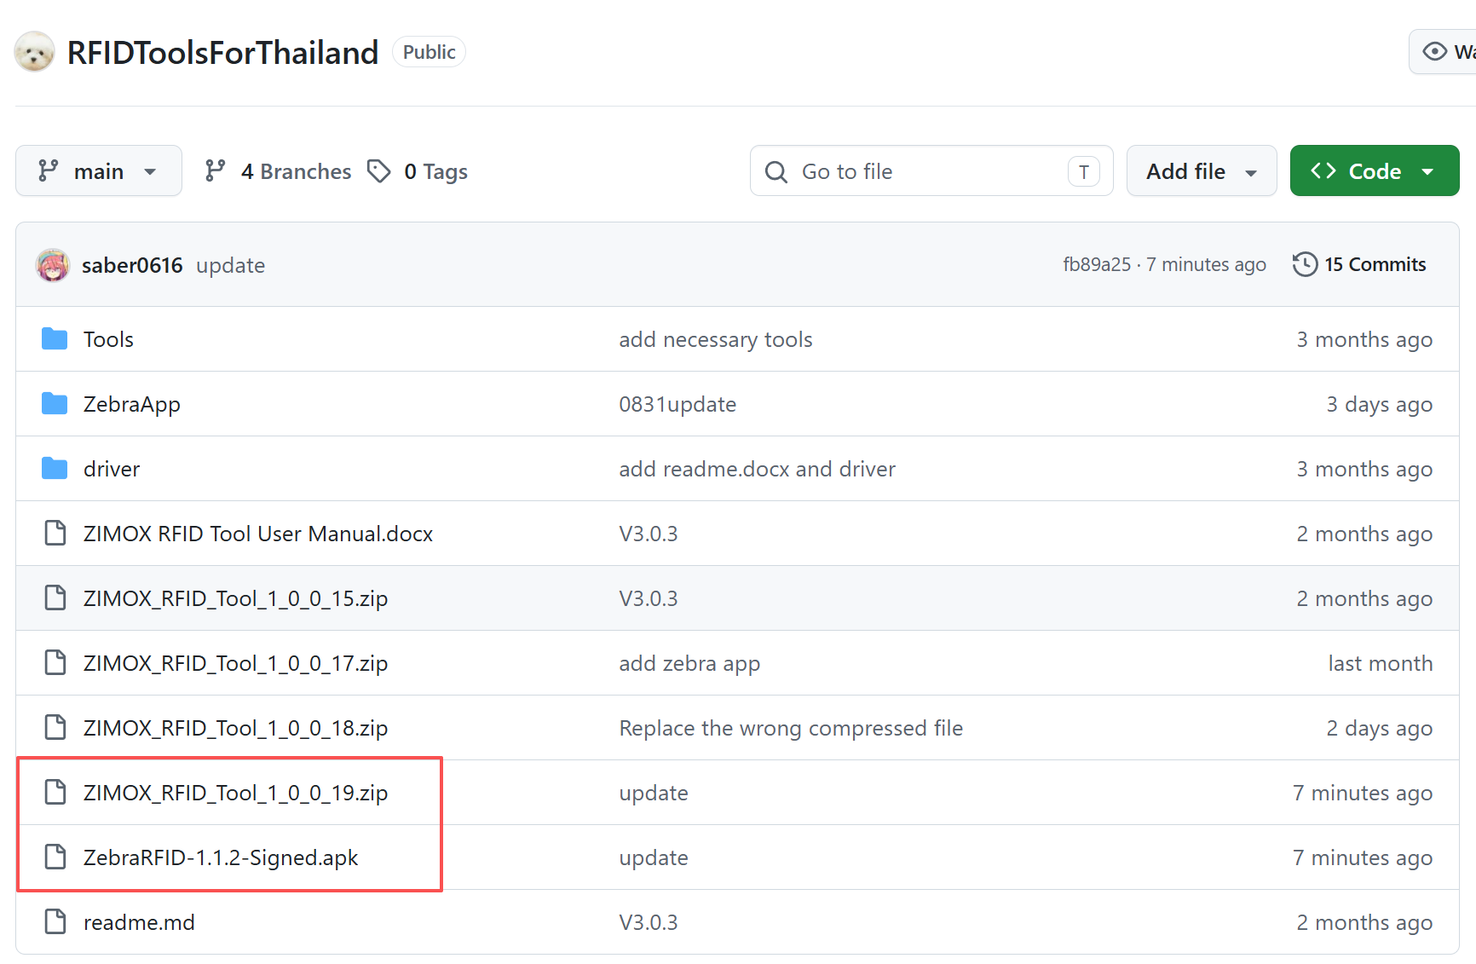

3. Read a tag
1. Connect desktop reader and computer via the usb cable.
2. Put one tag on the desktop reader. Like this
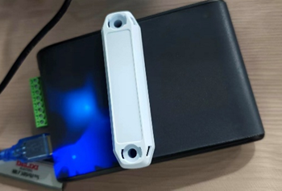
3. Chose the driver’s com number, select the baudrate to 115200 , then click the connect button.
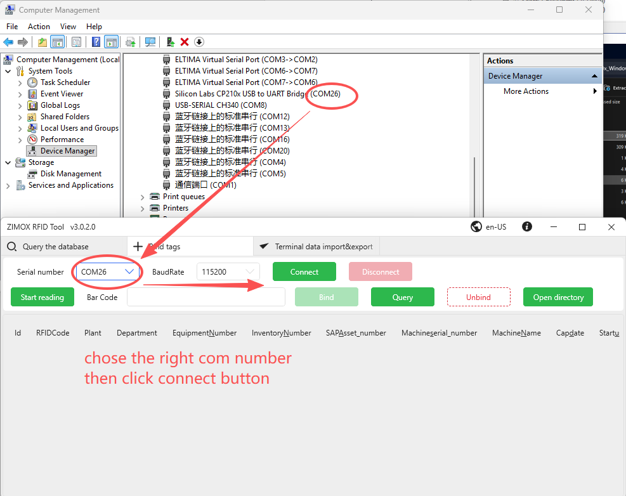
4. Click Start reading button, the tag number will be shown in the text box
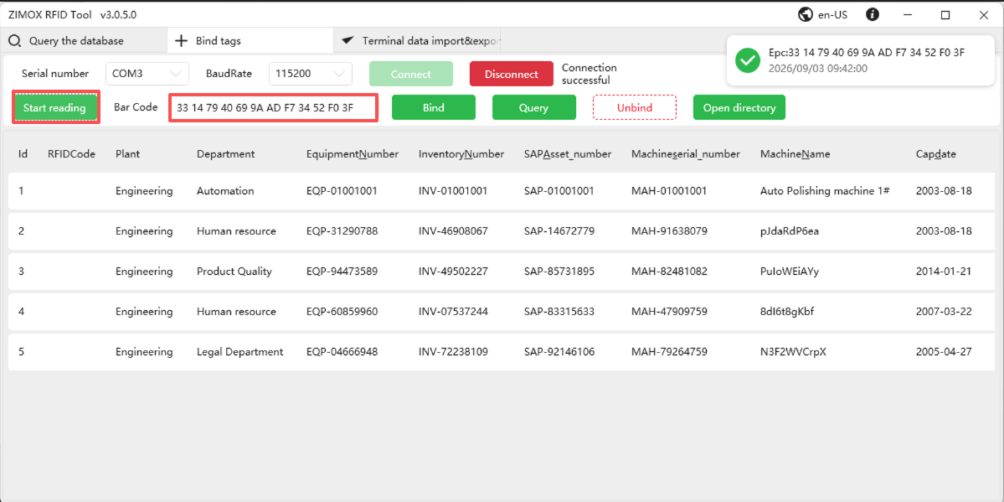

4. Import asset information
1. Click Open Directory Button to access the data folder , find “InputAssetsTable.xlsx” and Open “InputAssetsTable.xlsx” in Excel. Add some data to this spreadsheet, then close it. 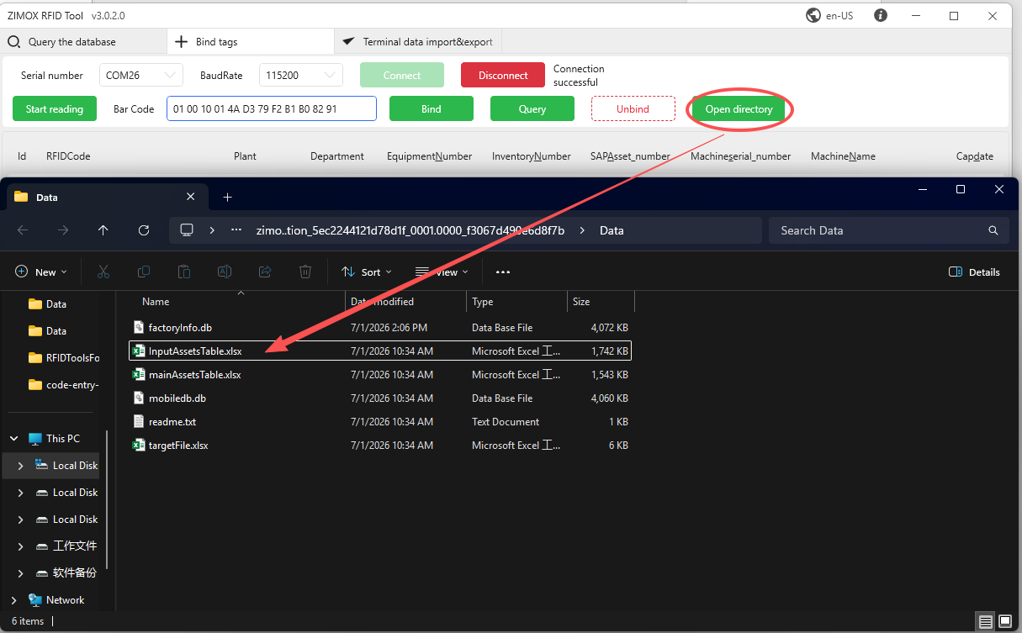
2. Navigate to “Query the database” panel, click import button. Wait the importing progress finish then click Complete button.
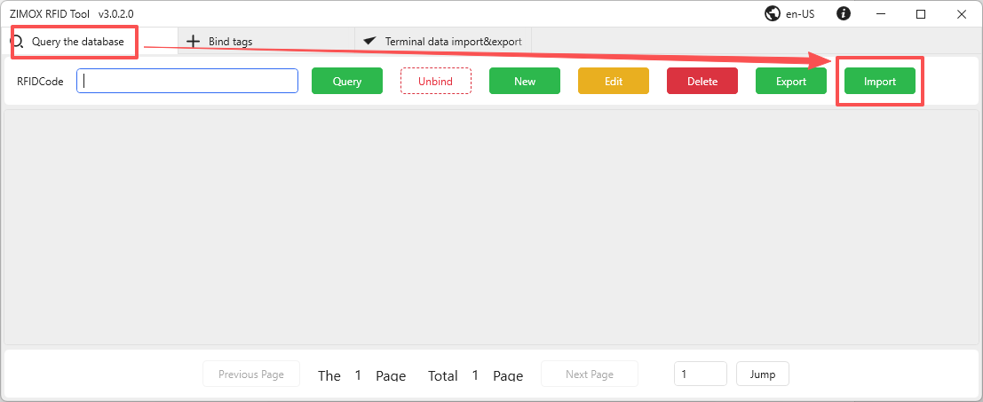
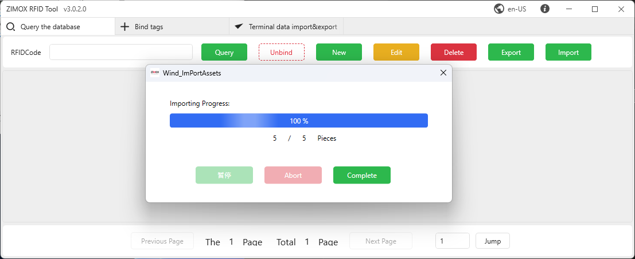

5. Bind a tag with one asset data
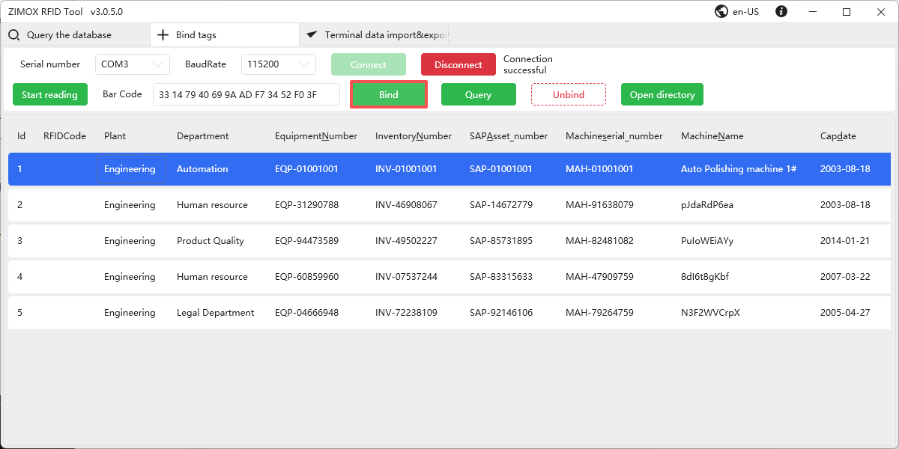
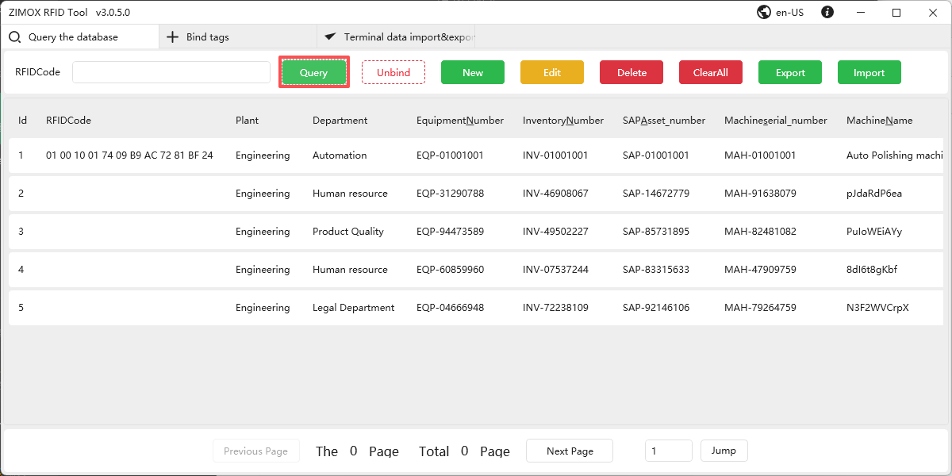

6. Send assets table to terminal
After connecting the handheld terminal to the PC via USB, refresh the terminal and click PC -> Terminal
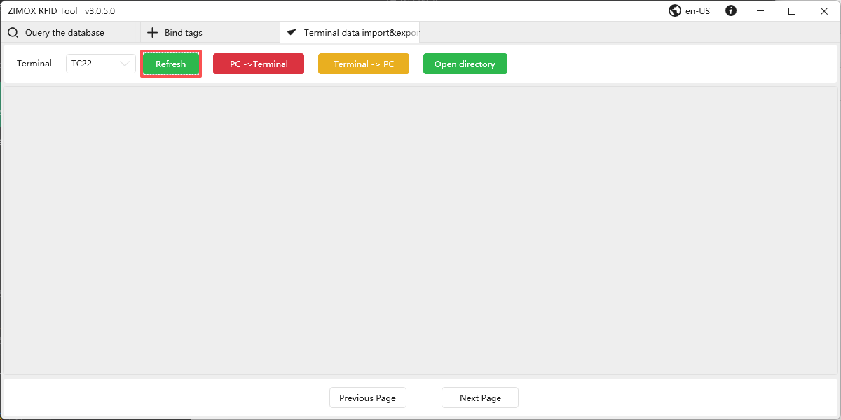
Click Confirm button
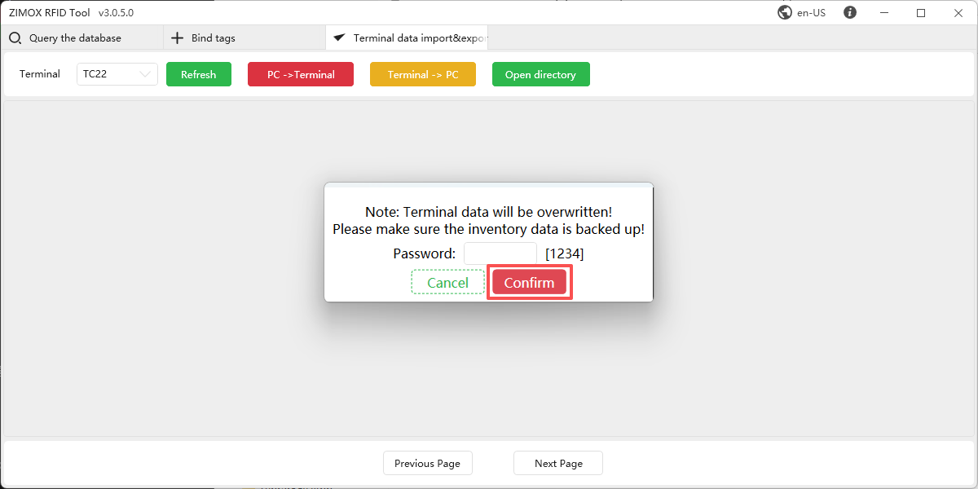

Copy PCAssetsTable.xlsx to the terminal's download directory
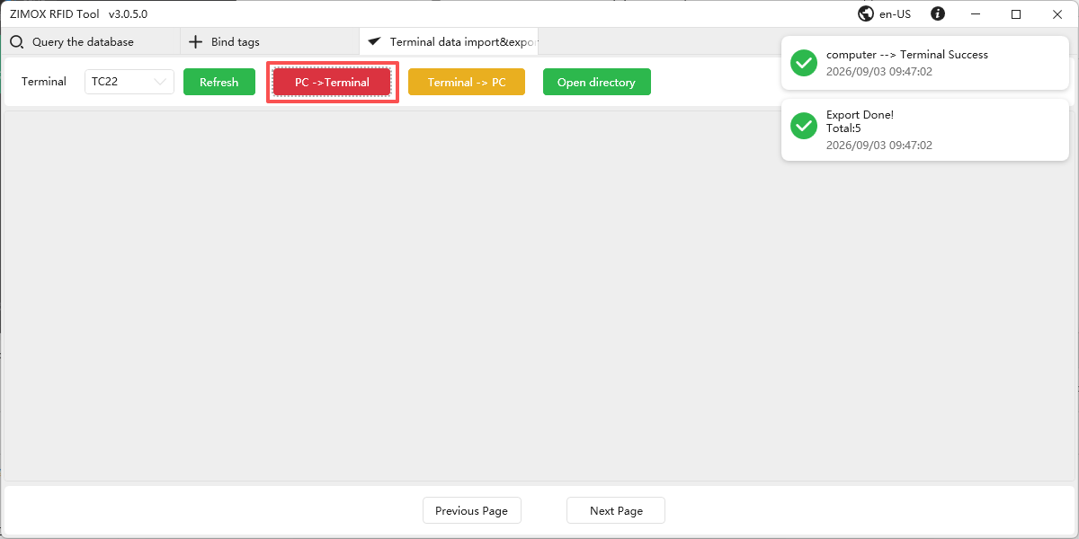

7. Scan using the terminal
Wait Reader status from Unconnected to Connected
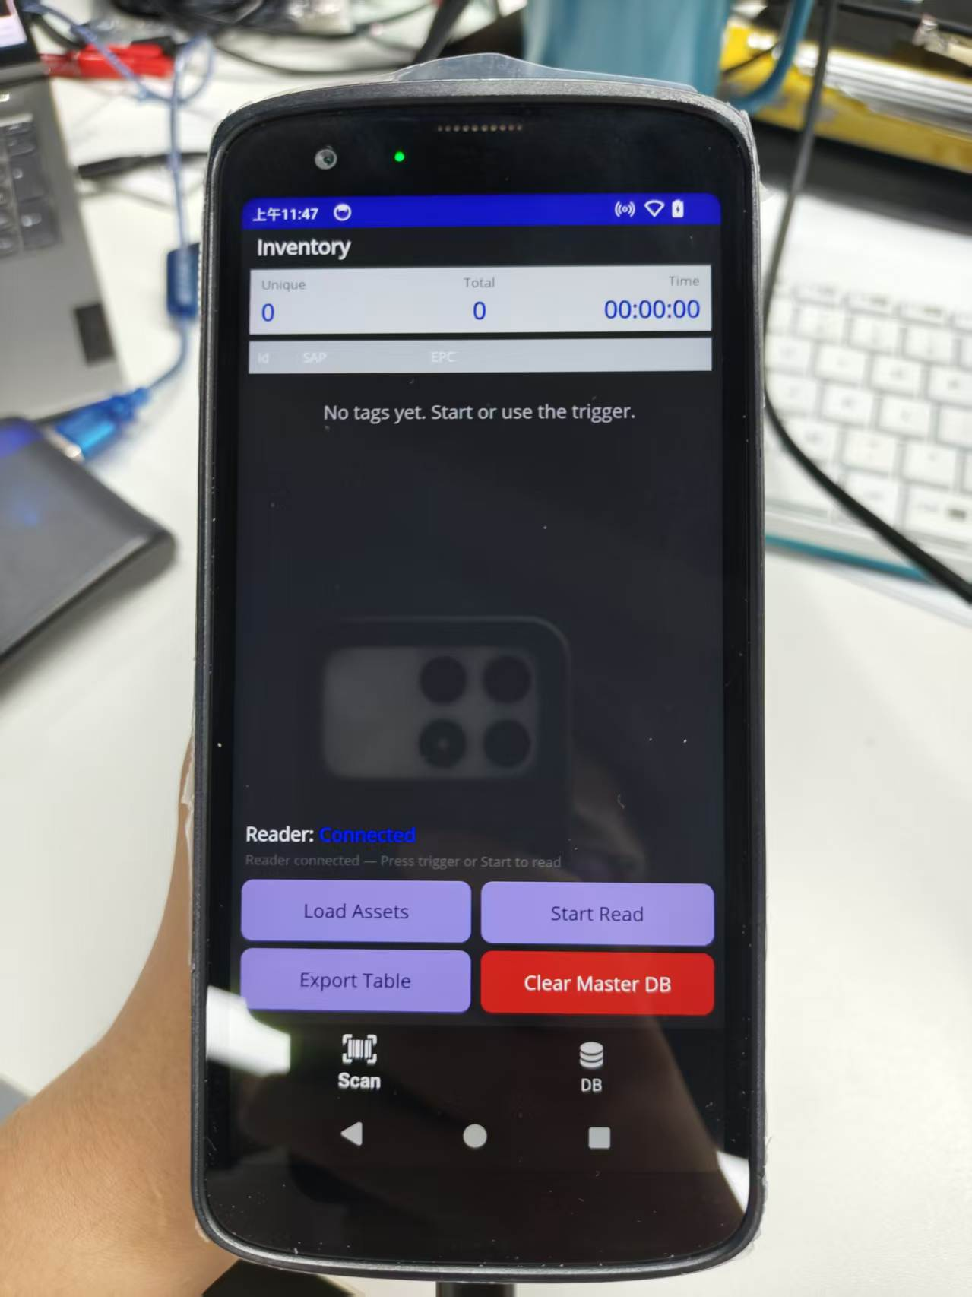

Click Load Assets button, choose the PCAssetsTable.xlsx

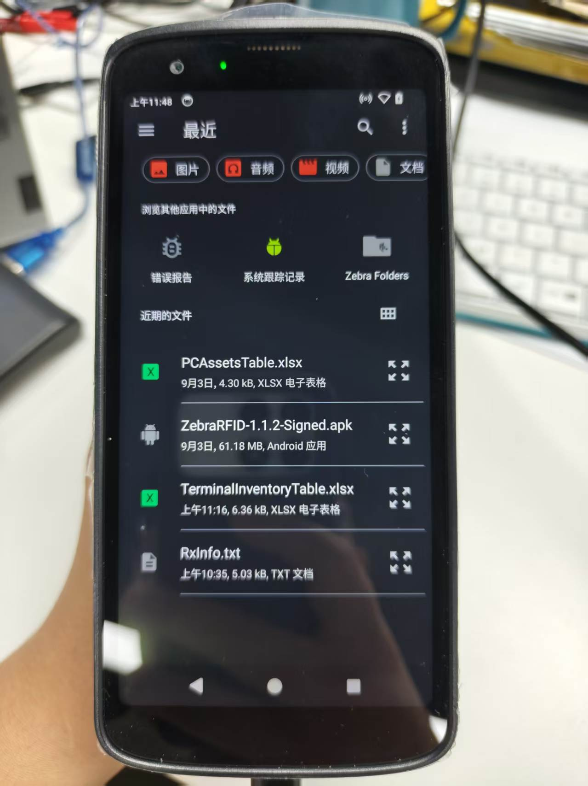
Pull the back trigger to start scanning,

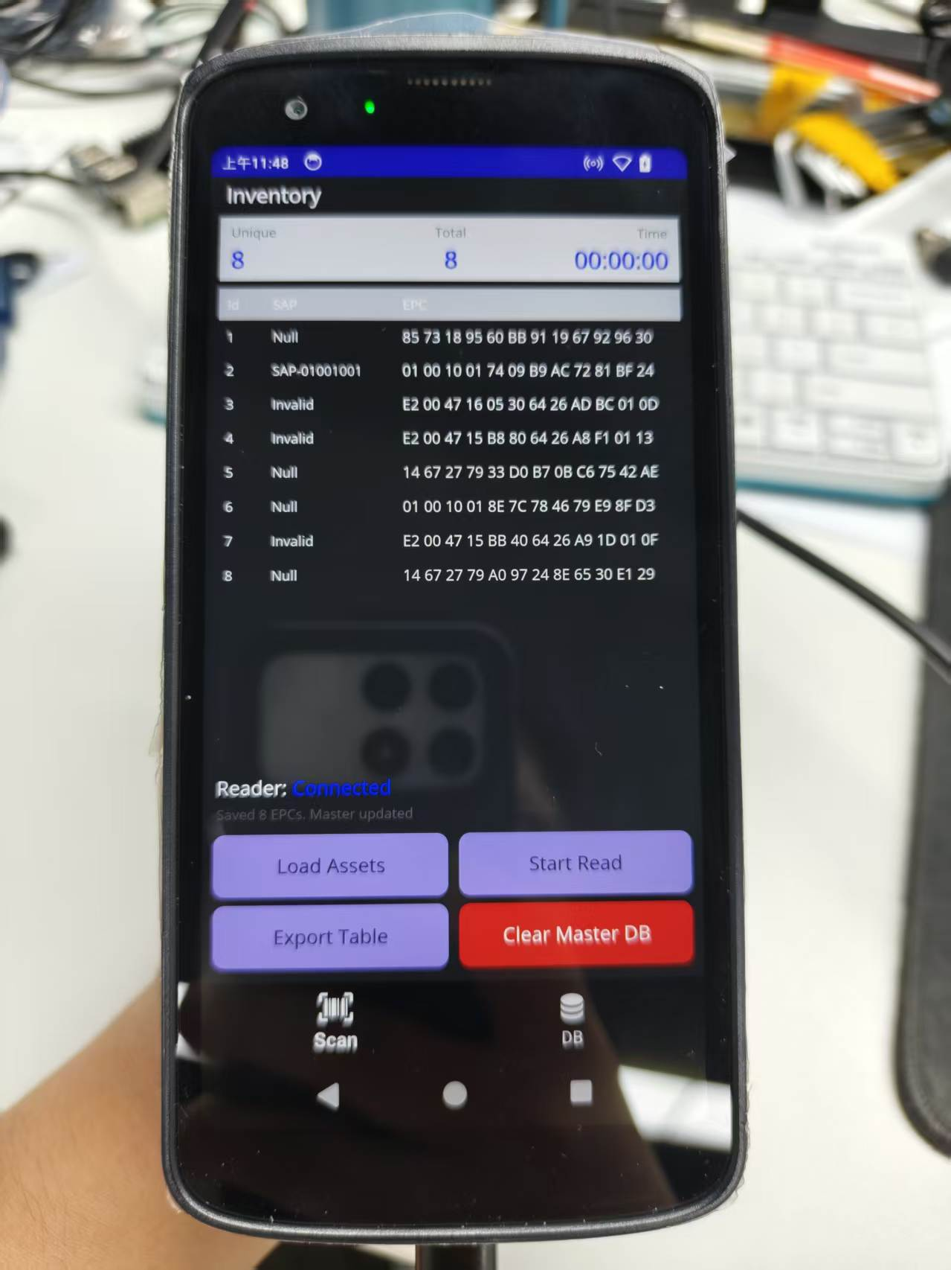

The table will automatically export to the download folder after you release the trigger.
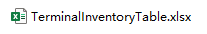

8. Get terminal files on PC
Click Terminal -> PC button
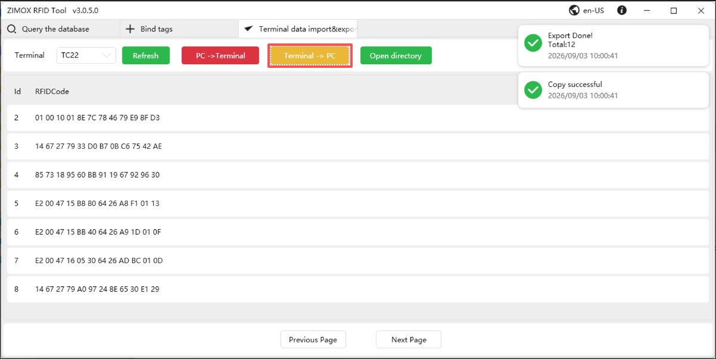
Click Open directory button , Inventory Results Table is targetFile.xlsx
