<http://localhost:8080/SpringBootRestApiExample2/api/jobs/>

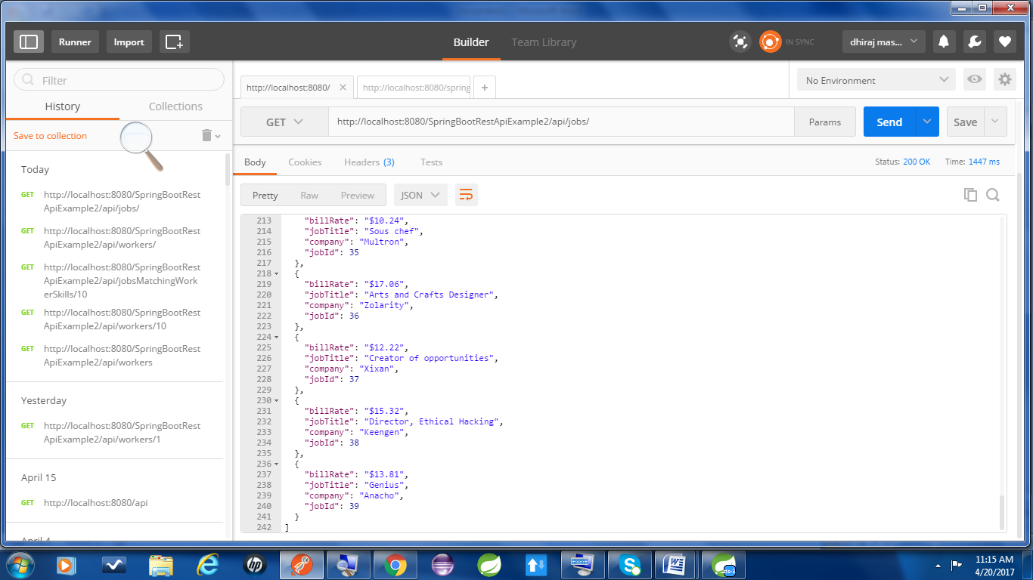

<http://localhost:8080/SpringBootRestApiExample2/api/workers/>

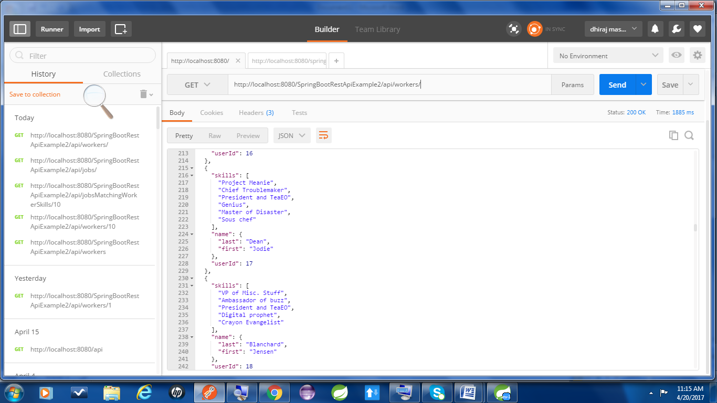

<http://localhost:8080/SpringBootRestApiExample2/api/jobsMatchingWorkerSkills/10>

This id has more than 3 matching jobs.

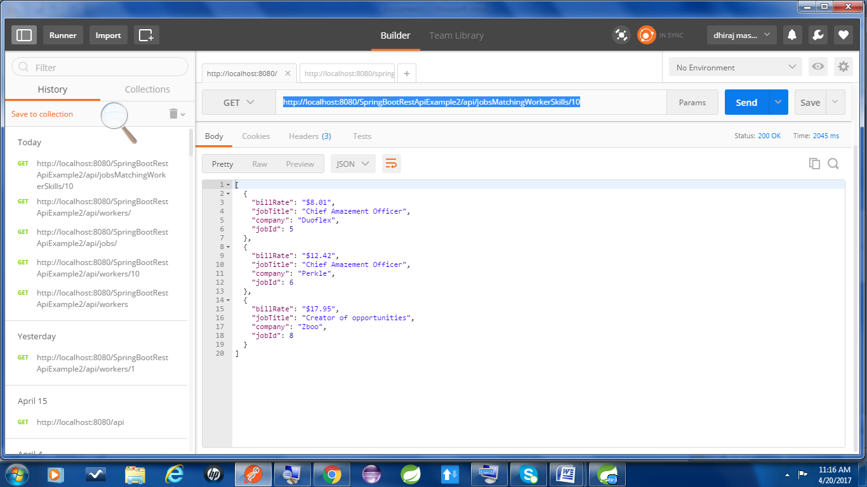

<http://localhost:8080/SpringBootRestApiExample2/api/jobsMatchingWorkerSkills/1>

This id has less than 3 jobs.

