GROUP 5
Game Design & Production COMS W4995
Prof. Bernard Yee

ZOMBIE QUEST.
Because the world depends on it.

If faced with an unquenchable thirst do bad,
could you still do good?

If the fate of the human race depended on it,
could you break the fabric of your very being?

HIGH LEVEL CONCEPT

Zombie Quest, a casual third-person action game, thrusts you into a heroic quest in the role of a dangerous zombie amidst internal conflict. Crazed by an insatiable appetite for human brains but nostalgic of human life prior to outbreak, you agree to help a scientist concoct an anecdote for Zombieism by collecting key items and ingredients strewn across the city. A friend of nobody and an enemy of virtually everybody, it won’t be easy because both Zombies Patrol and your fellow Zombies will stop at nothing to kill you.

STORY

After decades of attempting to convince the world that global warming is the biggest threat to human existence in the world today, Al Gore is pissed. It's 2010, and despite some mediocre media awareness generated from The Inconvenient Truth, still nobody gives a shit.

One night, in a fit of rage, former Vice President Al Gore decides that the human race is too stupid to protect itself and he must take matters into his own hands. If humans are incapable of making small sacrifices to lower global temperatures, then human body temperatures, and eventually that of all of the biomass on Earth, must be reduced. If humans can survive at lower body temperatures, then the global temperature will sink. Right?

With no time to lose, he enlists the help of scientist Harold Greenwater to invent a cocktail that will reduce human body temperatures. In just months, Greenwater concocts a drink that he claims will do the trick. Too impatient to do clinical trials and get FDA approval, Al Gore volunteers to be Patient 0 and ingests it.

Sure enough, Al Gore's body temperature drops. Immediately, he begins mass manufacturing the cocktail and millions of people gather at WalMart to pick up the cheapest bottle they can find.

Weeks later, global temperatures begin to decline, but those who drank the cocktail begin feel strong cravings for human brains. It is discovered that a major side effect of the cocktail is Zombieism!

You, the player, were one of the idiots to drink the proverbial Kool-Aid and now you are a Zombie. However, unlike the rest of the Zombies you decide you're going to help fight the War on Terror by working to find a cure. As if it were meant to be, you find Harold Greenwater who is hiding in a sewer in New York City. You resist your urge to eat his brains in order to obtain a list of items you need to collect for him to create the antidote to the cocktail.

You, a zombie with a ferocious appetite for human brains, must collect all the items needed for the antidote without getting shot by Zombie Patrol. The fate of the human race lies with you!

THE ZOMBIE QUESTER

The persona of a typical Zombie Quest player is an 18-35 male characterized as enthusiastic casual game player, user of various flash game portals, and procrastinating officer worker or student. This player seeks a game that offers a bit more of a narrative than your typical flash game - something that is easy to learn, has simple controls, but offers a rich narrative to make things a bit more interesting. In addition, this player can become committed to games, unlike some casual players who are looking for a completely novel experience each moment. This isn’t to say, however, that this player logs hours upon hours for a single game for months on end. Quite the opposite, a Zombie Quest enthusiast enjoys the fact that the game can be “completed” in the simplest way in less than 1 hour.

THE OBJECTIVE

The primary objective of the game is to complete the narrative by collecting all 5 items in the 5 locations on the map so that the scientist can concoct the antidote. The narrative is completed with a certain number of points. The points you earn depends on the number of kills, time to complete, number of deaths, items found and the number of brains you eat. Thus the secondary objective is to complete the narrative with the highest number of points.

DIFFICULTY PROGRESSION

The order in which you retrieve the items in the different locations is irrelevant. Put simply, the difficulty of the game does not depend on the map you are in. Difficulty is driven by progress towards completion of the narrative. As you collect more items, you are better known and perceived to be more dangerous; therefore, you will encounter more AIs, smarter enemies, and different types of combatants. The benefit of this is that you can complete the game in the way you want to, which will encourage participation in the secondary objective.

In addition to improving your score, you can scour around the maps to find hidden items which unlock funny, entertaining and dramatic parts of the core narrative. Example items could include Al Gore’s college transcripts, pictures of Al Gore in his private jet, and even memos indicating corporate conspiracy!

THE WORLD

Zombie Quest is set in a 2-D world with a top-down perspective. You can explore a map of a city, which has preset locations (i.e. places to find items) throughout it. Example locations include a hospital, supermarket, and church. You can enter these locations to explore a new map containing new combatants, obstacles and an item to collect.

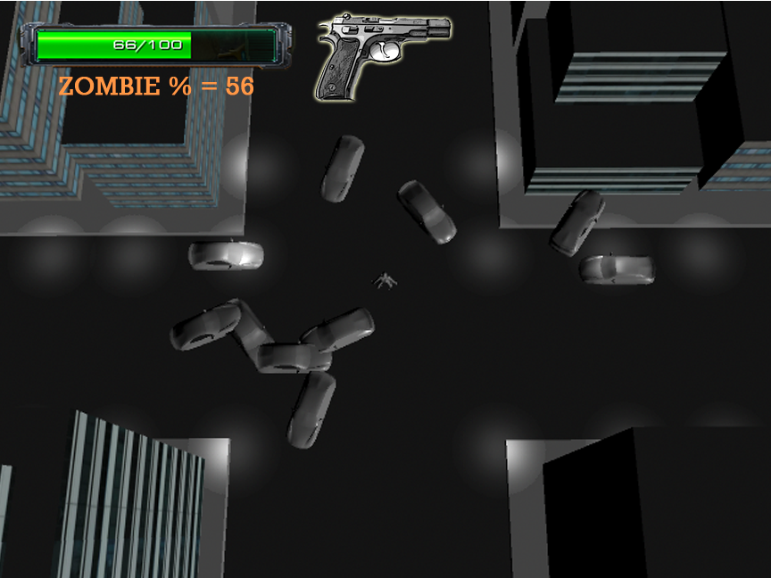
An early render of a screenshot

