

**İZMİR INSTITUTE OF TECHNOLOGY**

**ELECTRICAL AND ELECTRONICS ENGINEERING DEPARTMENT**

**SUMMER PRACTICE REPORT**

**Name - Last Name :** Muhammet NUR

**Student # :** 210206038

**Company Name :** ASELSAN

**Dates :** 17/07/2017 - 11/08/2017

**Summer Practice # :** 1st2nd

**İZMİR**

**T.C.**

**İZMİR INSTITUTE OF TECHNOLOGY**

**FACULTY OF ENGINEERING**

**ELECTRICAL & ELECTRONICS ENGINEERING DEPARTMENT**

**SUMMER PRACTICE REPORT INNER COVER PAGE**

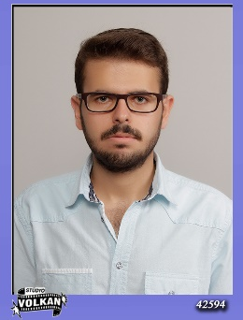

Name – Last Name : Muhammet NUR

Student # : 210206038

**COMPANY / FIRM**

Name : ASELSAN

Address : Konya Yolu 8. Km, Oğulbey Mah. 3051. Sok. No:3, 06830 Gölbaşı/ANKARA

Phone : +90 (312) 592 60 00

Fax : +90 (312) 592 60 06

E-mail : aselsan@hs02.kep.tr​

Starting Date : 17/07/2017

Ending Date : 11/08/2017

**SUPERVISOR AT COMPANY**

Name – Last Name : Ahmet AKTUĞ

Title : Lider Mühendis

Contact Info : aaktug@aselsan.com.tr

Signature and Stamp :

1. We encourage our students to start writing internship reports during their internships. In this way, they will have the chance to do an internship in awareness of what is required of them.
2. Internship reports must be prepared in accordance with the regulations defined in this document. **Reports that do not comply with these conditions are not assessed and the internship of the student is considered to be unsuccessful.**
3. The reports must be in English and written with computer with your own words. Drawing should conform to acceptable engineering standards). There is no page limit for Appendix, however the other sections must not exceed 30 pages in total.
4. When sources or documents are used in the report from other resources such as internet, company sources, books, data sheets etc., they should be specified both in the text where they are used and in the **References** section. The reports must not consist of cut and paste parts from other sources. The whole report must written in student’s own words. In mandatory cases, the tables and figures can be copied, but still must be cited in the text and referenced in the **References** section of the report. The students are responsible for knowing the contents of their reports. When necessary, the students may be invited to the oral exam and respond to the questions about the content of their reports.
5. Internship reports should provide information indicating that engineering activities complementary to the education received at the department have been performed at the company.
6. In the internship reports, the name and contact info of the supervisor must be clearly indicated and the signature and the firm stamp must exist.
7. The reports should be prepared and printed on **A4** size white papers in **1,5 line** spacings in **justified** paragraphs using **12 pt Times New Roman** fonts, with the **top, bottom, and right on 2.2 cm**, and **left on 3 cm**. Main headings are centered and written in capital boldface. Subtitles should be written in small letters and boldface. Drawings should conform to acceptable engineering standards.
8. Appendices may be added at the end of the internship reports if needed in a section named **Appendix**. The appendices are separated in the form of Appendix 1, Appendix 2, and these appendices, if any, are numbered in section number A.1, A.2. No unnecessary information and documents are put into the report and its annexes. There is no page limit for Appendix.
9. **Internship reports should be submitted in spiral bound or in filed form, and internship evaluation forms should be presented in closed envelops and approved form. Otherwise the reports will not be evaluated and the internship of the student will be considered as unsuccessful.**

EEE Department Internship Commission

I declare that I have prepared my internship report according to the regulations and notes above.

**Student’s Name and Last Name:** Muhammet NUR

**Student’s Signature:**

**TABLE OF CONTENTS**

1. Description of the Company ………………………………………………….. 5-7
2. Introduction …………………………………………………………………........8
3. Working Schedule …….………………………………………………………… 9
4. Body of The Report ………………………………………………………..10 - 40
5. Conclusion ……………………………………………………………………... 41
6. References ……………………………………………………………………....42
7. Appendix …………………………………………………………………...43 - 46

**1.** **DESCRIPTION OF THE COMPANY**

* The name of the company is ASELSAN[1].
* The name of the department is Microwave Components Design Management (REHİS)
* ASELSAN is located in Golbası Facility and the address is;

Konya Yolu 8. Km, Oğulbey Mah. 3051. Sok. No:3, 06830

Golbası/ANKARA

* Organizational Structure of ASELSAN[2]:

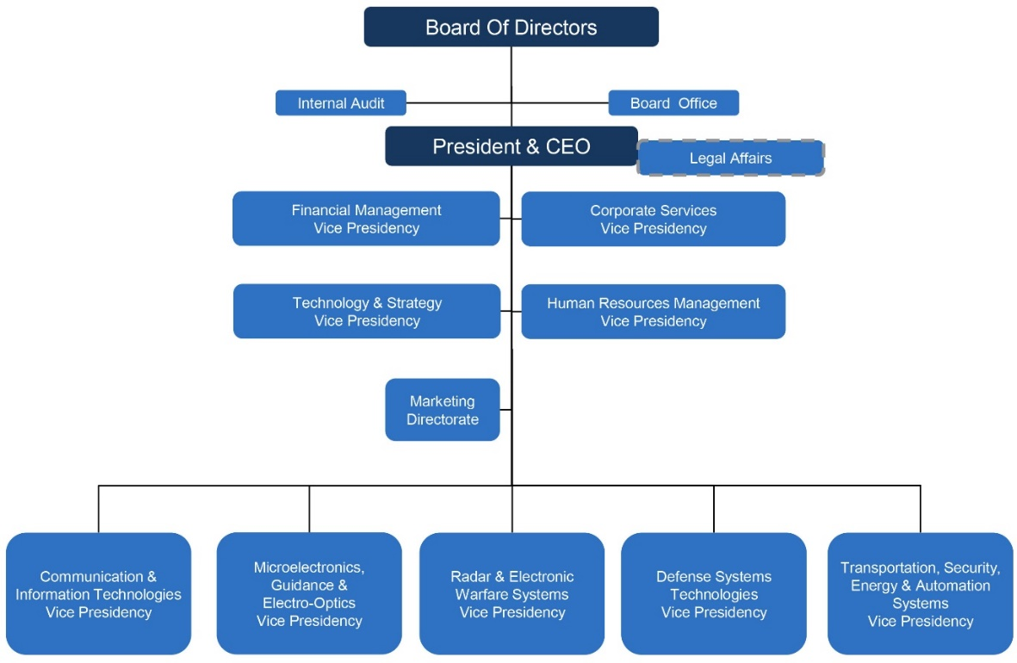

* There are more than 5000 employees.
* ASELSAN is the largest defence company in Turkey. ASELSAN’s main aim is to be a company that protects sustainable growth with values created in global markets; preferred because of its compatitiveness, trusted as a strategic partner and is sensitive to the environment and people. ASELSAN produces products that meet the needs of domestic and abroad need authorities, especially Turkish Armed Forces. The technology of these products: communication and information technologies, radar and electronic warfare, electro-optical, avionics, unmanned systems, land,naval and weapons systems, air defence and missile systems, command and control systems, transportation, security, traffic, automation and medical systems. [3]

ASELSAN operates under five business sectors;[4]

* Communication & Information Technologies Business Sector
* Microelectronics, Guidance & Electro-Optics Business Sector
* Radar & Electronic Warfare Systems Business Sector
* Defense Systems Technologies Business Sector
* Transportation, Security, Energy & Automation Systems Business Sector
* ASELSAN was founded in 1975 to meet the communication needs of the Turkish Armed Forces. It has developed itself has become an international company. It produce new products using developed new technology to provide security and peace. In 1978, the first buildings were completed at Macunkoy Facility and has begun production activities. In 1980, the first manpack and tank wireless radios were produced for Turkish Armed Forces. In 1981, designing of the first handheld radio and bank alarm systems was made. In 1983, the first export was occurred. Between the years 1982-1985, new products such as Field Telephones, Computer Controlled Central Systems and Laser Distance Measurement Appliances were produced. In 1986, ASELSAN improved the power of the Turkish Armed Forces with the developed Electronic Warfare and Data Terminal appliances. In 1987, ASELSAN was included in a common project participated by 4 NATO countries for the producing of Stringer Missile. In 1988, ASELSAN produced the first avionic device for F-16 program. In 1989, wireless radio production was begun with ASELSAN licence in Pakistan’s NRTC facilities. In 1991, ASELSAN founded Radar Technology Center with the SSIK 91-3 decision. In 1992, ASELSAN founded Electro-Optical Technology Center with the SSIK 92-4 decision. In 1995, ASELSAN realized the project activities in the main topics such as Microelectronic, Inertial Navigational System, Infrared Guiding, Laser Guiding, Thermal Imaging Sensors, Passive Imaging Concentrators, Laser generators and Sensors. In 1996, the TASMUS contract was signed. In 1997, ASELSAN 1919 Mobile Phone was released to the market. In 1998, thermal cameras, thermal weapon sight and thermal vision devices with target coordination addressing devices were presented to the Turkish Armed Forces. In 1999, Air Defence Early Warning and Command Control System, MILSIS Electronic Warfare and X-Band Satellite Communication System contracts were signed. In 2001, the project of serial production of KMS systems were signed. In 2002, project of MWS-TU Missile Warning System and Leopard Volkan Fire Control System was signed in order to be used Turkish Armed Forces Air Platforms. In 2003, projects of SPEWS-II F-16 Electronic Warfare Auto Defense System, Military Police Integrated Communication and Information System were signed. In 2004, project of HEWS-CMDS CHAFF/FLARE shooter system was signed. In 2005, HEWS, Helicopter Laser Warning Receiver System (LIAS) Project and Turkish Land Forces Avionic System Modernization Project was signed. In 2006, project of ASELPOD was signed.In 2007, MILGEM war system supply project was signed.In 2008, ATAK contract, project of Multi Band Digital Commmon Wireless Radio were signed and the first originally developed Air Defense Radar was delivered by ASELSAN. In 2008, the project of Coast Guard Command search and rescue, the project of AKSAZ and FOCA Naval base under and surface surveillance and acquisition system, the project of New Type Police Station Boat and JEMUS Kastamonu, the projects of Konya Wireless Radio system were signed. In 2009, four AR-GE Center was founded, Leopard-1 Tank modernization was completed, project of MILGEM Warfare System 2nd Vessel, project of Ammunition Transfer system for Self-Propelled Howitzer Ammunition vehicle, project of SAR/Reconnaissance System Supply Integration, STAMP and SOP system project for UAE, the project for Land Located, remote ED/ET capability gaining project were signed.In 2010, Tasmus-G 2nd Army Project deliveries were occurred. ATMACA Electronic Systems development project, Pakistan Ministry of Defense Software Based Wireless Radio project, project of Naval Platform 3B Research Radar were signed.In 2011, the first originally developed Shipborne LPI Radar system ALPER was completed by ASELSAN.In 2012, Pedestal Mounted Stinger System that is Turkey’s fist national Air Defense System has been produced by ASELSAN.In 2013, 4G Communication Technology Development Project (ULAK) contract was signed wit Ministry of Transport,Maritime Affairs and Communications by ASELSAN. In 2014, Transportation,Security,Energy and Automation Systems(UGES) Sector Presidency was founded.In 2015, ASELSAN Golbası Campus is opened where the radar and electronic warfare development production, test and engineering units of ASELSAN are located.[5]
* The total number of working days of internship is 20 days.

**2. INTRODUCTION**

The main aim of the my summer internship is searching an answer to two questions that was what encountering to me at the business life and how will proceed a path to become an engineer. The other purpose is to learn how the lessons I learned in school are used in business life.

I have taken compulsory courses in the school and I will take optional courses that depend on my department. There are many engineers working in different departments in ASELSAN. During my summer internship, I will plan what courses to take for the next semester by observing the engineers. My future, depends on that choosing courses in school.

My department is Microwave Components Design Management in ASELSAN. I did not take any lessons related to microwave. Thanks to my summer internship, I will learn about basics of microwave. I will learn about the microwave for my own development from engineers working in the department. Learning about new topics makes us well equipped.

The scope of my summer internship is to learn basic of microwave engineering, and Advanced Design System(ADS) that used in microwave frequencies. I learned to design circuit in Electronics course using PSPICE that is circuit design and simulation. Designing a circuit is one of the most necessary information for engineers. Thanks to my summer internship, I will improve this ability through my summer internship.

ASELSAN is the most important company that uses advanced technology in Turkey. Doing internship here is a great opportunity for engineers. I need to evaluate this opportunity.

**3.** **WORKING SCHEDULE**

|  |  |
| --- | --- |
| **From 17/07/2017 to 11/08/2017** | |
| **Day** | **Task Description** |
| **Monday** | Orientation |
| **Tuesday** | Occupational Health Safety Training |
| **Wednesday** | Occupational Health Safety Training , Meeting Engineer |
| **Thursday** | Learning Basics of Microvawe(S Parameters) |
| **Friday** | Learning Basics of Microvawe(Smith Chart) |
| **Monday** | Learning of Applications of Smith Chart |
| **Tuesday** | Set up ADS Program and Drawing Smith Chart on ADS |
| **Wednesday** | Filter Design |
| **Thursday** | Filter Examples |
| **Friday** | Filter Examples |
| **Monday** | Filter Examples |
| **Tuesday** | Microstrip Filters |
| **Wednesday** | Microstrip Filters Examples |
| **Thursday** | Power Amplifiers in Microwave |
| **Friday** | Power Amplifier Design |
| **Monday** | Power Amplifier Design |
| **Tuesday** | Power Amplifier Design |
| **Wednesday** | Power Amplifier Design |
| **Thursday** | Power Amplifier Design |
| **Friday** | End of My Summer Internship |

**4. BODY OF THE REPORT**

**17/07/2017 – Orientation and Presentations**

My summer internship started on July 17th in Macunkoy Facility. At the first day, ASELSAN collected documentations such as contracts and insurance certificate from each interns. Entry cards were distributed by ASELSAN. ASELSAN has 4 facilities: Macunkoy Facilities, Akyurt Facilities, Golbası Facilities and METU Teknokent. Someone who works in Academy Operations Directorate department were given general information and rules about ASELSAN. ASELSAN working hours that are between 7.30 to 16.35 were specified. They informed about the facilities provided to interns such as lunch, service etc. Company services were determined for each interns. We signed privacy contract because ASELSAN has secret informations. Communication expert told us how we can communicate well with people. Two people working in the human resources department gave information what we need to do in order to work in ASELSAN. They informed about Co-Op Applications. Co-Op students work part-time to be 1,5 days in week in ASELSAN. Co-Op students’ cumulative GPA must be at least 3 out of 4.

**18/07/2017 - Occupational Health Safety Training**

Occupational health safety training experts gave information about basics of occupatinal health safety training. In the morning, they presented about informations on working legislation, legal rights and responsibilities of employees, workplace cleaning and tidying and legal consequences of work accidents and occupational disases. Sides of occupational health safety training are state, employer and employee. They gave information obout the labor law numbered 4857 and 6331. Arrangement(classification), layout(systematization), cleanliness(sweep), perseverance(standardize) and discipline support each other. In the afternoon, doctor who works in ASELSAN presented about the reasons of occupational diseases, prevention of diseases and application of protection techniques, biological and psychosocial risk factors and first aid. Group A diseases are diseases with chemical substances. Group B diseases are diseases with skin. Group C diseases are diseases with respiratory. Group D diseases are infectious disease. Group E diseases are diseases with physical factors. Our ears are damaged after 85 dB so we need to have a headphone after 85 dB. Technical planning is done to prevent risk factors. The solution is produced respectively 1)on the source, 2)in the environment, 3)in person. Thermal comfort terms are known as air temperature, air humidity, air flow rate, and air radiant heat. It was said that the technical issues will be presented tomorrow.

**19/07/2017 - Occupational Health Safety Training, Meeting Engineering**

 Presentation of occupational health safety training continued. In the morning, they presented about information of technical topics such as chemical, physical and ergonomic risk factors, glare, explosion, fire and fire protection, working with screened tools, safety and health signs, use of personal protective equipment, evacuation and rescue. Fires can be various types such as fires of solid, liquid, gas, metal and electric. Fire signs progress in the order of smell, smoke and flame respectively. Safety and healh signs can be various colours and specific meaning. Red signs are forbidden, yellow signs are warning, blue signs are obligatory, green signs are safe situation.

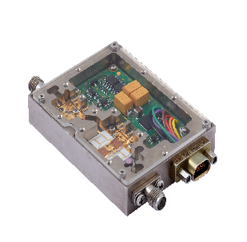 In the afternoon, interns were distributed to facilities by ASELSAN. My facilitity was Golbası Facilities. Me and 64 interns came to ASELSAN Golbası Facility by services. Someone who works in security department presented about safety principles. Interns were distributed to deparments by ASELSAN. My department was Microwave. I met Ahmet AKTUG who was responsible me. I met other engineers who works with Ahmet AKTUG. I and Ahmet AKTUG had an introductory meeting. He gave information about their works. He showed a work they did. We observed product by using microscope because products are in micron dimensions. He gave two books about microwave. These are Fundamentals of RF and Microwave Transistor Amplifiers written by Inder J. Bahl and Radio Frequency an Microwave Electronics Illustrated written by Matthew M. Radmanesh. I examined topics of scattering(S) parameters from books.

**20/07/2017 - Learning Basics of Microvawe (S Parameters)**

I continued studying topic of scattering(S) parameters from the books. To put it briefly S parameters use the appropriate load case to characterize behaviour of linear circuit. There are the Y parameters, the Z parameters, the H parameters, the T parameters and the ABCD parameters other than the S parameters. They use open and short circuit conditions to characterize behaviour of linear circuit. S parameters use in RF and microwave frequencies(at GHz), others use in low frequencies. S parameters depend on frequency. Circuit components (capacitance, 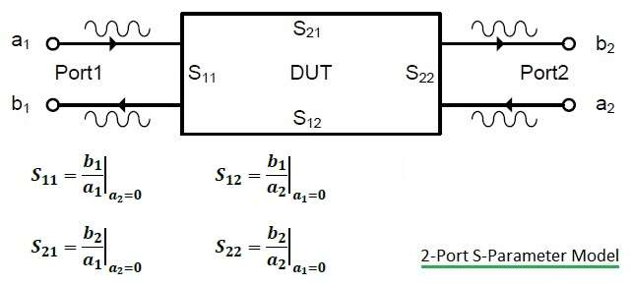inductance, resistance) expressed many electrical properties such as gain, return loss, voltage standing wave ratio, reflection coefficient and amplifier stability by using S parameters. S parameters can be determined with specific magnitudes such as frequency, characteristic impedance (generally 50 Ω), sorting of door numbers, conditions like temperature, control voltage and operating current which may affect the circuit.[6] On the Figure 1, a1 and a2 are incoming wave and b1 and b2 are outgoing wave.

Figure 1:S parameter[7]

Properties of S parameters

* In general, for an n-port network 🡺 [b]= [SOUTPUT,INPUT][a]
* For reciprocal network, the S matrix is symmetrical. So Sij=Sji i, j = 1,2…..
* To be matched line 🡺 Sii=0 i=0,1,2…. (there is no reflection)
* To be lossless network 🡺 (Sni)(Sni)*=1
* (Sns)(Snr)* = 0 (orthogonality) s, r = 1,2…
* For perfect transmission 🡺 reflected wave = 0.
* Reflection coefficient(S11) = (ZL-Z0) / (ZL+Z0) where ZL:load impedance and Z0:characteristic impedance

I learned this information about the S parameters.

**21/07/2017 - Learning Basics of Microvawe (Smith Chart)**

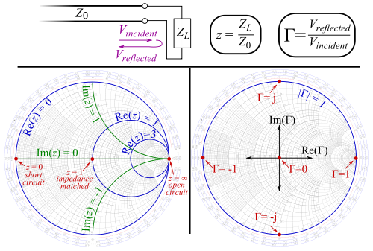I studied topic of Smith Chart from the books. To put it briefly the Smith Chart is a good method in order to visualize the impedance of a transmission line and antenna system as a function of frequency. The Smith Chart draws the complex reflection coefficient, in polar form, for a load impedance. The reflection coefficient(г) is defined by the impedance ZL and the “reference” impedance Z0. Z0 is generally assumed to 50 Ω in the Smith Chart. [9]

Figure 2:Smith Chart[8]

* Г = (ZL-Z0) / (ZL+Z0)

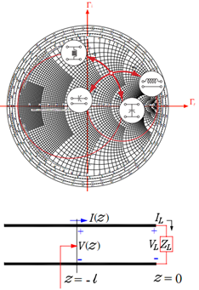We want to the load impedance to be close to the center of Smith Chart. Half-wavelength(λ/2) transmission line length rotates one full (360 ̊ ) on circle. λ/4 transmission line length rotates one half (180 ̊ ) on circle. λ/8 transmission line length rotates one quarter (90 ̊ ) on circle. The input impedance rotates clockwise around the load impedance. Load impedance should be close to the center of Smith Chart to reflection coefficient is too small. In order to get closer to the center of Smith Chart:

Figure 3: Matching with capaciors/inductors[10]

* If we add serial inductor, load impedance moves up clockwise along rr.
* If we add shunt inductor, load impedance moves up counter clockwise along ri.
* If we add serial capacitor, load impedance moves down counter clockwise along rr.
* If we add shunt capacitor, load impedance moves down clockwise along ri.[10]

I learned this information about the Smith Chart.

**24/07/2017 - Learning of Applications of Smith Chart**

Smith Chart has many applications. I will tell about some of those.

* Determine input impedance (ZIN) using a known load (ZL)

1. Plotting the normalized load impedance (ZL/Z0)
2. Drawing the constant VSWR(voltage standing wave ratio) circle,radius is length that is from center of Smith Chart to ZL.
3. Beginning from the normalized impedance, advance until “ l/λ ” in the constant VSWR circle.
4. 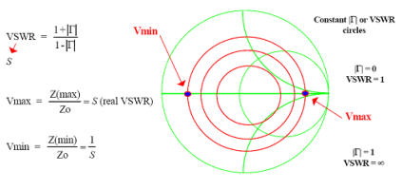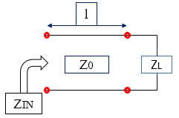Obtaining the value is input impedance. ( ZIN / Z0)

Figure 4 : VSWR circle

Figure 5 : Basic Circuit

* Determine using the input reflection coefficient ( ГIN <= 1 )

1. Input reflection coefficient is converted polar coordinates. ( ГIN = | ГIN| * ejθ )
2. Normalized value of impedance is expressed resistance and reactance (r,x). ZIN = Z0*(r+j*x)

* Determine admittance (Y) from impedance values

Beginning from the normalized impedance, advance 180 ̊ in the constant VSWR circle.

* Determine value and location of Zmax and Zmin from the ZL

If Smith Chart acts as an open circuit, Zmax obtains. If Smith Chart acts as an short circuit, Zmin obtains.

* Determine the input impedance using single stubs

Parallel (or Shunt) Stubs

1. 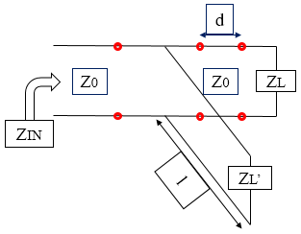Locate ZL on the Smith Chart
2. Draw a constant VSWR circle
3. Advance until “ d/λ ” in the constant VSWR circle.
4. Parallel stub was added. We switch to the Y-chart and move on a constant conductance circle.
5. 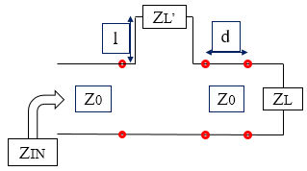In order to find the input impedance, we switch back to the Z-chart. That was input impedance.

Figure 6: Parallel Stub

Series Stubs

1. Locate ZL on the Smith Chart
2. Draw a constant VSWR circle
3. Advance until “ d/λ ” in the constant VSWR circle

Figure 7 : Series Stub

1. Series stub was added. We move on a constant resistance circle.
2. That was input impedance.

* Determine the input impedance for any combination of series and shunt reactive elements

First we find load impedance (ZL) on the Smith Chart. According to circumstances of series and parallel, load impedance(ZL) moves as in Figure 3 respectively. The final impedance is to be input impedance.[11]

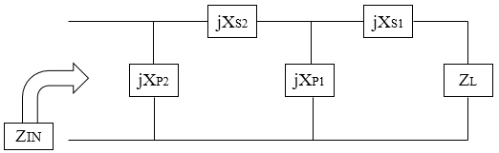

Figure 8 : Combination of series and shunt reactance

**25/07/2017 – Set up ADS Program and Drawing Smith Chart on ADS**

ADS, stands for Advanced Design System. It is an electronic design automation software for RF, microwave and high-speed digital applications. It produced by Keysight EEsof EDA. Design process apply such as schematic capture, layout, design rule checking, frequency-domain and time-domain circuit simulation, and electromagnetic field simulation.[12]

 I solved exercise of Smith Chart with ADS.

Figure 9 : Smith Chart Basic Examples



Figure 10 : Parallel Capacitor

Figure 11 : Series Capacitor

Figure 12 : Series Inductor

Figure 13 : Parallel Inductor

**26/07/2017 – Filter Design[13]**

I studied topic of filters at microwave frequency from the books. Filters are designed using the image parameter method and the insertion loss method. I designed using the insertion loss method. At microwave frequency, filters was examined using by Butterworth approximation, Chebyshev method, Bessel approximations and Elliptic approximations. Maximally flat characteristic is called Butterworth response. Equal-ripple is used in Chebyshev polynomial. PLR that means the power loss ratio.

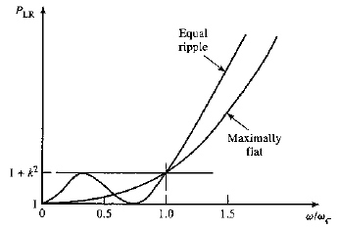Maximally flat for low pass filter 🡺 **PLR = 1+k2(w/wc)2N** where N is the order of the filter and wc is the cutoff frequency.

Equal-ripple for low pass filter 🡺 **PLR = 1+k2TN2(w/wc)** where TN is Chebyshev polynomial.

Intersection of points of attenuation and frequency are given filter orders.(See Appendix ІІ) To find the capacitor and inductor in designing filter:

* 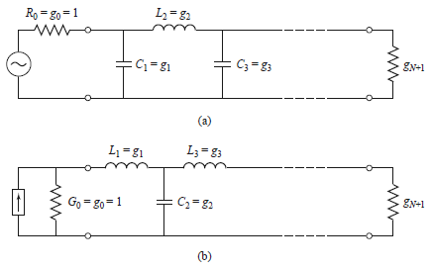Low Pass Filter

For series inductors;

* **Lk = (gk * Z0) / wc**

For parallel capacitors;

* **Ck = gk / (Z0 * wc)**

Figure 14 : (a) Prototype beginning with a shunt element

(b) Prototype beginning with a series element

* High Pass Filter

On the low pass filter, parallel capacitors are replaced by inductors, series inductors are replaced by capacitors to obtain high pass filter

For series capacitors;

* **Ck = 1 / (Z0 * wc * gk)**

For parallel inductors;

* **Lk = Z0 / (wc * gk)**
* 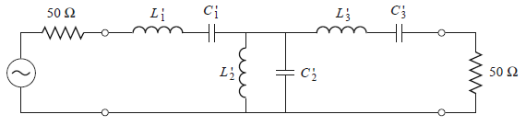Bandpass Filter

For series inductors;

* **Lk = gk / (Δ * w0)**

Figure 15: Bandpass filter design

* **Ck = Δ / (w0 * gk)**

For parallel capacitors;

* **Lk = Δ / (w0 * gk)**
* **Ck = gk / (Δ * w0)**
* 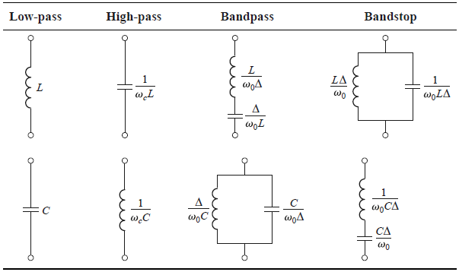Bandstop Filter

For series inductors;

* **Lk = (Δ * gk) / w0**
* **Ck = 1 / (gk *Δ * w0)**

For parallel capacitors;

* **Lk = 1 / (gk *Δ * w0)**
* **Ck = (Δ * gk) / w0**

Figure 16 : Summary of Prototype Filter Transformations (Δ = (w2 – w1) / w0 )

**27/07/2017 - Filter Examples[13]**

I calculated the values of capacitor and inductor, and designed in ADS.

1. Design a maximally flat low-pass filter, cutoff frequency(wc) is equal to 2 GHz, characteristic impedance(Z0) is 50 Ω and at least 15 dB insertion loss at 3 GHz.

First, I calculated “|w/wc|-1” and looked at the Table 4. I found the filter order that was N=5.

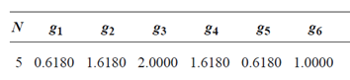

To find the capacitors and inductors, I used that formulas.

🡺 Ck = gk / (Z0 * wc)

🡺 Lk = (gk * Z0) / wc

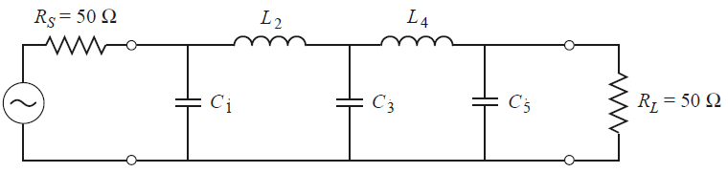

C1 = 0.984 pF C3 = 3.183 pF C5 = 0.984 pF

L2 = 6.438 nH L4 = 6.438 nH





Figure 17 : Schematic and Simulation of Example

1. Design a bandpass filter having a 0.5 dB equal ripple response, with N=3. The center frequency(w0) is 1 GHz, the bandwidth(Δ) 10 %, and the characteristic impedance(Z0) is 50 Ω.

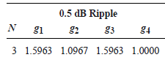

To find the capacitors and inductors, I used that formulas.

🡺 Lk = gk / (Δ * w0) 🡺 Ck = Δ / (w0 * gk) (series)

🡺 Lk = Δ / (w0 * gk) 🡺 Ck = gk / (Δ * w0) (parallel)

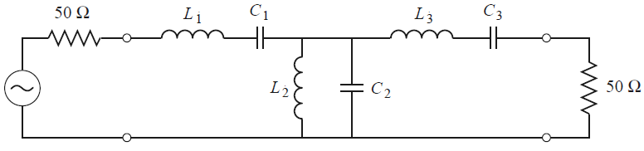

L1 = 127 nH L2 = 0.726 nH L3 = 127 nH

C1 = 0.199 pF C2 = 34.91 pF C3 = 0.199 pF





Figure 18: Schematic and Simulation of Example

**28/07/2017 - Filter Examples[13]**

I continued to design filter examples.

1. Design a low-pass, with a 3 dB equal ripple response, the cutoff frequency 3 GHz, and at least 30 dB insertion loss at 2 GHz. The characteristic impedance is 75 Ω.

First, I calculated “|w/wc|-1” and looked at the Table 5. I found the filter order that was N=5.

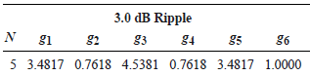

To find the capacitors and inductors, I used that formulas.

🡺 Ck = gk / (Z0 * wc)

🡺 Lk = (gk * Z0) / wc

L1 = 2.459 nH L3 = 7.958 nH L5 = 2.059 nH

C2 = 1.145 pF C4 = 1.145 pF





Figure 19: Schematic and Simulation of Example

1. Design a high-pass, with a 3 dB equal ripple response, the cutoff frequency 1 GHz, and at least 41 dB insertion loss at 0.6 GHz. The characteristic impedance is 50 Ω.

First, I calculated “|w/wc|-1” and looked at the Table 5. I found the filter order that was N=5.

**

To find the capacitors and inductors, I used that formulas.

🡺 Ck = 1 / (Z0 * wc * gk)

🡺 Lk = Z0 / (wc * gk)

C1 = 0.914 pF C3 = 0.701 pF C5 = 0.914 pF

L2 = 10.446 nH L4 = 10.446 nH





Figure 20: Schematic and Simulation of Example

**31/07/2017 - Filter Examples[13]**

I continued to design filter examples.

1. Design a four section band-pass filter having a maximally flat group delay . The bandwidth(Δ) 5% and center frequency(w0) is 2 GHz. The characteristic impedance is 50 Ω.

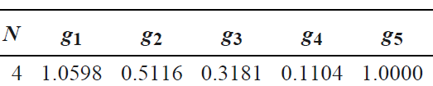

To find the capacitors and inductors, I used that formulas.

🡺 Lk = gk / (Δ * w0) 🡺 Ck = Δ / (w0 * gk) (series)

🡺 Lk = Δ / (w0 * gk) 🡺 Ck = gk / (Δ * w0) (parallel)

L1 = 84.3 nH L2 = 0.388 nH L3 = 25.3 nH L4 = 1.80 nH

C1 = 0.075 pF C2 = 16.3 pF C3 = 0.25 pF C4 = 3.51 pF





Figure 21: Schematic and Simulation of Example

1. Design a three section band-stop filter with a 0.5 dB equal-ripple response. The bandwidth(Δ) 10% and center frequency(w0) is 3 GHz. The characteristic impedance is 50 Ω.

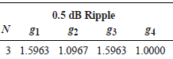

To find the capacitors and inductors, I used that formulas.

🡺 Lk = (Δ * gk) / w0 🡺 Ck = 1 / (gk *Δ * w0) (series)

🡺 Lk = 1 / (gk *Δ * w0) 🡺 Ck = (Δ * gk) / w0 (parallel)

L1 = 24.9 nH L2 = 0.436 nH L3 = 24.9 nH

C1 = 0.113 pF C2 = 6.45 pF C3 = 0.113 pF





Figure 22 : Schematic and Simulation of Example

**01/08/2017 - Microstrip Filters[13]**

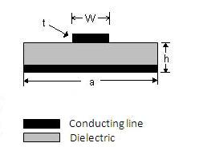Microstrip is a transmission line. Microstrip transmission lines occur conductive strip of width “W” and thickness “t” and a wider ground plane,seperated by a dielectric layer (substrate) of thickness “H”. Microstrip lines generally carry Electromagnetic Waves or microwave frequency signals.[14]

Figure 23 : Microstrip line

🡺 Effective dielectric constant

εe = (εr+1)/2 + ((εr -1)/2)*[ (1+12*(h/W))-1/2+0.04*(1-(W/h))2] when (W/h)<1

εe = (εr+1)/2 + ((εr -1)/2)*(1+12*(h/W))-1/2 when (W/h)>=1

🡺 Characteristic impedance

Z0 = (60 / (εe)1/2 )*ln(8*h/W + 0.25*W/h) (ohms) when (W/h)<1

Z0 = 120π / (εe)1/2 * [ W/h + 1.393 + 0.0667*ln(W/h + 1.444) ] (ohms) when (W/h)>=1

🡺 Maximum frequency

fT = 150 / (π * h(mm)) [2 / (εr -1)]-1/2 *tan-1(εr)

🡺 Cutoff frequency

fc = 300 / [(εr)1/2 * (2*W + 0.8*h)]

🡺 Microstrip advantages:

* Well characterized and has flexibility in design
* Low loss and high performance
* Has better harmonic tuning capability for high efficiency applications

🡺 Stepped Impedance Low Pass Filter Design

The electrical lengths of the inductor 🡺 β*l = (L*R0) / Zh

The electrical lengths of the capacitor 🡺 β*l = (C*Zl) / R0

where R0 is the filter impedance and L and C are the normalized element values (the gk) of the low-pass prototype.

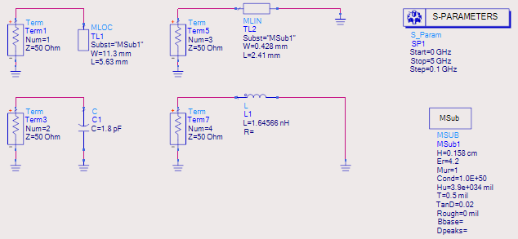



Figure 24 : Inductor and MLIN Comparison

Figure 25 : Capacitor and MLOC Comparison

If the reflection coefficient of value of capacitor or inductor and the reflection coefficient of microstripline are close, we can find width and length of microstrip line.

**02/08/2017 - Microstrip Filters Examples[13]**

I examined to design filter using microstrip lines.

1. Design a stepped impedance low pass filter having a maximally flat response and a cutoff frequency is 2.5 GHz. At least 20 dB insertion loss at 4 GHz. The filter impedance is 50 Ω, highest line impedance is 120 Ω and lowest line impedance 20 Ω. Microstrip substrate having d = 0.158 cm, εr = 4.2, tan(δ)=0.02 and copper conductors of 0.5 mil thickness.

First, I calculated “|w/wc|-1” and looked at the Table 4. I found the filter order that was N=6.



For lumped elements, I calculated values of capacitors and inductors. To find the capacitors and inductors, I used that formulas.

🡺 Ck = gk / (Z0 * wc)

🡺 Lk = (gk * Z0) / wc

C1 = 0.658 pF C3 = 2.46 pF C5 = 1.8 pF

L2 = 4.501 nH L4 = 6.15 nH L6 = 1.646 nH



For microstrip line, I calculated widths and lengths.

|  |  |  |  |  |
| --- | --- | --- | --- | --- |
| Section | Zi = Zl and Zh (Ω) | β*li (deg) | Wi (mm) | li (mm) |
| 1 | 20 | 11.8 | 11.3 | 2.05 |
| 2 | 120 | 33.8 | 0.428 | 6.63 |
| 3 | 20 | 44.3 | 11.3 | 7.69 |
| 4 | 120 | 46.1 | 0.428 | 9.04 |
| 5 | 20 | 32.4 | 11.3 | 5.63 |
| 6 | 120 | 12.3 | 0.428 | 2.41 |

Table 1: Microstrip Line Widths and Lengths





Figure 26 : Schematic and Simulation of Example

1. Design a stepped impedance low pass filter having a firth order 0.5 dB equal-ripple response. The cutoff frequency is 3 GHz. Assume R0 =50 Ω, Zl =15 Ω and Zh =120Ω. Microstrip substrate having d = 0.079 cm, εr = 4.2, tan(δ)=0.02 and copper conductors of 0.5 mil thickness.

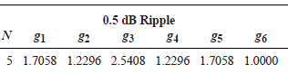

For lumped elements, I calculated values of capacitors and inductors. To find the capacitors and inductors, I used that formulas.

🡺 Ck = gk / (Z0 * wc)

🡺 Lk = (gk * Z0) / wc

C1 = 1.81 pF C3 = 2.7 pF C5 = 1.81 pF

L2 = 3.26 nH L4 = 3.26 nH



For microstrip line, I calculated widths and lengths.

|  |  |  |  |  |
| --- | --- | --- | --- | --- |
| Section | Zi = Zl and Zh (Ω) | β*li (deg) | Wi (mm) | li (mm) |
| 1 | 15 | 29.3 | 7.98 | 4.2 |
| 2 | 120 | 29.4 | 0.213 | 4.8 |
| 3 | 15 | 43.7 | 7.98 | 6.3 |
| 4 | 120 | 29.4 | 0.213 | 4.8 |
| 5 | 15 | 29.3 | 7.98 | 4.2 |

Table 2 : Microstrip Line Widths and Lengths





Figure 27 : Schematic and Simulation of Example

**🡺** Coupled Line Band Pass Filter Design

Z0J1 = [(π*Δ) / (2*g1)]

Z0Jn = (π*Δ) / [2*(gn-1*gn)1/2] n=2,3…N

Z0JN+1 = [(π*Δ) / (2*gN*gN+1)]1/2

Z0even = Z0 * [1 + JZ0 + (JZ0)2]

Z0odd = Z0 * [1 - JZ0 + (JZ0)2]

1. Design a coupled line bandpass filter with N=3 and a 0.5 dB equal-ripple response. The center frequency is 2.45 GHz the bandwidth is 10% and Z0 = 50 Ω. Microstrip substrate having d = 0.158 cm, εr = 4.2, tan(δ)=0.01 and copper conductors of 0.5 mil thickness.

**

For lumped elements, I calculated values of capacitors and inductors. To find the capacitors and inductors, I used that formulas.

🡺 Lk = gk / (Δ * w0) 🡺 Ck = Δ / (w0 * gk) (series)

🡺 Lk = Δ / (w0 * gk) 🡺 Ck = gk / (Δ * w0) (parallel)

L1 = 51.85 nH L2 = 0.3 nH L3 = 51.85 nH

C1 = 0.081 pF C2 = 14.25 pF C3 = 0.081 pF



For microstrip line, I calculated widths and lengths.

|  |  |  |  |  |
| --- | --- | --- | --- | --- |
| n | gn | Z0JN | Z0e(Ω) | Z0o(Ω) |
| 1 | 1.5963 | 0.3137 | 70.6 | 39.2 |
| 2 | 1.0967 | 0.1187 | 56.6 | 44.8 |
| 3 | 1.5963 | 0.1187 | 56.6 | 44.8 |
| 4 | 1.000 | 0.3137 | 70.6 | 39.2 |

Table 3 : Microstrip Line Widths and Lengths





Figure 28 : Schematic and Simulation of Example

**03/08/2017 – Power Amplifiers in Microwave**

I tried to learn power amplifiers in microwave frequency. A power amplifier (PA) is a circuit in order to convert dc-input power to RF/microwave output power that has specific gain. RF amplifiers have different classes such as class A, class B, class C and class E. At the same time, Class D amplifiers that operates low frequency can are used in audio equipment.[15] While designing an amplifier, there are some things that need to be understood such as stability and matching conditions. There are many equations for amplifier basic concept and design procedure. I used GaN transistor for designing power amplifier.

Stability Condition

That is the first step for amplifier design. It can be determined S-parameter, the matching networks, and terminations. For a linear 2-port device characterized by S-parameters, we need two conditions that are necessary, and sufficient to guarantee unconditional stability are a-) K > 1 and b-) | Δ | < 1 where

* Δ = S11 * S22 – S21 *S12
* K = [ 1 + | Δ |2 - |S11|2 - |S22|2 ] / [ 2 * |S21 *S12| ]

Matching Conditions

* Optimum Noise Match

ГL = [ (S22 – Гopt * Δ) / (1 - Гopt * S11) ]* (Гopt : the noise-optimizing source imp)

* Unilateral Case

ГIN = S11 + [(S12 * S21 * ГL) / (1-S22 * ГL)]

ГOUT = S22 + [(S12 * S21 * ГS) / (1-S11 * ГS)]

* Bilateral Case(when S12 is not equal to zero)

ГMS = [ B1 ±( B12 – 4|C1|2)1/2] / 2*C1

ГML = [ B2 ±( B22 – 4|C2|2)1/2] / 2*C2

B1 = 1 + |S11|2 - |S22|2 - | Δ |2

B2 = 1 + |S22|2 - |S11|2 - | Δ |2

C1 = S11 – Δ * (S22)*

C2 = S22 – Δ * (S11)*

If the stability factor K>1, the network gives MAG.

If the stability factor K<1, the network could cause oscillations, Gmax is infinite

Gmax = (S21 / S12) * [k – (k2 – 1)1/2

The ADS design procedure occurs the following steps respectively.

1. DC Analysis
2. Bias Circuit Design
3. Stability Analysis
4. Input and Output Matching Network Design
5. Overall Amplifier Performance Optimization[16]

**04/08/2017 – Power Amplifier Design**

I started to examine these design procedure step by step. The ADS contains schematics that related to these procedures. Amplifier tab that contained in Design Guide helped me for designing amplifier with ADS, however I have struggled for a long time. Today I will give information about DC analysis and bias network analysis using ADS schematics and simulation.

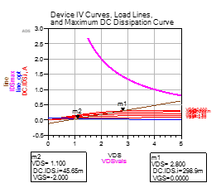DC Analysis

This is the first analysis to find out the appropriate bias points for power amplifiers.

Bias Network Analysis

The choise of bias network topology depends on the frequency of operation. For low frequencies, designers can use inductors/chokes in the bias path; for higher frequencies, designers can use high impedance quarter wavelength.



Figure 29 : Schematics of DC and Bias Network Analysis

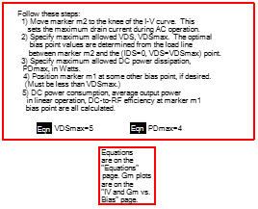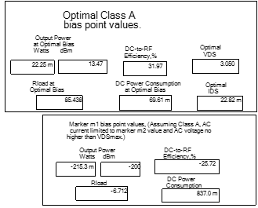

**07/08/2017 – Power Amplifier Design**

I will explain loadpull analysis. Parameters such as output power, gain, and efficiency can be measured using load pull as a function of load impedance. I didn’t solve the load pull analysis equations. I tried to find the parameters of load analysis using Design Guide in ADS. I plotted the Smith Chart on different frequencies sucas 8.5-9-9.5-10-10.5-11 GHz. I would like to have the reflection coefficient (S11) at the center of Smith Chart at given frequencies. I found the interval of the maximum power and efficiency. I marked places that have maximum power for given frequencies on the Smith Chart.



Figure 30 : At Different Frequencies, Impedance Values That Must Be Required



Figure 31 :Schematic and Simulation of Loadpull Analysis

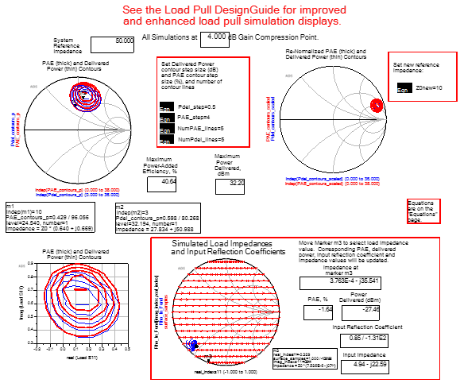

**08/08/2017 – Power Amplifier Design**

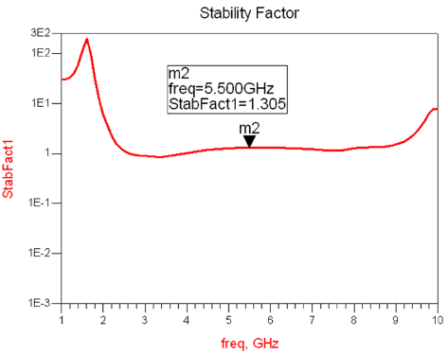 I tried to learn how power amplifiers stabilize. I stabilized my power amplifier using StabFact component that is in ADS. I want stability factor is to be greater than 1. In order to design active circuit, stability analysis is important.

The GaN transistor that I used provides 17.062 dB gain. I obtained the transistor gain using ADS Design Guide.



Figure 32 : Schematic and Simulation for Transistor Maximum Gain



**09/08/2017 – Power Amplifier Design**

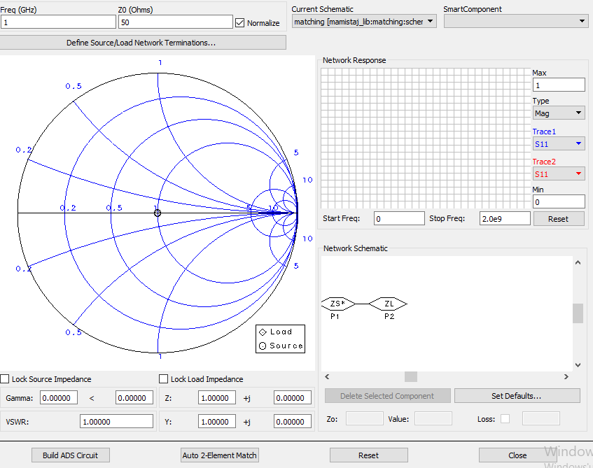 I tried to design matching circuit for output side. I used the Smith Chart Utility that is in ADS. There is two ports that are source and load. I entried 50 Ω for load impedance. I entried impedance that found in loadpull analysis for source impedance. Thanks to Smith Chart Utility, I tried to guess movement of series capacitor, shunt capacitor, series inductor, shunt inductor and ideal microstrip lines.

Figure 33 : Smith Chart Utility

When I completed the loadpull analysis, I got the points on different frequency values in Smith Chart. When performing output matching between frequency values of 8.5 GHz to 11 GHz, I tried to obtain the S11 parameters in the Smith Chart passing near these points.



Figure 34 : Schematic and Simulation for Output Matching



**10/08/2017 – Power Amplifier Design**

When I did input matching, I added the transistor, which I will use ADS schematic, to the circuit. When we look the output side from input side, as long as there is only 50 Ω, I set the points between frequencies of 8.5 GHz - 11 GHz. I tried to set these points close to Smith Chart because I would like the magnitude of the S11 to be less than -10 dB.

Input matching yaparken ADS schematicte kullanacağım transistoru koydum. Input tarafından output tarafına baktığımızda, sadece 50 Ω varken 8.5 – 11 GHz frekansları arasında noktalar belirledim. Bu noktaların smith chartın merkezine yakın ayarlamaya çalıştım. Çünkü S11 in magnitude grafiğinde -10 dB den az olmasını istiyorum.



Figure 35 : Schematic and Simulation for Input Matching

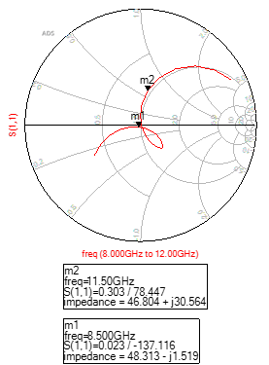

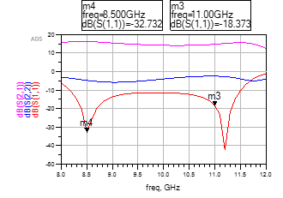

I completed the power amplifier.



Figure 36 : Schematic and Simulation for Input and Output Matching Power Amplifier

**11/08/2017 – End of My Summer Internship**

 Today was the last day of my summer internship. I tried to do everything that engineers said however there were parts I could not. Engineers always helped me. It was a great honor for me to learn something new from engineers working in a place like ASELSAN. My summer internship report was controlled and signed by Ahmet AKTUĞ. Internship terminations were performed. My entry card was taken back by ASELSAN. I will not never forget this summer internship. It was the most important experience for my life I have ever lived.

**5. CONCLUSION**

I believe that my summer internship was successful because as I talk about in introduction part, I wanted to search the answer of two questions these were what is encountering to me at the business life and how will proceed a path to become an engineer. At the end of the internship I found that answers and both of them are useful for my future.

Summer internships are quite important steps for students to develop themselves. Students have opportunity to practice their theoretical informations in business life. During my internship, I tried to gain experience as much as possible. I have always been in communication with the engineers I work with so I had the opportunity to work with experienced names in this sector. Thanks to this internship, I had the chance to be in most successful company of our country. It was an invaluable experience for me to be a part of a big company. I believe that I had a great time during my internship. I think I used this opportunity very well.

In ASELSAN, my department was “Microwave Components Design Management” under REHİS division as I said before. The working topic was about design components that is at microwave frequency. I got the general information about microwave. I learned how to use ADS simulation program. I learned to design power amplifiers and filters. It encouraged me about taking the microwave course in the next semester.

As a result, I can say clearly that it was a very useful internship experience for me. I strongly recommend ASELSAN to all engineering students. I would like to thank the company for giving me such an opportunity.

**REFERENCES**

[1] <http://www.aselsan.com.tr>

[2] <http://www.aselsan.com.tr/en-us/about-us/Pages/organizational-structure.aspx>

[3] <http://www.aselsan.com.tr/en-us/about-us/Pages/Default.aspx>

[4] <http://www.aselsan.com.tr/en-us/about-us/company-profile/Pages/default.aspx>

[5] http://www.aselsan.com.tr/en-us/about-us/Pages/milestones.aspx

[6] https://tr.wikipedia.org/wiki/Sa%C3%A7%C4%B1lma_parametreleri

[7] <http://www.rfwireless-world.com/Tutorials/Vector-Network-Analyzer-VNA-tutorial.html>

[8] <https://en.wikipedia.org/wiki/Smith_chart>

[9] http://www.antenna-theory.com/tutorial/smith/chart.php

[10] <http://allenluadvance.blogspot.com.tr/2009/01/smith-chart.html>

[11] Matthew M. Radmanesh, Radio Frequency and Microwave Electronics Illustrated

[12] https://en.wikipedia.org/wiki/Advanced_Design_System

[13] David M. Pozar, Microwave Engineering Fourth Edition. John Wiley & Sons, 2012, Chapter 8

[14] https://www.microwaves101.com/encyclopedias/microstrip

[15] https://en.wikipedia.org/wiki/RF_power_amplifier

[16] Keysight EEsof EDA, ADS Circuit Design Cookbook, Chapter 10

[17] <http://www.acs.psu.edu/drussell/Demos/SWR/SmithChart.pdf>

[18] David M. Pozar, Microwave Engineering Fourth Edition. John Wiley & Sons, 2012, Chapter 8

**APPENDIX**

**APPENDIX - І**

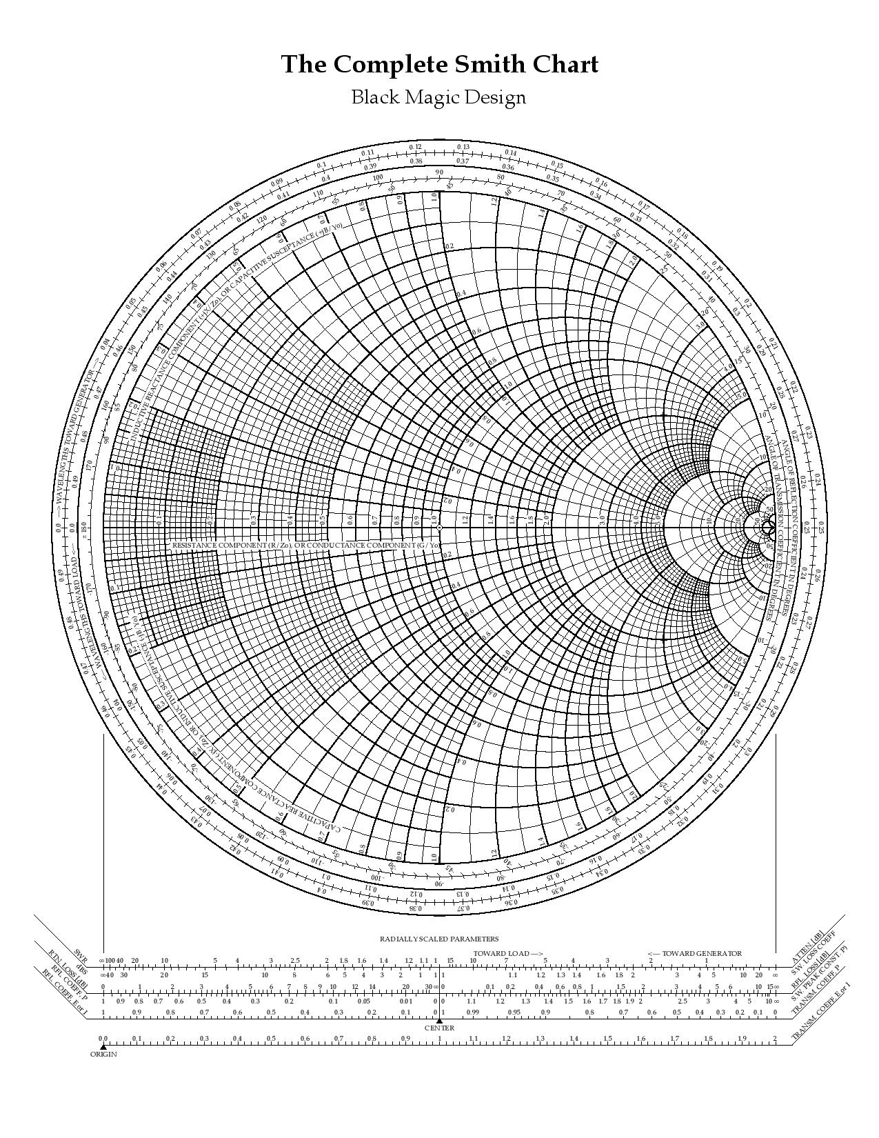

Figure 37 : The Smith Chart Graph

**APPENDIX - ІІ**

It is used to design filter.[18] First, value of “|w/wc| - 1”

**Maximally Flat**

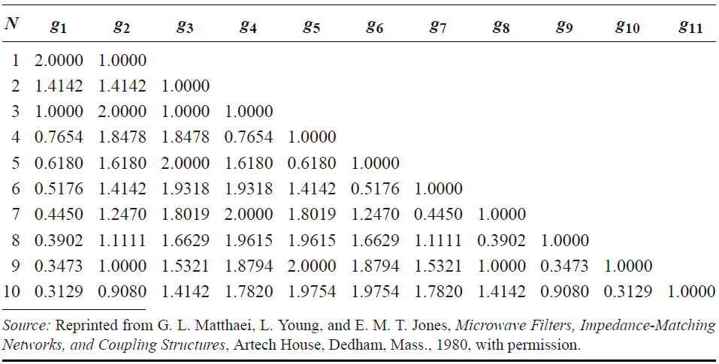

Table 4 : Element values for Maximally Flat Low-Pass Filter Prototypes (g0=1, wc=1, N=1 to 10 )

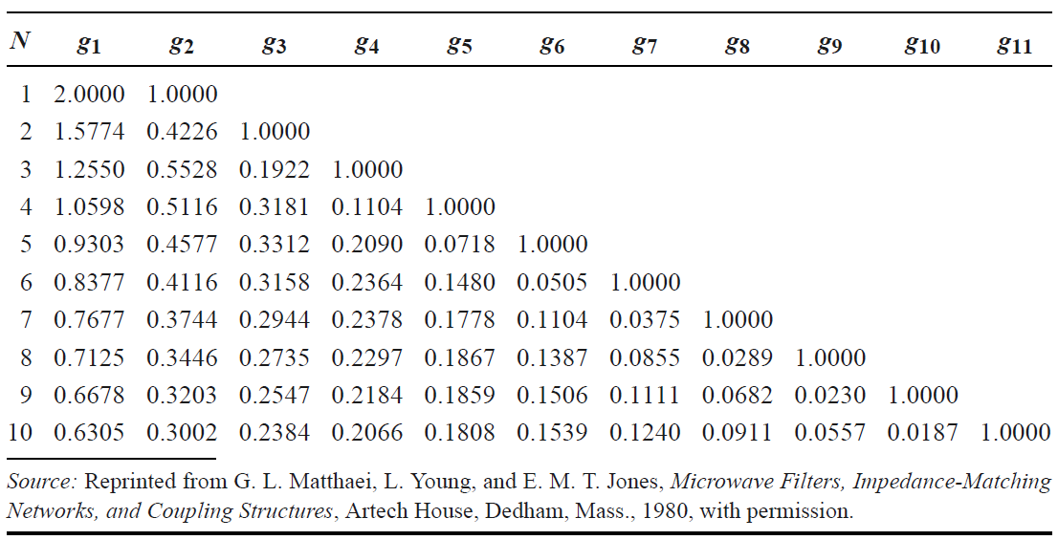

Table 5 : Element values for Maximally Flat Time Delay Low-Pass Filter Prototypes (g0=1, wc=1, N=1 to 10 )

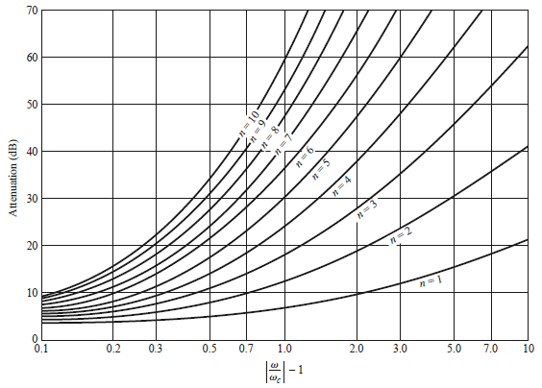

Figure 38 : Attenuation versus normalized frequency for maximally flat filter prototypes

**Equal Ripple**

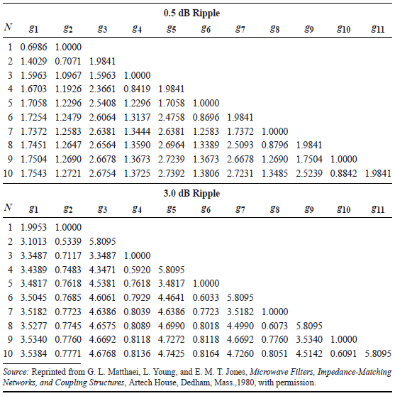

Table 5 : Element values for Equal-Ripple Low-Pass Filter Prototypes (g0=1, wc=1, N=1 to 10, 0.5 dB and 3 dB)

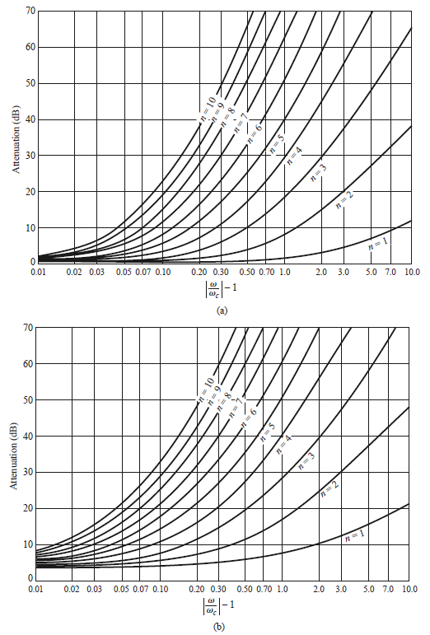

Figure 39 : (a) 0.5 dB ripple level (b) 3.0 dB ripple level