**Coding 101 Workshop**

**square_spiral.py**

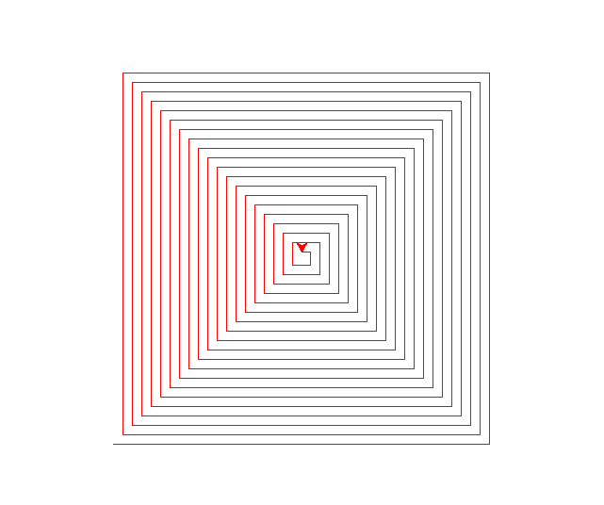

1. Change *side*: Gets bigger or smaller
2. Change *gap*: Lines get closer or further apart
3. *Additional:* Can also use negative values of side and gap to get inverted shape

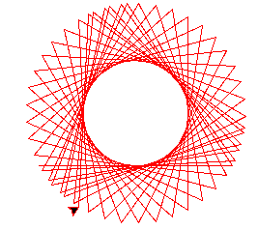

**corner_spiral.py**

1. Change *side*: Gets bigger or smaller
2. Change *angle*: Different shapes

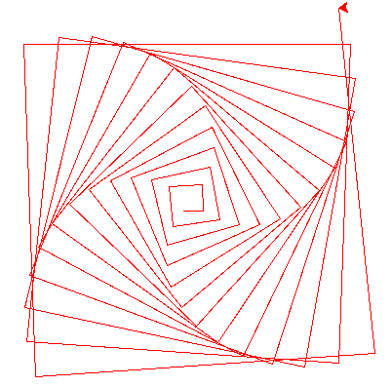**center_spiral.py**

1. Change *side*: Gets/starts bigger or smaller
2. Change *expand*: Spiral becomes wider or more compact
3. Change *angle*: Unspirals < 90 or > 270. 0-180 and 360-180 are the same
4. *Additional*: Interesting shapes after 110. Try *angle* = 120, 150, 160

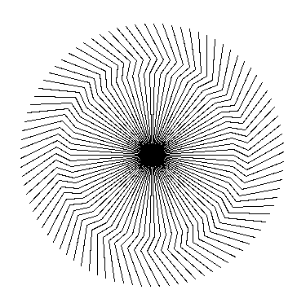**circle_illusion.py**

1. Lots of possible parameter combinations

**Fun extra ones**

**complex_spiral.py**

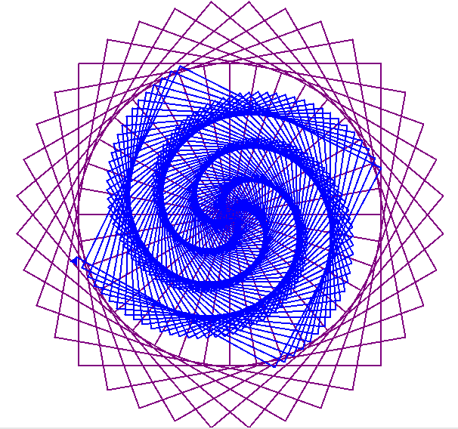

**web_spiral.py**

