Bridge Builder

# Analysis

## Overview

## I am going to build software that will allow engineers to design and test the performance of bridges. It will be able to build a digital twin of bridges. Then, using a variety of commonly used materials, the engineer can build and then simulate the bridge. By utilizing a custom physics engine, the engineer can investigate where the bridge has weaknesses, which will improve the design and quality of the bridge. All while considering the cost of the materials.

## There are two tools in the software, bridge design, and the bridge simulation tool. The bridge design tool is where the engineer can build the terrain that their bridge will stand on and construct their bridge. This will allow the engineer to place materials, connected by nodes, to easily modify and add to the design of their bridge. They can connect to the terrain at specified anchor points to traverse their chosen terrain.

## The second tool is a bridge simulation tool, this is where the bridge will be tested for integrity under load. Initially, it will be tested under its own weight. Then a traffic simulation will test the bridge with additional forces being applied to the road. This will create a heatmap of the maximum stress placed on the bridge and which components are likely to fracture under the stress. Resulting in the engineer creating informed decisions about the structure

## Background to the problem

Designing, modelling, and analysing bridges is incredibly important in modern society. Bridges are a commonplace structure which are vital to major arteries, from highways to train lines. If bridges fail, there can be disastrous consequences for a population because it can result in delays in travel or disruption to supply chains. As a result, it is important to test the load handling and durability. For these reasons, a design and simulation software – specifically designed for bridges - are vital to ensuring that resources are not wasted on faulty and often dangerous designs.

## Current applications

There are variety of solutions to the design and testing of bridges.

### CSI

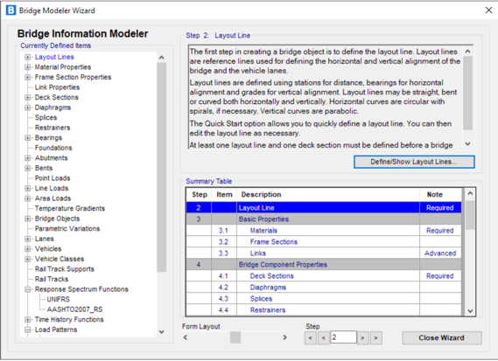CSI create a variety of software in the field of engineering. One of their products is known as CSIbridge, which is a tool for designing and testing bridges with an emphasis on earthquake simulations. Their software provide a 3D viewport which can be used to view the bridge that the client designs. It has features such as rotation which provides the user with a lot of flexibility on how they view their bridge from multiple angles. A key component of this feature is the speed at which the client can navigate through the 3D design space, which boosts productivity because the client receives instant feedback on their design. This was achieved by leveraging DirectX11 which is a graphics tool by Microsoft.

Another tool that CSIbridge contains is a bridge modelling wizard to speed up the repetitive tasks in bridge design, and provides information of the steps to creating a complete and comprehensive bridge model to ensure all the key components of the model are included. Key takeaways from this feature are the material properties section and the consideration for both car and train users of bridges.

As part of their simulation tool, there are features to move the position of key loads on the bridge and lanes where there will be dynamic loads that effect the bridge. This is key to the simulation tool because it allows the client to test the bridge more realistic condition with traffic.

Design codes …

<https://www.csiamerica.com/products/csibridge>

### Larsa4D

Larsa4D is a bridge design and analysis

https://www.larsa4d.com/

## Client interview

I have had a conversation…

## Key Objectives

1. Visualisation tool
   1. For both client and engineer
2. Bridge design and building tool
   1. Terrain design tool
      1. Functionality to add anchor points to the terrain
      2. Add or remove terrain using different size brushes
   2. Bridge building tool
      1. Material selection panel
      2. Connecting materials with nodes and changing the length of the materials
      3. Functionality to delete sections of the bridge
      4. The ability to copy and paste nodes to increase productivity for repetitive tasks
3. Bridge testing and analysis tool
   1. Build a physics engine that can model the forces applied to a bridge

## Proposed solution

# Design

# Technical Solution

# Testing

# Evaluation