Hi Farhad,

Attached are

1. the floor plan (although this part doesn't matter as much for our purposes, it can be very approximate)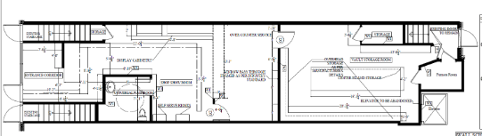

2.  Cabinetry for the point of sale (where the cash registers are, about 1/2 between the washroom and the drywall in the middle of the store

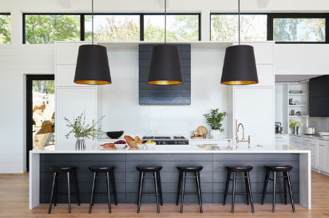

3. Exposed brick (186) - this will be on the right wall when you walk in and also the wall that extends out in front (the outer wall of the bathroom you would be looking at when you walk in)

4. Flooring

5. Shelving on the left wall after you come in: <https://www.wayfair.ca/storage-organization/pdp/foundry-select-bremer-acacia-wood-wall-shelf-c000978219.html?piid=1693598334>

6. Ceiling with pot lights

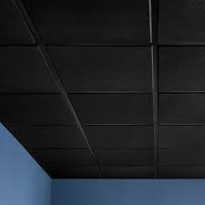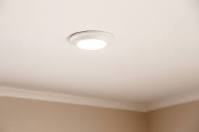

7. Colourful modern art on the walls



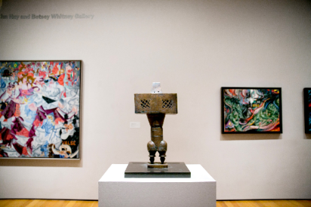

8. Wall paint colour

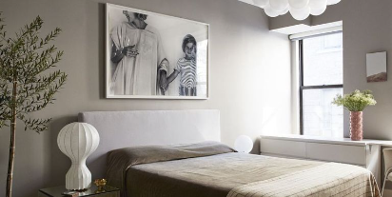

9. Interior metal logo sign like this one but with our logo

