実験協力者　Main　____________________　Partner_____________________

|  |  |
| --- | --- |
| 雰囲気 | |
| Topic |  |
| Start Time |  |
| End Time |  |

5

1

|  |  |
| --- | --- |
|  | Yes1~5No |
| Excite/热烈兴奋的 |  |
| Serious/严肃的 |  |
| Smooth/话题平滑的 |  |
| Bright/明亮 |  |
| Eminent/平静 |  |
| Close/亲密 |  |
| Equal/平等 |  |

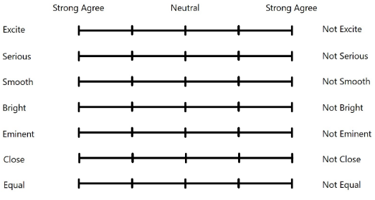

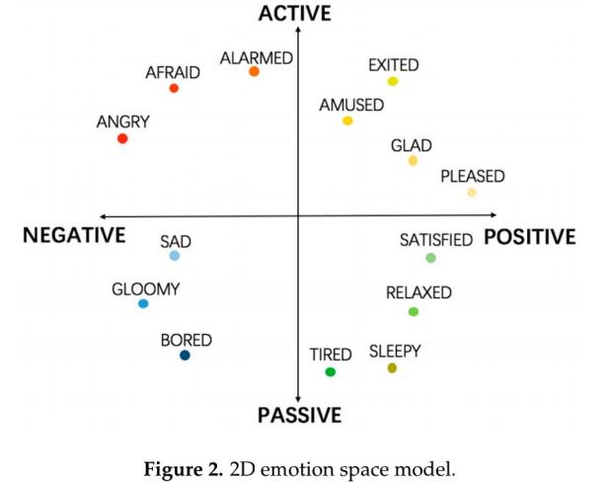

|  |  |
| --- | --- |
|  | No1~5Yes |
| Relax/放松 |  |
| Sad/悲伤 |  |
| Excited/兴奋 |  |
| Fear/害怕 |  |
| Disgust/恶心不爽 |  |
| Joy/开心 |  |

|  |  |
| --- | --- |
|  | No1~9Yes |
| Unhappy-Happy |  |
| Calm-excited |  |
| Controlled-Incontrol |  |

