実験協力者____________________　_____________________

|  |  |
| --- | --- |
| Relax | 天空の鏡 |
| Start Time |  |
| End Time |  |

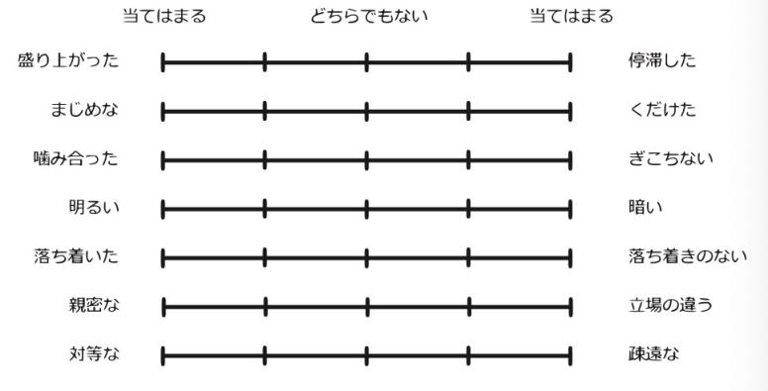

|  |  |
| --- | --- |
|  | 1~5 |
| 盛り上がる |  |
| 真面目な |  |
| 噛み合った |  |
| 明るい |  |
| 落ち着いた |  |
| 親密な |  |
| 対等な |  |

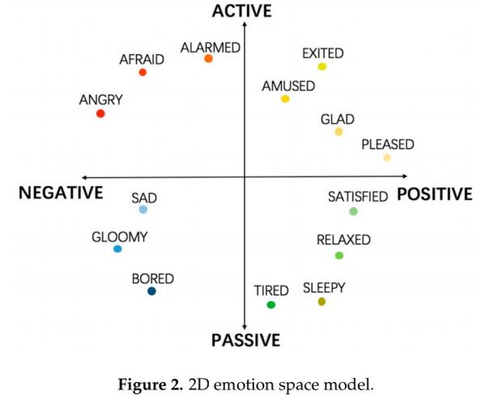

|  |  |
| --- | --- |
|  | 1~5 |
| Relax |  |
| Sad |  |
| Excited |  |
| Fear |  |
| Disgust |  |
| Joy |  |

|  |  |
| --- | --- |
|  | 1~9 |
| Unhappy-Happy |  |
| Calm-excited |  |
| Controlled-Incontrol |  |

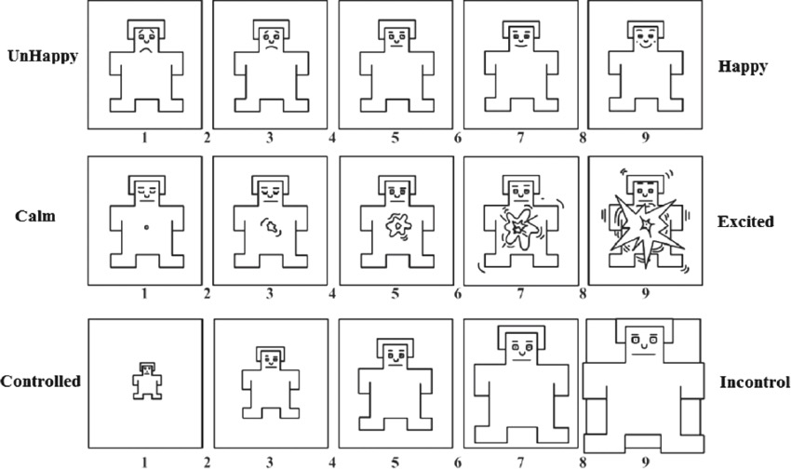

|  |  |
| --- | --- |
| Relax | 小雨の部屋 |
| Start Time |  |
| End Time |  |



|  |  |
| --- | --- |
|  | 1~5 |
| 盛り上がる |  |
| 真面目な |  |
| 噛み合った |  |
| 明るい |  |
| 落ち着いた |  |
| 親密な |  |
| 対等な |  |



|  |  |
| --- | --- |
|  | 1~5 |
| Relax |  |
| Sad |  |
| Excited |  |
| Fear |  |
| Disgust |  |
| Joy |  |

|  |  |
| --- | --- |
|  | 1~9 |
| Unhappy-Happy |  |
| Calm-excited |  |
| Controlled-Incontrol |  |



|  |  |
| --- | --- |
| Sad | 曇りと大雨の部屋 |
| Start Time |  |
| End Time |  |



|  |  |
| --- | --- |
|  | 1~5 |
| 盛り上がる |  |
| 真面目な |  |
| 噛み合った |  |
| 明るい |  |
| 落ち着いた |  |
| 親密な |  |
| 対等な |  |



|  |  |
| --- | --- |
|  | 1~5 |
| Relax |  |
| Sad |  |
| Excited |  |
| Fear |  |
| Disgust |  |
| Joy |  |

|  |  |
| --- | --- |
|  | 1~9 |
| Unhappy-Happy |  |
| Calm-excited |  |
| Controlled-Incontrol |  |



|  |  |
| --- | --- |
| Fear | 恐怖の部屋 |
| Start Time |  |
| End Time |  |



|  |  |
| --- | --- |
|  | 1~5 |
| 盛り上がる |  |
| 真面目な |  |
| 噛み合った |  |
| 明るい |  |
| 落ち着いた |  |
| 親密な |  |
| 対等な |  |



|  |  |
| --- | --- |
|  | 1~5 |
| Relax |  |
| Sad |  |
| Excited |  |
| Fear |  |
| Disgust |  |
| Joy |  |

|  |  |
| --- | --- |
|  | 1~9 |
| Unhappy-Happy |  |
| Calm-excited |  |
| Controlled-Incontrol |  |



|  |  |
| --- | --- |
| Disgust | Dead　Bodyの部屋 |
| Start Time |  |
| End Time |  |



|  |  |
| --- | --- |
|  | 1~5 |
| 盛り上がる |  |
| 真面目な |  |
| 噛み合った |  |
| 明るい |  |
| 落ち着いた |  |
| 親密な |  |
| 対等な |  |



|  |  |
| --- | --- |
|  | 1~5 |
| Relax |  |
| Sad |  |
| Excited |  |
| Fear |  |
| Disgust |  |
| Joy |  |

|  |  |
| --- | --- |
|  | 1~9 |
| Unhappy-Happy |  |
| Calm-excited |  |
| Controlled-Incontrol |  |



|  |  |
| --- | --- |
| Joy | 遊園地 |
| Start Time |  |
| End Time |  |



|  |  |
| --- | --- |
|  | 1~5 |
| 盛り上がる |  |
| 真面目な |  |
| 噛み合った |  |
| 明るい |  |
| 落ち着いた |  |
| 親密な |  |
| 対等な |  |



|  |  |
| --- | --- |
|  | 1~5 |
| Relax |  |
| Sad |  |
| Excited |  |
| Fear |  |
| Disgust |  |
| Joy |  |

|  |  |
| --- | --- |
|  | 1~9 |
| Unhappy-Happy |  |
| Calm-excited |  |
| Controlled-Incontrol |  |

