2.15.0
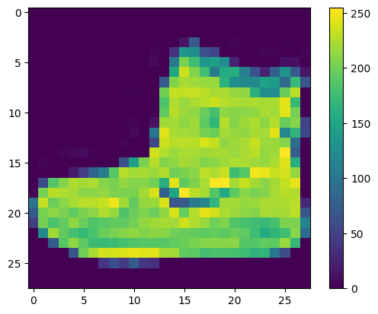
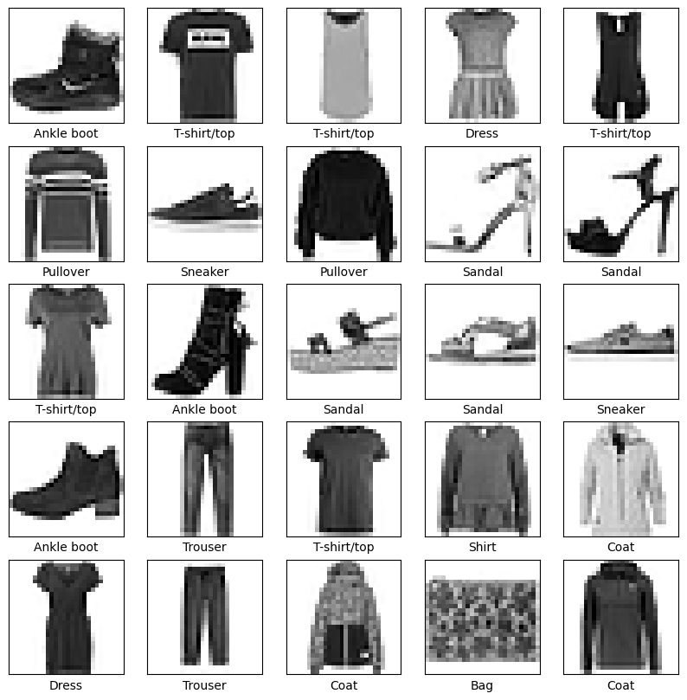
Epoch 1/10
1875/1875 [==============================] - 8s 4ms/step - loss: 0.4987 - accuracy: 0.8255
Epoch 2/10
1875/1875 [==============================] - 11s 6ms/step - loss: 0.3777 - accuracy: 0.8644
Epoch 3/10
1875/1875 [==============================] - 7s 4ms/step - loss: 0.3391 - accuracy: 0.8764
Epoch 4/10
1875/1875 [==============================] - 7s 4ms/step - loss: 0.3167 - accuracy: 0.8838
Epoch 5/10
1875/1875 [==============================] - 9s 5ms/step - loss: 0.2975 - accuracy: 0.8900
Epoch 6/10
1875/1875 [==============================] - 7s 4ms/step - loss: 0.2831 - accuracy: 0.8952
Epoch 7/10
1875/1875 [==============================] - 9s 5ms/step - loss: 0.2712 - accuracy: 0.8988
Epoch 8/10
1875/1875 [==============================] - 7s 4ms/step - loss: 0.2600 - accuracy: 0.9031
Epoch 9/10
1875/1875 [==============================] - 8s 4ms/step - loss: 0.2480 - accuracy: 0.9073
Epoch 10/10
1875/1875 [==============================] - 6s 3ms/step - loss: 0.2408 - accuracy: 0.9115
313/313 - 1s - loss: 0.3407 - accuracy: 0.8855 - 915ms/epoch - 3ms/step

Test accuracy: 0.8855000138282776
313/313 [==============================] - 1s 2ms/step
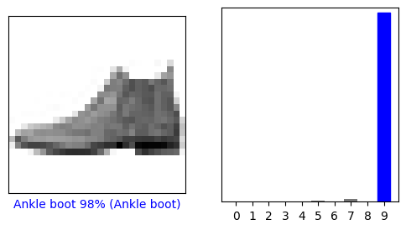
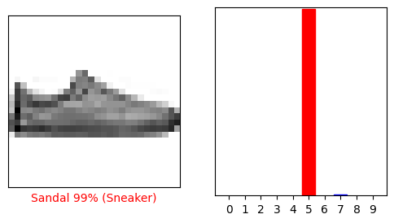
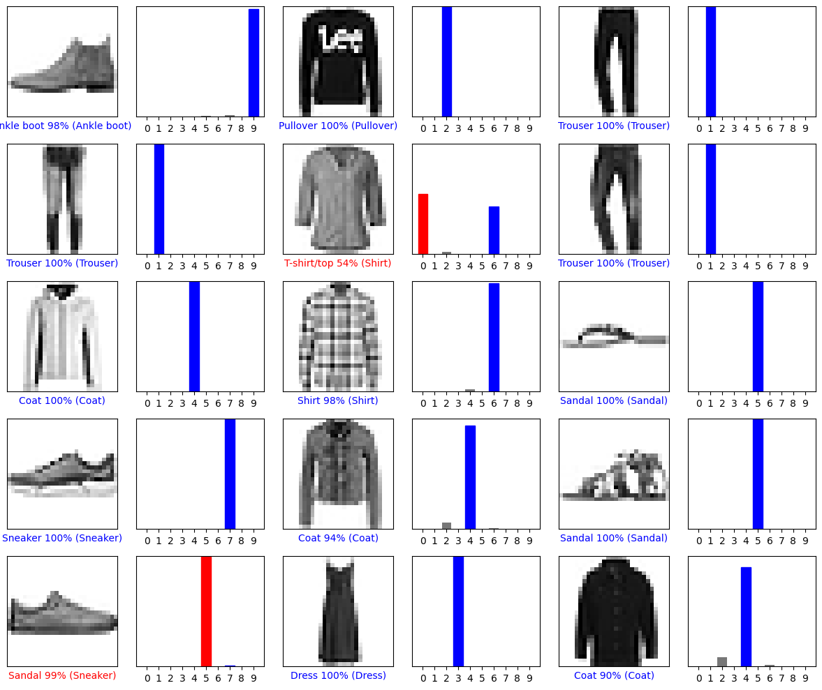
(28, 28)
(1, 28, 28)
1/1 [==============================] - 0s 21ms/step
[[6.5963595e-06 8.9769939e-16 9.9956292e-01 1.2924735e-10 1.9618066e-04
4.1161397e-13 2.3426251e-04 8.8534905e-20 6.6217331e-12 6.0688136e-15]]
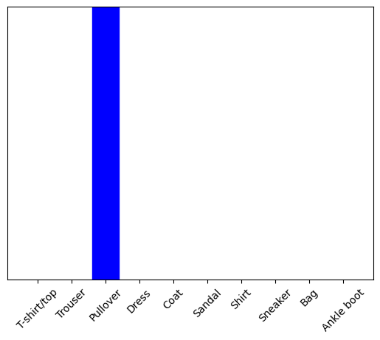
2

