2.15.0

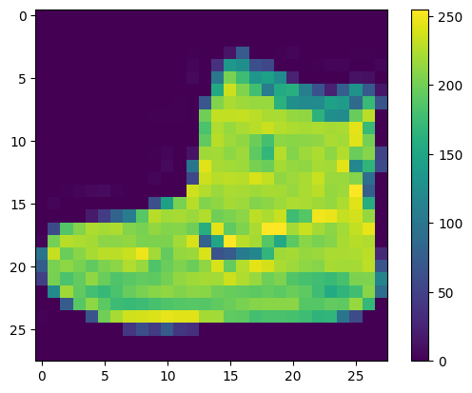

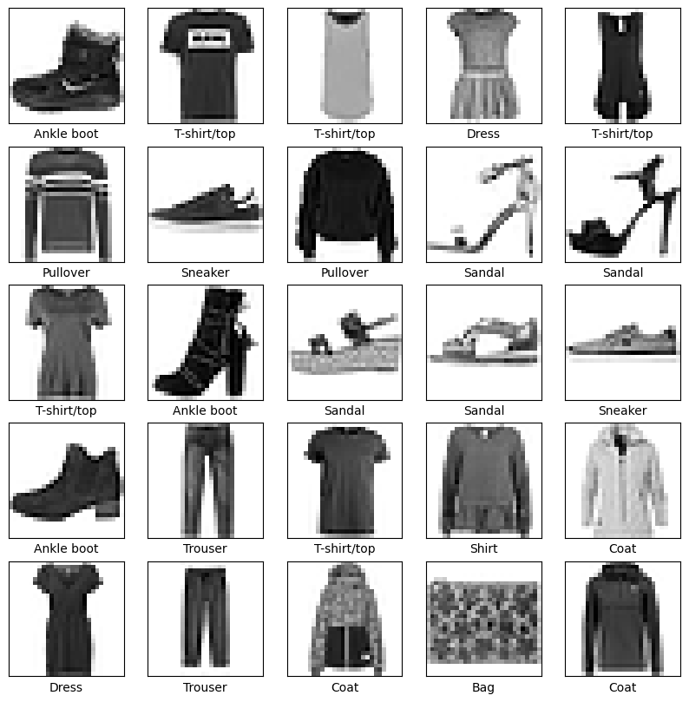

Epoch 1/10

1875/1875 [==============================] - 8s 4ms/step - loss: 0.4987 - accuracy: 0.8255

Epoch 2/10

1875/1875 [==============================] - 11s 6ms/step - loss: 0.3777 - accuracy: 0.8644

Epoch 3/10

1875/1875 [==============================] - 7s 4ms/step - loss: 0.3391 - accuracy: 0.8764

Epoch 4/10

1875/1875 [==============================] - 7s 4ms/step - loss: 0.3167 - accuracy: 0.8838

Epoch 5/10

1875/1875 [==============================] - 9s 5ms/step - loss: 0.2975 - accuracy: 0.8900

Epoch 6/10

1875/1875 [==============================] - 7s 4ms/step - loss: 0.2831 - accuracy: 0.8952

Epoch 7/10

1875/1875 [==============================] - 9s 5ms/step - loss: 0.2712 - accuracy: 0.8988

Epoch 8/10

1875/1875 [==============================] - 7s 4ms/step - loss: 0.2600 - accuracy: 0.9031

Epoch 9/10

1875/1875 [==============================] - 8s 4ms/step - loss: 0.2480 - accuracy: 0.9073

Epoch 10/10

1875/1875 [==============================] - 6s 3ms/step - loss: 0.2408 - accuracy: 0.9115

313/313 - 1s - loss: 0.3407 - accuracy: 0.8855 - 915ms/epoch - 3ms/step

Test accuracy: 0.8855000138282776

313/313 [==============================] - 1s 2ms/step

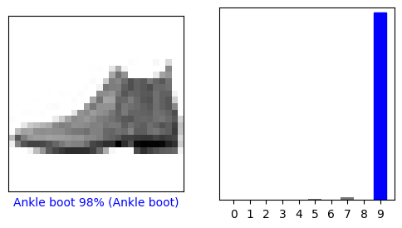

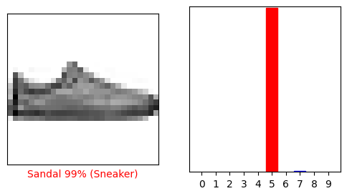

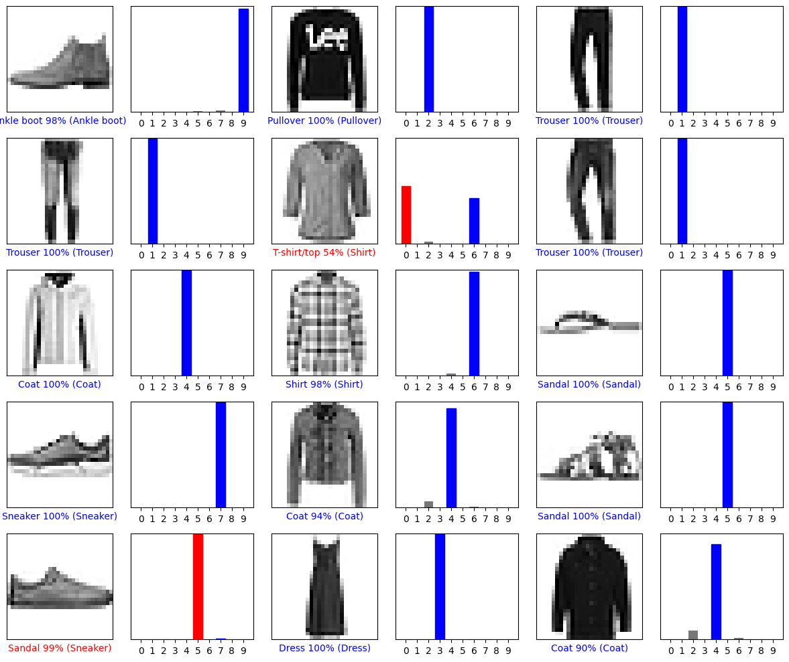

(28, 28)

(1, 28, 28)

1/1 [==============================] - 0s 21ms/step

[[6.5963595e-06 8.9769939e-16 9.9956292e-01 1.2924735e-10 1.9618066e-04

4.1161397e-13 2.3426251e-04 8.8534905e-20 6.6217331e-12 6.0688136e-15]]

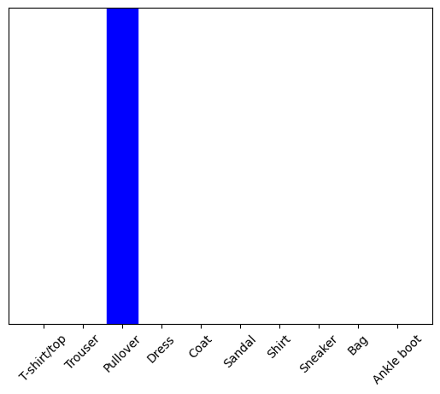

2