CIA PROJECT
Inventory Management System
Backend API + Frontend Implementation Report
Date: May 2026

1. Overview

The project required a complete inventory management system as part of the web application. The existing codebase only contained user authentication and management. This report documents the design, implementation and deployment of the full inventory system including Products and Orders management with complete CRUD operations.

Component | Technology | Location
Backend API | Node.js + TypeScript + TypeORM + Express | VM3 — 192.168.56.103:3000
Database | MySQL 5.7 | VM3 — 127.0.0.1:3306 (internal only)
Frontend | React + TypeScript + Redux | VM1 — 192.168.56.101:8080

2. Backend Implementation

2.1 New Database Entities
Two new TypeORM entities were created to support the inventory system:

2.1.1 Product Entity
The Product entity stores all product information matching the frontend interface:
// src/entity/Product.ts
@Entity()
export class Product {
@PrimaryGeneratedColumn() id: number;
@Column() name: string;
@Column() description: string;
@Column() category: string;
@Column() amount: number;
@Column() price: decimal;
@Column() hasExpiryDate: boolean;
}

Field | Type | Description
id | INT AUTO_INCREMENT | Primary key
name | VARCHAR(100) | Product name
description | VARCHAR(255) | Product description
category | VARCHAR(100) | Product category (Sweet, Fruit, Kitchen...)
amount | INT | Stock quantity
price | DECIMAL(10,2) | Unit price
hasExpiryDate | BOOLEAN | Whether product expires
createdAt | DATETIME | Creation timestamp
updatedAt | DATETIME | Last update timestamp

2.1.2 Order Entity
The Order entity stores order information with a ManyToOne relationship to Product:
// src/entity/Order.ts
@Entity()
export class Order {
@PrimaryGeneratedColumn() id: number;
@Column() name: string;
@ManyToOne(() => Product, {eager: true}) product: Product;
@Column() amount: number;
@Column() totalPrice: decimal;
}

2.2 API Routes
New RESTful API routes were added for Products and Orders:

Method | Endpoint | Auth Required | Description
GET | /product | No | List all products
GET | /product/stats | No | Get product statistics
GET | /product/:id | No | Get single product
POST | /product | ADMIN | Create new product
PATCH | /product/:id | ADMIN | Update product
DELETE | /product/:id | ADMIN | Delete product
GET | /order | ADMIN | List all orders
GET | /order/stats | ADMIN | Get order statistics
GET | /order/:id | ADMIN | Get single order
POST | /order | ADMIN | Create new order
PATCH | /order/:id | ADMIN | Update order
DELETE | /order/:id | ADMIN | Delete order

2.3 Seed Migration
A seed migration was created to populate the database with initial inventory data matching the frontend's expected content:

Product | Category | Amount | Price | Has Expiry
Chocolate | Sweet | 10 | $4.00 | Yes
Apple | Fruit | 5 | $2.00 | Yes
Straw | Kitchen | 100 | $1.00 | No
Spoon | Kitchen | 3 | $2.00 | No
Sugar | Sweet | 15 | $5.00 | Yes

Order | Product | Amount | Total Price
Apple order | Apple | 12 | $24.00
Straw order | Straw | 7 | $7.00

2.4 API Testing
All endpoints were tested via curl after deployment:

Get all products (public endpoint):
curl http://192.168.56.103:3000/product

Get all orders (authenticated):
curl http://192.168.56.103:3000/order -H 'auth: JWT_TOKEN'

Create product (authenticated):
curl -X POST http://192.168.56.103:3000/product \
-H "Content-Type: application/json" \
-H "auth: JWT_TOKEN" \
-d '{"name":"Banana","category":"Fruit","amount":20,"price":1.5}'
# Response: Product created

Delete product (authenticated):
curl -X DELETE http://192.168.56.103:3000/product/6 -H 'auth: JWT_TOKEN'
# Response: 204 No Content
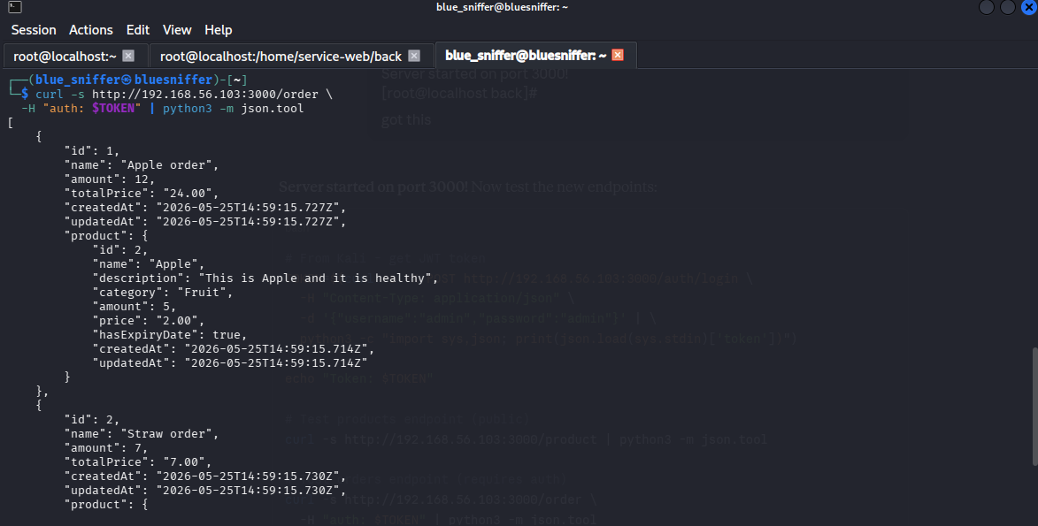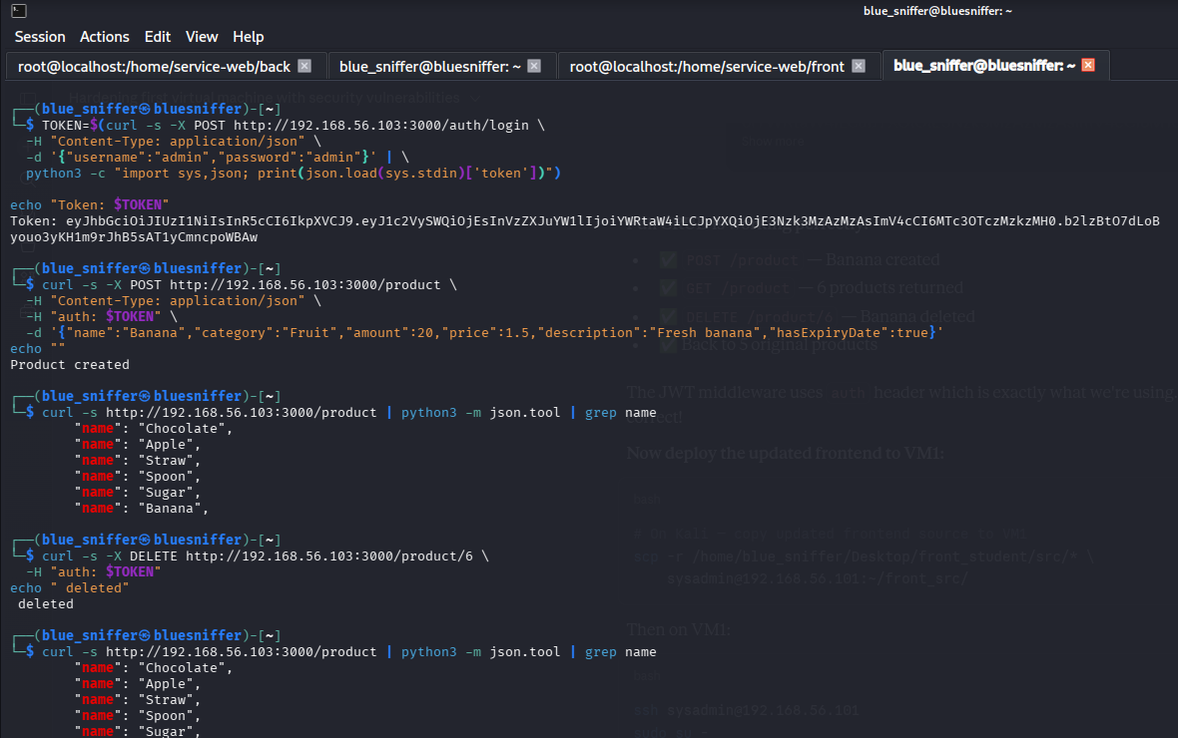

3. Frontend Implementation

3.1 Changes Made
The following frontend files were updated to connect the UI to the real backend API:

File | Change | Reason
store/actions/products.action.ts | Added getProducts(), editProduct(), removeProduct() API calls | Connect CRUD to backend
store/actions/orders.actions.ts | Added getOrders(), addOrder(), editOrder(), removeOrder() API calls | Connect CRUD to backend
store/reducers/products.reducer.ts | Removed hardcoded data, added GET_PRODUCTS handler | Load from API not memory
store/reducers/order.reducer.ts | Removed hardcoded data, added GET_ORDERS, REMOVE_ORDER, EDIT_ORDER | Load from API not memory
components/Admin/Admin.tsx | Added useEffect to dispatch getProducts() and getOrders() on mount | Load data on app start
components/LeftMenu/LeftMenu.tsx | Uncommented Products and Orders menu items | Enable navigation
components/Home/Home.tsx | Fixed Number() conversion for price/totalPrice strings from API | Fix dashboard totals
components/Products/Products.tsx | Fixed Number() conversion for price calculations | Fix product totals
components/Orders/Orders.tsx | Fixed Number() conversion for totalSales calculation | Fix order totals
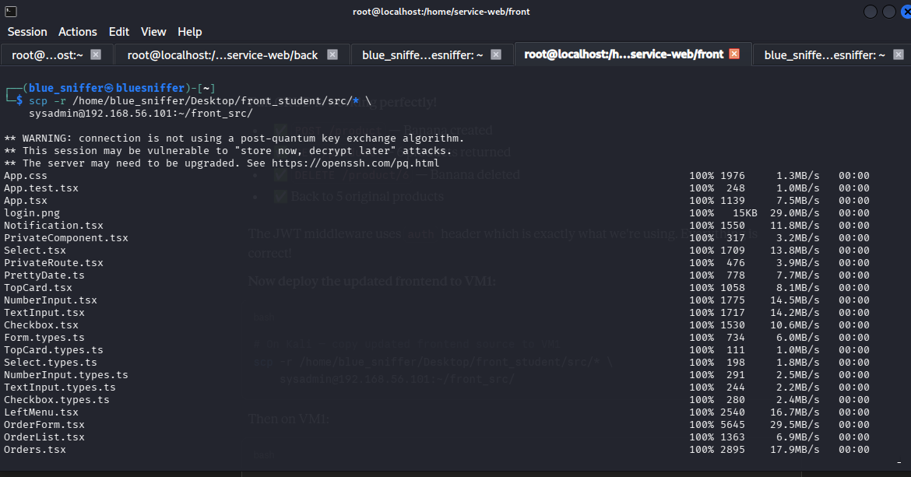

3.2 Data Flow
The complete data flow from database to UI:

MySQL (VM3) → TypeORM → Express API (VM3:3000)
↓
Redux dispatch(getProducts()) on Admin mount
↓
Axios GET /product → products.reducer GET_PRODUCTS
↓
React components re-render with real data

3.3 Dashboard Results
After connecting to the real database, the dashboard correctly shows:

Metric | Value | Calculation
Product Count | 5 | COUNT(*) from product table
Product Amount | 133 | SUM(amount) = 10+5+100+3+15
Summary Price | $231 | SUM(price*amount) = 40+10+100+6+75
Sales | $31 | SUM(totalPrice) = 24+7
Order Amount | 19 | SUM(amount) = 12+7

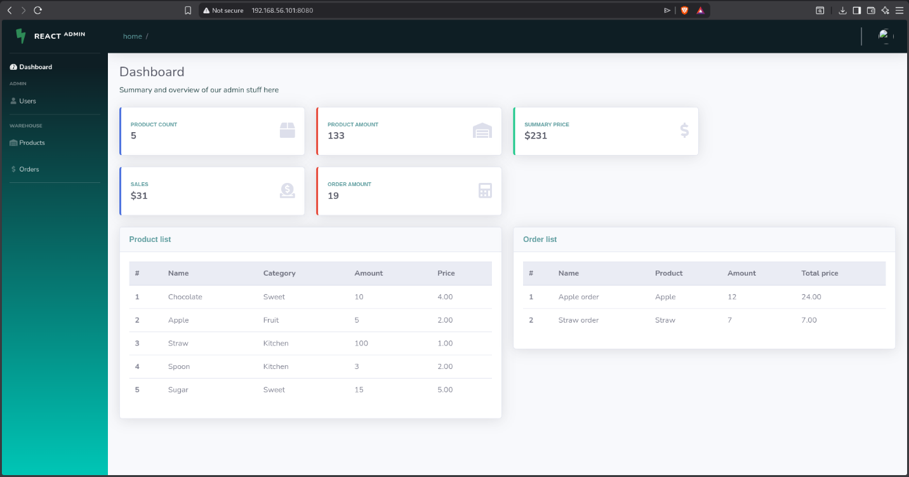

3.4 Products Page
The Products page provides full CRUD operations:
- Green + button — opens Create product form
- Blue pen button — opens Edit product form for selected product
- Red X button — opens confirmation popup to delete selected product
- Click on product row — selects the product for editing/deletion

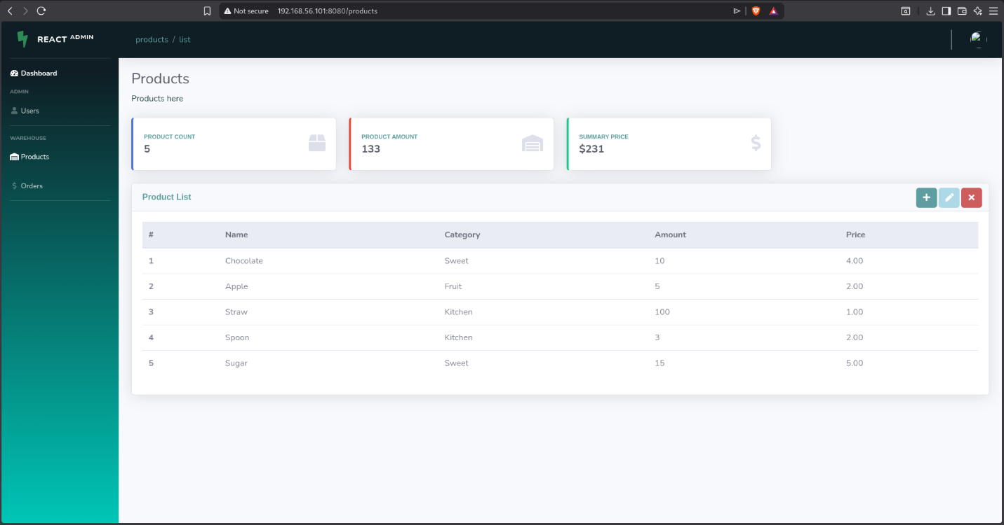

3.5 Orders Page
The Orders page provides order management:
- Order list showing all orders with product details
- Create order form — select product from list on the right
- Total sales and order amount statistics
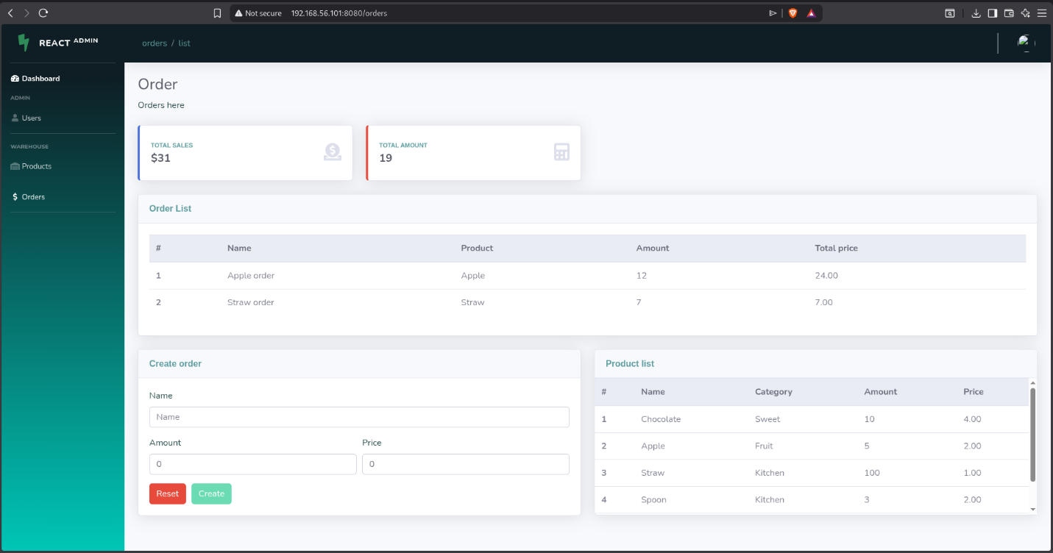

4. New File Structure

4.1 Backend New Files
File | Purpose
src/entity/Product.ts | Product database entity with TypeORM decorators
src/entity/Order.ts | Order database entity with ManyToOne relationship to Product
src/controller/ProductController.ts | CRUD operations for products (listAll, getOneById, newProduct, editProduct, deleteProduct, getStats)
src/controller/OrderController.ts | CRUD operations for orders (listAll, getOneById, newOrder, editOrder, deleteOrder, getStats)
src/routes/product.ts | Express router for /product endpoints
src/routes/order.ts | Express router for /order endpoints
src/routes/index.ts | Updated to include /product and /order routes
src/migration/SeedInventoryData.ts | Database seed migration for initial product and order data

4.2 Frontend Updated Files
File | Change Type
src/store/actions/products.action.ts | Updated — added API calls
src/store/actions/orders.actions.ts | Updated — added API calls
src/store/reducers/products.reducer.ts | Updated — removed hardcoded data
src/store/reducers/order.reducer.ts | Updated — removed hardcoded data
src/components/Admin/Admin.tsx | Updated — added data loading on mount
src/components/LeftMenu/LeftMenu.tsx | Updated — uncommented Products/Orders menu
src/components/Home/Home.tsx | Updated — fixed number type conversion
src/components/Products/Products.tsx | Updated — fixed number type conversion
src/components/Orders/Orders.tsx | Updated — fixed number type conversion

5. Deployment

5.1 Backend Deployment (VM3)
# Copy source files to VM3
scp -r back_student/src/* sysadmin@192.168.56.103:~/back_src/

# On VM3 — copy and rebuild
cp -rf ~/back_src/* /home/service-web/back/src/
cd /home/service-web/back
docker-compose down && docker-compose up --build -d

The migration script automatically runs on container start:
yarn migration:start
# 1. schema:drop — clears existing tables
# 2. schema:sync — creates new tables from entities
# 3. migration:run — runs CreateAdminUser + SeedInventoryData

5.2 Frontend Deployment (VM1)
# Copy updated source to VM1
scp front_student/src/* sysadmin@192.168.56.101:~/front_src/

# On VM1 — copy and rebuild React container
cp -rf ~/front_src/* /home/service-web/front/src/
cd /home/service-web/front
docker-compose down && docker-compose up --build -d

6. Final Application Status

Feature | Status | Notes
User authentication (login/logout) | ✅ Working | JWT-based, admin:admin
User management (list/promote/demote) | ✅ Working | Admin only
Product list (read) | ✅ Working | Public endpoint, real DB data
Product create | ✅ Working | Admin only, persisted to MySQL
Product edit | ✅ Working | Admin only, persisted to MySQL
Product delete | ✅ Working | Admin only, removed from MySQL
Order list (read) | ✅ Working | Admin only, real DB data
Order create | ✅ Working | Admin only, linked to product
Dashboard statistics | ✅ Working | Calculated from real DB data
API documentation (Swagger) | ✅ Working | Available at /api-docs
Data persistence across restarts | ✅ Working | MySQL volume persisted

