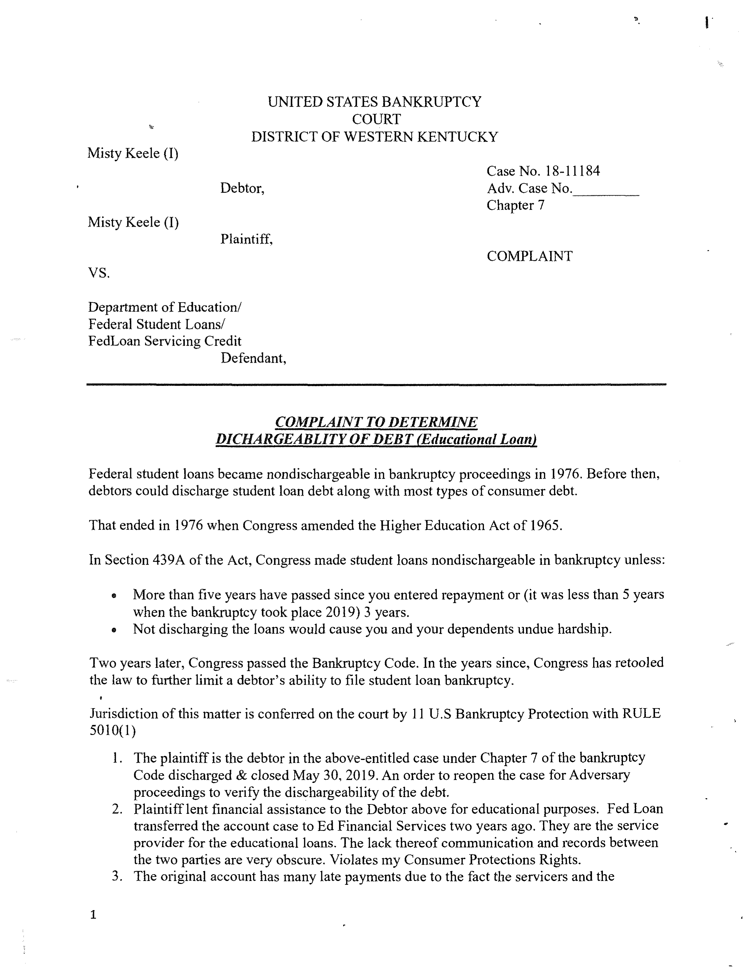
Case 23-01008-jal Doc 1 Filed 06/16/23 Entered 06/16/23 11:01:07 Page 1 of 3
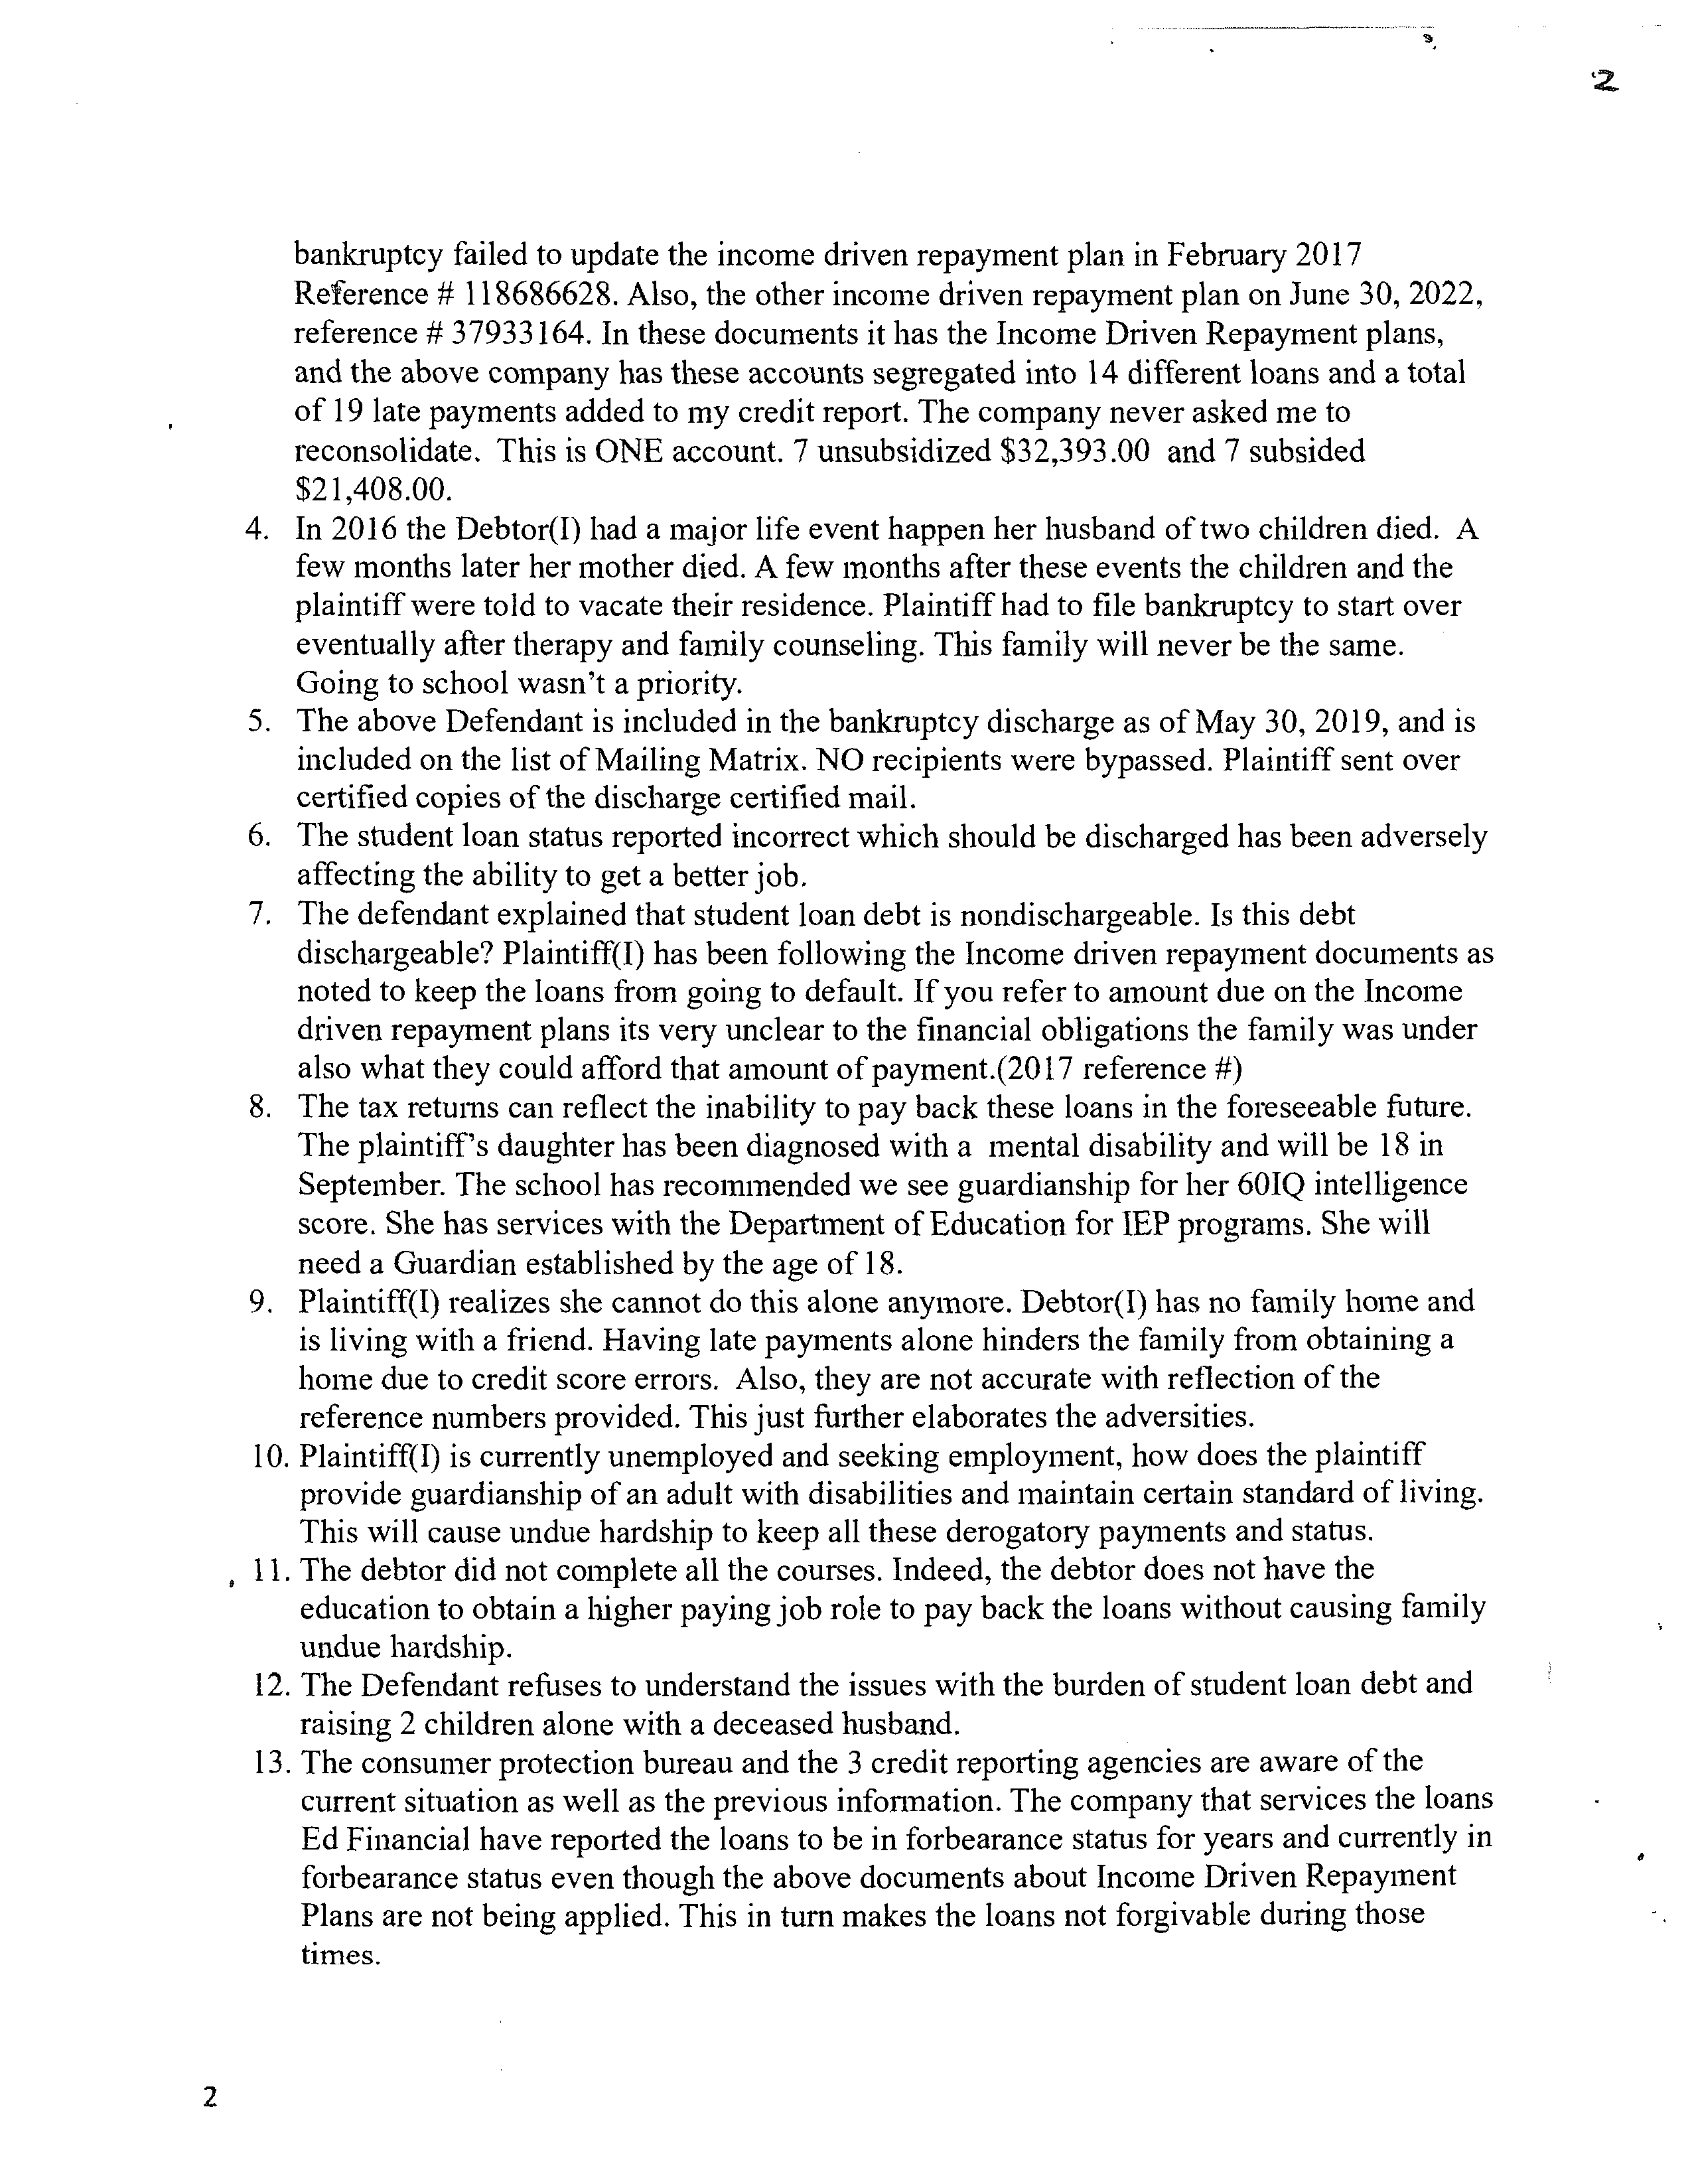
Case 23-01008-jal Doc 1 Filed 06/16/23 Entered 06/16/23 11:01:07 Page 2 of 3
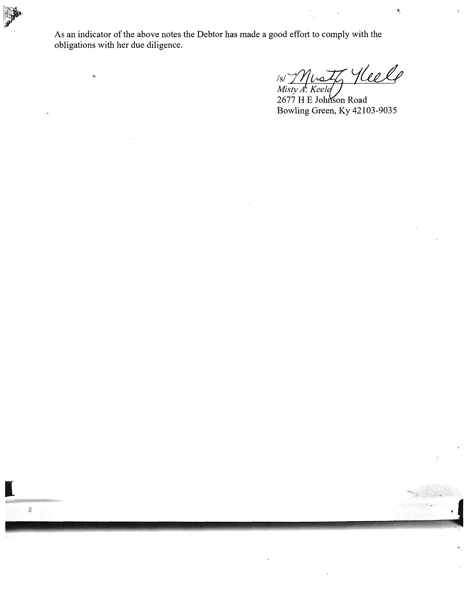
I
As an indicator of the above notes the Debtor has made a good effort to comply with the
obligations with her due diligence.
lsl~L/Ud/
Mistv
TKee/:
2677

H E Jo
son Road
Bowling Green, Ky 42103-9035
Case 23-01008-jal Doc 1 Filed 06/16/23 Entered 06/16/23 11:01:07 Page 3 of 3

