**Flutter: This is a Client work only**  
  
More information:  
Project: Anonymous Social Network  
Version:   
Flutter 3.10.5   
Tools • Dart 3.0.5 • DevTools 2.23.1  
Backend: NET  
DB: MSSQL  
UI Changes: No Figma and no Design, you should design with Existing UI   
  
  
**Blablog – User App**  
**Task 0: update project dependencies**   
and change Clean_api 1.2.0 to http 1.1.0 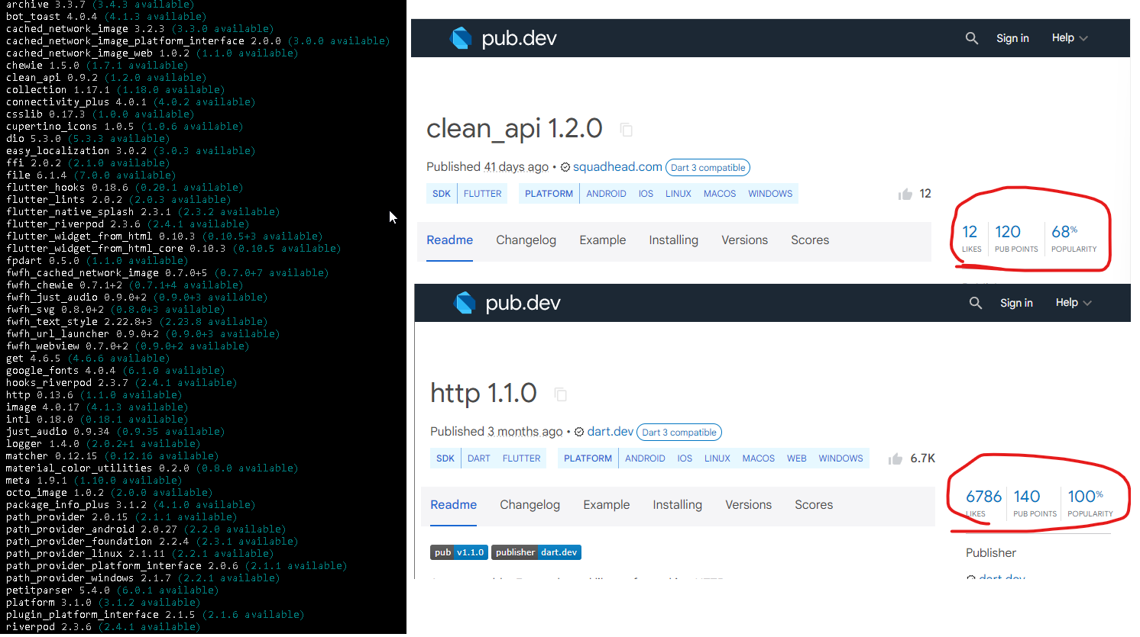  
Tasks Summary:  
  
**1: During app Navigating, between pages,**  
Especially in Consult (Groups) when we Hit the   
Android back button (physical button) it throws you out   
side the App.   
Mission A: in Consult Group, Back will take you back into Groups Selection  
Mission B: Before throws you out, Ask the User, with a Popup, if they want  
to Exit the app (+ Translation)

**2: UI Changes - move comment action on bar on other corner.**  
"Comment" should be move from under comments,  
to the top where like button in the Far corner  
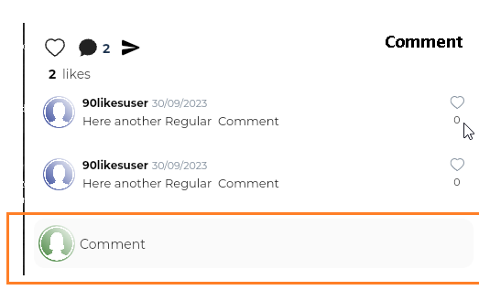  
  
**3: favorites Page, where I see posts from the   
Users I Follow:**   
Mission:   
Fetch only Stories posted in **Thoughts** page,  
And not posted in Consult Groups  
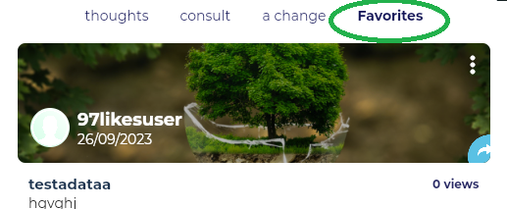  
  
**4: Refresh Content Fetched after Deleting Post / Comment / Blocking User**   
Unfollowing = It should be removed immediately from UI   
and not wait to move between changes so changes needs to reloaded.

**5: Polls - If user already voted:**   
Hide Voting and replace it with:  
" You already voted on this poll"  
+ Translations (need to think what to do fi i only edit the poll)  
  
**6: aChange Videos, Counts Views Per Click**  
(Not per UserId)  
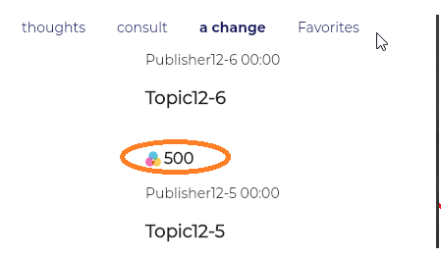  
  
**7: Popup alerts twice duplicated**   
1 as gray, one as purple   
should be popped only once and in the selected  
interface language  
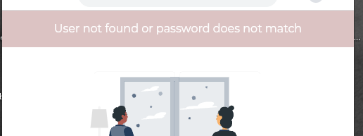  
  
**8: Thoughts Page, show only 3 from a single user**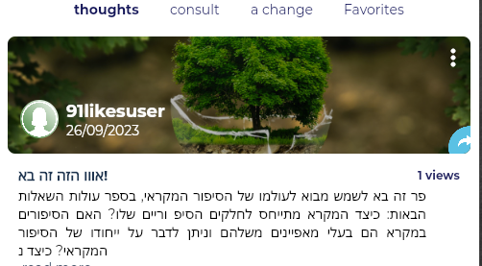

**9: Post Paragraphs in Thoughts Page**  
width should go to end of screen,  
Same as it is right now in Consult  
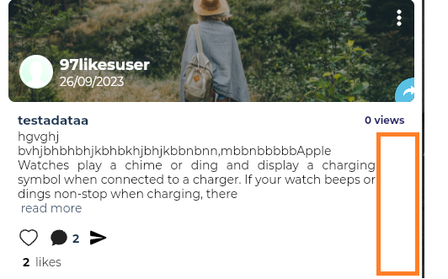  
  
**10: Check id WriterPage (Blue Icon) is using**   
GET /api/v1/stories/user/{id} and why its loading so slow  
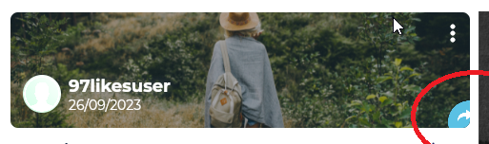  
  
**13: Polls Update GET with an Updated API**