|  |
| --- |
| **SPIS DUST Non Regression Case - Technical Data Sheet** |

|  |  |  |  |
| --- | --- | --- | --- |
| Test case name | Simulation of the dust modules | | |
| Summary | 3D domain above a cratered lunar surface with a lander | | |
| Date of creation | 01/06/2016 | | |
| Author : | S. Hess(ONERA/ DESP): [sebastien.hess@onera.fr](mailto:mateo@onera.fr) | | |
| Modification date |  |  |  |

*Description*

|  |  |
| --- | --- |
|  | **Description** |
| Geometry | Cratered surface: Non conductive lunar dusts  Two faces: reflective conditions  Two faces: periodic conditions  Top face: Particle injection + 0V Dirichlet |
| Source | Drifting maxwellian electrons and ions:   * kTe= 10 eV * Ne = 1.2×1010 m-3 * Drift velocity = 400000km/s * Debye length ~ 10 m |
| Plasma | All particles are PIC, ion and electrons are PICVolDistribUpdatable  Dust are emitted starting at t=10s |
|  |  |

*Challenges/Observables*

|  |  |  |  |
| --- | --- | --- | --- |
| **#** | **Description** | **Comparison to** | **Pass/Fail criteria** |
| 1 | Sheath modelling | Poppe et el, 2010; SPIS-DUST Final presentation | Should not present potential drop at the boundary |
| 2 | Dust | SPIS-DUST Final presentation | Dust density is about a few 10’s m-3 |
| 3 | Instruments |  | All dust instruments shall give physically relevant results. |

*SPIS Model*

|  |  |
| --- | --- |
|  | **Description** |
| SPIS project | All Dataset  (Project with correct E field boundary conditions launched by default) |
| Plasma | Electrons 1:   * PICVolDistribUpdatable * Density: 1.2E7 m-3. * Temperature: 10eV * Vz= -400000 m/s   Ions 1:   * PICVolDistribUpdatable * Density: 1.2E7 m-3. * Temperature: 10eV * Vz= -400000 m/s |
| Electric field | Symmetry Boundary condition on x external boundary, periodic conditions on y boundaries, open conditions on +z boundary and cratered lunar surface on -z. |
| Instruments | * Dust Mass flux on nodes (default) * Dust obscuration on nodes (default) * Dust current on nodes (default) * Dust risk for the spacecraft on nodes (default) * Dust Cloud Monitor * Dust Volume distributions (at 2 different altitudes) * High altitude dust profile * Dust particle detector * Dust trajectory sensor |

*Results*

**

Figure 1 : dust density in volume. It should be verified that the average density corresponds and that the structure related to the crater and lander are present.

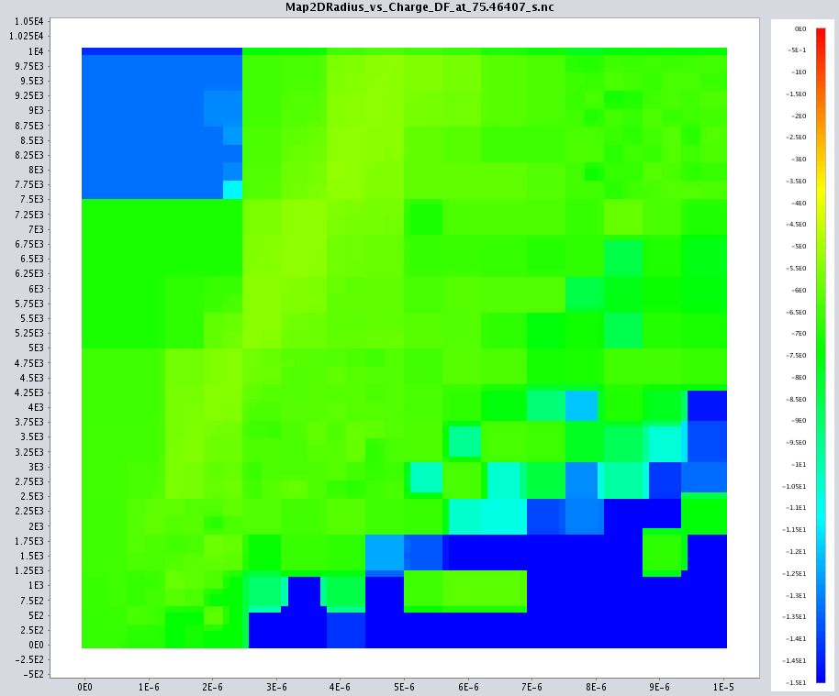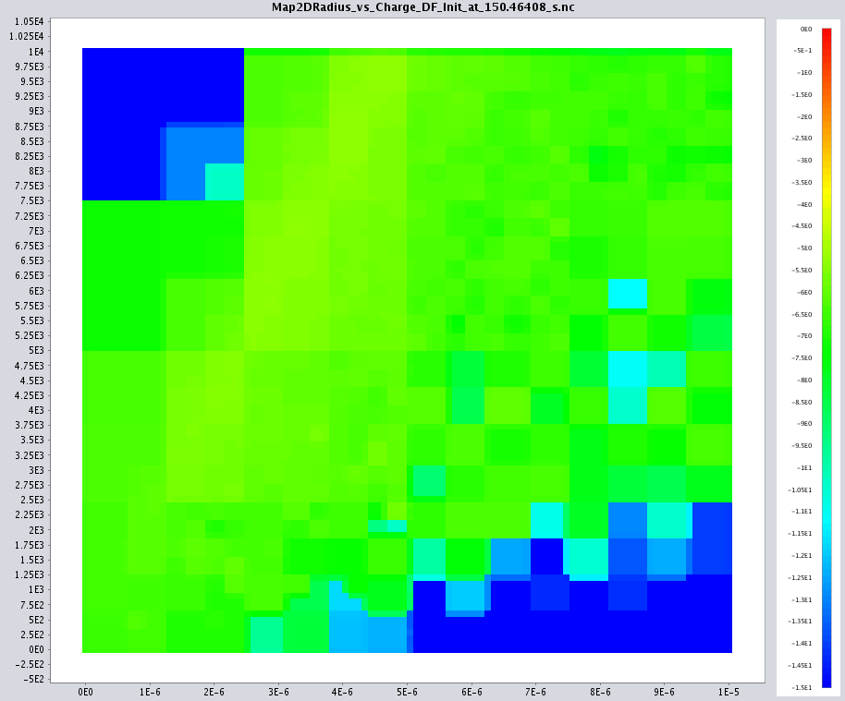

Figure 2 : Dust particle detector, f(r,q) initial and detected. It shall be verified that the charge increase as a function of radius and that the initial and detected distribution differ. Fon f(v,r) : the velocity decreases with radius.

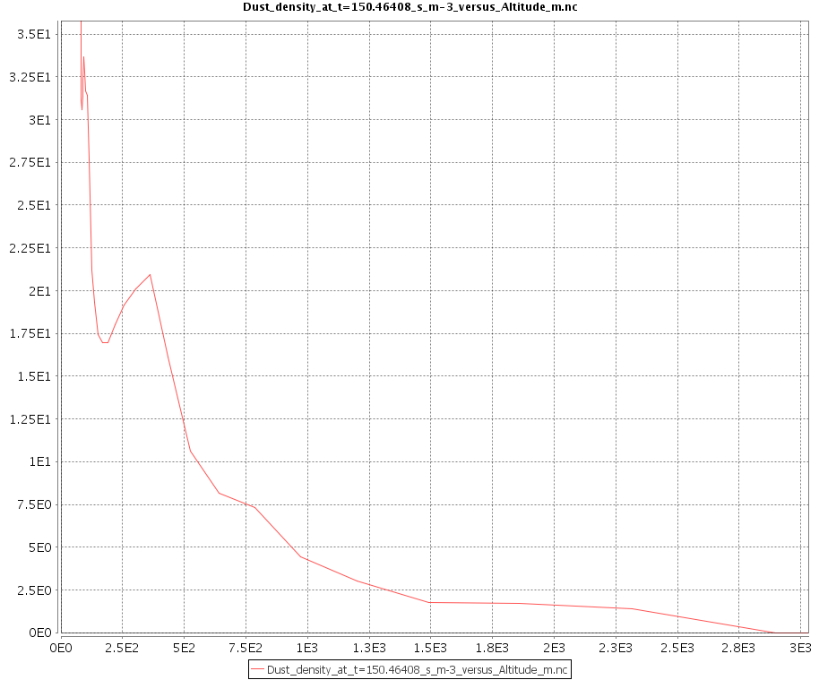

Figure 3 : High altitude profile : it shall be verified that the profile is consistent with the findings of Hess et al, 2014 . Dust density is very low (almost 0) above a few kilometers and may be 0 above a few tens kilometers.

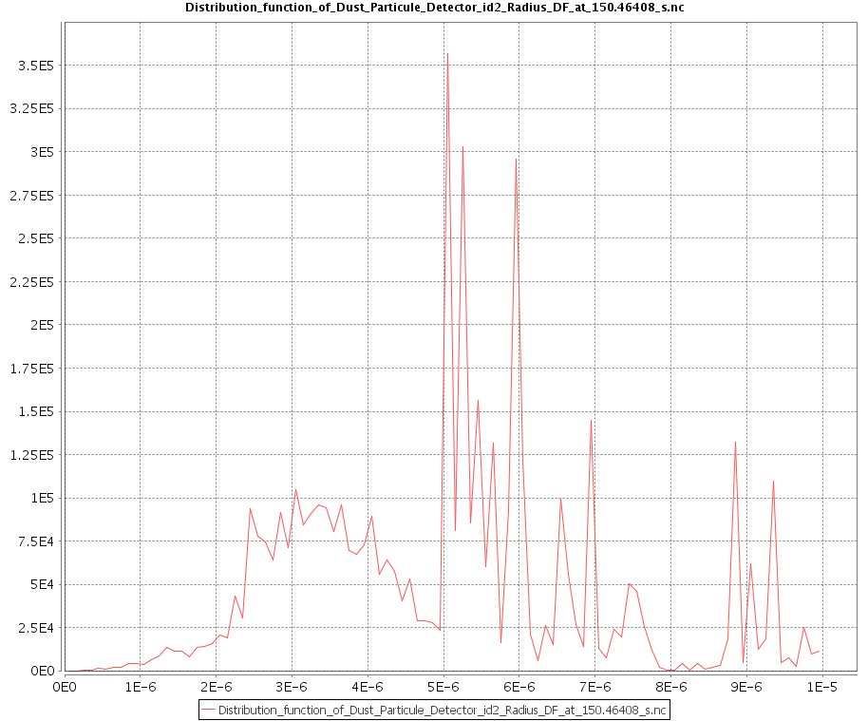

Figure 4 : radius distribution. It shall be checked that dust distribution are consistent with the simulation settings.