SPIS DUST Non Regression Case - Technical Data Sheet 1

Test case name | Simulation of the plasma sheath
Summary | Quasi monodimensional configuration. Cratered Moon surface facing dense solar wind conditions
Date of creation | 01/06/2016
Author : | S. Hess(ONERA/ DESP): sebastien.hess@onera.fr
Modification date

Description

 | Description
Geometry | Half cratered surface: Non conductive lunar dusts  Two faces: reflective conditions  Two faces: periodic conditions  Top face: Particle injection + 0V Dirichlet
Source | Drifting maxwellian electrons and ions:  - kT_{e}= 10 eV  - N_{e} = 1.2×10¹⁰ m⁻³  - ^{Drift velocity = 400000km/s}  - Debye length ~ 10 m
Plasma | All particles are PIC, ion and electrons are PICVolDistribUpdatable
Transition | From t=0 to t=20 s, Sun at zenith  From t=20 to t= 50 s , Sun from zenith to SZA=50°  From t=50 to t=60s, Sun at SZA=50°  Solar wind direction follows that of the Sun

Challenges/Observables

# | Description | Comparison to | Pass/Fail criteria
1 | Sheath modelling | Poppe et el, 2010; SPIS-DUST Final presentation | Should not present potential drop at the boundary
2 | Local time transition | Manka, 1973 | Flat ground potential (node 0) should follow the potential predicted by Manka, 1973

SPIS Model

 | Description
SPIS project | All Dataset  (Project with correct E field boundary conditions launched by default)
Plasma | Electrons 1:  - PICVolDistribUpdatable  - Density: 1.2E7 m-3.  - Temperature: 10eV  - Vz= -400000 m/s  Ions 1:  - PICVolDistribUpdatable  - Density: 1.2E7 m-3.  - Temperature: 10eV  - Vz= -400000 m/s
Electric field | Symmetry Boundary condition on x external boundary, periodic conditions on y boundaries, open conditions on +z boundary and cratered lunar surface on -z.  Error in BC for the first simulation. Correction made (see the end of the TDS2)
Electrodes | conductive lunar surface for the flat surface and non conductive lunar surface for the crater
Simulation | Use ElectronFluxFromPhotoelectron interactor and LocalTimeTransition

Results

SZA | 0° | 50°
Node Potential (v) | 4 | 2.3

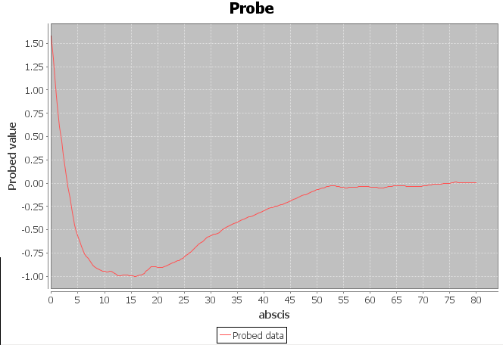
Figure 1 : Probing line of the potential (0,0,0 to 0,0,80) showing the absence of potential jumps at the boundary. Time =18s.
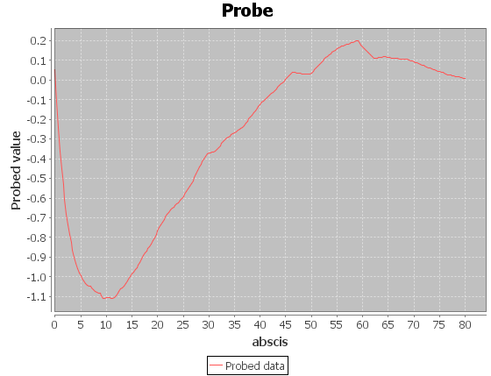
Figure 2 : Same probing line at T=60s. The potential profile is not yet stabilized, but the noise on it is limited.
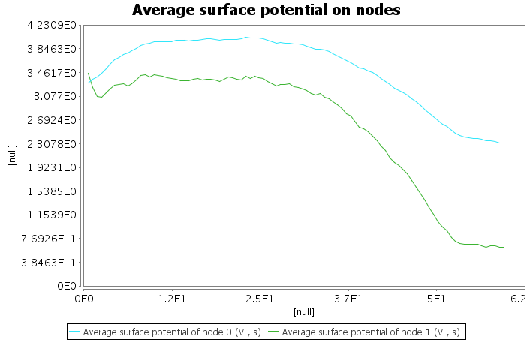
Figure 3 : Evolution of the surface potentials.

