| **Partei** | **Vor Shutdown [%]** | **Während Shutdown [%]** | **Vor Shutdown [-]** | **Während Shutdown [-]** |
| --- | --- | --- | --- | --- |
| CVP | 6.5 | 1.5 | 14 | 5 |
| FDP | 9.8 | 3.0 | 21 | 10 |
| GLP | 23.8 | 27.4 | 51 | 90 |
| GPS | 50.5 | 57.9 | 108 | 190 |
| SP | 6.1 | 6.7 | 13 | 22 |
| SVP | 2.3 | 2.1 | 5 | 7 |
| BDP | 0.0 | 0.3 | 0 | 1 |
| EVP | 0.0 | 0.0 | 0 | 0 |
| BastA! | 0.9 | 0.9 | 2 | 3 |
| Total: | 100 | 100 | 214 | 318 |

| **Partei** | **Vor Shutdown [%]** | **Während Shutdown [%]** | **Vor Shutdown [-]** | **Während Shutdown [-]** |
| --- | --- | --- | --- | --- |
| CVP | 17.9 | 13.0 | 22 | 12 |
| FDP | 8.9 | 15.2 | 11 | 14 |
| GLP | 4.9 | 10.9 | 6 | 10 |
| GPS | 14.6 | 10.9 | 18 | 10 |
| SP | 40.7 | 45.7 | 50 | 42 |
| SVP | 6.5 | 3.3 | 8 | 3 |
| BDP | 0.8 | 0.0 | 1 | 0 |
| EVP | 3.3 | 0.0 | 4 | 0 |
| BastA! | 2.4 | 1.1 | 3 | 1 |
| Total: | 100 | 100 | 132 | 83 |

| **Veränderung** | **Ausdruck** | **Rang vor Shutdown [-]** | **Rang während Shutdown [-]** |
| --- | --- | --- | --- |
|  | Corona* | 500+ | 2. |
|  | Bundesrat | 131. | 55. |
|  | Gleichstellung | 2. | 5. |
|  | Arbeit | 18. | 55. |
|  | Kitas | 500+ | 9. |
|  | Überbrückungsleistung | 18. | 500+ |

| **Veränderung** | **Ausdruck** | **Rang vor Shutdown [-]** | **Rang während Shutdown [-]** |
| --- | --- | --- | --- |
|  | Corona* | 286. | 9. |
|  | Bundesrat | 60. | 8. |
|  | Landwirtschaft | 5. | 500+ |
|  | Luftfahrt | 500+ | 3. |
|  | bäuerliche | 25. | 500+ |
|  | Swiss | 500+ | 26. |

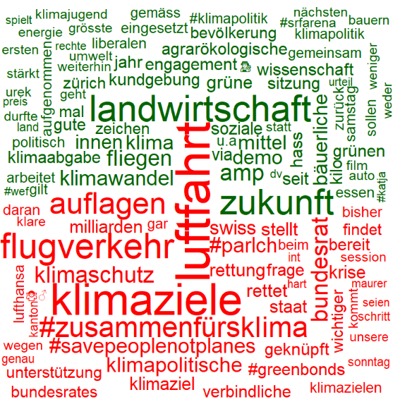

**Gleichstellung**

**Klima**

**Vor Shutdown**

**Während Shutdown**

