| **Partei** | **Vor Shutdown [%]** | **Während Shutdown [%]** | **Vor Shutdown [-]** | **Während Shutdown [-]** |
| --- | --- | --- | --- | --- |
| CVP | 7.0 | 2.6 | 17 | 9 |
| FDP | 10.3 | 4.6 | 25 | 16 |
| GLP | 25.6 | 27.9 | 62 | 97 |
| GPS | 47.1 | 56.0 | 114 | 195 |
| SP | 6.6 | 6.9 | 16 | 24 |
| SVP | 3.3 | 2.0 | 8 | 7 |
| Total: | 100 | 100 | 242 | 348 |

(Klima)

| **Partei** | **Vor Shutdown [%]** | **Während Shutdown [%]** | **Vor Shutdown [-]** | **Während Shutdown [-]** |
| --- | --- | --- | --- | --- |
| CVP | 19.1 | 13.2 | 22 | 12 |
| FDP | 9.6 | 15.4 | 11 | 14 |
| GLP | 5.2 | 11.0 | 6 | 10 |
| GPS | 15.7 | 11.0 | 18 | 10 |
| SP | 43.5 | 46.2 | 50 | 42 |
| SVP | 7.0 | 3.3 | 8 | 3 |
| Total: | 100 | 100 | 115 | 91 |

(Gleichstellung)

| **Veränderung** | **Ausdruck** | **Rang während Shutdown [-]** | **Rang vor Shutdown [-]** |
| --- | --- | --- | --- |
|  | Corona* | 2. | 500+ |
|  | Bundesrat | 55. | 131. |
|  | Gleichstellung | 7. | 2. |
|  | Arbeit | 44. | 22. |
|  | Kitas | 7. | 500+ |
|  | Überbrückungsleistung | 500+ | 17 |

| **Veränderung** | **Ausdruck** | **Rang während Shutdown [-]** | **Rang vor Shutdown [-]** |
| --- | --- | --- | --- |
|  | Corona* | 4. | 500+ |
|  | Bundesrat | 8. | 74. |
|  | Landwirtschaft | 500+ | 7. |
|  | Luftfahrt | 3. | 500+ |
|  | bäuerliche | 500+ | 33. |
|  | Swiss | 26. | 500+ |

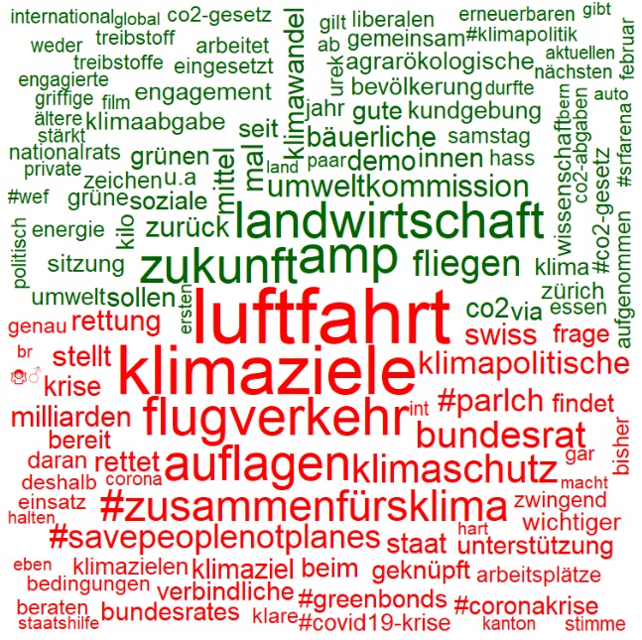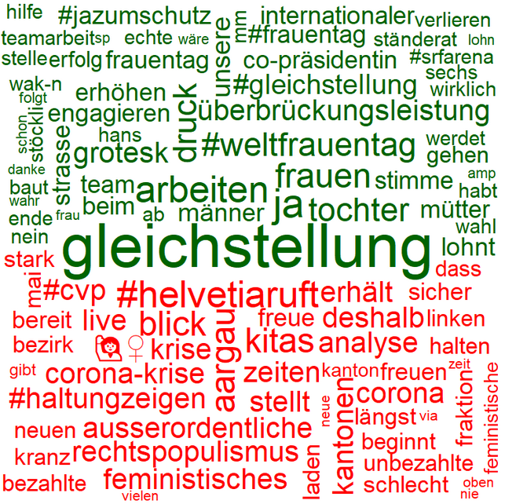

**Während Shutdown**

**Vor Shutdown**

**Gleichstellung**

**Klima**

