2016

Prepared by:

Amy Knowles

Steven Kundert

Yashwanth Reddy Muddireddy

Vaisali Namburi

2016 May 1

v.1

User Manual

User Manual





Contents

1 Introduction/Overview 2

1.1 Purpose 2

1.2 Overview 2

2 Class Search Screen 2

3 Results Screen 2

4 Maintenance 2

5 Glossary 2

6 References 3

7 Consultants 3

# Introduction/Overview

The Open Classes application is developed to be an application to serve the faculty of the Computer Science Department at Midwestern State University. The application is targeted for advising faculty. A faculty advisor can search through the current available classes, quickly weeding out any unavailable or closed classes.

## Purpose

The purpose of this document is to project the behavior and work flow of the application. This is a step by step guide to use the application. The role of the user of the system is explained.

## Overview

Section 2 describes the class search screen of the application. Section 3 describes the results screen while Section 4 describes how to update the system in order to a add new class category.

# Class Search Screen

The application begins with a selection screen. The user must select a term from the

drop down menu. The user then has a choice to select a number of course categories

via selection boxes on the right hand side of the selection screen. The user then has the

option of selecting only open classes via a radio button at the bottom center of the class

search screen. If the only open classes radio button is chosen, then only categories with classes that have open slots will be displayed on the screen. Any classes that are already at maximum capacity will not be displayed. Once all search parameters have been elected, the user will press the search button. If at any time, the user would like to clear out selections, they can simply press the reset button found right next to search button.

# Results Screen

Once all selections have been made, and the search button is pressed, the user is taken to the results screen. The results screen will display a list of classes separated by category. If all options are selected, and the open classes only button is also selected, a category with no available classes will display as only the class category banner and an empty list below. A user can navigate back to the Class Search screen by simply clicking the back button on the browser. The selected options from the previous search will remain until the reset button is pressed.

# Maintenance

This program was designed to allow a super user to add additional class categories. Class categories can be added on the by accessing the screen below (Fig. 1). Once the class category has been added, a new radio button will appear on the Class Search Screen. A new category can be added by adding a new line between the last category and the None category. The new line will read as follows:

<input type= “checkbox” name = “#” value = “newCategory”>New Category<br>

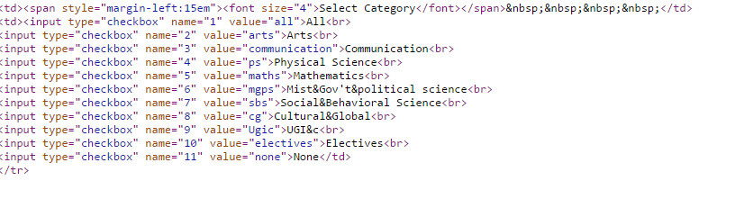

Figure 1. Class Category Addition Location

# Glossary

B.A. Degree Plan – a degree plan within the computer science department that allows students to take less rigorous mathematics courses in exchange for a number of credit hours in humanities/literature courses and fourteen semester hours of a foreign language.

B.S. Degree Plan – a degree plan within the computer science department that requires students to take more rigorous mathematics courses.

Course – an available college course during a given semester; can be either traditional or on-line.

Degree Plan – a roadmap of the required courses for a particular major within a collegiate institution.

Fundamental Core / Electives – courses required of all university students independent of major.

GUI – the graphical user interface that allows a person to interact with the software easily by utilizing a mouse and keyboard.

Major – a student’s desired field of study within the university.

Major Core / Electives – courses required by a specific department for students graduating with a degree from that department.

On-line Course – college class in which students access course information through an on-line portal, such as D2L, and are not required to present to a physical location.

Traditional Course – college class in which students are required to attend a lecture on specific days and times in a physical location.

# References

1. Sommerville I., Software Engineering 9th edition, Delhi, Pearson Education, Ltd, 2011, 84-88.
2. Uyttewaal E., “Microsoft Project: Plan Better with Microsoft Project”, New York, TechNet Magazine, February 2012.

# Consultants

1. Stringfellow, Dr. Catherine, Customer, Open Classes Project, MSU Wichita Falls, Fall 2015.
2. Kundert, Carley, Possible Future Customer, Open Classes Project, MSU Wichita Falls, Fall 2015.