Time Tracking (Week 2):

Chase’s clockify:

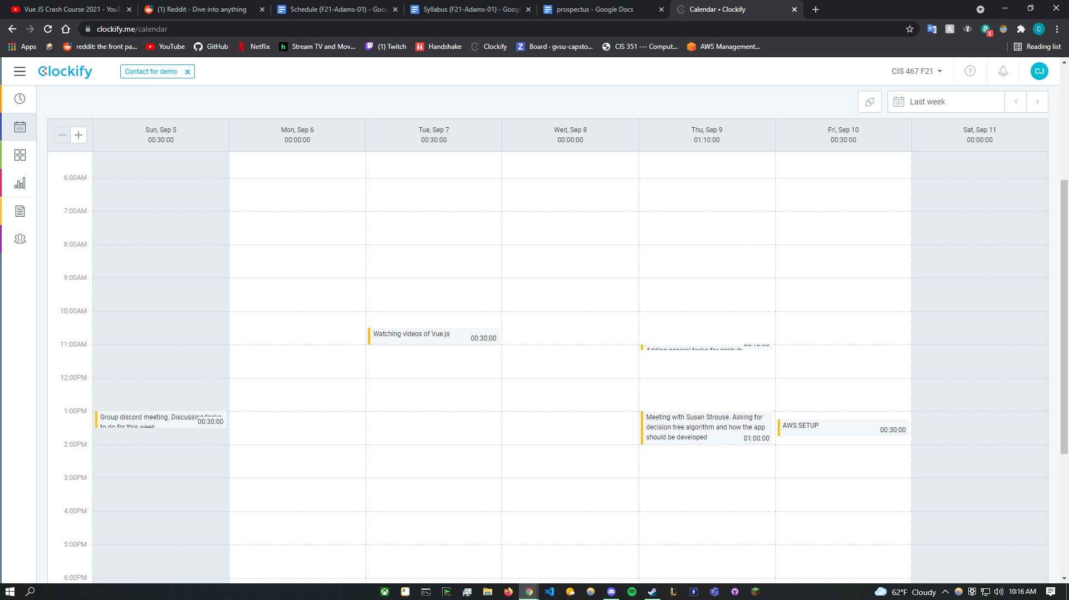

Christian’s clockify:

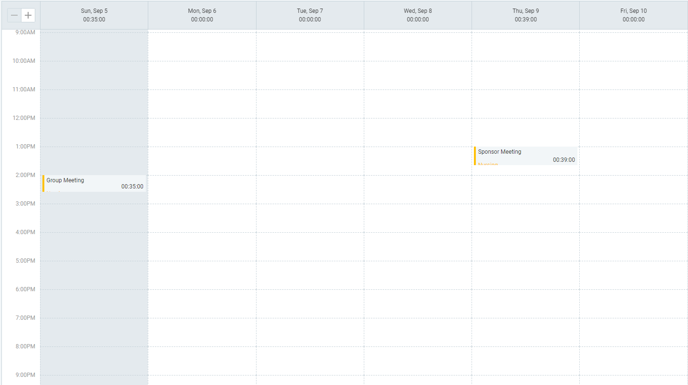

Lucas’s clockify:

Team Description + Growth Areas:

Chase Johnston: Has unpaid internship experience with web development in both frontend and backend using JavaScript and React.js Framework. I anticipate to grow in leadership and communication skills and become familiar with scrum and code sprints.

Christian Stam: I have experience writing web servers and enjoy working on the backend. I have extensive experience with python and socket programming which will benefit our project.

Lucas Bailey: Most familiar with Vue.js.

Project Description:

Our website aims to be an interactive quiz with a nice user interface. It must contain a homepage, results page, feedback page, and administration page. Prof Strouse also requested a logging system to keep tab of comments + rating and the users results. We are debating on whether to add a login system to keep tabs on users and gvsu login authentication if requested. She also requested easy to use administration tools to modify her site/quiz. We must plan to make this tool easy to use for the end user. We offered to make a widget UI with buttons for it and that sounded like a great idea. Prof Strouse is also discussing if it should be an independent website or be used by GVSU. If it is for grand valley state university should we use student data to help determine the outcome of the quiz. For example can we scrape students' classes they took and current major information. Is it an invasion of privacy?