1.

import tkinter as tk  
root = tk.Tk()  
root.title('Blue')  
root.geometry('200x80')  
w1 = tk.Label(root, text="莫忘少年凌云志",bg='pink')  
w2=tk.Label(root,text="曾许天下第一流",bg='yellow')  
w1.pack(side='left')  
w2.pack(side='left')  
root.mainloop()  
  
import tkinter as tk  
root = tk.Tk()  
root.title('Blue')  
root.geometry('200x80')  
w1 = tk.Label(root, text="莫忘少年凌云志",bg='pink')  
w2=tk.Label(root,text="曾许天下第一流",bg='yellow')  
w1.pack(pady=3)  
w2.pack(pady=1)  
root.mainloop()

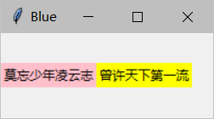 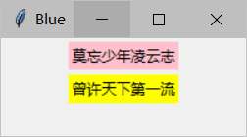

2.

import tkinter as tk  
root = tk.Tk()  
root.title('Blue')  
root.geometry('300x150')  
w1 = tk.Label(root, text="确认退出本窗口吗？")  
b1= tk.Button(root,text="我再想想")  
b2= tk.Button(root,text="果断退出")  
w1.pack()  
b1.place(relx = 1, x =-90, y = 80, anchor = 'ne')  
b2.place(relx = 1, x =-15, y = 80, anchor = 'ne')  
root.mainloop()

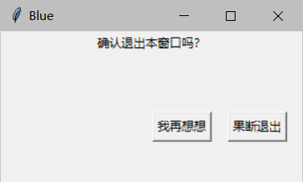

3.

from tkinter import*  
win=Tk()  
img=PhotoImage(file='D:\Desktop\###.png')  
Label(win,image=img).pack()  
win.mainloop()

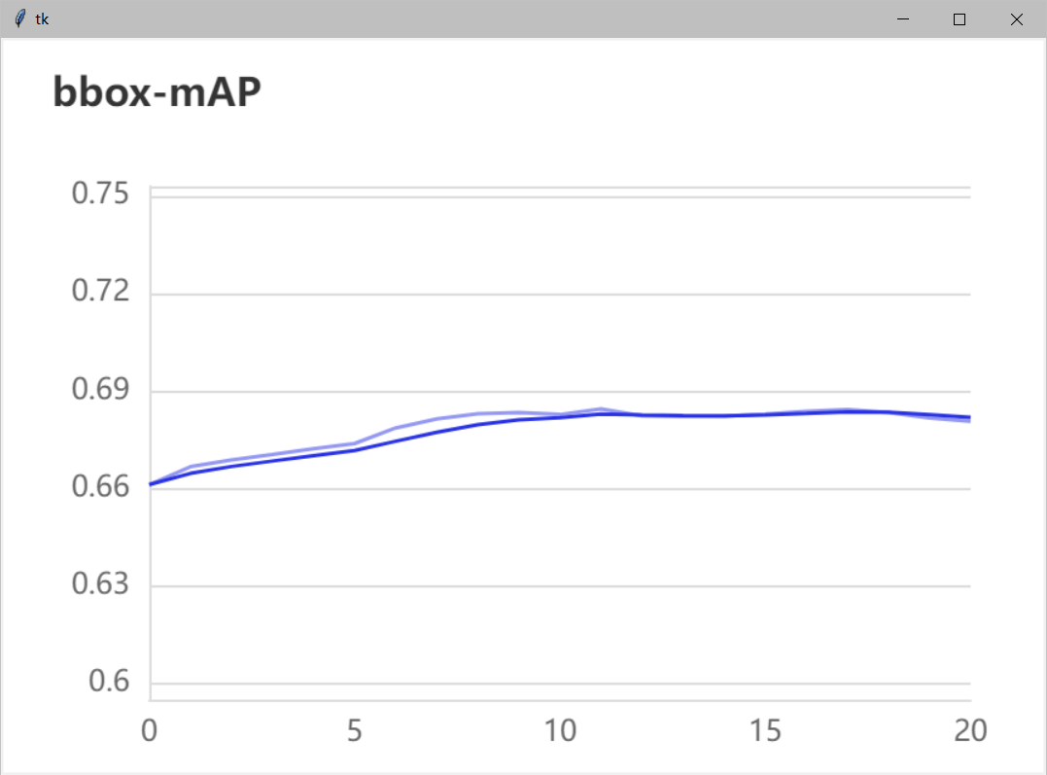

4.

from tkinter import *  
from tkinter.messagebox import *  
def run1():  
 a = str(enter1.get())  
 b = str(enter2.get())  
 if a=='user1' and b=='123':  
 btn.config(text='登陆成功！')  
 else :  
 btn.config(text='账号密码错误！')  
root=Tk()  
root.title('Blue')  
root.geometry('260x150')  
l1=Label(root,text='用户名：')  
l1.grid(row=0, padx='10', pady='10')  
enter1 = Entry(root)  
enter1.grid(row=0, column=1, padx='10', pady='10')  
l2=Label(root,text='密码：')  
l2.grid(row=1, padx='10', pady='10')  
enter2 = Entry(root)  
enter2.grid(row=1, column=1, padx='10', pady='10')  
btn= Button(root, text="登 录", width='15',command=run1)  
btn.grid(row=2, column=0, columnspan=2, pady='10')  
root.mainloop()

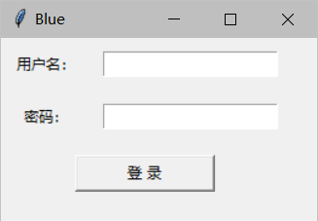

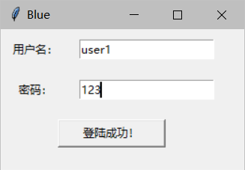

5.

from tkinter import*  
import math  
def run1():  
 a = float(inp1.get())  
 b = float(inp2.get())  
 x = a+b  
 inp3.insert(END, x)  
root=Tk()  
root.config(bg='gray')  
root.title('Form1')  
root.geometry('350x250')  
#输入框1  
inp1 = Entry(root,bg='pink')  
inp1.place(relx=0.1, rely=0.1, relwidth=0.2, relheight=0.1)  
#‘+’号  
lb1 = Label(root,text='+',bg='gray')  
lb1.place(relx=0.35, rely=0.1, relwidth=0.02, relheight=0.1)  
#输入框2  
inp2 = Entry(root,bg='green')  
inp2.place(relx=0.42, rely=0.1, relwidth=0.2, relheight=0.1)  
#‘=’号  
lb2 = Label(root,text='=',bg='gray')  
lb2.place(relx=0.66, rely=0.1, relwidth=0.02, relheight=0.1)  
#结果框  
inp3 = Entry(root,bg='blue')  
inp3.place(relx=0.72, rely=0.1, relwidth=0.2, relheight=0.1)  
# 按钮  
btn1 = Button(root, text='计算', command=run1,bg='yellow')  
btn1.place(relx=0.35, rely=0.35, relwidth=0.3, relheight=0.1)  
root.mainloop()

