1.# 11111111111111  
import random  
  
var = "hello python"  
print(var.lstrip()) # 方法用于截掉字符串左边的空格或指定字符  
print(var.rsplit()) # 使用后跟空格的逗号作为分隔符，将字符串拆分为列表  
print(var.strip()) # 删除字符串开头和结尾的空格  
print(var.strip().strip("on")) # 方法删除任何前导（开头的空格）和尾随（结尾的空格）字符（空格是要删除的默认前导字符）。  
print(var.strip().strip("h").strip("e"))  
one = var.replace("", ",") # 替换  
two = var.replace("hello", "good")  
third = var.replace("h", "")  
print(one)  
print(two)  
print(third)  
# strip()例题  
# txt = ",,,,,rrttgg.....banana....rrr"  
# x = txt.strip(",.grt")  
# print(x)  
#  
# <<banana  
  
# 2222222222222222  
item = ''  
num = ''  
password = ''  
new = chr(ord(item) + 3)  
low = random.choice(num)  
upp = random.choice(num).upper()  
password += upp + new + low  
s1 = "Python"  
uppers1 = s1.upper()  
print(uppers1)  
lowers1 = uppers1.lower()  
print(lowers1)  
capitalizes1 = s1.capitalize()  
print(capitalizes1)  
name = "赵钱孙李周吴郑王"  
for i in range(len(name)):  
 print(name[i])  
for index, item in enumerate(name):  
 print(index + 1, item)  
  
# 3333333333333333333  
name = "玄德出马，左有云长，右有翼德"  
count = name.count(name[6])  
new = name.find("德", 5)  
len(name[0:2])  
surname = '赵构钱丽孙周可安李冯赵周同吴钱郑周'  
print(surname.count("周"))  
print(surname.count("冯", 3))  
name = "www.miniaturising.com,www.huawei.com,www.jd.com"  
print(name.count("com", 5))  
print(name.count("www"))

2.import random  
x = ""  
y = ""  
for i in range(4):  
 index = random.randrange(0, 3) # 它在[0,1)范围内  
 if index == 0:  
 x = x + chr(random.randint(97, 122))  
 elif index == 1:  
 x = x + chr(random.randint(65, 90))  
 else:  
 x = x + str(random.randint(1, 9))  
print("验证码：{}".format(x))  
y = str(input("请输入验证码:"))  
while y != x:  
 print("验证码错误！")  
 x = ""  
 y = ""  
 for i in range(4):  
 index = random.randrange(0, 3) # 它在[0,1)范围内  
 if index == 0:  
 x = x + chr(random.randint(97, 122))  
 elif index == 1:  
 x = x + chr(random.randint(65, 90))  
 else:  
 x = x + str(random.randint(1, 9))  
 print("验证码：{}".format(x))  
 y = str(input("请输入验证码:"))  
print("验证码正确！")

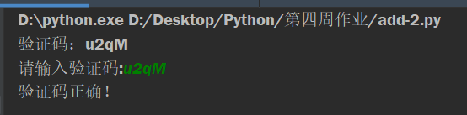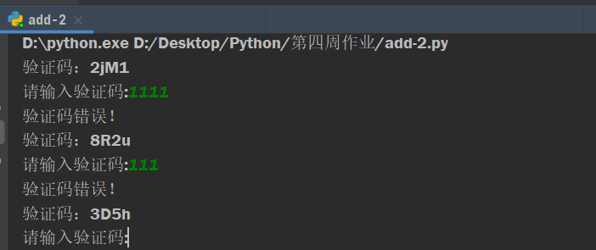

3.word = "当下两军相对，玄德出马，左有云长，右有翼德，扬鞭大骂：“反国逆贼，何不早降！”程远志大怒，遣副将邓茂出战。张飞挺丈八蛇矛直出，手起处，刺中邓茂心窝，翻身落马。程远志见折了邓茂，拍马舞刀，直取张飞。云长舞动大刀，纵马飞迎。程远志见了，早吃一惊，措手不及，被云长刀起处，挥为两段。 "  
name = "云长翼德"  
count = word.count(name[0] + name[1])  
print("云长出现的次数：{}".format(count))  
  
  
def find_all(string, sub):  
 start = 0  
 pos = []  
 while True:  
 start = string.find(sub, start)  
 if start == -1:  
 return pos  
 pos.append(start)  
 start += len(sub)  
  
  
print("云长出现的位置：", end='')  
print(find_all(word, '云长'))

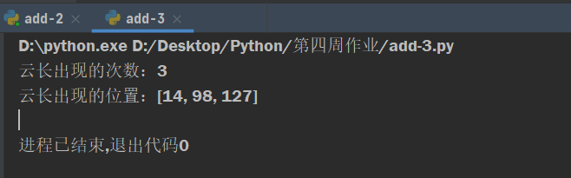

4.

x = str(input("请输入您的银行卡号："))  
for i in range(0, len(x)):  
 if (i + 1) % 4 == 0:  
 print(end=' ')  
 print(x[i], end='')

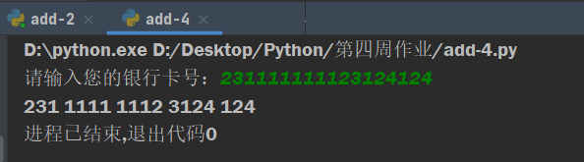

5.

x = str(input("请输入您的银行卡号："))  
for i in range(0, len(x)):  
 if (i + 1) % 4 == 0:  
 print(end=' ')  
 print(x[i], end='')

