**Test Scanning Application**

1. Set Factory Defaults

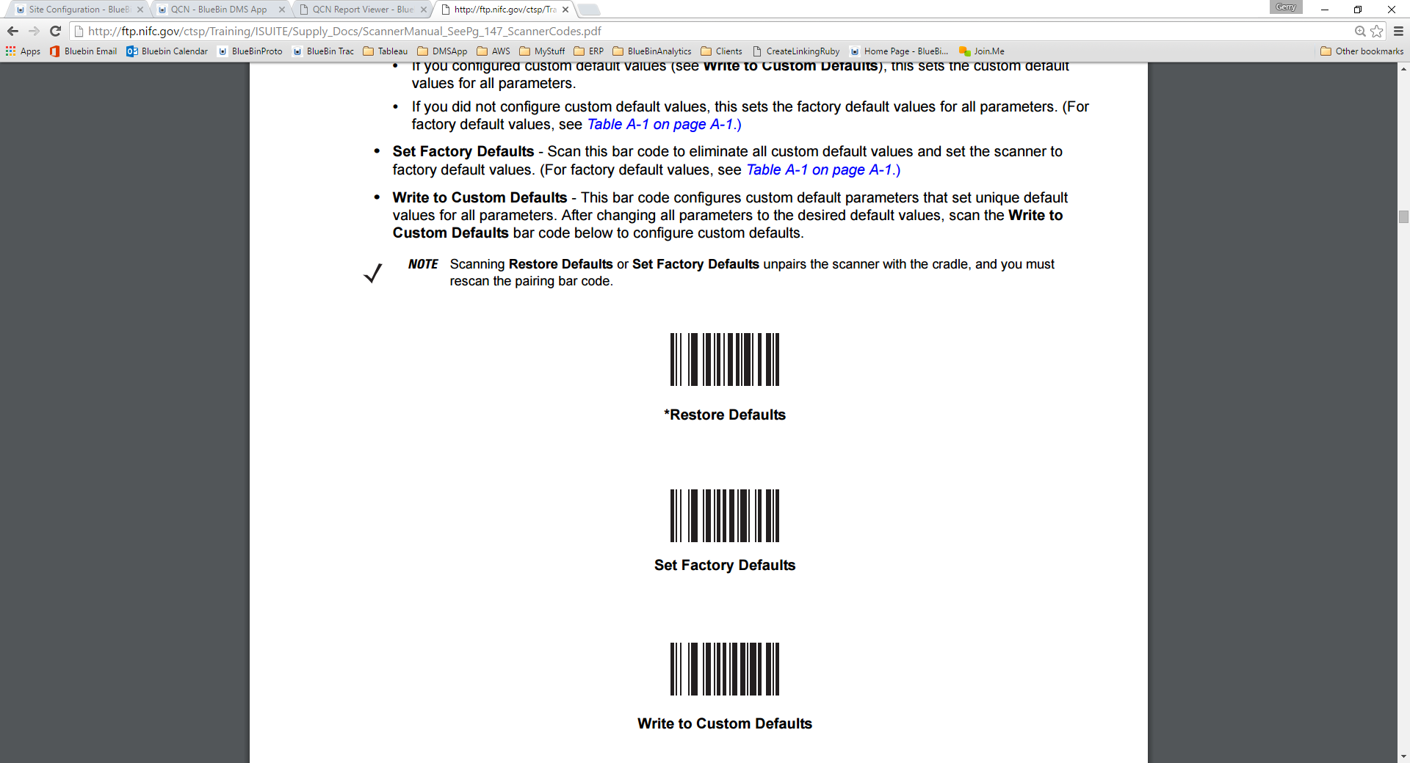

1. “Pair” (cradle)
2. Enable Function Key Mapping

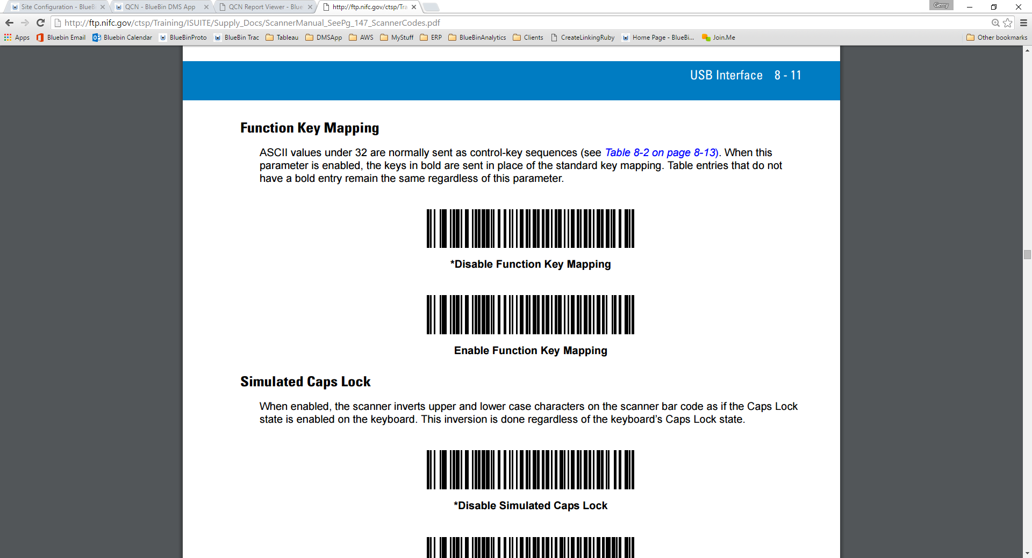

___________________________________________________________________________________________

1. Scan Location



1. Scan Items (Add more items if you want, the below are just samples)







1. Enter Enter to Submit

