**Test Scanning Application – Alternate 20151228**

1. Set Factory Defaults

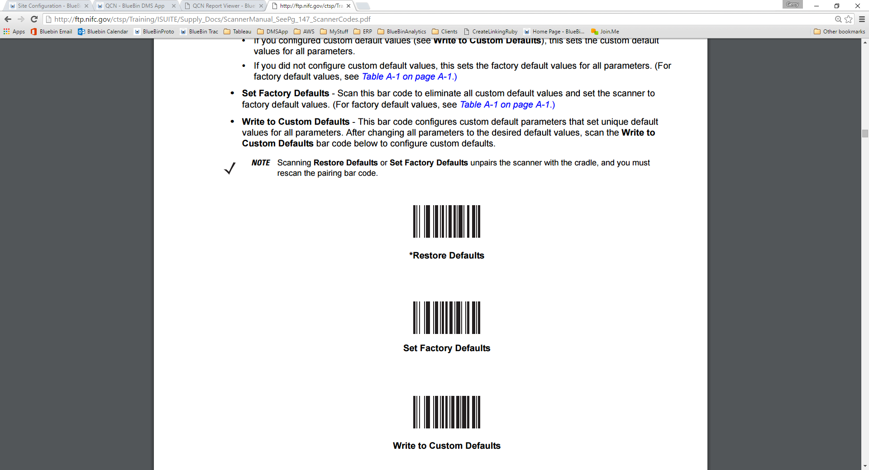

1. “Pair” (cradle)
2. Enable Function Key Mapping

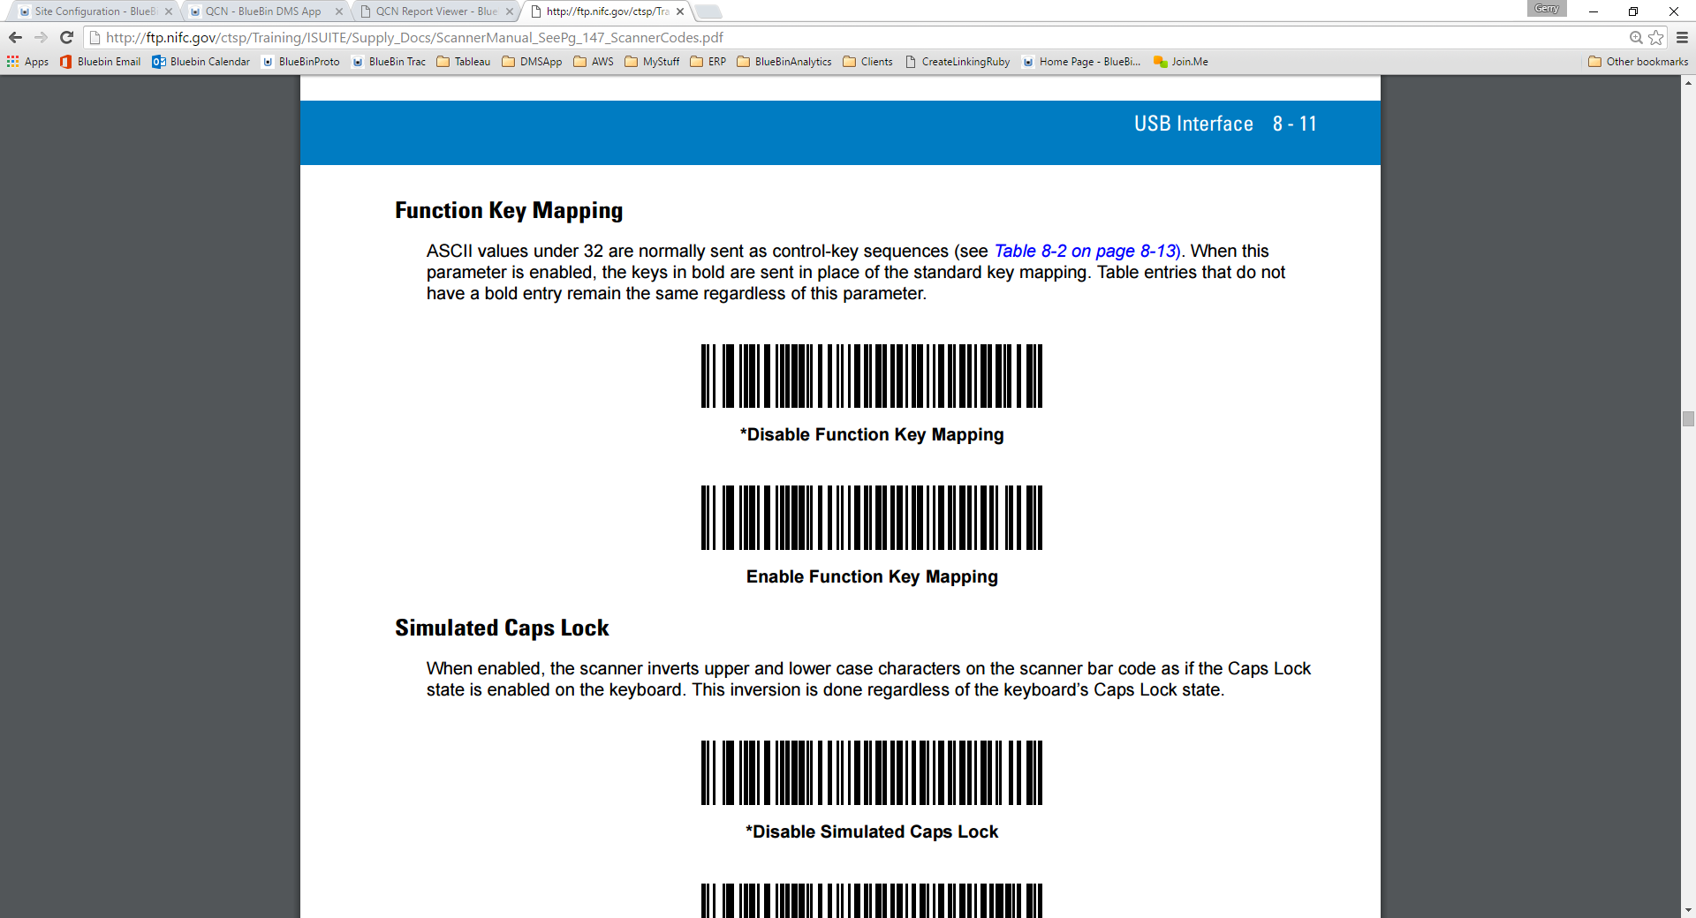

___________________________________________________________________________________________

1. Scan Location (sample below, but you can use any)



1. Scan Item (both steps a & b must be done on every item)
   1. Scan Item (sample below, but you can use any)



* 1. Scan “Next Barcode” (Tab, CR) to move past confirmation (Must be done on every item



**Next**

1. Scan “Complete Barcode” (CR, CR)



**Complete**