**Test Scanning Application – Alternate 20151229**

1. Set Factory Defaults

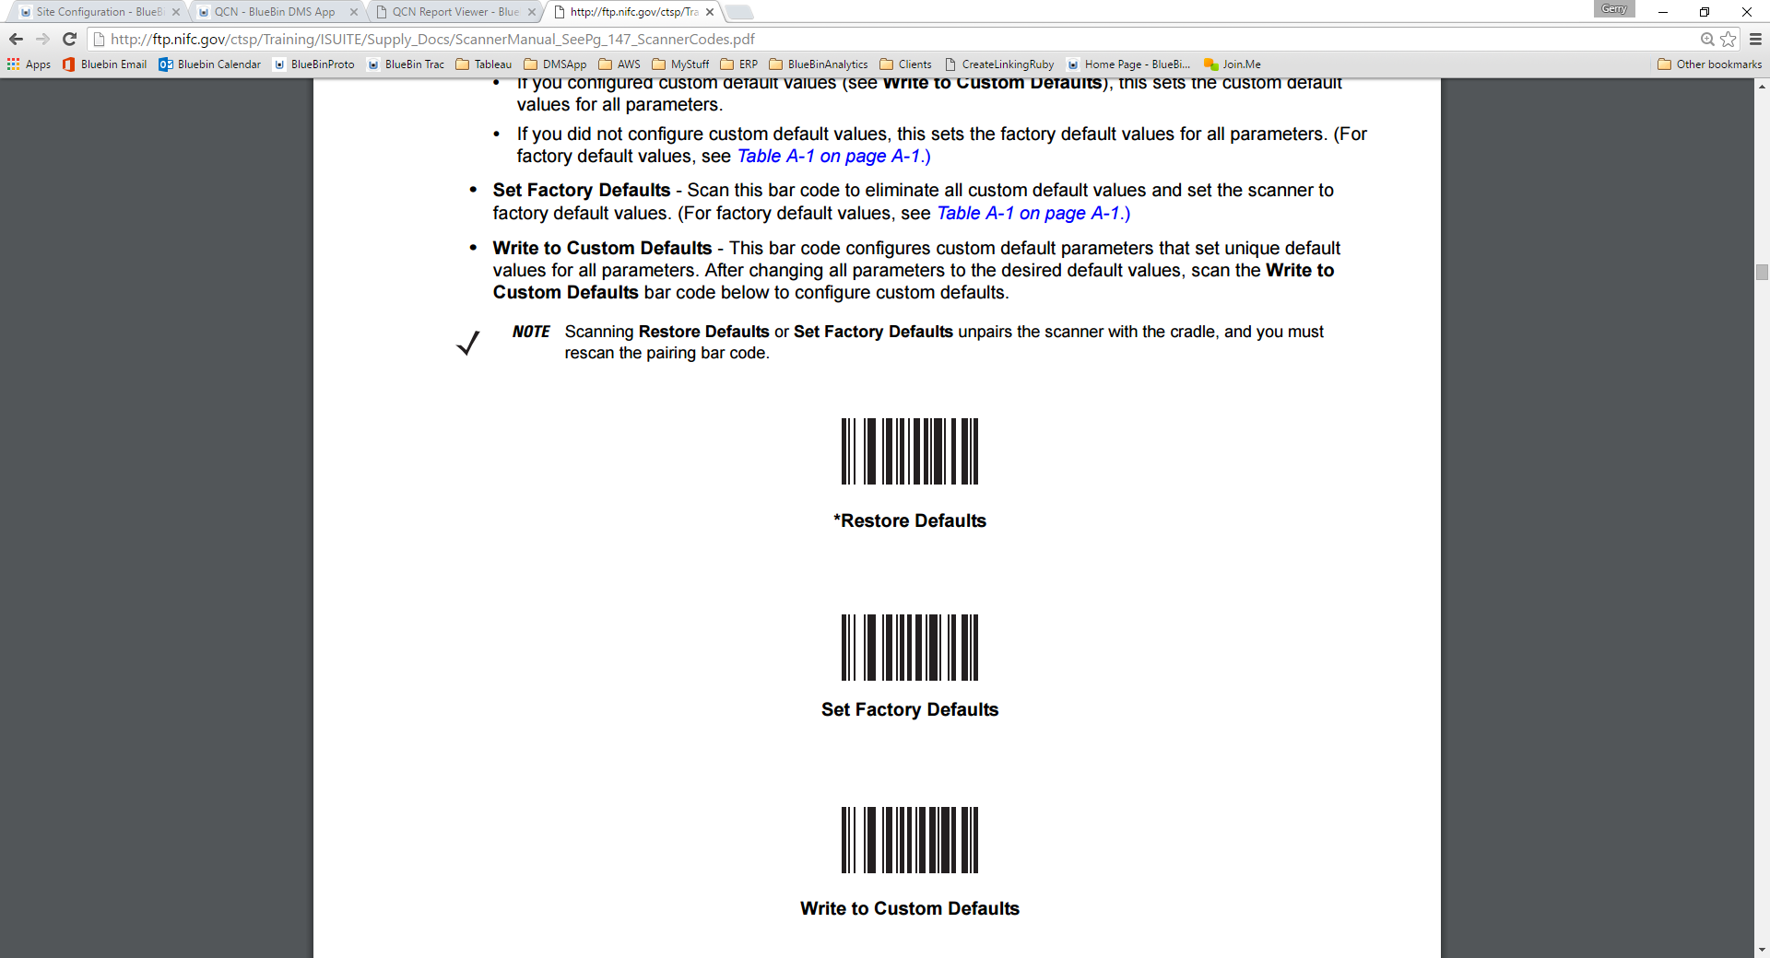

1. “Pair” (cradle)
2. Enable Function Key Mapping

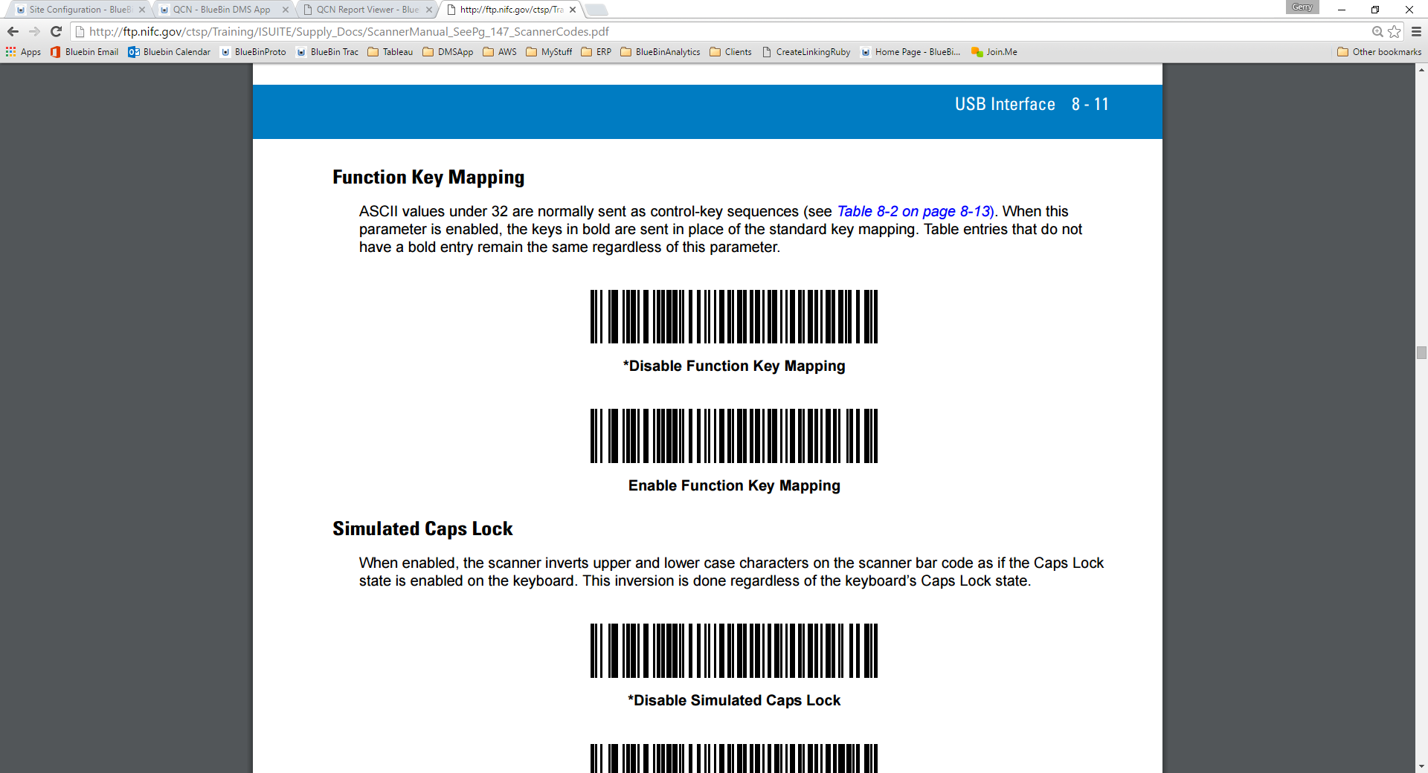

___________________________________________________________________________________________

1. Scan Location (sample below, but you can use any, must be JUST the code, no tabs or CR)



1. Scan Item (sample below, but you can use any)



1. Scan “Complete Barcode” (TAB,CR, CR)



**Complete**