Creation of tables

create table Employee_Table(emp_id varchar(10) Primary key,
name varchar(50),
immediate_head_id varchar(10),
dept_id varchar(10),
insurance_id varchar(10),
employee_info varchar(10),
Foreign key (dept_id) references Department_Table(dept_id),
Foreign key (insurance_id) references Insurance_Table(insurance_id),
Foreign key (employee_info) references Employee_Info_Table(id));

create table Department_Table(dept_id varchar(10) Primary key,
dept_name varchar(50))
create table Insurance_Table(insurance_id varchar(10) Primary key,
insurance_name varchar(50));
create table Office_Table(office_id varchar(10) primary key,
office_name varchar(50),
place varchar(50));
create table Employee_Office_Table(id varchar(10) primary key,
emp_id varchar(10),
office_id varchar(10),
Foreign key(emp_id) references Employee_Table (emp_id),
foreign key(office_id) references Office_Table(office_id));

create table Employee_Info_Table(id varchar(10)Primary key, DOJ date, salary int);

<!--insert in to -->
<!--insert in to Office table-->
insert into Office_Table values("O-01", "main office", "hitech city")
insert into Office_Table values("O-02", "sub office 1", "madhapur")
insert into Office_Table values("O-03", "sub office 2", "kukatpally")

<!--insert in to Department table-->
insert into Department_Table values("D-01","development");
insert into Department_Table values("D-02","Testing");
insert into Department_Table values("D-03","app development");
insert into Department_Table values("D-04","BPO");

<!--insert in to Insurance table-->
insert into Insurance_Table values("I-01", "ICIC");
insert into Insurance_Table values("I-02", "LIC");
insert into Insurance_Table values("I-03", "SBI");

<!--insert in to Employee_Info_Table-->
insert into Employee_Info_Table values("E-01", "06/06/2022", 45000);
insert into Employee_Info_Table values("E-02", "06/06/2019", 85000);
insert into Employee_Info_Table values("E-03", "06/02/2020", 65000);
insert into Employee_Info_Table values("E-04", "02/01/2022", 15000);
insert into Employee_Info_Table values("E-05", "01/02/2012", 95000);
insert into Employee_Info_Table values("E-06", "04/05/2012", 95000);
insert into Employee_info_table values("E-07", "19/09/2021", 45000);
insert into Employee_Info_Table values("E-08", "01/05/2012", 18000);
insert into Employee_Info_Table values("E-09", "02/07/2021", 25000);

<!--insert in to Employee_Table-->
insert into Employee_Table values("E-01", "venky", "E-02", "D-01","I-01", "E-01");
insert into Employee_Table values("E-02","ram",Null,"D-01","I-02","E-02");
insert into Employee_Table values("E-03","raj","E-02","D-01","I-02","E-03");
insert into Employee_Table values("E-05","jp","E-05","D-02","I-03","E-05");
insert into Employee_Table values("E-04","venkat","E-05","D-04","I-01","E-04")
insert into Employee_Table values("E-06","vishnu","E-05","D-03","I-03","E-06");
insert into Employee_Table values("E-07","hari","E-05","D-03","I-02","E-07")
insert into Employee_Table values("E-08","krishna","E-05","D-03","I-02","E-08");
insert into Employee_Table values("E-09","rajesh","E-05","D-03","I-02","E-09")

<!--insert in to Employee_Office_Table-->
insert into Employee_Office_Table values("EO-01", "E-01", "O-01")
insert into Employee_Office_Table values("EO-02", "E-02", "O-02");
insert into Employee_Office_Table values("EO-03", "E-03", "O-03");
insert into Employee_Office_Table values("EO-04", "E-04", "O-02");
insert into Employee_Office_Table values("EO-05", "E-05", "O-03");
insert into Employee_Office_Table values("EO-06", "E-06", "O-01");
insert into Employee_Office_Table values("EO-07", "E-07", "O-01");
insert into Employee_Office_Table values("EO-08", "E-08", "O-02");
insert into Employee_Office_Table values("EO-09", "E-09", "O-01");
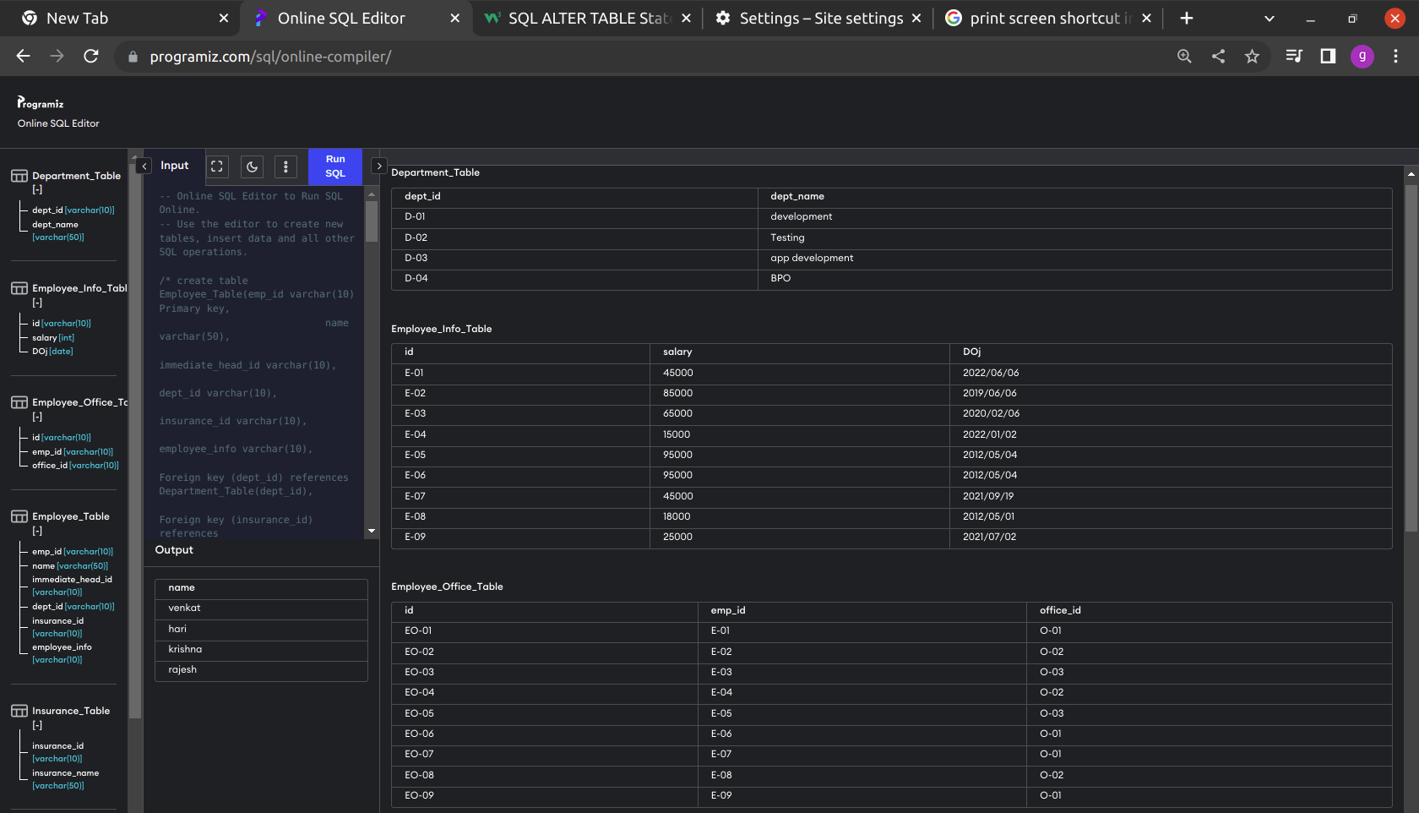

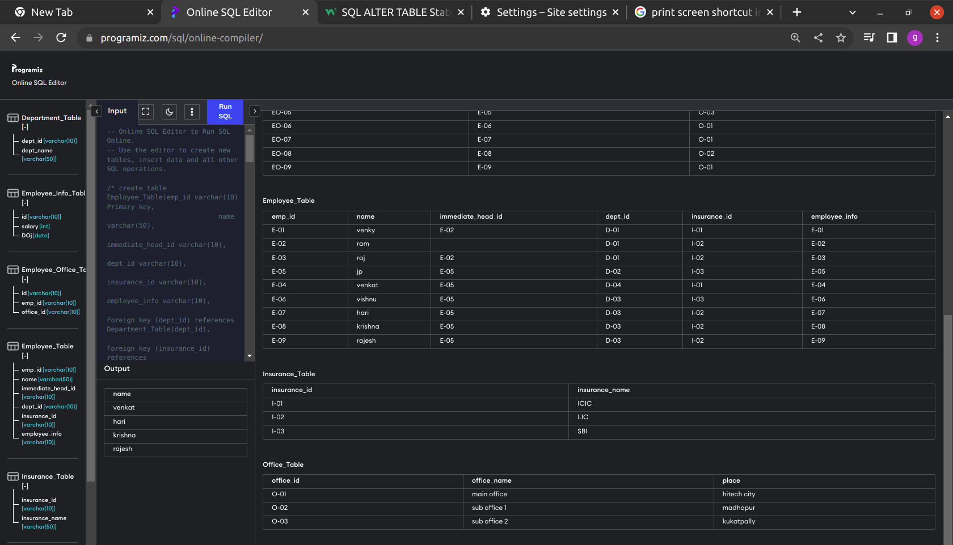

Write the queries to,
1. Get the list of employee details which should include their name,department and
name of the insurance type

select e.name, d.dept_name, i.insurance_name from Employee_Table as e, Department_Table as d,Insurance_Table as i where i.insurance_id = e.insurance_id And e.dept_id = d.dept_id

2.Get the list of departments of employees working at particular place(e.g: Madhapur)
select d.dept_name,o.place from Department_Table as d,Office_Table as o,Employee_Office_Table as eo,Employee_Table as e where o.office_id = eo.office_id And eo.emp_id = e.emp_id and e.dept_id = d.dept_id and o.place = "madhapur";

3. Get the count of employees working in each location
select count(e.emp_id), o.place from Employee_Office_Table as e, Office_Table as o where o.office_id = e.office_id group by e.office_id

4.Get the third highest salaried employee name, insurance name and salary(Joins)
with result as
(select salary, id from Employee_Info_Table order by salary desc limit 3)

select Employee_Table.name, Insurance_Table .insurance_name, min(r.salary)
from result as r, Insurance_Table
join Employee_Table on Insurance_Table.insurance_id = Employee_Table.insurance_id where Employee_Table.emp_id = r.id

5.Get the Average salary of employees from each department for a particular location

select Avg(salary), Department_Table.dept_name from ((Department_Table join
Employee_Table on Employee_Table.dept_id = Department_Table.dept_id) join Employee_Info_Table
on Employee_Info_Table.id = Employee_Table.emp_id)
join Employee_Office_Table on Employee_Table.emp_id = Employee_Office_Table.emp_id
where Employee_Office_Table.office_id= "O-01"
group by Department_Table.dept_id

6.Get the sum of salaries of the employees joined after 02-01-2022 working in ‘Madhapur’

with result as
(select * from (Employee_Info_Table join Employee_Office_Table
on Employee_Office_Table.emp_id = Employee_Info_Table.id)
join Office_Table on Office_Table.office_id = Employee_Office_Table.office_id)

select sum(salary) from result where DOJ> "2022/01/02" and place ="madhapur"

7. Get name, department, salary of employees who joined after 20-02-2022 and salary is greater than 20000 and has insurance either in lic or icici or both and whose work location is madhapur.

select e.name , d.dept_name, eit.salary
from Employee_Table as e
join Department_Table as d
on d.dept_id = e.dept_id
join Employee_Info_Table as eit
on eit.id = e.emp_id
join Insurance_Table as i
on i.insurance_id = e.insurance_id
join Employee_Office_Table as eot
on eot.emp_id = e.emp_id
join Office_Table as ot on eot.office_id = ot.Office_id
where salary >20000 AND DOJ > '2012/01/02'
And (i.insurance_name= "ICIC" OR i.insurance_name= "LIC")
And ot.place = "madhapur"

8. Get the list of employee names and their respective immediate head name

with temp_table as
(select name, emp_id from employee_table)

select e.name, r.name
from temp_table as r, Employee_Table as e
where r.emp_id = e.immediate_head_id

9. Get the list of employee names and their respective immediate head name with their respective department names.
Eg: emp name | emp department name | immediate head name | immediate head department name

with result as
(select e.name, e.emp_id, d.dept_name
from employee_table as e,Department_Table as d where d.dept_id = e.dept_id)

select e.name, d.dept_name, r.name,r.dept_name
from result as r, Employee_Table as e ,
Department_Table as d
where r.emp_id = e.immediate_head_id
And d.dept_id = e.dept_id

10. Get the list of employees whose immediate head working in location ‘madhapur’
and whose salary is less than twice the salary of their respective immediate heads.

with result as
(select e.emp_id, eit.salary
from employee_table as e,Employee_Info_Table as eit join (Employee_Office_Table join Office_Table on Office_Table.office_id = Employee_Office_Table.office_id) on eit.id = e.emp_id where eit.id = e.emp_id And place ="madhapur")

select distinct e.name
from result as r, Employee_Table as e
join Employee_Info_Table as eit
on eit.id = e.emp_id
where r.salary > (eit.salary*2) And r.emp_id = e.immediate_head_id

