Abstract:
The airport database management system consists of different airports with theirs available terminals. It keeps track of all the flights, Arrival and departure times. it also keeps tracks of the passenger and their booking information. For each airport there will be many terminals. each terminal is allowed to departure or arrive the flights of some specific airlines. each airline might have many flights with different capacities.

Passengers personal information such as Passenger name, city, mobile number, email address should be available. passenger gets the passenger id up on registering into the system. Only the registered passenger are allowed to book the tickets. The passenger can have the option to select the flight for booking the ticket. The arrivals and departures can also be tracked in the system for each flight. The airline services will have the Origin country and each airlines will have a owner. a specific terminal of airport will be allocated to the airlines for departures and arrivals. for each airport there will be different employees and each employ works for only one airlines.

Entities:

1.Airport
2.Terminal
3.Airlines
4.Flight
5.Passenger
6.Ticket
7.Schedule
8.Staff

ER diagram:

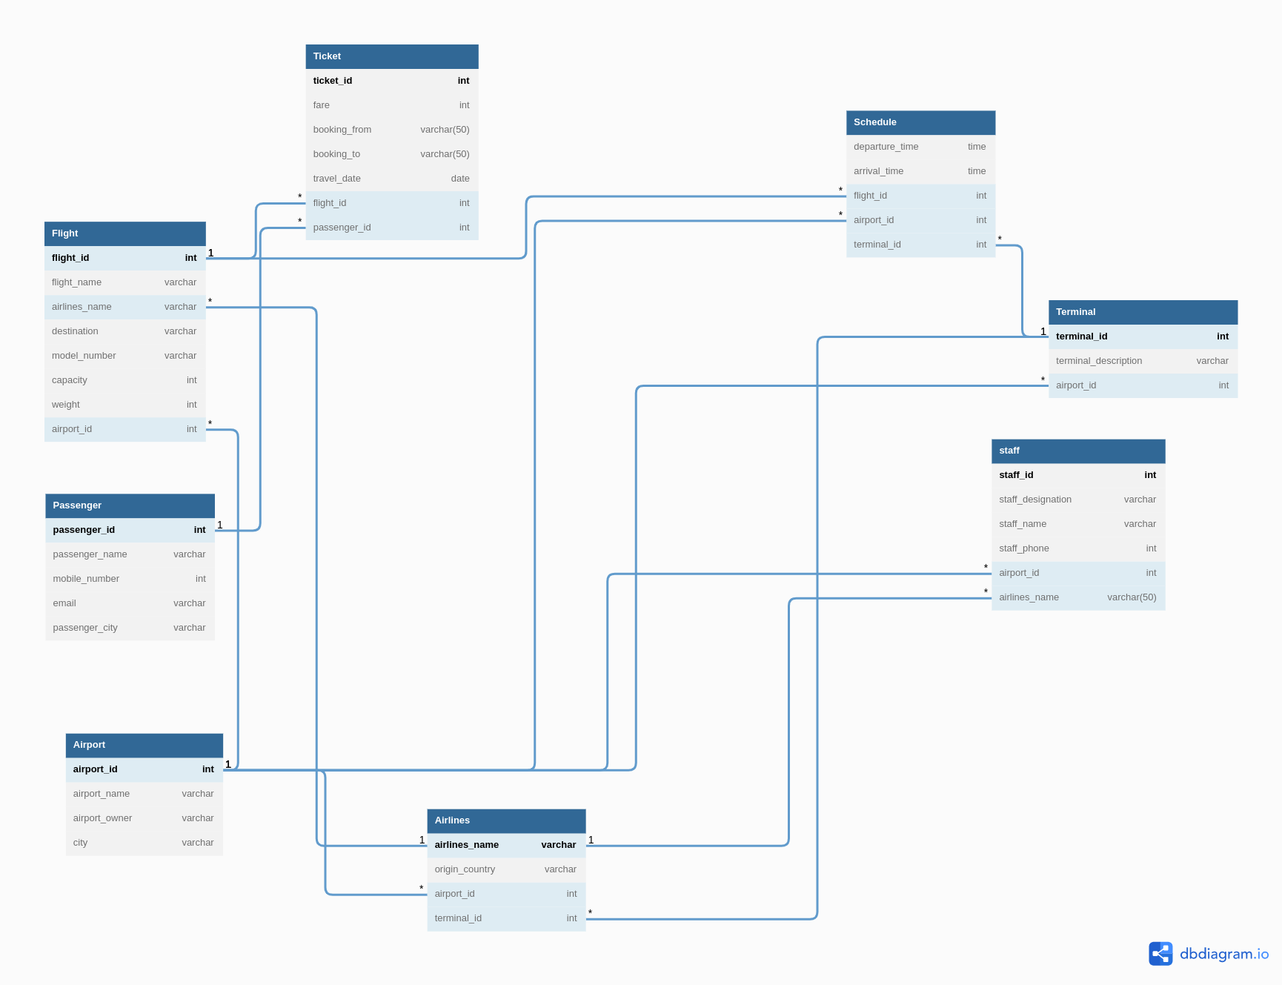

SQL CODE:

create database airport;
use airport;

create table Airport(
airport_id int primary key,
airport_name varchar(50),
airport_owner varchar(50),
city varchar(50)
);

create table Terminal(
terminal_id int primary key,
terminal_description varchar(50),
airport_id int,
foreign key(airport_id) references Airport(airport_id));

create table Airlines(
airlines_name varchar(50) primary key,
origin_country varchar(50),
airport_id int,
terminal_id int,
foreign key(airport_id) references Airport(airport_id),
foreign key(terminal_id) references Terminal(terminal_id));

create table Flight(
flight_id int primary key,
flight_name varchar(50),
airlines_name varchar(50),
destination varchar(50),
model_number varchar(50),
capacity int,
weight int,
airport_id int,
foreign key(airport_id) references Airport(airport_id),
foreign key(airlines_name) references Airlines(airlines_name));

create table Passenger(
passenger_id int primary key,
passenger_name varchar(50),
mobile_number int,
email varchar(50),
passenger_city varchar(50));

create table Ticket(
ticket_id int primary key,
booking_from varchar(50),
booking_to varchar(50),
fare int,
flight_id int,
travel_date date,
passenger_id int,
foreign key(passenger_id) references Passenger(passenger_id));
foreign key(flight_id) references Flight(flight_id));

create table Schedule(
departure_time time,
arrival_time time,
flight_id int,
airport_id int,
terminal_id int,
foreign key(flight_id) references Flight(flight_id),
foreign key(airport_id) references Airport(airport_id),
foreign key(terminal_id) references Terminal(terminal_id));

create table Staff(
staff_id int primary key,
staff_designation varchar(50),
staff_name varchar(50),
staff_phone int,
airport_id int,
airlines_name varchar(50),
foreign key(airport_id) references Airport(airport_id),
foreign key(airlines_name) references Airlines(airlines_name));

